CampusNetSim: A Cloud-Native Wi-Fi Congestion Simulation and Automated Load-Balancing System on AWS Serverless Services
Sumedha Phadnis and Priyanka J
Cloud Architecture Design (AWS) - Course Project Report

Keywords—Serverless computing, AWS Lambda, Amazon API Gateway, Amazon DynamoDB, DynamoDB Streams, event-driven architecture, WLAN load balancing, access point utilization, campus network simulation.
Abstract—Campus Wi-Fi load is lopsided. Phones and laptops choose an access point (AP) by signal strength alone. The AP nearest a busy lecture hall saturates, while neighbouring APs stay quiet. We built CampusNetSim, a cloud-native simulator that tracks which AP each campus device uses, flags overloaded APs and moves simulated clients to APs with free slots. Its backend consists of ten AWS Lambda functions behind one Amazon API Gateway HTTP API; except for TrafficGenerator, which we invoke by hand, each function serves one route or one stream trigger. Data lives in four on-demand Amazon DynamoDB tables, one each for AP state, history, devices and migrations. A DynamoDB Stream record follows every write to the AP state table, and only that record starts load balancing and history logging. No scheduled job exists in the backend. To join, a user scans the QR code assigned to one of the APs. That page is a single HTML file on Amazon S3. A React dashboard on AWS Amplify gives operators live utilization, the migration log, the device roster and a traffic trend for each AP. PUT /aps/{ap_id}/config, added in the final build, lets an operator change an AP's capacity during a run after server-side validation. Conditional writes in EventProcessor stop two simultaneous events from erasing each other's update. DynamoDB therefore holds the only copy of the campus layout. Every function reads AP capacities from APState at run time, and none of the ten keeps a cached copy. We tested the system end to end twice with real phones: in September, and at the final demonstration on 20 October 2026. Each time, check-ins from participants' phones filled one AP to 100%. LoadBalancer then shifted a single device to the AP with the most free capacity, as Eq. (4) prescribes. That brought the source back below the 85% trigger. On the target AP, which had been empty, utilization rose to 33.33% (one of three slots). All 14 functional API tests, from GET /aps through an invalid JOIN on /devices, returned the status codes we expected. For the three most frequently polled routes, the median warm-read latency was 60-69 ms, under 1.4% of the five-second polling interval.
I. Introduction
Class changes are the worst case: the whole lecture hall reconnects at once. Each client radio in the room picks the access point with the strongest signal, and nothing in that choice looks at how many clients that AP already serves. One AP saturates. Meanwhile the library AP, two buildings over, still has half its capacity free. Research on WLAN association control has shown that signal-strength-only association produces markedly worse throughput and fairness than load-aware association [1]-[3].
Getting a client onto a less loaded AP is not as simple as it sounds. The IEEE 802.11 standard [4] lets an AP suggest a transition through BSS Transition Management [5] and speeds up the roam once the client decides to move [6], but the decision always remains with the client's chipset and driver. Consumer routers rarely open their steering controls to outside software. Mobile operating systems also stop applications from switching networks silently. Within a student project, therefore, reliable steering of real clients is not achievable, since neither the routers nor the phones give us the necessary control.
Our answer is to simulate association in CampusNetSim. Since the simulation owns every device-to-AP link, every move LoadBalancer decides on actually happens, something real clients cannot guarantee because they may ignore a steering request. Four APs, spread over three buildings, make up the model. AP01 and AP04 are in the academic block, AP02 is in the hostel, and AP03 is in the library. We set each AP's capacity separately. In Run A, AP02 held two devices and AP04 three; for Run B we changed AP01-AP04 to 3, 1, 3 and 1. Association changes only through explicit CONNECT and DISCONNECT events, whether a phone, LoadBalancer or TrafficGenerator sends them. CampusNetSim holds the association state itself. Holding that state lets CampusNetSim spot an overloaded AP, choose a target and make the move. It then logs both APs' utilization, before and after, in the Migrations table. Real phones still have a role. When a user scans an AP-specific QR code, a browser check-in page opens and registers that phone with the AP in application state; the phone's real network connection stays exactly as it was.
Nothing in the stack needs a provisioned server, since every component is a managed AWS serverless service [7]-[9]. Four contributions come out of this work. The first two are (i) an event-driven, polling-free load-balancing pipeline built on DynamoDB Streams and (ii) run-time capacity reconfiguration with server-side validation and concurrency-safe event processing; we also contribute (iii) a phone check-in path that lets real devices trigger the pipeline without any installation and (iv) a live evaluation with real phones, functional API tests and latency measurements.
Nine sections follow. In Section II we review WLAN association control [1]-[3], the 802.11v and 802.11r roaming amendments [5], [6] and serverless computing [7]-[9]. Section III gives the methodology. Sections IV and V then present the architecture and the check-in and capacity workflows, while Section VI formalises the utilization model and Algorithm 1. Tables II-V, in Section VII, record the deployed configuration. Implementation and results are reported in Section VIII, and Sections IX and X give the conclusion and future work.
II. Related Works
Most prior work on wireless LAN load balancing operates at the level of AP association. Bejerano, Han and Li [1] cast association control as a max-min fair bandwidth allocation problem. Against the default strongest-signal policy, their load-aware scheme came out clearly ahead. Bejerano and Han [2] later proposed cell breathing. Each AP adjusts its transmit power to shrink or grow its coverage, and clients drift toward less loaded cells with no client-side change. Balachandran, Bahl and Voelker [3] studied hot-spot congestion in public-area wireless networks and proposed network-directed roaming, in which an overloaded AP explicitly redirects users to neighbouring APs. CampusNetSim follows the same idea of network-side redirection, but performs it on a simulated association model where every move can be enforced and audited.
The 802.11 standard [4] defines how roaming can be influenced in real deployments. In 802.11v [5], BSS Transition Management lets an AP ask a client to move, while 802.11r [6] adds Fast BSS Transition to cut roaming latency. Neither mechanism can force a move, since a client is free to ignore a transition request. For this reason above all, CampusNetSim enforces moves inside its own event model and makes no attempt at real client steering.
Jonas et al. [7] and Castro et al. [8] describe serverless computing from the cloud side. Developers deploy stateless functions and the provider handles provisioning and scaling, with cold starts and platform-specific integration as the price. Li et al. [9] go further and survey serverless architectures, sorting them by the design trade-offs each one makes. Amazon's Dynamo paper [10] describes a key-value store, the forerunner of DynamoDB, built for single-item reads and writes. CampusNetSim's data match that design closely, since each AP state, history snapshot and migration log entry is a single item. Ahmed et al. [11] built a four-layer IoT platform to monitor and control smart campus buildings remotely. CampusNetSim also targets live campus monitoring through a web dashboard, but its data come from simulated association events and phone check-ins, not physical sensors. Table I sets these five mechanisms side by side with CampusNetSim.
TABLE I
Comparison of Related Approaches
Approach | Where control lives | Needs client support | Relation to CampusNetSim
Association control [1] | Network (central) | Yes | Same objective; simulated enforcement
Cell breathing [2] | AP transmit power | No | Alternative real-network mechanism
Network-directed roaming [3] | Overloaded AP | Partly | Closest idea: redirect from hot spot
802.11v / 802.11r [5], [6] | AP request, client decides | Yes | Advisory only; motivates simulation
Smart-campus IoT [11] | Cloud platform | Sensors | Similar cloud monitoring stack

III. Proposed Methodology
A. System Model
We model the campus as a set of APs, each stored as one item in the APState table with its configuration and live device count. Each AP has an ID (e.g., AP01), a building and a name. Alongside these, we store a capacity C_{i} (the number of devices at which we treat the AP as full) and a live connected-device count n_{i}. Association changes arrive as CONNECT and DISCONNECT events from three sources: phones using the check-in page, the load balancer when it moves devices, and an optional synthetic traffic generator. Each AP's state sits in one DynamoDB item. Changing an AP therefore means updating exactly one item, and DynamoDB Streams can publish each such update as a record [14].
B. Design Principles
Four design principles follow. One function per responsibility: every API route gets its own Lambda function, whose permissions cover only the tables it needs, as the AWS serverless guidance recommends [12]. Event-driven reaction: stream records from APState start load balancing and history logging, so nothing runs while the campus is quiet [13], [14]. Single source of truth: AP capacities, buildings and names live only in the APState table; every function reads them from there at run time. Verifiable actions: every automated move writes a Migrations record with the utilization of both APs before and after the move.
C. Functional Components
Event ingestion. Every check-in reaches EventProcessor through POST /events. It validates the event and then reads the AP's configuration and device count with a strongly consistent read. A capacity changed a moment earlier is therefore already visible. EventProcessor answers a CONNECT to a full AP with HTTP 409. For any other event, EventProcessor computes utilization with Eq. (1), maps it to a status with Eq. (2) and writes the result back through a conditional update. Only the live-state attributes change. If the AP becomes CONGESTED, EventProcessor also attaches an advisory recommendation for another AP in the same building, AP04 for AP01, for example.
Reactive load balancing. LoadBalancer listens to the APState stream. When an AP reaches the 85% trigger, it selects the AP with the most free capacity, computes how many devices to move (at most five) and moves them by posting DISCONNECT and CONNECT events through the public API, so every move passes the same validation as any other event. Real phones are moved first, and their roster entries are updated so that the phone's page can show the redirect. HistoryWriter consumes the same stream and stores each AP state in APHistory with a 24-hour expiry using DynamoDB time to live (TTL) [15].
Read services and administration. StatusReader, HistoryReader and MigrationReader serve the dashboard and the check-in page. DeviceRegistry handles GET and POST /devices and records each phone, together with its current AP, in the Devices table that the check-in page and dashboard both read. We run AdminReset (POST /admin/reset) before each demonstration. It zeroes all four APs, empties the Migrations and APHistory tables and marks every phone in the Devices roster as disconnected, all within a 40 s timeout.
D. Run-Time Capacity Reconfiguration and Consistency
UpdateAPConfig is the final build's new function; with it, capacities change without a redeploy. PUT /aps/{ap_id}/config accepts building and ap_name besides capacity. Test 9 in Table VII shows what happens to anything else: a color field gets HTTP 400. UpdateAPConfig rejects capacities of 0, "four" or 5000 with HTTP 400, since only integers from 1 to 1000 are allowed. Going below the current device count returns HTTP 409 (Eq. (7)). When a request passes these checks, the write changes only the supplied attributes and recomputes utilization with Eq. (1), keeping the stored percentage consistent with the new capacity. EventProcessor reads capacity from APState on every event, so the next CONNECT or DISCONNECT already uses the new value for the status and for the 85% trigger.
Two concurrent events on the same AP could otherwise read the same count and overwrite each other. EventProcessor therefore uses optimistic concurrency [16]: its update succeeds only if the stored count and capacity still equal the values it read; otherwise DynamoDB rejects the write and the API returns HTTP 409 so that the caller can retry. The same condition protects against a capacity change that lands between the read and the write of an event.
IV. Architecture Diagram
Fig. 1 shows the deployed architecture in five layers. The client layer contains the phone check-in page, a static page on Amazon S3, and the monitoring dashboard, a React and Vite application on AWS Amplify Hosting. Both call a single API Gateway HTTP API [17] with CORS enabled. Seven request handlers, one per API route, make up most of the compute layer. Two event-driven functions are attached to the APState stream, and TrafficGenerator, deployed without a trigger, is invoked manually to create synthetic load. Storage consists of the four on-demand DynamoDB tables listed in Table III, all created without provisioned throughput. Every function, including the stream-triggered LoadBalancer and HistoryWriter, sends its logs to Amazon CloudWatch Logs.
The logic travels over two kinds of connection. API calls are synchronous and land on one of seven request handlers; StatusReader, for instance, answers GET /aps by reading every AP item from APState. Stream records are asynchronous. They arrive in batches of up to 100 and deliver every APState change to LoadBalancer and HistoryWriter, so neither function reads APState on a schedule. We deliberately kept LoadBalancer away from APState. Instead, each move goes to POST /events as a DISCONNECT from the source AP and then a CONNECT to the target. Phone events and balancer moves therefore pass the same capacity check and conditional write.

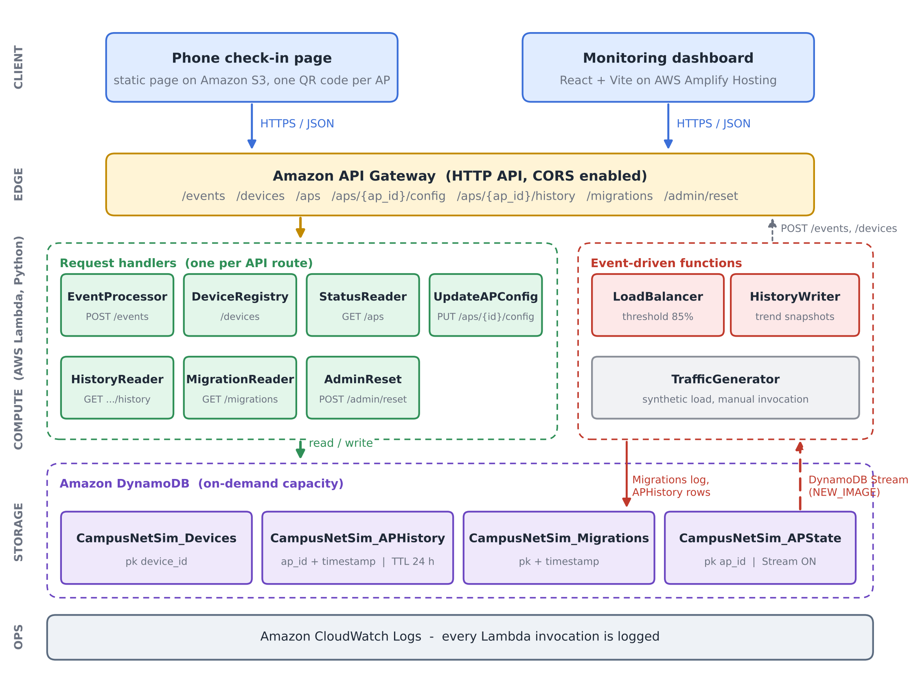
Fig. 1. CampusNetSim system architecture. Seven handlers, one per route, sit behind the HTTP API. Two functions, LoadBalancer and HistoryWriter, run on the APState stream (NEW_IMAGE view), and four on-demand tables, from APState to Migrations, hold all state.

V. Workflow
Fig. 2 numbers the eight steps between a QR scan and the next dashboard refresh. Scanning the code (step 1) opens the check-in page with, for example, AP02 already in the link. Tapping Join (step 2) sends a CONNECT to /events and a JOIN to /devices, updating the AP's count and the phone roster in turn. EventProcessor validates and writes in step 3. One stream record follows (step 4). LoadBalancer and HistoryWriter each receive that record (steps 5 and 6) and act on it independently. LoadBalancer acts only when the AP has reached 85%, moving devices and logging the migration (step 7), while HistoryWriter always stores a snapshot for the trend chart. In step 8, the dashboard and the check-in page each poll the read endpoints every five seconds. A phone that LoadBalancer has moved finds its new AP in the roster on the next poll and shows a banner saying where it went.
Fig. 3 covers resizing an AP. Suppose, for example, that the operator wants AP04 (capacity 1 in Run B) to hold two devices. The operator opens AP04's capacity editor and enters 2. The dashboard checks the value locally: it must be a positive integer no smaller than the number of connected devices. Only then does it send PUT /aps/{ap_id}/config. On the server, UpdateAPConfig runs the same checks again, adds the 1-1000 range test and returns HTTP 400 or 409 for any request that fails. Requests that skip the dashboard get no shortcut. HistoryWriter sees that write as well, through the APState stream. As a result, the trend chart records the recalculated utilization immediately.

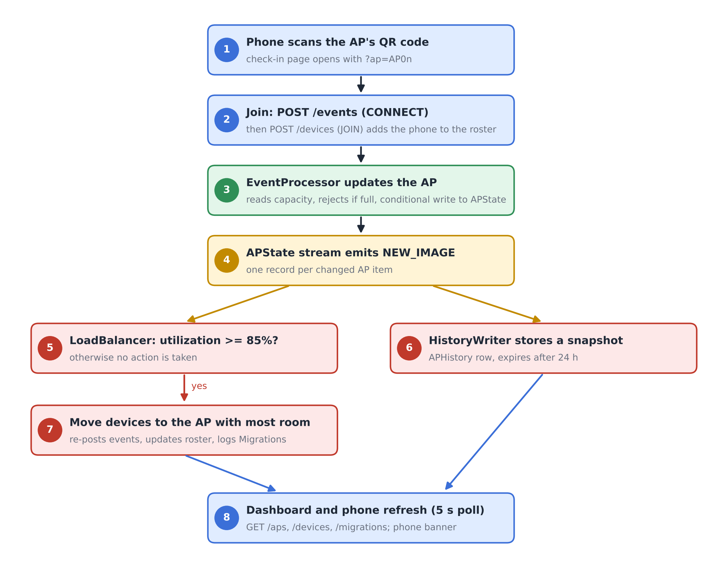
Fig. 2. End-to-end workflow from phone check-in to automated rebalancing and dashboard refresh.
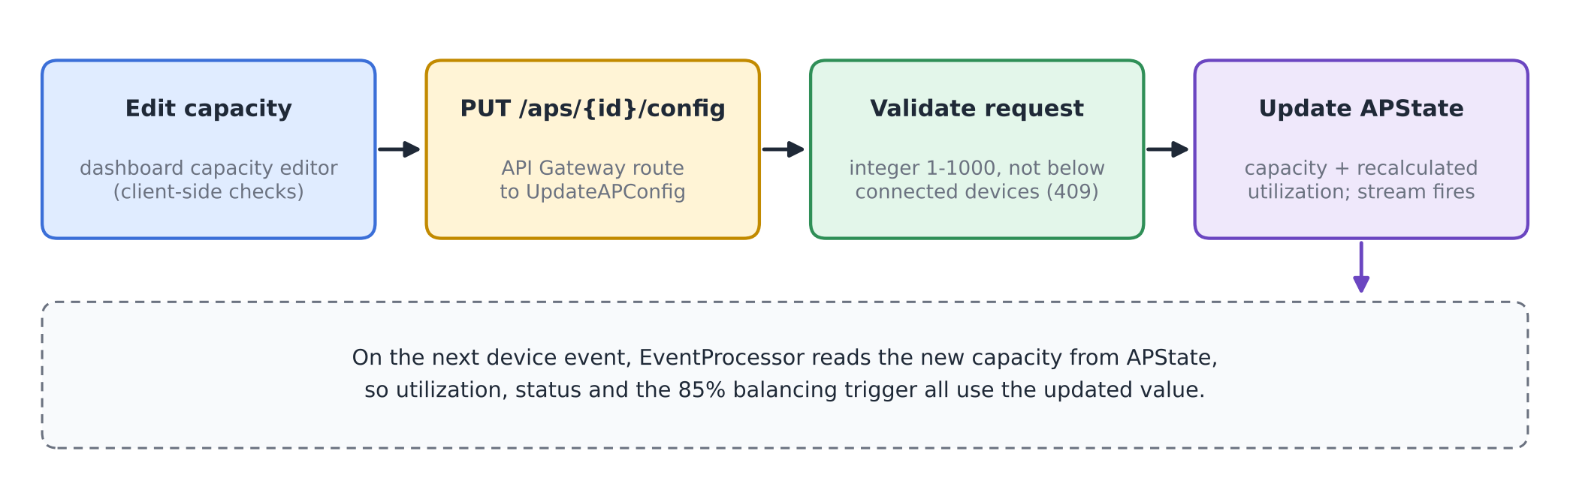
Fig. 3. Run-time capacity reconfiguration flow.

VI. Algorithm / Formulas
A. Utilization and Status
For an AP i with n_{i} connected devices and capacity C_{i}, utilization is
U_{i} = (n_{i} / C_{i}) × 100 (1)
rounded to two decimals. The status shown on the dashboard and the check-in page is
S_{i} = NORMAL (U_{i} < 70), BUSY (70 ≤ U_{i} < 90) (2)
with HIGH_LOAD for 90 ≤ U_{i} < 100 and CONGESTED for U_{i} ≥ 100. EventProcessor rejects any CONNECT once n_{i} = C_{i}. Utilization therefore never exceeds 100%, and CONGESTED means exactly full.
B. Balancing Trigger, Target and Move Size
LoadBalancer reacts to a stream record for AP i only when
U_{i} ≥ θ, θ = 85 (3)
and the condition still holds in a fresh read of GET /aps. The target is the AP with the most free slots,
j* = argmax_{j ≠ i} (C_{j} − n_{j}) (4)
and the source should drop to about five points below the trigger, giving a target count
n_{i}^{tgt} = ⌊C_{i} (θ − 5) / 100⌋ (5)
The number of devices moved is limited by the need, the free space at j* and a per-migration cap K = 5:
k = min( max(1, n_{i} − n_{i}^{tgt}), C_{j*} − n_{j*}, K ) (6)
C. Capacity Update and Consistency Rules
A capacity change for AP i to a new value C_{i}' is accepted only if
n_{i} ≤ C_{i}' ≤ 1000, C_{i}' ∈ ℤ (7)
and the stored utilization is recomputed with (1). An event write computed from a read of (n_{i}, C_{i}) is committed only if the stored item still matches that read:
commit ⇔ n_{i}^{stored} = n_{i}^{read} ∧ C_{i}^{stored} = C_{i}^{read} (8)
As a worked example, consider an AP with C_{i} = 2 and n_{i} = 2 (U_{i} = 100%). Equation (5) gives n_{i}^{tgt} = ⌊2 × 80 / 100⌋ = 1, so (6) moves k = 1 device, provided the target has at least one free slot. The source keeps one device of two, or 50%. Run A in Section VIII matched this calculation exactly: AP02 went from 100% to 50% while AP04, the target, rose from 0% to 33.33%.
D. Algorithm
Algorithm 1 gives the per-record procedure of LoadBalancer. Fig. 4 draws the same logic as a flowchart.
Algorithm 1: Reactive AP load balancing (per stream record)
1: input: stream record r for AP i
2: if r is not INSERT/MODIFY or device id starts with "migrated-" then return
3: if U_{i} < θ in r then return
4: read all APs via GET /aps; if U_{i} < θ then return
5: j* ← argmax_{j≠i} (C_{j} − n_{j}) (4); if C_{j*} − n_{j*} ≤ 0 then return
6: k ← min(max(1, n_{i} − n_{i}^{tgt}), C_{j*} − n_{j*}, 5) (5)-(6)
7: D ← connected real phones on AP i (roster)
8: for m = 1 to k do
9: d ← D[m] if available, else synthetic id "migrated-i-xxxx"
10: POST /events (d, i, DISCONNECT); POST /events (d, j*, CONNECT)
11: if d is a real phone then POST /devices (d, JOIN, j*)
12: if at least one move succeeded then write Migrations record {i, j*, moved, U before/after}

Line 2 keeps LoadBalancer from reacting to its own moves. Without it, LoadBalancer would see its own moves as fresh load and might start a new migration. Its events change APState again, but LoadBalancer ignores records for synthetic devices whose ids start with "migrated-", and a target AP that has just received devices normally sits below the trigger. Each move is a DISCONNECT/CONNECT pair posted to /events. EventProcessor's capacity check and conditional write therefore protect the balancer's own writes as well.
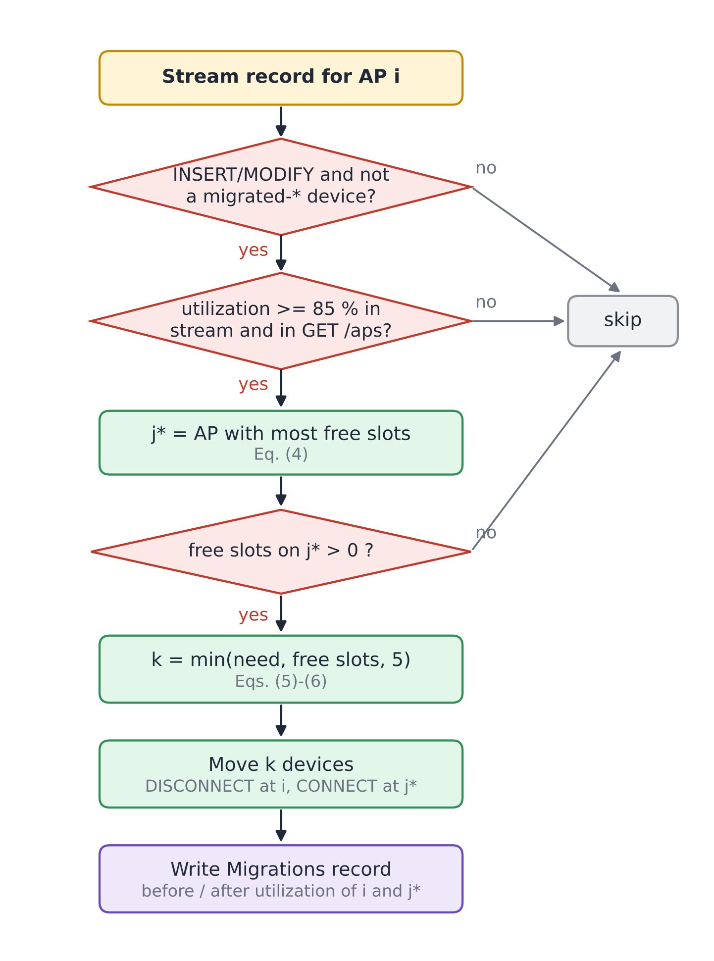
Fig. 4. Decision flowchart of the LoadBalancer function (Algorithm 1).
VII. Tables and Figures
Four tables document the deployed configuration. Table II lists the Lambda functions with their triggers and settings, Table III the DynamoDB tables, Table IV the API routes and Table V the parameters used in Section VI. Figures 1-4 above describe the architecture, workflows and algorithm; Figs. 5-10 in Section VIII document the running system and the measured results.

TABLE II
AWS Lambda Functions (ap-south-1, x86_64, 128 MB)
Function | Trigger | Runtime / timeout | Responsibility
CampusNetSim-EventProcessor | HTTP API: /events | Python 3.13 / 3 s | Validate CONNECT/DISCONNECT, conditional APState update, advisory recommendation
CampusNetSim-DeviceRegistry | HTTP API: /devices | Python 3.13 / 3 s | Phone roster: JOIN, LEAVE, list
CampusNetSim-StatusReader | HTTP API: /aps | Python 3.13 / 3 s | Live state of all APs
UpdateAPConfig | HTTP API: /aps/{ap_id}/config | Python 3.14 / 3 s | Validated capacity, building and name update
CampusNetSim-HistoryReader | HTTP API: /aps/{ap_id}/history | Python 3.13 / 3 s | Up to 200 history points for one AP
CampusNetSim-MigrationReader | HTTP API: /migrations | Python 3.13 / 3 s | 50 most recent migrations
CampusNetSim-AdminReset | HTTP API: /admin/reset | Python 3.13 / 40 s | Reset APs, clear logs, disconnect phones
CampusNetSim-LoadBalancer | DynamoDB Stream (APState) | Python 3.13 / 30 s | Detect >= 85% and move devices
CampusNetSim-HistoryWriter | DynamoDB Stream (APState) | Python 3.13 / 3 s | Append snapshot to APHistory
CampusNetSim-TrafficGenerator | None (manual) | Python 3.13 / 30 s | Synthetic CONNECT/DISCONNECT traffic

TABLE III
Amazon DynamoDB Tables (On-Demand Capacity)
Table | Key schema | Purpose / features
APState | ap_id | Live AP config and counts; stream (NEW_IMAGE)
APHistory | ap_id + timestamp | Utilization snapshots; TTL 24 h
Devices | device_id | Phone roster and current AP
Migrations | pk + timestamp | Audit log of automated moves

TABLE IV
API Gateway Routes
Route | Method | Function
/events | POST | EventProcessor
/devices | GET, POST | DeviceRegistry
/aps | GET | StatusReader
/aps/{ap_id}/config | PUT | UpdateAPConfig
/aps/{ap_id}/history | GET | HistoryReader
/migrations | GET | MigrationReader
/admin/reset | POST (else 405) | AdminReset

TABLE V
Model Parameters
Symbol | Value | Meaning
BUSY / HIGH_LOAD / CONGESTED | 70 / 90 / 100 % | Status thresholds, Eq. (2)
θ | 85 % | Balancing trigger, Eq. (3)
θ − 5 | 80 % | Source target after a move, Eq. (5)
K | 5 | Max devices per migration, Eq. (6)
C_{i} range | 1-1000 | Allowed capacity, Eq. (7)
History TTL | 24 h | APHistory retention
Poll interval | 5 s | Dashboard and check-in refresh

VIII. Implementation, Results, and Discussion
A. Backend Deployment
The backend runs in the AWS Mumbai region (ap-south-1). The four tables were created with on-demand capacity, so no throughput had to be provisioned. The APState stream uses the NEW_IMAGE view type and has two enabled consumers, LoadBalancer and HistoryWriter, each with a batch size of 100 starting from the latest record [13], [14]. APHistory has TTL enabled on its expires_at attribute, so old readings disappear without a clean-up job [15]. All functions are written in Python and use the boto3 SDK; read functions convert DynamoDB Decimal values back to JSON numbers. The complete source of every deployed function, the check-in page, the dashboard and an AWS SAM template that recreates the stack are published in the project repository [19].
B. Front Ends and Hosting
The phone check-in page is a single HTML file on Amazon S3. On first use it generates a device identifier with the browser's random UUID generator and keeps it in local storage, so later check-ins from the same phone map to the same roster entry. Joined phones poll GET /devices and GET /aps every five seconds. The page reacts to two changes in its roster entry, and it checks for both on every five-second poll. A new AP there means LoadBalancer has moved the phone. DISCONNECTED means AdminReset has cleared the campus. Either way, a banner explains what happened.
The dashboard is built with React, Vite, Tailwind CSS and Recharts. It shows the AP cards, a utilization bar chart with the 70% and 90% reference lines, the automated load-balancing log, the connected-device roster and the traffic trend of the selected AP. The final build adds the capacity editor and an AP details panel that lists the devices on the selected AP (Fig. 5). The production build is deployed to AWS Amplify Hosting by manual upload [18]. Two deployment issues had to be fixed: a ZIP archive created on Windows stored backslash paths, which made the hosted page request its JavaScript and CSS files at wrong URLs, and the Vite configuration initially lacked the Tailwind CSS plugin, which left the page unstyled. A small script now rebuilds the archive with forward-slash paths.

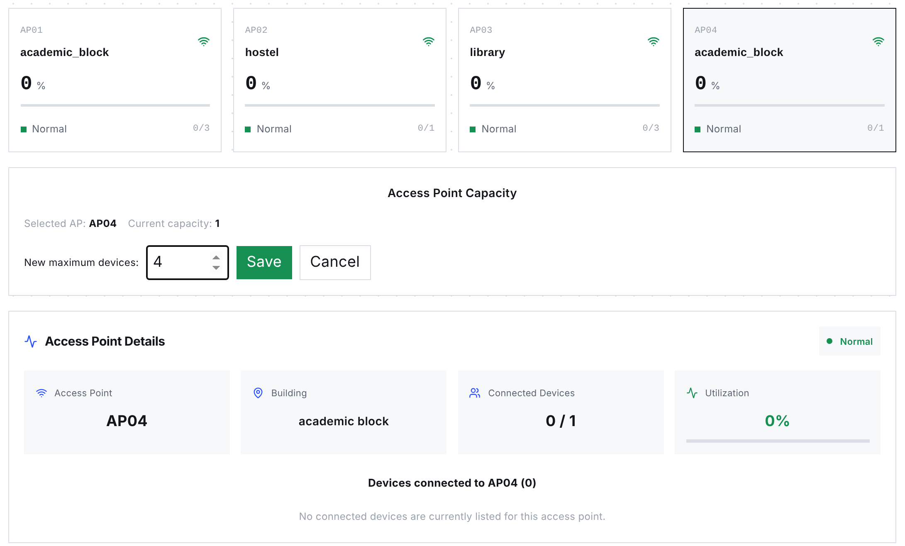
Fig. 5. Dashboard (final build) showing the capacity editor for AP04. AP cards show capacities of 3, 1, 3 and 1 for AP01-AP04; a details panel lists the devices on the selected AP. Screenshot of the production build, taken with the API state of 23 October 2026.

C. Capacity Reconfiguration and Consistency Enhancements
Table VI lists the six final-build changes. EventProcessor no longer contains hard-coded capacities; every value now comes from APState, which the operator edits through PUT /aps/{ap_id}/config. When two writes conflict, the second caller now receives HTTP 409 and can retry. No update is lost. The dashboard also gives the operator direct control of the campus layout.

TABLE VI
Enhancements in the Final Build
Component | Change | Effect
UpdateAPConfig (new Lambda) and PUT /aps/{ap_id}/config | Validated partial update of capacity, building and AP name; utilization recalculated with the capacity | Operators change capacity at run time without touching DynamoDB
EventProcessor | Reads capacity, building and name from APState on every event (strongly consistent read) | DynamoDB is the single source of truth for the layout
EventProcessor | Rejects CONNECT at capacity (409); conditional update on count and capacity (409 on conflict) | No lost updates and no utilization above 100%
EventProcessor | Updates only live-state attributes instead of replacing the item | Configuration fields survive device events
Dashboard | Capacity editor with local checks (positive integer, not below connected devices) and AP details panel | Capacity changes and per-AP devices visible in one place
Dashboard deployment | Forward-slash ZIP packaging script; Tailwind plugin in the Vite configuration | Reliable Amplify deployments

D. Functional Verification
On 23 October 2026, we sent 14 requests to the deployed API, covering all seven routes, with most of them aimed at validation paths that leave the data untouched. Ten of them are validation tests. The remaining four call the read endpoints GET /aps, /devices, /migrations and /aps/AP03/history, which only return stored data. Table VII lists the requests and responses; all 14 returned the expected status code and error message. The reset endpoint was checked only with a GET, which is correctly refused, because a POST permanently deletes the logs.

TABLE VII
Functional API Tests Against the Deployed System
# | Request | Expected | Observed response
1 | GET /aps | 200, four APs | 200, AP01-AP04 with capacities 3, 1, 3, 1
2 | GET /devices | 200, roster | 200, roster list
3 | GET /migrations | 200, log | 200, one migration (AP04 to AP03)
4 | GET /aps/AP03/history | 200 | 200, empty list (readings older than 24 h expired)
5 | GET /admin/reset | 405 | 405 "Use POST to trigger a reset"
6 | PUT /aps/AP01/config {capacity: 0} | 400 | 400 "Capacity must be an integer from 1 to 1000"
7 | PUT /aps/AP01/config {capacity: "four"} | 400 | 400, same message
8 | PUT /aps/AP01/config {capacity: 5000} | 400 | 400, same message
9 | PUT /aps/AP01/config {color: "red"} | 400 | 400 "Unsupported configuration field"
10 | PUT /aps/AP99/config {capacity: 4} | 404 | 404 "AP not found"
11 | POST /events, event_type PING | 400 | 400 "event_type must be CONNECT or DISCONNECT"
12 | POST /events, no device_id | 400 | 400 "device_id, ap_id and event_type are required"
13 | POST /events, ap_id AP99 | 400 | 400 "Unknown ap_id: AP99"
14 | POST /devices JOIN without ap_id | 400 | 400 "ap_id required for JOIN"

Response times of the three most frequently polled routes were measured from a browser client in India with 20 sequential requests per route after the functions were warm (Table VIII). Median latencies of 60-69 ms are far below the five-second polling interval. The first requests after a period of inactivity took up to about 1.3 s, which reflects Lambda cold starts [8].
TABLE VIII
Warm Request Latency (20 Requests per Route)
Route | Min (ms) | Median (ms) | P90 (ms) | Max (ms)
GET /aps | 57 | 68 | 79 | 84
GET /devices | 56 | 69 | 78 | 81
GET /migrations | 58 | 60 | 80 | 282

E. Live Load-Balancing Runs
The pipeline was tested end to end with real phones instead of staged data. In Run A (September 2026), AP02 in the hostel had a capacity of 2 and AP04 in the academic block a capacity of 3. Two team members joined AP02 from their phones within a few minutes, driving it to 2 of 2 devices and 100% utilization (Fig. 8a). The resulting APState write reached LoadBalancer through the stream; it chose AP04, which had the most free slots, and moved one phone there. AP02 dropped to 50% and AP04 rose to 33.33%. The moved phone displayed the redirect banner with its new AP (Fig. 8b), and the dashboard logged the migration and showed both phones in the roster (Figs. 6 and 7).
Run B took place on 20 October 2026 during the final demonstration, after the capacities had been changed through the new capacity editor to 3, 1, 3 and 1 for AP01-AP04. Several participants checked in from their own phones. When a phone joined AP04 (capacity 1), the AP reached 100%, and LoadBalancer moved the phone to AP03 in the library, leaving AP04 at 0% and AP03 at 33.33% (Fig. 9). This run also confirms that a capacity set at run time is used by EventProcessor and by the balancing trigger without redeploying anything. Table IX lists both migrations and Fig. 10 compares utilization before and after each move.

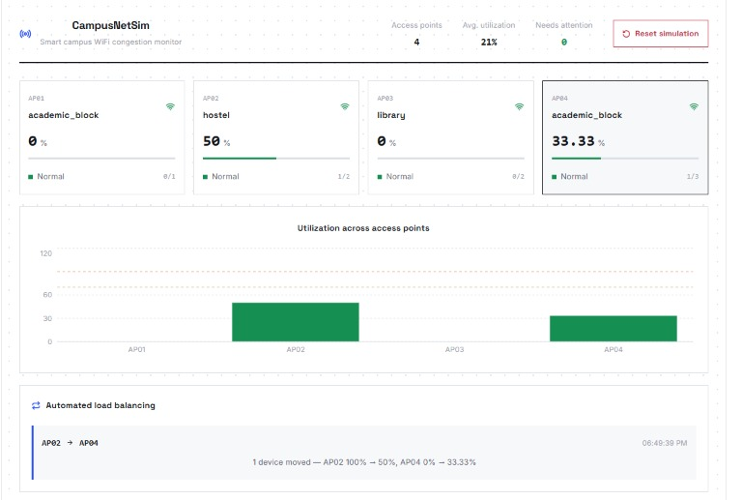
Fig. 6. Dashboard during Run A: AP02 at 50% (1 of 2) and AP04 at 33.33% (1 of 3) after the automated move, with the migration in the load-balancing panel.
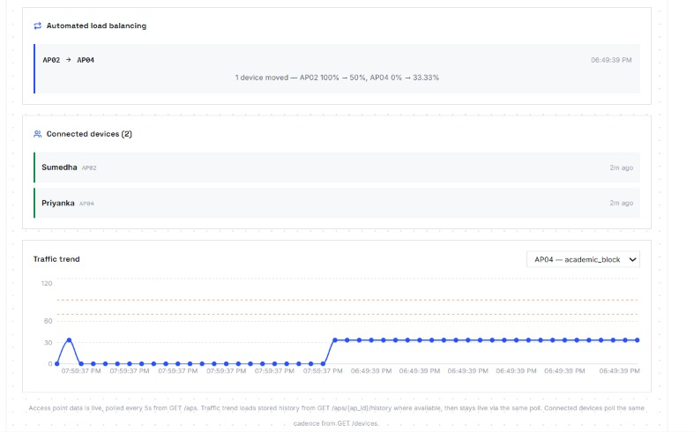
Fig. 7. Dashboard during Run A: migration log, connected-device roster with both phones and the AP04 traffic trend rising after the move.
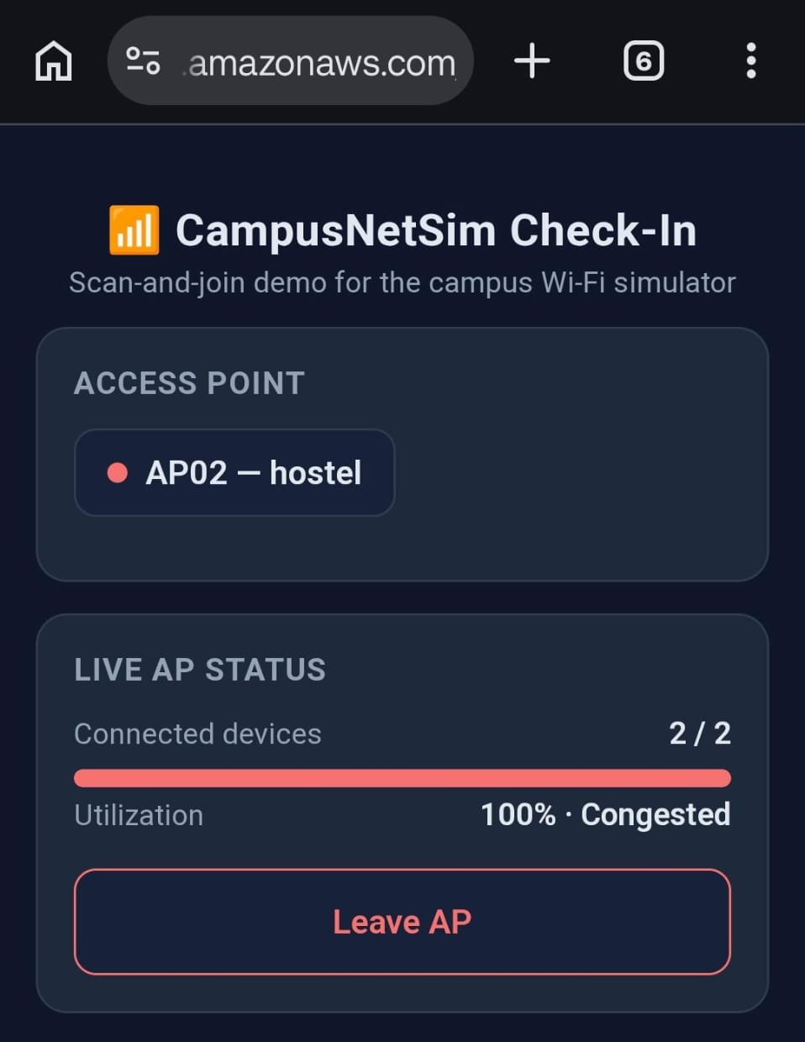  (a) AP02 full before the move | 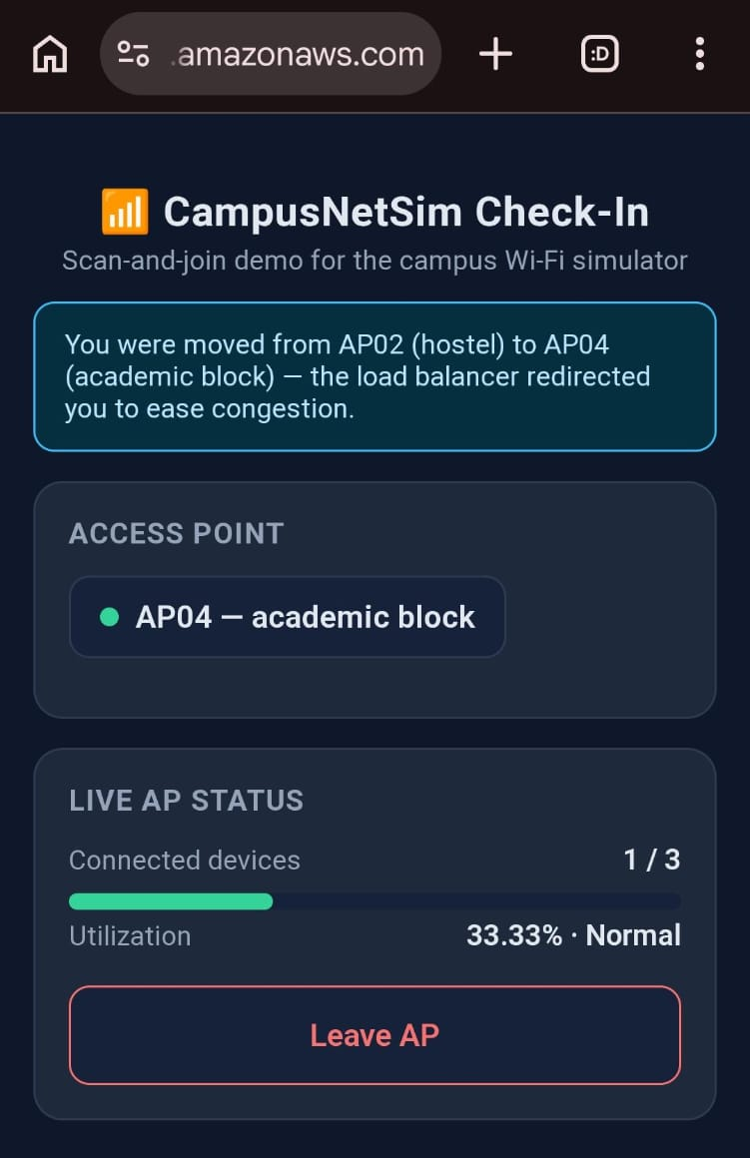  (b) after the move to AP04
Fig. 8. Phone check-in page in Run A: (a) AP02 at 2 of 2 devices and 100% (Congested); (b) moments later, the redirect banner and AP04 at 1 of 3 devices (33.33%, Normal).
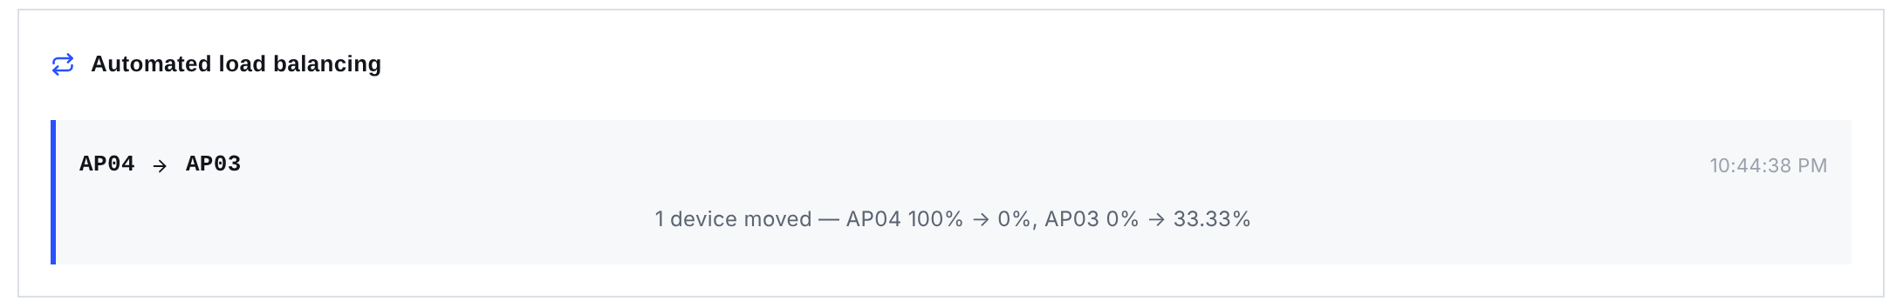
Fig. 9. Migration recorded in Run B: one device moved from AP04 (100% to 0%) to AP03 (0% to 33.33%).
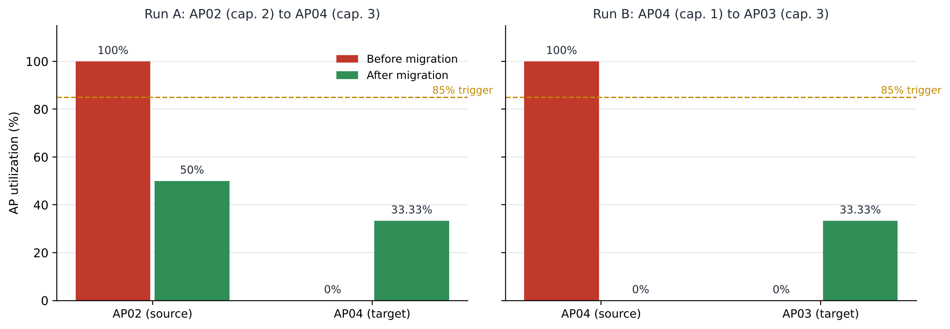
Fig. 10. Utilization of the source and target APs before and after each live migration. Both sources fell below the 85% trigger.

TABLE IX
Recorded Migrations
Run | Source (C) | Target (C) | k | Source U | Target U
A | AP02 (2) | AP04 (3) | 1 | 100 → 50 % | 0 → 33.33 %
B | AP04 (1) | AP03 (3) | 1 | 100 → 0 % | 0 → 33.33 %

F. Discussion
In each run, LoadBalancer followed Algorithm 1 from line 1 to line 12, ending with a Migrations record. In both runs the APState stream delivered the full-AP state to LoadBalancer without any polling. Its targets were AP04 in Run A and AP03 in Run B. Afterwards the source sat below the 85% trigger and the target stayed under it. Its moves went through POST /events. They therefore faced the same capacity limit and conditional write as any phone check-in. Every move left a row in Migrations with both APs' utilization before and after.
Several limitations remain. No AP in our demonstrations had more than three slots. A single device therefore swings utilization sharply; on an AP of capacity 1 it goes from 0% straight to 100%. Most of what the system exercised was the full-AP case. Target selection is split between EventProcessor and LoadBalancer, and the two can disagree. EventProcessor recommends an AP in the same building, so a full AP01 would point to AP04. LoadBalancer, however, searches the whole campus for free slots, and its choice is the one that is executed. LoadBalancer also talks to the other functions over HTTPS via the public API. That costs an API Gateway round trip per request. Its base URL is also hard-coded. If we redeployed the API under a new invoke URL, balancing would stop working until we updated LoadBalancer's code. EventProcessor also scans the entire APState table each time an event arrives. Four items cost almost nothing to scan. On a real campus with hundreds of APs, however, the cost would grow linearly with the AP count, and every event would pay it. Authentication is missing on all seven routes. With only the endpoint URL and no credentials, anyone could resize an AP through PUT /aps/{ap_id}/config or wipe the logs through POST /admin/reset. The check-in page still keeps a static list of valid AP IDs, so adding an AP05 would mean editing the page. Four simulated APs and a handful of phones produced Tables VII-IX. We have not measured what happens when many phones check in at the same moment, which is exactly the load a real class change would create.
IX. Conclusion
CampusNetSim detects a congested AP and moves devices off it without human intervention. Ten Lambda functions and four DynamoDB tables, all managed services, are all it needs. Each APState write produces one stream record, and both LoadBalancer and HistoryWriter run from it, so balancing and history logging always see the same change. On a quiet campus, balancing and history logging stay idle. The only Lambda invocations during such periods come from the dashboard and check-in pages, which read state every five seconds. Joining needs no app, only a QR scan. A migration shows up on the dashboard within five seconds, one polling interval, so an observer sees the move almost as it happens. Run-time resizing is new in the final build. Before Run B, we used it to set AP01-AP04 to 3, 1, 3 and 1. Every resize passes server-side validation in UpdateAPConfig before APState changes. In EventProcessor, conditional writes stop concurrent events from overwriting each other's counts. DynamoDB stays the single source of truth for the campus layout. Both live runs began with real phones checking in, the second during the final demonstration on 20 October 2026. The balancer moved a device from AP02 to AP04 in Run A and from AP04 to AP03 in Run B. Both targets had the most free slots at the time. Every functional test passed (14 of 14), and warm reads took 60-69 ms at the median.
X. Future Work
Seven items remain for future work. (1) Add JWT authorizers to the HTTP API. PUT /aps/{ap_id}/config and POST /admin/reset come first, since they change or delete data, followed by the other five routes. (2) Trigger TrafficGenerator from an Amazon EventBridge rule; today we start it by hand. A scheduled peak-hour or congestion scenario could then run identically day after day, giving us comparable numbers across repetitions. We would log pre- and post-balancing utilization and the migration count each time. (3) Have LoadBalancer prefer same-building targets. (4) Look up the single AP an event needs with GetItem on ap_id, removing the full-table Scan whose cost grows with the campus. Direct Lambda invocation of EventProcessor, or shared code, would remove both the HTTPS hop and the hard-coded base URL. (5) Use the last 24 hours of APHistory snapshots to forecast when an AP will cross 85%, and rebalance before it does. (6) Recover from AP failure by moving a dead AP's devices elsewhere. (7) Measure how EventProcessor's conditional writes hold up when many phones check in simultaneously. CloudWatch alarms and an AWS budget alert should follow.
References
[1] Y. Bejerano, S.-J. Han, and L. Li, "Fairness and load balancing in wireless LANs using association control," IEEE/ACM Trans. Netw., vol. 15, no. 3, pp. 560-573, Jun. 2007.
[2] Y. Bejerano and S.-J. Han, "Cell breathing techniques for load balancing in wireless LANs," IEEE Trans. Mobile Comput., vol. 8, no. 6, pp. 735-749, Jun. 2009.
[3] A. Balachandran, P. Bahl, and G. M. Voelker, "Hot-spot congestion relief in public-area wireless networks," in Proc. 4th IEEE Workshop Mobile Comput. Syst. Appl. (WMCSA), Callicoon, NY, USA, 2002, pp. 70-80.
[4] IEEE Standard for Information Technology - Telecommunications and Information Exchange Between Systems - Local and Metropolitan Area Networks - Specific Requirements - Part 11: Wireless LAN Medium Access Control (MAC) and Physical Layer (PHY) Specifications, IEEE Std 802.11-2020, 2021.
[5] IEEE Standard for Information Technology - Part 11, Amendment 8: IEEE 802.11 Wireless Network Management, IEEE Std 802.11v-2011, 2011.
[6] IEEE Standard for Information Technology - Part 11, Amendment 2: Fast Basic Service Set (BSS) Transition, IEEE Std 802.11r-2008, 2008.
[7] E. Jonas et al., "Cloud programming simplified: A Berkeley view on serverless computing," EECS Dept., Univ. California, Berkeley, CA, USA, Tech. Rep. UCB/EECS-2019-3, Feb. 2019.
[8] P. Castro, V. Ishakian, V. Muthusamy, and A. Slominski, "The rise of serverless computing," Commun. ACM, vol. 62, no. 12, pp. 44-54, Dec. 2019.
[9] Z. Li, L. Guo, J. Cheng, Q. Chen, B. He, and M. Guo, "The serverless computing survey: A technical primer for design architecture," ACM Comput. Surv., vol. 54, no. 10s, Art. no. 220, 2022.
[10] G. DeCandia et al., "Dynamo: Amazon's highly available key-value store," in Proc. 21st ACM Symp. Operating Syst. Principles (SOSP), Stevenson, WA, USA, 2007, pp. 205-220.
[11] M. A. Ahmed, S. A. Chavez, A. M. Eltamaly, H. O. Garces, A. J. Rojas, and Y.-C. Kim, "Toward an intelligent campus: IoT platform for remote monitoring and control of smart buildings," Sensors, vol. 22, no. 23, Art. no. 9045, 2022.
[12] Amazon Web Services, "Serverless architectures with AWS Lambda: Overview and best practices," AWS Whitepaper, 2017. [Online]. Available: https://d1.awsstatic.com/whitepapers/serverless-architectures-with-aws-lambda.pdf
[13] Amazon Web Services, "Using AWS Lambda with Amazon DynamoDB," AWS Lambda Developer Guide. [Online]. Available: https://docs.aws.amazon.com/lambda/latest/dg/with-ddb.html (accessed Oct. 23, 2026).
[14] Amazon Web Services, "Change data capture for DynamoDB Streams," Amazon DynamoDB Developer Guide. [Online]. Available: https://docs.aws.amazon.com/amazondynamodb/latest/developerguide/Streams.html (accessed Oct. 23, 2026).
[15] Amazon Web Services, "Using time to live (TTL) in DynamoDB," Amazon DynamoDB Developer Guide. [Online]. Available: https://docs.aws.amazon.com/amazondynamodb/latest/developerguide/TTL.html (accessed Oct. 23, 2026).
[16] Amazon Web Services, "Optimistic locking with version number," Amazon DynamoDB Developer Guide. [Online]. Available: https://docs.aws.amazon.com/amazondynamodb/latest/developerguide/BestPractices_OptimisticLocking.html (accessed Oct. 23, 2026).
[17] Amazon Web Services, "Working with HTTP APIs," Amazon API Gateway Developer Guide. [Online]. Available: https://docs.aws.amazon.com/apigateway/latest/developerguide/http-api.html (accessed Oct. 23, 2026).
[18] Amazon Web Services, "Deploying an application to Amplify without a Git repository," AWS Amplify Hosting User Guide. [Online]. Available: https://docs.aws.amazon.com/amplify/latest/userguide/manual-deploys.html (accessed Oct. 23, 2026).
[19] S. Phadnis and P. J, "CampusNetSim: Cloud-native campus Wi-Fi congestion simulation and load balancing," GitHub repository, 2026. [Online]. Available: https://github.com/pj-06/campusnetsim

