CampusNetSim: A Cloud-Native Wi-Fi Congestion Simulation and Automated Load-Balancing System on AWS Serverless Services
Sumedha Phadnis and Priyanka J
Cloud Architecture Design (AWS) - Course Project Report

Keywords—Serverless computing, AWS Lambda, Amazon API Gateway, Amazon DynamoDB, DynamoDB Streams, event-driven architecture, WLAN load balancing, access point utilization, campus network simulation.
Abstract—Campus Wi-Fi load is uneven because phones and laptops choose an access point (AP) by signal strength alone, so the AP nearest a busy lecture hall saturates while its neighbours carry little traffic. We built CampusNetSim, a cloud-native simulator that tracks which AP each campus device uses, detects overloaded APs and moves simulated clients to APs with free slots. The backend runs on ten AWS Lambda functions behind one Amazon API Gateway HTTP API and keeps its data in four on-demand Amazon DynamoDB tables. A DynamoDB Stream on the AP state table triggers load balancing and history logging, so no backend function polls. Phones join by scanning an AP's QR code, which opens a check-in page hosted on Amazon S3, and a React dashboard on AWS Amplify shows live utilization, migrations, connected devices and per-AP traffic trends. The final build adds run-time capacity changes through a validated PUT endpoint and uses conditional writes to make event processing safe under concurrency, which leaves DynamoDB as the only copy of the campus layout. In two live runs with real phones, an AP reached 100% utilization and LoadBalancer moved one device to the AP with the most free capacity. The source fell below the 85% trigger and the target ended at 33.33%. All 14 functional API tests returned the expected status codes, and warm reads had a median latency of 60-69 ms.
I. Introduction
Class changes show the problem most clearly, because a whole lecture hall reconnects at once. Each client radio picks the access point with the strongest signal and ignores how many clients that AP already serves. One AP saturates while the library AP, two buildings away, still has half its capacity free. Research on WLAN association control has shown that signal-strength-only association produces markedly worse throughput and fairness than load-aware association [1]-[3].
Moving a client to a less loaded AP is harder than it sounds. The IEEE 802.11 standard [4] lets an AP suggest a transition through BSS Transition Management [5] and speeds up the roam once the client decides to move [6], but the decision always remains with the client's chipset and driver. Consumer routers rarely expose steering controls to outside software, and mobile operating systems do not let applications switch networks silently. A student project therefore cannot steer real clients reliably.
CampusNetSim simulates association instead. Because the simulation owns every device-to-AP link, each move that LoadBalancer decides on takes effect, which real clients cannot guarantee. The model has four APs in three buildings: AP01 and AP04 in the academic block, AP02 in the hostel and AP03 in the library. Each AP has its own capacity; in Run A, AP02 held two devices and AP04 three, and for Run B we set AP01-AP04 to 3, 1, 3 and 1. Association changes only through explicit CONNECT and DISCONNECT events, sent by a phone, by LoadBalancer or by TrafficGenerator. Because CampusNetSim holds this state itself, it can detect an overloaded AP, choose a target, make the move and log both APs' utilization before and after it in the Migrations table. Real phones still take part. Scanning an AP-specific QR code opens a browser check-in page that registers the phone with that AP in application state, while the phone's actual network connection stays unchanged.
Every component is a managed AWS serverless service [7]-[9]. The paper makes four contributions: (i) an event-driven, polling-free load-balancing pipeline built on DynamoDB Streams; (ii) run-time capacity reconfiguration with server-side validation and concurrency-safe event processing; (iii) a phone check-in path that lets real devices trigger the pipeline without installing anything; and (iv) a live evaluation with real phones, functional API tests and latency measurements.
Section II reviews WLAN association control [1]-[3], the 802.11v and 802.11r roaming amendments [5], [6] and serverless computing [7]-[9]. The methodology follows in Section III; Sections IV and V present the architecture and the check-in and capacity workflows, and Section VI formalises the utilization model and Algorithm 1. Tables II-V in Section VII record the deployed configuration, Section VIII reports implementation and results, and Sections IX and X give the conclusion and future work.
II. Related Works
Most prior work on wireless LAN load balancing operates at the level of AP association. Bejerano, Han and Li [1] cast association control as a max-min fair bandwidth allocation problem and showed that load-aware association clearly outperforms the default strongest-signal policy. Bejerano and Han [2] later proposed cell breathing, in which each AP adjusts its transmit power to shrink or grow its coverage and clients drift toward less loaded cells with no client-side change. Balachandran, Bahl and Voelker [3] studied hot-spot congestion in public-area wireless networks and proposed network-directed roaming, in which an overloaded AP explicitly redirects users to neighbouring APs. CampusNetSim follows the same idea of network-side redirection, but performs it on a simulated association model where every move can be enforced and audited.
The 802.11 standard [4] defines how roaming can be influenced in real deployments. In 802.11v [5], BSS Transition Management lets an AP ask a client to move, while 802.11r [6] adds Fast BSS Transition to cut roaming latency. Neither mechanism can force a move, since a client is free to ignore a transition request. This is the main reason CampusNetSim enforces moves inside its own event model.
Jonas et al. [7] and Castro et al. [8] describe serverless computing as a model in which developers deploy stateless functions and the provider handles provisioning and scaling, at the cost of cold starts and platform-specific integration. Li et al. [9] survey serverless architectures and classify their design trade-offs. Amazon's Dynamo paper [10] describes a key-value store, the forerunner of DynamoDB, built for single-item reads and writes. CampusNetSim's data match that design closely, since each AP state, history snapshot and migration log entry is a single item. Ahmed et al. [11] built a four-layer IoT platform to monitor and control smart campus buildings remotely. CampusNetSim also provides live campus monitoring through a web dashboard, with data from simulated association events and phone check-ins where Ahmed et al. use physical sensors. Table I compares the five mechanisms with CampusNetSim.
TABLE I
Comparison of Related Approaches
Approach | Where control lives | Needs client support | Relation to CampusNetSim
Association control [1] | Network (central) | Yes | Same objective; simulated enforcement
Cell breathing [2] | AP transmit power | No | Alternative real-network mechanism
Network-directed roaming [3] | Overloaded AP | Partly | Closest idea: redirect from hot spot
802.11v / 802.11r [5], [6] | AP request, client decides | Yes | Advisory only; motivates simulation
Smart-campus IoT [11] | Cloud platform | Sensors | Similar cloud monitoring stack

III. Proposed Methodology
A. System Model
We model the campus as a set of APs, each stored as one item in the APState table with its configuration and live device count. Each AP has an ID (e.g., AP01), a building and a name. Alongside these, we store a capacity C_{i} (the number of devices at which we treat the AP as full) and a live connected-device count n_{i}. Association changes arrive as CONNECT and DISCONNECT events from three sources: phones using the check-in page, the load balancer when it moves devices, and an optional synthetic traffic generator. Changing an AP therefore means updating exactly one DynamoDB item, which DynamoDB Streams publishes as a record [14].
B. Design Principles
Four principles guided the design. One function per responsibility: every API route gets its own Lambda function, whose permissions cover only the tables it needs, as the AWS serverless guidance recommends [12]. Event-driven reaction: stream records from APState start load balancing and history logging, so nothing runs while the campus is quiet [13], [14]. Single source of truth: AP capacities, buildings and names live only in the APState table; every function reads them from there at run time. Verifiable actions: every automated move writes a Migrations record with the utilization of both APs before and after the move.
C. Functional Components
Event ingestion. EventProcessor handles POST /events, which every check-in uses. It validates the event and reads the AP's configuration and device count with a strongly consistent read, so a capacity changed a moment earlier is already visible. A CONNECT to a full AP is rejected with HTTP 409. For any other event, EventProcessor computes utilization with Eq. (1) and status with Eq. (2), then writes only the live-state attributes back with a conditional update. When an AP becomes CONGESTED, EventProcessor also attaches an advisory recommendation for another AP in the same building, such as AP04 for AP01.
Reactive load balancing. LoadBalancer consumes the APState stream. When an AP reaches the 85% trigger, it selects the AP with the most free capacity, computes how many devices to move (at most five) and moves them by posting DISCONNECT and CONNECT events through the public API, so every move passes the same validation as any other event. Real phones are moved first, and their roster entries are updated so that the phone's page can show the redirect. HistoryWriter consumes the same stream and stores each AP state in APHistory with a 24-hour expiry using DynamoDB time to live (TTL) [15].
Read services and administration. StatusReader, HistoryReader and MigrationReader serve the dashboard and the check-in page. DeviceRegistry handles GET and POST /devices and records each phone, together with its current AP, in the Devices table that the check-in page and dashboard both read. AdminReset (POST /admin/reset) zeroes all four APs, empties the Migrations and APHistory tables and marks every phone in the Devices roster as disconnected, so each demonstration starts from a clean state.
D. Run-Time Capacity Reconfiguration and Consistency
The final build adds UpdateAPConfig, which changes an AP's capacity while the system is running. Behind PUT /aps/{ap_id}/config, it accepts only capacity, building and ap_name and returns HTTP 400 for any other field, such as color (Table VII, test 9). Capacity must be an integer from 1 to 1000, so values such as 0, "four" or 5000 also return HTTP 400, and a capacity below the current device count returns HTTP 409 (Eq. (7)). A valid request updates only the supplied attributes and recomputes utilization with Eq. (1) in the same write. EventProcessor reads capacity from APState on every event, so the next CONNECT or DISCONNECT already uses the new value for the status and for the 85% trigger.
Two concurrent events on the same AP could otherwise read the same count and overwrite each other. EventProcessor therefore uses optimistic concurrency [16]: its update succeeds only if the stored count and capacity still equal the values it read; otherwise DynamoDB rejects the write and the API returns HTTP 409 so that the caller can retry. The same condition protects against a capacity change that lands between the read and the write of an event.
IV. Architecture Diagram
Fig. 1 shows the deployed architecture in five layers. The client layer contains the phone check-in page, a static page on Amazon S3, and the monitoring dashboard, a React and Vite application on AWS Amplify Hosting. Both call a single API Gateway HTTP API [17] with CORS enabled. Seven request handlers, one per API route, make up most of the compute layer. Two event-driven functions are attached to the APState stream, and TrafficGenerator, deployed without a trigger, is invoked manually to create synthetic load. The storage layer is the four on-demand DynamoDB tables in Table III, and every function logs to Amazon CloudWatch Logs.
Two kinds of connection carry the system's logic. Synchronous API calls reach the seven request handlers, which read and write the tables; StatusReader, for instance, answers GET /aps by reading every AP item from APState. Asynchronous stream records, in batches of up to 100, carry each APState change to LoadBalancer and HistoryWriter. LoadBalancer never writes APState directly. It sends each move to POST /events as a DISCONNECT from the source AP and a CONNECT to the target, so its moves pass the same capacity check and conditional write as phone events.

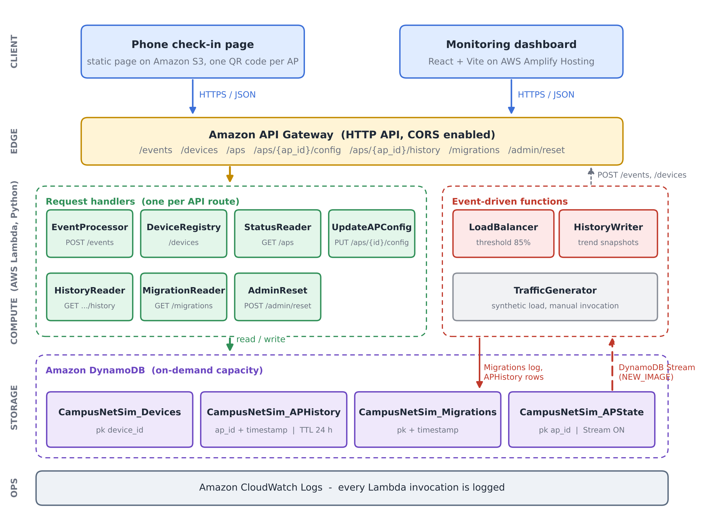
Fig. 1. CampusNetSim system architecture. Seven request handlers serve the API routes, LoadBalancer and HistoryWriter run on the APState stream (NEW_IMAGE view), and four on-demand DynamoDB tables hold all state.

V. Workflow
Fig. 2 traces one device through eight steps, from the QR scan to the next dashboard refresh. Scanning the code opens the check-in page with the AP identifier, for example AP02, in the link (step 1). Tapping Join sends a CONNECT to /events and then a JOIN to /devices (step 2). EventProcessor validates the event and updates APState (step 3), which emits one stream record (step 4). The record reaches LoadBalancer and HistoryWriter independently (steps 5 and 6). LoadBalancer acts only when the AP has reached 85%, moving devices and logging the migration (step 7), while HistoryWriter always stores a snapshot for the trend chart. Both front ends poll the read endpoints every five seconds (step 8), and a phone that LoadBalancer has moved finds its new AP in the roster and shows a banner explaining the move.
Fig. 3 shows how an operator changes an AP's capacity. To let AP04 (capacity 1 in Run B) hold two devices, the operator opens its capacity editor and enters 2. The dashboard first checks that the value is a positive integer no smaller than the number of connected devices and then sends PUT /aps/{ap_id}/config. UpdateAPConfig repeats these checks on the server, adds the 1-1000 range test and returns HTTP 400 or 409 if any check fails, so a request that bypasses the dashboard is still validated. The update also passes through the APState stream, and the trend chart records the recalculated utilization immediately.

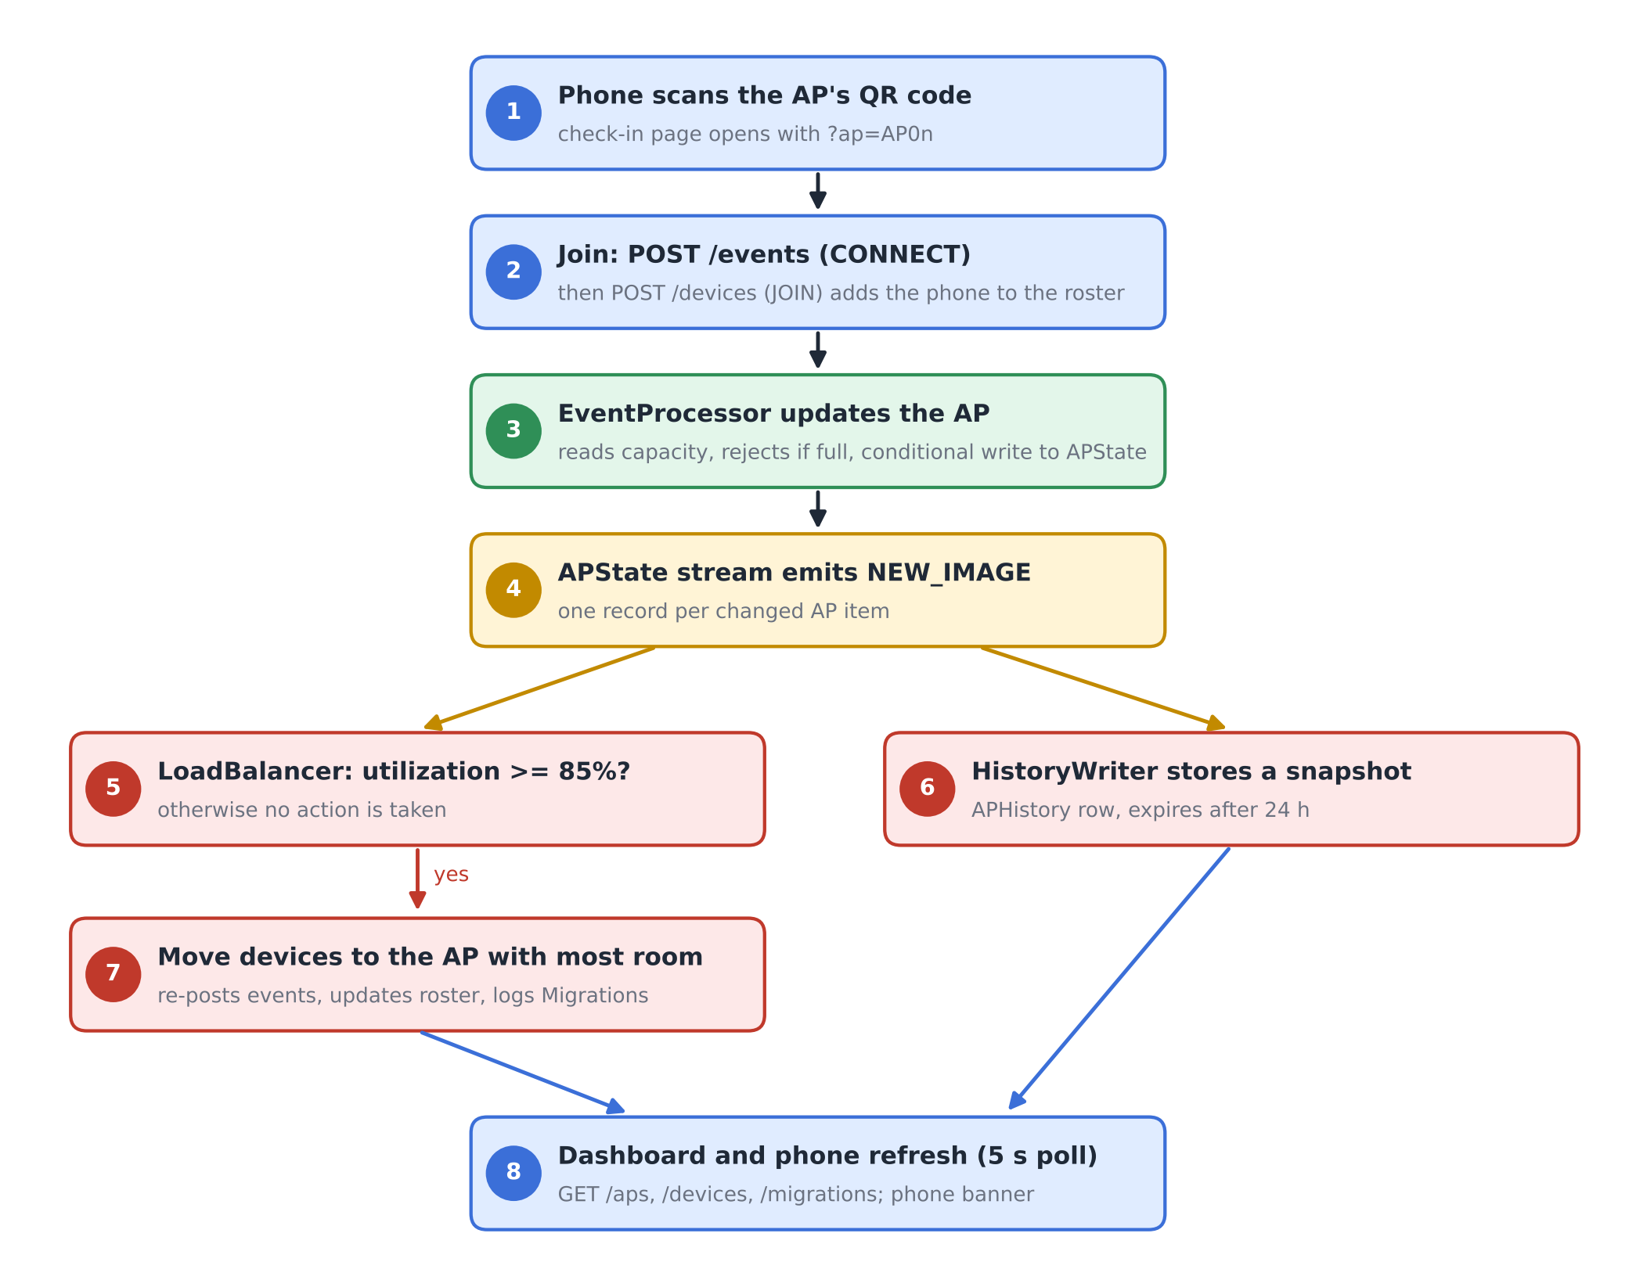
Fig. 2. End-to-end workflow from phone check-in to automated rebalancing and dashboard refresh.
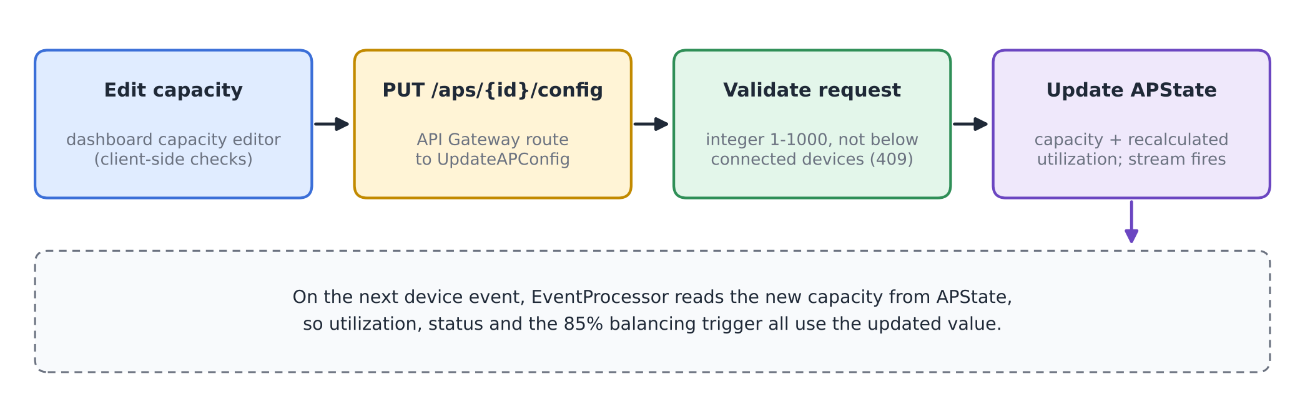
Fig. 3. Run-time capacity reconfiguration flow.

VI. Algorithm / Formulas
A. Utilization and Status
For an AP i with n_{i} connected devices and capacity C_{i}, utilization is
U_{i} = (n_{i} / C_{i}) × 100 (1)
rounded to two decimals. The status shown on the dashboard and the check-in page is
S_{i} = NORMAL (U_{i} < 70), BUSY (70 ≤ U_{i} < 90) (2)
with HIGH_LOAD for 90 ≤ U_{i} < 100 and CONGESTED for U_{i} ≥ 100. EventProcessor rejects any CONNECT once n_{i} = C_{i}. Utilization therefore never exceeds 100%, and CONGESTED means exactly full.
B. Balancing Trigger, Target and Move Size
LoadBalancer reacts to a stream record for AP i only when
U_{i} ≥ θ, θ = 85 (3)
and the condition still holds in a fresh read of GET /aps. The target is the AP with the most free slots,
j* = argmax_{j ≠ i} (C_{j} − n_{j}) (4)
and the source should drop to about five points below the trigger, giving a target count
n_{i}^{tgt} = ⌊C_{i} (θ − 5) / 100⌋ (5)
The number of devices moved is limited by the need, the free space at j* and a per-migration cap K = 5:
k = min( max(1, n_{i} − n_{i}^{tgt}), C_{j*} − n_{j*}, K ) (6)
C. Capacity Update and Consistency Rules
A capacity change for AP i to a new value C_{i}' is accepted only if
n_{i} ≤ C_{i}' ≤ 1000, C_{i}' ∈ ℤ (7)
and the stored utilization is recomputed with (1). An event write computed from a read of (n_{i}, C_{i}) is committed only if the stored item still matches that read:
commit ⇔ n_{i}^{stored} = n_{i}^{read} ∧ C_{i}^{stored} = C_{i}^{read} (8)
As a worked example, consider an AP with C_{i} = 2 and n_{i} = 2 (U_{i} = 100%). Equation (5) gives n_{i}^{tgt} = ⌊2 × 80 / 100⌋ = 1, so (6) moves k = 1 device, provided the target has at least one free slot. The source then holds one device of two, or 50%. Run A in Section VIII matches this calculation: AP02 went from 100% to 50% and AP04 rose from 0% to 33.33%.
D. Algorithm
Algorithm 1 lists the procedure LoadBalancer runs for each stream record, and Fig. 4 shows the same logic as a flowchart.
Algorithm 1: Reactive AP load balancing (per stream record)
1: input: stream record r for AP i
2: if r is not INSERT/MODIFY or device id starts with "migrated-" then return
3: if U_{i} < θ in r then return
4: read all APs via GET /aps; if U_{i} < θ then return
5: j* ← argmax_{j≠i} (C_{j} − n_{j}) (4); if C_{j*} − n_{j*} ≤ 0 then return
6: k ← min(max(1, n_{i} − n_{i}^{tgt}), C_{j*} − n_{j*}, 5) (5)-(6)
7: D ← connected real phones on AP i (roster)
8: for m = 1 to k do
9: d ← D[m] if available, else synthetic id "migrated-i-xxxx"
10: POST /events (d, i, DISCONNECT); POST /events (d, j*, CONNECT)
11: if d is a real phone then POST /devices (d, JOIN, j*)
12: if at least one move succeeded then write Migrations record {i, j*, moved, U before/after}

The guard in line 2 prevents feedback loops. A migration's events change APState again, but LoadBalancer ignores records for synthetic devices whose ids start with "migrated-", and a target AP that has just received devices is normally below the trigger. Because each move is a DISCONNECT/CONNECT pair posted to /events, EventProcessor's capacity check and conditional write also protect the balancer's own writes.
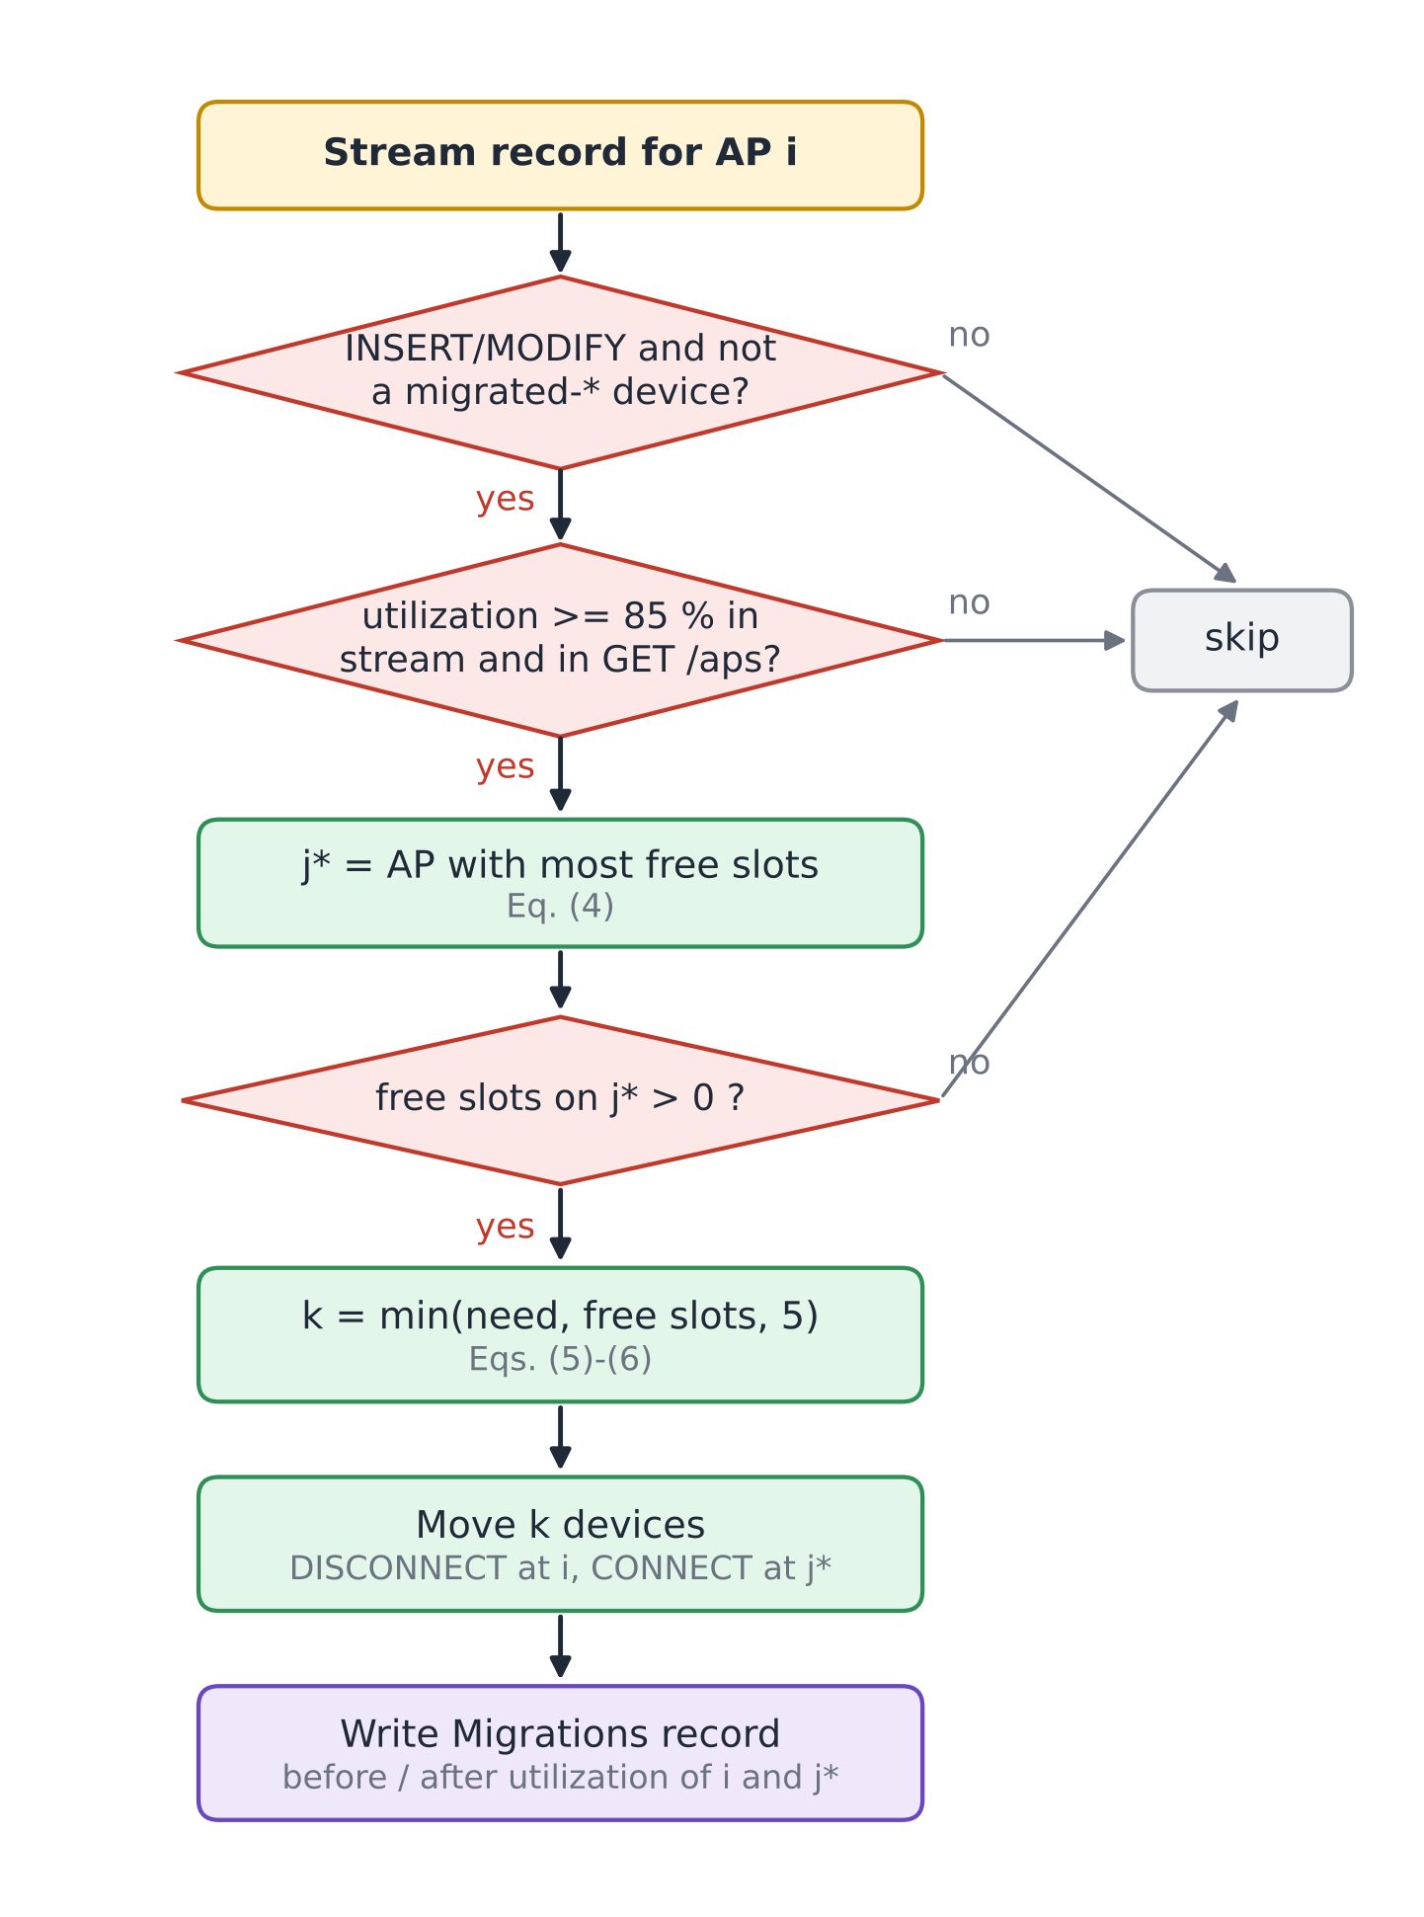
Fig. 4. Decision flowchart of the LoadBalancer function (Algorithm 1).
VII. Tables and Figures
This section collects the configuration of the deployed system. Table II lists the Lambda functions with their triggers and settings, Table III the DynamoDB tables, Table IV the API routes and Table V the parameters used in Section VI. Figures 1-4 above describe the architecture, workflows and algorithm; Figs. 5-10 in Section VIII document the running system and the measured results.

TABLE II
AWS Lambda Functions (ap-south-1, x86_64, 128 MB)
Function | Trigger | Runtime / timeout | Responsibility
CampusNetSim-EventProcessor | HTTP API: /events | Python 3.13 / 3 s | Validate CONNECT/DISCONNECT, conditional APState update, advisory recommendation
CampusNetSim-DeviceRegistry | HTTP API: /devices | Python 3.13 / 3 s | Phone roster: JOIN, LEAVE, list
CampusNetSim-StatusReader | HTTP API: /aps | Python 3.13 / 3 s | Live state of all APs
UpdateAPConfig | HTTP API: /aps/{ap_id}/config | Python 3.14 / 3 s | Validated capacity, building and name update
CampusNetSim-HistoryReader | HTTP API: /aps/{ap_id}/history | Python 3.13 / 3 s | Up to 200 history points for one AP
CampusNetSim-MigrationReader | HTTP API: /migrations | Python 3.13 / 3 s | 50 most recent migrations
CampusNetSim-AdminReset | HTTP API: /admin/reset | Python 3.13 / 40 s | Reset APs, clear logs, disconnect phones
CampusNetSim-LoadBalancer | DynamoDB Stream (APState) | Python 3.13 / 30 s | Detect >= 85% and move devices
CampusNetSim-HistoryWriter | DynamoDB Stream (APState) | Python 3.13 / 3 s | Append snapshot to APHistory
CampusNetSim-TrafficGenerator | None (manual) | Python 3.13 / 30 s | Synthetic CONNECT/DISCONNECT traffic

TABLE III
Amazon DynamoDB Tables (On-Demand Capacity)
Table | Key schema | Purpose / features
APState | ap_id | Live AP config and counts; stream (NEW_IMAGE)
APHistory | ap_id + timestamp | Utilization snapshots; TTL 24 h
Devices | device_id | Phone roster and current AP
Migrations | pk + timestamp | Audit log of automated moves

TABLE IV
API Gateway Routes
Route | Method | Function
/events | POST | EventProcessor
/devices | GET, POST | DeviceRegistry
/aps | GET | StatusReader
/aps/{ap_id}/config | PUT | UpdateAPConfig
/aps/{ap_id}/history | GET | HistoryReader
/migrations | GET | MigrationReader
/admin/reset | POST (else 405) | AdminReset

TABLE V
Model Parameters
Symbol | Value | Meaning
BUSY / HIGH_LOAD / CONGESTED | 70 / 90 / 100 % | Status thresholds, Eq. (2)
θ | 85 % | Balancing trigger, Eq. (3)
θ − 5 | 80 % | Source target after a move, Eq. (5)
K | 5 | Max devices per migration, Eq. (6)
C_{i} range | 1-1000 | Allowed capacity, Eq. (7)
History TTL | 24 h | APHistory retention
Poll interval | 5 s | Dashboard and check-in refresh

VIII. Implementation, Results, and Discussion
A. Backend Deployment
The backend runs in the AWS Mumbai region (ap-south-1). The four tables were created with on-demand capacity, so no throughput had to be provisioned. The APState stream uses the NEW_IMAGE view type and has two enabled consumers, LoadBalancer and HistoryWriter, each with a batch size of 100 starting from the latest record [13], [14]. APHistory has TTL enabled on its expires_at attribute, so old readings disappear without a clean-up job [15]. All functions are written in Python and use the boto3 SDK; read functions convert DynamoDB Decimal values back to JSON numbers. The complete source of every deployed function, the check-in page, the dashboard and an AWS SAM template that recreates the stack are published in the project repository [19].
B. Front Ends and Hosting
The phone check-in page is a single HTML file on Amazon S3. On first use it generates a device identifier with the browser's random UUID generator and keeps it in local storage, so later check-ins from the same phone map to the same roster entry. After joining, the page polls GET /devices and GET /aps every five seconds. It treats a new AP in its roster entry as a migration and a DISCONNECTED status as a reset, and shows a banner explaining either event.
The dashboard is built with React, Vite, Tailwind CSS and Recharts. It shows the AP cards, a utilization bar chart with the 70% and 90% reference lines, the automated load-balancing log, the connected-device roster and the traffic trend of the selected AP. The final build adds the capacity editor and an AP details panel that lists the devices on the selected AP (Fig. 5). The production build is deployed to AWS Amplify Hosting by manual upload [18]. Two deployment issues had to be fixed: a ZIP archive created on Windows stored backslash paths, which made the hosted page request its JavaScript and CSS files at wrong URLs, and the Vite configuration initially lacked the Tailwind CSS plugin, which left the page unstyled. A small script now rebuilds the archive with forward-slash paths.

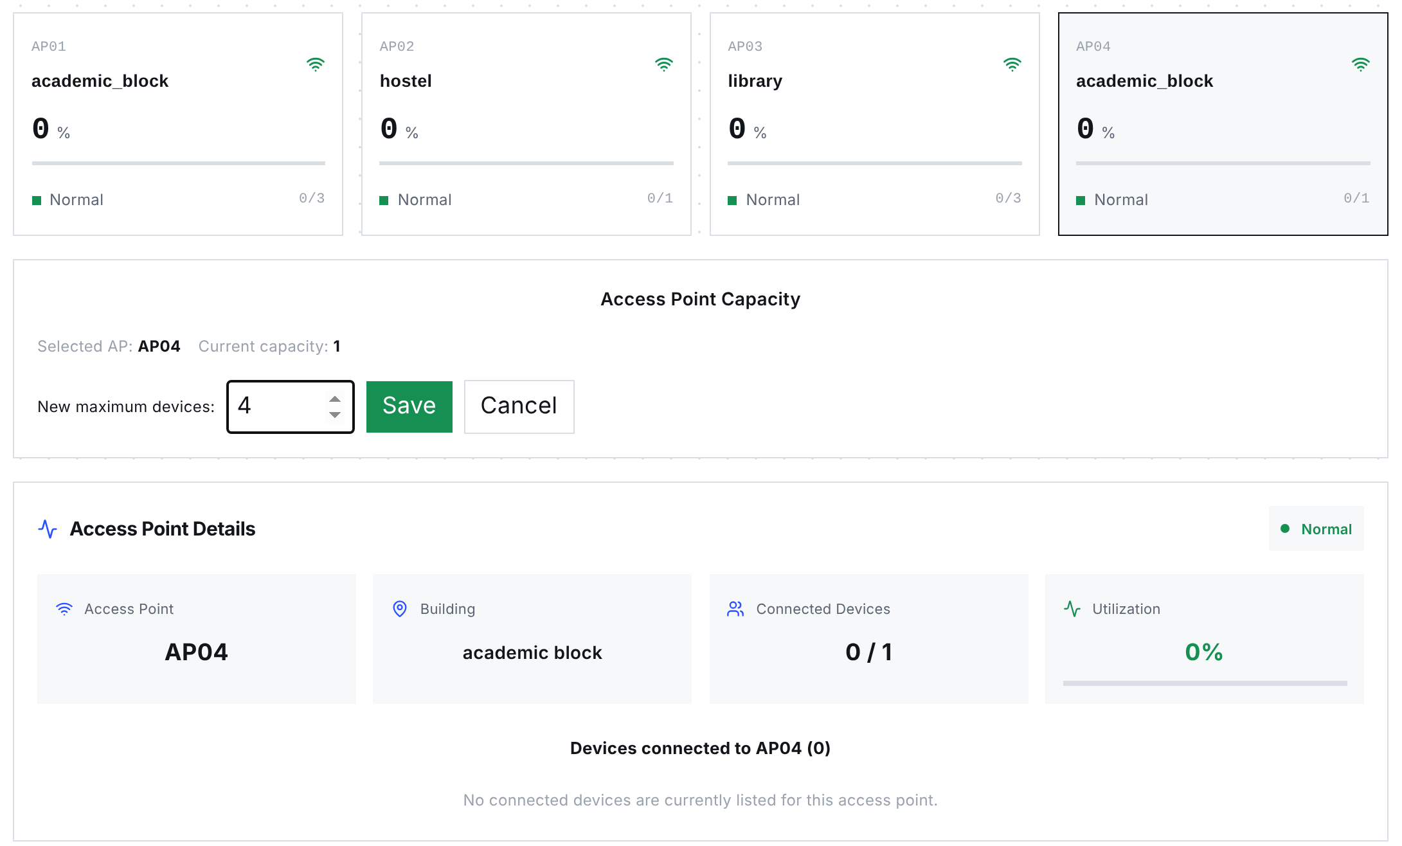
Fig. 5. Dashboard of the final build with the capacity editor open for AP04, AP cards showing capacities of 3, 1, 3 and 1, and the details panel for the selected AP. Rendered from the production build with the API state recorded on 23 October 2026.

C. Capacity Reconfiguration and Consistency Enhancements
Table VI lists the six changes in the final build. EventProcessor now reads every capacity from APState, which the operator edits from the dashboard through PUT /aps/{ap_id}/config. When two writes conflict, the second caller receives HTTP 409 and can retry, so no update is lost.

TABLE VI
Enhancements in the Final Build
Component | Change | Effect
UpdateAPConfig (new Lambda) and PUT /aps/{ap_id}/config | Validated partial update of capacity, building and AP name; utilization recalculated with the capacity | Operators change capacity at run time without touching DynamoDB
EventProcessor | Reads capacity, building and name from APState on every event (strongly consistent read) | DynamoDB is the single source of truth for the layout
EventProcessor | Rejects CONNECT at capacity (409); conditional update on count and capacity (409 on conflict) | No lost updates and no utilization above 100%
EventProcessor | Updates only live-state attributes instead of replacing the item | Configuration fields survive device events
Dashboard | Capacity editor with local checks (positive integer, not below connected devices) and AP details panel | Capacity changes and per-AP devices visible in one place
Dashboard deployment | Forward-slash ZIP packaging script; Tailwind plugin in the Vite configuration | Reliable Amplify deployments

D. Functional Verification
On 23 October 2026 we sent 14 requests to the deployed API, covering all seven routes. Ten exercise validation paths that change no data, and the other four call the read endpoints GET /aps, /devices, /migrations and /aps/AP03/history. Table VII lists the requests and responses; all 14 returned the expected status code and error message. The reset endpoint was checked only with a GET, which is correctly refused, because a POST permanently deletes the logs.

TABLE VII
Functional API Tests Against the Deployed System
# | Request | Expected | Observed response
1 | GET /aps | 200, four APs | 200, AP01-AP04 with capacities 3, 1, 3, 1
2 | GET /devices | 200, roster | 200, roster list
3 | GET /migrations | 200, log | 200, one migration (AP04 to AP03)
4 | GET /aps/AP03/history | 200 | 200, empty list (readings older than 24 h expired)
5 | GET /admin/reset | 405 | 405 "Use POST to trigger a reset"
6 | PUT /aps/AP01/config {capacity: 0} | 400 | 400 "Capacity must be an integer from 1 to 1000"
7 | PUT /aps/AP01/config {capacity: "four"} | 400 | 400, same message
8 | PUT /aps/AP01/config {capacity: 5000} | 400 | 400, same message
9 | PUT /aps/AP01/config {color: "red"} | 400 | 400 "Unsupported configuration field"
10 | PUT /aps/AP99/config {capacity: 4} | 404 | 404 "AP not found"
11 | POST /events, event_type PING | 400 | 400 "event_type must be CONNECT or DISCONNECT"
12 | POST /events, no device_id | 400 | 400 "device_id, ap_id and event_type are required"
13 | POST /events, ap_id AP99 | 400 | 400 "Unknown ap_id: AP99"
14 | POST /devices JOIN without ap_id | 400 | 400 "ap_id required for JOIN"

Response times of the three most frequently polled routes were measured from a browser client in India with 20 sequential requests per route after the functions were warm (Table VIII). Median latencies of 60-69 ms are far below the five-second polling interval. The first requests after a period of inactivity took up to about 1.3 s, which reflects Lambda cold starts [8].
TABLE VIII
Warm Request Latency (20 Requests per Route)
Route | Min (ms) | Median (ms) | P90 (ms) | Max (ms)
GET /aps | 57 | 68 | 79 | 84
GET /devices | 56 | 69 | 78 | 81
GET /migrations | 58 | 60 | 80 | 282

E. Live Load-Balancing Runs
The pipeline was tested end to end with real phones instead of staged data. In Run A (September 2026), AP02 in the hostel had a capacity of 2 and AP04 in the academic block a capacity of 3. Two team members joined AP02 from their phones within a few minutes, driving it to 2 of 2 devices and 100% utilization (Fig. 8a). The resulting APState write reached LoadBalancer through the stream; it chose AP04, which had the most free slots, and moved one phone there. AP02 dropped to 50% and AP04 rose to 33.33%. The moved phone displayed the redirect banner with its new AP (Fig. 8b), and the dashboard logged the migration and showed both phones in the roster (Figs. 6 and 7).
Run B took place on 20 October 2026 during the final demonstration, after the capacities had been changed through the new capacity editor to 3, 1, 3 and 1 for AP01-AP04. Several participants checked in from their own phones. When a phone joined AP04 (capacity 1), the AP reached 100%, and LoadBalancer moved the phone to AP03 in the library, leaving AP04 at 0% and AP03 at 33.33% (Fig. 9). This run also confirms that a capacity set at run time is used by EventProcessor and by the balancing trigger without redeploying anything. Table IX lists both migrations and Fig. 10 compares utilization before and after each move.

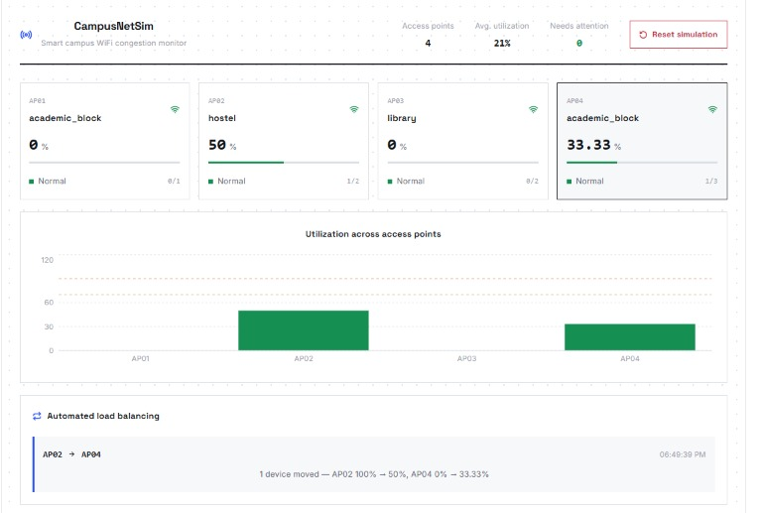
Fig. 6. Dashboard during Run A: AP02 at 50% (1 of 2) and AP04 at 33.33% (1 of 3) after the automated move, with the migration in the load-balancing panel.
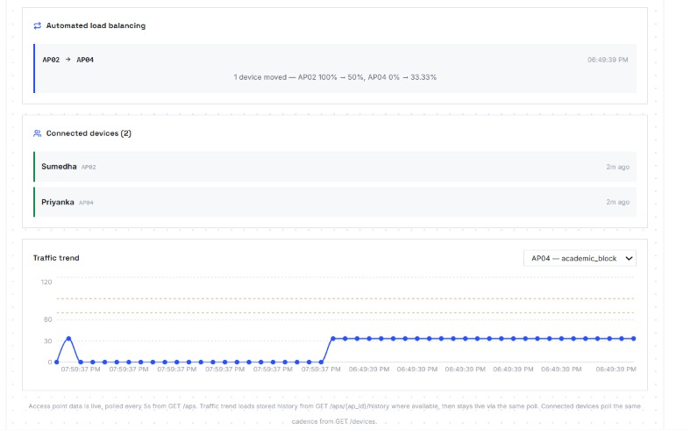
Fig. 7. Dashboard during Run A: migration log, connected-device roster with both phones and the AP04 traffic trend rising after the move.
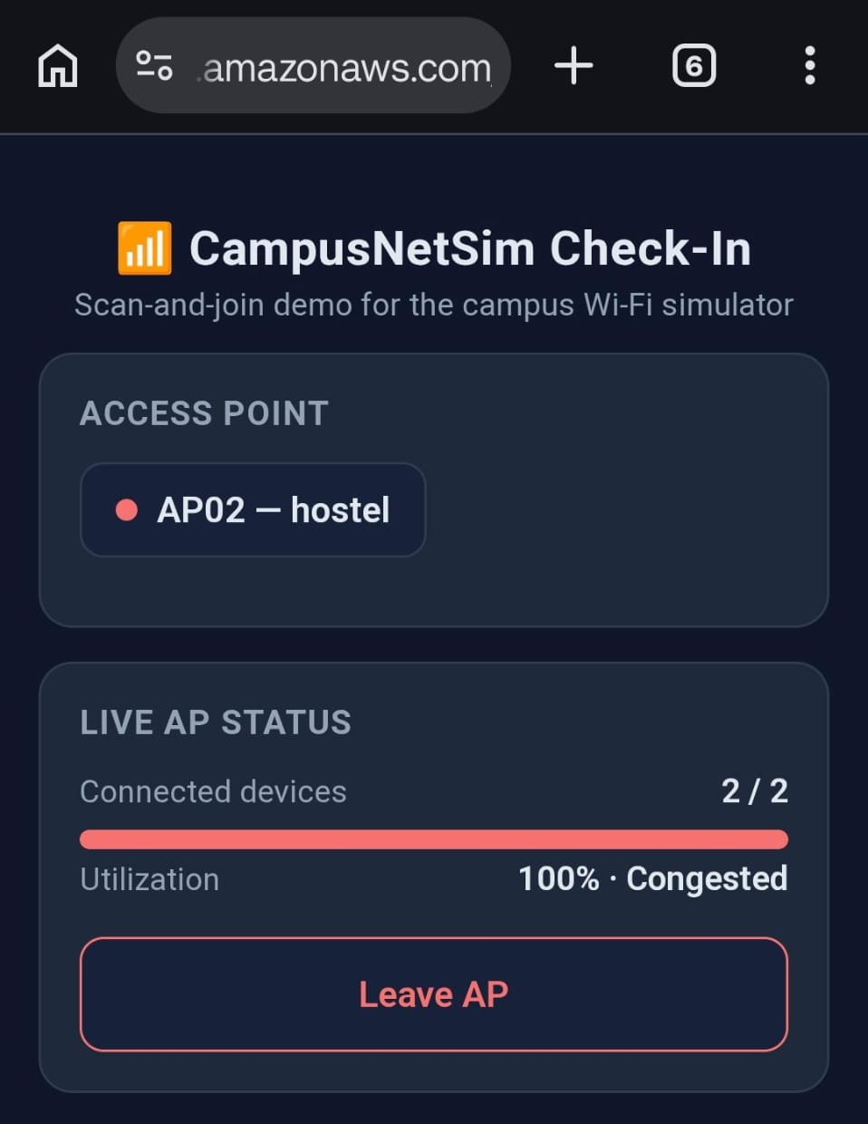  (a) AP02 full before the move | 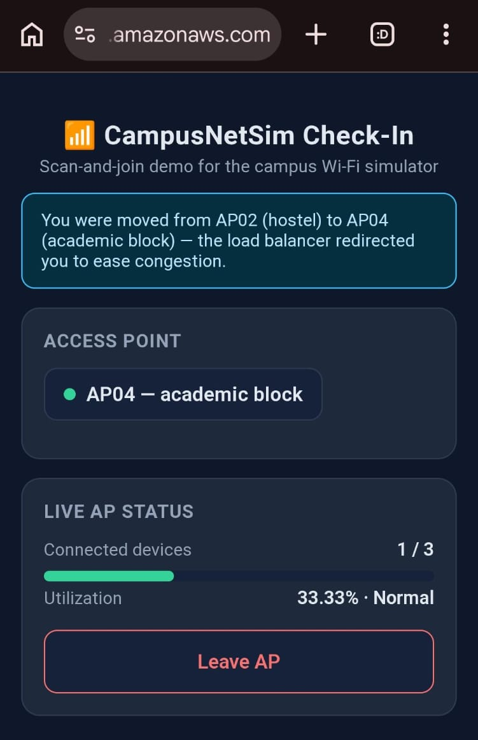  (b) after the move to AP04
Fig. 8. Phone check-in page in Run A: (a) AP02 at 2 of 2 devices and 100% (Congested); (b) moments later, the redirect banner and AP04 at 1 of 3 devices (33.33%, Normal).
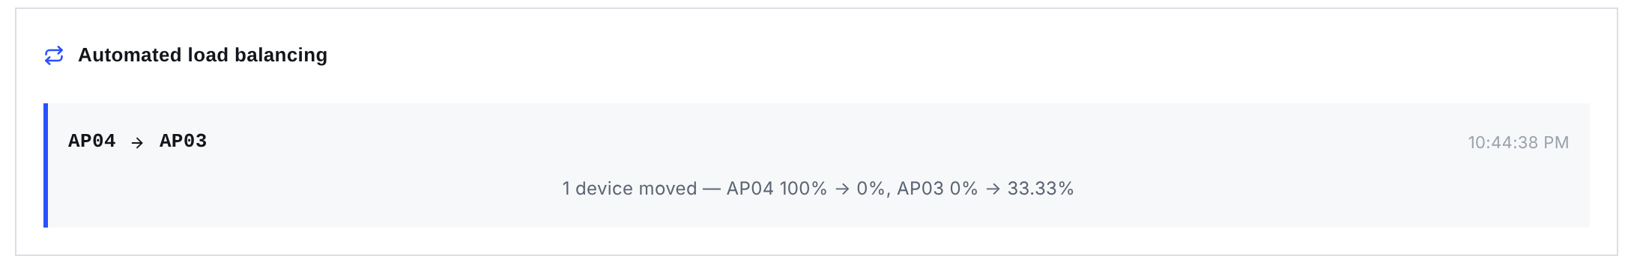
Fig. 9. Migration recorded in Run B: one device moved from AP04 (100% to 0%) to AP03 (0% to 33.33%).
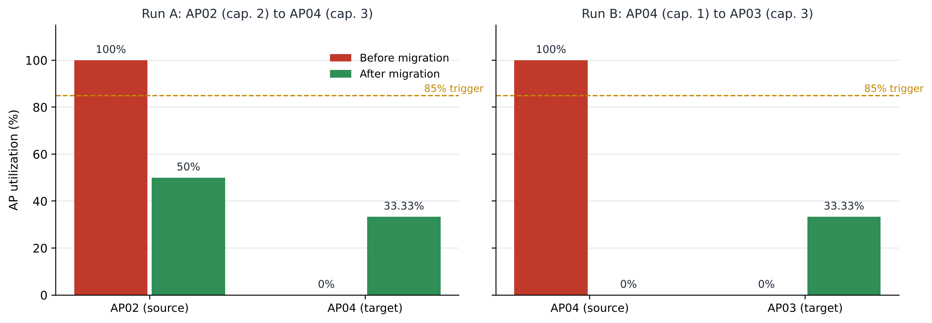
Fig. 10. Utilization of the source and target APs before and after each live migration. Both sources fell below the 85% trigger.

TABLE IX
Recorded Migrations
Run | Source (C) | Target (C) | k | Source U | Target U
A | AP02 (2) | AP04 (3) | 1 | 100 → 50 % | 0 → 33.33 %
B | AP04 (1) | AP03 (3) | 1 | 100 → 0 % | 0 → 33.33 %

F. Discussion
Both runs behaved as designed. The APState stream delivered the full-AP state to LoadBalancer, which picked the AP with the most free capacity (AP04 in Run A, AP03 in Run B); afterwards the source was below the 85% trigger and the target stayed under it. The moves went through POST /events, so they obeyed the same capacity limit and conditional write as phone check-ins, and each left a Migrations record with both APs' utilization before and after.
Several limitations remain. No AP in the demonstrations had more than three slots, so a single device changes utilization in large steps (on an AP of capacity 1, from 0% straight to 100%) and the system mostly exercised the full-AP case. Target selection is split between two functions: EventProcessor recommends an AP in the same building, so a full AP01 would point to AP04, while LoadBalancer picks the AP with the most free slots anywhere on campus, and the move follows LoadBalancer. LoadBalancer also calls the other functions over HTTPS through the public API, which adds an API Gateway round trip to each request and depends on a hard-coded base URL; redeploying the API under a new invoke URL would break balancing until we update the code. EventProcessor scans the whole APState table on every event, which costs little with four items but grows linearly with the number of APs. No route is authenticated, so anyone with the endpoint URL could resize an AP through PUT /aps/{ap_id}/config or wipe the logs through POST /admin/reset, and the check-in page still keeps a static list of valid AP IDs. Finally, Tables VII-IX come from four simulated APs and a handful of phones, and we have not measured behaviour when many phones check in at once, the load a real class change would create.
IX. Conclusion
CampusNetSim detects a congested AP and moves devices off it automatically, using ten Lambda functions and four DynamoDB tables, all managed serverless services. Each APState write produces one stream record that triggers both LoadBalancer and HistoryWriter, so balancing and history logging see the same change and stay idle when nothing changes; on a quiet campus the only invocations are the front ends' five-second reads. Phones join through a QR-code check-in page without installing an app, and a migration appears on the dashboard within one five-second polling interval. The final build adds run-time capacity changes, validated on the server by UpdateAPConfig, and conditional writes in EventProcessor that keep concurrent events from overwriting each other, so DynamoDB remains the single source of truth for the campus layout. In two live runs started by real phone check-ins, the balancer moved a device from AP02 to AP04 (Run A) and from AP04 to AP03 (Run B), each time to the AP with the most free slots. All 14 functional tests passed, and warm reads had a median latency of 60-69 ms.
X. Future Work
Seven extensions are planned. (1) Add JWT authorizers to the HTTP API, starting with PUT /aps/{ap_id}/config and POST /admin/reset, which change or delete data, and then the other five routes. (2) Trigger TrafficGenerator from an Amazon EventBridge schedule and run repeatable peak-hour and congestion scenarios, logging utilization before and after balancing and the number of migrations. (3) Make LoadBalancer prefer same-building targets, as EventProcessor's recommendation already does. (4) Replace the per-event Scan with GetItem lookups on ap_id, and replace the balancer's HTTPS calls with direct Lambda invocations or shared code, which also removes the hard-coded base URL. (5) Use APHistory snapshots, kept for 24 hours, to forecast when an AP will cross 85% and rebalance before it does. (6) Detect AP failures and move the affected devices to other APs. (7) Load-test concurrent check-ins against EventProcessor's conditional writes, and add CloudWatch alarms and an AWS budget alert.
References
[1] Y. Bejerano, S.-J. Han, and L. Li, "Fairness and load balancing in wireless LANs using association control," IEEE/ACM Trans. Netw., vol. 15, no. 3, pp. 560-573, Jun. 2007.
[2] Y. Bejerano and S.-J. Han, "Cell breathing techniques for load balancing in wireless LANs," IEEE Trans. Mobile Comput., vol. 8, no. 6, pp. 735-749, Jun. 2009.
[3] A. Balachandran, P. Bahl, and G. M. Voelker, "Hot-spot congestion relief in public-area wireless networks," in Proc. 4th IEEE Workshop Mobile Comput. Syst. Appl. (WMCSA), Callicoon, NY, USA, 2002, pp. 70-80.
[4] IEEE Standard for Information Technology - Telecommunications and Information Exchange Between Systems - Local and Metropolitan Area Networks - Specific Requirements - Part 11: Wireless LAN Medium Access Control (MAC) and Physical Layer (PHY) Specifications, IEEE Std 802.11-2020, 2021.
[5] IEEE Standard for Information Technology - Part 11, Amendment 8: IEEE 802.11 Wireless Network Management, IEEE Std 802.11v-2011, 2011.
[6] IEEE Standard for Information Technology - Part 11, Amendment 2: Fast Basic Service Set (BSS) Transition, IEEE Std 802.11r-2008, 2008.
[7] E. Jonas et al., "Cloud programming simplified: A Berkeley view on serverless computing," EECS Dept., Univ. California, Berkeley, CA, USA, Tech. Rep. UCB/EECS-2019-3, Feb. 2019.
[8] P. Castro, V. Ishakian, V. Muthusamy, and A. Slominski, "The rise of serverless computing," Commun. ACM, vol. 62, no. 12, pp. 44-54, Dec. 2019.
[9] Z. Li, L. Guo, J. Cheng, Q. Chen, B. He, and M. Guo, "The serverless computing survey: A technical primer for design architecture," ACM Comput. Surv., vol. 54, no. 10s, Art. no. 220, 2022.
[10] G. DeCandia et al., "Dynamo: Amazon's highly available key-value store," in Proc. 21st ACM Symp. Operating Syst. Principles (SOSP), Stevenson, WA, USA, 2007, pp. 205-220.
[11] M. A. Ahmed, S. A. Chavez, A. M. Eltamaly, H. O. Garces, A. J. Rojas, and Y.-C. Kim, "Toward an intelligent campus: IoT platform for remote monitoring and control of smart buildings," Sensors, vol. 22, no. 23, Art. no. 9045, 2022.
[12] Amazon Web Services, "Serverless architectures with AWS Lambda: Overview and best practices," AWS Whitepaper, 2017. [Online]. Available: https://d1.awsstatic.com/whitepapers/serverless-architectures-with-aws-lambda.pdf
[13] Amazon Web Services, "Using AWS Lambda with Amazon DynamoDB," AWS Lambda Developer Guide. [Online]. Available: https://docs.aws.amazon.com/lambda/latest/dg/with-ddb.html (accessed Oct. 23, 2026).
[14] Amazon Web Services, "Change data capture for DynamoDB Streams," Amazon DynamoDB Developer Guide. [Online]. Available: https://docs.aws.amazon.com/amazondynamodb/latest/developerguide/Streams.html (accessed Oct. 23, 2026).
[15] Amazon Web Services, "Using time to live (TTL) in DynamoDB," Amazon DynamoDB Developer Guide. [Online]. Available: https://docs.aws.amazon.com/amazondynamodb/latest/developerguide/TTL.html (accessed Oct. 23, 2026).
[16] Amazon Web Services, "Optimistic locking with version number," Amazon DynamoDB Developer Guide. [Online]. Available: https://docs.aws.amazon.com/amazondynamodb/latest/developerguide/BestPractices_OptimisticLocking.html (accessed Oct. 23, 2026).
[17] Amazon Web Services, "Working with HTTP APIs," Amazon API Gateway Developer Guide. [Online]. Available: https://docs.aws.amazon.com/apigateway/latest/developerguide/http-api.html (accessed Oct. 23, 2026).
[18] Amazon Web Services, "Deploying an application to Amplify without a Git repository," AWS Amplify Hosting User Guide. [Online]. Available: https://docs.aws.amazon.com/amplify/latest/userguide/manual-deploys.html (accessed Oct. 23, 2026).
[19] S. Phadnis and P. J, "CampusNetSim: Cloud-native campus Wi-Fi congestion simulation and load balancing," GitHub repository, 2026. [Online]. Available: https://github.com/pj-06/campusnetsim

