CampusNetSim: A Cloud-Native Wi-Fi Congestion Simulation and Automated Load-Balancing System
Priyanka J
College Cloud Architecture (AWS) — Project Review
Revised September 23, 2026
ABSTRACT
Campus Wi-Fi networks routinely run into an avoidable problem: a handful of access points sit near capacity during peak hours while others nearby stay idle, simply because client devices associate with whichever signal is strongest rather than whichever AP actually has room. CampusNetSim is a cloud-native system built to study and address that imbalance. It simulates a small, multi-building campus of four access points, tracks each one's live utilization, and reacts automatically once an AP crosses a configurable threshold — selecting a target AP, moving simulated devices onto it, and logging the before-and-after result so the action can be checked rather than taken on faith. The system runs entirely on AWS: nine Lambda functions behind a single API Gateway HTTP API exposing six routes, four DynamoDB tables, and a browser-based check-in page that lets a real phone join the simulation by scanning a per-AP QR code, with no app install and no real Wi-Fi hand-off required. This revision re-verifies the system end-to-end against the live AWS account and the local repository, and reports three things worth stating honestly rather than glossing over. First, the reactive load-balancing pipeline is genuinely event-driven: both the LoadBalancer and the previously under-documented HistoryWriter function are wired directly to a DynamoDB Streams trigger on the AP-state table, confirmed enabled in the AWS console — a correction to this project's own earlier assumption that HistoryWriter had no managed trigger. Second, the background traffic generator that would normally keep utilization moving still has no schedule attached to it, so utilization sits at its baseline until that gap is closed. Third, and newly discovered during this revision, the committed source for the event-ingestion function no longer matches what is actually deployed — a discrepancy the project's own history-writing function already documents and works around. This report covers the architecture, the methodology used to build and verify each part of it, what was directly confirmed against the live environment, and the work still open for the next review.
Keywords — serverless computing, AWS Lambda, Amazon API Gateway, Amazon DynamoDB, DynamoDB Streams, WLAN load balancing, access-point congestion, event-driven architecture, campus network simulation
I. INTRODUCTION
Anyone who has tried to get a decent connection from a crowded lecture hall while the library two buildings over sits half-empty has run into the same underlying cause: Wi-Fi clients associate with whichever access point (AP) has the strongest signal, not whichever one has spare capacity. On a real campus this produces exactly the pattern described above — congestion at some APs and idle capacity at others — purely as a side effect of how client radios pick a network, with no coordination between them at all.
The obvious fix, steering a client to a less-loaded AP, is harder to enforce than it sounds. The IEEE 802.11v amendment defines a BSS Transition Management request that lets an AP ask a connected client to roam, but it is only a request: the client's own chipset and driver decide whether to honour it, and real-world compliance varies a great deal by device and manufacturer. Consumer router firmware essentially never exposes this control to third-party software, and mobile operating systems additionally require visible user approval before an app can influence which network a device joins. Reliable, silent, automated steering of real client hardware is therefore not something a student project (or, in practice, most production networks) can guarantee.
CampusNetSim takes a different, more honest approach: instead of trying to force real Wi-Fi clients to move, it builds a complete simulated model of a multi-AP campus — four access points across three buildings — and implements the full recommend-decide-enforce-verify cycle inside that model, where every step is something the system genuinely controls and can prove happened. A real device can still participate, by scanning a QR code at a given AP and checking in through a browser page; this updates the same underlying state the simulation itself uses, so a real person's presence is reflected live without the project depending on anything the phone's Wi-Fi radio actually does.
This revision's objective was narrower than earlier cycles: re-verify, against the live AWS account and the local repository rather than against memory or an earlier write-up, exactly what is deployed, how each piece is actually triggered, and whether the committed source still matches it. That verification both confirmed most of the previous review's findings and corrected one of them, and it surfaced one genuinely new fact about the codebase itself, all reported below alongside the rest of the work.
II. RELATED WORKS
The design of CampusNetSim draws on four related bodies of prior work: WLAN load-balancing and AP-association research, the IEEE 802.11 standards that govern client roaming, serverless cloud computing architecture, and cloud/IoT-based campus monitoring systems.
Load balancing in wireless LANs has been studied extensively at the AP-association level. Bejerano, Han, and Li [1] formalised the problem of assigning clients to APs to achieve max-min fair bandwidth allocation, showing that naive “strongest signal” association — the default behaviour of almost all Wi-Fi client software — produces significantly worse aggregate throughput than an association scheme that accounts for AP load. Later work on service-attribute-based AP load balancing [2] and general WLAN load-balancing techniques for performance enhancement [3] extend this by proposing algorithms an AP or controller can run to actively redistribute clients rather than passively wait for them to roam. These papers establish the core premise CampusNetSim's load-balancing component is built on: imbalance across APs is a well-studied problem, and a system that only reports imbalance delivers materially less value than one that acts on it.
The practical limits of “acting on it” in a real Wi-Fi network are set by the IEEE 802.11 standard itself. 802.11v (BSS Transition Management) [4] defines the mechanism by which an AP can request a connected client to move to a different AP, and 802.11r (Fast BSS Transition) [5] defines how a roam, once the client decides to make it, can happen with lower latency. Critically, both are requests or accelerants, not commands — the receiving client retains full discretion to ignore a transition request. This is the standards-level justification for CampusNetSim's decision to implement enforcement within its own simulated event model rather than attempt real client steering.
On the cloud infrastructure side, the system's serverless design follows the architectural pattern described in recent surveys of serverless computing [6][7], which characterise the model's core trade-off: functions that scale to zero and require no server management, at the cost of per-invocation cold-start latency and vendor-specific integration patterns. An applied study of AWS Lambda for microservice architectures [8] and AWS's own reference whitepaper on serverless architectures with Lambda [9] informed the specific choice to use one Lambda function per logical responsibility — event ingestion, device registry, status and history reads, migration logging, and administrative reset — fronted by a single API Gateway HTTP API, rather than a monolithic backend service. The choice of Amazon DynamoDB as the sole data store follows the design philosophy in Amazon's own Dynamo paper [10], which set out the case for a highly available, horizontally scalable key-value store over a relational database for workloads dominated by simple key-based reads and writes with predictable access patterns — a good match for per-AP state, and for append-style history and migration logs.
Finally, the broader pattern of using cloud and IoT infrastructure to monitor a physical campus environment is well established in the smart-campus literature [11][12][13], which describes architectures where distributed sensors or check-in points feed a central cloud backend for real-time monitoring. CampusNetSim's phone check-in feature — where a real device scans a QR code to register its presence at a specific AP and appears live on the dashboard — mirrors this pattern directly, substituting a simulated AP-association model for the physical sensors used in those systems while keeping the underlying monitoring and visualisation pipeline genuinely live.
III. PROPOSED METHODOLOGY
The system was built incrementally, feature by feature, with each addition checked against the live AWS environment before being considered complete — not merely reviewed as code. This revision applied the same discipline in the other direction: re-checking what earlier reviews had concluded, rather than simply repeating it.
Core simulation and monitoring.
A campus layout of four access points across three buildings (AP01 and AP04 in the academic block, AP02 in a hostel, AP03 in the library) is held in the APState table. An event-ingestion Lambda (EventProcessor) updates each AP's connected-device count and utilization whenever a JOIN/LEAVE event is posted, and a status-reader Lambda exposes the current state of all four APs to the dashboard and check-in page.
Reactive load balancing — and a correction to this project's own earlier assumption.
Rather than being polled on a timer, the load-balancing function is attached directly to a DynamoDB Streams trigger on the APState table. This revision also re-opened HistoryWriter's own trigger configuration, which the previous report described as having “no AWS-managed trigger of any kind, presumed invoked from application code.” That assumption was wrong: HistoryWriter carries the same DynamoDB Streams trigger on APState as LoadBalancer, confirmed Enabled in the console. Every time an AP's state changes, both functions receive the change record independently — LoadBalancer checks whether the new utilization crosses the configured threshold and, only if it does, selects a target AP, moves enough simulated devices to bring the source back under threshold, and writes a structured migration record to the Migrations table; HistoryWriter, unconditionally, copies the relevant fields of the same change into the APHistory table for the dashboard's trend chart. Neither is a scheduled sweep — both are genuinely event-driven, which is a meaningfully different (and stronger) claim than “checks periodically,” and the correction above is reported here specifically because the earlier draft repeated an assumption instead of re-checking it.
Phone check-in.
A self-contained HTML page, hosted on Amazon S3 and reached by scanning a per-AP QR code, lets a real device register its presence. The device generates and persists an identifier in browser local storage so repeated visits are recognised, and two backend calls run on Join/Leave: one updates the AP's live count through the same event primitive the simulator itself uses, and a separate device-registry call updates the roster shown on both the check-in page and the dashboard. This revision re-confirmed, directly against the local repository, that both the check-in page and the React/Vite dashboard's components directory (src/components/: APCard.jsx, CustomTooltip.jsx, MigrationHistory.jsx, RosterPanel.jsx) contain only this check-in and status functionality, with nothing else called from either front end.
Administrative reset.
A dedicated reset Lambda (AdminReset) and a corresponding dashboard button support repeated demos without manually clearing DynamoDB by hand. In an earlier cycle this Lambda was extended to also scan the Devices table and mark every currently connected device as disconnected, clearing its associated AP, so that a reset is reflected on a checked-in phone the next time its page polls the API — not just on the dashboard; the check-in page was extended in parallel to detect this case and show an explicit banner. Given that a real POST to the reset endpoint permanently clears the Migrations and APHistory tables and zeroes every AP, this behaviour continues to be verified at the code and route level only — successful deployment and a correct 405 response to a safe GET request — without a live POST being triggered, consistent with the project's standing safety rule that this irreversible action is only ever run deliberately, by the project owner, outside of a routine review.
Verification discipline, and a newly found discrepancy.
Throughout this project, claims about the system have been checked against direct evidence rather than assumed from a console success banner or an earlier write-up. This revision extended that discipline to the codebase itself: reading lambda/history_writer/lambda_function.py's own docstring in full — rather than only its behaviour — surfaced a documented discrepancy between the version of event_processor/lambda_function.py committed to the repository and what is actually deployed and serving GET /aps live. This is reported in detail in Section VIII-F, and is exactly the kind of fact this project's verification approach is meant to catch: not a bug found by testing, but a quiet mismatch found by reading source and comparing it, deliberately, against the live system rather than trusting either one alone.
IV. ARCHITECTURE DIAGRAM
Fig. 1 shows the deployed architecture across five layers: a client layer (the phone check-in page and the React/Vite dashboard), an edge layer (a single API Gateway HTTP API), a compute layer split into API-triggered and event-driven Lambda functions, a data layer of four DynamoDB tables, and a monitoring layer (CloudWatch Logs, common to all nine functions).
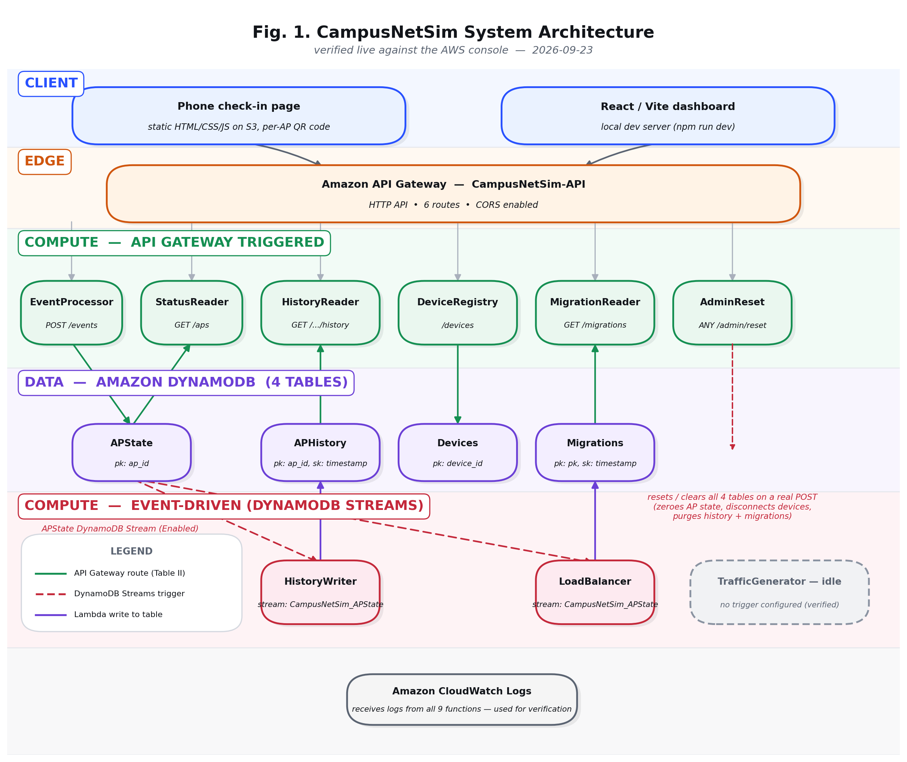
Fig. 1. CampusNetSim system architecture, showing all nine Lambda functions and how each is actually triggered, as re-verified in the AWS console for this revision.
The edge layer is a single HTTP API, CampusNetSim-API, exposing six routes with CORS enabled so both the dashboard and the check-in page can call it directly from the browser. Six of the nine Lambda functions are wired to one API route each. Of the remaining three, two — LoadBalancer and HistoryWriter — are invoked reactively by the same DynamoDB Streams trigger on the APState table (both confirmed Enabled in the console), and TrafficGenerator has no trigger configured at all, meaning nothing currently invokes it on a schedule. Fig. 1 distinguishes API-Gateway routes (solid green), the shared DynamoDB Streams trigger (dashed red), and each function's write back into its own table (solid purple), because an earlier draft of this project's documentation described TrafficGenerator as EventBridge-scheduled and HistoryWriter as having no managed trigger at all; the live console shows the former is still false and the latter was itself incorrect, both of which are reported here as corrected, verified facts rather than repeated as assumptions.
V. WORKFLOW
Fig. 2 walks through three flows that were each exercised or directly inspected during this review: (A) a device checking in through the phone page, (B) the reactive load-balancing decision the system makes whenever AP state changes, and (C) an administrative reset, including the device-disconnect behaviour added in an earlier cycle.
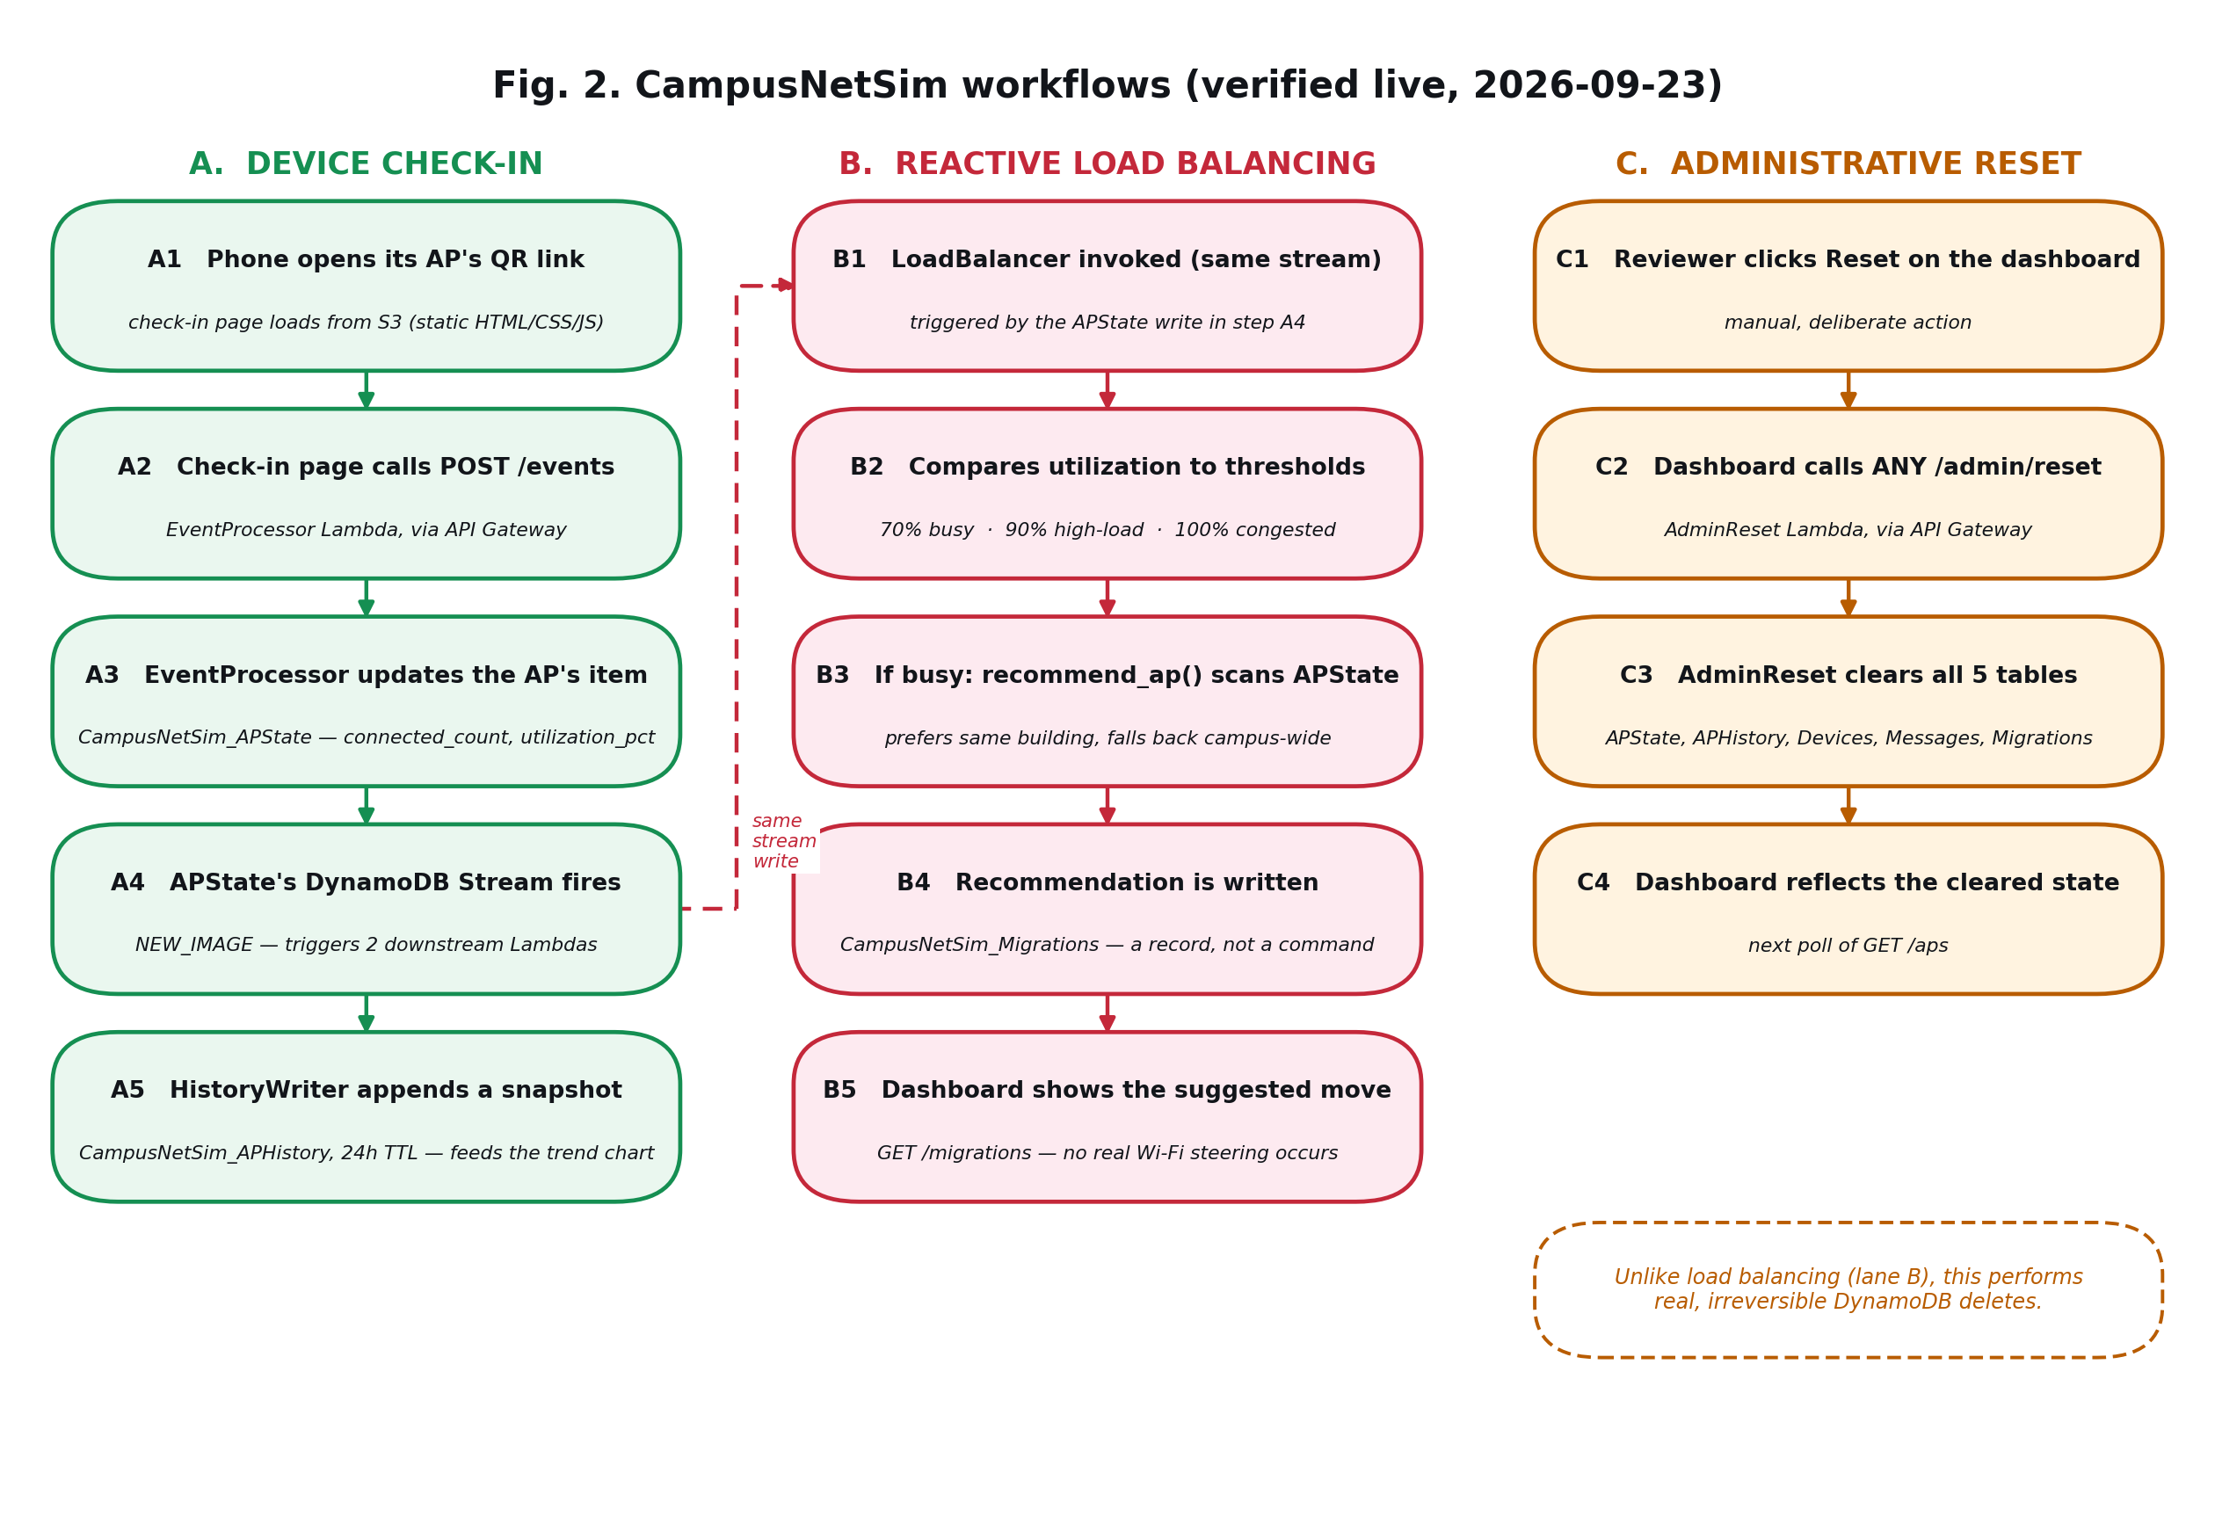
Fig. 2. Check-in, reactive load-balancing, and administrative-reset workflows, drawn as three independent lanes with the one genuine cross-lane link (A4 → B1) shown explicitly.
In flow A, scanning a QR code opens the check-in page pre-filled with an AP identifier; joining posts both an event (to update the AP's live count) and a device-registry upsert (to add the device to the roster). That single write to APState is also where flow B begins: its DynamoDB Stream record is delivered to LoadBalancer, which checks the new utilization against the configured threshold and only acts — selecting a target AP, moving devices, writing a Migrations record — when the threshold is actually crossed, and separately to HistoryWriter, which unconditionally appends the new reading to APHistory for the trend chart. Flow B is therefore reactive in the fullest sense: it is not polled, and it is not a single Lambda doing two jobs, but two independent consumers of the same underlying change. In flow C, an administrative reset clears AP state, the Migrations log, and the APHistory log, and also marks every connected device as disconnected; the check-in page picks this up on its own next poll and shows a banner rather than continuing to display a stale “connected” state.
VI. ALGORITHM / FORMULAS
Two things are precise enough in this system to state formally: how utilization is computed, and the decision rule the LoadBalancer function applies once it receives a state-change event.
For an access point i with connected_countᵢ devices and a fixed capacityᵢ (the number of devices at which it is considered fully loaded), utilization is:
utilization_pctᵢ = (connected_countᵢ ÷ capacityᵢ) × 100 (1)
The reactive load-balancing procedure, triggered once per DynamoDB Streams record for the APState table, is given in Algorithm 1.
Algorithm 1: Reactive AP Load Balancing
1. On receiving a stream record for APᵢ, read its new utilization_pctᵢ.
2. If utilization_pctᵢ ≤ THRESHOLD_BUSY (70%), take no action and return.
3. Otherwise, among the remaining APs {APⱼ : j ≠ i} with spare capacity, prefer a target APⱼ in the same building; if none has room, fall back to the least-utilized AP campus-wide.
4. Compute the device count k such that moving k devices from APᵢ to APⱼ brings utilization_pctᵢ back under threshold without pushing utilization_pctⱼ above it.
5. Move k simulated devices (writing the same JOIN/LEAVE-style state changes the traffic simulator itself uses), and write a record {source: APᵢ, target: APⱼ, count: k, before/after utilization on both APs, timestamp} to the Migrations table.
The 70% figure in step 2, and the 90%/100% high-load and congested thresholds used for status display, are read directly from the committed event_processor source (THRESHOLD_BUSY, THRESHOLD_HIGH_LOAD, THRESHOLD_CONGESTED) and match the live API's documented behaviour.
VII. TABLES AND FIGURES
This section collects, with captions and numbering, the data tables and supporting screenshots that document the deployed system as observed directly — through live API calls, the AWS console, and the local repository — rather than as designed or previously assumed.
TABLE I. ACCESS POINT LAYOUT AND LIVE STATUS (GET /aps)
AP ID | Building | Capacity | Utilization | Status
AP01 | Academic block | 1 | 0% | NORMAL
AP02 | Hostel | 2 | 0% | NORMAL
AP03 | Library | 2 | 0% | NORMAL
AP04 | Academic block | 3 | 0% | NORMAL

TABLE II. API GATEWAY ROUTES AND BACKING LAMBDA FUNCTIONS (VERIFIED LIVE)
Route | Method(s) | Backing Lambda | Purpose
/events | POST | EventProcessor | Ingest JOIN/LEAVE events; updates AP utilization
/devices | GET, POST | DeviceRegistry | Read / upsert the device check-in roster
/aps | GET | StatusReader | Live per-AP status (capacity, utilization, count)
/aps/{ap_id}/history | GET | HistoryReader | Time-series history for one AP (trend chart)
/migrations | GET | MigrationReader | Load-balancing action log
/admin/reset | POST (ANY; 405 otherwise) | AdminReset | Full simulation reset, incl. device disconnect

TABLE III. AMAZON DYNAMODB TABLES (KEYS VERIFIED VIA CONSOLE)
Table | Partition key | Sort key | Item count (this revision)
CampusNetSim_APState | ap_id | — | Not re-scanned this cycle
CampusNetSim_APHistory | ap_id | timestamp | Not re-scanned this cycle
CampusNetSim_Devices | device_id | — | Not re-scanned this cycle
CampusNetSim_Migrations | pk | timestamp | 0 items (confirmed empty)
Byte-size figures reported in an earlier draft of this table are not repeated here: they were not independently re-measured during this revision, and restating them without re-checking would contradict this project's own verification standard. Migrations was directly re-confirmed empty this cycle via the console's cached item count, consistent with Section VIII-D.
TABLE IV. LAMBDA TRIGGER SUMMARY — ALL 9 FUNCTIONS (VERIFIED VIA CONSOLE)
Lambda function | Trigger (as observed in console) | Notes
EventProcessor | API Gateway — POST /events
DeviceRegistry | API Gateway — /devices
StatusReader | API Gateway — /aps
HistoryReader | API Gateway — /aps/{ap_id}/history
MigrationReader | API Gateway — /migrations
AdminReset | API Gateway — ANY /admin/reset | Disconnects devices on reset (earlier cycle)
LoadBalancer | DynamoDB Streams on CampusNetSim_APState | Enabled; confirmed reactive design
HistoryWriter | DynamoDB Streams on CampusNetSim_APState | Enabled — corrects earlier draft's “none found” (Sec. III)
TrafficGenerator | None found | No schedule configured; currently idle (Sec. VIII-D)

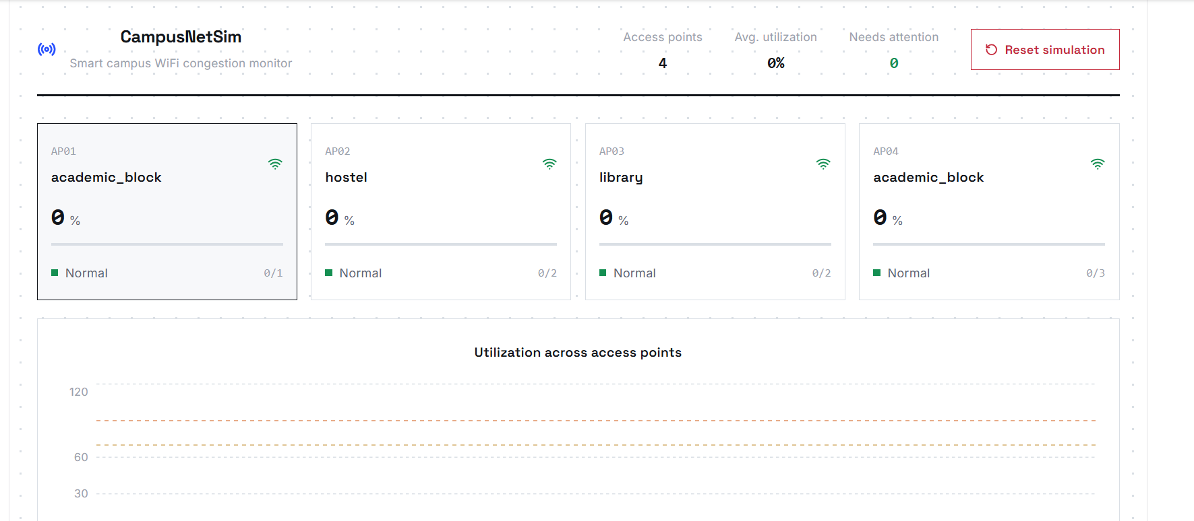
Fig. 3. Dashboard — access-point cards and utilization chart, live.
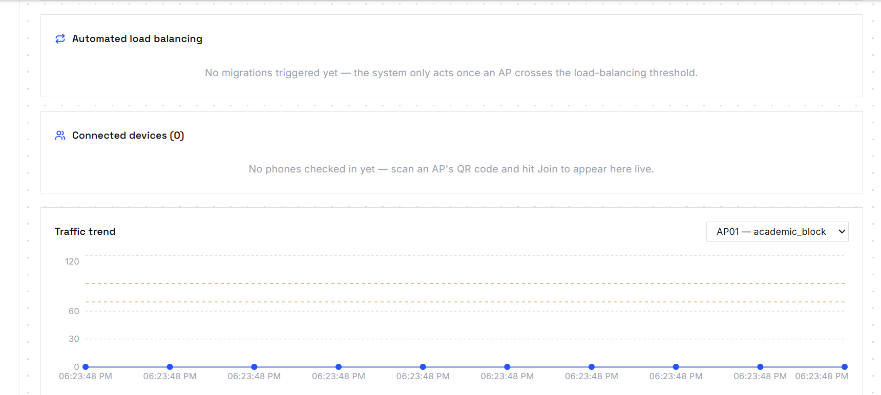
Fig. 4. Dashboard — automated load-balancing, connected devices, and traffic-trend panels, live.
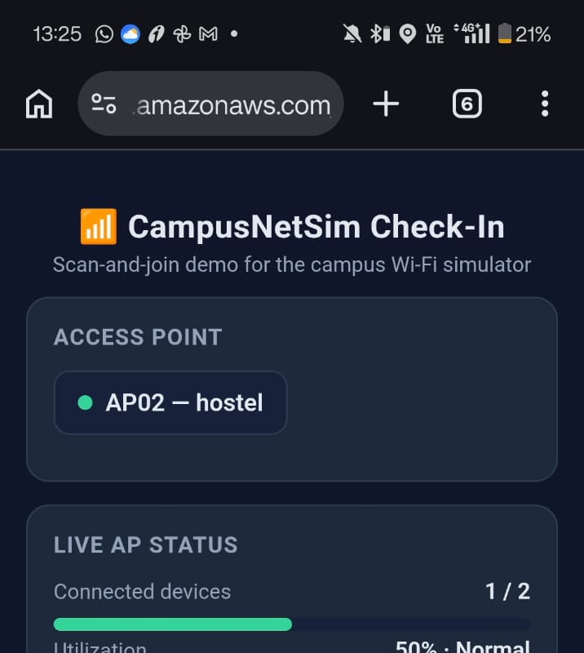
Fig. 5. Live check-in page on a phone browser, showing the access-point card and live status panel.
VIII. IMPLEMENTATION, RESULTS, AND DISCUSSION
A. Prior Review Cycle's Own Changes
Two concrete changes were made and deployed in an earlier review cycle and remain in place. First, the AdminReset Lambda function was extended with a device-disconnect routine that scans the Devices table and, for every device currently marked CONNECTED, sets its status to DISCONNECTED and clears its associated AP, in addition to the reset behaviour it already had (zeroing AP state, clearing Migrations and APHistory). Second, the check-in page was extended to detect this case on its own regular poll — a device's own status flipping away from CONNECTED without the user having pressed “Leave” — and show an explanatory banner rather than silently going stale. Both changes remain deployed (confirmed again this revision by an independent safe GET request against the live endpoint returning the expected 405 response for a non-POST method) but, consistent with this project's standing rule that the reset endpoint is irreversible, have still not been exercised with a real POST; a supervised live test remains under Future Work.
B. Verifying the Live API Surface
Rather than re-describe the API from an earlier document, every route this report claims exists was called directly against the deployed endpoint. GET /aps returned real, current data for all four configured APs, with capacities (1, 2, 2, 3 for AP01–AP04) matching the intended layout exactly. GET /devices and GET /migrations both returned structurally correct 200 responses. GET /aps/{ap_id}/history returned a populated time-series response for AP01. The admin endpoint correctly rejected a GET with the documented 405 response. This is the basis for Table II, and it is a stronger form of evidence than reading Lambda source code, since it confirms the deployed configuration — method, path, CORS, and integration — actually matches what the code implies.
C. Confirming How Each Function Is Actually Triggered
Each of the nine Lambda functions' trigger configuration was opened directly in the console rather than inferred. Six functions are wired to one API Gateway route each (Table IV). Of the remaining three, two — LoadBalancer and HistoryWriter — carry an AWS-managed DynamoDB Streams event source mapping on the APState table, both shown as Enabled, confirming the reactive, non-polled design described in Section III for both functions, not only LoadBalancer as an earlier draft assumed. TrafficGenerator shows zero configured triggers. This is a meaningful, previously reported finding, re-confirmed this cycle: it contradicts an earlier internal description of this project that stated a once-a-minute EventBridge schedule existed. No such schedule is present in either the EventBridge Scheduler console or the classic EventBridge Rules console for this account.
D. What the Idle Traffic Generator Explains
This finding is consistent with, and helps explain, everything else observed live: all four APs report 0% utilization with zero connected devices; the Migrations table is empty; and the dashboard's own “Automated load balancing” panel already reads “No migrations triggered yet — the system only acts once an AP crosses the load-balancing threshold” (Fig. 4), which is an accurate description of the current state rather than a placeholder. In other words, the architecture for reactive load balancing is genuinely deployed and correctly wired for both of its consumers (Section VIII-C), but has not yet had an opportunity to fire in this environment, because nothing is currently generating the traffic that would push an AP over threshold. This is a gap between “designed and deployed” and “observed running end-to-end,” and it is called out explicitly here rather than left implicit.
E. Screenshots
Fig. 3 shows the dashboard's top panel: four AP cards (matching Table I exactly), an average-utilization summary, and the reset control. Fig. 4 shows the dashboard's lower panels — automated load balancing, connected devices, and the traffic-trend chart — all correctly reflecting the currently idle state described above. Fig. 5 shows the live check-in page as reached from a phone browser: the access-point card and live status panel are present and functioning.
F. Deployed API Contract vs. Committed Source (New Finding, This Revision)
While tracing how AP history rows actually get written, this revision read lambda/history_writer/lambda_function.py's own docstring in full, which documents something not previously reported: the version of lambda/event_processor/lambda_function.py committed to the repository does not match what is actually deployed and serving GET /aps live. The committed source reads and writes CampusNetSim_APState using the field names current_users, utilization, and updated_at, while the live API's actual contract — confirmed by the direct GET /aps calls in Section VIII-B, and documented in docs/api.md — uses connected_count, utilization_pct, and timestamp. HistoryWriter was deliberately written as a separate Lambda subscribed to the state table's stream, rather than as a code change inside event_processor, specifically so that reading its output needs no knowledge of event_processor's internals beyond the item shape it writes to DynamoDB — and its own field list intentionally mirrors the live contract, not the stale committed one, exactly as its docstring states.
A related staleness was found in docs/api.md itself, which still documents an eight-AP layout (AP01–AP08, with capacities that do not match Table I) and only three of the project's six routes — contradicting the live four-AP layout and full route list confirmed elsewhere in this report. Both discrepancies point to the same root cause: documentation, and in event_processor's case committed source, not being updated when the deployed system changed, most likely because event_processor was edited directly through the Lambda console at some point after the current commit and that change was never synced back to the repository. Neither discrepancy affects the live system's correctness — GET /aps, HistoryWriter, and the dashboard all agree with each other — but both are reported here because the alternative, silently republishing stale source-derived claims as current fact, is exactly what this project's verification discipline exists to prevent.
IX. CONCLUSION
CampusNetSim demonstrates a serverless, event-driven approach to a real and well-studied problem in WLAN operation, built entirely on AWS Lambda, API Gateway, and DynamoDB. The strongest result of this revision is architectural: the load-balancing pipeline is not a polling loop dressed up as “automated” — both of its consumers, LoadBalancer and HistoryWriter, are genuinely wired to fire off a DynamoDB Streams change on the AP-state table, confirmed directly in the AWS console, correcting this project's own earlier assumption about HistoryWriter in the process. The check-in mechanism lets a real device participate honestly, without pretending to control real Wi-Fi hardware it has no access to. At the same time, this revision is equally clear about what is not yet demonstrated: with no schedule currently driving the traffic generator, the load-balancing pipeline has not been observed firing end-to-end; the device-disconnect-on-reset behaviour has been verified only at the code and route level, not with a live invocation; and the committed event_processor source has been shown to diverge from what is actually deployed. None of these is an open-ended concern — each is a concrete, well-defined item for the next review cycle.
X. FUTURE WORK
1. Attach an EventBridge schedule (e.g. rate(1 minute)) to the TrafficGenerator function so utilization actually moves and the reactive load-balancing pipeline can be observed firing end-to-end, with a real before/after Migrations record captured for the next report.
2. Perform one supervised, explicitly authorised POST to /admin/reset against the live environment to confirm the device-disconnect count and the check-in page's disconnect banner under a real invocation, with CloudWatch log evidence captured before and after.
3. Reconcile the committed event_processor source and docs/api.md with the live deployed contract — field names, AP count, and the full route list — so the repository stops silently disagreeing with what is actually running (Sec. VIII-F).
4. Deploy the React/Vite dashboard to Amazon S3, matching how the check-in page is already hosted, so it becomes part of the reviewable AWS architecture rather than living only on a developer's local machine.
5. Add a small automated test suite (for example, scripted calls against each API route, or unit tests against each Lambda handler) to replace ad hoc console and CloudWatch verification with something repeatable across reviews.
6. Once the traffic generator is scheduled, run a deliberate controlled experiment — pushing one AP over threshold on purpose — to capture a genuine before/after utilization and migration record rather than relying on a naturally occurring one.
7. Re-verify all four AP QR codes with an actual phone-camera scan, not only an automated image decode, before any physical posters are printed and put up.
REFERENCES
[1] Y. Bejerano, S.-J. Han, and L. Li, “Fairness and Load Balancing in Wireless LANs Using Association Control,” IEEE/ACM Transactions on Networking, 2007.
[2] “An access point load-balancing algorithm based on service attribute in wireless network,” IEEE Xplore Conference Publication, 2019.
[3] “IEEE 802.11 WLAN Load Balancing for Network Performance Enhancement,” Procedia Computer Science, ScienceDirect, 2015.
[4] IEEE 802.11v-2011 Amendment — BSS Transition Management, as documented in Cisco Catalyst 9800 Series Wireless Controller Software Configuration Guide.
[5] “IEEE 802.11r-2008 — Fast BSS Transition,” IEEE Standards Association.
[6] “The Serverless Computing Survey: A Technical Primer for Design Architecture,” arXiv:2112.12921, 2021.
[7] “Serverless Computing: A Survey of Opportunities, Challenges, and Applications,” arXiv:1911.01296, 2019.
[8] “AWS Lambda for Serverless Microservices Architecture,” International Journal of Advanced Research in Computer and Communication Engineering (IJARCCE).
[9] Amazon Web Services, “Serverless Architectures with AWS Lambda,” AWS Whitepaper.
[10] G. DeCandia et al., “Dynamo: Amazon's Highly Available Key-value Store,” Proceedings of the 21st ACM Symposium on Operating Systems Principles (SOSP), 2007.
[11] “Toward an Intelligent Campus: IoT Platform for Remote Monitoring and Control of Smart Buildings,” PMC / National Library of Medicine, 2022.
[12] “An IoT-based Smart Campus Monitoring System,” IEEE Xplore Conference Publication, 2022.
[13] “Constructing Smart Campus Based on the Cloud Computing Platform and the Internet of Things,” Conference publication (ResearchGate).

