CampusNetSim: A Cloud-Native Wi-Fi Congestion Simulation and Automated Load-Balancing System
Priyanka J
College Cloud Architecture (AWS) — Project Review

Abstract
Campus Wi-Fi deployments routinely suffer from uneven load across access points (APs): some APs sit near capacity during peak hours while nearby APs are lightly used, degrading throughput and user experience for no reason other than static, unmanaged client association. CampusNetSim is a cloud-native system that simulates a multi-AP campus network, continuously monitors per-AP utilization, and — going beyond a system that merely recommends a fix — autonomously decides on and enforces a load-balancing action when an AP crosses a configurable utilization threshold, logging the before/after result for verification. The system is built entirely on AWS using a serverless architecture: nine AWS Lambda functions, a single API Gateway HTTP API, and five Amazon DynamoDB tables, with a React dashboard for live visualization and a real, browser-based phone check-in page (reached by scanning a per-AP QR code) that lets genuine devices join the simulation and participate in a live campus chat. A key design decision, reached after evaluating the technical feasibility of genuinely steering a real Wi-Fi client via 802.11v BSS Transition Management, was that deterministic client-side steering cannot be guaranteed on consumer or student-accessible hardware; the project therefore implements an honest, fully-enforced simulated load-balancing pipeline — recommendation, decision, enforcement, and verification — entirely within its own event model, which is demonstrable reliably and repeatably rather than being dependent on uncontrollable client Wi-Fi chipset behaviour. This report documents the system's architecture, the methodology used to build and verify each component, the results of that verification, and the work planned for the next review cycle.

Literature Survey
The design of CampusNetSim draws on four related bodies of prior work: WLAN load-balancing and AP-association research, the IEEE 802.11 standards that govern client roaming, serverless cloud computing architecture, and cloud/IoT-based campus monitoring systems.
Load balancing in wireless LANs has been studied extensively at the AP-association level. Bejerano, Han, and Li [1] formalised the problem of assigning clients to APs to achieve max-min fair bandwidth allocation, showing that naive “strongest signal” association (the default behaviour of almost all Wi-Fi client software) produces significantly worse aggregate throughput than an association scheme that accounts for AP load. Later work on service-attribute-based AP load balancing [2] and general WLAN load-balancing techniques for performance enhancement [3] extend this by proposing algorithms an AP or controller can run to actively redistribute clients rather than passively wait for them to roam. These papers establish the core premise CampusNetSim's LoadBalancer Lambda is built on: that load imbalance across APs is a well-known, well-studied problem, and that a system which only reports imbalance (a recommendation) delivers materially less value than one that acts on it (enforcement).
The practical limits of “acting on it” in a real Wi-Fi network are set by the IEEE 802.11 standard itself. 802.11v (BSS Transition Management) [4] defines the mechanism by which an AP can request a connected client to move to a different AP, and 802.11r (Fast BSS Transition) [5] defines how a roam, once the client has decided to make it, can happen with lower latency. Critically, both are requests or accelerants, not commands: the receiving client's Wi-Fi chipset and driver retain full discretion to ignore a BSS Transition request, and real-world compliance varies significantly by device and manufacturer. This is the standards-level justification for CampusNetSim's decision to implement enforcement within its own simulated event model rather than attempt real client steering — a choice documented in detail in the project's internal feasibility analysis, which additionally found that consumer router firmware essentially never exposes 802.11v control to third-party software at all, and that Android explicitly requires user-visible approval before an app can influence which network a device joins, ruling out silent automated steering on commodity hardware.
On the cloud infrastructure side, the system's serverless design follows the architectural pattern described in recent surveys of serverless computing [7][8], which characterise the model's core trade-off: functions that scale to zero and require no server management, at the cost of per-invocation cold-start latency and vendor-specific integration patterns. An applied study of AWS Lambda for microservice architectures [9] and AWS's own reference whitepaper on serverless architectures with Lambda [13] informed the specific choice to use one Lambda function per logical responsibility (event ingestion, load-balancing decisions, migration history retrieval, traffic simulation, device registry, chat, and administrative reset) fronted by a single API Gateway HTTP API, rather than a monolithic backend service. The choice of Amazon DynamoDB as the sole data store follows the design philosophy set out in Amazon's own Dynamo paper [6], which established the case for a highly-available, horizontally-scalable key-value store over a traditional relational database for workloads dominated by simple key-based reads and writes with predictable access patterns — a good match for per-AP state, append-only history, and append-only chat/migration logs.
Finally, the broader pattern of using cloud and IoT infrastructure to monitor a physical campus environment is well established in the smart-campus literature [10][11][12], which describes architectures where distributed sensors or check-in points feed a central cloud backend for real-time monitoring and visualization. CampusNetSim's phone check-in feature — where a real device scans a QR code to register its presence at a specific AP and appears live on a dashboard — mirrors this pattern directly, substituting a simulated AP-association model for the physical sensors used in those systems while keeping the underlying monitoring and visualization pipeline genuinely live.

System Architecture
The system is organised into five layers: a client layer (the dashboard and the phone check-in page), an edge layer (a single API Gateway HTTP API), a compute layer (seven AWS Lambda functions, invoked either by API Gateway or on a schedule via Amazon EventBridge), a data layer (five DynamoDB tables), and a monitoring layer (Amazon CloudWatch Logs, capturing every Lambda invocation for debugging and verification). Figure 1 shows the full architecture and the data flow between layers.
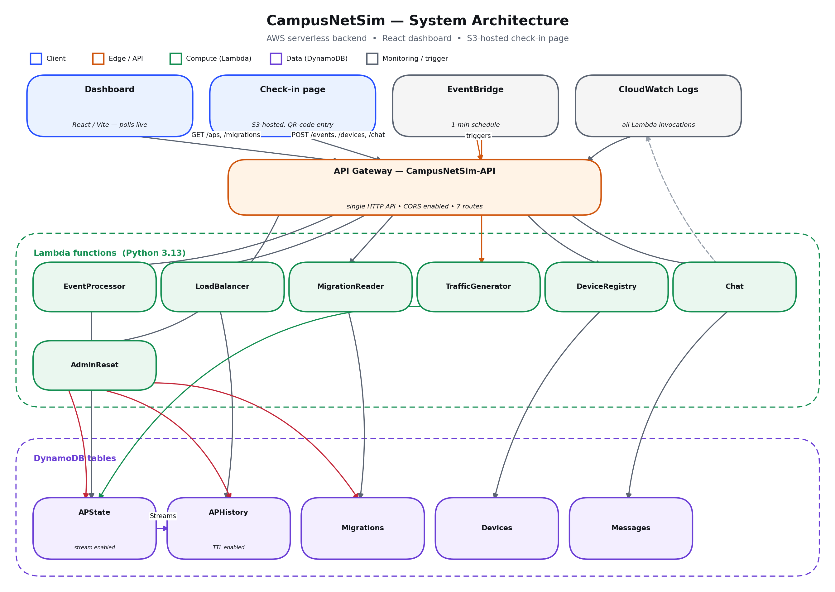
Figure 1. CampusNetSim system architecture.
API Gateway exposes seven routes over a single HTTP API with CORS enabled account-wide, so both the dashboard and the check-in page can call it directly from the browser. Each route maps to exactly one Lambda function: event ingestion and AP state queries, load-balancing recommendations and enforcement, migration history retrieval, phone check-in (device registry), campus chat, and an administrative reset endpoint. A separate EventBridge schedule invokes the traffic-generator Lambda once a minute, independent of any user action, to keep simulated utilization moving realistically even with no phones connected. On the data side, the APState table (which holds each AP's live connected-device count, utilization percentage, and status) has DynamoDB Streams enabled, feeding a dedicated APHistory table with time-to-live-based expiry so historical trend data does not grow unbounded; Migrations, Devices, and Messages are independent append-style tables for the load-balancer's action log, the phone check-in roster, and the campus chat feed respectively.

Methodology
The system was built incrementally, feature by feature, with each addition verified against live AWS infrastructure before being considered complete — not merely reviewed as code. The methodology for each major component is summarised below.
Core simulation and monitoring. A traffic-generator Lambda, triggered every minute by EventBridge, mutates simulated per-device connect/disconnect events against a reduced 4-AP campus layout (two buildings, four APs of varying capacity). An event-processing Lambda aggregates these into live per-AP state (connected count, utilization percentage, status tier), and a DynamoDB Streams pipeline mirrors every state change into a time-series history table, which the dashboard's trend chart reads from.
Load-balancing pipeline. The load-balancing Lambda implements the full recommend → decide → enforce → verify cycle described in the literature survey: when an AP's utilization crosses a configurable threshold, the function selects a target AP using the same logic that previously only powered a passive recommendation, decides how many simulated devices to move to bring the source AP back under threshold without overloading the target, executes the migration by writing the same connect/disconnect event primitives the traffic generator itself uses, and writes a structured migration record (source AP, target AP, device count, before/after utilization on both APs, timestamp) to the Migrations table. The dashboard's migration history panel and utilization charts pick this up on the next poll cycle, closing the verification loop.
Phone check-in and chat. A self-contained HTML page, hosted directly on Amazon S3 and reached by scanning a per-AP QR code, lets a real device register its presence. The device generates and persists an identifier in browser local storage so repeated visits from the same device are recognised, and two backend calls run together on Join/Leave: one updates the AP's live congestion count using the same event primitive as the simulator, and a separate device-registry call updates a roster used by the dashboard and the check-in page itself. A lightweight, separately-polled chat feature was added on top of the same registry so a live demo has a visibly interactive, real (not simulated) element.
Dashboard. A React/Vite single-page application polls the API on independent cycles per feature (AP state and migrations every five seconds, chat every 2.5 seconds, matching the check-in page's own cadence) and renders per-AP utilization cards, a comparative bar chart, a load-balancing recommendations panel, a migration history feed, a live device roster, a live chat feed, and a selectable per-AP trend line chart.
Administrative reset. To support repeated demos and testing without manually clearing DynamoDB by hand, a dedicated reset Lambda and a corresponding dashboard button were added, which zero every AP's state and permanently clear the migration and history logs. Given the irreversible nature of this action, the feature was built with an explicit client-side confirmation step and was deliberately verified using only safe, non-destructive requests before any real invocation was made.
Verification discipline. Throughout development, claims of correctness were checked against direct evidence rather than assumed from a console success message. Examples include: confirming cross-origin CORS behaviour with real preflighted requests from a third-party origin rather than trusting the API Gateway configuration screen; decoding every generated QR code image back into a URL with an independent computer-vision library and comparing it to the intended link, rather than trusting that the generation step worked; and, when an endpoint misbehaved, checking Amazon CloudWatch Logs to determine whether a Lambda was even being invoked at all before assuming the function's own code was at fault.

Result Analysis
The core monitoring and load-balancing pipeline is confirmed live and working end-to-end. A direct query against the live API returns correct, current per-AP state for all four APs, matching the intended reduced campus layout. The full recommendation-decision-enforcement-verification cycle has been observed to execute and log a migration record with correct before/after utilization figures on both the source and target AP, and the dashboard reflects a new migration within one poll cycle (five seconds) of it occurring.
The phone check-in and chat feature was verified with a real end-to-end session rather than only unit-level checks: joining from a real browser session against a live QR-encoded URL correctly updated the target AP's utilization and the device roster, a chat message sent from that session appeared on the dashboard within one poll cycle, and leaving correctly removed the device from the roster. This exercise also surfaced and fixed two real defects before they could affect a live demo: an account-wide CORS misconfiguration that would have silently broken every cross-origin POST request (not only the new feature's), and a roster panel that displayed a misleadingly stale “last active” time because it read a field that is only set on a device's very first-ever join rather than the field that updates on every reconnect.
All four AP QR codes were verified twofold: visually, and by independently decoding each generated image and confirming the extracted URL exactly matched the intended check-in link, including the correct AP identifier. Three of the four decoded successfully at native resolution with a standard open-source decoder; the fourth required the image to be cropped or rescaled before that same decoder could read it, even though the underlying encoded data was confirmed correct by that same process. This is flagged as a known limitation of the particular decoder used for automated verification, not a defect in the QR data itself, and is called out explicitly below as requiring a real phone-camera scan test before the posters are physically printed and posted.
The administrative reset feature is partially verified. Its endpoint responds correctly to safe test requests, and the dashboard button, its confirmation step, and its client-side state handling all behave correctly when exercised. A first real invocation, however, surfaced a genuine backend defect: the operation correctly resets AP state but fails partway through clearing the historical logs, returning a server error. Raising the function's execution time limit did not resolve it, which rules out a simple timeout as the cause and points instead to a logic issue in how the affected function queries the database — specifically, a suspected unescaped use of a reserved database keyword in one of its two table-clearing calls, alongside a separate and already-resolved defect in how AWS Identity and Access Management permissions were scoped after an API route was renamed. This is treated as an open item rather than a resolved one: the specific root cause has not yet been confirmed against the actual error log, and it is listed explicitly under future work below rather than being reported as fixed.

Planned Work for the Next Review
The following items are scoped and prioritised for the next review cycle:
- Confirm and fix the remaining defect in the administrative reset endpoint by inspecting the actual CloudWatch error log, then complete one full, real, irreversible reset and confirm the dashboard reaches a clean zero-state.
- Host the dashboard publicly (it currently runs only in local development), using the same static-hosting approach already proven for the check-in page, or a CDN-fronted alternative.
- Commit all backend Lambda source code to the project's git repository — several functions currently exist only as code deployed directly through the AWS console, which is a real configuration-drift risk if the two ever diverge.
- Complete API documentation for the routes added since the last review.
- Perform a real phone-camera scan test of all four QR code posters, with particular attention to the one that required rescaling for automated decoding, before they are physically printed and posted.
- Run a full end-to-end test with multiple real phones joining concurrently through the QR codes, to validate the system under closer-to-real demo conditions.
- Complete a pre-review cost and resource sanity pass, including a shutdown/cleanup plan for the AWS resources once the review is complete.
- Produce the remaining report artefacts: a dedicated architecture-decisions record and a complete project README.
- Evaluate, as an optional bonus track and only if suitable hardware is available, a real (best-effort) physical demonstration using a Linux device running hostapd with 802.11v enabled, to be shown alongside — never instead of — the reliable simulated enforcement pipeline that remains the project's primary deliverable.

References
[1] Y. Bejerano, S.-J. Han, and L. Li, “Fairness and Load Balancing in Wireless LANs Using Association Control,” IEEE/ACM Transactions on Networking, 2007.
[2] “An access point load-balancing algorithm based on service attribute in wireless network,” IEEE Xplore Conference Publication, 2019.
[3] “IEEE 802.11 WLAN Load Balancing for Network Performance Enhancement,” Procedia Computer Science, ScienceDirect, 2015.
[4] IEEE 802.11v-2011 Amendment — BSS Transition Management, as documented in Cisco Catalyst 9800 Series Wireless Controller Software Configuration Guide.
[5] “IEEE 802.11r-2008 — Fast BSS Transition,” IEEE Standards Association.
[6] G. DeCandia et al., “Dynamo: Amazon's Highly Available Key-value Store,” Proceedings of the 21st ACM Symposium on Operating Systems Principles (SOSP), 2007.
[7] “The Serverless Computing Survey: A Technical Primer for Design Architecture,” arXiv:2112.12921, 2021.
[8] “Serverless Computing: A Survey of Opportunities, Challenges, and Applications,” arXiv:1911.01296, 2019.
[9] “AWS Lambda for Serverless Microservices Architecture,” International Journal of Advanced Research in Computer and Communication Engineering (IJARCCE).
[10] “Toward an Intelligent Campus: IoT Platform for Remote Monitoring and Control of Smart Buildings,” PMC / National Library of Medicine, 2022.
[11] “An IoT-based Smart Campus Monitoring System,” IEEE Xplore Conference Publication, 2022.
[12] “Constructing Smart Campus Based on the Cloud Computing Platform and the Internet of Things,” Conference publication (ResearchGate).
[13] Amazon Web Services, “Serverless Architectures with AWS Lambda,” AWS Whitepaper.

