Patient Portal Technology Evaluation and Workflow Design
Project Overview
I evaluated technology approaches for improving administrative self-service at a community health clinic. The project focused on three services: scheduling appointments, viewing and downloading billing statements, and submitting financial-assistance applications with supporting documents.
My work included comparing solution approaches, developing a recommendation, and designing system architecture and workflow diagrams in Microsoft Visio. The resulting proposal explains how a portal upgrade could support patient access and administrative operations.
Project status: Conceptual solution proposal. Implementation and operational results have not been measured.
Business Objective
The objective was to explore how digital self-service could reduce reliance on telephone calls, paper forms, and repeated staff assistance.
The analysis addressed four questions:
- Which technology approach would best support the clinic’s administrative requirements?
- Could an existing EHR patient portal meet those requirements?
- How would patients, employees, and systems interact with the proposed solution?
- What conditions would need to be satisfied before implementation?

My Contribution
I worked independently on this project, conducting the technology evaluation, issuing recommendations, and developing the proposed solution design.
My work included:
- Comparing three technology approaches and assessing their benefits and limitations.
- Identifying business and functional requirements.
- Evaluating integration, cost, security, accessibility, scalability, and support considerations.
- Developing the proposed system architecture and patient workflow diagrams.
- Preparing the recommendation and implementation considerations
Tools and Skills Used
- Microsoft Visio
- Microsoft Word
- Business analysis
- Technology evaluation
- Requirements analysis and documentation
- Comparative analysis
- System architecture modelling
- Process mapping and workflow design
- Research and source evaluation
- Professional presentation
Business Requirements
The proposed solution should improve patient access to routine administrative services while remaining manageable within the clinic’s staffing, budget, and support capacity.
Provider messaging, telehealth, and replacement of the entire EHR were outside the proposed scope.
Functional Requirements
The proposed portal would support the following functions:
ID | Requirement
FR01 | Allow patients to sign in securely and access their own information.
FR02 | Display eligible appointment types and available times.
FR03 | Check availability before saving a booking and display confirmation or pending status.
FR04 | Allow patients to view and download their billing statements.
FR05 | Allow patients to complete and submit financial-assistance applications.
FR06 | Support secure document uploads and check mandatory fields before submission.
FR07 | Allow authorised financial counsellors to review applications and request missing information.
FR08 | Allow patients to provide additional information and check application status.
FR09 | Allow authorised staff to record application decisions and update the displayed status.

Nonfunctional Requirements
The proposed portal would also need to meet these quality and operational requirements:
ID | Area | Requirement
NFR01 | Security | Protect information during transmission and storage, with staff access restricted by role.
NFR02 | Privacy | Collect information needed for each service and apply defined retention and disposal rules.
NFR03 | Usability | Provide clear instructions, understandable status messages, and consistent navigation.
NFR04 | Accessibility | Support keyboard navigation, screen readers, readable text, and sufficient colour contrast.
NFR05 | Compatibility | Support common mobile and desktop browsers without requiring a dedicated application.
NFR06 | Performance | Meet response-time targets agreed during requirements validation and verified through testing.
NFR07 | Reliability | Prevent duplicate bookings and submissions and provide recovery instructions when a task fails.
NFR08 | Integration | Exchange information accurately with connected systems and identify failed updates for staff follow-up.
NFR09 | Auditability | Record relevant access, submissions, changes, and decisions for authorised review.
NFR10 | Maintainability | Provide documented support responsibilities, update procedures, and issue-resolution processes.
These are proposed requirements. Detailed acceptance criteria and service targets would require validation before implementation.

Evaluation Approach
I connected the technology comparison to the tasks patients and employees would need to complete.
The evaluation considered functional fit, total cost, integration, accessibility, security, scalability, implementation complexity, and ongoing support. I also examined whether each approach would reduce manual work or move it into another system.
For example, an online appointment request would provide limited operational benefit if staff still needed to re-enter the information. Similarly, document upload alone would not provide a complete financial-assistance process.
Vendor capabilities and costs were treated as items requiring validation rather than confirmed facts. The evaluation drew on guidance about EHR selection and patient engagement from the Office of the National Coordinator for Health Information Technology (ONC, n.d.-a, n.d.-b).

Technology Options Compared
Approach | Potential benefits | Limitations and trade-offs
Upgrade the existing EHR portal | Retains familiar systems and could reduce additional interfaces and repeated data entry | Depends on existing vendor capabilities, licensing, and customisation limits
Adopt a third-party patient-engagement platform | Provides additional functions and interface choices | Introduces integration work, subscription costs, and coordination between vendors
Use a hybrid approach | Preserves suitable existing functions while addressing a specific gap | Can create separate screens, work queues, duplicate storage, and support responsibilities

Proposed System Architecture
Figure 1. Proposed Patient Portal System Architecture
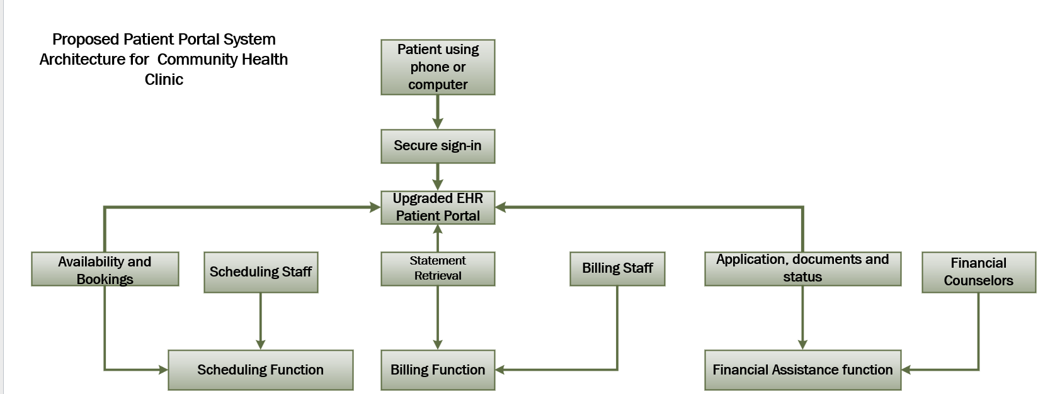

I created this diagram to illustrate the relationships among patients, secure sign-in, portal functions, and administrative staff.
Patients would access the portal through a phone or computer. After authentication, they could access scheduling, billing statements, or financial assistance.
The scheduling function would exchange appointment information with the scheduling system. The billing function would retrieve statements associated with the patient’s verified account. The financial-assistance function would route applications and supporting documents to a restricted counsellor work queue.
The design identifies the employees responsible for each service, connecting the technology proposal to operational ownership. These functions represent logical capabilities and do not necessarily require separate software products.

Patient Self-Service Workflow
Figure 2. Proposed Patient Self-Service Workflow
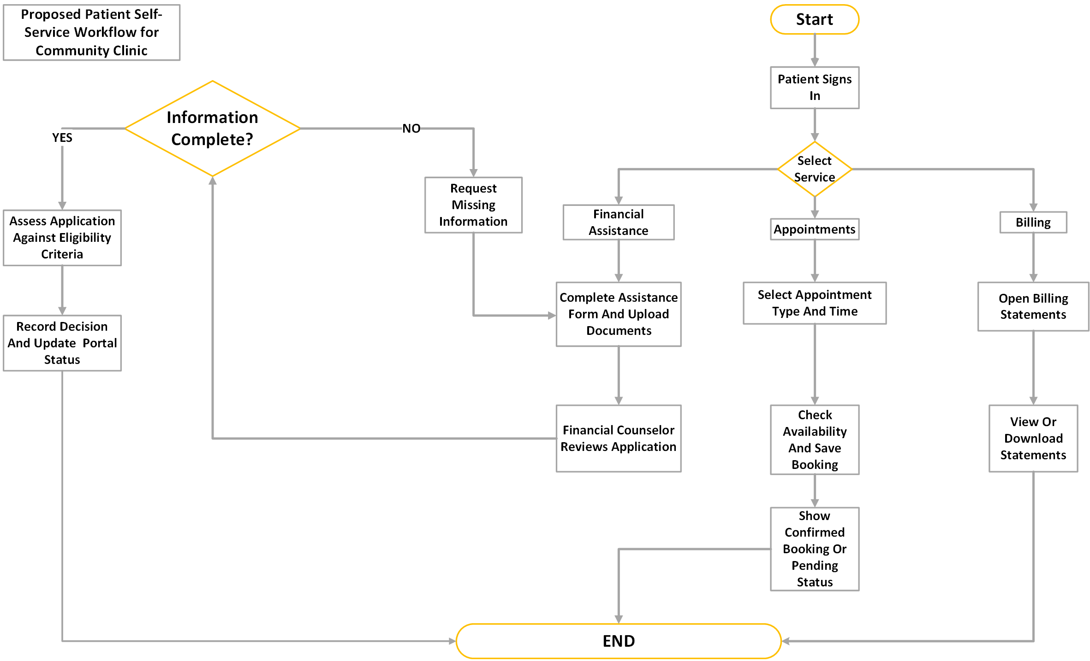

I mapped the three service paths to show how patients would complete tasks and how employees would manage reviews and exceptions.

Appointment Scheduling
The patient selects an appointment type and time. The system checks availability before saving the booking.
The patient receives confirmation only after the appointment is recorded. Requests requiring staff approval display a pending status. If the selected time is unavailable, the patient would need to choose another option.
This distinction helps prevent confusion between requesting an appointment and receiving a confirmed booking.

Billing Statements
The patient opens the billing area and views or downloads an available statement.
Billing employees remain responsible for resolving discrepancies and answering questions. Self-service statement access provides another way to obtain information while maintaining access to assistance.

Financial Assistance
The patient completes an application and uploads supporting documents. A financial counsellor reviews the submission for completeness.
If information is missing, the counsellor requests the required details or documents. The patient updates the application and resubmits the information for review.
Once the application is complete, the counsellor assesses it against the clinic’s eligibility rules, records the decision, and updates the portal status. Completing an application does not automatically mean approval.

Key Findings
- Financial assistance requires a complete review and follow-up workflow.
- Clear status information is essential for appointments and applications.
- Staff ownership remains necessary for exceptions, corrections, and decisions.
- Telephone, paper, and in-person alternatives should remain available.
Final Recommendation
I recommend evaluating an upgrade to the existing EHR patient portal before introducing another platform.
This approach could preserve familiar workflows and limit the need for additional interfaces. However, approval should depend on demonstrated capability, affordable total costs, reliable integration, accessibility, and appropriate security arrangements.
The vendor evaluation should demonstrate complete scenarios, including successful bookings, statement retrieval, application submission, missing-document requests, and status updates.
If the existing platform cannot meet a critical requirement, the third-party and hybrid approaches should be reconsidered using the same evaluation criteria.

Implementation Considerations
Important next steps would include confirming requirements with patients and employees, obtaining vendor demonstrations and quotations, assigning workflow owners, and testing information exchanges.
A phased pilot could introduce scheduling and statement access first, followed by financial assistance after the application and review process has been tested. The sequence would depend on confirmed capabilities and operational priorities.
Training and support should cover both routine tasks and exceptions, including account access problems, incomplete applications, booking conflicts, and service interruptions.

Expected Value and Success Measures
The proposed design could improve access to administrative services and help employees manage requests more consistently.
Because the solution has not been implemented, these are expected benefits rather than measured results.
Intended outcome | Potential measure
Fewer routine calls | Call volume by administrative service
Less paper processing | Number of mailed statements and paper applications
More efficient administration | Staff processing time per task
Easier application completion | Financial-assistance completion and resubmission rates
Improved self-service access | Successful task-completion rates
Better user experience | Patient and employee feedback
Baseline information would be needed before setting performance targets.

Limitations
The evaluation did not include live patient information, access to a production EHR, confirmed vendor capabilities, or validated pricing.
The diagrams communicate a conceptual design. Detailed interfaces, permissions, technical specifications, and exception handling would require further development and testing.
The project does not demonstrate achieved cost savings, reduced call volumes, or improved patient satisfaction.

What I Learned
This project strengthened my ability to connect business requirements to technology decisions. I considered how each option would affect daily work, integration, costs, and support responsibilities.
Creating the diagrams in Visio improved my process-mapping and visual communication skills. I practised organising activities, showing decision points, and connecting patient actions to employee responsibilities.
An important lesson was the difference between providing a feature and supporting a complete process. A document-upload feature may be useful, but financial assistance also requires instructions, review, follow-up, and a recorded decision.
The project reinforced the importance of separating assumptions from verified information. A recommendation becomes more useful when it clearly states what must be demonstrated before an organisation commits resources.

References
Office of the National Coordinator for Health Information Technology. (n.d.-a). Electronic health records. Health IT Playbook. https://playbook.healthit.gov/playbook/electronic-health-records/
Office of the National Coordinator for Health Information Technology. (n.d.-b). Promote health IT literacy. Patient Engagement Playbook. https://playbook.healthit.gov/playbook/pe/chapter-1/

