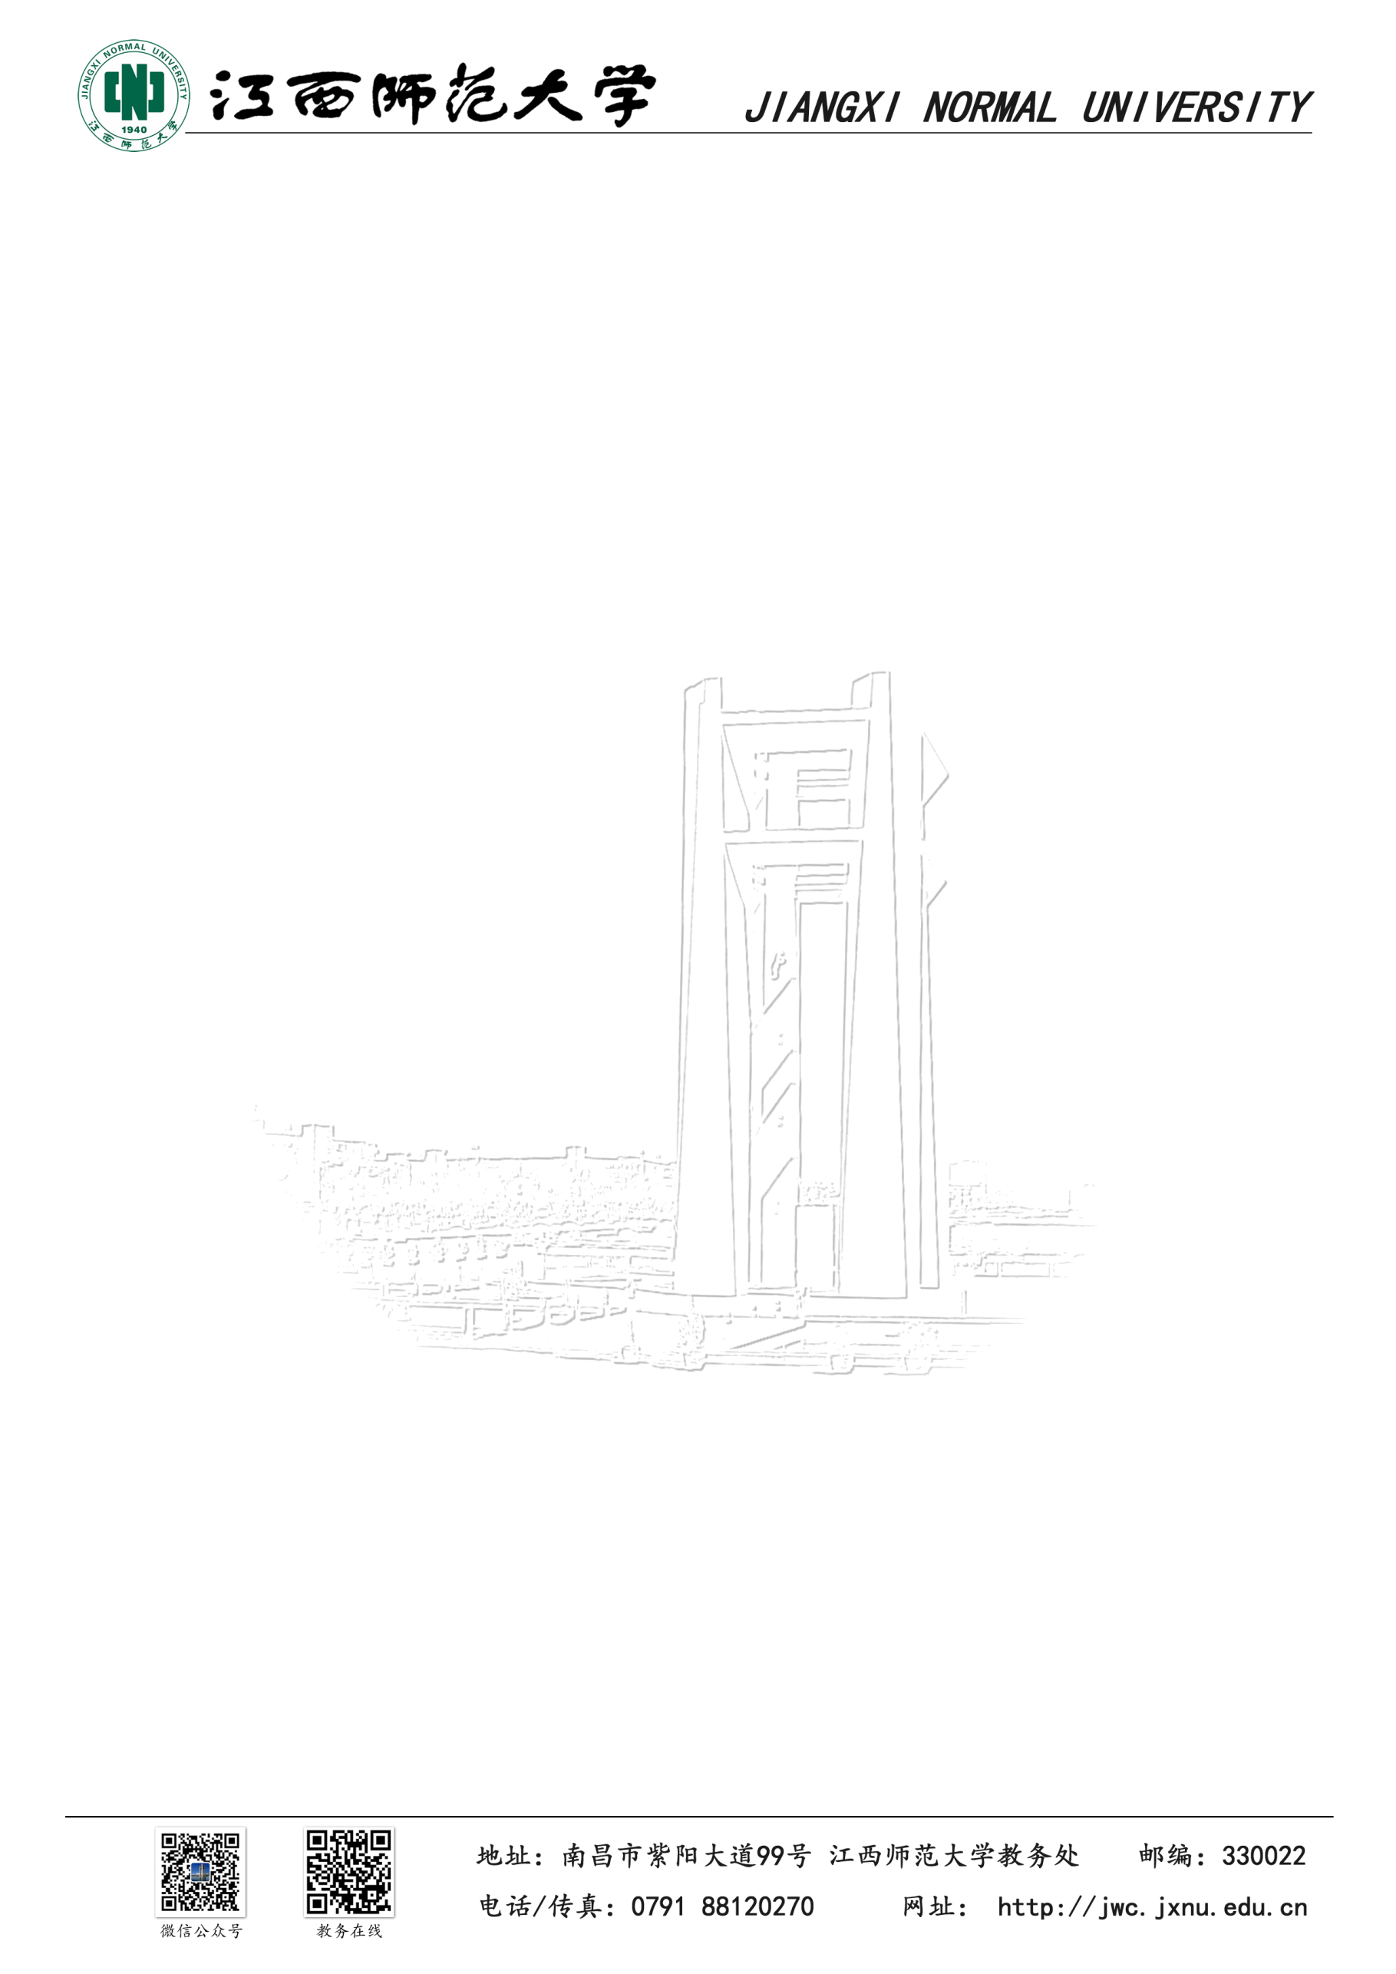
Contact Information: Date: April 23, 2026
YinKui Du
Professor, School of Artificial Intelligence
Jiangxi Normal University
Phone: [Tutor's Phone Number]
Email: [Tutor's Email Address]
To: Admissions Committee
Subject: Letter of Recommendation for Mr. Jie PAN

Dear Admissions Committee,

It is my distinct pleasure to recommend Jie PAN for admission to your graduate program. As a Professor at the School of Artificial Intelligence, Jiangxi Normal University, and a PhD from the Chinese Academy of Sciences, I have mentored Jie through our Undergraduate Tutorship System and supervised his leadership as the Head of the Engineering Software Development Centre.

Jie’s academic growth is exceptional. He ascended from a ranking of 5th in his freshman year to 1st in his sophomore year. His engineering proficiency is further evidenced by his First Prize in the 16th Lanqiao Cup (Web Development) and an Excellence Award in the National Finals. These achievements reflect his mastery of complex architectures and his persistent "problem-solver" mindset.

In my laboratory, Jie led several high-level AI projects. In a collaborative project with the University of Electronic Science and Technology of China (UESTC), he integrated Spring AI with the Tongyi Qianwen model to automate security risk reporting. Furthermore, his development of the "TCM-Intelligent-Inquiry" platform using RAG and Ollama demonstrates his ability to deploy large language models to solve domain-specific challenges.

Beyond technical skills, Jie is a natural leader. Serving as the Class Monitor and the Head of the Comprehensive Service Department, he successfully organized numerous campus activities and managed departmental operations under pressure. His combination of technical depth and leadership makes him an ideal fit for your innovative academic environment. I wholeheartedly support his application.

Yours sincerely,

[Signature Space]

YinKui Du
PhD, Chinese Academy of Sciences
Professor, School of Artificial Intelligence
Jiangxi Normal University

致：招生委员会
尊敬的招生委员会：
我非常荣幸推荐潘杰同学申请贵校的研究生项目。作为江西师范大学人工智能学院教授及中国科学院博士，我通过本科生导师制对他进行了直接指导，并监督其担任工程软件研发中心负责人期间的工作。

潘杰的学术表现极其优异，其专业排名从大一的第5名上升至大二的第1名 。他在第十六届蓝桥杯全国软件和信息技术专业人才大赛（Web应用开发）中荣获一等奖，这充分证明了他对复杂架构的掌控力与解决技术难题的毅力 。

在科研实践中，潘杰展现了深厚的技术底蕴。在与电子科技大学合作的项目中，他集成了 Spring AI 与大语言模型，实现了安全风险报告的自动生成 。同时，他利用 RAG 与 Ollama 技术开发的“中医智能问诊平台”，证明了他具备将 AI 前沿技术应用于实际场景的能力。

此外，潘杰具备卓越的领导力。作为班长及院综合服务部负责人，他展现了出色的部门统筹与抗压能力 。这种技术深度与领导才能的结合，使他能够完美适配贵校的学术环境。我毫无保留地向贵校推荐他。

诚挚地，
[推荐人姓名]
中国科学院博士、教授
江西师范大学人工智能学院

