**6.9. Go to a specific packet**

You can easily jump to specific packets with one of the menu items in the Go menu.

**6.9.1. The "Go to Packet" dialog box**

**Figure 6.10. The "Go To Packet" dialog box**

A description...

This dialog box will let you enter a packet number. When you press **OK**, Wireshark will jump to that packet.

A description...

Enter the packet number and it will display the requested packet:

A description...

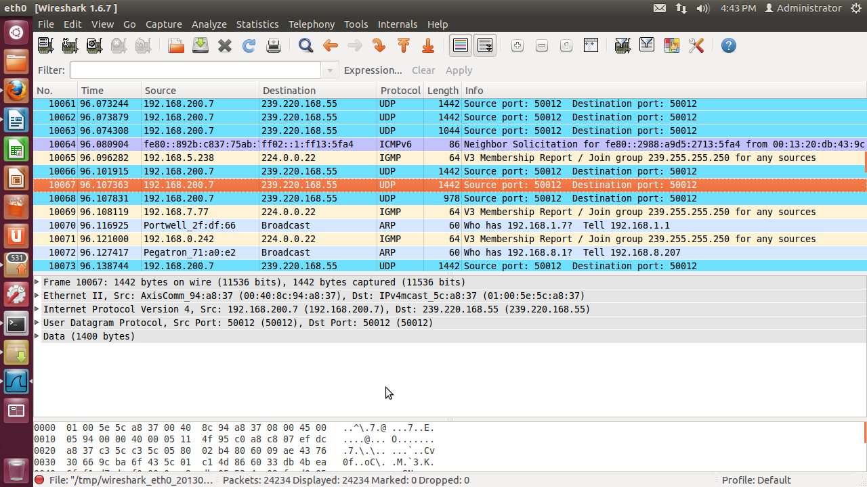

**6.9.1. The "Go Previous Packet" command**

Go back in the packet history, works much like the page history in current web browsers.

A description...

**6.9.2. The "Go Next Packet" command**

Go forward in the packet history, works much like the page history in current web browsers.

A description...

**6.9.4. The "Go to First Packet" command**

This command will simply jump to the first packet displayed.

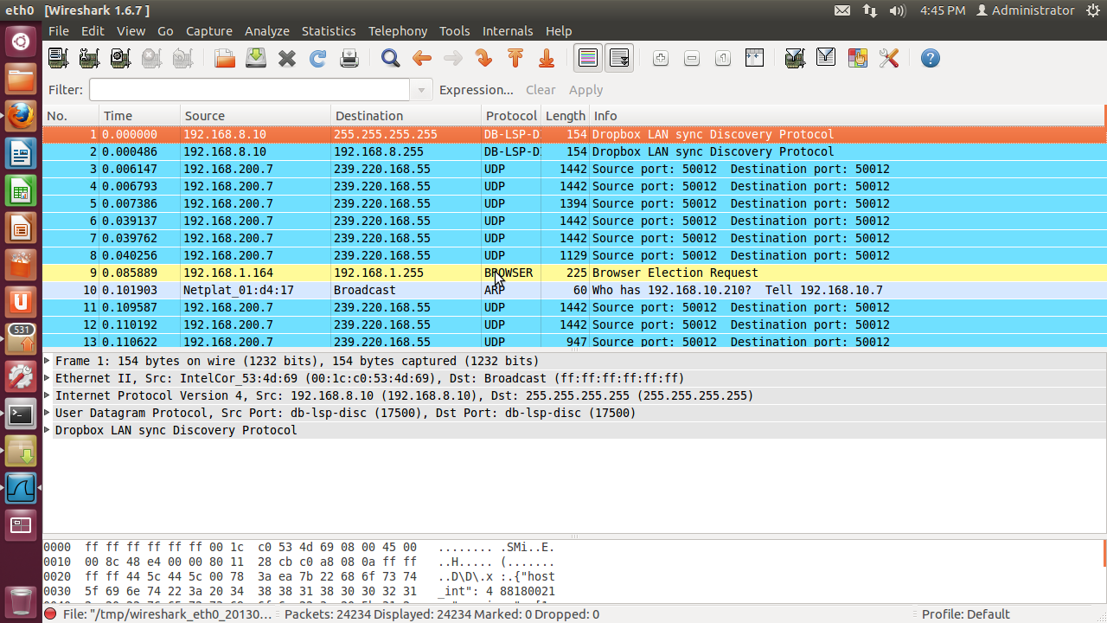

**6.9.5. The "Go to Last Packet" command**

This command will simply jump to the last packet displayed. 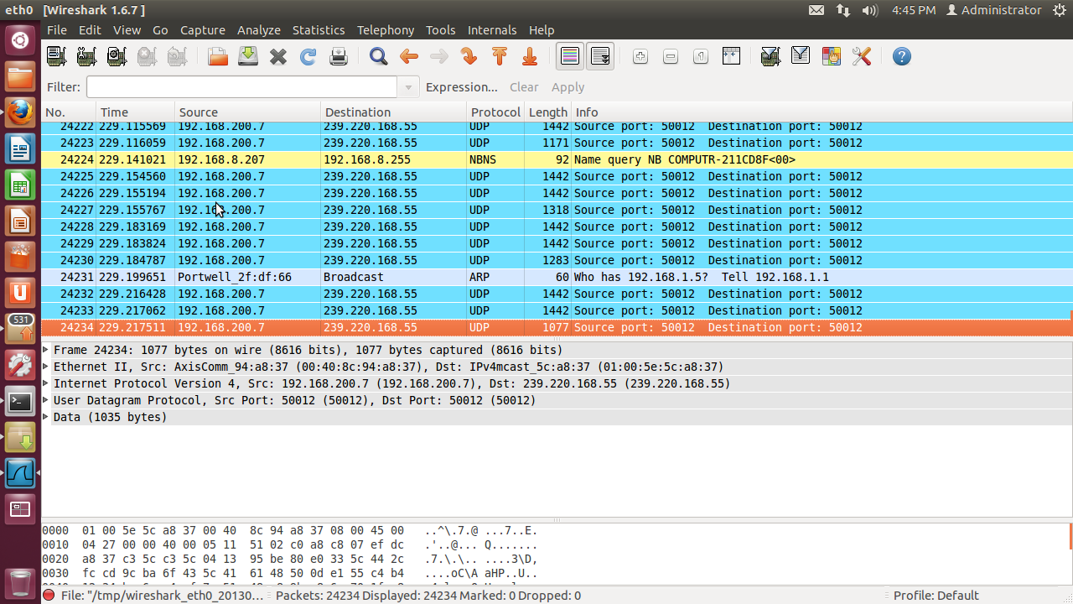

**6.9.6. The "Go to Previous Packet in conversation" command**

Go to the previous packet of the conversation (TCP, UDP or IP)

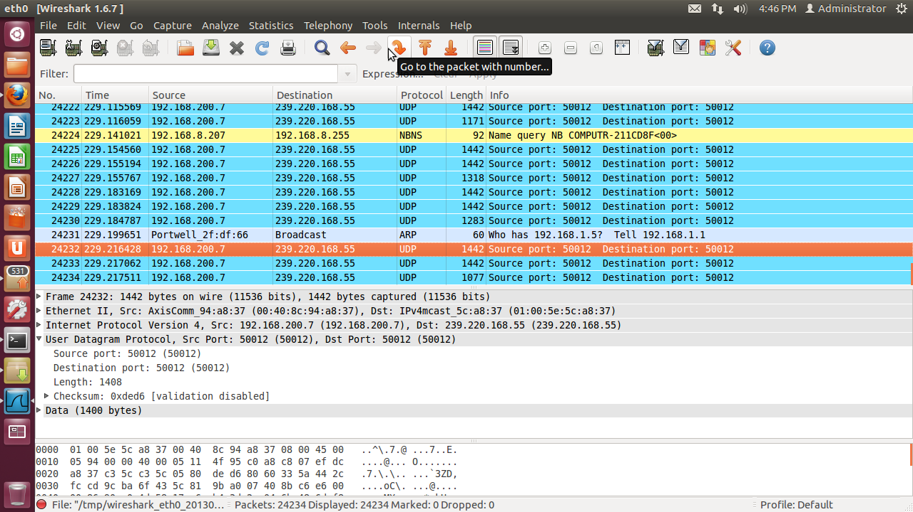

**6.9.6. The "Go to Next Packet in conversation" command**

Go to the next packet of the conversation (TCP, UDP or IP)

