AI Disclosure Form
Samsung PRISM Gen AI Hackathon 3.0
1. Team details
Team name | Procrastinators
Project / product name | Hybrid code retrieval (codeprism), Theme 1: Agentic Code Intelligence
Organization / institution | Vellore Institute of Technology, Vellore
Submission date | 30 Sept 2026
2. Was AI used in this project?
Yes
3. Purpose of AI usage
Purpose | Used | Notes
Idea generation | Yes | Choice of the hybrid design (dense + keyword + topic bonus), the versioned index, and the list of limits.
Code generation or assistance | Yes | All source code, tests, Dockerfile and scripts were written by the AI at the team's direction.
UI/UX design | No | There is no UI. The demo is a command line tool.
Content creation | Yes | README, presentation text and this disclosure were drafted by the AI.
Data analysis | Yes | The AI launched the benchmark on the team's own laptop at the team's direction and copied the scores from run_summary.json. It did not change or estimate any score.
Testing and debugging | Yes | The AI wrote the tests and fixed bugs it found while running them.
Other | Yes | The team picked the theme, chose the model and approved each benchmark run.
4. Feature origin classification
Feature | Query preprocessing and views
Origin | AI-Generated
Description and AI tool | Splits a question into a full view and a statement-only view without input/output sections; maps words like maximum to max. Tool: Claude (Anthropic), used through the Claude desktop app (Cowork and Claude Code).
Prompt (summary) | Build a retrieval pipeline for the CoIR apps task with pre and post processing of queries.
Output | codeprism/preprocess.py
Modification by team | Reviewed and tested by the team.

Feature | Topic lexicon (query and snippet categories)
Origin | AI-Generated
Description and AI tool | Hand written keyword lexicon of 13 topics used for a small score bonus. Tool: Claude (Anthropic), used through the Claude desktop app (Cowork and Claude Code).
Prompt (summary) | Use categorization of queries and snippets as one of the improvement ideas.
Output | codeprism/categories.py
Modification by team | Reviewed and tested by the team.

Feature | BM25 keyword search over code words
Origin | AI-Generated
Description and AI tool | BM25 on scipy sparse matrices; identifiers split into parts, plus comments and strings. Tool: Claude (Anthropic), used through the Claude desktop app (Cowork and Claude Code).
Prompt (summary) | Add a keyword pass beside the embedding model.
Output | codeprism/lexical.py
Modification by team | Reviewed and tested by the team.

Feature | Dense retrieval and score fusion
Origin | AI-Generated
Description and AI tool | Wraps a third party pretrained embedding model (BAAI/bge-small-en-v1.5, not written or trained by us) and fuses scores per query. Tool: Claude (Anthropic), used through the Claude desktop app (Cowork and Claude Code).
Prompt (summary) | Combine dense, keyword and topic scores in two passes.
Output | codeprism/embedders.py, codeprism/retriever.py
Modification by team | Reviewed and tested by the team.

Feature | MTEB adapter and evaluation script
Origin | AI-Generated
Description and AI tool | PrePostPipelineEncoder for MTEB and scripts/run_eval.py that writes appsretrieval_results.json. Tool: Claude (Anthropic), used through the Claude desktop app (Cowork and Claude Code).
Prompt (summary) | Make the pipeline scorable by the organizers' MTEB task.
Output | codeprism/mteb_model.py, scripts/run_eval.py
Modification by team | Run on the team's own laptop through Claude Code, at the team's direction.

Feature | Embedding cache and versioned index (P1, bonus)
Origin | AI-Generated
Description and AI tool | Hash based sqlite cache so only changed snippets are re-embedded; search one version or all versions. Tool: Claude (Anthropic), used through the Claude desktop app (Cowork and Claude Code).
Prompt (summary) | Handle index rebuilds per version and search across versions.
Output | codeprism/versioned.py
Modification by team | Reviewed and tested by the team.

Feature | Code chunker
Origin | AI-Generated
Description and AI tool | Python (ast) and JavaScript (brace matching) function level chunking. Tool: Claude (Anthropic), used through the Claude desktop app (Cowork and Claude Code).
Prompt (summary) | Split repos into function sized snippets with stable ids.
Output | codeprism/chunker.py
Modification by team | Reviewed and tested by the team.

Feature | Command line demo and sample repo
Origin | AI-Generated
Description and AI tool | Three versions of a small JavaScript voice assistant and a demo CLI. Tool: Claude (Anthropic), used through the Claude desktop app (Cowork and Claude Code).
Prompt (summary) | Make a demo that shows version aware search.
Output | codeprism/cli.py, demo/sample_repo/
Modification by team | Reviewed and tested by the team.

Feature | Tests, Dockerfile, README
Origin | AI-Generated
Description and AI tool | 19 offline tests, Dockerfile, pinned requirements, README. Tool: Claude (Anthropic), used through the Claude desktop app (Cowork and Claude Code).
Prompt (summary) | Make the project reproducible.
Output | tests/, Dockerfile, README.md
Modification by team | Reviewed and tested by the team.

Feature | Presentation
Origin | AI-Generated
Description and AI tool | Slides filled into the organizers' template. Tool: Claude (Anthropic), used through the Claude desktop app (Cowork and Claude Code).
Prompt (summary) | Build the submission deck from the template.
Output | Submission .pptx
Modification by team | Team to add names, links and final results.

Feature | Theme choice and project scope
Origin | Both
Description and AI tool | The team chose Theme 1 and asked for a CPU only, retrieval only solution. The AI proposed the design.
Prompt (summary) | Choose a theme and plan the submission.
Output | Decision
Modification by team | Team decision.

5. Ethical and compliance confirmation
[x] The AI use described here is complete to the best of our knowledge.
[x] No confidential data, personal data or third party proprietary code was given to the AI.
[x] The only external assets are open source libraries and a public pretrained model, listed in requirements.txt and the README.
[x] The team takes responsibility for the submission and can explain how it works.
(Team to tick each box after reading it.)
6. Declaration and sign-off
Representative name | Sudiksha Kathuria
Role | Team Leader
Signature | 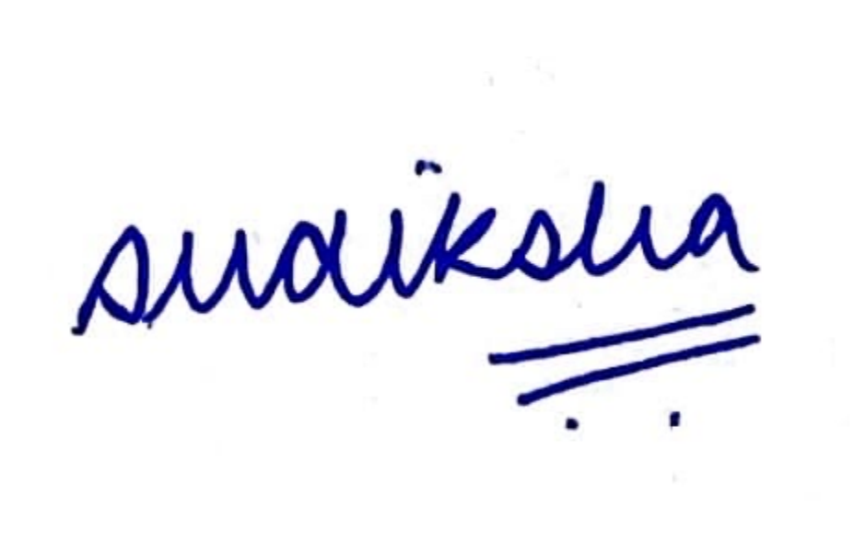
Date | 30 Sept 2026

