Pablo Arrighi  Senior Researcher in Quantum Computing | 9 rue Greneta, 75003 Paris  +33 611257467  pablo.arrighi@universite-paris-saclay.fr  https://lmf.cnrs.fr/Perso/PabloArrighi  French-Uruguayan, speaks French, Spanish, English, Java, C, Python, Ocaml.  Born on the 24th of August 1978, Paris 14th  3 children
ㅡ  Permanent positions | Inria-Saclay/Research Director (1st class)  2024–  Research at the LMF laboratory.  Head of the QuaCS (Quantum Computation Structures) EPC Inria team.  Univ. Paris-Saclay/Full Professor (1st class)  2020–2024  As above. Teaching ~220hrs/y. at the DI.  Univ. Aix-Marseille Univ./Full Professor  2014–2020  Research at the LIS laboratory. Teaching ~220hrs/y. at the DII.  Univ. Grenoble-Alpes/Maître de Conférences  2005–2014  Research at the LIG laboratory. Teaching ~200hrs/y. at IM²AG.
ㅡ  Research leaves | INRIA Saclay/Détachement INRIA  2023–2024  ENS Paris-Saclay/Délégation INRIA  2019–2020  Research at the LSV laboratory.  Univ. de Lorraine/Demi-délégation INRIA  2014  Research at the LORIA laboratory. Teaching ~100hrs at IM²AG.  ENS de Lyon/Délégation CNRS & établissement  2009–2011  Research at the LIP laboratory. Teaching ~12hrs at the DI.  Aarhus University, Denmark/EU Marie Curie Fellowship  Sept. 2002–Jan. 2003  PhD-level. Research at the DAIMI, in the BRICS institute.
ㅡ  Previous positions | Univ. Grenoble-Alpes/CNRS Post-doc  Jan. 2005–Sept. 2005  Research at the LIG laboratory.  Universidad de la República, Uruguay/Profesor Adjunto grado 3  Sept. 2004–Jan. 2005  Research and teaching ~20hrs at the Physics institute.  Univ. de Paris-Est/ATER  Sept. 2003–Sept. 2004  Research at the IGM institute, teaching ~100hrs at IUT.
ㅡ  Degrees | Univ. Grenoble Alpes/Habilitation à Diriger les Recherches  2009 (16.6.2009)  Title: Quantum cellular automata. Jury: Jens Eisert, Jozef Gruska, Jarkko Kari (reports), Jérôme Durand-Löse, Pascal Koiran, Reinhard Werner (members), Philippe Jorrand (president), Jacques Mazoyer (invited).  University of Cambridge, U.-K./PhD  2000–2003 (22.12.2003)  Research and teaching ~20hrs/y. at the Computer Lab.  Title: Representations of quantum operations with applications to quantum cryptography. Supervisor: Anuj Dawar. Jury: Adrian Kent, Rémy Mosseri. Viva : December 2003. Graduation: February 2004. Funded by Marconi & EPSRC.  Imperial College, London U.-K./Bachelor of Engineering  1997–2000  First class degree in Information Systems Engineering.  Lycée Saint-Louis/Mathématiques supérieures  1996–1997
ㅡ  Responsibilities | STAB of the Quanta Institute at AMU/Member of the committee  2026–  The Scientific and Training Advisory Board is composed of external scientific personalities and aims at providing the strategy of the Quanta Institute, which gathers the quantum activities of Aix-Marseille Université.  CoNRS Section 6/Member of the committee  2019–2021  The CoNRS, Section 6, is key to the scientific policy of CNRS in Informatics, e.g. selecting whom to recruit as a CNRS researcher, whom to promote, attributing the CNRS medals.  Quantum center of Saclay/Executive committee member  2020–  The center coordinates the French strategy for quantum technologies, in particular the QuantumEdu plan, at the scale of U. Paris-Saclay and Institut Polytechnique de Paris.  Center for Quantum Spacetime/Board member  2020–  The center gathers donations and manages grants in Quantum Gravity research, some at the interface with quantum information, e.g. QISS.  Bureau du Comité des Équipes Projet/Member  2024–  The BCEP evaluates the creation of new Inria and associated teams, as well as relationships with labs and doctoral schools.  Univ. Paris-Saclay/Head of the Master QDCS (Quantum and Distributed Computer Science)  2021–2023  Creation and promotion of the Master track, selection of the ~20 students, evolution of the teaching offer, managing internships, juries…  Univ. Paris-Saclay/Head of the 1nd year the MPRI (Parisian Research Master in Computer Science)  2020–2023  Promoting the Master track, selection of the ~12 students, evolution of the teaching offer, managing internships, juries....  Univ. Paris-Saclay/Head of the 2nd year Double-degree in Informatics Mathematics  2020–2021  Promoting the degree, selection of the ~50 students, evolution of the teaching offer, managing the juries.  Aix-Marseille Univ./Head of the 1st year in Informatics at Aix  2014–2018  Promoting the degree, welcoming the ~150 students, late admissions, handling particular cases, managing the juries.  U. Paris-Saclay/Graduate school of Computer Science elected council member  2021–  The GS structures the Master-level CS teaching offer at the scale of U. Paris-Saclay as a whole.  Computability in Europe/Bureau member, council member  2016–2017, 2017–2018  The international scientific society has a journal and a conference.  GdR IQFA/Founding member, bureau member  2010–2014  The national research network structures the French community in quantum information across all disciplines, organizing yearly colloquiums and spreading key information.  Selection committee member  2025 Assistant Prof. position at AMU  2024 Permanent researcher positions Inria Lyon  2023 Chaire d’excellence – AMU  2023 Assistant Prof. position at Télécom Paris – IPP  2023 Permanent researcher positions of Inria-Alpes and Inria Lyon  2019 Aix-Marseille Univ. for ATER  2008, 2009 ENS-Lyon for ATER  Lab seminar organization  2018–2020 LIS > Pôle calcul  2017 LIF  HCERES expert, evaluating:  Dec. 2018 LTCI laboratory  March 2010 Strategy of Ecoles des Mines de Nantes  June 2008 Research strategy of the Univ. of Mulhouse  Referee for grant making bodies  2025 Slovenian ARIS, Swiss SNSF, Luxembourgish FNR  2024 Chilean Fondecyt, Luxembourgish FNR  2023 Belgian FNR  2016, 2017, 2018 Grand-Est region via European Science Foundation  2018 SIRTEQ  2017 Grenoble QuEng PhD program & Chairs of excellence  2017 EU CHIST-ERA projects (twice)  May. 2010, Jul. 2012, March 2019, 2021, 2022 Belgian FNRS projects and recruitment  2016 Italian PRIN-CINECA projects  2011, 2014 Uruguayan ANII projects  Dec. 2009 Digitéo projects  Other expertise  2024 “Shepherd” for the creation of the EPC Inria team Phiqus  2022 “Shepherd” for the creation of the EPC Inria team Quriosity  2022 RIPEC C3 expert for three applicants
ㅡ  Scientific production | 42 international-level refereed journals including J. of Computer and Systems Sciences, Int. J. Found. of Computer Science, Mathematical Structures in Computer Science, Information and Computation, Logical Methods in Computer Science, Quantum Information Processing, New Journal of Physics, Quantum, Physical Review Letters.  31 international-level refereed conferences including ICALP, QIP, MFCS.  13 invited talks at international-level conferences.  3 book chapters.  Cf. up-to-date list.
ㅡ  Some major contributions  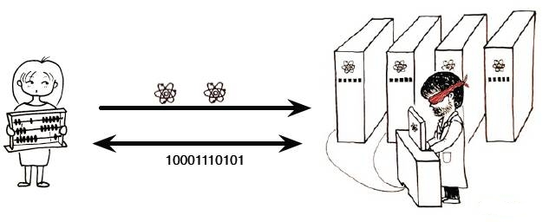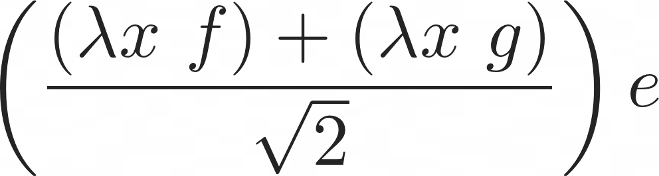    Espace  Lumière  Temps  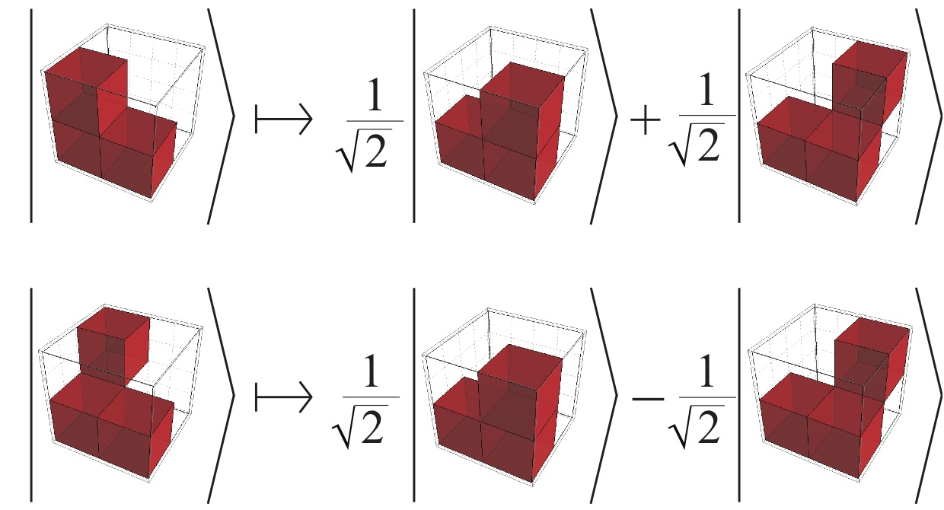  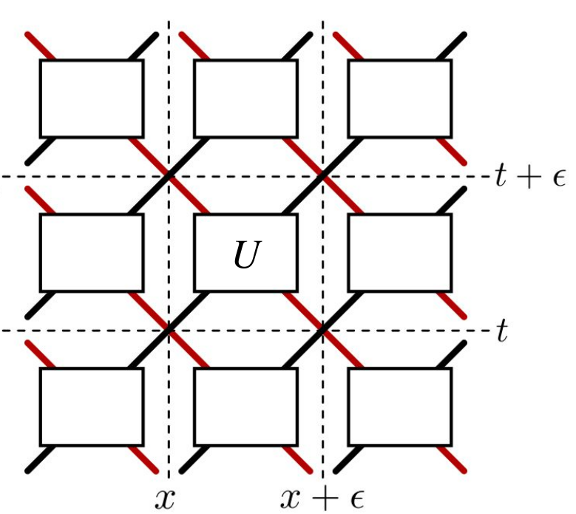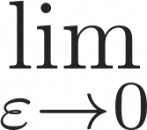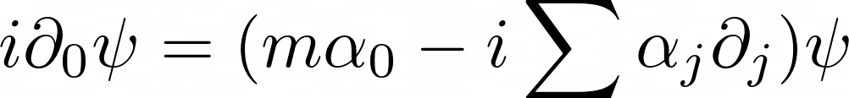  i.e. electrons.  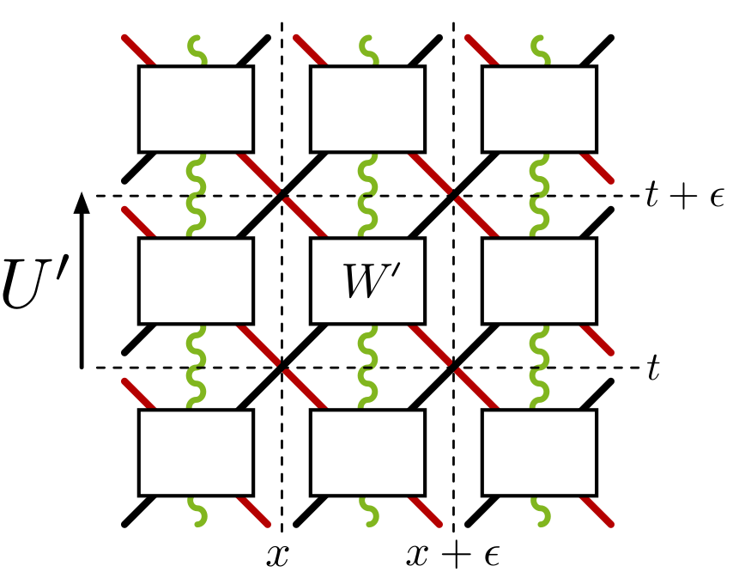  Interactions :  electrons +  photons.  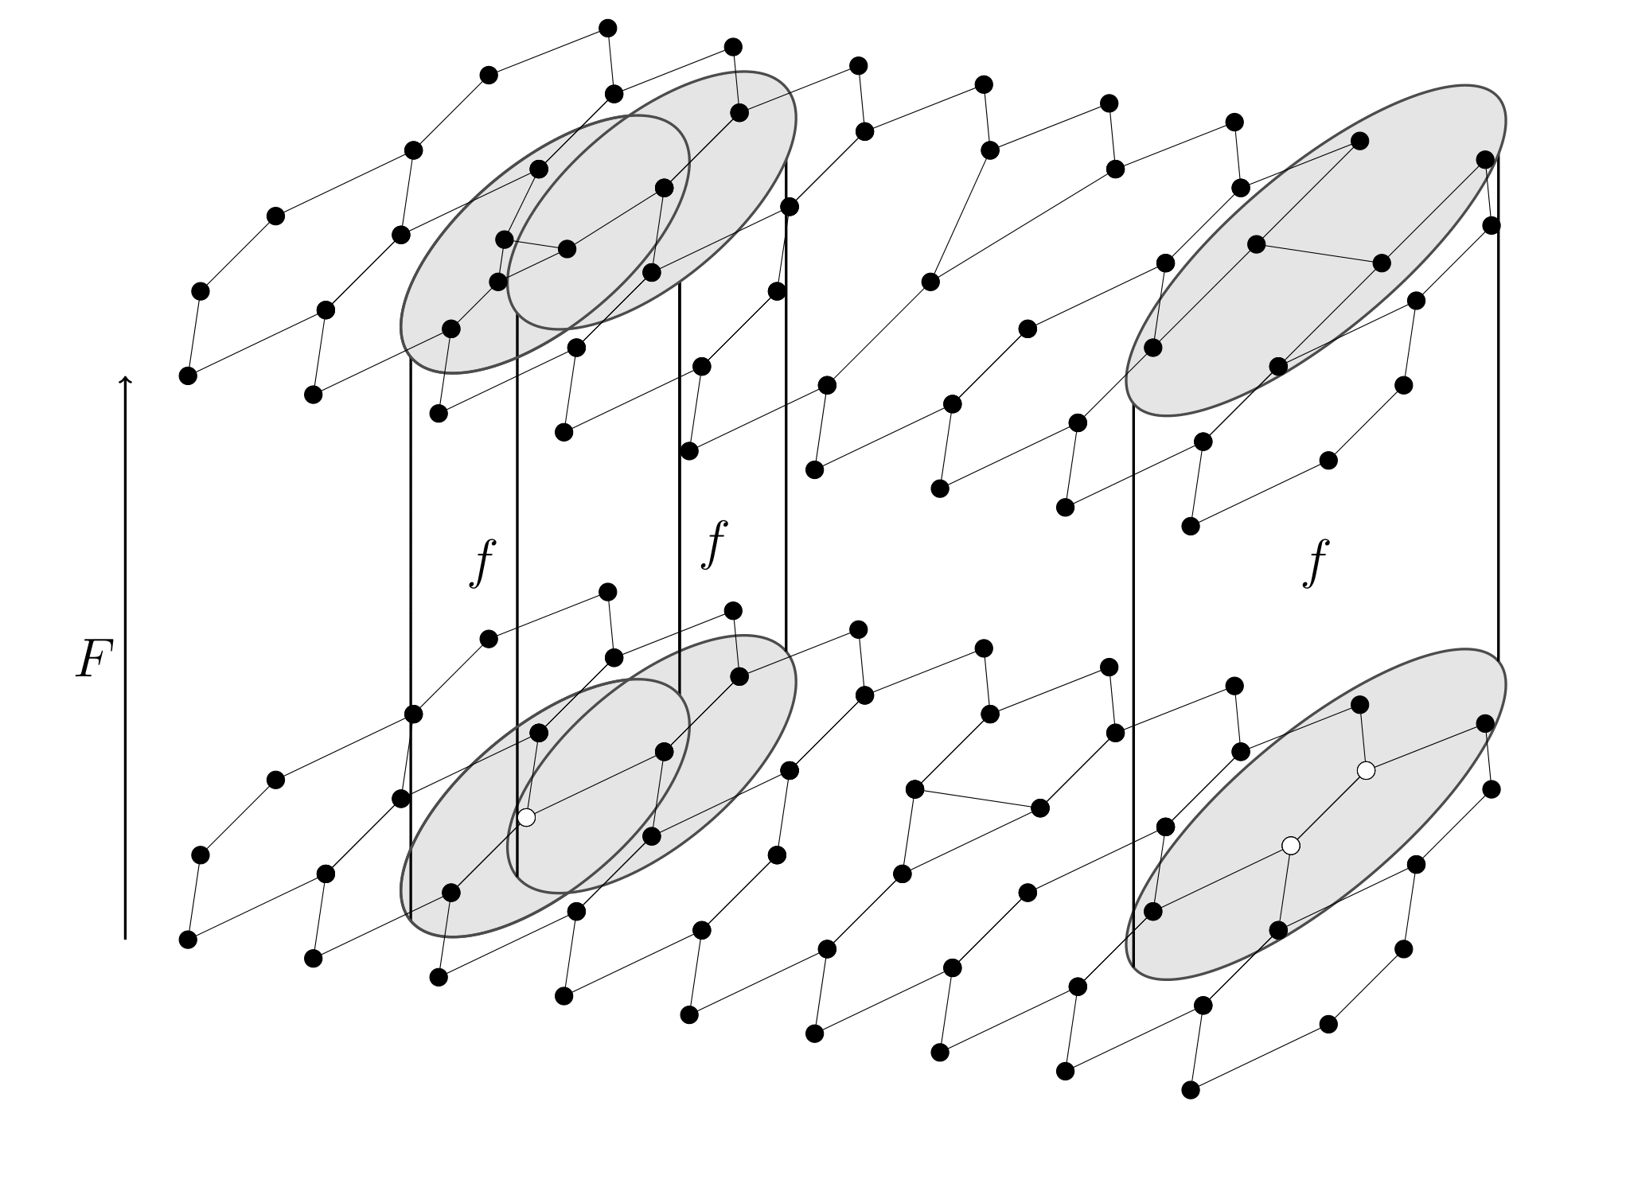  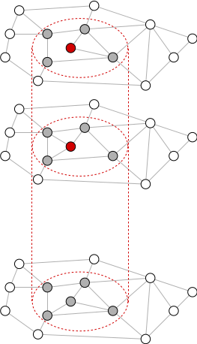  +  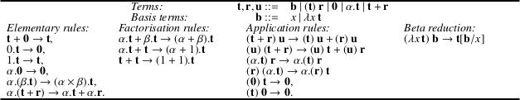 | Blind quantum computation. At a time when quantum cryptography research was focussing on the symmetric scenarios of secure-two-party computation and hitting the no-go result for unconditionally secure bit commitment, I was the first to shift the focus on the asymmetric scenario of “blind quantum computing”. My protocol offers an efficient, quantum alternative to the later discovered classical homomorphic encryption scheme. The topic has become a full-blown research topic and enjoyed experimental demonstration.  A structure theorem for discrete-time discrete-space quantum theory. We proved a general, mathematical physics theorem applicable to any quantum evolutions in discrete space, showing that these can always be represented by a finite-depth circuit of local quantum gates.  Proof of the Church-Turing thesis from quantum, physical hypotheses. Robin Gandy (Alan Turing’s PhD student) has proved the Church-Turing thesis from physical hypotheses. Indeed, a number of natural assumptions (homogeneity, causality, bounded density) entail that the evolution of any physical system must be computable. Based on the previous structure theorem, we generalised Gandy’s theorem to the quantum setting.  Universal quantum cellular automata. Focussing on the case where the discrete space is a grid leads to quantum cellular automata (QCA). We constructed minimal examples of intrinsically universal QCA, which are capable of simulating all other QCA in a spacetime-preserving manner, thereby contributing to export the Computer Science notion of universality, to the realm of Physics, including via popular science.  Quantum walks for simulating particles. Focussing on the one-particle case of QCA leads to quantum walks (QW). We proved in full rigour, using numerical analysis methods, that some QW converge towards the dynamics of real-life particles, such as the propagation of the electron— thereby providing very simple, algorithmic explanations of their behaviours, as well as quantum simulation algorithms for them. We showed that, surprisingly, QW can even simulate particles in curved spacetime, in spite of their fixed background grid.  Quantum cellular automata for simulating particles. Back to the many-particle case, we provided the first QCA model for real-life interacting particles, namely electrons and photons, a.k.a 3+1 quantum electrodynamics. We motivated our construction by proposing a discrete version of a fundamental symmetry of Physics, namely gauge symmetry, which turns out to be reminiscent of fault-tolerance in Computer Science. This opens the way for natively discrete formulations of quantum field theories, otherwise renowned for their ill-definedness.  Causal graph dynamics. We generalised the fundamental theorems of Cellular Automata theory, namely their topological characterization as continuous functions, and consequences, to causal dynamics over arbitrary bounded-degree time-varying graphs. We also generalised the block-decomposition theorem from Reversible Cellular Automata to Reversible Causal Graph Dynamics, and dealt with the intricate question whether reversibility forbids the local creation/destruction of nodes.  Quantum Causal graph dynamics. Extending the structure theorem to the quantum setting was particularly challenging, because it is no longer clear whom is next to whom, when two nodes may be in a quantum superposition of being connected, or not. We therefore had to generalise the standard concepts of locality, causality, and reduced density matrix to these quantum superpositions of topologies. We did so in a very satisfactory manner: all of the logical relations between these concepts are preserved.  Linear-algebraic λ-calculus and vectorial type systems. Whilst partly unexplained, it is clear that the algorithmic speed-up of Quantum Computation arises by tapping into the parallelism granted by the superposition principle. The idea of a vector space of computations arises quite naturally in this context. We designed the Linear-algebraic λ-calculus, merging higher-order computation, be it terminating or not, in its simplest and most general form (namely the untyped λ-calculus) with linear algebra in its simplest and most general form also (the oriented axioms of vector spaces we obtained beforehand), and proved its confluence. The language allows for quantum control structures, and superpositions in the order of application of functions. We devised vectorial type systems, where the term α.t+β.u has type α.T+β.U. We proved results such as subject reduction, strong normalization, the ability to check that a term normalizes to a probability distribution. The topic has become a full-blown research topic, including a breakthrough LICS paper by former co-authors, guaranteeing unitarity.
ㅡ  Research aims | Formal models of distributed quantum computation, towards quantum control structures.  Quantum cellular automata, quantum simulation algorithms and applications to theoretical physics.  Quantum networks theory, quantum rewriting and applications to theoretical physics.
ㅡ  Scientific recognition | Prizes  2024 Ranked 1st at the admissibility of the Inria Research Director external recruitment competition  2021 First class professor (PR1) on the national contingent (CNU 27)  2009–2017, 2020-2024 PEDR  2016 Prime d'Engagement pédagogique for this course.  2000–2003 Cambridge European Trust fellowship  2000–2003 Cambridgecourse Isaac Newton Trust fellowship  2002 European Union Marie Curie fellowship  2000 Psion Prize for the best final year project, on Automatic signature extraction for mimetic viruses  Editor  2023– Theoretical Computer Science  Program Committee  QPL 2026, QPL 2025, QSQW 2025, QPL 2024, QPL 2023, MCU 2022, UCNC 2021, QPL 2021, QPL 2020 (Chair), UCNC 2020, FCSD 2018, UCNC 2018, MCU 2018, New Worlds Comp. 2017, Phys. Comp. 2017, Phys. Comp. 2016, Phys. Comp. 2015, DCM 2013, four colloquiums of the GdR IQFA 2010-2014.  Organizer  Sept. 2027 Les Houches WOST School  Jul. 2026 Floc workshop Tribute to Gilles Dowek  Oct. 2024 EqiP yearly meeting (~60 pers., Paris-Saclay)  Jul. 2021 Automata 2021 & WAN (~100 pers., AMU)  Jun. 2020 QPL Quantum Physics and Logics (~150 pers., Paris-Saclay)  Jun. 2020 MFPS Mathematical Foundations of Programming Semantics (~60 pers., Paris-Saclay)  Apr. 2016 JIQ GdR-IM GT-IQ Days (~30 pers., Marseille)  Jun. 2012 Foun. QI 2 (~40 pers., Grenoble, UCNC satellite).  Jun. 2009 Foun. QI (~40 pers., Grenoble)  May 2007 Atelier Information et communication quantique (~60 pers., Aspet)  Habilitation à Diriger les Recherche/Jury member  Jan. 2025 Marco Túlio Quintino (Sorbonne Université)―report  Jun. 2020 Giuseppe Di Molfetta (Institut Néel, Grenoble)―président.  Oct. 2019 Cyril Branciard (Institut Néel, Grenoble)―président.  2021 HDR tutor for Benoît Valiron (LMF, Paris-Saclay)  2020 HDR tutor for Nathalie Aubrun (LISN, Paris-Saclay)  PhD/Written report and jury member  Avr. 2026 Maarten Grothus (U. Grenoble-Alpes)  Mar. 2023 Matteo Luigi (U. of Pavia)  Nov. 2022 Nicola Pinzani (Oxford U.)  Jan. 2022 Hippolyte Dourdent (Institut Néel, Grenoble)  Oct. 2021 Emmanuel Emeriau (Sorbonne U.)  Mar. 2020 Julian Wechs (Institut Néel, Grenoble)―président.  Jan. 2018 Marco Erba (U. of Pavia)  Sept. 2017 Pablo Arnault (Sorbonne U.)  Oct. 2015 Michele Avalle (UCL, London)  July 2015 Giuseppe Di Molfetta (UPMC, Paris)  Oct. 2014 Franco Manessi (U. of Pavia)  Sept. 2013 Anne Marin (LTCI, Telecom Paris)  Dec. 2009 Ph.D. Thesis of Ludovic Arnaud (LPT, Toulouse)  PhD/Jury member (discounting my own students)  June 2025 Julien Zylberman (Sorbonne U.)  Dec. 2023 Aurélien Emmanuel (U. d’Orléans)  Dec.. 2022 Alexandre Fernandez (UPEC)―président.  Nov. 2022 Kevissen Selapillay (AMU)  Sept. 2021 Hugo Perrin (Sorbonne U.)  Jan. 2018 Barbara De Palma (U. of Pavia)  Jan. 2018 Luca Montavi (U. of Pavia)  Jan. 2018 Nicola Mosco (U. of Pavia)  Mar. 2013 Zizhu Wang (LTCI, Paris)  Referee  For ICALP, LICS, RTA, TCS, MFCS, CONCUR, JCSS, LAA, Nat. Comms etc.  Selected research invitations  22/04/2024–27/04/2024 CBPF Rio, LNCC Petrópolis, Brésil, by Profs. Fernando de Melo and Renato Portugal.  6/11/2023–1/12/2023 UBA Argentina, UdelaR, Uruguay, UniAndes, Colombia, by Profs. Alejandro Díaz-Caro & Andrés Reyes  24/01/2022–27/01/2022 IQOQI, Vienna, Austria, by Prof. Caslav Brukner  9/05/2022–12/05/2022 U. of Pavia by Prof. Paolo Perinotti  21/03/2022–25/03/2022 Oxford U. & Cambridge U., UK  24/06/2019–26/06/2019 Morelia, Mexico, by Prof. Robert Oeckl  27/02/2017–2/3/2017, Valencia, Spain by Prof. Armando Pérez  21/08/2016–26/08/2016, Hannover, Germany by Prof. Reinhard Werner  27/02/2015–26/03/2015 Montevideo, Uruguay by Prof. A. Romanelli  27/3/2014–29/3/2014 Hannover, Germany by Prof. Reinhard Werner  9/12/2013–13/12/2013 Beijing, China by Prof. Giulio Chiribella  For invitations to international, non-refereed workshops, see here.
ㅡ  Scientific diffusion | Popular science, see an up-to-date list.  4 articles in Physics World, Cosmos, La Recherche (2), Programmez.  3 book chapters e.g. in Current Trends in Theoretical Computer Science  5 columns on my work in New Scientist, Pour la Science, MIT Technology review and APS Physics.  1 interview France Info.  1 podcast RDV Tech.  2 round-table discussion at industrial congress Systematic and at the Argentinian Ministry of Science.  2 popular science talks e.g. for CS high school teachers or at La commanderie.  6 Philosophy of science seminars including at ENS Ulm; La Sorbonne; Cerisy-la-Salle.  Created and organised the reception of ~100/y. high school students for a half-day long practical programming class at Aix-Marseille Univ., supervised by our best L2-L3 students, and followed by a coffee break discussing university life.  2015–2019  Weekly programming club at the International school of Lyon.  2018–2019
ㅡ  PhD supervisions | Aymane Maaitat on Feynman path integrals and quantum automata.  2025–  Seonghun Jung on Causal decompositions of quantum processes..  2025–  Dogukan Bakircioglu on Quantum simulation of quantum field theories.  2023–  Octave Mestoudjian on Generalised subsystems for quantum theory.  2023–  Marin Costes on Quantum networks theory.  2022–2025  Nicolas Heurtel on Measurement-based quantum computing for photonics at Quandela (CIFRE).  2022–2025  Amélia Durbec on Reversible and quantum causal graph dynamics, currently a postdoc in Lille.  2018–2022  Nathanaël Eon on Gauge-invariant quantum cellular automata.  2019–2022  Ivan Marquez (co-supervised with U. Valencia) on Quantum walks: background geometry and gauge invariance.  2017–2019  Alejandro Diaz-Caro, now a Lecturer at U. de Quilmes, and a CONICET researcher at UBA, Argentina.  2008–2011  Simon Martiel (co-directed with Bruno Martin), JTF Turing Scholar prize winner, now a researcher at IBM Quantum.  2012–2015  Marcelo Forets, now Lecturer at UTEC, Uruguay.  2012–2015  Administrative supervisor for Louis Lemonnier (effective supervisor B. Valiron), 2021-2024, Kostia Chardonnet (effective supervisor B. Valiron), 2020-2022, Jérôme Javelle (effective supervisor S. Perdrix), 2011–2014, David Cattanéo (effective supervisor S. Perdrix), 2012–2017  Master 2 thesis supervisor for many students including  Aurélien Emmanuel (ENS-Ulm), now a PhD student at LIFO.  2016–2017  Zizhu Wang, now a Lecturer at IFFS, University of Electronic Science and Technology of China  2006–2007
ㅡ  Collaborative networks & grants | Quantum Information Structure of Spacetime/JTF Large grant  2020–2023, 2023–2025  Initiated, and composed this 18 sites international consortium made of the top researchers, worldwide, on the question of the interaction between quantum information and quantum gravity. The 2M$+4M$ grant is managed by the board of this center, of which I am a member. We will have shared postdocs and three colloquiums.  Causality in Quantum Information/ANR Young Researcher, PI  2010–2014  This grant shared with Simon Perdrix and Mehdi Mhalla was key to the recognition of the Quantum Computation activity in Grenoble.  International grants/Leader  2012–2015 Coordinator of Simon Martiel's JTF Turing prize  2008–2010 Work Package 4 of Foundational structures in Quantum Information and Computation, an EU FP6 FET STREP OPEN project.  The EU QICS project, coordinated by U. of Oxford, had a long lasting impact, establishing long-lasting collaborations between partners, e.g. with Prof. Reinhard Werner of U. of Hannover in my case.  International networks grants/Member  2025–2026 EU STIC-Amsud QComical with Italy, Argentina, Uruguay  2018–2021 France-Spain PICS project with U. of Valencia  2018–2020 ECOS-Sud Quantum Calculi with Argentina  2016–2018 Stic-Amsud Foundations of Quantum Computation : Syntax and Semantics with Argentina  National networks grants/Member  2022–2025 ANR CPJ « QuantPhy » (PI)  2022–2025 ANR TaQC « Taming Quantum Causality »  2019–2021 ANR JCJC Quantum Machine Learning at LIS  2018 PEPS Infiniti Lattice Quantum Simulation Theory with UPMC  2012–2016 ANR Theory of AlgoRithms: Machines, completeness, Axiomatization and physical Constraints with UPEC  2005–2006 Machines quantiques abstraites BQR UGA  CNRS research networks/Member  GdR IQFA, GdR IM > GT Quantum Information, Computability, SDA2
ㅡ  Industry contracts & software development | CIFRE PhD thesis with Quandela/Supervisor  2022–2025  Together with Benoît Valiron and Shane Mansfield as co-supervisors, PhD student Nicolas Heurtel is working on measurement-based quantum computing for photonics, developing a dedicated programming language with proper semantics, so that optimization can be done rigorously.  CFSSI-ANSSI/Practice of information systems security audits  February 2019 Followed the one week intensive course 8b.  Atos-Fourier prize/Jury member  June 2018 See here.  DGA-REI contract/Leader  16 months, 2009–2010  This grant is now called ANR Astrid. I employed two software engineers full-time, at Floralis developing an implementation of a higher-order process algebra, aiming at a transfer of technology for the DGA.  Crédit Impôt Recherche/Expert  2006–2008  Evaluation of private sector research entitling to tax reductions, 3 companies.  Free software projects/Leader  2019 Logic Gate  2017–2018 PyRobots  2015–2017 LateX Dragon  2009–2017 GOOL, white paper at the ICOOOLPS conference  2011–2017 Secure eXchange Protocols (SXP), see wiki  These were developed mainly by generations of Master students and interns under my guidance. The last two enjoyed support from the development team of the Archimede Labex. LogicGate and GOOL are quite mature and could be put into production by anyone willing; the others are advanced prototypes.
ㅡ  Teaching > graduates | Research schools/Master & PhD level  2019 Computación Cuántica y física digital (ECI 2019, UBA, Argentina)  2016 Models of Quantum Computation (CNRS-EJCIM 2016, Strasbourg)  2010 Quantum Automata, machines, calculi (QICS School, U. of Oxford)  2009 Physics-like models of computation (ER04, ENS de Lyon)  2007–2008 Introduction to theoretical physics (UGA, ED MSTII)  2005 Graphs and quantum computation (UGA, ED MSTII)  Responsibilities/Master level  2021–2023 Co-head of M1 & M2 QDCS, ~30 students/y. (UPSaclay)  2020–2023 Head of M1 MPRI, ~15 students/y. (UPSaclay)  2014–2019 Software engineering, ~100 students/y. (AMU)  2007–2014 Compiler project, ~30 students/y. (M1, UGA)  2006–2009 Internships, ~90 students/y. (M1, UGA)  Courses/Master level  2020–2023 Found. of quantum information ~30 students/y. (M1, UPSaclay)  2020–2023 Elements of CS for quantum technologies. ~30 students/y. (M1.5, ENS PSaclay)  2020–2023 Introduction to research ~10 students/y. (M1, ENS PSaclay)  2020–2023 Func. programming (M1, Polytech PSaclay)  2014–2020 Models of Natural Computing (M2, AMU)  2018–2019 Quantum computation (M1, AMU)  2018–2019 Computer security watch (M2, AMU)  2007–2009 Firewalls (M1 Practicals, UGA)  2007–2009 Object Oriented Programming (M2, UGA)  2007–2009 Quantum cryptography (M2, UGA)  2007–2008 Quantum computation (M2, UGA)  2005–2007 Computer security (M2, UGA)  2004 Quantum computation (M1 & M2, U. de la Rep., Uruguay)  2000–2003 Computability theory (M2 supervisions, U. of Cambridge)
ㅡ  Teaching > undergraduates | Responsibilities/Undergraduate level  2020–2023 Advanced functional prog., ~100 students/y. (L3, UPSaclay)  2020–2021 Head of LDD2 Informatics, Mathematics, ~80 students (L2, UPSaclay)  2018–2019 Informatics in practice, ~700 students/y. (L1, AMU)  2017–2019 Examiner for the FUF admissions of Ecole Polytechnique  2015–2019 Programming class for ~100 high school students/y. (AMU)  2014–2018 Head of the 1st year in Informatics at Aix, ~150 students/y. (L1, AMU)  Courses/Undergraduate level  2020–2023 Functional prog., ~50 students/y. (M1, UPSaclay-Polytech)  2005–2009, 2011–2018 Unix and C (L1, UGA & AMU).  2011–2014 Algorithmics and the web (L1, UGA)  2005–2010 Languages and Automata (L2, UGA)  2006–2009 Logics (L1, UGA)  2004 Algorithmics (L1, IUT of UPEM)  2004 Databases (L2, IUT of UPEM)  2004 Unix (L1, IUT of UPEM)

