Pablo Arrighi  Senior Researcher in Quantum Computing — Scientific Advisor | +33 611257467  pablo.arrighi@universite-paris-saclay.fr  https://lmf.cnrs.fr/Perso/PabloArrighi  French-Uruguayan, speaks French, Spanish and English.
ㅡ  Degrees | Univ. Grenoble Alpes/Habilitation à Diriger les Recherches  2009  Title: Quantum cellular automata.  University of Cambridge, U.-K./PhD  2000–2003  Title: Representations of quantum operations with applications to quantum cryptography  Imperial College, London U.-K./Bachelor of Engineering  1997–2000  First class degree in Information Systems Engineering.
ㅡ  Permanent positions | Inria-Saclay/Research Director (1st class)  2024–  Research at the LMF laboratory.  Head of the QuaCS (Quantum Computation Structures) EPC Inria team.  Univ. Paris-Saclay/Full Professor (1st class)  2020–2024
ㅡ  Evaluation & Advisory Experience | STAB of the Quanta Institute at AMU/Member of the committee  2026–  The Scientific and Training Advisory Board is composed of external scientific personalities and aims at providing the strategy of the Quanta Institute, which gathers the quantum activities of Aix-Marseille Université.  CoNRS Section 6/Member of the committee  2019–2021  The CoNRS, Section 6, is key to the scientific policy of CNRS in Informatics, e.g. selecting whom to recruit as a CNRS researcher, whom to promote, attributing the CNRS medals.  Quantum center of Saclay/Executive committee member  2020–  The center coordinates the French strategy for quantum technologies, in particular the QuantumEdu plan, at the scale of U. Paris-Saclay and Institut Polytechnique de Paris. Its ecosystem includes startups such as Quandela and Pasqal.  Bureau du Comité des Équipes Projet/Member  2024–  The BCEP evaluates the creation of new Inria and associated teams, as well as relationships with labs and doctoral schools.  Selection committee member  2025 Assistant Prof. position at AMU  2024 Permanent researcher positions Inria Lyon  2023 Chaire d’excellence – AMU  2023 Assistant Prof. position at Télécom Paris – IPP  2023 Permanent researcher positions of Inria-Alpes and Inria Lyon  2019 Aix-Marseille Univ. for ATER  2008, 2009 ENS-Lyon for ATER  GdR IQFA/Founding member, bureau member  2010–2014  The national research network structures the French community in quantum information across all disciplines, organizing yearly colloquiums and spreading key information.  HCERES expert, evaluating:  Dec. 2018 LTCI laboratory  March 2010 Strategy of Ecoles des Mines de Nantes  June 2008 Research strategy of the Univ. of Mulhouse  Referee for grant making bodies  2025 Slovenian ARIS, Swiss SNSF, Luxembourgish FNR  2024 Chilean Fondecyt, Luxembourgish FNR  2023 Belgian FNR  2016, 2017, 2018 Grand-Est region via European Science Foundation  2018 SIRTEQ  2017 Grenoble QuEng PhD program & Chairs of excellence  2017 EU CHIST-ERA projects (twice)  May. 2010, Jul. 2012, March 2019, 2021, 2022 Belgian FNRS projects and recruitment  2016 Italian PRIN-CINECA projects  2011, 2014 Uruguayan ANII projects  Dec. 2009 Digitéo projects  Other expertise  2024 “Shepherd” for the creation of the EPC Inria team Phiqus  2022 “Shepherd” for the creation of the EPC Inria team Quriosity  2022 RIPEC C3 expert for three applicants
ㅡ  Industry Engagement | CIFRE PhD thesis with Quandela/Supervisor  2022–2025  Together with Benoît Valiron and Shane Mansfield as co-supervisors, PhD student Nicolas Heurtel is working on measurement-based quantum computing for photonics, developing a dedicated programming language with proper semantics, so that optimization can be done rigorously.  Atos-Fourier prize/Jury member  June 2018 See here.  DGA-REI contract/Leader  16 months, 2009–2010  This grant is now called ANR Astrid. I employed two software engineers full-time, at Floralis developing an implementation of a higher-order process algebra, aiming at a transfer of technology for the DGA.  Crédit Impôt Recherche/Expert  2006–2008  Evaluation of private sector research entitling to tax reductions, 3 companies.
ㅡ  Some major contributions  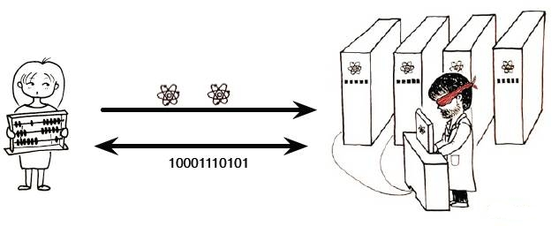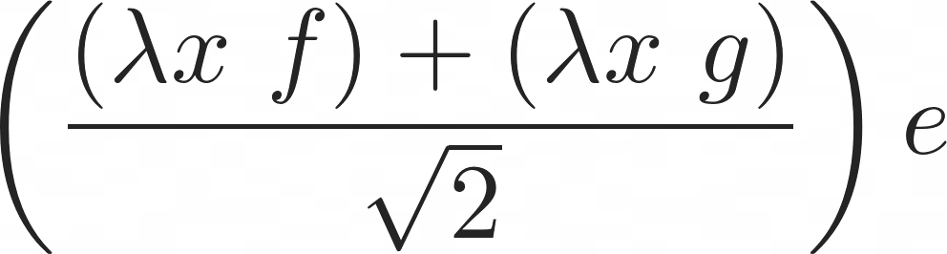  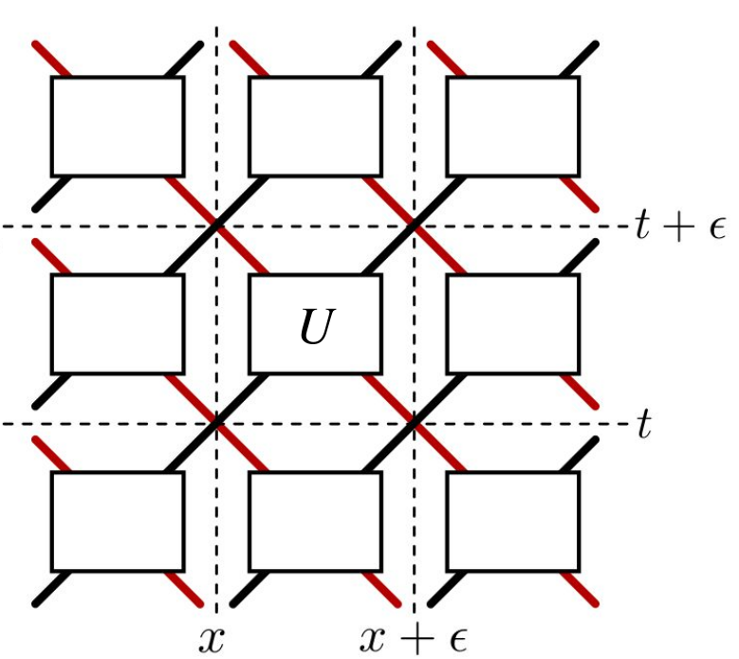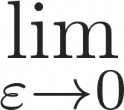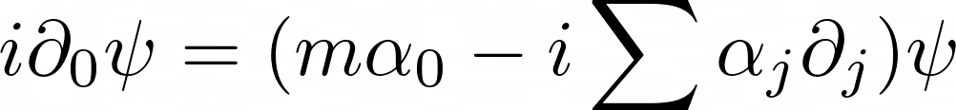  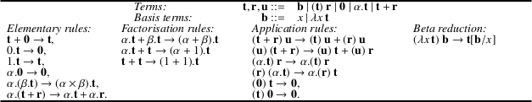 | Blind quantum computation. At a time when quantum cryptography research was focussing on the symmetric scenarios of secure-two-party computation and hitting the no-go result for unconditionally secure bit commitment, I was the first to shift the focus on the asymmetric scenario of “blind quantum computing”. My protocol offers an efficient, quantum alternative to the later discovered classical homomorphic encryption scheme. The topic has become a full-blown research topic and enjoyed experimental demonstration.  Quantum walks for simulating particles. QW are discrete-time discrete-space unitary evolutions driving the propagation of a particle. They constitute numerical schemes to be run on quantum computers. We proved in full rigour, using numerical analysis methods, that some QW converge towards the dynamics of real-life particles, such as the propagation of the electron— thereby providing very simple, algorithmic explanations of their behaviours, as well as quantum simulation algorithms for them. The topic is a very active field of research, and we are leading the shift towards multi-particle quantum simulation.  Linear-algebraic λ-calculus and vectorial type systems. Whilst partly unexplained, it is clear that the algorithmic speed-up of Quantum Computation arises by tapping into the parallelism granted by the superposition principle. The idea of a vector space of computations arises quite naturally in this context. We designed the Linear-algebraic λ-calculus, merging higher-order computation, be it terminating or not, in its simplest and most general form (namely the untyped λ-calculus) with linear algebra in its simplest and most general form also (the oriented axioms of vector spaces we obtained beforehand), and proved its confluence. The language allows for quantum control structures, and superpositions in the order of application of functions. We devised vectorial type systems, where the term α.t+β.u has type α.T+β.U. The topic has become a full-blown research topic.
ㅡ  Scientific production | 42 international-level refereed journals including J. of Computer and Systems Sciences, Int. J. Found. of Computer Science, Mathematical Structures in Computer Science, Information and Computation, Logical Methods in Computer Science, Quantum Information Processing, New Journal of Physics, Quantum, Physical Review Letters.  31 international-level refereed conferences including ICALP, QIP, MFCS.  13 invited talks at international-level conferences.  3 book chapters.  Cf. up-to-date list.
ㅡ  Scientific recognition | Prizes  2024 Ranked 1st at the admissibility of the Inria Research Director external recruitment competition  2021 First class professor (PR1) on the national contingent (CNU 27)  2009–2017, 2020-2024 PEDR  2016 Prime d'Engagement pédagogique for this course.  2000–2003 Cambridge European Trust fellowship  2000–2003 Cambridgecourse Isaac Newton Trust fellowship  2002 European Union Marie Curie fellowship  2000 Psion Prize for the best final year project, on Automatic signature extraction for mimetic viruses  Editor  2023– Theoretical Computer Science
ㅡ  Scientific diffusion | Popular science, see an up-to-date list.  4 articles in Physics World, Cosmos, La Recherche (2), Programmez.  3 book chapters e.g. in Current Trends in Theoretical Computer Science  5 columns on my work in New Scientist, Pour la Science, MIT Technology review and APS Physics.  1 interview France Info.  1 podcast RDV Tech.  2 round-table discussion at industrial congress Systematic and at the Argentinian Ministry of Science.  2 popular science talks e.g. for CS high school teachers or at La commanderie.  6 Philosophy of science seminars including at ENS Ulm; La Sorbonne; Cerisy-la-Salle.

