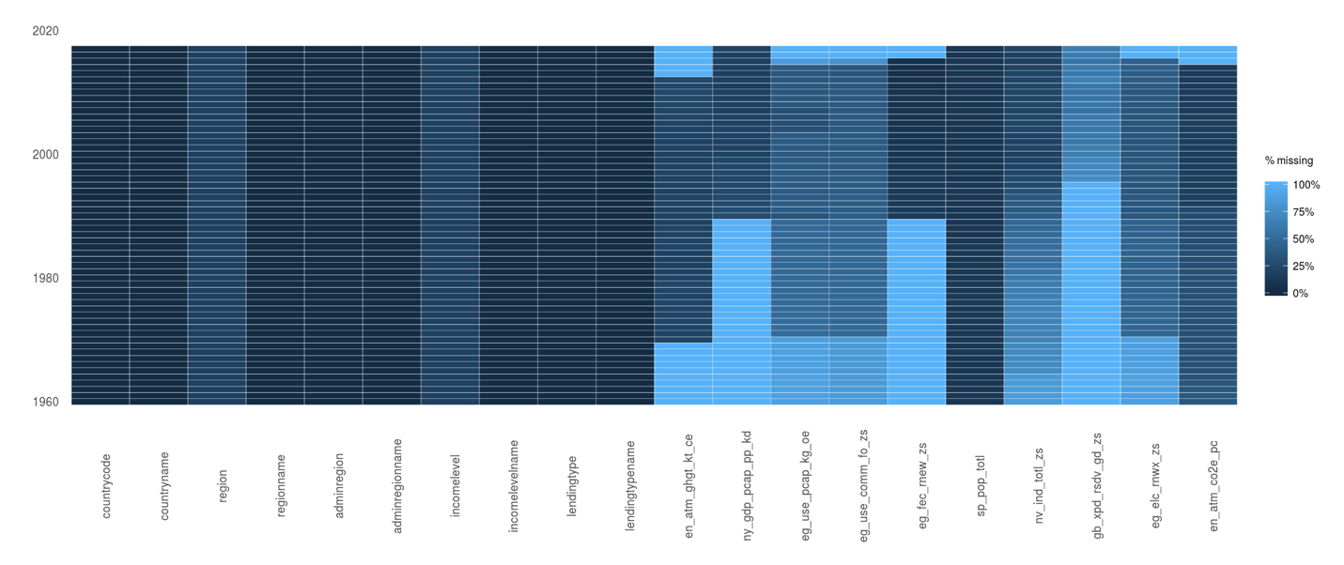This article is about [carbon dioxide (CO2)](https://ec.europa.eu/eurostat/statistics-explained/index.php?title=Glossary:Carbon_dioxide_emissions) emissions classified by final use of products in the [EU-27](https://ec.europa.eu/eurostat/statistics-explained/index.php?title=Glossary:EU_enlargements), also known as 'carbon footprints'. Eurostat uses a modelling approach to compile these [estimates](https://ec.europa.eu/eurostat/statistics-explained/index.php?title=Glossary:Estimate), based on economic information and [air emissions accounts (AEA)](http://ec.europa.eu/eurostat/statistics-explained/index.php/Greenhouse_gas_emission_statistics_-_air_emissions_accounts). Carbon footprints are one particular analytical application of AEA.

[Eurostat](https://ec.europa.eu/eurostat/statistics-explained/index.php?title=Glossary:Eurostat) estimates the EU-27’s carbon footprint at 7.0 tonnes [per person](https://ec.europa.eu/eurostat/statistics-explained/index.php?title=Glossary:Per_capita) in 2018. The EU-27 emits 0.4 tonnes CO2 per person more to produce exports than it avoids by importing goods and services. Services that account for 25 % of the total carbon footprint only account for 7 % of the direct CO2 emissions (transport, construction and real estate services are accounted for separately). The majority of the emissions originate from EU production activities.[1]

|  |  |  |  |  |
| --- | --- | --- | --- | --- |
| Variable | HIC | UMC | LMC | LIC |
| y | -211.455 | -356.934 | -2254.323 | -1720.444 |
| y2 | 56.578 | 50.130 | 343.604 | 323.595 |
| y3 | -2.898 | -1.769 | -16.562 | -18.881 |
| _cons | 261.406 | 1280.371 | 5234.966 | 3193.771 |
|  | | | | |

Due to the importance of greenhouse gas (GHG) emission data for fighting climate change, you will find more information below to explain why there are several datasets that report different values.

There are two internationally established approaches to report greenhouse gas emissions:

National inventories for greenhouse gases and other pollutants; the official reporting framework for international policy commitments

Air emissions accounts; part of the system of environmental-economic accounting

The main differences between the two are:

National inventories for greenhouse gases and

other air pollutants (territory principle) Air emissions accounts (residence principle)

Emissions are assigned to the country where the emission takes place. Emissions are assigned to the country where the economic operator causing the emission is resident.

Emissions are assigned to processes classified according to their technical nature (e.g. combustion in power plants, solvent use). Emissions are classified by economic activity, following the NACE classification of the system of national accounts.

Emissions from international navigation and aviation are assigned to the countries where the associated fuel is bunkered, irrespective of the operator's place of residence. Emissions from international navigation and aviation are assigned to the countries where the operator of the ship/aircraft is resident, regardless of where the emission takes place.

Note: National and EU totals differ between the two approaches, as different boundaries apply. GHG inventories include international aviation and maritime transport (international bunker fuels) as memorandum items, which means that they are excluded from national totals reported. However, they are included in air emissions accounts totals. Therefore total emissions reported in GHG inventory databases can differ significantly from the total reported in air emissions accounts for countries with a large international aircraft and/or shipping fleet.

The indicator measures total national emissions of the so called ‘Kyoto basket’ of greenhouse gases, including carbon dioxide (CO2), methane (CH4), nitrous oxide (N2O), and the so-called F-gases (hydrofluorocarbons, perfluorocarbons, nitrogen triflouride (NF3) and sulphur hexafluoride (SF6)). Using each gas’ individual global warming potential (GWP), they are being integrated into a single indicator expressed in units of CO2 equivalents.

Emissions data are submitted annually by the EU Member States as part of the reporting under the United Nations Framework Convention on Climate Change (UNFCCC). The average population of the reference year (calculated as the arithmetic mean of the population on 1st January of two consecutive years) is used as denominator (per capita). The indicator does not include emissions and removals related to land use, land-use change and forestry (LULUCF); it does not include emissions reported as a memorandum item according to UNFCCC Guidelines but does include emissions from international aviation as well as indirect CO2 emissions.

## Data Descriptions

Total greenhouse gas emissions (kt of CO2 equivalent)

Total greenhouse gas emissions in kt of CO2 equivalent are composed of CO2 totals excluding short-cycle biomass burning (such as agricultural waste burning and Savannah burning) but including other biomass burning (such as forest fires, post-burn decay, peat fires and decay of drained peatlands), all anthropogenic CH4 sources, N2O sources and F-gases (HFCs, PFCs and SF6).

ID: EN.ATM.GHGT.KT.CE

Source: European Commission, Joint Research Centre ( JRC )/Netherlands Environmental Assessment Agency ( PBL ). Emission Database for Global Atmospheric Research ( EDGAR ), EDGARv4.2 FT2012: edgar.jrc.ec.europa.eu

Aggregation Method: Sum

Development Relevance: The addition of man-made greenhouse gases to the Atmosphere disturbs the earth's radiative balance. This is leading to an increase in the earth's surface temperature and to related effects on climate, sea level rise and world agriculture. Emissions of CO2 are from burning oil, coal and gas for energy use, burning wood and waste materials, and from industrial processes such as cement production. Emission intensity is the average emission rate of a given pollutant from a given source relative to the intensity of a specific activity. Emission intensities are also used to compare the environmental impact of different fuels or activities. The related terms - emission factor and carbon intensity - are often used interchangeably. The carbon dioxide emissions of a country are only an indicator of one greenhouse gas. For a more complete idea of how a country influences climate change, gases such as methane and nitrous oxide should be taken into account. This is particularly important in agricultural economies. The environmental effects of carbon dioxide are of significant interest. Carbon dioxide (CO2) makes up the largest share of the greenhouse gases contributing to global warming and climate change. Converting all other greenhouse gases (methane (CH4), nitrous oxide (N2O), hydrofluorocarbons (HFCs), perfluorocarbons (PFCs), Sulphur hexafluoride (SF6)) to carbon dioxide (or CO2) equivalents makes it possible to compare them and to determine their individual and total

1. <https://ec.europa.eu/eurostat/statistics-explained/index.php/Greenhouse_gas_emission_statistics_-_carbon_footprints>