Lab 2 In Class
Peter James
2026-09-30
packages <- c("tidygeocoder", "sf", "terra", "tidyverse", "tidycensus", "flextable", "tmap")
installed <- packages %in% rownames(installed.packages())
if (any(!installed)) {
install.packages(packages[!installed])
}
lapply(packages, library, character.only = TRUE)
## Linking to GEOS 3.13.0, GDAL 3.8.5, PROJ 9.5.1; sf_use_s2() is TRUE
## terra 1.9.46
## ── Attaching core tidyverse packages ──────────────────────── tidyverse 2.0.0 ──
## ✔ dplyr 1.2.1 ✔ readr 2.2.0
## ✔ forcats 1.0.1 ✔ stringr 1.6.0
## ✔ ggplot2 4.0.3 ✔ tibble 3.3.1
## ✔ lubridate 1.9.5 ✔ tidyr 1.3.2
## ✔ purrr 1.2.2
## ── Conflicts ────────────────────────────────────────── tidyverse_conflicts() ──
## ✖ tidyr::extract() masks terra::extract()
## ✖ dplyr::filter() masks stats::filter()
## ✖ dplyr::lag() masks stats::lag()
## ℹ Use the conflicted package (<http://conflicted.r-lib.org/>) to force all conflicts to become errors
##
## Attaching package: 'flextable'
##
##
## The following object is masked from 'package:purrr':
##
## compose
##
##
## The following objects are masked from 'package:terra':
##
## align, colorize, rotate, width
## [[1]]
## [1] "tidygeocoder" "stats" "graphics" "grDevices" "utils"
## [6] "datasets" "methods" "base"
##
## [[2]]
## [1] "sf" "tidygeocoder" "stats" "graphics" "grDevices"
## [6] "utils" "datasets" "methods" "base"
##
## [[3]]
## [1] "terra" "sf" "tidygeocoder" "stats" "graphics"
## [6] "grDevices" "utils" "datasets" "methods" "base"
##
## [[4]]
## [1] "lubridate" "forcats" "stringr" "dplyr" "purrr"
## [6] "readr" "tidyr" "tibble" "ggplot2" "tidyverse"
## [11] "terra" "sf" "tidygeocoder" "stats" "graphics"
## [16] "grDevices" "utils" "datasets" "methods" "base"
##
## [[5]]
## [1] "tidycensus" "lubridate" "forcats" "stringr" "dplyr"
## [6] "purrr" "readr" "tidyr" "tibble" "ggplot2"
## [11] "tidyverse" "terra" "sf" "tidygeocoder" "stats"
## [16] "graphics" "grDevices" "utils" "datasets" "methods"
## [21] "base"
##
## [[6]]
## [1] "flextable" "tidycensus" "lubridate" "forcats" "stringr"
## [6] "dplyr" "purrr" "readr" "tidyr" "tibble"
## [11] "ggplot2" "tidyverse" "terra" "sf" "tidygeocoder"
## [16] "stats" "graphics" "grDevices" "utils" "datasets"
## [21] "methods" "base"
##
## [[7]]
## [1] "tmap" "flextable" "tidycensus" "lubridate" "forcats"
## [6] "stringr" "dplyr" "purrr" "readr" "tidyr"
## [11] "tibble" "ggplot2" "tidyverse" "terra" "sf"
## [16] "tidygeocoder" "stats" "graphics" "grDevices" "utils"
## [21] "datasets" "methods" "base"

Geocoded marijuana dispensaries
download.file("https://raw.githubusercontent.com/pjames-ucdavis/SPH215/refs/heads/main/san_francisco_active_marijuana_retailers.csv", "san_francisco_active_marijuana_retailers.csv", mode = "wb")
sf_mj <- read_csv("san_francisco_active_marijuana_retailers.csv")
## Rows: 33 Columns: 10
## ── Column specification ────────────────────────────────────────────────────────
## Delimiter: ","
## chr (10): License Number, License Type, Business Owner, Business Structure, ...
##
## ℹ Use `spec()` to retrieve the full column specification for this data.
## ℹ Specify the column types or set `show_col_types = FALSE` to quiet this message.
head(sf_mj)
## # A tibble: 6 × 10
## `License Number` `License Type` `Business Owner` `Business Structure`
## <chr> <chr> <chr> <chr>
## 1 C10-0000614-LIC Cannabis - Retailer Li… Terry Muller Limited Liability C…
## 2 C10-0000586-LIC Cannabis - Retailer Li… Jeremy Goodin Corporation
## 3 C10-0000587-LIC Cannabis - Retailer Li… Justin Jarin Corporation
## 4 C10-0000539-LIC Cannabis - Retailer Li… Ondyn Herschelle Corporation
## 5 C10-0000522-LIC Cannabis - Retailer Li… Ryan Hudson Limited Liability C…
## 6 C10-0000523-LIC Cannabis - Retailer Li… Ryan Hudson Limited Liability C…
## # ℹ 6 more variables: `Premise Address` <chr>, Status <chr>,
## # `Issue Date` <chr>, `Expiration Date` <chr>, Activities <chr>,
## # `Adult-Use/Medicinal` <chr>
head(sf_mj$`Premise Address`)
## [1] "2165 IRVING ST san francisco, CA 94122 County: SAN FRANCISCO"
## [2] "122 10TH ST SAN FRANCISCO, CA 941032605 County: SAN FRANCISCO"
## [3] "843 Howard ST SAN FRANCISCO, CA 94103 County: SAN FRANCISCO"
## [4] "70 SECOND ST SAN FRANCISCO, CA 94105 County: SAN FRANCISCO"
## [5] "527 Howard ST San Francisco, CA 94105 County: SAN FRANCISCO"
## [6] "2414 Lombard ST San Francisco, CA 94123 County: SAN FRANCISCO"
sf_mj$Premise_Address <- gsub(" County: SAN FRANCISCO",
"", sf_mj$`Premise Address`)
head(sf_mj$Premise_Address)
## [1] "2165 IRVING ST san francisco, CA 94122"
## [2] "122 10TH ST SAN FRANCISCO, CA 941032605"
## [3] "843 Howard ST SAN FRANCISCO, CA 94103"
## [4] "70 SECOND ST SAN FRANCISCO, CA 94105"
## [5] "527 Howard ST San Francisco, CA 94105"
## [6] "2414 Lombard ST San Francisco, CA 94123"

Tidygeocoder
sf_mj_geo <- geocode(sf_mj, "Premise_Address",
method = "osm")
## Passing 33 addresses to the Nominatim single address geocoder
## Query completed in: 33.2 seconds
Let’s check our data
head(sf_mj_geo)
## # A tibble: 6 × 13
## `License Number` `License Type` `Business Owner` `Business Structure`
## <chr> <chr> <chr> <chr>
## 1 C10-0000614-LIC Cannabis - Retailer Li… Terry Muller Limited Liability C…
## 2 C10-0000586-LIC Cannabis - Retailer Li… Jeremy Goodin Corporation
## 3 C10-0000587-LIC Cannabis - Retailer Li… Justin Jarin Corporation
## 4 C10-0000539-LIC Cannabis - Retailer Li… Ondyn Herschelle Corporation
## 5 C10-0000522-LIC Cannabis - Retailer Li… Ryan Hudson Limited Liability C…
## 6 C10-0000523-LIC Cannabis - Retailer Li… Ryan Hudson Limited Liability C…
## # ℹ 9 more variables: `Premise Address` <chr>, Status <chr>,
## # `Issue Date` <chr>, `Expiration Date` <chr>, Activities <chr>,
## # `Adult-Use/Medicinal` <chr>, Premise_Address <chr>, lat <dbl>, long <dbl>
summary(sf_mj_geo$lat)
## Min. 1st Qu. Median Mean 3rd Qu. Max. NAs
## 37.71 37.75 37.78 37.77 37.78 37.80 11
summary(sf_mj_geo$long)
## Min. 1st Qu. Median Mean 3rd Qu. Max. NAs
## -122.5 -122.4 -122.4 -122.4 -122.4 -122.4 11
Let’s try the ArcGIS database
sf_mj_geo_arc <- geocode(sf_mj, "Premise_Address",
method = "arcgis")
## Passing 33 addresses to the ArcGIS single address geocoder
## Query completed in: 11.2 seconds
Check our data
head(sf_mj_geo_arc)
## # A tibble: 6 × 13
## `License Number` `License Type` `Business Owner` `Business Structure`
## <chr> <chr> <chr> <chr>
## 1 C10-0000614-LIC Cannabis - Retailer Li… Terry Muller Limited Liability C…
## 2 C10-0000586-LIC Cannabis - Retailer Li… Jeremy Goodin Corporation
## 3 C10-0000587-LIC Cannabis - Retailer Li… Justin Jarin Corporation
## 4 C10-0000539-LIC Cannabis - Retailer Li… Ondyn Herschelle Corporation
## 5 C10-0000522-LIC Cannabis - Retailer Li… Ryan Hudson Limited Liability C…
## 6 C10-0000523-LIC Cannabis - Retailer Li… Ryan Hudson Limited Liability C…
## # ℹ 9 more variables: `Premise Address` <chr>, Status <chr>,
## # `Issue Date` <chr>, `Expiration Date` <chr>, Activities <chr>,
## # `Adult-Use/Medicinal` <chr>, Premise_Address <chr>, lat <dbl>, long <dbl>
summary(sf_mj_geo_arc$lat)
## Min. 1st Qu. Median Mean 3rd Qu. Max.
## 37.71 37.76 37.77 37.77 37.78 37.80
summary(sf_mj_geo_arc$long)
## Min. 1st Qu. Median Mean 3rd Qu. Max.
## -122.5 -122.4 -122.4 -122.4 -122.4 -122.4
Let’s map our data!
plot(sf_mj_geo_arc$long, sf_mj_geo_arc$lat)
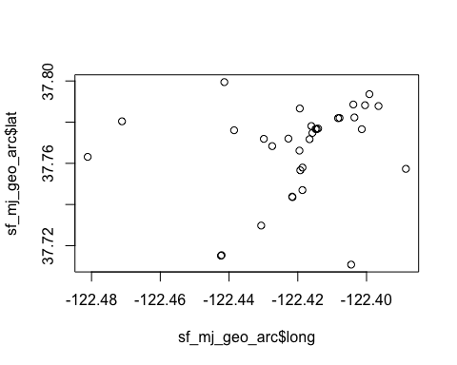

Working with cancer point data
Download the cancer data
# Download Cancer Dataset
download.file("https://raw.githubusercontent.com/pjames-ucdavis/SPH215/refs/heads/main/CAdata.rds", "CAdata.rds", mode = "wb")
# Read in Cancer Dataset
cancer <- readRDS("CAdata.rds")
summary(cancer)
## time event X Y
## Min. : 0.004068 Min. :0.0000 Min. :1811375 Min. :-241999
## 1st Qu.: 1.931247 1st Qu.:0.0000 1st Qu.:2018363 1st Qu.: -94700
## Median : 4.749980 Median :1.0000 Median :2325084 Median : -60386
## Mean : 6.496130 Mean :0.6062 Mean :2230219 Mean : 87591
## 3rd Qu.: 9.609031 3rd Qu.:1.0000 3rd Qu.:2380230 3rd Qu.: 318280
## Max. :24.997764 Max. :1.0000 Max. :2705633 Max. : 770658
## AGE INS
## Min. :25.00 Mcd: 431
## 1st Qu.:53.00 Mcr:1419
## Median :62.00 Mng:2304
## Mean :61.28 Oth: 526
## 3rd Qu.:71.00 Uni: 168
## Max. :80.00 Unk: 152

Make our cancer dataset spatial
cancer_points <- st_as_sf(cancer, coords=c("X","Y"))

CHECK THE CRS
st_crs(cancer_points)
## Coordinate Reference System: NA

Add coordinate reference system
ca_projection <- "+proj=lcc +lat_1=40 +lat_2=41.66666666666666
+lat_0=39.33333333333334 +lon_0=-122 +x_0=2000000
+y_0=500000.0000000002 +ellps=GRS80
+datum=NAD83 +units=m +no_defs"
#Set CRS
cancer_points_crs <- st_set_crs(cancer_points, ca_projection)
#Look at dataset
summary(cancer_points_crs)
## time event AGE INS
## Min. : 0.004068 Min. :0.0000 Min. :25.00 Mcd: 431
## 1st Qu.: 1.931247 1st Qu.:0.0000 1st Qu.:53.00 Mcr:1419
## Median : 4.749980 Median :1.0000 Median :62.00 Mng:2304
## Mean : 6.496130 Mean :0.6062 Mean :61.28 Oth: 526
## 3rd Qu.: 9.609031 3rd Qu.:1.0000 3rd Qu.:71.00 Uni: 168
## Max. :24.997764 Max. :1.0000 Max. :80.00 Unk: 152
## geometry
## POINT :5000
## epsg:NA : 0
## +proj=lcc ...: 0
##
##
##
Check our CRS
st_crs(cancer_points_crs)
## Coordinate Reference System:
## User input: +proj=lcc +lat_1=40 +lat_2=41.66666666666666
## +lat_0=39.33333333333334 +lon_0=-122 +x_0=2000000
## +y_0=500000.0000000002 +ellps=GRS80
## +datum=NAD83 +units=m +no_defs
## wkt:
## PROJCRS["unknown",
## BASEGEOGCRS["unknown",
## DATUM["North American Datum 1983",
## ELLIPSOID["GRS 1980",6378137,298.257222101,
## LENGTHUNIT["metre",1]],
## ID["EPSG",6269]],
## PRIMEM["Greenwich",0,
## ANGLEUNIT["degree",0.0174532925199433],
## ID["EPSG",8901]]],
## CONVERSION["unknown",
## METHOD["Lambert Conic Conformal (2SP)",
## ID["EPSG",9802]],
## PARAMETER["Latitude of false origin",39.3333333333333,
## ANGLEUNIT["degree",0.0174532925199433],
## ID["EPSG",8821]],
## PARAMETER["Longitude of false origin",-122,
## ANGLEUNIT["degree",0.0174532925199433],
## ID["EPSG",8822]],
## PARAMETER["Latitude of 1st standard parallel",40,
## ANGLEUNIT["degree",0.0174532925199433],
## ID["EPSG",8823]],
## PARAMETER["Latitude of 2nd standard parallel",41.6666666666667,
## ANGLEUNIT["degree",0.0174532925199433],
## ID["EPSG",8824]],
## PARAMETER["Easting at false origin",2000000,
## LENGTHUNIT["metre",1],
## ID["EPSG",8826]],
## PARAMETER["Northing at false origin",500000,
## LENGTHUNIT["metre",1],
## ID["EPSG",8827]]],
## CS[Cartesian,2],
## AXIS["(E)",east,
## ORDER[1],
## LENGTHUNIT["metre",1,
## ID["EPSG",9001]]],
## AXIS["(N)",north,
## ORDER[2],
## LENGTHUNIT["metre",1,
## ID["EPSG",9001]]]]

Start working with tmap
tmap_mode("plot")
## ℹ tmap modes "plot" - "view"
## ℹ toggle with `tmap::ttm()`
cancer_map <- tm_shape(cancer_points_crs) + tm_dots(size=0.5)
cancer_map
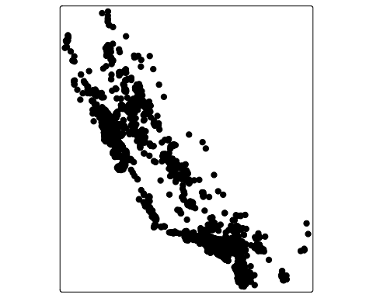
cancer_map_small = tm_shape(cancer_points_crs) +
tm_dots(fill = "green", size = 0.3, fill_alpha = 0.5) +
tm_basemap("CartoDB.Positron")
cancer_map_small
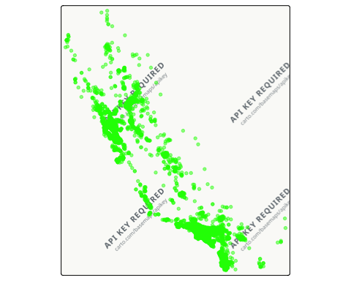

visualize by event status
cancer_map_events = tm_shape(cancer_points_crs) +
tm_dots(size=0.3, fill="event", fill.scale=tm_scale_categorical())
cancer_map_events
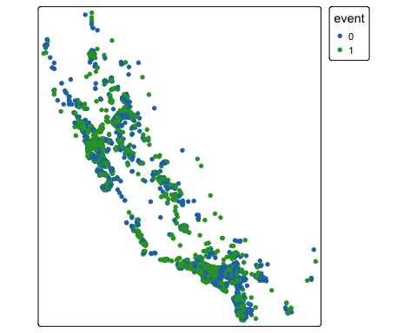
change color scheme
cancer_map_events_rg = tm_shape(cancer_points_crs) +
tm_dots(fill = "event", fill.scale=tm_scale_categorical(values=c("0"="gray","1"="red")))
cancer_map_events_rg
## Multiple palettes called "gray" found: "matplotlib.gray", "tableau.gray", "ocean.gray", "gmt.gray". The first one, "matplotlib.gray", is returned.
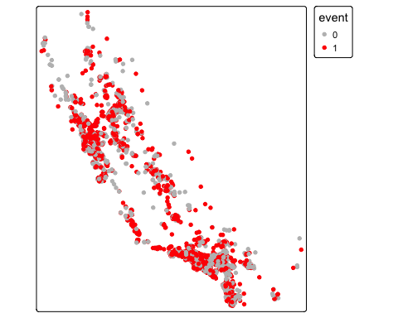

Import Census data
acs2023 <- load_variables(2023, "acs5", cache = TRUE)
## Warning: `cache` is deprecated and ignored. tidycensus no longer writes
## variable metadata to a local cache.
View(acs2023)
ca <- get_acs(geography = "county",
year = 2023,
variables = c(tpopr = "B03002_001",
nhwhite = "B03002_003", nhblk = "B03002_004",
nhasn = "B03002_006", hisp = "B03002_012"),
state = "CA",
survey = "acs5",
output = "wide")
## Getting data from the 2019-2023 5-year ACS
glimpse(ca)
## Rows: 58
## Columns: 12
## $ GEOID <chr> "06001", "06003", "06005", "06007", "06009", "06011", "06013"…
## $ NAME <chr> "Alameda County, California", "Alpine County, California", "A…
## $ tpoprE <dbl> 1651949, 1695, 41029, 209470, 45995, 21895, 1161458, 27293, 1…
## $ tpoprM <dbl> NA, 234, NA, NA, NA, NA, NA, NA, NA, NA, NA, NA, NA, NA, NA, …
## $ nhwhiteE <dbl> 466445, 993, 30234, 139527, 35599, 6869, 455961, 16668, 14254…
## $ nhwhiteM <dbl> 1170, 215, 341, 767, 318, 133, 1843, 199, 589, 979, 75, 554, …
## $ nhblkE <dbl> 159042, 0, 781, 3550, 529, 311, 94864, 805, 1522, 42060, 158,…
## $ nhblkM <dbl> 1736, 14, 143, 393, 140, 44, 1594, 123, 232, 1334, 126, 271, …
## $ nhasnE <dbl> 528377, 8, 587, 11010, 1066, 101, 212373, 821, 9640, 108809, …
## $ nhasnM <dbl> 2269, 8, 129, 497, 238, 159, 2008, 264, 416, 1332, 182, 403, …
## $ hispE <dbl> 385245, 249, 6361, 40829, 6403, 13639, 316799, 5350, 27230, 5…
## $ hispM <dbl> NA, 115, NA, NA, NA, NA, NA, NA, NA, NA, NA, NA, NA, NA, NA, …
head(ca)
## # A tibble: 6 × 12
## GEOID NAME tpoprE tpoprM nhwhiteE nhwhiteM nhblkE nhblkM nhasnE nhasnM hispE
## <chr> <chr> <dbl> <dbl> <dbl> <dbl> <dbl> <dbl> <dbl> <dbl> <dbl>
## 1 06001 Alam… 1.65e6 NA 466445 1170 159042 1736 528377 2269 385245
## 2 06003 Alpi… 1.69e3 234 993 215 0 14 8 8 249
## 3 06005 Amad… 4.10e4 NA 30234 341 781 143 587 129 6361
## 4 06007 Butt… 2.09e5 NA 139527 767 3550 393 11010 497 40829
## 5 06009 Cala… 4.60e4 NA 35599 318 529 140 1066 238 6403
## 6 06011 Colu… 2.19e4 NA 6869 133 311 44 101 159 13639
## # ℹ 1 more variable: hispM <dbl>
Bring in external datasets
setwd("/Users/pjames1/Dropbox/UC Davis Folders/SPH 215 GIS and Public Health/Github_Website/SPH215/")
ca.pm <- read_csv("PolicyMap Data 2025-03-27 192555 UTC.csv", skip = 1)
## Rows: 58 Columns: 10
## ── Column specification ────────────────────────────────────────────────────────
## Delimiter: ","
## chr (8): GeoID_Description, GeoID_Name, SitsinState, GeoID, GeoID_Formatted,...
## dbl (2): mhhinc, GeoVintage
##
## ℹ Use `spec()` to retrieve the full column specification for this data.
## ℹ Specify the column types or set `show_col_types = FALSE` to quiet this message.
glimpse(ca.pm)
## Rows: 58
## Columns: 10
## $ GeoID_Description <chr> "County", "County", "County", "County", "County", "C…
## $ GeoID_Name <chr> "Alameda", "Alpine", "Amador", "Butte", "Calaveras",…
## $ SitsinState <chr> "CA", "CA", "CA", "CA", "CA", "CA", "CA", "CA", "CA"…
## $ GeoID <chr> "06001", "06003", "06005", "06007", "06009", "06011"…
## $ GeoID_Formatted <chr> "=\"06001\"", "=\"06003\"", "=\"06005\"", "=\"06007\…
## $ mhhinc <dbl> 126240, 110781, 81526, 68574, 79877, 75149, 125727, …
## $ TimeFrame <chr> "2019-2023", "2019-2023", "2019-2023", "2019-2023", …
## $ GeoVintage <dbl> 2022, 2022, 2022, 2022, 2022, 2022, 2022, 2022, 2022…
## $ Source <chr> "Census", "Census", "Census", "Census", "Census", "C…
## $ Location <chr> "California (State)", "California (State)", "Califor…
cacounty <- ca %>%
left_join(ca.pm, by = c("GEOID" = "GeoID")) %>%
mutate(pwhite = nhwhiteE/tpoprE, pasian = nhasnE/tpoprE,
pblack = nhblkE/tpoprE, phisp = hispE/tpoprE,
mhisp = case_when(phisp > 0.5 ~ "Majority",
TRUE ~ "Not Majority")) %>%
rename(County = GeoID_Name) %>%
select(GEOID, County, pwhite, pasian, pblack, phisp, mhisp, mhhinc)
glimpse(cacounty)
## Rows: 58
## Columns: 8
## $ GEOID <chr> "06001", "06003", "06005", "06007", "06009", "06011", "06013", …
## $ County <chr> "Alameda", "Alpine", "Amador", "Butte", "Calaveras", "Colusa", …
## $ pwhite <dbl> 0.28236041, 0.58584071, 0.73689342, 0.66609538, 0.77397543, 0.3…
## $ pasian <dbl> 0.319850673, 0.004719764, 0.014306954, 0.052561226, 0.023176432…
## $ pblack <dbl> 0.0962753693, 0.0000000000, 0.0190353165, 0.0169475343, 0.01150…
## $ phisp <dbl> 0.2332064, 0.1469027, 0.1550367, 0.1949157, 0.1392108, 0.622927…
## $ mhisp <chr> "Not Majority", "Not Majority", "Not Majority", "Not Majority",…
## $ mhhinc <dbl> 126240, 110781, 81526, 68574, 79877, 75149, 125727, 66780, 1061…
cacounty %>%
summarize(Mean = mean(mhhinc))
## # A tibble: 1 × 1
## Mean
## <dbl>
## 1 87001.
cacounty <- cacounty %>%
mutate(region = case_when(County == "Sonoma" | County == "Napa" |
County == "Solano" | County == "Marin" |
County == "Contra Costa" | County == "San Francisco" |
County == "San Mateo" | County == "Alameda" |
County == "Santa Clara" ~ "Bay Area",
County == "Imperial" | County == "Los Angeles" |
County == "Orange" | County == "Riverside" |
County == "San Diego" | County == "San Bernardino" |
County == "Ventura" ~ "Southern California",
County == "Fresno" | County == "Madera" |
County == "Mariposa" | County == "Merced" |
County == "Tulare" |
County == "Kings" ~ "Central Valley",
County == "Alpine" | County == "Colusa" |
County == "El Dorado" | County == "Glenn" |
County == "Placer" | County == "Sacramento" |
County == "Sutter" | County == "Yolo" |
County == "Yuba" ~ "Capital Region",
TRUE ~ "Rest"))
cacounty %>%
group_by(region) %>%
summarize(Mean = mean(mhhinc))
## # A tibble: 5 × 2
## region Mean
## <chr> <dbl>
## 1 Bay Area 129297.
## 2 Capital Region 89288.
## 3 Central Valley 69265.
## 4 Rest 74959.
## 5 Southern California 91332.

