DEVELOPED vs DEVELOPING COUNTRIES

In this section, we’ll be exploring the suicide rates between developed and developing nations. The first challenge is to determine what parameter(s) will be used to define a developed vs developing country.

A developed country is a country that has an advanced and mature economy and infrastrucutre. This is led to believe to a higher standard of living and proseprity for it’s citizens. On the other hand, a developing country is one that has an under-developed economic system and low to mediocre infrastructure, this providing a lower quality of life to it’s citizens.

There are several metrics to measure how developed a country is: income inequality, GDP per capita, average income. Since we have one of the metrics available to us in the dataset (GDP per capita), we will be using this to classify developed vs developing countries.

There is no concrete rule about a cut-off level for GDP per capita in terms of determining how developed a country is, but a rule of thumb is anything above $20,000 of GDP per capita is considered a developed country. Of course, there are several other factors that go into determing the eligiblity, but this is a quick way that we’re going to use for our dataset.

ADDING TYPE ATTRIBUTE

After loading the dataset into a dataframe, we will add a new column called ‘Type’. This attribute tells us whether or not the country specified in the column is developed or developing. The following line of code was used for adding the column:

This line works almost like an if/else statement where anything above with a GDP per capita above 20,000 is assigned Developed and Developing otherwise.

The first task is to see the suicide rates between the developed and developing countries over the years. In order to do this from the main dataframe, we needed to group the dataframe by year and by country because the data is split up into multiple rows (by age). After the grouping, we can make a dataframe based on the mean of the 'suicides/100k pop' column values. The following code achieves this:

After the grouping, we can plot our dataframe with matplotlib:

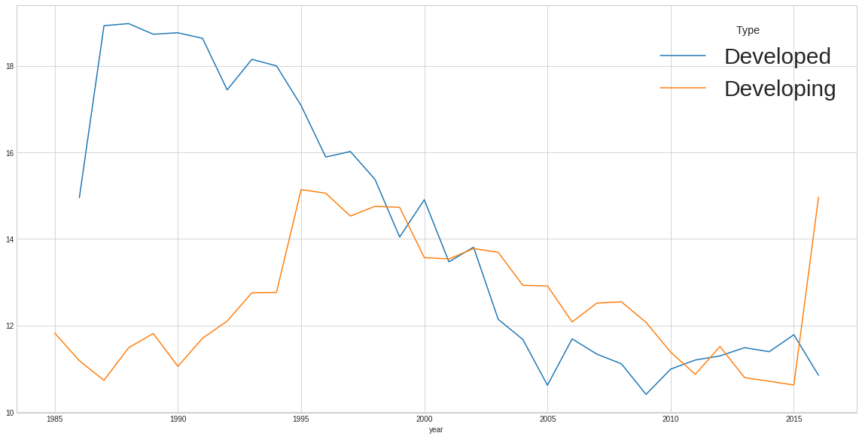
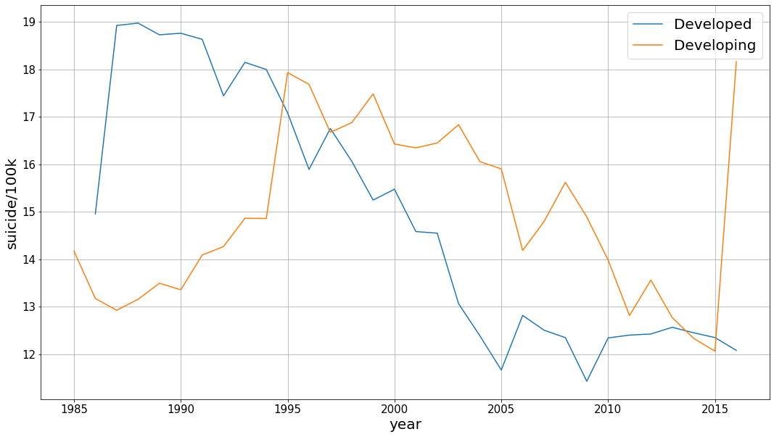

There are four interesting things to note here. First, right off the bat, the suicide rate for developed countries is way higher than developing countries in the first few years. It is almost twice as much as the developing countries. Secondly, as the time moves foward, the suicide rate for developing countries increases while the suicide rate for developed countries decreases, intercepting at around 1994. Lastly, there’s a sudden spike in 2005 (and a subsequent downturn) followed by a trend where the rates start increasing after about 2009 for developed countries. Lastly, there’s a sharp increase for developing countries after 2015.

To address the first note, we decided to gather the number of countries for each year that fall into each category. To do this, we grouped the dataframe by year, country and Type and get a count for the number of countries in each type by year. A plot of the count is shown as follows:

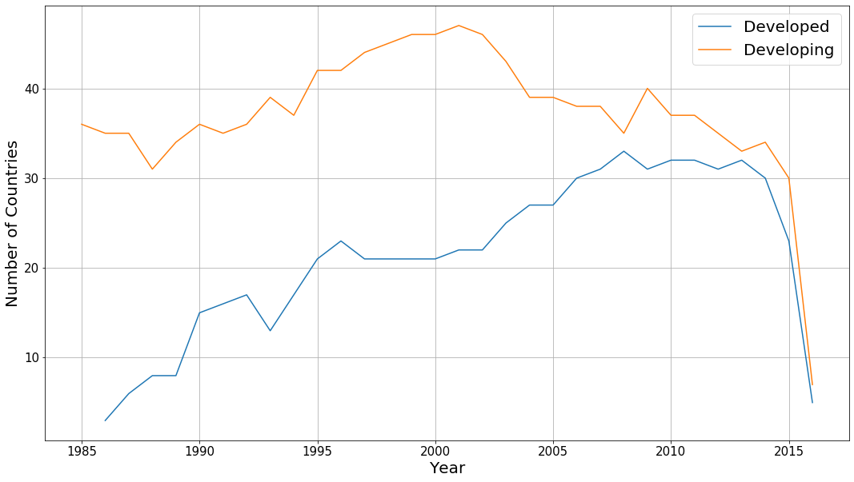
As you can see, the number of countries in developed countries is significantly lower compared to developing countries. It’s very possible that initially (around 1985), a lot of countries didn’t meet the criteria for a developed country, which is why the count for them is so low. The count increases dramatically over time, so a lot more countries are counted as a developed country as time goes on.
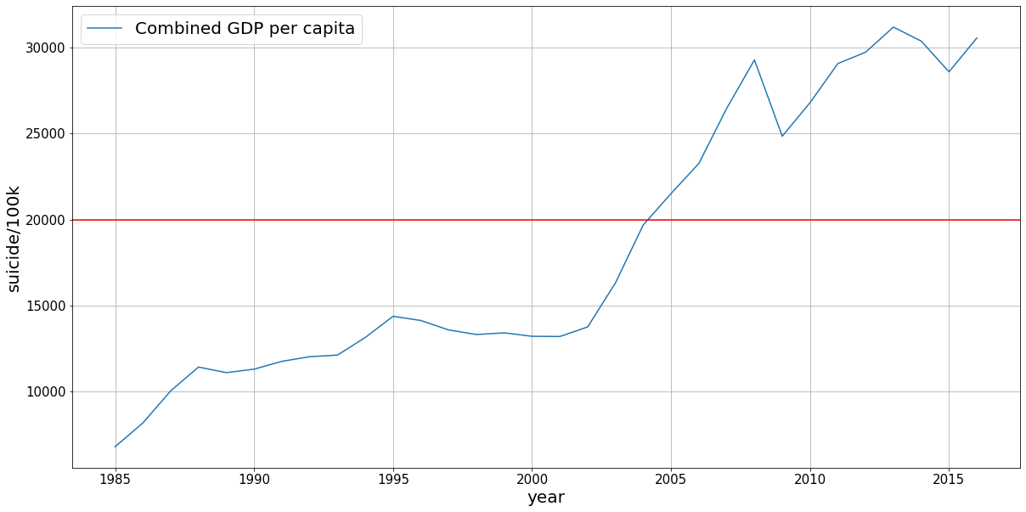

As you can see from the graph above, the combined GDP per capital has steadily increased over 1985 onwards which means a lot more countries end up meeting the criteria of being developed. (indicated by the horizontal red line).

There is also a huge drop in the number after 2015. This shows us that the data for 2016 is faulty as it contains relatively fewer countries compared to previous years. Therefore, we’ll be ignoring this outlier.

As observed earlier, a trend can be noticed after 2008 for developed countries where the suicide rates begin to increase over time, after a period of significant decrease in the 2 decades prior to that. 2008/09 was the beginning of the financial crisis that led to the Great Recession. This time saw the life savings wiped for a lot of people and many developed countries were especially hit hard. It’s very possible this is what led to the increasing suicide rates after 2008 among developed countries.

Age breakdown
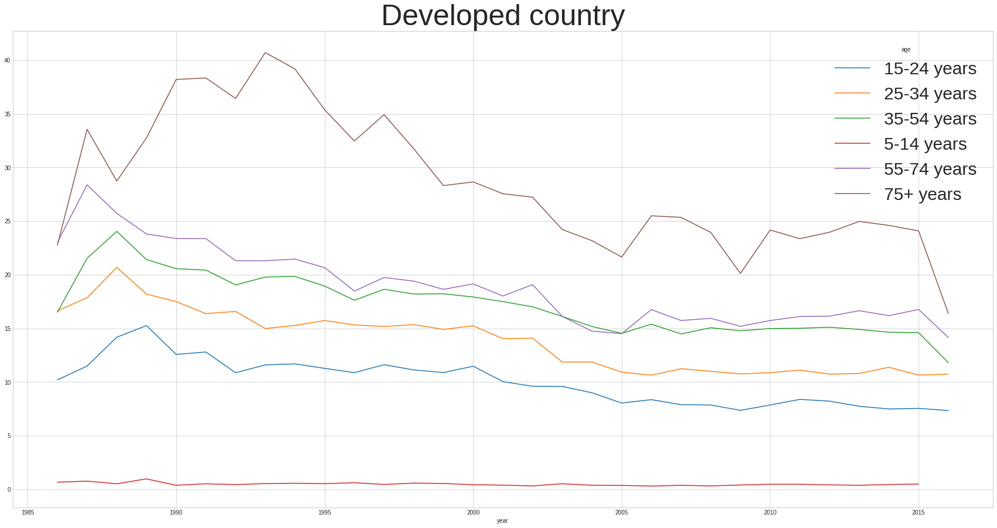
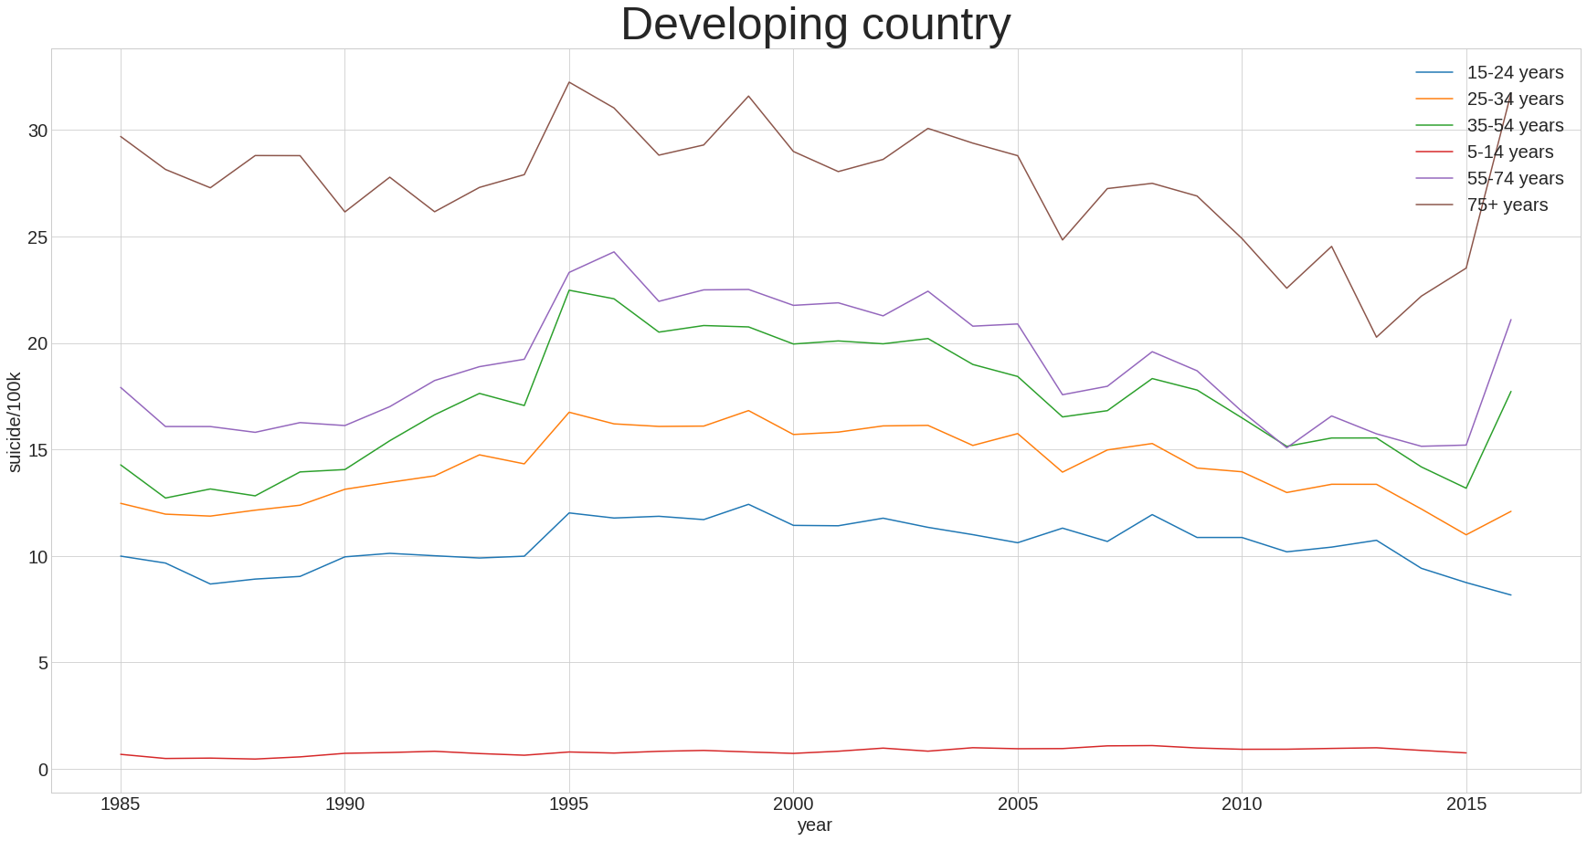
From the two graphs above, one thing that jumps out age has a high positive correlation with suicide rate. That is, the higher the age, the higher the suicide rate. This correlation is consistent across both developing and developed countries.

One thing to note is that there a downward trend across all age groups (except 75+). The 75+ age group also follows this downward trend after the mid 90s. Contrasting this with developing countries, there is a similar downward trend after the mid 90s, but the downward trend is much less extreme, with quite a bit of variablity for the 75+ age group.

BREAKDOWN BY CONTINENT

Since we have the breakdown by country, we can get a breakdown of suicide rate by continent as well. In order to do this, we need to make a new column called ‘continent’ and map the country names to the corresponding continent. In order to do this, we used a python library called pycountry-convert (https://pypi.org/project/pycountry-convert/).

This involved a two-step process. The first step is to convert each country to a 2 letter code with the country_name_to_country_alpha2 method. The next step is to convert the 2 letter country code to a 2 letter continent code with the country_alpha2_to_continent_code method. This process was defined in a function and applied to every column.

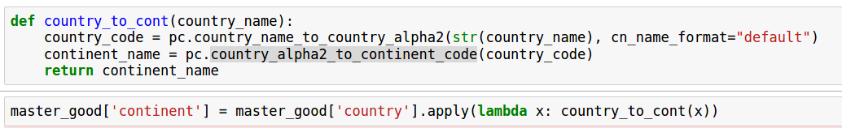
Now, plotting the suicide rate by continent gives us the following:

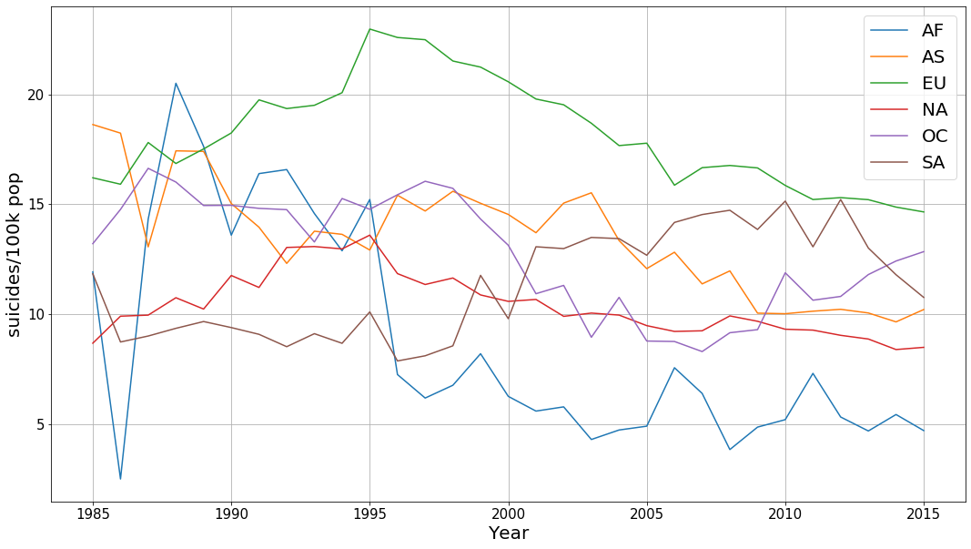
Two things jump out from this plot: The rate for Africa (AF) has a high variance and the rate for Europe is consistently higher compared to other continents.

If we plot the number of countries in each year by continent (shown below), we can see that the number for Africa is very low. This means the variability of suicide rate in each country within Africa has a large effect on the overall variability for Africa.
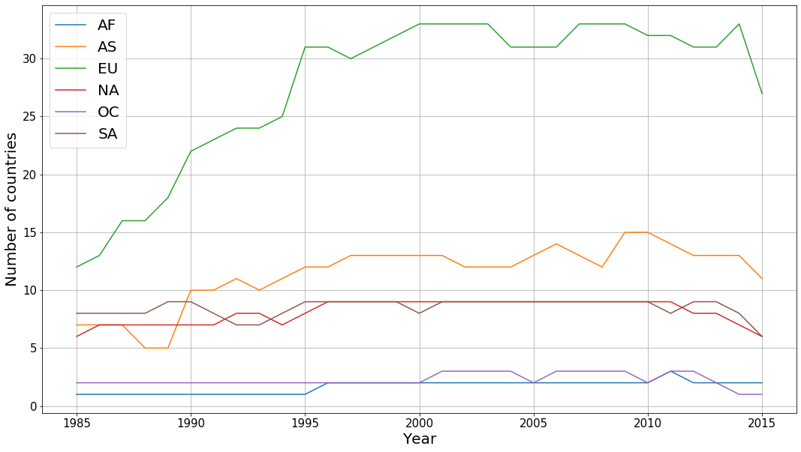
On the other hand, Europe has a lot of countries represented in the dataset. The number of countries represented keeps on increasing until 1995. Mapping this to the suicide rates, we can see that the suicide rates for Europe until 1995 and then start decreasing. So, the numbers after 1995 are a truer representation of Europe as they represent more of Europe compared to earlier years. Finally, another interesting thing to note is that after 1995, the suicide rate for every continent starts decreasing with the exception of South America.

PLOTTING COUNTRIES AFFECTED BY RECESSION

One thing we wanted to explore was how economic events like the 2008 great recession affect the suicide rates. We wanted to see if the great recession cause a spike in suicide rates as a lot of people lost their jobs and savings worldwide.

In order to proceed with this, we’ll need to find out the countries most affected by the recession. According to our reasearch, the following countries were most affected: Argentina, Ukraine, Ireland, Russia. We will also include United States since it was the epicentre of the crisis.

A dataframe that holds all these countries was created from the master dataframe. This dataframe contained the suicide rates from 2002 to 2012 inclusive as we want to see the trends around the recession.

After the dataframe is created, it can be grouped (by year and country) and unstacked as follows:
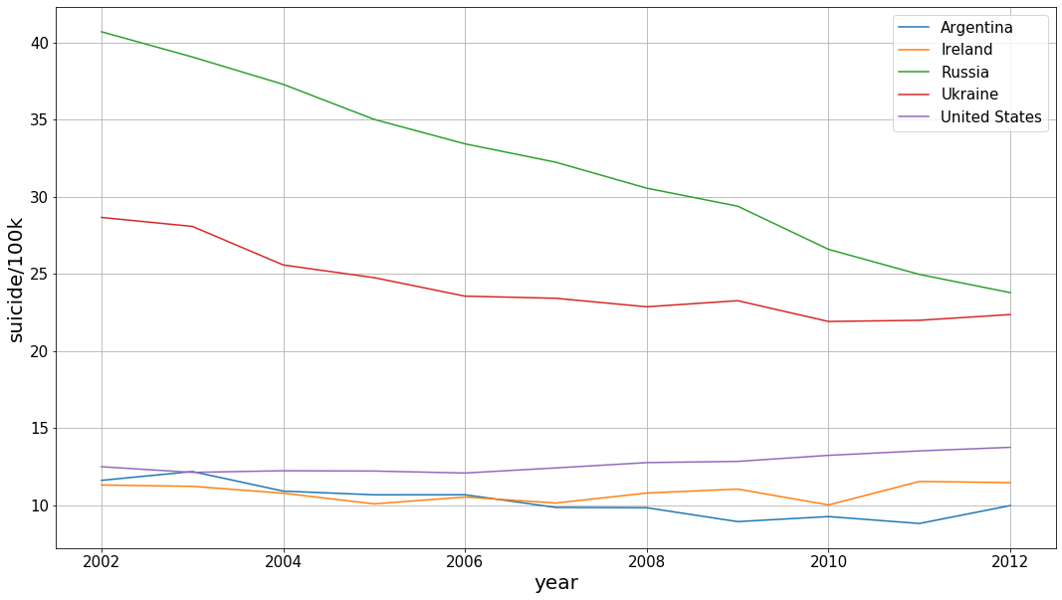
This new dataframe was then plotted to reveal the following plot:
As you can see above, every country except US shows either a decrease or no change in suicide rates around 2008. The suicide rates for US show a slight increase after about 2006 and it continues onwards with time. This trend could be a result of the tough financial times faced by Americans during the recession or it could be a lot of other factors. There isn’t enough evidence here to suggest so.

HDI

Human Development Index (HDI) is a metric used by United National Development Programme to measure the level of human development in each individual country. The index consists of three components: life expectancy, education and per capita income. Scoring high in these components results in a high HDI.

Within our dataset, we have a column called HDI that measures the HDI for each country for each year. Checking for null values for the HDI column, we can see there are quite a lot of empty values.
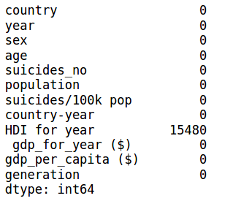

There are 15,480 null rows for the ‘HDI for year’ column, which gives us about 8000 rows to work with. First step is to make a dataframe that doesn’t contain any null values for the ‘HDI for year’ column.
A new dataframe can be created by grouping the HDI dataframe by year and country and including the mean for ‘suicides/100k pop’ and ‘HDI for year’ columns.

Next step is to classify the HDI column into tiers of very high (0.90-1.00), high (0.80-0.89), moderate (0.55-0.79) and low (less than 0.55). The classification can then be done with the following function:
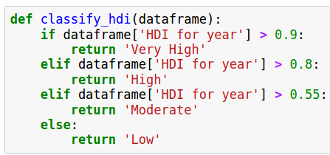

After applying the function on every row, a new column can be made with the new tiers:

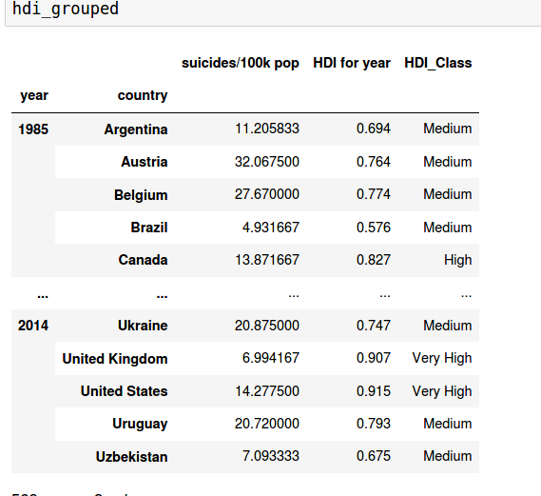

Plotting the new column against the suicide rate mean for each tier, we get:

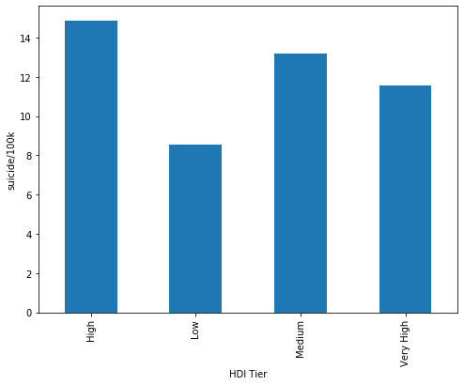

From the plot, there might be a general negative linear relation between HDI and suicide rates (i.e.: the higher the HDI, the lower the rate), but the low HDI tier having the lowest rate disproves that. Upon investigating further for the number of values in each category (see figure below), we can see that the value counts for low category are significantly lower compared to others. Since it has such low numbers, we’ll ignore this category as it can’t be used for any conclusions. This means that the linear relation between HDI and suicide rates is maintained.
