TRENDS RELATED TO AGE

Notebook reference:

Within the given dataset, there’s a column called age which provides us with the age of the victims at the time of their suicide. This column provides us with six age ranges: '75+ years', '55-74 years', '35-54 years', '25-34 years', '15-24 years' and '5-14 years’.

CORRELATION WITH AGE

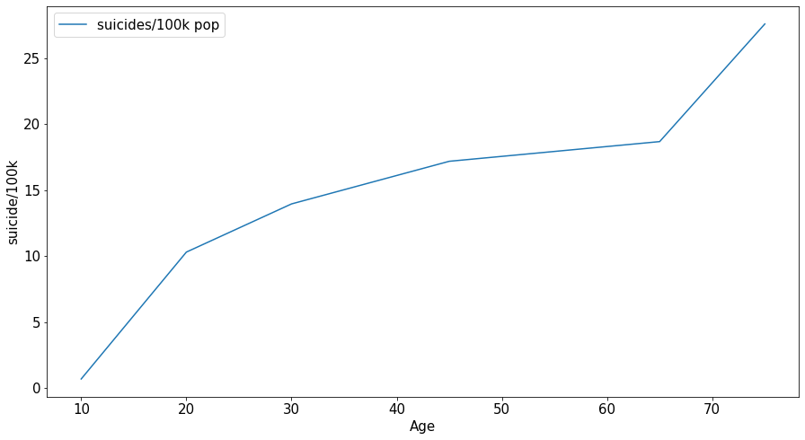In this section we wanted to start off by determining if there was any correlation between age and suicide rates. Unfortunately, the age column is of type object which made it hard to determine correlation. Therefore, we created a function called age_to_int which converted the age range into an integer based on the mean of each range. For age range ‘75+’ we chose 75 as the mean. After grouping by this new column (age_int) and year, we saw the following relationship between age and ‘suicides/100k pop’:

There’s a pretty strong positive correlation between age and suicide. That is, as age increases, the rates increase as well.

The .corr() method is a method in pandas library that can measure the correlation between two columns in a dataframe. Using this method on the grouped dataframe reveals a very strong positive correlation:

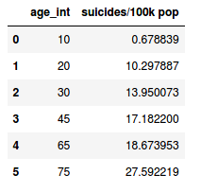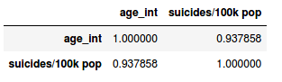

As you can see, the correlation coefficient is 0.94 which implies a strong positive relationship between the two variables. One more interesting thing to note is that the increase is occuring at a decreasing rate except for the very high ages where the slope becomes steeper and the rate shoots up. This means that the suicide rates are increasing at a decreasing up until the age range of -55-74’ and then it shoots up dramatically for the ‘75+’ range

1985 vs 2015

The data in the datatset displays data about suicide rates from 1985 to 2015. Therefore, we wanted to see if there were any major differences between the first year and the last year in terms of the age groups. Figure shows the ‘suicides rates/100k’ plotted per age group for 1985 and 2015

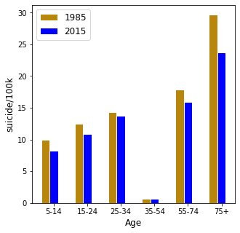

The graph shows that there isn’t much difference between the two years, except for the 75+ age group. In 2015, the suicide rates for 75+ age group are significantly lower compared to 1985. Although it may not be defintive proof, but this shows that the world has gotten better at taking care of the elderly when it comes to suicide.