**MALE VS FEMALE**

In this section, we’ll focus on the sex attribute of the dataset. We’ll explore the global trends over the years between the two genders, as well as how they fare other attributes within the dataset.

By grouping the data frame with year and sex columns, we can plot the mean of the ‘suicides/100k pop’ column which reveals the following plot:

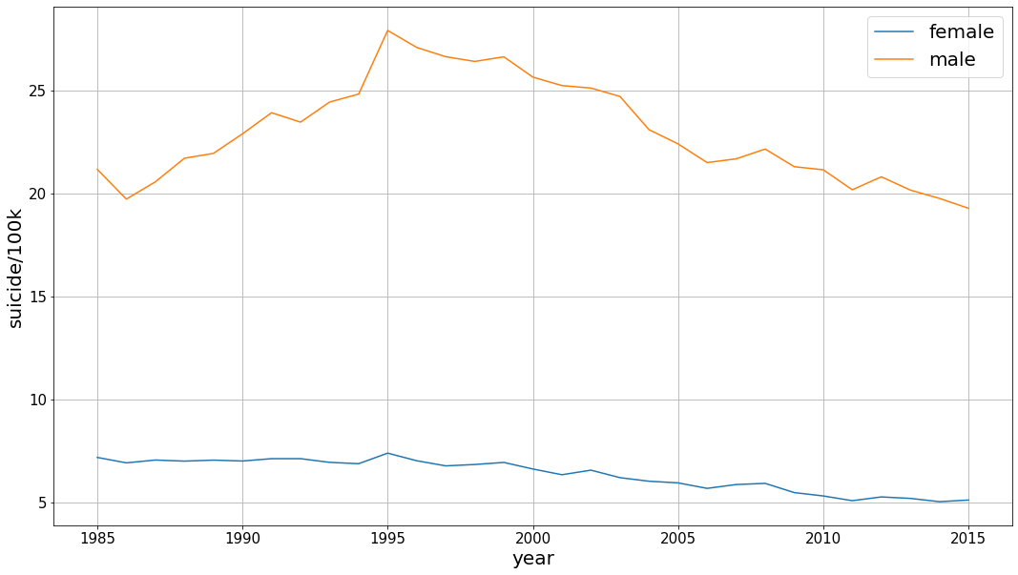

This graph shows a very telling picture. It shows us that there is a significant difference between male and female suicide rates globally. In fact, it shows us that men commit suicide at a rate of 3 to 4 times as much throughout all the two decades shown in the dataset.

This significant difference has been the subject of much research and articles over the years. According to a BBC article studying this subject, there are several factors for this difference. According to the article, men are less likely to reach out for help when dealing with mental health problems. Additionally, men are also more at risk of alcohol dependence and addiction which are used as unhealthy coping mechanisms for mental health problems. These two factors lead to the higher rates for men. Interestingly, the article states that suicide attempts for women (in US) are slightly higher than men. This means that American men choose more lethal ways when attempting suicide.

**SEX AND AGE**

Exploring how these rates are affected by age for both genders, we’ll group the data frame by the age group and sex to find the mean of ‘suicides/100k pop' column for each group.

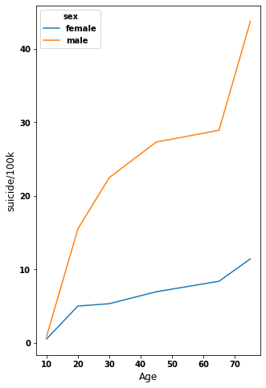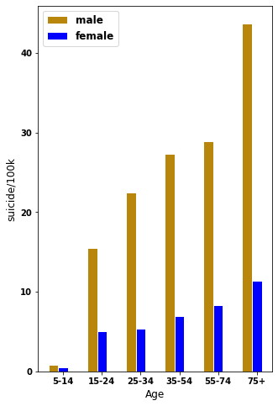

From the figures above, two observations can be made: 1) The suicides rates are positively correlated with age for both genders, and 2) The difference between male and female rates becomes more extreme with age.

There’s almost a steady straight-line relation between suicide rates and age for women, whereas the slope for men’s is a lot more steeper and become very steep for 75+ age group. Therefore, the difference between men and women’s suicide rates increase with age.

**COMPARING SOME AVERAGES**

**Average Male vs Female Suicides per 100k population (All countries)**

We started by grouping the data set by just Sex alone and taking the average of the suicide per 100,000 from all countries. We used this metric because it is a more standardized type of data and it would enable us to present more accurate result from the data as opposed to just using the suicide number’s column information as some countries have much more bigger populations than others.

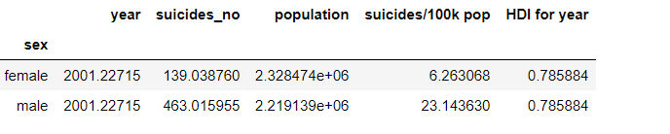

We see that females have a much lower average number of suicides per 100,000 population. Males suicides per 100,000 is almost four times that of the females on average. This is a substantial difference between the two sexes.

**Average Male vs Female Suicide numbers by Generation (All countries)**

Next up we went ahead to analyse the data frame by looking at it from the perspective of different generations to see if we could identify any difference among the generations of humans.

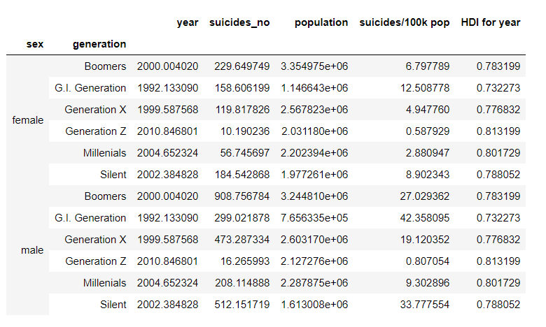

We can see that for both male and female the G.I. Generation had the highest suicides per 100,000

when looking at the averages for all countries based on generations of human beings. The results for males still greatly outnumbered that of females on average, when comparing results for both genders from all generations.

Note: Please see code from note book to view how these figures where gotten.