Exercise 4-2

1. The following figures show an IE diagram and a Chen diagram for the ProAudio database with the relationships and cardinality of the relationships:

Information Engineering diagram:

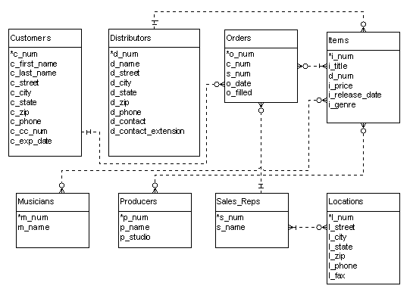

Chen ER diagram (shown without attributes for clarity):

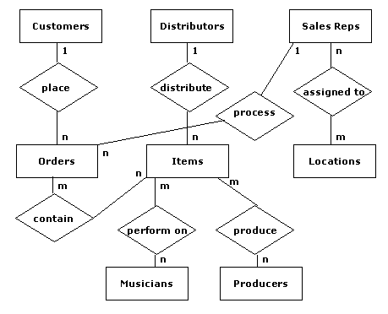

Chen ER diagram (note that the customer, musician, producer, and sales rep names and address attributes are combined):

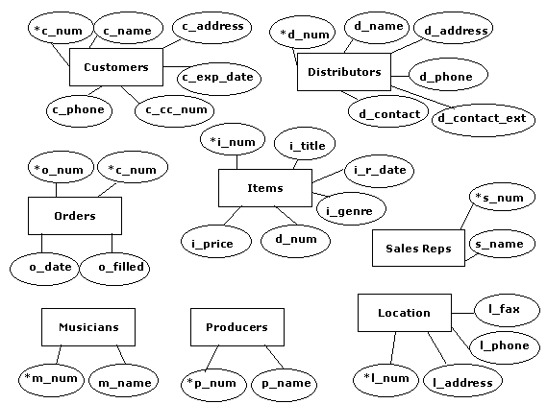

2. Data types for the attributes:

Customer(*c_num - INTEGER,
c_first_name - VARCHAR,
c_last_name - VARCHAR,
c_street - VARCHAR,
c_city - VARCHAR,
c_state - VARCHAR,
c_zip - VARCHAR,
c_phone - VARCHAR,
c_cc_num - VARCHAR,
c_exp_date - VARCHAR)

Distributors(*d_num - INTEGER,
d_name - VARCHAR,
d_street - VARCHAR,
d_city - VARCHAR,
d_state - VARCHAR,
d_zip - VARCHAR,
d_phone - VARCHAR,
d_contact - VARCHAR,
d_contact_extension - INTEGER)

Orders(*o_num - INTEGER,
*c_num - INTEGER,
s_num - INTEGER,
o_date - DATE,
o_filled – VARCHAR (Boolean))

Items(*i_num - INTEGER,
i_title - VARCHAR,
d_num - INTEGER,
i_price - DECIMAL,
i_release_date - DATE,
i_genre - VARCHAR)

Musicians(*m_num - INTEGER,
m_first_name - VARCHAR,
m_last_name - VARCHAR)

Producers(*p_num - INTEGER,
p_first_name - VARCHAR,
p_last_name - VARCHAR)

Sale Reps(*s_num - INTEGER,
s_first_name - VARCHAR,
s_last_name - VARCHAR)

Locations(*l_num – INTEGER,
l_street - VARCHAR,
l_city - VARCHAR,
l_state - VARCHAR,
l_zip - VARCHAR,
l_phone - VARCHAR,
l_fax - VARCHAR)

