Lab 6-1

1. The following is the IE diagram of the normalized relations for the ProAudio database.

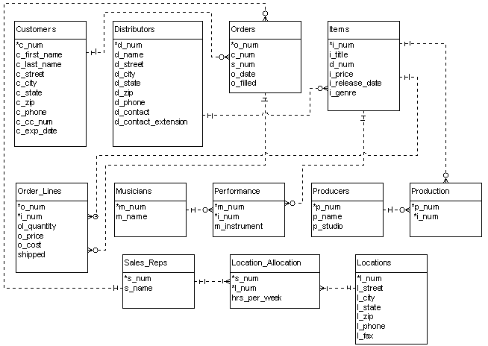

Chen ER diagram (shown without attributes for clarity):

