Lab 5-3

1. The following is the Assistants relation shown in the lab. The primary key for the relation is a composite key made up of the asst_num and loc_num attributes.

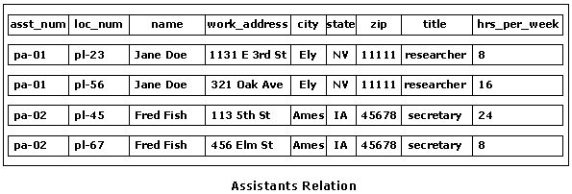

Functional dependencies for the ProRentals Assistant relation:

1. asst_num -> name, title
#1 and #2 not in 2NF
2. loc_num -> work_address, city, state,zip

3. asst_num + loc_num -> hrs_per_week

2. The following decompositions place the Assistants relation into 2NF:

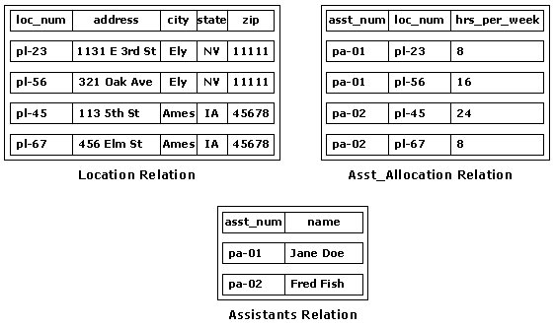

3. The functional dependencies are as follows:

loc_num -> manager_num, address, city, state, zip, telephone, manager
zip -> city, state

The following transitive dependency can be identified:

manager_num -> manager, so manager is transitively dependent on loc_num (primary key).

The following decomposition places the Location_Manager relation into 3NF:

