**Crystal Molecular Dynamics**

**by**

**Paweł A. Janowski**

**A dissertation submitted to the**

**Graduate School of New Brunswick**

**Rutgers, the State University of New Jersey**

**in partial fulfillment of the requirements**

**for the degree of**

**Doctor of Philosophy**

**Graduate Program in Chemistry and Chemical Biology**

**and**

**Graduate Program in Computational Biology and Molecular Biophysics**

**Written under the direction of**

**Prof. David A. Case**

**and**

**Prof. Darrin M. York**

**and approved by**

**______________________**

**______________________**

**______________________**

**______________________**

**New Brunswick, New Jersey**

**August, 2015**

# Abstract of the dissertation

**Improved Molecular Dynamics and Macromolecular Crystallography through Simulations of Biomolecular Crystals**

**By Paweł A. Janowski**

**Dissertation Directors**

**David A. Case Ph.D and Darrin M. York Ph.D**

We present a broad effort at the development of crystal simulation methodology and its application to benefit both macromolecular crystallography and molecular dynamics methods. Crystallography is the current method of choice for structural determination of biomolecules, but it is hampered by the inherently time and space averaged nature of the experiment as well as methodological limitations that do not sufficiently account for the heterogeneous and dynamic nature of crystals. Molecular dynamics has proven itself as a method capable of probing the physics and chemistry of biomolecules on an atomic scale, but requires continued development of the underlying force field parameters to more accurately reproduce observables. Our effort has focused on developing the framework for molecular dynamics simulations of biomolecular crystals. We first present our methodology for performing crystal simulations and show how it is applied first to simple peptide crystals and then to increasingly complex biomolecular systems. Next we demonstrate the utility of crystal simulations for validation of molecular dynamics methods through two case studies of the biophysics of enzyme reactions. Finally we demonstrate the improvement to crystallographic methods that can be gained by incorporating molecular dynamics methods. Our work is of great benefit to both the molecular dynamics and macromolecular crystallography communities and proposes specific approaches to integrate the two fields for the benefit of both.

# Acknowledgements

I thank the Lord for the beautiful gift of His Creation, for the flowers, the mountains, the creatures and the fascinating molecular mechanisms of life that testify to His love. Thank you for the gift of reason, free will and desire of the Good, the True and the Beautiful that drives us in all our pursuits. May we one day attain the fullness of Love.

I thank Maria my wife who accompanied me throughout this path in person and in spirit. Thank you for your care, your patience, your inspiration. We have truly walked the past five years together in friendship. May we walk many more!

I thank my parents, Jolanta and Andrew, for their love in raising me to be the person I am. Thank you for teaching me what is important in life and what is not. I am forever indebted in the bond of filial love.

I thank my family and my friends for all your kindess, your love, all the good times spent together that will forever form part of the treasure of my memories. Without those wonderful times shared together, I would have been hard pressed to keep my sanity along the way.

I thank all my colleagues, my lab mates, my teachers, all the wonderful scientists I have had the pleasure to work with. Especially Prof. Karsten Krogh-Jaspersen and Prof. Krzysztof Lewiński for transmitting the beauty of science through their lectures. Thank you for showing me how exciting science is!

I thank all of the good people I have met. Each encounter with each one of you enriches both of us. Only in relationship with others does man become truly man. Never stop being who you are. I love you all.

I thank my collaborators with whom I have had the enormous fortune of interacting over the course of the last five years. I have learned so much from all of you! Thank you for all of your support and encouragement. In no particular order: David Cerutti, Nigel Moriarty, James Holton, Chunmei Liu, Paul Adams, Nathaniel Echols, Pavel Afonine, Thomas Terwilleger, Jane Richardson and the entire Phenix team, Greg Warren, Brian Kelley, Anthony Nicholls, Timothy Giese, Jason Swails.

Finally, and in a special way, I thank my advisors, Prof. David Case and Prof. Darrin York. You have challenged and inspired me constantly and at the same time been caring guides along the path. I have learned so much from you, not just about science but about what it means to be good human beings. I will remain forever grateful.

To the loving memory of my Father who would have wanted to be here but is even closer than we can imagine.

# Contents

Abstract of the dissertation ii

Acknowledgements iv

Contents vi

Abbreviations used vii

Section I. Introduction 1

Chapter 1. Introduction and background 1

Section II. Developing molecular dynamics of crystals. 20

Chapter 2. Fav8 1 20

Chapter 3. Fav8 2 21

Chapter 4. 4lzt 22

Chapter 5. DNA/RNA 23

Section III. Applications of molecular dynamics of crystals 24

Chapter 6. Hairpin 24

Chapter 7. RnaseA 25

Section IV. Improved crystallographic methods through crystal molecular dynamics 26

Chapter 8. AFITT 26

Chapter 9. Phenix-Amber 27

Bibliography 28

# Abbreviations used

MD – Molecular dynamics;

BX – Biomolecular crystallography;

FT – Fourier transform;

Å – Ångstrom;

PDB – Protein Data Bank;

NVE – microcanonical ensemble;

NVT – canonical ensemble;

NPT – isobaric-isothermal ensemble;

ps – picosecond;

fs – femtosecond;

ns – nanosecond;

μs – microsecond;

ms – millisecond;

PME – particle mesh Ewald;

PBC – periodic boundary conditions;

# Introduction

## Introduction and background

I distinctly remember my excitement when, during my initial visit to Rutgers University, Prof. David Case first mentioned the idea of applying molecular dynamics to simulate crystals and improve crystallographic methods. I had studied crystallography for two semesters in the course of my undergraduate degree in biophysics at Jagiellonian University in Krakow. The subject matter was eloquently taught by Prof. Krzysztof Lewiński, one of the best lecturers whose classes I’ve ever had the fortune of attending. I thank him for instilling in me a deep appreciation for x-ray crystallography. But he also succeeded in shrouding the topic in a sense of wonder and mystery: despite all my efforts at the time I was not able to grasp the essence of how a seemingly random arrangement of dots of varying intensity could be converted into the fascinating three dimensional mesh of electron density. I liked crystallography, but I also respected it and I feared it’s mystery that had left me so stumped at university. Thus when Dr. Case presented the idea of molecular dynamics on crystals, I was excited: I could carry out my doctoral research on the development of molecular dynamics methods as I had wanted and I could at the same time get a second chance at figuring out this crystallography business… or die trying.

I have thus very happily spent the last five years focused on our effort to simulate biomolecular crystals with molecular dynamics. The original question we asked ourselves was simple: what can be learned from molecular dynamics of crystals? This was quickly reformulated into the following four overarching questions that form the focus of this work:

1. What is the best way to carry out molecular dynamics of biomolecular crystals?
2. How can we use crystal simulations to improve molecular dynamics methods?
3. How can we use crystal simulations to improve crystallography methods?
4. What can we learn about real crystals from our simulations of crystals?

What follows is a brief introduction to the methods of crystallography and molecular dynamics, with special emphasis on aspects that relate directly to our work. We then discuss the goals and specific aims of this research and present the general organization of the dissertation before moving on to a presentation of the work in subsequent chapters.

### Crystallography background[1]

Crystallography is a biophysical technique used to probe the three-dimensional atomic structure of molecules by analyzing the diffraction pattern of electromagnetic radiation on a crystal.[1]–[3] As the name implies, crystallography requires that billions of copies of the molecule of study arrange themselves in a regular repeating array which is, by definition, a crystal. When used to study the structure of biomolecules using x-rays, the method is referred to as macromolecular x-ray crystallography (MX). The fact that protein molecules can form crystals has been known for almost 150 years.[4] In general, crystal formation of biomolecules is promoted by slowly removing solvent from a solution of the protein of study. If the solvent is removed too quickly or if the solution is not of the required purity, the protein molecules will precipitate out of the solution and form an amorphous powder. However if the solution becomes supersaturated slowly the molecules may pack themselves in a regularly repeating array held together by non-covalent chemical interactions in a way that minimizes the overall energy of the solute. Finding the exact conditions under which a given biomolecule crystallizes can be very challenging and in many cases constitutes the crux of the crystallographic method.

Once crystallized, the regularly repeating array of the crystal acts as a diffraction grating when light is shined upon it. Diffraction refers in general to the physical behavior of waves as they impact objects or slits. Etimologically, the term was coined by Francesco Maria Grimialdi in 1665 in his *Physico mathesis de lumine, coloribus, et iride, aliisque annexis libri duo* and comes from the Latin diffringere meaning “to break up into pieces”. In particular a regularly spaced array of slits or objects will cause the waves scattered off each object to interfere with each other. Wave crests lining up lead to constructive interference resulting in waves of higher amplitude, whereas when crests and troughs mix, destructive interference results in low amplitudes. Because of the dual nature of electromagnetic radiation, when light shines on diffraction grating it behaves like a wave and interference leads to the formation of bands (in the case of a one-dimensional diffraction grating) or spots (in the case of a two-dimensional diffraction grating). James Gregory’s observation of the diffraction pattern of light shining through a bird feather in the late 17th century is regarded as the discovery of the first diffraction grating.

A crystal is a repeating array of objects and thus can naturally act as a diffraction grating. However, because the wavelength of visible light is much larger than the typical spacing between array planes in molecular crystals, the diffraction of light on molecular crystals is not observed. The breakthrough moment for x-ray crystallography came in 1912 during a conversation between Paul Peter Ewald and Max van Laue, when van Laue suggested that x-rays (discovered in 1895 by Wilhelm Roentgen) might have a shorter wavelength that would allow their diffraction on crystals to be observed.[5], [6] In 1912 van Laue recorded the first ever x-ray diffraction pattern on a copper sulfate crystal. Shortly thereafter the father-son pair of William Lawrence Bragg and William Henry Bragg formulated the law that describes the diffraction of x-rays on a crystal.[7], [8] The first diffraction pattern from a protein crystal was obtained by John Desmond Bernal and Dorothy Hodgkin using pepsin, and the first three-dimensional structure of a protein molecule solved using x-ray crystallography was myoglobin in 1958 by John Kendrew.[9] Van Laue, the Braggs and Kendrew all received Nobel Prizes for their work. In all thirteen Nobel Prizes have been award for work on or using crystallography.

The raw experimental data obtained in a crystallography experiment is a diffraction pattern. This pattern is obtained as a beam of x-rays is focused on a crystal and the x-ray photons scatter (diffract) off the electron clouds of the atoms that make up the crystal. For the work presented here it is crucial to understand that the diffraction pattern is not obtained in a single instant from single x-rays scattering off the crystal. Rather it is obtained over a significant period of time usually ranging from a few up to about several dozen minutes. The diffraction spots themselves require the constructive interference of an enormous number of x-rays to be observed. Furthermore the x-rays themselves diffract off the billion of molecules that make up the crystal. Thus crystallography is a time and space-averaged experiment.

The diffraction patterned obtained in the crystallography experiment contains two essential pieces of information. The first of these is the location and spacing of the diffraction spots. The spots appear on those vertices of an array called the reciprocal space lattice that intersect the Ewald sphere. The reciprocal space lattice and the Ewald sphere are mathematical constructs directly related to the parameters of the real space lattice of the crystal being studied. The appearance of diffraction spots can be described via the equation that is know as Bragg’s Law (named for the younger of the two Braggs mentioned above). Essentially, diffraction spots can only form in locations where the x-rays arrive in phase (in more simple language, where the crests and troughs of the arriving x-ray waves are lined up with each other). The condition for this to happen is that the distances of the paths that all the arriving x-rays travel must all differ by an integral number of wavelengths of the x-rays. The resulting description of the formation of diffraction spots is Bragg’s Law:

|  |  |  |
| --- | --- | --- |
|  |  | (Eq. ) |
|  |  |  |

where d is the spacing between a given set of planes in the array, θ is the angle at which the x-rays impact the set of planes, *n* is a positive integer known as the order of reflection and λ is the wavelength of the x-rays. The lattice (spacing between planes) and wavelength are constant under normal experimental conditions. Thus they uniquely specify the angle at which the scattered x-rays interact constructively and form a diffraction spot. Each spot thus corresponds uniquely to a specific set of planes in the array. Furthermore the angle is inversely proportional to the spacing. In other words smaller diffraction angles correspond to larger plane spacing in the lattice. Diffraction spots closer to the center of the diffraction pattern carry information about larger-scale features of the crystal. This is the basis for the concept of resolution: usually the diffraction pattern can only measured up to a certain radius away from the center: beyond that the angle of diffraction is too large and the spots too weak to be reliably recorded. Most importantly, by accurately measuring the location and spacing of the diffraction spots, one can deduce the spacing of the crystal’s array and thus obtain the parameters of the crystal unit cell (the three box dimensions *a*, *b*, *c* and three box angles α,β,γ).

The other essential information in the diffraction pattern are the intensities of the diffraction spots. Whereas the location of the spots reveals the unit cell parameters of the crystal array, the intensities of the spots tell us about the actual distribution of scattering objects, i.e. atoms, within the crystal unit cell. The intensity of a wave (and thereby of the diffraction spot) is equal to the square of the wave’s amplitude:

|  |  |  |
| --- | --- | --- |
|  |  | (Eq. ) |
|  |  |  |

We know from the previous discussion and Bragg’s Law that an identical scattering object located at each lattice plane of a certain spacing *d* would produce an ideal constructive interference between x-rays and consequently a diffraction spot at the position corresponding to angle θ. But what happens if there is a second scattering objects located between the planes? The x-rays scattering off the object between the planes will arrive at the diffraction spot with a phase different from that of the rays scattering from the object on the plan. The resulting amplitude of the total x-ray wave arriving at the diffraction spot location will result from the sum of two waves: one resulting from the constructive interference caused by all the copies of the first object lying on the plane and the second resulting from the constructive interference caused by all the copies of the second object lying between planes. Because the objects do not all lie integral distances of the scattering plane away from each other, the resulting waves that are summed are not all perfectly in phase. This results in an attenuation of the amplitude of the resulting wave or even in a complete disappearance of the diffraction spot.

If we treat the scattering electron density in the unit cell as continuous and divide it into infinitesimal sections *dx* along the scattering vector, the amplitude of the resulting diffraction spot can be obtained by integrating the partial x-ray wave scattered by each section *dx* of electron density:

|  |  |  |
| --- | --- | --- |
|  |  | (Eq. ) |
|  |  |  |

(Eq. 3) is presented for the one dimensional case but the generalization to three dimensions is straightforward. Each partial wave has an amplitude proportional to the electron density at *x* but with a phase relative to *x=0* of *2πhx*. The integration is performed over the unit cell vector *h* and the position *x* are described in fractional coordinates. ρ(x) is the electron density at position *x.* ***Fh*** is called the structure factor and is a wave described by an amplitude  and a phase . The intensity of the diffraction spot is related to the structure factor amplitude via (Eq. 2). Mathematically this equation is equal to the operation known as the Fourier Transform (FT). If the electron density is presented discontinuously as a set of scattering points (atoms) we obtain the discreet form of the structure factor equation:

|  |  |  |
| --- | --- | --- |
|  |  | (Eq. ) |
|  |  |  |

which we have now presented in three dimensions. *f* is the scattering contribution of atom *i* in the scattering direction corresponding to reflection ***h***. Conversely if we sum over each one of the diffracted waves (at each diffraction spot), we obtained the scattering electron density:

|  |  |  |
| --- | --- | --- |
|  |  | (Eq. ) |
|  |  |  |

Here again we present the one-dimensional form for pedagogical purposes. The summation is over all the diffraction spots of order *h*. This equation corresponds mathematically to the inverse Fourier Transform and is the inverse of the (Eq. 3). Thus we arrive at one of the fundamental concepts of x-ray crystallography: the electron density of the crystal unit cell is the inverse FT of the diffraction pattern.

Now let us examine what is needed to calculate the electron density. (Eq. 5) states that we need to perform a summation over each diffraction spot. For each spot we need the amplitude and phase of its corresponding structure factor. The amplitude is readily obtained as the square root of the intensity measured in the experiment, but unfortunately there is no information about the phase. This is known as the phase problem. Many ingenious methods exist to tackle the phase problem. However, assuming that a sufficiently good estimate of the phases is obtained from which a sufficiently good estimate of the electron density can be calculated, one can move on to the next part of the process, called refinement, that is of greater relevance in the context of the present work. In practice, the great majority of biomolecular structures are solved today by a technique called molecular replacement where a sufficiently good initial estimate of the electron density and phases is obtained by comparison to another similar molecule whose structure is already known.

Supposing that a fairly good estimate of the structure of the molecule has been obtained, one can move on to the next stage in the crystallography process which is called refinement (structural refinement, crystallographic refinement). Let us summarize what information we have at this stage. From the experiment we have the amplitudes of all the structure factors. If we also had the phases we would be able to calculate the electron density directly by (Eq. 5), but we usually don’t have the phases. On the other hand we have an estimated structure of the molecule. This is referred to as a model and usually consists of a position relative to the crystal unit cell for each atom that we know makes up the molecule we are studying. From these atomic positions we can calculate the overall electron density of the model (the electron density is calculated by a mathematical function, usually a sum of Gaussians, related to the number of electrons in the type of atom. The functions most commonly used today are the Cromer-Mann Gaussian functions.[10]) Then from the electron density of the model we can calculate amplitudes and phases via (Eq. 3). We now have a set of experimentally measured structure factor amplitudes which are commonly referred to as Fobs, and we have a set of structure factor amplitudes calculated from the current best estimate model of the molecule, which are commonly referred to as *Fcalc*­. We can now quantify how well the proposed model accounts for the experimental data (or alternatively, how well the experimental data describes the proposed model) by comparing *Fcalc* to *Fobs*. This is usually done by a statistic known as the R-factor:

|  |  |  |
| --- | --- | --- |
|  |  | (Eq. ) |
|  |  |  |

where and are the amplitudes of the *F­­obs* and *Fcalc* set of structure factors respectively. We can envision the following process: given a starting model we calculate the R-factor. We can use the phases obtained from the model via (Eq. 3) together with the experimental amplitudes *Fobs* to calculate an electron density via (Eq. 5). Next we adjust the atomic positions of our model to better fit the electron density calculated from *Fobs.* From there we calculate a new set of *Fcalc*and a new R-factor. If the R-factor is better (lower) than the previous one, than the new model is better than the previous model. This iterative process of calculating the electron density using phases from the model and adjusting atomic positions of the model to fit the resulting density is called refinement.

Refinement is a complex and one could carry out the process just described by hand for a very long time and not obtain any significant improvement. Fortunately refinement can be formulated mathematically as a non-linear optimization problem and solved via one of many known mathematical algorithms. In the most basic formulation a least squares residual between the observed and calculated structure factor amplitudes is minimized:

|  |  |  |
| --- | --- | --- |
|  |  | (Eq. ) |
|  |  |  |

However, in practice this problem is often not well-defined because of the low ratio between the observed data (the set of structure factor amplitudes) and the parameters to be estimated via the optimization (the set of x,y,z coordinates of all the atoms in the asymmetric unit of the crystal) combined with the various sources of noise and error inherent in the x-ray diffraction experiment. Therefore several approaches exist to increase the data to parameter ratio. For example one can decrease the number of parameters to be refined by ignoring some set of atomic coordinates such as the hydrogens. Alternatively, one can increase the set of “observed” data by incorporating previous knowledge about the structure of molecules into the equation. For example, we know that an sp3 carbon-carbon bond should have a length of 1.54Å. This knowledge imposes a set of restraints on the final solution set of atomic positions in the molecule. Thus the residual to be minimized becomes:

|  |  |  |
| --- | --- | --- |
|  |  | (Eq. ) |
|  |  |  |

Here the x-ray term corresponds to the same residual as in (Eq. 7). The chemistry term (also sometimes called stereochemistry or geometry term) corresponds to the summed residual over all the restraints where r0 is the target value of the restraint and rcalc is the value of the restraint in the proposed model. *w* is a relative scaling weight that is adjusted in the refinement procedure to adjust the relative weight between the x-ray and the restraint term. The restraints used can be obtained from a variety of previously known information about the chemical structure of molecules but most commonly include knowledge of bond lengths, angles and torsions. The most popular crystal refinement programs in use today apply a set known as the Engh & Huber restraints which were derive from survey of accurate small molecule crystal structures from the Cambridge Crystallographic Database.[11], [12]

In practice several additional levels of complexity are present in modern refinement programs. First, the least squares formulation of the residual to be minimized is most often replaced with a maximum likelihood formulation. This allows for a statistical treatment of observation and restraint probabilities. The chemistry restraints can be incorporated as *a priori* knowledge in a Bayesian formulation. Statistical probability estimates can then be obtained on the resulting parameters. Furthermore, by incorporating this statistical knowledge a large degree of the model bias present in the calculated electron density maps due to the use of phases obtained from the model can be removed.[13] Second, sophisticated mathematical algorithms such as the Limited memory Broyden–Fletcher–Goldfarb–Shanno (L-BFGS) algorithm are implemented to optimize the residual based on gradients of its component terms. Third the equation for calculating the structure factors from the model is often more complex than the integral shown in (Eq. 3) as it includes contributions from overall anisotropy and fluctuations and from the contribution of the unmodeled bulk solvent atoms that don’t show up distinctly in the experimental electron density. Lastly, crystallographic refinement usually proceeds in stages where the refinement of the x,y,z positions of the atoms in the asymmetric unit is just one stage. Other parameters that affect the calculated structure factors are refined in the other stages. Arguably the most important of these are the B-factors.[14], [15] Where the x,y,z coordinates describe the mean positions of the atom in the structure, B-factors describe how that atoms’ instantaneous position fluctuates around that mean. A significant portion of that oscillation can be ascribed to thermal fluctuations. Thus B-factors are often also referred to as temperature factors. B-factors can be isotropic (describing a spherical isotropic fluctuation around the mean position and leading to a single additional parameter to be refined per atom) or anisotropic (describing a three dimensional elliptical oscillation, requiring a symmetric 3x3 tensor and thus 6 additional parameters to be refined per atom). In real space B-factors act like a convolution of a Gaussian function with the electron cloud around the mean position of an atom, effectively smearing out that atom’s electron density. The equation for the FT of the electron density thus becomes:

|  |  |  |
| --- | --- | --- |
|  |  | (Eq. ) |
|  |  |  |

Importantly the isotropic B-factor is related to the physical mean displacement of the atom around its mean position by the following equation:

|  |  |  |
| --- | --- | --- |
|  |  | (Eq. ) |
|  |  |  |

Other stages within the refinement process include refinement of bulk solvent contribution, overall anisotropic scaling parameters, atomic occupancies and alternate conformations, rigid body motion and translation-libration-screw (TLS) parameters. A full completion of each of the stages of refinement is usually referred to as a macrocycle. A complete solution of a crystallographic structure usually requires many macro-cycles of refinement interspersed with stages of manual adjustment of the structure to better fit the electron density.

The end result of refinement and of the crystallography experiment in general is a complete three dimensional structure of the atoms in the molecule as it is found in the crystal of study. As of July 4th, 2015, there were 110071 biomolecular structures in the Protein Data Bank (PDB)[16] of which 98000 had been solved by x-ray crystallography. This represents 89% of all solved biomolecular atomic structures making x-ray crystallography by far the most important contributor of data to structural biology.

### Molecular Dynamics Background[2]

Molecular dynamics is a computational technique that aims at analyzing the internal dynamics of a physical multi-body system such as a liquid, a gas or a molecule.[17]–[22] The was first developed by B.J. Alder and T.E. Wainright[23] and independently by A. Rahman[24] in the late 1950’s and early 1960’s. It was originally invented as a method to study hard sphere collisions in statistical physics, but quickly grew in its application to other fields. The first simulation of a protein was a study of bovine pancreatic tripsin inhibitor by McCammon et al. in 1977.[25] Today molecular dynamics simulations are routinely performed for a wide variety of applications ranging from biophycis and chemistry to atmospheric sciences and astrophysics. Molecular dynamics can be used to obtain both a time resolved detailed view of the dynamics of the system as well as to calculate thermodynamic statistical averages over the system of study.

Molecular dynamics models the system of study as a set of balls connected by springs. Dynamics of the system is obtained by applying Newtonian physics. By Newton’s second law of motion we have

|  |  |  |
| --- | --- | --- |
|  |  | (Eq. ) |
|  |  |  |

where ***F*** is the force on a body and is the second derivative of the position which is the acceleration on that body induced by the force. Because acceleration is the first derivative of velocity and the second derivative of position and can be related to the former two by:

|  |  |  |
| --- | --- | --- |
|  |  | (Eq. ) |
|  |  |  |
|  |  | (Eq. ) |
|  |  |  |

given initial positions and velocities, one can integrate the acceleration at a given time to obtain new velocities and positions. By (Eq. 11) to obtain the acceleration, one needs the force, but the force is known to be minus the gradient of the potential energy of the system:

|  |  |  |
| --- | --- | --- |
|  |  | (Eq. ) |
|  |  |  |

Thus, by calculating the potential energy of a system with respect to the coordinates of the bodies that make up the system, one can take the gradient of the potential energy with respect to a specific body’s position to obtain the force acting on that particle. From there an updated set of velocities and coordinates of the body can be obtained by integrating the laws of motion (Eq. 12) and (Eq. 13). By applying this to all bodies in the system at a given time and by iterating the process over subsequent moments in time a “movie-like” trajectory of the dynamics of the system can be obtained.

We now discuss how to calculate the potential energy of the system. The potential energy equation can take many forms depending on the system being studied. In the case of biomolecular systems, the most common molecular dynamics software packages in use today (Amber[26], CHARMM[27], NAMD[28], Gromacs[29]) use a similar potential function. In the case of Amber, which is the program used in this work, the potential energy function has the form

|  |  |  |
| --- | --- | --- |
|  |  | (Eq. ) |
|  |  |  |

The terms in the potential energy equation correspond to bond, angle, torsion or dihedral angle, Lennard-Jones or van der Waals interaction and electrostatic interaction energies respectively. The bond term makes it immediately clear why in molecular dynamics the many-body system is treated via a “beads on springs” model: the bond energy is calculated as the square of the deviation of the current bond length *r* from the ideal or target bond length *r0* times a constant *k* which is equivalent to Hook’s law for the potential energy of a spring displaced from equilibrium. Angles and torsion angles are treated similarly with the torsion term incorporating the trigonometric function to account for a periodicity of at most 2π. The fourth term of the equation accounts for quantum repulsive and dispersive forces, sometimes known as van der Waals forces. These interactions result from the repulsion of electrons from each other as two atoms draw near to each other (why two atoms cannot overlap) and from the relatively weak attraction between atoms due to instantaneous anisotropy in the electrostatically charged electron clouds as two atoms are separated from each other. The mathematical form of this term is known as the Lennard-Jones potential and has been found to model the repulsive/dispersive interactions sufficiently well. The final term accounts for the Coulomb force electrostatic interactions between the charges of individual atoms in the system.

Examination of the potential function reveals what is needed to run a molecular dynamics simulation. First, one requires starting coordinates of the atoms in the system. These are necessary to calculate the distances between atoms pairs as well as bonds, angles and torsions. Sometimes the velocities are also provided but if not they can be assigned from a Boltzmann distribution at a given temperature. Second, one needs to know which atoms are connected by bonds. This allows for the summations over all atoms connected by bonds, angles or torsions as well as all remaining pairs of non-bonded atoms. This information is referred to as the topology of the system. Finally, one requires the parameters that go into the potential energy function. These include the ideal bond lengths, angles and torsion measures, the Lennard-Jones parameters for different types of atoms as well as the electrostatic charges of atoms required to calculate the Coulomb interaction. This collective set of parameters used to calculate the potential energy function given a set of atomic positions and topology is known as a force field.

The greater bulk of effort at developing and improving the accuracy of molecular dynamics simulations goes into deriving better sets of force field parameters. Force field parameters are derived by fitting simulated properties to calculations obtained through *ab initio* quantum methods or to experimental measurements of thermodynamic or spectroscopic properties. Several force fields exist in the Amber program. The most recent force field as of this writing is the ff14SB Amber force field which is an elaboration of earlier Amber force fields.[30], [31] Other available force fields include Amber ff14ipq[32], CHARMM36[33], OPLS as well as the AMOEBA[34], [35] polarizable force field that allows for changes to atomic partial charges as the simulation proceeds.

This generally simple outline of molecular dynamics is made slightly more complex by a multitude of enhancements mostly aimed at improving the accuracy and/or the computational efficiency of the simulation. First, a straightforward run of molecular dynamics replicates the thermodynamic microcanonical ensemble where the number of particles, volume of the system and total energy of the system are constant (NVE). However by adding computational algorithms to maintain a specified temperature or a specified pressure in the system, the canonical constant particles, volume and temperature (NVT) and the isobaric-isothermal constant particles, pressure and temperature (NPT) ensembles can be enforced. These temperature and pressure monitoring algorithms are called thermostats and barostats and the most common algorithms in use today include the Berendsen[36], Langevin[37] and Monte Carlo algorithms. The NPT ensemble is of particular importance in our work as it allows the system volume to fluctuate under constant temperature and pressure as is the case with a physical crystal in experimental conditions.

Second, there are enhancements aimed at increasing the efficiency of the molecular dynamics calculations. Each cycle of calculating the potential energy and its gradients with respect to atomic positions, integrating the equations of motion and updating the atomic velocities and positions is called a step. The length of the step can be regulated by specifying the value of *t* in (Eq. 12) and (Eq. 13). The rules of statistical thermodynamics govern the rate of occurrence of events of interest at the atomic/molecular scale. Some events, such as the rotation of an amino acid side chain around a torsion angle, may occur often, on a nanosecond time scale. Other events, such as the complete folding of a protein require orders of magnitude more time, usually on the microsecond timescale. Therefore, it is desirable in molecular dynamics to simulate a length of time sufficient to be make it probable that the event of interest will occur within the simulated time window. However, one cannot simply make the time step larger: if the time step is larger than the time scale of the fastest events simulated by the force field, the integration of positions and velocities will proceed in leaps without responding in time to the effects of these events and resulting in severe instabilities in the system. Normally the fastest events observable in the simulations are bond length vibrations that occur on a femtosecond scale. Thus the time step employed in a typical simulation is usually 1 or 2 femtoseconds. By constraining the fastest bond vibrations which are those involving hydrogen atom bonds, to constant values using specifically designed Lagrange multiplier based algorithms (for example SETTLE[38], SHAKE[39] and RATTLE[40]), time steps can sometimes be increased up to about 5 femtoseconds.

Molecular dynamics thus proceeds in steps, in which the greatest amount of computational time is spent on calculating the potential energy function. As mentioned, there is a need to simulate time lengths long enough to observe events of interest. This is called the sampling problem in molecular dynamics: when an event of interest is not observed in a simulation one can only speculate whether the event does not happen due to the actual physics and chemistry of the system or if it does happen but we have simply not simulated for a long enough time. The problem is further complicated by inaccuracies in the force fields as well as physical limitations in the accuracy of floating point operations on modern day computers: these small inaccuracies tend to add up as the simulation progresses often leading to instability before the target time scale is reached. The first protein simulation in 1977[25] was 8.8 picoseconds (ps) long. The longest simulations to date have attained the millisecond time scale[41], but the great majority of simulations performed today range from 10s to 100s of nanoseconds (ns).

Since the great bulk of calculation time is spent on the potential energy function, a number of approaches aim increase the efficiency of this part of the method. For example, the three bonded term calculations can easily be split up between several computer processers and thus calculated in parallel. Because the Lennard-Jones potential decreases very quickly with distance (*1/r6*), a cut-off can be introduced to only calculate the energy over pairs of atoms that are sufficiently close together. This is a significant savings as the number of pairs of atoms increases as *N2*. A number of sophisticated algorithms, especially parallel computing ones, exist for efficiently maintaining and updating the list of particle pairs within the cut-off distance.[27], [42], [43] The same cannot be done for electrostatics, which decreases much more slowly with distance (*1/r*).[44] Fortunately however, when dealing with a periodic system, an algorithm called Ewald summation is able to accurately calculate the electrostatic energy by decomposing the interactions into short-range and long-range terms and calculating the Fourier transformed long-range terms in reciprocal space. In 1993 Thomas Darden and Darrin York devised a method called Particle Mesh Ewald (PME) that is able to calculate the Ewald sum in significantly faster time by spreading the charge density on a three dimensional grid.[45]

Finally, we mention that molecules are very rarely simulated in molecular dynamics *in vacuo*. Not only is this unrealistic as molecules usually are not encountered in nature in solitary confinement, but it also would lead to sever artefacts on account of the high energy of electrostatic interaction between charged moieties within proteins and nucleic acids. Thus the standard approach in molecular dynamics is to immerse the molecule of interest in a water box composed usually of several thousand water molecules surrounding the protein. There are many sets of force field parameters for water of which the most popular ones are spc-e[46], tip3p, tip4p[47] and tip4p-ew[48]. However, even such a system would not be successful as the box of water with protein would itself be located in a vacuum leading all of the waters to fly away from each other into space. Thus an algorithm called periodic boundary conditions (PBC) is used. This essentially consists of replicating the simulated box out infinitely in space in all directions. In other words copies of the box itself are placed all around it so that when a particle flies out of the box on one side, an identical particle flies in on the other side. This not only surrounds the simulated box with virtual matter preventing an exploding artefact but also essentially creates a periodic system, thus enabling us to use the PME algorithm to calculate electrostatics.

### Goals and outline of reasearch

Both macromolecular x-ray crystallography and molecular dynamics have proven to be extremely valuable methods in the biophysical arsenal. However, both also suffer from several limitations. It is the overarching idea in the present work that molecular dynamics simulations of crystals can contribute to resolving some of these limitations.

Crystallography suffers from several sources of both systematic and random experimental error.[49]–[51] In many cases this error and the innate qualities of the system being studied result in very low resolution structures that preclude the accurate determination of structural details. For example, often crystallographers will be forced to eliminate atoms, side chains or even several-residue long fragments from the final structure. Simulations of crystals, if found to be reliable, would present the possibility of modelling these sections. Information from simulation could be combined with the indeterminate low-resolution information from experiment to accurately resolve these features. Second, by it’s very nature, the diffraction experiment is time and space averaged as the diffraction spots of the x-rays result from the summation of x-rays diffracting from the billions of copies of the asymmetric unit in the crystal during exposures of up to several dozen minutes at a time. The general approach to analyzing the data has been traditionally been to find a single static structure that best interprets the experimental data. However, it has been recognized that this approach is limited at best.[52] Biomolecular crystals are not mathematical entities in which the crystal lattice is perfectly maintained and each unit cell is an identical copy of all the other ones. In fact, there is a degree of heterogeneity and variation within the structures of the molecules from one unit cell to the other and furthermore crystals are dynamic which a rich variety of motion still able to occur within the lattice. Thus a fuller interpretation of the experimental data and a complete structural understanding of a crystal would require a representation of the conformational ensemble represented by the various copies of the molecule in the crystal and of the dynamics being sampled by them. Recent efforts by several groups have aimed at moving the state of the art towards such a more integral understanding of crystals. For example, ensemble refinement has been proposed where the calculated structure factors used in refinement are taken over a best-fit ensemble of structures rather than a single model.[53], [54] Room temperature and cryogenic crystallography of the same crystal have been compared against each other to reveal differences that point at structural heterogeneity and dynamics.[55] Computational algorithms have been developed to find alternate conformations in an automated manner and to discover networks of alternate conformations that point toward large scale conformational changes in the molecules within the crystal.[56]–[58] Also, recent attempts have been made to develop methods aimed at interpreting the diffuse scattering (x-ray scattering outside of the Bragg peaks) than contains information about disorder within the crystal.[59]–[61] Molecular dynamics is well poised to contribute to this field. By simulating multiple independent copies of the crystal unit cell over extended periods of time the dynamics and disorder inherent in the crystal can be studied. Information gained, if judged sufficiently accurate, can then be applied to the experimental data resulting in an ensemble-based interpretation of the experiment that agrees better with experimental results then a single static structure model. Furthermore, crystal simulations can be used to investigate the fundamental physics of crystals such as the non-covalent interactions that hold crystals together or the free-energy barriers of conformational transitions within crystals. Also, in itself the molecular dynamics force fields that have been steadily improving in accuracy and reliability over the years, can be incorporated in crystallography refinement schemes to provide an improved set of priors (chemistry restraints). Lastly, molecular dynamics simulations can be used to create high quality synthetic crystallography data sets. These can be used for testing, validation and improvement of crystallography methods as they provide simulated experimental data for which the exact solution is known ahead of time, since we have direct access to all measurable quantities from the simulation.

Molecular dynamics can equally well be served by research on simulations of crystals. The standard practice in molecular dynamics is to simulate the molecule of interest in a solvated environment, i.e. surrounded by several thousand water molecules in the simulated box. This makes good sense first because the biomolecule should not be simulated in vacuum for reasons mentioned above and second because the solvated state best replicates the native state of the molecules. Nevertheless, the solvated approach to simulations also presents several drawbacks. First, because the solvated environment is different from the crystalline environment of the experiment, it is not possible to directly compare simulation results to experimental results. As mentioned, one of the greatest obstacles for molecular dynamics simulations is the development of accurate force field parameters. This process is usually accomplished by assessing the quality of simulation results with a set of new force field parameters. Crystal simulations can prove to be very useful in this regard because they allow for direct validation of the molecular dynamics simulations against experimental data. Structural averages and fluctuations can be directly compared against the structures and B-factors of experiment. Moreover, the average electron density and consequently the structure factor amplitudes and intensities can be calculated from a crystal simulation and compared directly against the raw data of the experiment. A second benefit of crystal simulations is related to the sampling problem. Molecular dynamics suffers from the requirement of sufficient computational resources and time to accurately sample the simulated system for the events of interest. Molecular dynamics simulations can help alleviate the problem. In a typical crystal set-up the ratio of protein or nucleic acid atoms to solvent atoms is much greater than in a solvated simulation. The crystal does not require a buffer of solvent to surround the system but is rather made up mostly of the independent copies of the molecule of interest and solvent is only used to simulate the mother liquor found in the interstices of the crystal. Thus in a crystal simulation a relatively greater portion of time is spent on calculations pertaining to the biomolecule. Plus there are many independent copies of the molecule being simulated at the same time thus further greatly increasing the degree of sampling. In this way crystal simulations can serve to help overcome both the sampling and validation problems in molecular dynamics.

We have thus introduced briefly the two methods of biomolecular crystallography and molecular dynamics in a way that should permit the general understanding of the work that follows. We continue with a specific presentation of the research carried out on the various aspects of molecular dynamics of crystals. Part I is methodological and deals with the development of methods for all-atom crystal molecular dynamics simulations. It investigates how to set up and carry out crystal simulations as well as how to analyze them given the unique qualities of the produced data. After investigating pilot simulations of a small peptide crystal (Chapter 2 and 3) we move on to more relevant simulations of proteins (Chapter 4) and nucleic acids (Chapter 5). Chapters 2 and 3 also demonstrate a proof of concept that information from molecular dynamics crystal simulations can be directly used to enhance our knowledge about crystals and to aid in the interpretation of experimental data. Chapters 4 and 5 examine various aspects of molecular dynamics force field validation and indicate possible further paths for improving force fields based on data obtained from crystal simulations. Chapter 2 first appeared in the *Journal of the American Chemical Society* as “Peptide Crystal Simulations Reveal Hidden Dynamics Pawel A. Janowski, David S. Cerutti, James Holton, and David A. Case. Journal of the American Chemical Society 2013 135 (21), 7938-7948.”[62] Chapter 4 first appeared in *Protein Science* as “Molecular Dynamics Simulation of Triclinic Lysozyme in a Crystal Lattice. Pawel A. Janowski, Chumei Liu, Jason Deckman, David A. Case. Protein Science 2015.”[63] Chapter 5 first appeared in *Biochimica et Biophysica Acta* as “All-atom crystal simulations of DNA and RNA duplexes. Chunmei Liu, Pawel A. Janowski, David A. Case. Biochimica et Biophysica Acta 2015 1850(5), 1059-1071.”[64] Chapter 3 is being prepared for submission.

Part II presents examples of crystal simulations used in applied biophysical research. In Chapter 6 various states of the hairpin ribozyme are examined, both active precursor and transition states, to shed light on the specific mechanism of the enzyme’s self-cleavage reaction and to propose further paths for experimental validation. Chapter 7 studies Rnase A by a combination of solution state and crystal state molecular dynamics simulations in order to elucidate the mechanism of the phosphoryl transfer reaction it catalyzes. Chapter 6 first appeared in the *Journal of the American Chemical Society* as “Evidence for the Role of Active Site Residues in the Hairpin Ribozyme from Molecular Simulations along the Reaction Path. Hugh Heldenbrand, Pawel A. Janowski, George Giambaşu, Timothy J. Giese, Joseph E. Wedekind, and Darrin M. York. Journal of the American Chemical Society 2014 136 (22), 7789-7792.”[65] Chapter 7 is being prepared for submission.

Part III presents the application of crystal molecular dynamics to improve crystallography methods. In Chapter 8 a molecular dynamics force field is implemented to accurately model protein ligands and small molecules in macromolecular crystals thus leading to chemically more accurate ligand geometries. Chapter 9 presents an integration of the Amber molecular dynamics software package with Phenix software for crystallographic refinement. Incorporation of molecular dynamics of crystals directly in biomolecular crystal refinement leads to improved structural models and better agreement with experimental data. Chapter 8 has been submitted for publication and is currently under review at *Acta Crystallographica D*. Chapter 9 is being prepared for submission.

# Developing molecular dynamics of crystals.

## Peptide Crystal Simulations Reveal Hidden Dynamics[3]

### Abstract

Molecular dynamics simulations of biomolecular crystals at atomic resolution have the potential to recover information on dynamics and heterogeneity hidden in X-ray diffraction data. We present here 9.6 μs of dynamics in a small helical peptide crystal with 36 independent copies of the unit cell. The average simulation structure agrees with experiment to within 0.28 Å backbone and 0.42 Å all-atom RMSD; a model refined against the average simulation density agrees with the experimental structure to within 0.20 Å backbone and 0.33 Å all-atom RMSD. The R-factor between the experimental structure factors and those derived from this unrestrained simulation is 23% to 1.0 Å resolution. The B-factors for most heavy atoms agree well with experiment (Pearson correlation of 0.90), but B-factors obtained by refinement against the average simulation density underestimate the coordinate fluctuations in the underlying simulation where the simulation samples alternate conformations. A dynamic flow of water molecules through channels within the crystal lattice is observed, yet the average water density is in remarkable agreement with experiment. A minor population of unit cells is characterized by reduced water content, 310 helical propensity and a gauche(-) side-chain rotamer for one of the valine residues. Careful examination of the experimental data suggests that transitions of the helices are a simulation artifact, although there is indeed evidence for alternate valine conformers and variable water content. This study highlights the potential for crystal simulations to detect dynamics and heterogeneity in experimental diffraction data as well as to validate computational chemistry methods.

### Introduction

X-ray crystallography has played the essential role in the development of the field of structural biology. In doing so, the conventional focus of biomolecular X-ray crystallography has been on identifying a single structure to represent the molecule that best explains the collected diffraction data. Yet, it is well established that biomolecules, both in solution and in crystal, are highly dynamic objects which populate an ensemble of structurally heterogeneous states.[55] Information on this dynamicity and heterogeneity is “hidden” in the experimental data set which, by its nature, is essentially time and space averaged.[66] In recent years, several attempts have been made to develop methods to mine the experimental data for information on dynamics and structural heterogeneity in the protein.[53], [58] Here we present a further advance in this direction by employing the power of all atom, explicit solvent, molecular dynamics (MD) simulations of crystals to gain a more exact and time-resolved picture of the inner dynamics of a peptide crystal. Crystallographic refinements against the computed average electron density are critically compared against refinements against the experimental density.

The potential of computer simulations to extend our understanding of the motions of biomolecules beyond the experimental images offered by X-ray crystallography or NMR experiments has driven the application of computational techniques to problems in structural biology. It is now feasible to simulate protein systems containing hundreds of residues for microseconds of real time. Commensurate with improved simulation algorithms and computer hardware, the molecular models have been scrutinized for their dynamic, equilibrium thermodynamic, and structural characteristics. In many respects, the models perform realistically,[67]–[70] but by pressing the models to jump from reproducing known results to correctly predicting new data,[71], [72] the models also show signs of overfitting and reduced transferability. Peptide and protein crystals offer a rich set of experimental data and the opportunity to subject molecular models to tests in which the time-averaged positions and fluctuations of atoms are known.

The applicability of simulations to the interpretation and even improvement of X-ray data sets is a goal on the horizon. More immediately, efforts have been focused on tailoring simulations to match crystallization conditions and devising appropriate analyses to directly compare molecular models with crystallized biomolecules.[73]–[75] Crystallographic data have also been used to validate computational results in many forms.[76] One of the challenges of simulating crystals lies in the necessity to extrapolate the unknown crystal solvent content. It remains a high priority to select systems with as little uncertainty in the crystallization solution as possible. Our previous simulations[77]–[79] were among the longest crystal simulations performed at the time, but even with 8–12 independent copies of the unit cell and hundreds of nanoseconds of simulation, some of the most interesting parameters, such as the persistence of hydrogen bonds and density of material near crystallographic water sites, were not sufficiently converged to determine whether the simulation matched the X-ray data.

In this study we present simulations of the crystallized decapeptide hereafter referred to as “fav8”.[80] The sequence of this synthetic peptide favors helix formation and aromatic intermolecular interactions. Furthermore, the crystal is exceptionally dry, with only four waters placed in the experimental electron density, and no room for disordered “bulk” solvent. As we show in the results, the unit cell volume is correctly maintained by including only the four crystal water molecules. The ability to simulate the entire fav8 decapeptide crystal lattice with certainty about its material composition for microseconds enables us to compare the simulation and the X-ray diffraction data in unprecedented detail. We perform several simulations, the longest of which reached 2.4 μs, of an extended fav8 lattice comprising 36 independent unit cells—in all, roughly 10 times the simulation length of our previous simulations with 10 times the number of independent unit cells. The results give a much clearer picture of the time-averaged solvent density, solvent diffusion within the peptide lattice, and hydrogen bonding for maintaining peptide structure.

### Methods

#### Preparation of the Simulation Supercell

Atomic coordinates were taken from the cif format file in the Supporting Information of the publication that reported the molecule’s structure.[80] This is a synthetic decapeptide (sequence Boc-Aib-Ala-Phe-Aib-Phe-Ala-Val-Aib-Ome) designed to fold in a helical conformation with aromatic t-stacking interactions between phenylalanine rings of separate monomers in its crystallized form. In the decapeptide, Aib (α-aminoisobutyryl) is a nonstandard amino acid (alanine modified by methylation of the Cα hydrogen) and Boc (N-tert-butoxycarbonyl) and Ome (O-methyl ester) are terminal blocking groups. The peptide formed crystals in the P1 space group, with one asymmetric unit (ASU) per triclinic unit cell of dimensions a = 10.802, b = 16.361, c = 17.853 Å, α =116.405°, β = 95.535°, and γ = 93.164°. The ASU consists of two nonequivalent decapeptides, referred to as monomer A (residues A1–A10) and monomer B (residues B1–B10) as well as four crystallographic water oxygen positions. The diffraction experiment was carried out at a temperature of 294 K. The major structural features of the unit cell include phenylalanine side chain π- and t-stacking interactions, as discussed in the original publication; four crystallographic water molecules lie within hydrogen-bonding distance of each other and of the N- and C-termini of adjacent decapeptides.

A “supercell” of 4 × 3 × 3 unit cells was created by using the PropPDB module of the Amber11 package,[81] measuring 43.208 × 49.083 × 53.559 Å and comprising 72 copies of the fav8 decapeptide. Views of the supercell along the three crystal vectors are shown in Figure 1. Inspection of the supercell shows that crystal packing places the crystallographic waters clusters in interstices, connected to one another with little steric hindrance between adjacent unit cells forming channels along the a vector of the crystal lattice.

In previous all-atom crystal simulations,[77]–[79] solvent that was unaccounted for in the X-ray data was added to the simulation supercell until the experimental volume of the crystal was accurately reproduced by MD at the temperature and pressure of the crystal growth conditions. Furthermore, different species of solvent were added in proportions to mimic the composition of the crystal mother liquor. In the case of fav8, initial equilibration and trial MD production runs reproduced crystal lattice parameters accurately without any additional solvent. Therefore, we performed all production runs with only the molecules found in the original cif file.

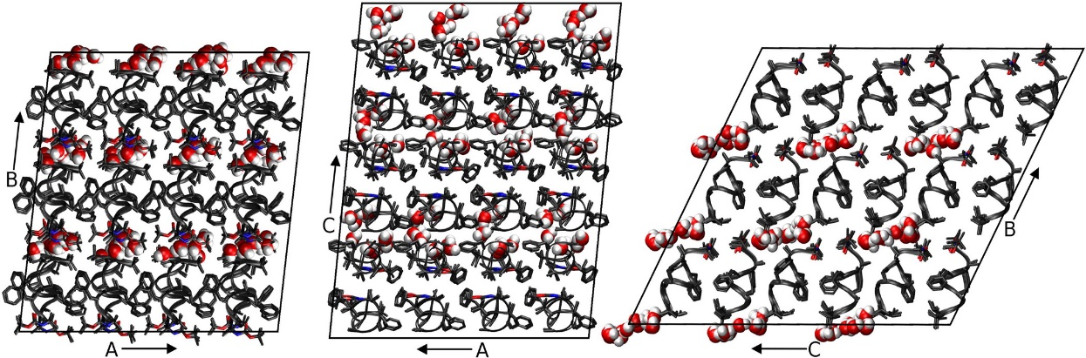

Figure ‑: Three views of the simulated fav8 crystal lattice. 36 unit cells are stacked in a 4 × 3 × 3 arrangement in the triclinic supersystem; each unit cell comprises two fav8 decapeptide helices arranged roughly parallel to one another. Each view looks down one axis of the lattice, and borders of the simulated system are marked in black lines. The peptide backbone is shown in ribbons or in licorice form in the case of Aib and terminal blocking residues. Water molecules are illustrated in space-filling form; we find that the water forms continuous channels running through the lattice along the a axis.

#### MD Simulations

Protonation of the peptide structure and construction of molecular topology and coordinate files for the crystal supercell was done using the tleap module of Amber11 and Reduce.[82] The peptide in the simulation supercell was modeled using parameters of the Amber ff99SB force field[30] and the TIP3P water model.[83] The Boc, Aib, and Ome residues are not found in the standard Amber force field, but we obtained charges for these residues using RESP fitting[84] and took other parameters from similar compounds described by ff99SB; details are in the Supporting Information.

System optimization, equilibration, and production dynamics were performed using the PMEMD module of AMBER11. When the system volume was allowed to vary, constant pressure was maintained by a Berendsen barostat[36] with isotropic pressure scaling (at the time this study was conducted, anisotropic scaling was not available in Amber for a triclinic box. This feature has since been added). Constant temperature was maintained during all dynamics with a Langevin thermostat[37] (collision frequency of 1/ps) at the experimental crystal diffraction temperature of 294 K. To avoid artifacts arising from the reuse of the same random number sequences,[85] a different random number generator seed was used each time a simulation was restarted. Force calculations were performed with a 9.0 Å real space cutoff in the context of periodic boundary conditions, smooth particle-mesh Ewald electrostatics,[45], [86] and a homogeneity assumption for long-range van der Waals contributions. The SHAKE[39] and SETTLE[38] algorithms were used to constrain the lengths of bonds to hydrogen and the internal geometry of rigid water molecules, respectively.

System equilibration was carried out using the following scheme: First, the conformations of peptide residues, including added hydrogens, were relaxed via 100 steps of steepest-descent optimization followed by 900 steps of conjugate gradient optimization with 256 kcal/(mol-Å2) position restraints applied to solvent molecules. Next, the entire system was optimized in the same manner but with no restraints. Initial restrained dynamics were performed at constant volume for 50 ps with a 1.0 fs time step and 256 kcal/(mol-Å2) restraints on all peptide heavy atoms, followed by another 225 ps of restrained dynamics at a 1.5 fs time step during which restraints were gradually reduced to 4.0 kcal/(mol-Å2). Next, restrained dynamics were performed at a pressure of 1 bar for 400 ps using a 2 fs time step as restraints on peptide heavy atoms were gradually relaxed from 4.0 to 0.0625 kcal/(mol-Å2). Unrestrained production dynamics were propagated at a 2 fs time step, matching the final phase of equilibration in which all restraints had been reduced to zero.

Production simulations were carried out on clusters of 48 core 2.2 GHz Opteron CPUs provided by the Rutgers BioMaPS High-Performance Computing facility and also on a private cluster of serial GPUs. A total of 4 simulations were propagated for 1.6–2.4 μs each.

#### Analysis of Data

Data analysis was carried out using in-house scripts and the Amber11 ptraj module for MD trajectory analysis. Two root-mean-square deviation (RMSD) metrics which we refer to as “ASU RMSD” and “lattice RMSD” were calculated using the Kabsch algorithm.[87], [88] They are described briefly in Section , and more details can be found in ref 15. Secondary structure was determined using the DSSP[89] algorithm. Experimental electron density maps were calculated from experimental intensities kindly provided by S. Aravinda and P. Balaram, coordinates and anisotropic displacement parameters found in the Supporting Information of Aravinda et al., 2003 by zero-cycle unrestrained maximum likelihood refinement using Refmac.[90] Molecular refinement was performed with Phenix.[91], [92] The Visual Molecular Dynamics (VMD) program[93] and ccp4mg[94] were used for visualization and image generation. Approaches to calculating B-factors are described in Section 3.

To calculate average simulation electron density and structure factors, an evenly spaced selection of 4000 snapshots was taken from the final 2 μs of the longest of our simulation trajectories, amounting to 144 000 conformations of the ASU. Electron density maps were generated directly from each of these conformations using the CCP4 program SFALL.(39, 40) For each map-generation run, all 36 unit cells for the given time point were included in the calculation using a unit cell repeat that was an integral reduction of the simulation cell. For any given time point in the simulation the B-factors of all the atoms are formally zero, but this presents certain problems in calculating electron density because the constant “c” term in the conventional Cromer–Mann reciprocal-space atomic form factor tables(41) becomes a Dirac δ-function in real space. This results in a singularity when plotting the electron density onto a grid for the fast Fourier transform calculation of the structure factors.(40) To avoid this singularity, a B-factor of 15 was assigned to all atoms (large enough to avoid aliasing errors) before calculating the electron density maps. Despite the slightly different cells (due to simulation in the NPT ensemble, see Section ), all of these maps were calculated to have the same number of grid points: 96 × 108 × 120.

Structure factors were calculated from each of these maps, and the translation needed to optimally superimpose each time point in the simulation onto the published structure was determined by deconvolution in reciprocal space. This was necessary because the “origin” is not restrained and drifts slowly throughout the simulation, so that averaging electron density in real space (or structure factors with phases in reciprocal space) would eventually “blur” itself down to a constant (the average electron density of the crystal), driving all structure factors to zero. Specifically, the complex structure factors calculated from the published atomic coordinates were divided by the complex structure factors obtained from the electron density of the simulation time point. The map calculated from these “quotient” structure factors is the correlation function of the two parent maps, and the tallest peak in this map is located at the optimal translation to “align” them.

After determining these optimal shifts, the atoms from each simulation time point were translated appropriately, and the electron density maps recalculated. The average of all these electron-density maps was then taken, and a final Fourier transform was computed to obtain the expected structure factors of a single crystal mosaic domain comprised of all 144 000 ASUs represented in the trajectory. The CCP4 program CAD was used to remove the contribution of the B-factor = 15 from the structure factors. The R-factor of these simulation structure factors with the observed structure factors was calculated after applying an optimal scale and B-factor with the CCP4 program SCALEIT.(39, 42)

### Results and Discussion

Dynamics of the fav8 peptide crystal lattice were analyzed on the microsecond time scale in a system comprising 36 unit cells stacked 4 × 3 × 3. Simulations were run in quadruplicate (one 2.4 μs trajectory, and three additional 1.6 μs trajectories). The simulated system retained the unit cell angles and aspect ratios of the crystal due to the isotropic pressure rescaling of cell dimensions, but the corresponding atoms in each of the 36 unit cells were otherwise allowed to move independently. In addition to structural comparisons, we computed isotropic B-factors for all peptide heavy atoms and again found close agreement with the experiment. Finally, we turned our attention to dynamics of water molecules and found them to migrate between different unit cells, indicating that the electron density of water molecules in the fav8 crystal arises from many distinct molecules interchanging positions during the experiment.

#### Comparison to Experimental Structure

It is less straightforward than one might think to quantify the agreement between a crystal lattice simulation and the refined structure inferred from X-ray diffraction data. Unit cell volume, positional RMSD, average unit cell structure, and thermal vibrations provide a strong set of indicators as to the simulation’s accuracy. Positional RMSD was measured in two distinct ways. First, we define “ASU RMSD” as

|  |  |  |
| --- | --- | --- |
|  |  | (Eq. ) |
|  |  |  |

where the inner summation runs over N atoms, the outer summation runs over M ASUs, is the position vector of an atom in the simulation snapshot, is the experimentally determined position vector of that atom, and the statistic is calculated after rotational and translational alignment of the backbone heavy atom coordinates in each ASU against the crystal fav8 structure using the Kabsch algorithm.(31) This RMSD, which was computed for backbone and side-chain atoms (with provisions for the symmetry of atoms in Phe rings and the Boc terminus), accounts for all disorder arising from bending and distortion of individual fav8 monomers and disorder arising from changes in the contacts between the pair of monomers that composes each ASU. Second, we compute a “lattice RMSD” which follows the same formula as the ASU RMSD; however in this case ASUs are not aligned in the traditional manner. Instead, ASU’s are superimposed by first center of mass aligning each supercell and then reversing the translational space group operations by which the simulation supercell was constructed. The center of mass alignment is necessary due to translational drift of the origin of the supercell, since its potential energy is translationally invariant. This metric captures rigid-body librations of the peptides in the unit cell and lattice distortion between fav8 monomers in different unit cells, since atoms in different unit cells are not constrained to move in any symmetric fashion. Figure 2 plots these RMSD measurements over the course of the 2.4 μs trajectory. If one focuses on a much shorter time scale, the RMSD of both the backbone and of the side-chain atoms appears to converge to 0.5/0.7 Å after as little as 20 ns of dynamics, but Figure 2 shows that these metrics rise suddenly at 400 ns to 0.6/0.75 Å, levels which are maintained for the remainder of the simulation. (Convergence of the other three trajectories is illustrated in Figure S1; backbone and side-chain RMSDs in these simulations are comparable to that of the 2.4 μs trajectory.) Also after roughly 400 ns, backbone lattice RMSD converges to about 0.75 Å. RMSD adds in quadrature, and therefore these results indicate that there is an approximately equal contribution to overall RMSD from intra- and intermolecular distortions. All further analyses were performed after discarding the first 400 ns of simulation.

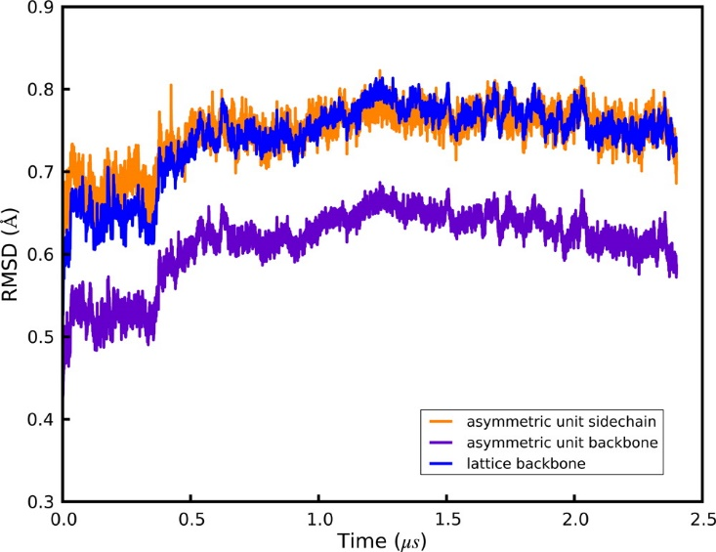

Figure ‑. Positional RMSDs of heavy atoms relative to the X-ray structure. Details of each metric are given in the main text. All quantities are plotted over the course of a 2.4 μs simulation, and plots for three additional 1.6 μs simulations are given in the Supporting Information. Purple: ASU RMSD for backbone (N,CA,C) atoms. Orange: ASU RMSD for side-chain heavy atoms. Blue: lattice RMSD for backbone atoms.

The crystallographic raw data are a diffraction pattern that is the averaged result over time and over three-dimensional space of the repeating unit cell. To set our analysis in line with the experimental results, we calculated an average structure of the simulated unit cells using the same reverse symmetry operations and Phe/Boc atom equivalencies that had been used to compute lattice and ASU RMSDs. A superposition of the resulting average structure with the X-ray result is shown in Figure 3. The RMSD of backbone and side chain heavy atoms for this average structure is 0.32/0.45 Å, which is much lower than the RMSD of the individual snapshots cited above. Thus, structural deviations can occur at instantaneous snapshots of the simulation, while the time-averaged structure maintains close similarity to the X-ray model, as is consistent with a dynamic interpretation of the crystal. In the average structure, monomer A agrees nearly perfectly (0.15/0.17 Å backbone/side chain RMSD) with the refined X-ray structure, and only the C-terminus of monomer B (residues B8–B10) is seen to deviate significantly (residues A1-B7 0.20/0.21 Å, residues A1-B8 0.21/0.38 Å, residues A1-B9 0.29/0.44 Å; indicating disorder in only the side chain of residue B8 and in both backbone and side chain of residues B9/B10). As shown in Figure S3, the deviations in monomer B are in fact confined to a subset of 9 of the 36 unit cells. The average heavy atom RMSD of monomer B in this subset is 0.84 Å, while in the remaining cells it is 0.51 Å (for comparison, the average RMSD of monomer A in all cells is 0.23 Å). Furthermore, if the C-terminus (residues B8–B10) is removed from the calculation, the RMSD of the subset of 9 unit cells drops from 0.84 to 0.63 Å and for the remaining cells from 0.51 to 0.23 Å, identical to the average RMSD of monomer A (0.23 Å). As is evident in Figure 3 and is discussed more fully below, the simulation reflects an ensemble of two structural populations characterized by differences at the C-terminus of monomer B.

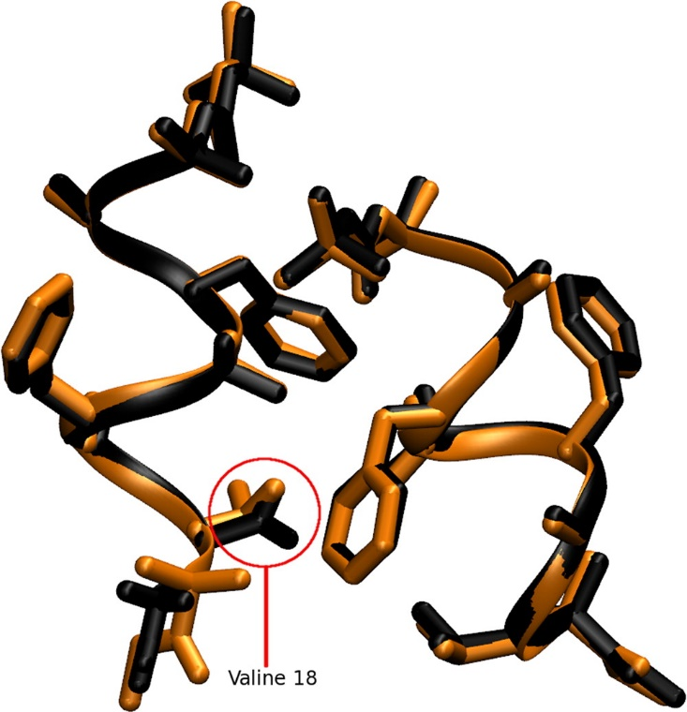

Figure ‑: Superposition of the average simulated structure (black) against the structure refined from diffraction data (orange). The first decapeptide (monomer A) matches the X-ray data closely; and monomer B deviates in the side-chain conformation of its Val residue and in the helicity of its C-terminal backbone residues B6–B10.

Direct comparison of electron densities provides a more useful criterion for a structural comparison of the simulation against experiment, since it is X-ray scattering from an average density that determines the intensities of the observed diffraction peaks. For this, we calculated the electron density of 4000 evenly spaced snapshots taken from the simulation trajectory, amounting to 144 000 conformations of the ASU. The electron densities were optimally aligned to the crystallographic origin, as described in Section , to account for the slow drift of the origin during the simulation. The average of all these electron-density maps was then taken, and a final Fourier transform computed to obtain the expected structure factors of a single crystal mosaic domain comprised of 144 000 ASUs. Comparison to the observed structure factors using the CCP4 program SCALEIT(39, 42) resulted in best-fit scale = 1.09 and B = −0.7948, indicating that the overall Wilson B-factor of the real crystal was remarkably similar to that predicted by the simulation. The R-factor of these calculated structure factors with the observed structure factors was 28% to 1.0 Å resolution and 21% to 2.0 Å resolution. After applying the 4-σ intensity cutoff traditionally employed when computing R-factors for small molecules, the agreement of our simulation-averaged structure factors with observed structure factors was 23% to 1.0 Å and 20% to 2.0 Å. This is remarkably good agreement considering that the observed structure factors were not used to bias the simulation run, qualifying this R-factor as not just an R-free(43) but as the R-vault statistic proposed by Kleywegt.(44) Given the clearly anomalous behavior of the C terminus of the B chain in the simulation, some disagreement with the observed structure factors is expected, so the close agreement of the observed structure factors with those predicted by averaging over this unbiased MD simulation is remarkable.

We next refined the fav8 coordinates against the structure factors from the simulation density, which yielded an R-work/R-free of 9.6%/12.1%. This is higher than the reported experimental R-factor of 8%(18) primarily because the simulated crystal has more disorder than the experimental one, as discussed below. This refinement represents an “expected refined structure given the simulation density” and is arguably the best vehicle for making structural comparisons between theory and experiment, since X-ray scattering is determined by the average electron density and not by any average of the coordinates themselves. Table 1 presents RMSD statistics between this model and coordinates obtained by refinement against experimental density and by the more common procedure of simply averaging the coordinates over the simulation snapshots. (For consistency we use results from our rerefinement against experimental data; the RMSD of our rerefined structure vs the one originally deposited is 0.04/0.05 Å backbone/side chain.) The RMSD of the simulation-refined model to the experiment-refined model was 0.21/0.30 Å backbone/side chain, which is lower than the values (0.28/0.44 Å) obtained by coordinate averaging. Furthermore, calculation of the mean obtained by comparing simulation snapshots against each of these three structures yield higher RMSDs showing that while instantaneous simulation coordinates can differ to a greater degree from the refined model, the overall simulation average remains close. Therefore, a simulation-refined model provides a good representation of the average simulation structure while avoiding the geometric irregularities incurred with the more commonly employed coordinate averaging.

|  |  |  |  |  |
| --- | --- | --- | --- | --- |
|  | Exp. refined | Sim. refined | Sim. average | Average snapshot |
| Experiment refined | 0.0/0.0 | 0.205/0.301 | 0.283/0.423 | 0.462/1.180 |
| Simulation refined |  | 0.0/0.0 | 0.129/0.282 | 0.387/1.121 |
| Simulation average |  |  | 0.0/0.0 | 0.372/0.822 |

Table ‑. RMDS Values between Various Structures. The statistics in each box are the backbone (first) and the all heavy atom RMSDs. Terminal capping residues were excluded from the calculation. “Experiment-refined” is the model obtained from refinement of fav8 against the experimental density in Phenix. “Simulation refined” is the structure obtained by refinement against the simulation average density. “Simulation average” is the structure composed of the mean coordinates of each atom over the entire length of the 2.4 μs simulation. The last column presents the average backbone/side chain RMSD of all simulation snapshots against the single structure for that row.

One global parameter which indicates how well a crystal lattice simulation is reproducing the crystal is its volume. In previous work, we have sought to reproduce this parameter arbitrarily to within 0.3% of the experimental result(15) and found that the choice of simulation models has a significant impact on the outcome.(17) As before, our simulations were performed in an NPT ensemble using a Berendsen barostat and Langevin thermostat. The experimental volume of 2795.8 Å3 was maintained at a mean of 99.89 ± 0.003% of experiment (Figures 4 and S2). It is noteworthy that this was achieved without the addition of extra water molecules or other solvent. The fav8 X-ray structure is of high resolution, and the unit cell itself is very compact, but perhaps most importantly the unit cell is very dry for a proteinaceous crystal.

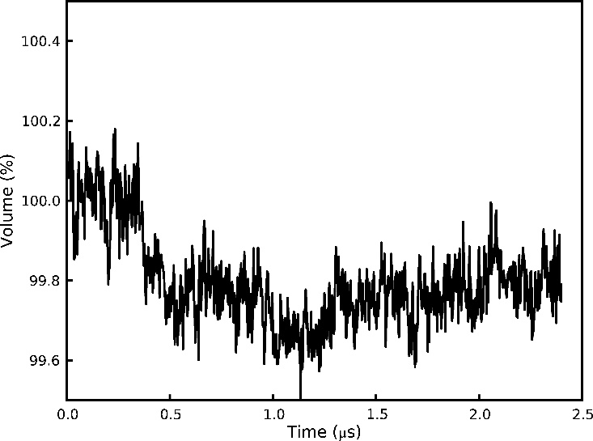

Figure ‑: Volume of the supercell over the course of a 2.4 μs simulation. Following an initial settling, the system volume reaches an equilibrium value roughly 0.2% below the volume of the unit cell observed by X-ray diffraction. Instantaneous fluctuations of the volume have amplitudes of an additional 0.2%.

Crystallographic B-factors may be loosely interpreted as indicators of the thermal motion occurring in a crystal structure, but it is more accurate to say that B-factors can arise both from movements of the individual atoms within an ASU (intra-ASU or “local” disorder) as well as from rigid-body librations and lattice distortion (inter-ASU or “global” disorder). Isotropic B-factors are related to the mean-squared fluctuations of atoms around their average position by the formula:(45)

|  |  |  |
| --- | --- | --- |
|  |  | (Eq. ) |
|  |  |  |

where ⟨u2⟩ is the three-dimensional mean square deviation and B is the thermal isotropic B-factor. In crystallographic refinement models, an atom that is posited to be responsible for the surrounding electron density must exhibit a distribution of positions; this distribution is estimated from the available electron density, and the mean squared fluctuations of the distribution then imply a B-factor. The difference between contributions to the B-factors arising from “local” and “global” disorder, which can be discriminated by MD, is related to the difference between calculations of ASU and lattice RMSD.(15) We computed B-factors for the 2.4 μs simulation using both methods as described in ref 26. Briefly, “RMSD B-factors” are calculated by first translationally and rotationally fitting each snapshot of each ASU during the trajectory to the crystal ASU and then calculating mean positions and positional variance. “Reverse symmetry” B-factors are calculated by reversing the translational space group operations by which the simulation supercell was constructed to align each snapshot of each ASU but without any translational/rotational fitting to minimize structural RMSD. The former method thus calculates positional variance stemming from intra-ASU fluctuations, while the latter also takes account of contributions from rigid-body librations and lattice distortion (i.e departure from crystal symmetry in the relative positions of the ASUs to each other). The computed B-factors are compared to the X-ray model in the left-hand side of Figure 5. If global disorder is removed from the calculation (“RMSD B-factors”), the simulation would underestimate the B-factors of most atoms. However, when disorder from rigid body libration is included in the B-factor estimates (“reverse symmetry B-factors”), the results for monomer A are in much better agreement with experiment (backbone B-factor RMSD 0.66 vs 1.73 for reverse symmetry and RMSD B-factors, respectively). Similar results are observed for monomer B except for C-terminal residues B6–B10. These residues undergo changes in their helical state that are coupled to water motion in the crystal lattice (discussed in detail in the following section). The right-hand side of Figure 5 presents the B-factors obtained from refinement against the average simulation density. These are generally in close agreement with the “reverse symmetry” B-factors that directly reflect the mean square fluctuations of the coordinates among the simulation snapshots. The refinement-derived and coordinate fluctuation-derived B-factors agree less well in the C-terminus of monomer B, where the simulation samples two different structural conformations. Whereas the coordinate-based B-factor statistic includes the large fluctuations between the two conformations, the refinement algorithm only models one conformation, but its B-factors underestimate the actual magnitude of fluctuations in the underlying simulation. The underlying disorder that is then not reflected in the B-factors gives rise to a higher R-work/R-free statistic. Five cycles of occupancy refinement with an alternate conformation for residues 15–20, reflecting the minor population found in the simulation, reduced R-work/R-free to 7.7%/9.2% (9.6%/12.1% without the alternate conformation) and converged to a relative occupancy of 71%/29% for the major and minor population of the ensemble, in close agreement with the relative ensemble populations of 72%/28% derived directly from the simulation.

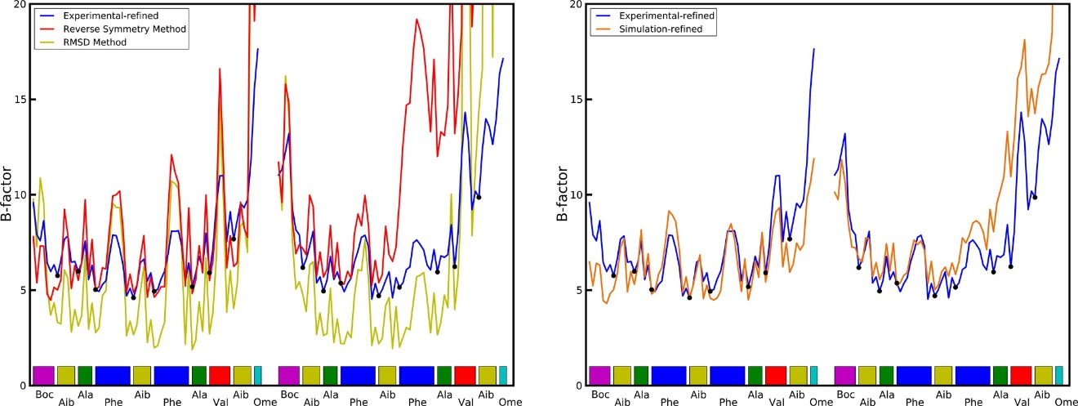

Figure ‑. Left-hand plot: Comparison of computed atomic B-factors obtained over the course of the 2.4 μs trajectory to experimental data. “RMSD” B-factors only account for intra-ASU fluctuations and consistently underestimate experimental values. “Reverse symmetry” B-factors account for both local and global (inter-ASU) fluctuations and more closely match experiment. See text for further explanation of the two methods. Right-hand plot: Comparison of B-factors obtained from refinement against the experimental density and against the simulation average density. Cα atoms are indicated with dots.

#### Crystal Solvent Dynamics

While the RMSD of the peptide converges very quickly in the simulation, the RMSD of the solvent does not converge even after >2 μs of simulation. A visualization of the crystal reveals that the packing of the crystal is such that “channels” for water molecules are formed within the crystal. These channels are colinear with lattice vector a and provide little steric hindrance for waters to move between adjacent unit cells. The waters are seen to rapidly diffuse between unit cells through the channels. A careful inspection of the trajectory reveals that the water molecules do not flow smoothly through the channels but rather make sudden hops between positions in adjacent unit cells. Trajectory frames were recorded every 10 ps, and in this time water molecules are sometimes seen to move by several angstrom.

A diffusion constant was calculated for the water from a linear fit of the cumulative mean square displacement of the waters from their initial position using the Einstein diffusion equation for one dimension:

|  |  |  |
| --- | --- | --- |
|  |  | (Eq. ) |
|  |  |  |

Plots of the mean square displacement in each direction of space, shown in Figures 6 and S8, do indeed demonstrate that the water is dynamic along the channels, while it is restrained from moving in other directions by the channel walls. The channels can be estimated to be 3–4 Å wide based on a converged mean square displacement of about 12 Å2 in the directions perpendicular to the channel axis. Diffusion along the channel in the four simulations ranged from 1 × 10–8 to 3.4 × 10–8 cm2/s, with a mean diffusion rate of 2.5 × 10–8 cm2/s calculated after discarding the first 400 ns of each trajectory for equilibration. This is roughly 2000 times slower than the reported 5.2 × 10–5 cm2/s diffusion constant of TIP3P water(46) and 1000 times slower than the experimental diffusion constant of liquid water at the same temperature; the waters are dynamic in the simulation, but movement through the channels is constricted. Some variability in water diffusion is evident, as a function of time, in each of the four simulations and particularly in the 2.4 μs trajectory; over the first 400–500 ns, a diffusion constant of 3.6 × 10–8 cm2/s could be calculated, but the rate abruptly changed to 1.0 × 10–8 cm2/s thereafter. A possible connection between these abrupt changes and the disorder in the C-terminus of monomer B is explored later in this section.

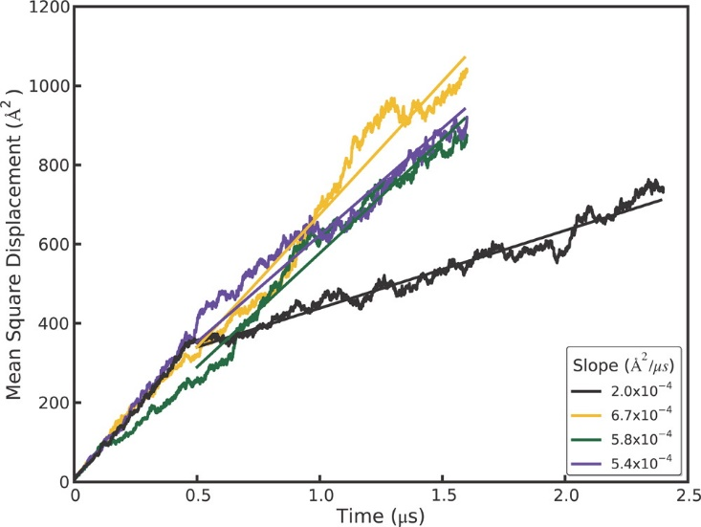

Figure ‑. Mean square displacements (MSD) of water molecules over the course of three 1.6 μs and one 2.4 μs simulation trajectories. The slope of the linear fit used to compute the diffusion coefficient is shown in the box.

Further analysis in Figure 7 shows that the water molecules occupy several distinct sites within each unit cell along a channel. Hydrogen bonding between water molecules or to peptide backbone atoms is expected to be the primary determinant of these energy minima. Although the average number of waters per unit cell is set to be four in our simulation, the water dynamics produce a heterogeneous population of individual unit cell states; at any given time unit cells may contain as few as zero and as many as eight water molecules. A histogram of the water states occurring throughout the simulation (Figure 7) shows that although 4 is the average state, 5 is in fact the most populous water state. A direct comparison of the cumulative water density from simulation (Figure 8, left panel) to the experimental electron density (Figure 8, right panel) reveals close correspondence between the simulation and X-ray data. In both the simulated and experimental structures, two crystallographic waters are located centrally within a compact and spherical lobe of the simulated density, while the other two crystallographic waters are located on smeared, dumbbell-shaped regions of density. Correspondingly, these waters also have 3 times higher experimental B-factors. Both images also reveal a fifth area of water density. No specific water was attributed to this density in the X-ray structure, but a partial water occupancy at this position is indicated by the frequently occurring 5-water state (Figure 7) and is consistent with the experimental electron density. Furthermore, a meticulous strategy of free refinement of water occupancy identified 17 putative water peaks and converged to a total of 61 electrons or 6 water molecules altogether. The final R-work/R-free statistics for this model were 4.1%/5.8% compared to 6.5%/9.2% for refinement of the 4-water model. Therefore, although exchange of the water molecules between unit cells is not directly reflected in the refined fav8 structure, a model in which exchanges and migration occur continuously is fully consistent with the X-ray diffraction data and leads to improved agreement with the observed structure factors.

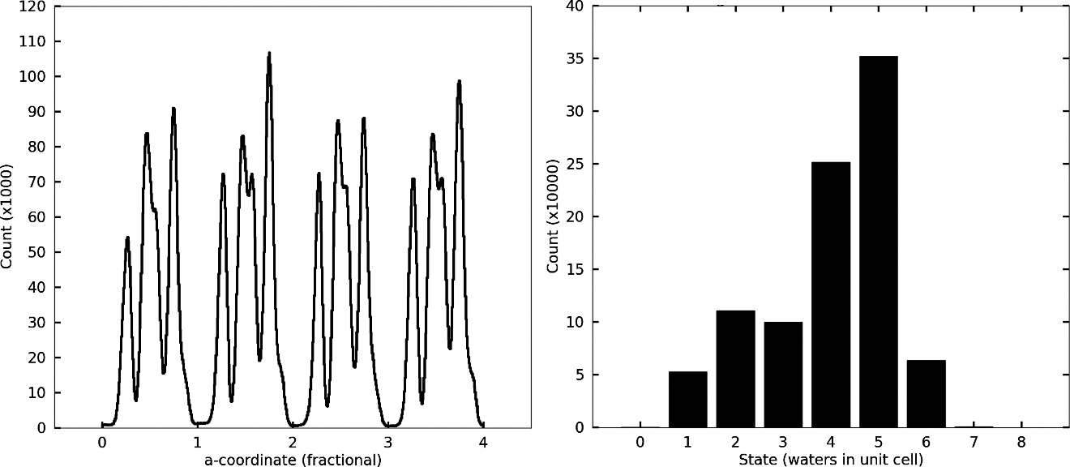

Figure ‑. Water densities in the channels observed in simulations. The left-hand panel depicts the density of waters as a function of the a crystal vector coordinate, summed over all nine channels running across the simulation box. The abscissa is numbered according to unit cell fractional coordinates. The right-hand panel plots a histogram of times which each unit cell in the simulation was observed to be associated with a particular number of waters during the 2.4 μs trajectory.

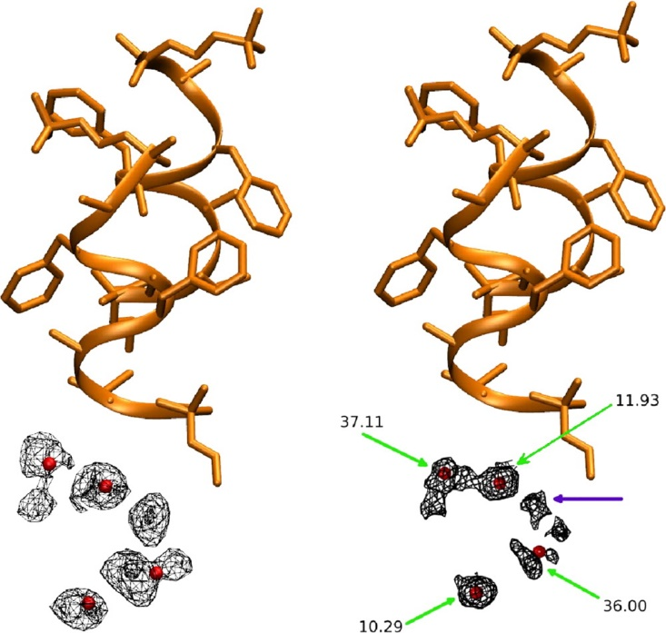

Figure ‑. Water density observed in the 2.4 μs simulation, obtained by using crystal symmetry operations to superimpose all simulated waters onto a single unit cell. Crystallographic peptide is shown in orange and crystallographic water oxygens as red spheres. Left-hand panel shows the simulated water density (mesh encloses 90% of water density), right-hand panel shows the electron density obtained by X-ray diffraction (2mFo–DFcalc map at 0.8σ). Green arrows point to crystallographic waters and indicate their experimental B-factors, and purple arrow shows a fifth lobe of water density (see text). Produced with VMD and ccp4 mg.

To investigate the tendency of unit cells to take on varying amounts of water, residence times were calculated for each of the water states. We used different smoothing windows to eliminate noise, but regardless of the smoothing window, the one water state exhibits by far the longest residence time (Figure 9). Closer examination of individual water cells revealed that unit cells were rarely occupied by only a single water, but when such dry states did occur, they tended to persist for hundreds of nanoseconds or even indefinitely. A visual inspection of the trajectory revealed that these dry unit cells undergo a conformational change upon acquiring the defect, strongly associated with two other characteristics: elevated propensity for a 310 helical conformation in monomer B and the χ1 dihedral of Val B8 flipping to gauche(-). By creating a vector of zeros (state absent) and ones (state present) for all unit cells and all frames of a trajectory, the Pearson correlation coefficients between various states can be computed. Over the course of the 2.4 μs trajectory, the dry state correlates with monomer B 310 helicity by a coefficient of 0.986 and with the Val B8 gauche(-) rotamer state by a coefficient of 0.965, and the correlation between the Val B8 gauche(-) rotamer state and monomer B helicity is 0.967 (see Figure S10). It is difficult to determine whether one of these characteristics leads to another, but we can quantify the time by which the correlations develop. If the correlation between states A and B is 0.95 over a period of 2 μs but only 0.3 when averaged over many short intervals of 10 ns, it can be said that state A or B does not lead to the other within 10 ns, although the two are associated in the long term. Formally, we computed the Pearson correlations between the three states over windows of up to 100 ns from all trajectories using the formula

|  |  |  |
| --- | --- | --- |
|  |  | (Eq. ) |
|  |  |  |

For a given window size, the summation runs over all the nonoverlapping windows in the trajectory, and cov(x,y) denotes the covariance of the vectors x and y. The elements of x and y are the average values of the given characteristic in the window for each of the unit cells. As shown in Figure 10 the correlation between monomer B 310 helicity and the dry state rapidly approaches its long-term asymptotic correlation, whereas the other two correlations take much longer to develop, implying that C-terminal helicity and wet or dry unit cell states are tightly coupled, whereas the gauche(-) Val B8 rotamer conformation may be favored by monomer B 3(10) helicity or the dry state but is not a gating motion leading to either.

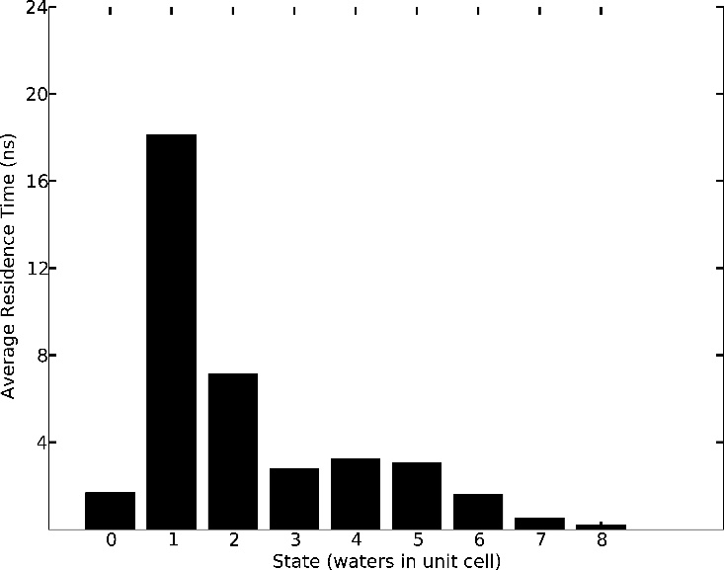

Figure ‑. Mean residence times for each occurring water state over the course of the 2.4 μs trajectory. The one and two water states, though much less frequent than other states (cf. Figure 7), exhibit very long residence times, in some cases extending into hundreds of nanoseconds.

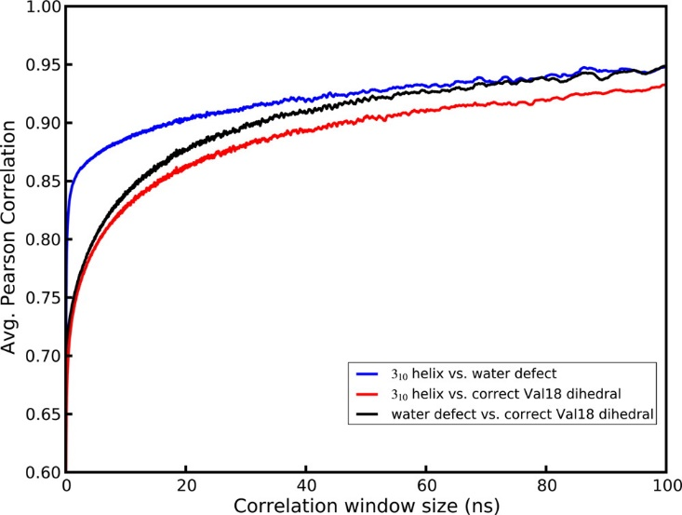

Figure ‑. Correlation, as a function of measurement time, between the presence of a Val B8 gauche(-) rotamer, 1- or 2-water defects, and 310 helical conformation. A conformational change of monomer B helicity is found to be more strongly connected to water defects than either condition is to the Val B8 rotamer state.

In our simulations, there appear to be two structural subpopulations of unit cells. The major population, about 75% of the cells, maintains the crystallographic C-terminal α-helical conformation, a wet unit cell with 3–5 water molecules, but puts the side-chain of Val B8 in a noncrystallographic trans conformation. The minor population of unit cells displays increased propensity for a 310 helical conformation in monomer B, leading to high B-factors and higher positional RMSD in these residues, and retains only one or two waters per unit cell; the minor population also places the Val B8 side-chain in its crystallographic gauche(-) rotamer. The disagreement in average structure and B-factors leads us to conclude that the minor population is an artifact of the calculation. For the Val B8 rotamer, however, both the Fo–Fc map and a Ringer(47) plot shown in Figure 11 provide evidence of a minor trans conformation for Val B8 in the original fav8 data. Furthermore, the trans conformation is the favored conformation of valine generally,(48) so the preponderance of this state in our simulations is unsurprising. Evidence for the occurrence of the alternate valine rotamer in the crystal is provided by occupancy refinement of the model with two alternate conformers. Standard anisotropic refinement of the model with and without the alternate valine conformer produced an R-work/R-free of 4.11%/5.84% (without the alternate trans rotamer) and 3.89%/5.53% (with the alternate rotamer). The occupancy of the trans/gauche(-) rotamer refined to 74%/26% ± 2%, which is the reverse of that seen in the 2.4 μs simulation (32%/68%), suggesting that the relative energy of the gauche(-) conformation is about 1 kcal/mol too negative in the simulation, but that finding both conformers present is to be expected.

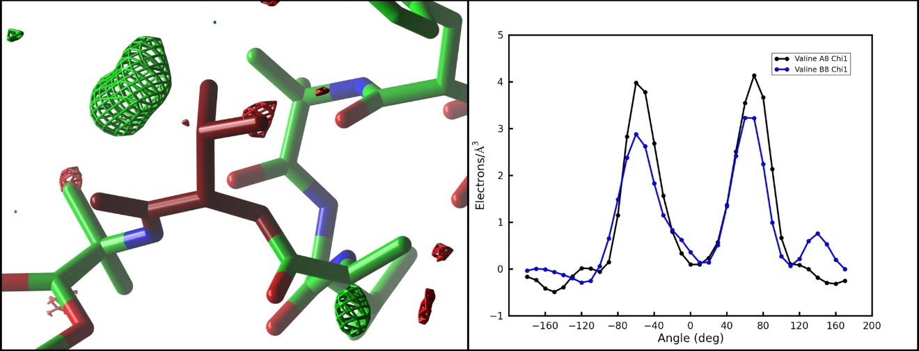

Figure ‑. Experimental electron density of the Val B8 side chain reveals evidence for partial occupancy of the trans rotamer that is preferentially sampled in our simulations. The left-hand panel shows the Fo–Fc map sampled on a 0.50 Å3 grid and contoured at 4.0 (green) and −4.0 (red) in the vicinity of Val B8 (burgundy). The valine side chain is seen in the experimentally determined gauche(-) rotamer. A region of positive density indicates the missing alternate trans rotamer sampled in our simulation. Image generated with ccp4 mg. The right-hand panel shows the output of Ringer(47) for the χ1 angle of Val A8 (black) and B8 (blue). An additional peak in the latter case points to the presence of a partially occupied trans rotamer in the electron density.

The coupling between C-terminal helicity and the dry states offers a possible explanation for the sudden shifts in the water diffusivity seen in Figure 6. During the 2.4 μs simulation, after about 400 ns of dynamics, 9 of the unit cells in the crystal enter a prolonged 1 water defect state. The supercell has nine water channels, and dry cell defects are distributed one per channel. Near the end of the trajectory, from 2 to 2.4 μs, some cells are seen to escape the water defect: with only 6 dry unit cells remaining, water diffusivity increases by almost 2-fold. These observations indicate that sampling of the one water defect corresponds to slowing of the water flow in a given channel. Moreover, two concurrent water defects are very rarely observed in one water channel. We hypothesized that because the water defect corresponds strongly to 310 helical sampling and because the 310 helix is a more tightly wound but longer helix, it could be jutting into the channel to sterically impede water movement at that point. Effectively it would serve as a block in the channel which would reduce overall water diffusion. However, expelling waters at the defect site would force them into adjacent cells and inhibit other cells from drying along that particular channel.

### Conclusions

We present here results of 6 simulations of a peptide crystal composed of 36 unit cells in a P1 crystal system. Our results offer some of the most detailed agreement to date between a simulation and the diffraction data taken from a biomolecular crystal. In all, the peptide crystal supercell was simulated for 9.6 μs. Our results show that the Amber ff99SB force field coupled with a TIP3P water model maintains the integrity of the crystal structure very well. Volume, RMSD, and average structure all agree well with experiment. Remarkable B-factor agreement is obtained, except for the final residues of the second peptide. Both the aromatic t-stacking and hydrogen-bonding interactions that stabilize crystal packing are maintained. Methodologically, refinement against the average simulation density yields an optimal representation of the average simulation structure and avoids the pitfalls of the more commonly employed coordinate averaging over the simulation trajectory. Calculation of B-factors from coordinate fluctuations yields close agreement with B-factors from crystallographic refinement only when global disorder and lattice distortion effects are accounted for. On the other hand, B-factors from refinement are found to underestimate coordinate fluctuations where the simulation samples an alternate conformation.

The simulation also provided a glimpse into the hidden dynamics of the crystal. The atomic motions seen in the simulation can be placed into three broad categories. Most of the peptide atoms vibrate around a single average structure (with amplitudes well-described by the experimental atomic displacement parameters.) Atoms at the end of the second peptide visit alternate conformations, and the B-factors obtained by refinement against a single structural model underestimate the extent of this motion. (Some evidence for the alternate conformations is present in the observed electron density, but the simulation appears to exaggerate their importance.)

Water molecules observed in the X-ray structure are not bound to any particular unit cell but rather exchange positions frequently within unit cells and between neighboring cells along solvent channels. The time scale of the simulations permits measurements of this diffusion as well as correlation of protein motion and structural heterogeneity resulting from the migratory crystal defects in unit cells. The dynamic nature of the solvent produces a heterogeneous population of water states with individual unit cells at any given time containing anywhere from zero to eight water molecules. A five water state is seen to occur most frequently, and a fifth lobe of water density is observed corresponding to electron density found in the experimental diffraction data. Somewhat larger defects are also observed in which unit cells dry to only a single water molecule, and these defects appear to slow the diffusion of water throughout entire channels. This transient variability in solvent content offers a reasonable model of the true crystal lattice—the average density of simulated water recovers the crystallographic density with remarkable precision. While traditional crystal refinement to a single ASU gives no indication of water hopping or variation in water content between cells, it is known that mean residence times of single water molecules are short (microseconds even for waters buried deep within a protein cavity).(49-51) This behavior is explicitly revealed here by the MD simulations. Moreover the simulations lead to the identification of additional water positions and improved refinement statistics (R-work/R-free), thus demonstrating the potential utility of all-atom crystal simulations in the interpretation of experimental electron density. We thus provide evidence for the potential of MD to contribute additional structural information to the interpretation of crystallographic data that would otherwise remain lost.

An ensemble of two structurally different populations of unit cells is observed. About 25% of the unit cells are characterized by increased 310 helical propensity, decreased water content (containing only 1 or 2 waters) and occupancy of the gauche(-) χ1 rotmer of Val B8. These three characteristics are highly correlated over the course of the microsecond long simulations, but it is unclear which of them might be the driving factor. Because 310 propensity is not seen in the sequentially identical monomer A, we believe that this behavior is not driven by the valine dihedral but rather must be caused by factors external to the monomer itself. The water channel at the C-terminus provides a spatial opening for the tighter but longer 310 helix to form, and variations in water content or close contacts with an Aib 5 side chain in monomer A can affect hydrogen bond-stabilizing interactions in the helix. Nevertheless, the presence of this conformational ensemble is only partly consistent with the experimental data, which leads us to believe that part of this observation is a simulation artifact. Careful examination of the experimentally derived electron density and refinement of a model with an alternate conformation does indeed support the presence of a minor population of the alternate valine rotamer. This is consistent with recent results from the Ringer program,(47) showing that 18% of a test set of pdb structures contained unidentified alternate conformations. As discussed above, the simulated water density also closely tracks the diffraction data. However, the disagreement in B-factors observed in the C-terminus of monomer B indicates that a simulation artifact is present. There is also no substantial evidence in the experimental electron density for the presence of both 310 and α-helical varieties of the second monomer. Thus we conclude that the observed correlation between the unit cell water content, the Val B8 rotamer, and the helical conformation of the molecule is an artifact of the simulation. This is valuable information for further work on improved force field models for MD. A fine equilibrium of protein–protein and protein–solvent interactions drives the formation of the various types of helices,(52) and we suspect that further fine-tuning of hydrogen-bond treatment and solvent parameters in current force field models is necessary.(53, 54)

Thus the development of all-atom crystal simulations requires continued work. More simulations on both small and large structures are needed. We are also continuing investigation of the fav8 peptide with simulations of varying water content as well as simulations using the all-atom AMOEBA(55-57) force field to elucidate the interactions leading to the alternate unit cell population. Taken together, our results demonstrate that MD simulations of crystals possess strong potential as both a tool for validating next generation force fields against experimental data and as a powerful tool for extricating additional information about biomolecular structure and dynamics from diffraction data.

### Supporting Information

Parameters for nonstandard amino acids; simulation input files for Amber programs; additional figures analyzing RMSD, volume, and water displacement over time. This material is available free of charge via the Internet at http://pubs.acs.org.

### Acknowledgement

Experimental diffraction data of the fav8 decapeptide was kindly provided by S. Aravinda and P. Balaram. We thank Darrin York, Huanwang Yang, and Joe Marcotrigiano for helpful discussions. This work was supported in part by NIH grant GM 45811 and by a Rutgers Presidential Fellowship to P.A.J. J.M.H. is also supported by the National Institutes of Health GM073210, GM082250, and GM094625 and the Integrated Diffraction Analysis Technologies (IDAT) program under contract no. DE-AC02-05CH11231 with the U.S. Department of Energy.

## Fav8 2

Blah blah

## 4lzt

Blah blah

## DNA/RNA

Blah blah

# Applications of molecular dynamics of crystals

## Hairpin

Blah blah

## RnaseA

Blah blah

# Improved crystallographic methods through crystal molecular dynamics

## AFITT

Blah blah

## Phenix-Amber

Blah blah

# Bibliography

[1] B. Rupp, *Biomolecular Crystallography*. New York: Garland Science, Taylor & Francis Group, 2010.

[2] D. Blow, *Outline of Crystallography for Biologists*. New York: Oxford University Press, 2002.

[3] C. Hammond, *The Basics of Crystallography and Diffraction*. New York: Oxford University Press, 1997.

[4] A. McPherson, “A brief history of protein crystal growth,” *J. Cryst. Growth*, vol. 110, no. 1–2, pp. 1–10, Mar. 1991.

[5] P. Ewald, *Fifty Years of X-Ray Diffraction*. Springer, 1972.

[6] M. Eckert, “Max von Laue and the discovery of X-ray diffraction in 1912,” *Ann. Phys.*, vol. 524, no. 5, pp. A83–A85, May 2012.

[7] W. Bragg, “The Specular Reflection of X-rays.,” *Nature*, vol. 90, no. 2250, pp. 410–410, Dec. 1912.

[8] W. L. Bragg, “The Structure of Some Crystals as Indicated by Their Diffraction of X-rays,” *Proc. R. Soc. A Math. Phys. Eng. Sci.*, vol. 89, no. 610, pp. 248–277, Sep. 1913.

[9] J. C. Kendrew, G. Bodo, H. M. Dintzis, R. G. Parrish, H. Wyckoff, and D. C. Phillips, “A Three-Dimensional Model of the Myoglobin Molecule Obtained by X-Ray Analysis,” *Nature*, vol. 181, no. 4610, pp. 662–666, Mar. 1958.

[10] E. N. Maslen, A. G. Fox, and M. A. O’Keefe, *International Tables for Crystallography, Volunme C: Mathematical, Physical and Chemical Tables*, 2nd ed. Dordrecht: Kluwer Academic Publishers, 1999.

[11] R. A. Engh and R. Huber, “Accurate bond and angle parameters for X-ray protein structure refinement,” *Acta Crystallogr., Sect. A*, vol. 47, no. 4, pp. 392–400, Jul. 1991.

[12] R. A. Engh and R. Huber, “Structure quality and target parameters,” in *International Tables for Crystallography. Volume F: Crystallography of Biological Macromolecules*, M. G. Rossman and E. Arnold, Eds. Dordrecht: Kluwer, 2001, pp. 382–392.

[13] R. J. Read, “Improved Fourier coefficients for maps using phases from partial structures with errors,” *Acta Crystallogr. Sect. A Found. Crystallogr.*, vol. 42, no. 3, pp. 140–149, May 1986.

[14] D. W. J. Cruickshank, “The determination of the anisotropic thermal motion of atoms in crystals,” *Acta Crystallogr.*, vol. 9, no. 9, pp. 747–753, Sep. 1956.

[15] B. T. M. Willis and A. W. Pryor, *Thermal Vibrations in Crystallography*. Cambridge, United Kingdom: Cambridge University Press, 1975.

[16] H. M. Berman, J. Westbrook, Z. Feng, G. Gilliland, T. N. Bhat, H. Weissig, I. N. Shindyalov, and P. E. Bourne, “The Protein Data Bank.,” *Nucleic Acids Res.*, vol. 28, no. 1, pp. 235–42, Jan. 2000.

[17] M. Allen and D. Tildesley, *Computer Simulations of Liquids*. Oxford University Press, 1989.

[18] J. Haile, *Molecular Dynamics Simulation: Elementary Methods.* New York: John Wiley & Sons, Inc., 1997.

[19] A. Leach, *Molecular Modelling: Principles and Applications*. Prentice Hall, 2001.

[20] T. Schlick, *Molecular Modeling and Simulation.* New York: Springer, 2002.

[21] C. Cramer, *Essentials of Computational Chemistry*. John Wiley & Sons, Inc., 2004.

[22] D. Frenkel and B. Smit, *Understanding Molecular Simulation: from algorithms to applications.* San Diego: Academic Press, 2001.

[23] B. J. Alder and T. E. Wainwright, “Studies in Molecular Dynamics. I. General Method,” *J. Chem. Phys.*, vol. 31, no. 2, p. 459, Aug. 1959.

[24] A. Rahman, “Correlations in the Motion of Atoms in Liquid Argon,” *Phys. Rev.*, vol. 136, no. 2A, pp. A405–A411, Oct. 1964.

[25] J. A. McCammon, B. R. Gelin, and M. Karplus, “Dynamics of folded proteins,” *Nature*, vol. 267, no. 5612, pp. 585–590, Jun. 1977.

[26] D. A. Case, V. Babin, J. T. Berryman, R. M. Betz, Q. Cai, D. S. Cerutti, T. E. Cheatham, III, T. A. Darden, R. E. Duke, H. Gohlke, A. W. Goetz, S. Gusarov, N. Homeyer, P. Janowski, J. Kaus, I. Kolossváry, A. Kovalenko, T. S. Lee, S. LeGrand, T. Luchko, R. Luo, B. Madej, K. M. Merz, F. Paesani, D. R. Roe, A. Roitberg, C. Sagui, R. Salomon-Ferrer, G. Seabra, C. L. Simmerling, W. Smith, J. Swails, R. C. Walker, J. Wang, R. M. Wolf, X. Wu, and P. A. Kollman, “AMBER 14.” University of California, San Francisco, 2014.

[27] A.-P. Hynninen and M. F. Crowley, “New faster CHARMM molecular dynamics engine.,” *J. Comput. Chem.*, vol. 35, no. 5, pp. 406–13, Feb. 2014.

[28] J. C. Phillips, R. Braun, W. Wang, J. Gumbart, E. Tajkhorshid, E. Villa, C. Chipot, R. D. Skeel, L. Kalé, and K. Schulten, “Scalable molecular dynamics with NAMD.,” *J. Comput. Chem.*, vol. 26, no. 16, pp. 1781–802, Dec. 2005.

[29] B. Hess, C. Kutzner, D. van der Spoel, and E. Lindahl, “GROMACS 4:  Algorithms for Highly Efficient, Load-Balanced, and Scalable Molecular Simulation,” *J. Chem. Theory Comput.*, vol. 4, no. 3, pp. 435–447, Mar. 2008.

[30] V. Hornak, R. Abel, A. Okur, B. Strockbine, A. Roitberg, and C. Simmerling, “Comparison of multiple Amber force fields and development of improved protein backbone parameters.,” *Proteins*, vol. 65, no. 3, pp. 712–725, 2006.

[31] W. D. Cornell, P. Cieplak, C. I. Bayly, I. R. Gould, K. M. Merz, D. M. Ferguson, D. C. Spellmeyer, T. Fox, J. W. Caldwell, and P. A. Kollman, “A Second Generation Force Field for the Simulation of Proteins, Nucleic Acids, and Organic Molecules,” *J. Am. Chem. Soc.*, vol. 117, no. 19, pp. 5179–5197, May 1995.

[32] D. S. Cerutti, W. C. Swope, J. E. Rice, and D. A. Case, “ff14ipq: a self-consistent force field for condensed-phase simulations of proteins.,” *J. Chem. Theory Comput.*, vol. 10, no. 10, pp. 4515–4534, Oct. 2014.

[33] K. Vanommeslaeghe and A. D. MacKerell, “CHARMM additive and polarizable force fields for biophysics and computer-aided drug design.,” *Biochim. Biophys. Acta*, vol. 1850, no. 5, pp. 861–871, May 2015.

[34] J. W. Ponder, C. Wu, P. Ren, V. S. Pande, J. D. Chodera, M. J. Schnieders, I. Haque, D. L. Mobley, D. S. Lambrecht, R. A. DiStasio, M. Head-Gordon, G. N. I. Clark, M. E. Johnson, and T. Head-Gordon, “Current status of the AMOEBA polarizable force field.,” *J. Phys. Chem. B*, vol. 114, no. 8, pp. 2549–64, Mar. 2010.

[35] P. Ren, C. Wu, and J. W. Ponder, “Polarizable Atomic Multipole-based Molecular Mechanics for Organic Molecules.,” *J. Chem. Theory Comput.*, vol. 7, no. 10, pp. 3143–3161, Oct. 2011.

[36] H. J. C. Berendsen, J. P. M. Postma, W. F. van Gunsteren, A. DiNola, and J. R. Haak, “Molecular dynamics with coupling to an external bath,” *J. Chem. Phys.*, vol. 81, no. 8, p. 3684, Oct. 1984.

[37] J. A. Izaguirre, D. P. Catarello, J. M. Wozniak, and R. D. Skeel, “Langevin stabilization of molecular dynamics,” *J. Chem. Phys.*, vol. 114, no. 5, p. 2090, Feb. 2001.

[38] S. Miyamoto and P. A. Kollman, “Settle: An analytical version of the SHAKE and RATTLE algorithm for rigid water models,” *J. Comput. Chem.*, vol. 13, no. 8, pp. 952–962, 1992.

[39] J. Ryckaert, G. Ciccotti, and H. Berendsen, “Numerical integration of the cartesian equations of motion of a system with constraints: molecular dynamics of n-alkanes,” *J. Comput. Phys.*, vol. 23, no. 3, pp. 327–341, Mar. 1977.

[40] H. C. Andersen, “Rattle: A ‘velocity’ version of the shake algorithm for molecular dynamics calculations,” *J. Comput. Phys.*, vol. 52, no. 1, pp. 24–34, Oct. 1983.

[41] D. E. Shaw, “166 Millisecond-long molecular dynamics simulations of proteins on a special-purpose machine,” *J. Biomol. Struct. Dyn.*, vol. 31, no. sup1, pp. 108–108, Jan. 2013.

[42] K. J. Bowers, R. O. Dror, and D. E. Shaw, “The midpoint method for parallelization of particle simulations.,” *J. Chem. Phys.*, vol. 124, no. 18, p. 184109, May 2006.

[43] K. J. Bowers, R. O. Dror, and D. E. Shaw, “Zonal methods for the parallel execution of range-limited N-body simulations,” *J. Comput. Phys.*, vol. 221, no. 1, pp. 303–329, Jan. 2007.

[44] D. M. York, T. A. Darden, and L. G. Pedersen, “The effect of long-range electrostatic interactions in simulations of macromolecular crystals: A comparison of the Ewald and truncated list methods.,” *J. Chem. Phys.*, vol. 99, no. 10, pp. 8345–8348, 1993.

[45] T. Darden, D. M. York, and L. Pedersen, “Particle mesh Ewald: An N*log(N) method for Ewald sums in large systems,” *J. Chem. Phys.*, vol. 98, no. 12, p. 10089, Jun. 1993.

[46] H. J. C. Berendsen, J. R. Grigera, and T. P. Straatsma, “The missing term in effective pair potentials,” *J. Phys. Chem.*, vol. 91, no. 24, pp. 6269–6271, Nov. 1987.

[47] W. L. Jorgensen, J. Chandrasekhar, J. D. Madura, R. W. Impey, and M. L. Klein, “Comparison of simple potential functions for simulating liquid water,” *J. Chem. Phys.*, vol. 79, no. 2, p. 926, Jul. 1983.

[48] H. W. Horn, W. C. Swope, J. W. Pitera, J. D. Madura, T. J. Dick, G. L. Hura, and T. Head-Gordon, “Development of an improved four-site water model for biomolecular simulations: TIP4P-Ew.,” *J. Chem. Phys.*, vol. 120, no. 20, pp. 9665–78, May 2004.

[49] D. Borek, W. Minor, and Z. Otwinowski, “Measurement errors and their consequences in protein crystallography,” *Acta Crystallogr., Sect. D*, vol. 59, no. 11, pp. 2031–2038, Oct. 2003.

[50] J. M. Holton and K. A. Frankel, “The minimum crystal size needed for a complete diffraction data set.,” *Acta Crystallogr., Sect. D*, vol. 66, no. Pt 4, pp. 393–408, Apr. 2010.

[51] J. M. Holton, “A beginner’s guide to radiation damage.,” *J. Synchrotron Radiat.*, vol. 16, no. Pt 2, pp. 133–42, Mar. 2009.

[52] N. Furnham, T. L. Blundell, M. A. DePristo, and T. C. Terwilliger, “Is one solution good enough?,” *Nat. Struct. Mol. Biol.*, vol. 13, no. 3, pp. 184–5, Mar. 2006.

[53] B. T. Burnley, P. V Afonine, P. D. Adams, and P. Gros, “Modelling dynamics in protein crystal structures by ensemble refinement,” *Elife*, vol. 1, p. e00311, Dec. 2012.

[54] E. J. Levin, D. A. Kondrashov, G. E. Wesenberg, and G. N. Phillips, “Ensemble refinement of protein crystal structures: validation and application,” *Structure*, vol. 15, no. 9, pp. 1040–1052, 2007.

[55] J. S. Fraser, H. van den Bedem, A. J. Samelson, P. T. Lang, J. M. Holton, N. Echols, and T. Alber, “Accessing protein conformational ensembles using room-temperature X-ray crystallography.,” *Proc. Natl. Acad. Sci. U. S. A.*, vol. 108, no. 39, pp. 16247–52, Sep. 2011.

[56] H. van den Bedem, G. Bhabha, K. Yang, P. E. Wright, and J. S. Fraser, “Automated identification of functional dynamic contact networks from X-ray crystallography.,” *Nat. Methods*, vol. 10, no. 9, pp. 896–902, Sep. 2013.

[57] P. T. Lang, H.-L. Ng, J. S. Fraser, J. E. Corn, N. Echols, M. Sales, J. M. Holton, and T. Alber, “Automated electron-density sampling reveals widespread conformational polymorphism in proteins.,” *Protein Sci.*, vol. 19, pp. 1420–31, Jul. 2010.

[58] J. S. Fraser and C. J. Jackson, “Mining electron density for functionally relevant protein polysterism in crystal structures.,” *Cell. Mol. Life Sci.*, vol. 68, no. 11, pp. 1829–41, Jun. 2011.

[59] M. E. Wall, P. D. Adams, J. S. Fraser, and N. K. Sauter, “Diffuse X-ray scattering to model protein motions.,” *Structure*, vol. 22, no. 2, pp. 182–4, Feb. 2014.

[60] S. Héry, D. Genest, and J. C. Smith, “X-ray diffuse scattering and rigid-body motion in crystalline lysozyme probed by molecular dynamics simulation.,” *J. Mol. Biol.*, vol. 279, no. 1, pp. 303–19, May 1998.

[61] M. E. Wall, A. H. Van Benschoten, N. K. Sauter, P. D. Adams, J. S. Fraser, and T. C. Terwilliger, “Conformational dynamics of a crystalline protein from microsecond-scale molecular dynamics simulations and diffuse X-ray scattering.,” *Proc. Natl. Acad. Sci. U. S. A.*, vol. 111, no. 50, pp. 17887–92, Dec. 2014.

[62] P. A. Janowski, D. S. Cerutti, J. M. Holton, and D. A. Case, “Peptide crystal simulations reveal hidden dynamics,” *J. Am. Chem. Soc.*, vol. 135, no. 21, pp. 7938–7948, 2013.

[63] P. A. Janowski, C. Liu, J. Deckman, and D. A. Case, “Molecular dynamics simulation of triclinic lysozyme in a crystal lattice.,” *Protein Sci.*, May 2015.

[64] C. Liu, P. A. Janowski, and D. A. Case, “All-atom crystal simulations of DNA and RNA duplexes.,” *Biochim. Biophys. Acta*, vol. 1850, no. 5, pp. 1059–71, May 2015.

[65] H. Heldenbrand, P. A. Janowski, G. Giambaşu, T. J. Giese, J. E. Wedekind, and D. M. York, “Evidence for the role of active site residues in the hairpin ribozyme from molecular simulations along the reaction path.,” *J. Am. Chem. Soc.*, vol. 136, no. 22, pp. 7789–92, Jun. 2014.

[66] D. Kruschel and B. Zagrovic, “Conformational averaging in structural biology: issues, challenges and computational solutions.,” *Mol. Biosyst.*, vol. 5, no. 12, pp. 1606–16, Dec. 2009.

[67] B. Zagrovic, Z. Gattin, J. K.-C. Lau, M. Huber, and W. F. van Gunsteren, “Structure and dynamics of two beta-peptides in solution from molecular dynamics simulations validated against experiment.,” *Eur. Biophys. J.*, vol. 37, pp. 903–12, 2008.

[68] W. F. van Gunsteren and A. E. Mark, “Validation of molecular dynamics simulation,” *J. Chem. Phys.*, vol. 108, p. 6109, 1998.

[69] S. A. Showalter and R. Brüschweiler, “Validation of Molecular Dynamics Simulations of Biomolecules Using NMR Spin Relaxation as Benchmarks: Application to the AMBER99SB Force Field,” *J. Chem. Theory Comput.*, vol. 3, pp. 961–975, 2007.

[70] C. Grindon, S. Harris, T. Evans, K. Novik, P. Coveney, and C. Laughton, “Large-scale molecular dynamics simulation of DNA: implementation and validation of the AMBER98 force field in LAMMPS.,” *Philos. Trans. R. Soc. London. Ser. A, Math. Phys. Eng. Sci.*, vol. 362, no. 1820, pp. 1373–86, Jul. 2004.

[71] P. L. Freddolino and K. Schulten, “Common structural transitions in explicit-solvent simulations of villin headpiece folding.,” *Biophys. J.*, vol. 97, no. 8, pp. 2338–47, Oct. 2009.

[72] A. Nicholls, D. L. Mobley, J. P. Guthrie, J. D. Chodera, C. I. Bayly, M. D. Cooper, and V. S. Pande, “Predicting Small-Molecule Solvation Free Energies: An Informal Blind Test for Computational Chemistry,” *J. Med. Chem.*, vol. 51, no. 4, pp. 769–779, Feb. 2008.

[73] L. Meinhold and J. C. Smith, “Protein dynamics from X-ray crystallography: anisotropic, global motion in diffuse scattering patterns.,” *Proteins*, vol. 66, no. 4, pp. 941–53, Mar. 2007.

[74] M. J. Schnieders, T. D. Fenn, and V. S. Pande, “Polarizable Atomic Multipole X-Ray Refinement: Particle Mesh Ewald Electrostatics for Macromolecular Crystals,” *J. Chem. Theory Comput.*, p. 110309124812033, Mar. 2011.

[75] M. J. Schnieders, T. D. Fenn, V. S. Pande, and A. T. Brunger, “Polarizable atomic multipole X-ray refinement: application to peptide crystals.,” *Acta Crystallogr., Sect. D*, vol. 65, no. Pt 9, pp. 952–65, Sep. 2009.

[76] M. D. Tyka, D. A. Keedy, I. André, F. Dimaio, Y. Song, D. C. Richardson, J. S. Richardson, and D. Baker, “Alternate states of proteins revealed by detailed energy landscape mapping.,” *J. Mol. Biol.*, vol. 405, no. 2, pp. 607–18, Jan. 2011.

[77] D. S. Cerutti, P. L. Freddolino, R. E. Duke, and D. A. Case, “Simulations of a protein crystal with a high resolution X-ray structure: evaluation of force fields and water models.,” *J. Phys. Chem. B*, vol. 114, no. 40, pp. 12811–24, Oct. 2010.

[78] D. S. Cerutti, I. Le Trong, R. E. Stenkamp, and T. P. Lybrand, “Dynamics of the streptavidin-biotin complex in solution and in its crystal lattice: distinct behavior revealed by molecular simulations.,” *J. Phys. Chem. B*, vol. 113, no. 19, pp. 6971–85, May 2009.

[79] D. S. Cerutti, I. Le Trong, R. E. Stenkamp, and T. P. Lybrand, “Simulations of a protein crystal: explicit treatment of crystallization conditions links theory and experiment in the streptavidin-biotin complex.,” *Biochemistry*, vol. 47, no. 46, pp. 12065–77, Nov. 2008.

[80] S. Aravinda, N. Shamala, C. Das, A. Sriranjini, I. L. Karle, and P. Balaram, “Aromatic-aromatic interactions in crystal structures of helical peptide scaffolds containing projecting phenylalanine residues,” *J. Am. Chem. Soc.*, vol. 125, no. 18, pp. 5308–15, 2003.

[81] D. A. Case, T. A. Darden, T. E. I. Cheatham, C. L. Simmerling, J. Wang, R. E. Duke, R. Luo, R. C. Walker, W. Zhang, K. M. Merz, B. Roberts, S. Hayik, A. Roitberg, G. Seabra, J. Swails, A. W. Götz, I. Kolossváry, K. F. Wong, F. Paesani, J. Vanicek, R. M. Wolf, J. Liu, X. Wu, S. R. Brozell, T. Steinbrecher, H. Gohlke, Q. Cai, X. Ye, M.-J. Hsieh, G. Cui, D. R. Roe, D. H. Mathews, M. G. Seetin, R. Salomon-Ferrer, C. Sagui, V. Babin, T. Luchko, S. Gusarov, A. Kovalenko, and P. A. Kollman, “AMBER 12,” *Univ. California, San Fr.*, 2012.

[82] J. M. Word, S. C. Lovell, J. S. Richardson, and D. C. Richardson, “Asparagine and glutamine: using hydrogen atom contacts in the choice of side-chain amide orientation.,” *J. Mol. Biol.*, vol. 285, no. 4, pp. 1735–47, Jan. 1999.

[83] W. L. Jorgensen, J. Chandrasekhar, J. D. Madura, R. W. Impey, and M. L. Klein, “Comparison of simple potential functions for simulating liquid water,” *J. Chem. Phys.*, vol. 79, no. 2, p. 926, Jul. 1983.

[84] J. Wang, P. Cieplak, and P. A. Kollman, “How well does a restrained electrostatic potential (RESP) model perform in calculating conformational energies of organic and biological molecules?,” *J. Comput. Chem.*, vol. 21, no. 12, pp. 1049–1074, Sep. 2000.

[85] D. S. Cerutti, R. Duke, P. L. Freddolino, H. Fan, and T. P. Lybrand, “Vulnerability in Popular Molecular Dynamics Packages Concerning Langevin and Andersen Dynamics.,” *J. Chem. Theory Comput.*, vol. 4, no. 10, pp. 1669–1680, Oct. 2008.

[86] U. Essmann, L. Perera, M. L. Berkowitz, T. Darden, H. Lee, and L. G. Pedersen, “A smooth particle mesh Ewald method,” *J. Chem. Phys.*, vol. 103, no. 19, pp. 8577–8593, 1995.

[87] W. Kabsch, “A discussion of the solution for the best rotation to relate two sets of vectors,” *Acta Crystallogr., Sect. A*, vol. 34, no. 5, pp. 922–923, Sep. 1976.

[88] W. Kabsch, “A discussion of the solution for the best rotation to relate two sets of vectors,” *Acta Crystallogr., Sect. A*, vol. 34, no. 5, pp. 827–828, Sep. 1978.

[89] W. Kabsch and C. Sander, “Dictionary of protein secondary structure: pattern recognition of hydrogen-bonded and geometrical features.,” *Biopolymers*, vol. 22, no. 12, pp. 2577–637, Dec. 1983.

[90] G. N. Murshudov, A. A. Vagin, and E. J. Dodson, “Refinement of macromolecular structures by the maximum-likelihood method.,” *Acta Crystallogr., Sect. D*, vol. 53, pp. 240–55, May 1997.

[91] P. D. Adams, P. V Afonine, G. Bunkóczi, V. B. Chen, I. W. Davis, N. Echols, J. J. Headd, L.-W. Hung, G. J. Kapral, R. W. Grosse-Kunstleve, A. J. McCoy, N. W. Moriarty, R. Oeffner, R. J. Read, D. C. Richardson, J. S. Richardson, T. C. Terwilliger, and P. H. Zwart, “PHENIX: a comprehensive Python-based system for macromolecular structure solution.,” *Acta Crystallogr., Sect. D*, vol. 66, no. 2, pp. 213–21, Feb. 2010.

[92] P. V Afonine, R. W. Grosse-Kunstleve, N. Echols, J. J. Headd, N. W. Moriarty, M. Mustyakimov, T. C. Terwilliger, A. Urzhumtsev, P. H. Zwart, and P. D. Adams, “Towards automated crystallographic structure refinement with phenix.refine.,” *Acta Crystallogr., Sect. D*, vol. 68, no. 4, pp. 352–67, Apr. 2012.

[93] W. Humphrey, “VMD: Visual molecular dynamics,” *J. Mol. Graph.*, vol. 14, no. 1, pp. 33–38, Feb. 1996.

[94] S. McNicholas, E. Potterton, K. S. Wilson, and M. E. M. Noble, “Presenting your structures: the CCP4mg molecular-graphics software.,” *Acta Crystallogr., Sect. D*, vol. 67, pp. 386–94, Apr. 2011.

1. There are many excellent books on the subject of crystallography. For the interested reader I particularly recommend:

   Rupp B. Biomolecular Crystallography. New York: Garland Science, Taylor & Francis Group; 2010.

   Blow D. Outline of Crystallography for Biologists. New York: Oxford University Press; 2002

   Hammond C. The Basics of Crystallography and Diffraction. New York: Oxford University Press; 1997.
2. There are many excellent books on molecular dynamics. For the interested reader I particularly recommend:

   Allen M, Tildesley D. Computer Simulations of Liquids. Oxford University Press; 1989.

   Cramer C. Essentials of Computational Chemistry. John Wiley & Sons, Inc.; 2004.

   Frenkel D, Smit B. Understanding Molecular Simulation: from algorithms to applications. San Diego: Academic Press; 2001.
3. Reproduced with permission from P. A. Janowski, D. S. Cerutti, J. M. Holton, and D. A. Case, “Peptide crystal simulations reveal hidden dynamics,” *J. Am. Chem. Soc.*, vol. 135, no. 21, pp. 7938–7948, 2013. Copyright 2013 American Chemical Society.