# Retirement finances

I designed this tool to give me some idea if I had enough money to retire and also to allow me to plan monthly and one off expenditure so that I can try and predict the effect of spending decisions into the future. I choose the above approach as it allows me to adjust my spending as time progresses.

I used spreadsheets to do some projections and these were useful but it appeared it would be easier and more flexible to have the functionality included in a software package. As I have worked as a software engineer for some time I thought I would give this a go.

I wanted a tool that I could use to project various scenario’s based on what I considered possible parameters (E.G pension growth rates, savings interest rates etc). Professionals with much more knowledge of such predictions/guesses than I, appear not to be able to make very accurate predictions (particularly over longer timescales).

Therefore I (who have no background in finance) wanted a tool to track the progression of my finances over time so that I can adjust my spending as early as possible if required.

This tool must be used with care, the retirement choices you make are yours alone. You may wish to consult a financial advisor to understand your options so that you make the best decisions with regard to your retirement as mistakes can be very costly. Also the UK money and pensions service (https://maps.org.uk/en) has useful information when considering retirement.

It is unclear to me if this tool will be useful to others given it was designed for my requirements.

It is offered as is under the MIT license, you can make the judgment on whether it may be useful to you.

# Assumptions this tool makes

The assumptions made by this tool are shown below. These assumptions define the constraints I chose when designing this tool. They may not be directly applicable to your situation.

* The tool is aimed at retirement in the UK.
* Savings interest accrues daily but is added at the start of each year for the previous year.
* Pensions funds accrue (rise/fall) daily and are added daily.
* State pension changes (hopefully increases) in April for the new financial year. The first full month of the changed state pension will be in May.
* This tool does not take tax into account.
* Money is taken from either savings or pensions to meet outgoings during retirement.
* This tool deals with draw down pensions only.
* If you die before age 75 then your personal pension will be available to your partner (if you have one) as a tax free lump sum.

# Installing the software

The ‘Retirement Finances’ software (the App) can be installed on Linux and Windows platforms.

# Installing on Linux

To install onto a Linux PC ensure you have python 3.12 installed. Details of how to install python can be found [here](https://docs.python.org/3.12/using/unix.html). pipx must also be installed onto the Linux PC. Details of how to install pipx can be found [here](https://pipx.pypa.io/latest/installation/)

To install the ‘Retirements Finances’ application open a terminal window in the installers/linux folder and enter

pipx install retirement_finances-3.5-py3-none-any.whl  
 installed package retirement-finances 3.5, installed using Python 3.12.3  
 These apps are now globally available  
 - retirement_finances  
done! ✨ 🌟 ✨

# Installing on Windows

* To install onto a Linux PC ensure you have python 3.12 installed. Details of how to install python can be found [here](https://docs.python.org/3.12/using/windows.html). When the initial screen is displayed you mus select the ‘Add Python to PATH’ checkbox.
* Double click on installers/windows/Retirement_Finances_4.4.exe (4.4 version may change) file and step through the installation.

The installation may take several minutes to complete. When complete the Retirement_Finances launcher can be found from the Windows Start button.

# Using the software

## Overview

The software stores details of your savings and pension accounts. This information is only stored locally on your PC and all the files in which this information is stored are encrypted.

A general overview of the Apps functionality is listed below.

* Enter your savings details.
* Enter your pension details.
* Enter details of your spending as time progresses.
* Make predictions of how long these will last.
* Check your expenditure as time progresses to see how you are doing against the above predictions.

As stated previously the predictions are based on your guesses regarding future growth of pension funds, interest rates and spending.

# Starting the software

## On Linux

* Open a terminal window and enter

retirement_finances

Shortly afterwards (the time will depend how fast your PC is) a ‘Retirement Finances’ browser window should open asking you to enter a password as shown below under ‘Initial browser window’.

### Creating a gnome startup icon

* To create a gnome app startup icon enter

retirement_finances -a  
INFO: Created gnome desktop application launcher

The startup icon has now been created. To access the gnome launcher icon on Ubuntu, press the Windows key on your keyboard and enter ‘retire’. You should see the icon displayed below. Selecting this icon should startup the retirement_finances program.

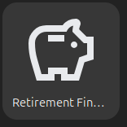

alt text

## On Windows

Type ‘Retirement_Finances’ after selecting the Windows Start button and select ‘Retirement_Finances’ under ‘best match’. This opens a window indicating that the application is starting up. Shortly afterwards (the time will depend how fast your PC is) a ‘Retirement Finances’ browser window should open asking you to enter a password as shown below under ‘Initial browser window’.

# Initial browser window

This will open your systems default web browser as shown below

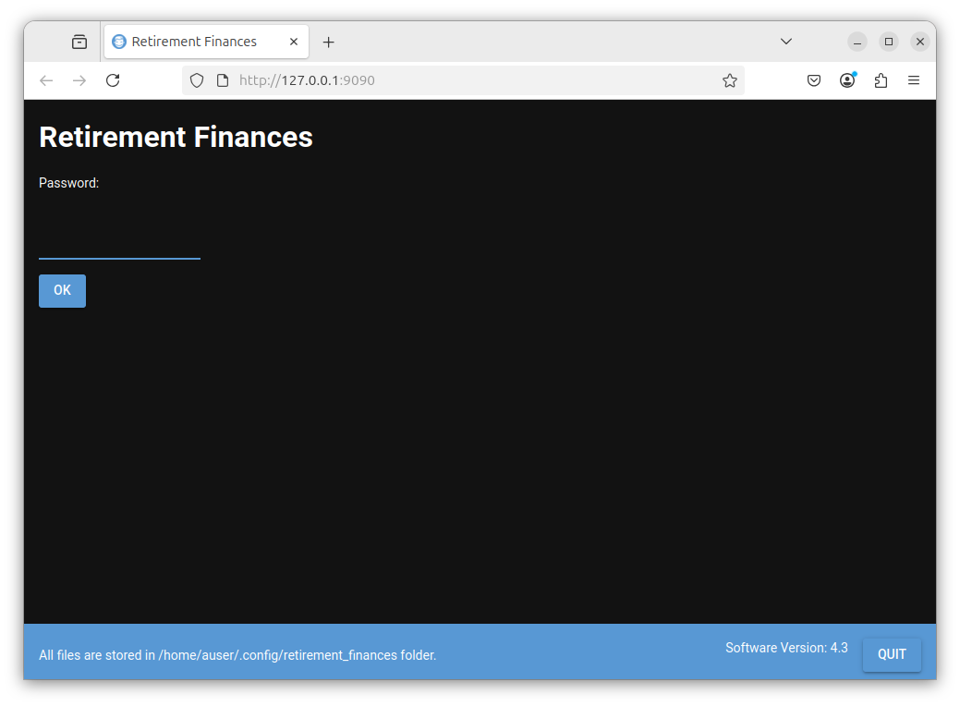

alt text

## Blue bar at the bottom of the browser window.

* Quit button

This must be selected to shut down the program. If you just close the browser window the Retirement Finances (App) will stay running. You can reconnect to it by entering 127.0.0.1:9090 into the browsers address bar. The app will only be accessible from your local machine.

* Software Version

To the left of the Quit button the Retirement Finances App software version is displayed.

* Storage Folder

On the left hand side of the blue bar the folder where all the files created by the App are stored is detailed. All these files are encrypted. The password prompted for is used to decrypt the data in these files. If you ever wish to delete all data used by the App and start again then you should shut down the App (click the Quit button) and then manually delete this folder.

## Entering a password.

As detailed above all the files created by the App are encrypted and you must enter a password to encrypt and decrypt the data in these files.

The first time you open the App no password will have been set.

To create a password enter the password that you wish to set in the Password field and select the OK button. If you select the Password field with your mouse then a tooltip is displayed indicating what to enter into the field as shown below. When using the App all fields should have tooltips associated with them to indicated the expected input.

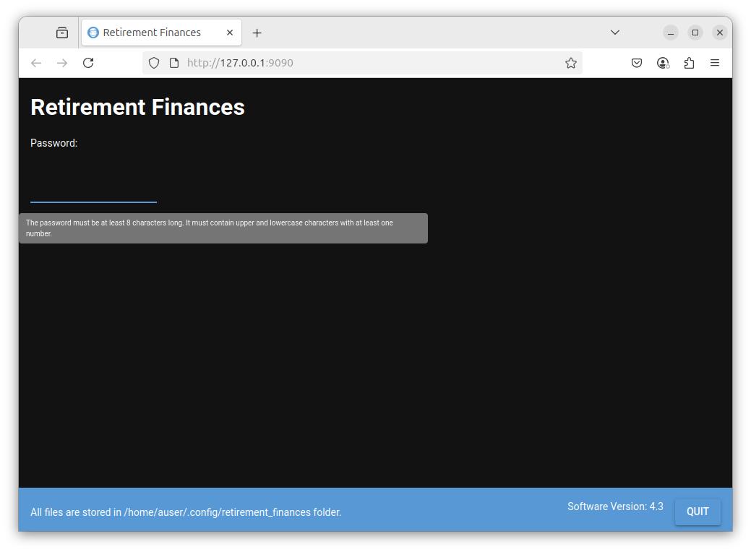

alt text

Enter a password that you wish to use. The following message will then be displayed

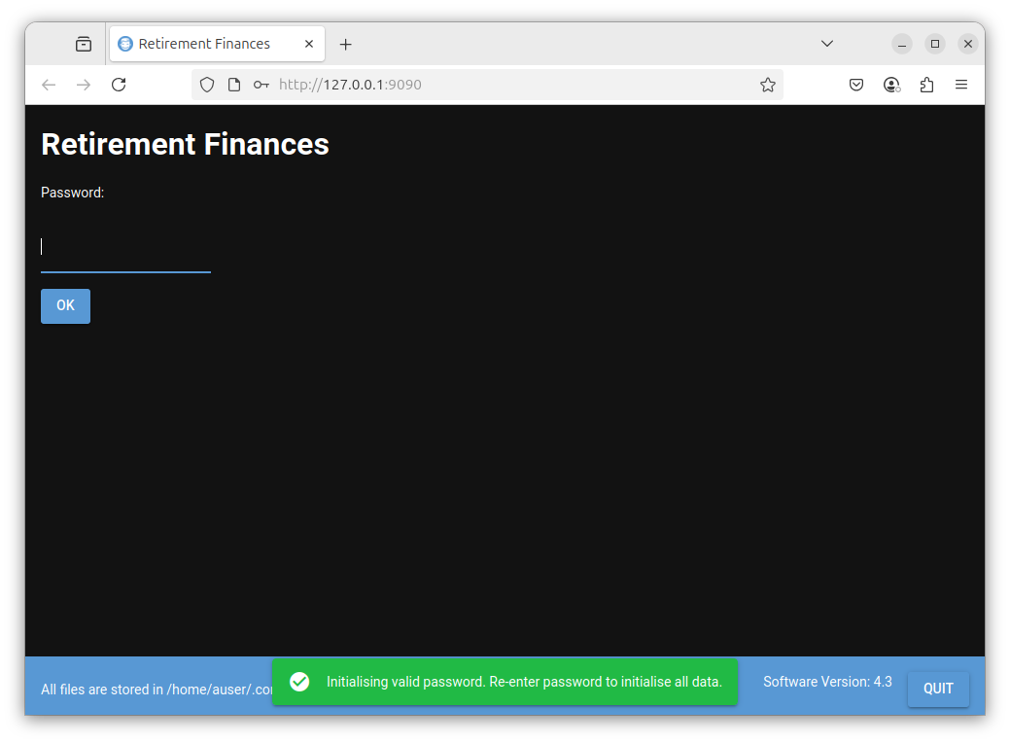

alt text

Enter your password again and the following is displayed

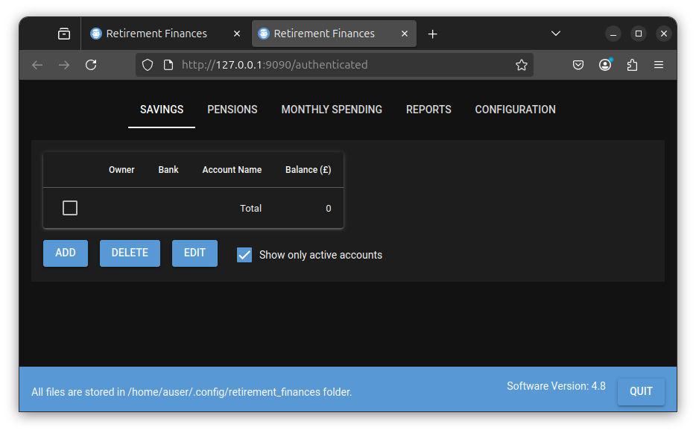

alt text

# Note !!!

If you forget this password you will no longer be able to access the App data.

The App has now been started and you have logged in. You may now move onto the section below.

# Initial Configuration

The window displayed has the following tabs

* SAVINGS

Details your savings accounts.

* PENSIONS

Details your pensions (Personal and State).

* MONTHLY SPENDING

You may add details of the total amount you spend each month here. This is used to track your actual spending against your predicted spending.

* REPORTS

This is where you can generate reports including predictive plots of your current and future finances.

* CONFIGURATION

The global configuration for the App is stored here.

At this point you should select the CONFIGURATION tab.

Initially this will be as shown below

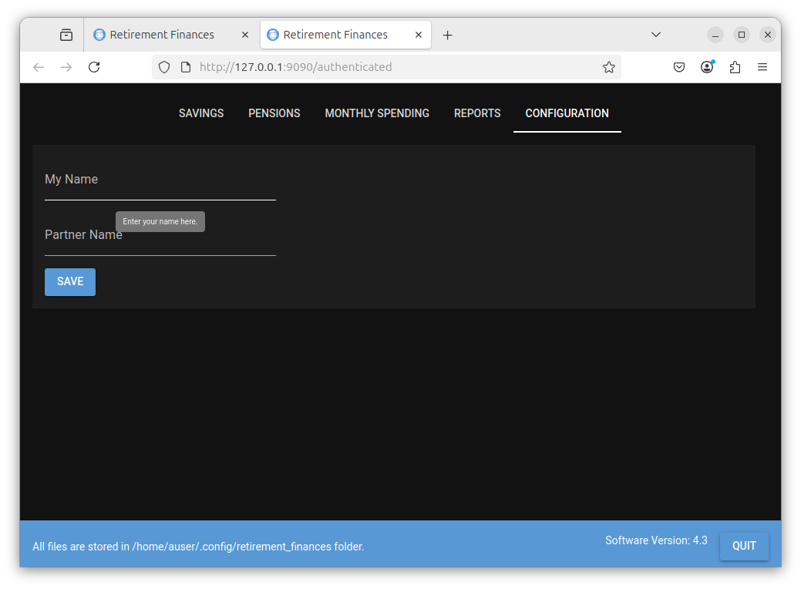

alt text

You must enter your name here. You may optionally enter your partners name.

For the purposes of this tutorial ‘Joe Bloggs’ and ‘Jane Bloggs’ will be entered.

Enter the name/s as required and select the OK button to save them, as shown below.

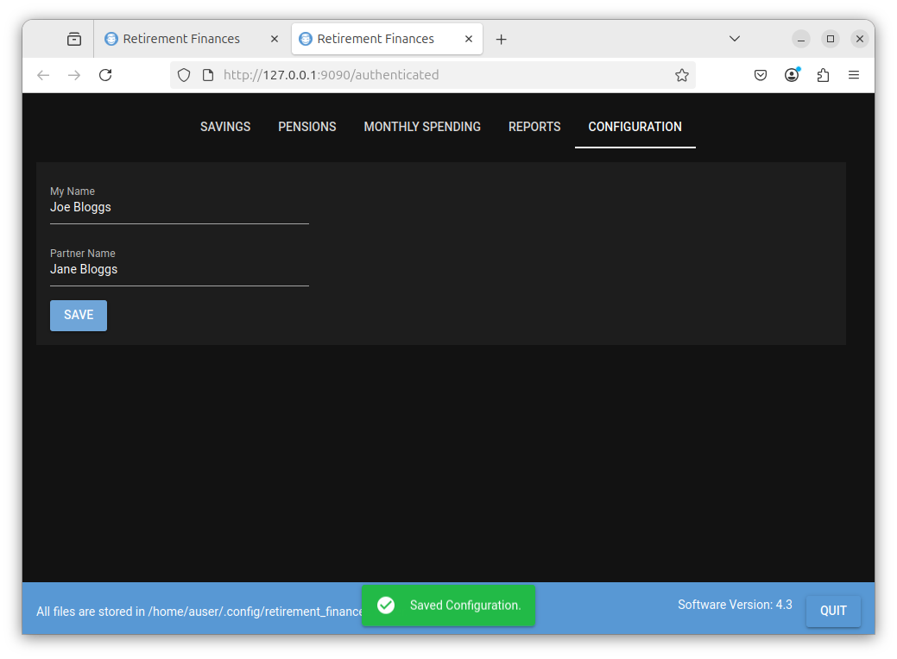

alt text

## Steps Required To Enter Your Current Financial State

Once the initial configuration (as detailed above) is complete the following steps should be performed.

* Setup savings accounts as details here
* Setup pensions information as detailed here

## Enter Monthly Spending

The ‘MONTHLY SPENDING’ tab allows you to enter the total amount you spend each month as time goes by. This is not your predicted monthly spending but the actual amount your spend each month. Over time this data builds up and is used to plot your actual spending each month and your average spending each month and can be displayed against your predicted spending each month. This is useful to show you how much a ‘grasp’ you have on your outgoings.

This monthly spending table should be updated regularly (E.G monthly).

* For details of how to use the ’Enter Monthly Spending tab click here

## REPORTS

This is where you can see the total state of your finances and try out different predictions including predictive plots.

* For details of how to use the reports functionality click here

# SAVINGS Tab

The savings tab displays a list of your savings accounts.

The initial state with no savings accounts defined is shown below.



alt text

The ADD, DELETE and EDIT buttons allow add, delete and edit the savings accounts in this list.

# Add A Savings Account

Select the Add button and the following is displayed

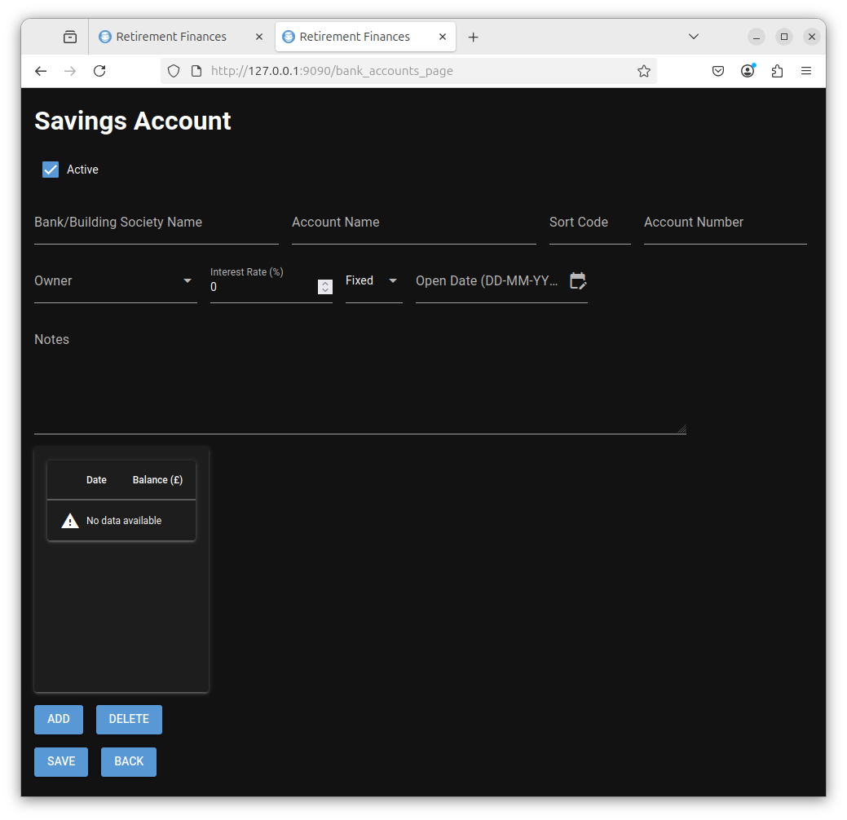

alt text

If you hover the mouse over each field a tooltip will be displayed indicating the expected input.

These are

* Active
* This should be selected if this account should be included in your retirement planning finances. Typically this would be checked initially but can be unchecked if the account is no longer used or contains money that you don’t wish to be included in funding your retirement.
* Bank/Building Society Name
* The name of the organisation where the savings are held. This is a required field (I.E you must enter something). Initially, when getting used to how this program can be used you may wish to enter dummy data.
* Account Name
* This field details the name of the account. This is also a required field.
* Sort code
* This is not a required field and may be left blank.
* Account Number
* This is not a required field and may be left blank.
* Owner
* You may select the owner of this account from the drop down list. This is either you, your partner or Joint.
* Interest rate
* The expected interest rate when the account was opened. This is not a required field and may be left at 0%. This value is not used in any calculations and is just for your reference.
* Fixed/Variable
* This is a dropdown list and indicates whether the interest is fixed rate or variable rate. This is not a required field and may be left at fixed. his value is not used in any calculations and is just for your reference.
* Open Date
* This should be the date when the account was opened. This is a required field. The date format is DD-MM-YYYY.
* Notes

This is a free form text field that allows you to enter any information you wish about the savings account. This is optional and can be left blank.

* Date/Balance Table.
* Initially this will be empty. Select the ADD button and enter a date and balance and then select the OK button to add a balance to the savings account. Values in this table are used as part of your total savings when making predictions.

Once you have finished filling in this form select the SAVE button to save the savings account details. The BACK button will take you to the previous window.

# Example Data

For purposes of this tutorial I added the following savings accounts.

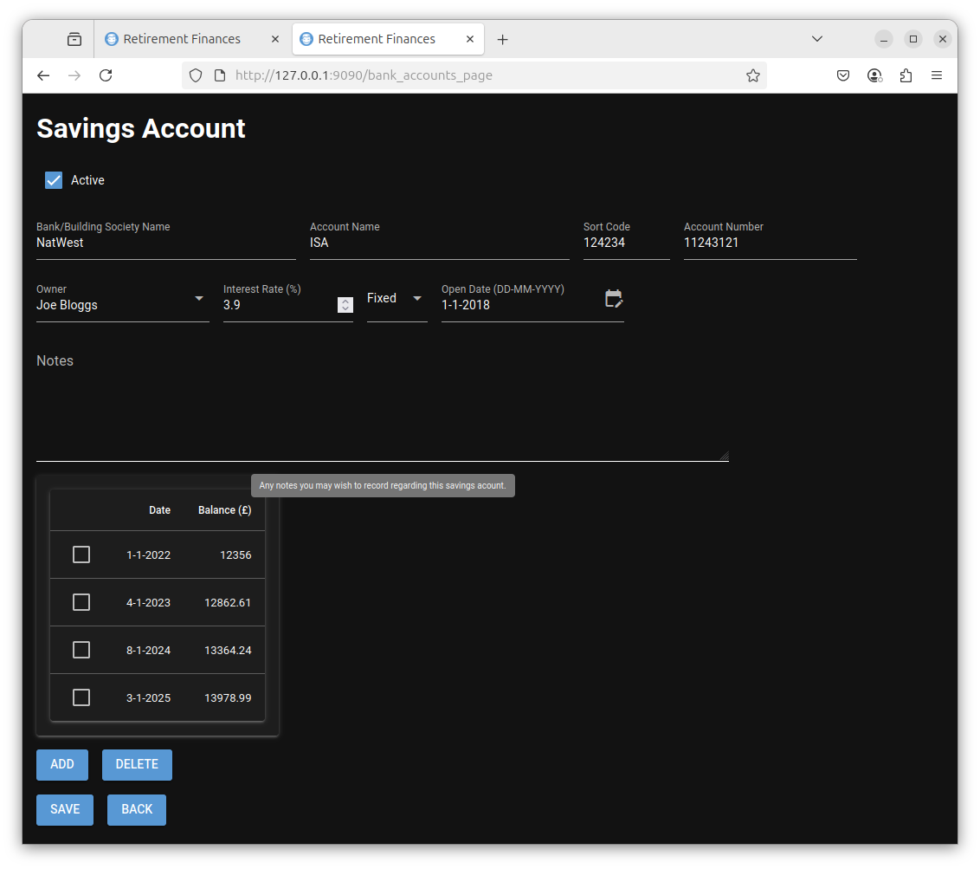

alt text

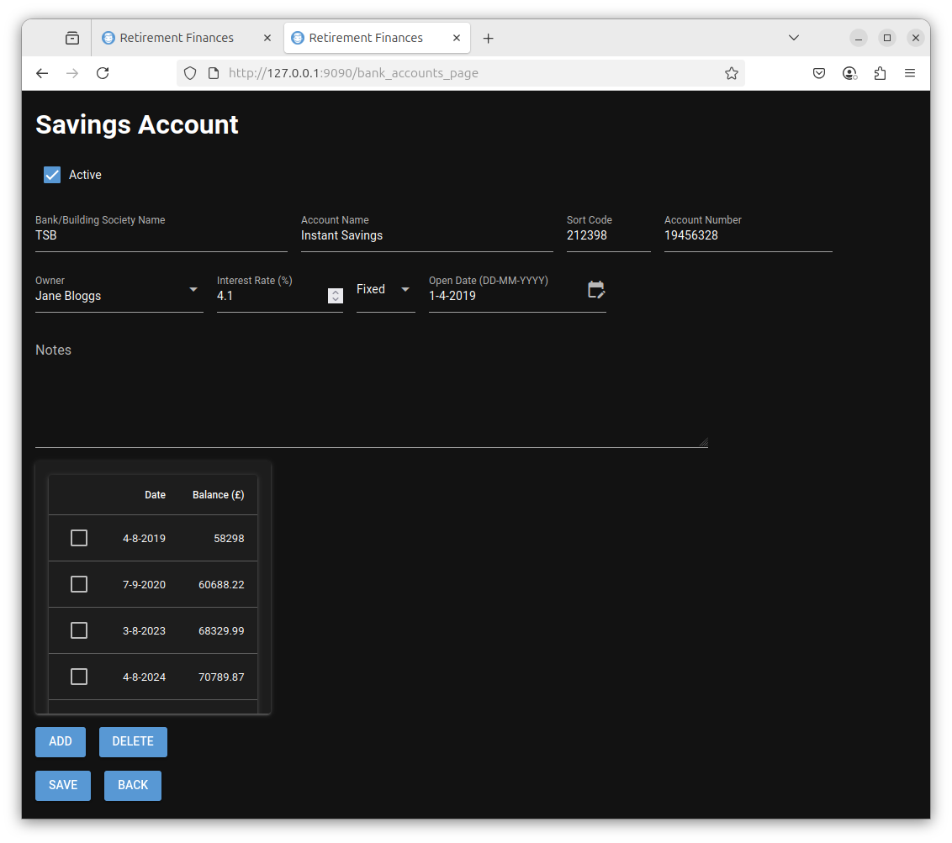

alt text

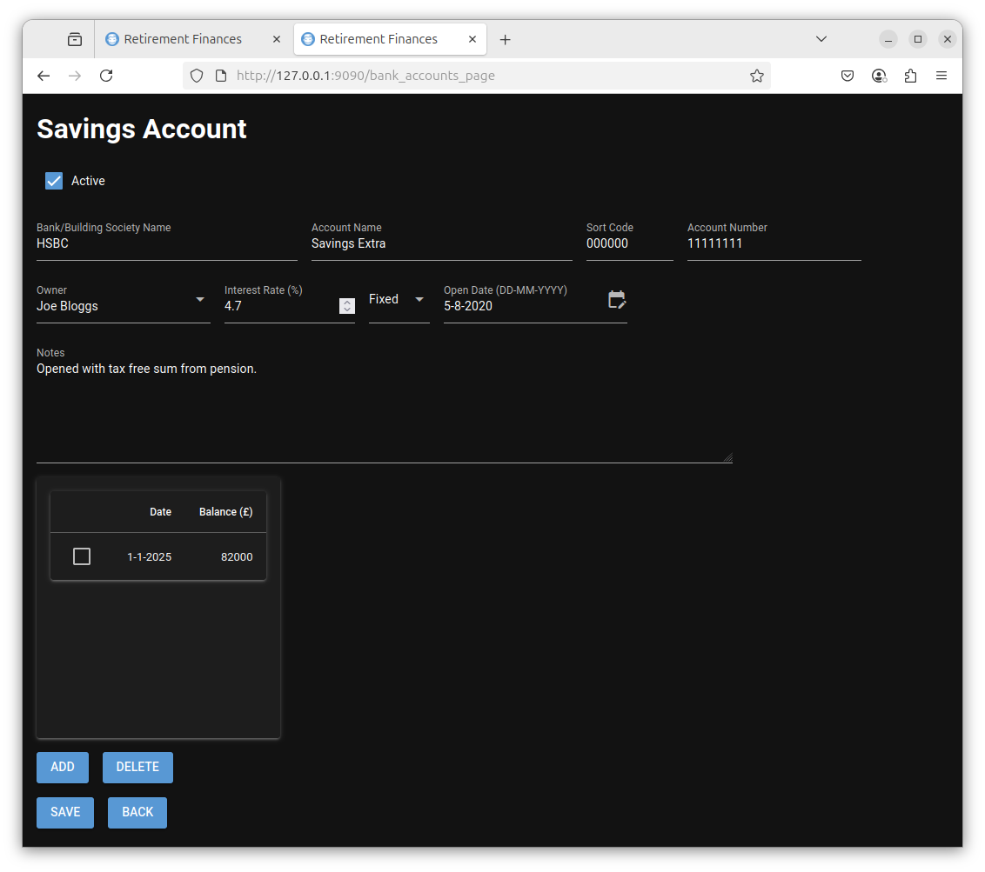

alt text

When the BACK button is selected these three accounts are displayed as shown below.

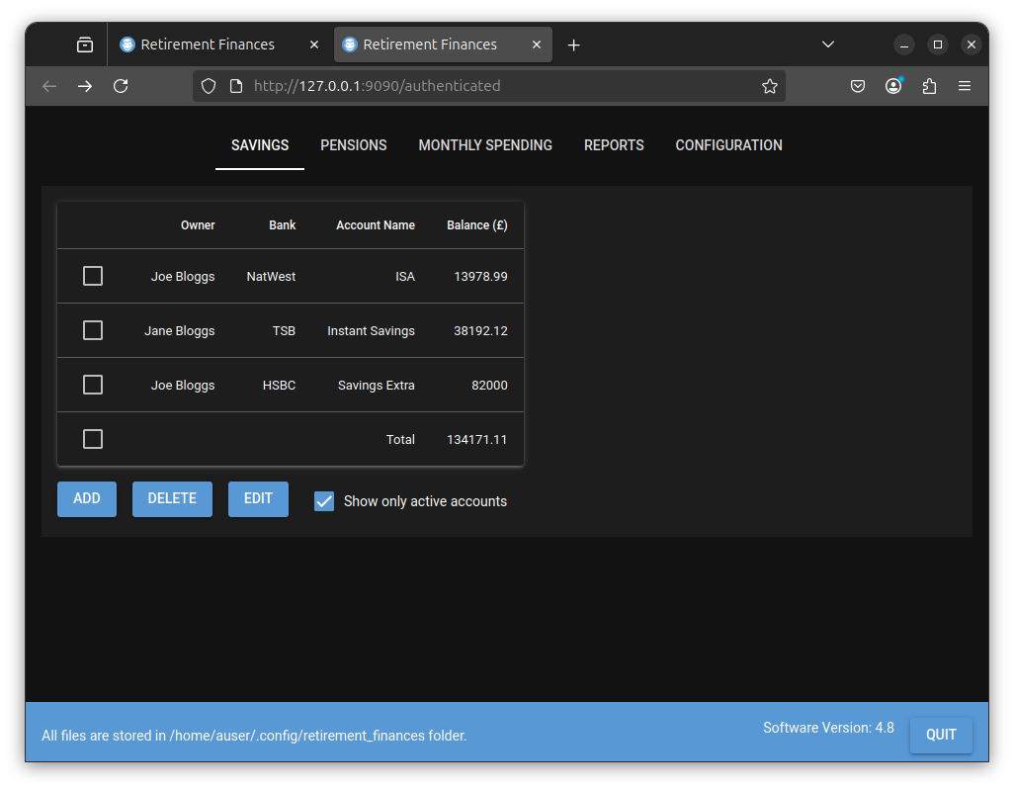

alt text

# PENSIONS Tab

This is similar to the SAVINGS tab but allows you to add all your pensions (State and Personal). The list of pensions will initially be empty. Select the ADD button to add details of a pension to the list.

Before any pensions are added this should appear as shown below.

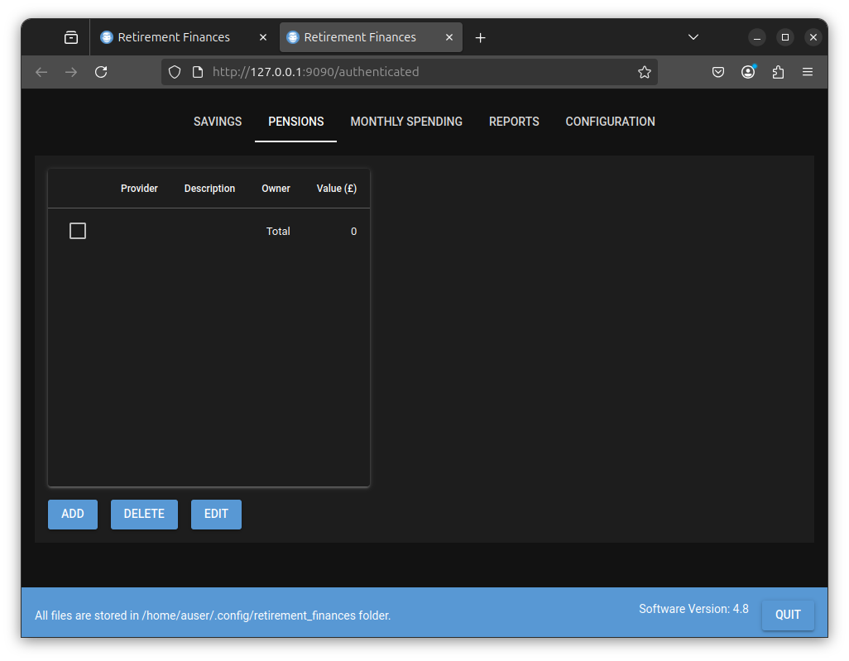

alt text

The ADD, DELETE and EDIT buttons allow add, delete and edit the pension list.

Select the Add button and the following is displayed in a similar fashion to the SAVINGS tab.

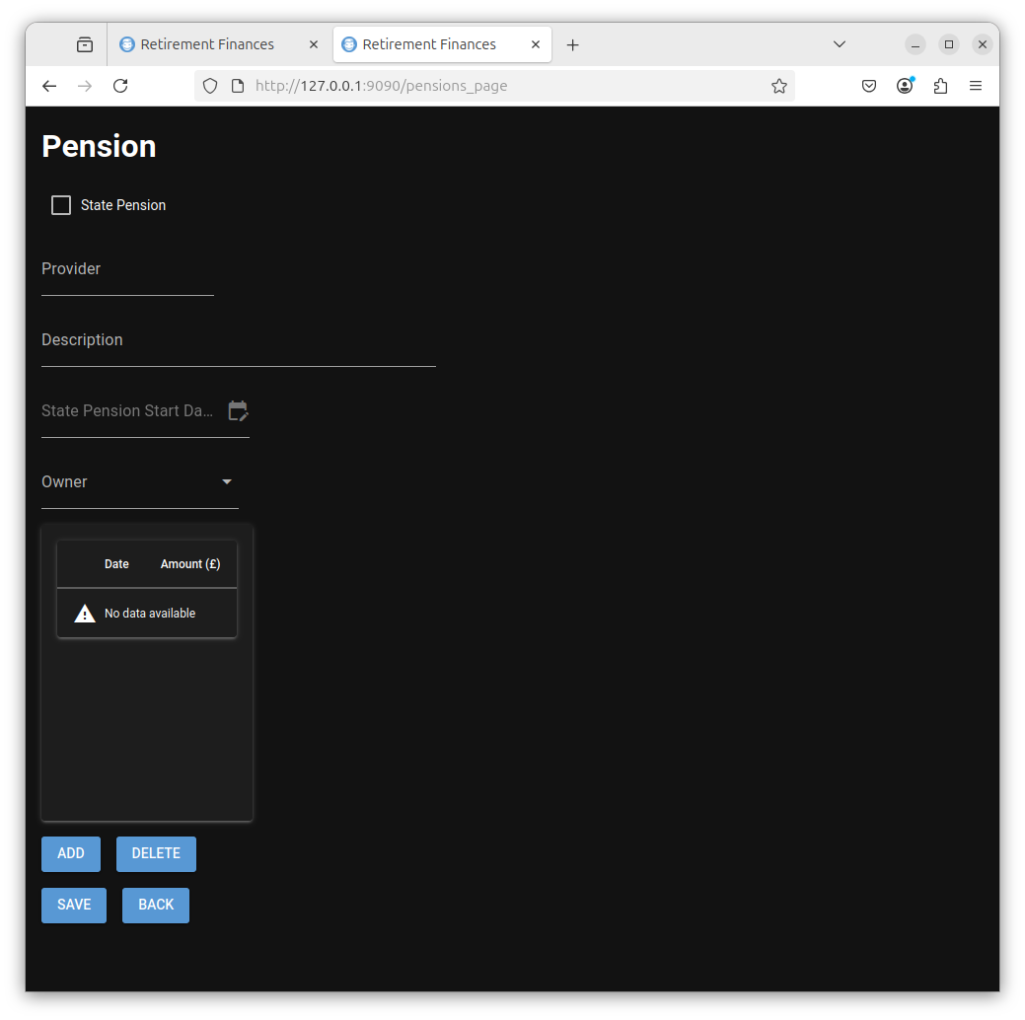

alt text

This contains the following fields.

* State Pension
* If checked then you must enter details of your expected state pension. If deselected then the page should hold details of a non state pension (E.G personal pension) that you hold.
* Provider
* If the state pension field is selected then this field is fixed as GOV. If the state pension field is deselected then you may enter details of your pension provider in this field. This is not a required field.
* Description
* This allows you to enter a description of the pension. This is a required field.
* State Pension State Date
* If the state pension field is selected then you should enter the date at which your state pension is expected to start. If the state pension field is deselected then this field is greyed out. This is a required field for a state pension.
* Owner
* You may select the owner of this account from the drop down list. This should be either you or your partner.
* Date/Amount table

If the state pension field is selected then you should enter your current state pension amount. This is the value that the HMRC say will be your yearly pension if you received it now. You can update this each year as the state pension changes.

If the state pension field is deselected then this should be the current value of your pension fund. You should update this from time to time to detail the value of your pension fund.

# Example Data

For purposes of this tutorial I added the following pensions.

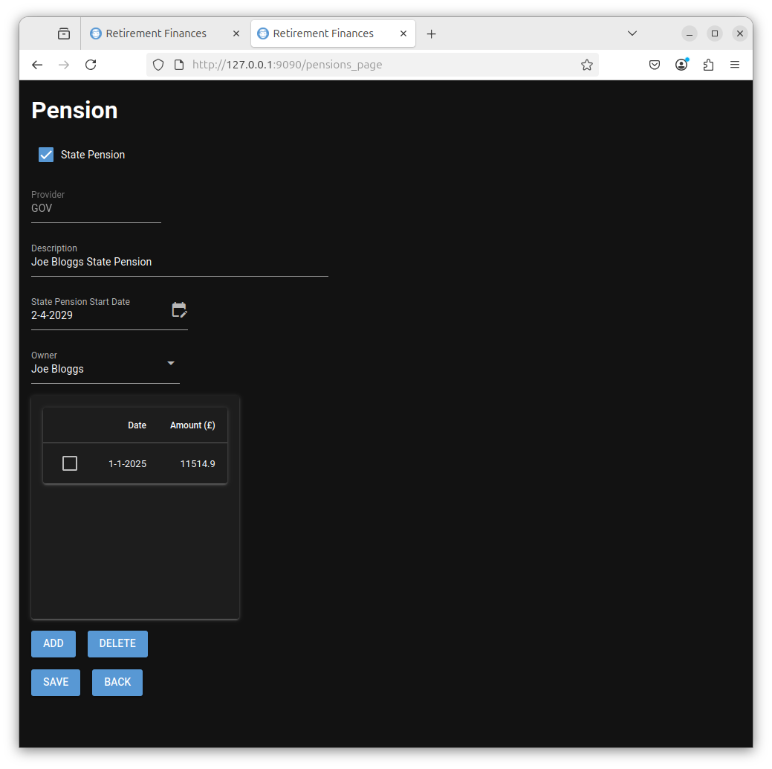

alt text

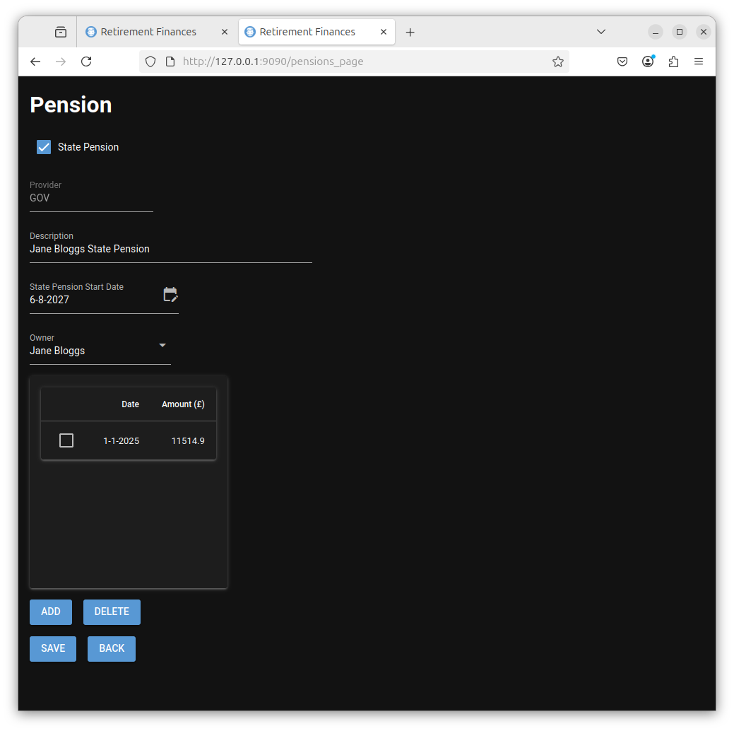

alt text

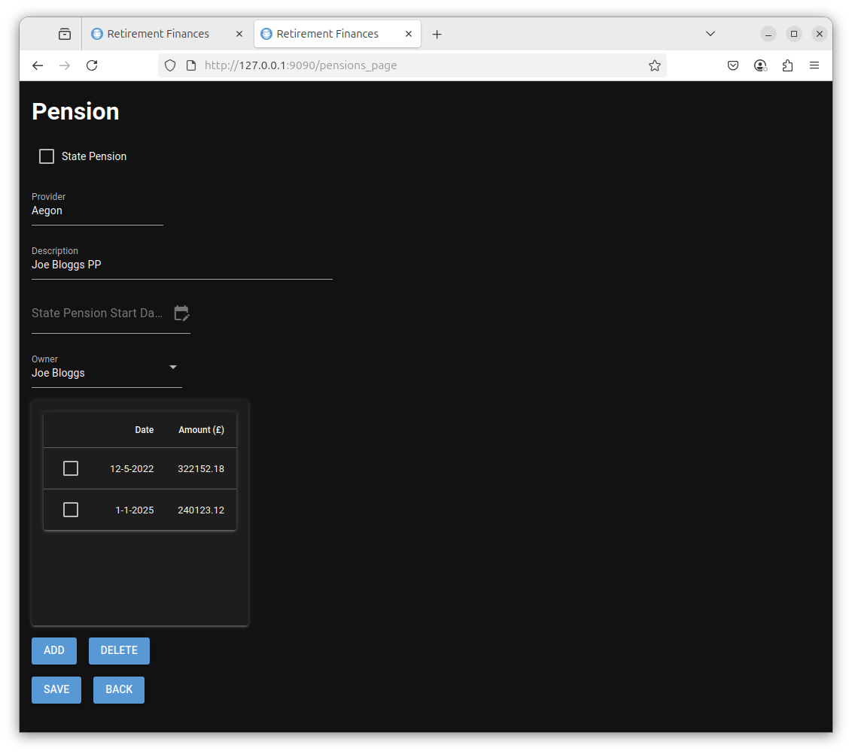

alt text

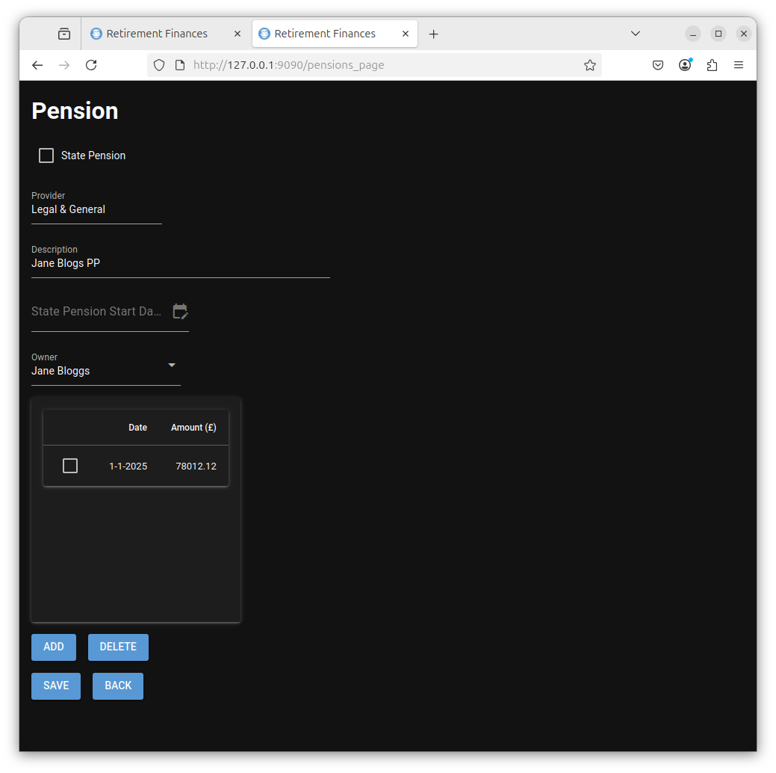

alt text

When the BACK button is selected these four pensions are displayed as shown below.

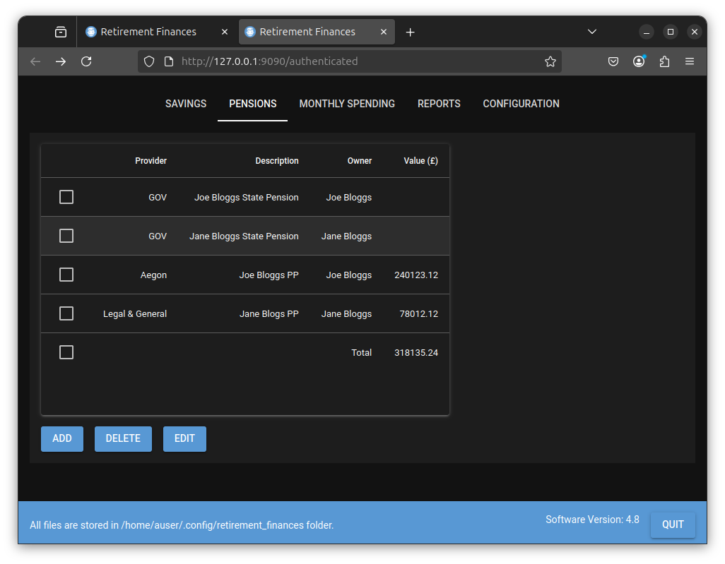

alt text

# MONTHLY SPENDING

This table allows you to record the total amount you spend each month as time progresses. When predicting how long your savings and pensions will last, this is used to plot against the predicted monthly spending.

The table details the date and the amount spent. Select the ADD button to add the date set to the 1’st of the month. The amount entered should be the total amount you spent in that month.

The Notes field is a field to allow you to enter any information you wish, about your monthly spending.

# Example Data

For purposes of this tutorial I added the following monthly spending values.

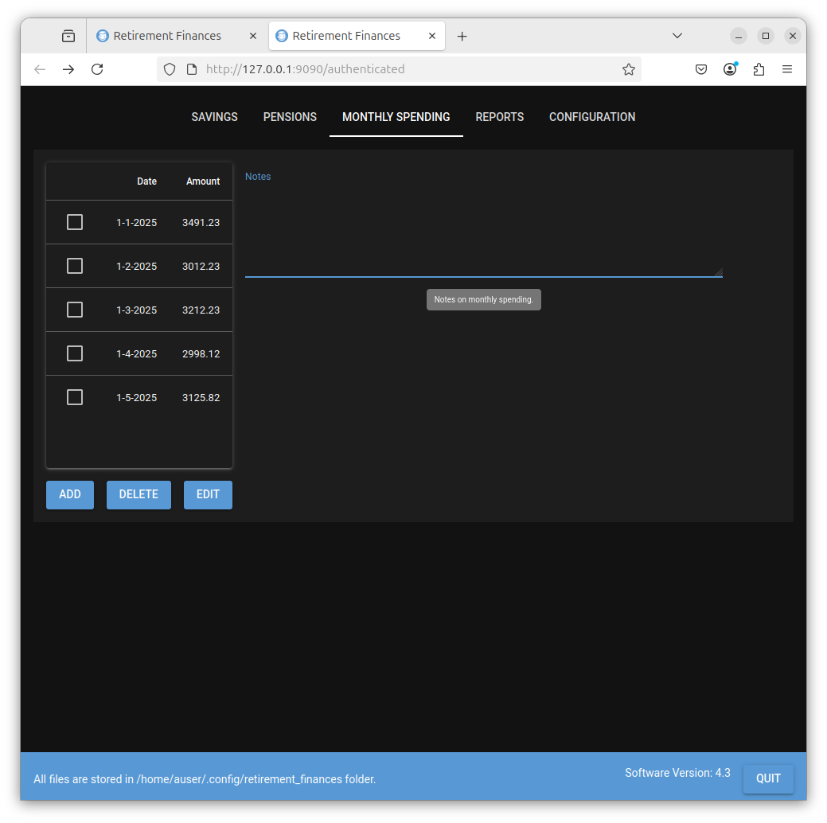

alt text

# REPORTS

This contains two buttons as detailed below.

### TOTALS

Simply gives the current total of all the latest entries in all the SAVINGS and PENSIONS amounts tables.

The following shows the totals of the all the entered example savings and pensions.

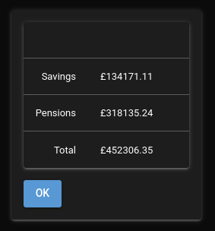

alt text

### DRAWDOWN RETIREMENT PREDICTION.

This is where predictions can be made based on your guesses about how long you and your partner (if you have one) will live, future savings and pensions performance, etc.

There are a number of parameters on this form. The default/initial state of this form is shown below.

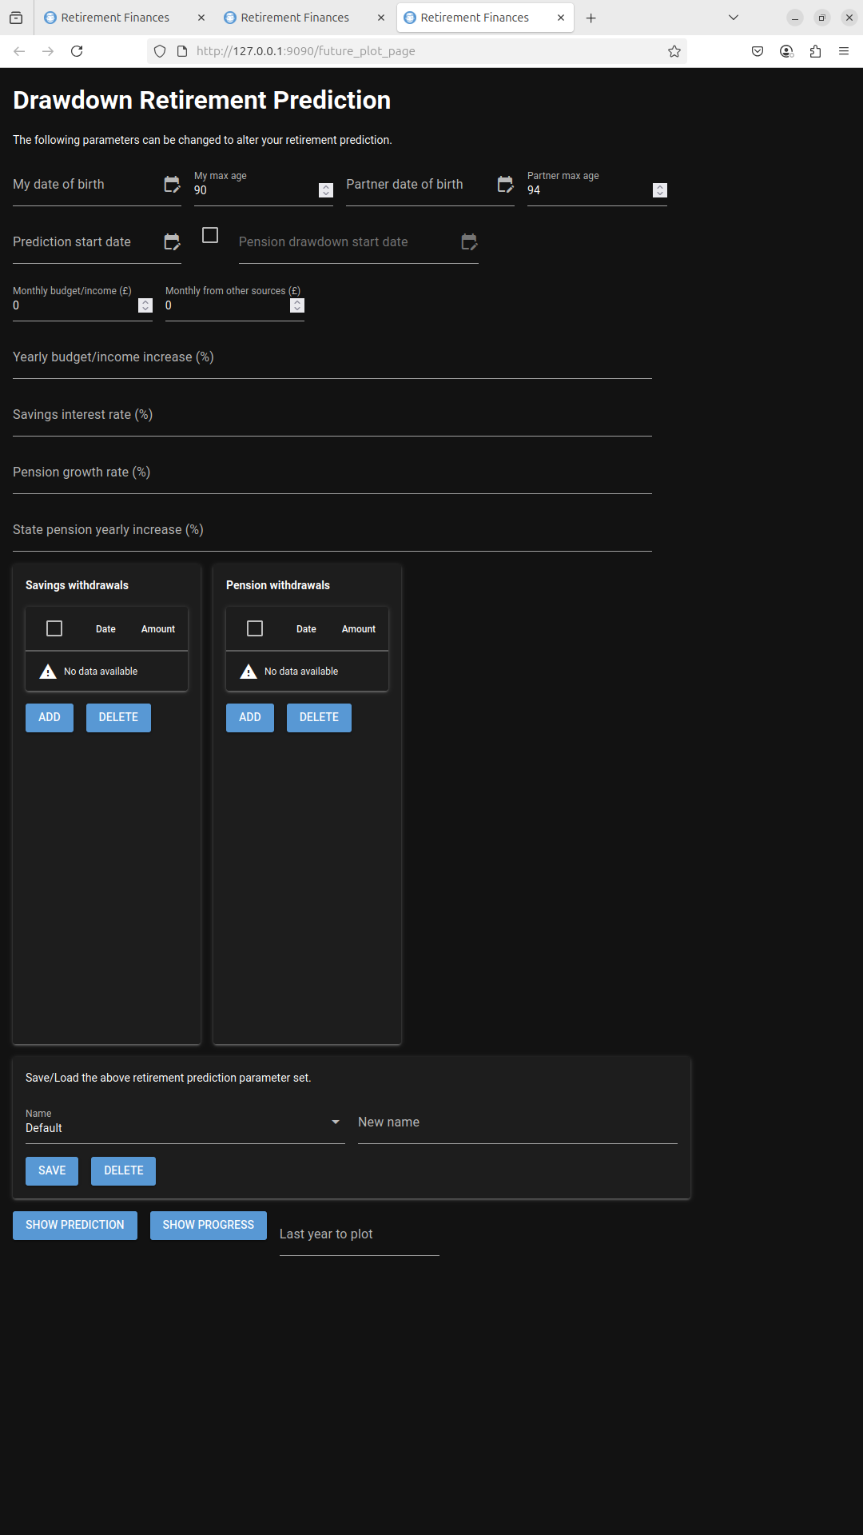

alt text

Each of these parameters is detailed below.

* My Date of Birth
* Enter your date of birth here.
* My max age
* This is the maximum age that you wish to plan for.
* Partner date of birth
* If you have included your partner in your finances then add their date of birth here.
* Partner max age
* This is the maximum age that you wish to plan for.
* Prediction state date
* The date you wish the prediction to start. This would typically be the date at which you wish to retire.
* Pension draw down start date
* The checkbox to the left of this field must be selected to allow you to enter this date. When entered the date defines the point at which you start regularly drawing down from your pension to fund your retirement. Before this date your savings are initially used to fund your retirement.
* Monthly budget/income
* This is the amount you expect to spend each month (on average).
* Monthly from other sources
* This is a fixed amount that you expect to receive each month from any source. This amount is deducted from the ‘Monthly budget/income’ to determine how much you need to take from savings or pensions each month.
* Yearly budget/income increase (%)

This is a list (comma separated. This first value being the prediction start year, the second being the next year and so on) of yearly percentage increases in your ‘Monthly budget/income’ in order to allow you to keep pace with inflation. Enter your guesses here !!!

* Savings Interest rate (%)

This is a list (comma separated. This first value being the prediction start year, the second being the next year and so on) of yearly savings interest rates to be applied to all your savings. If you have several savings accounts then you are likely to have different interest rates for different accounts. This value is a general interest rate applied to all savings accounts for purposes of this prediction. Enter your guesses here !!!

* Pension growth rate (%)

This is a list (comma separated. This first value being the prediction start year, the second being the next year and so on) of yearly pension growth rates rates as a percentage to be applied to all your pensions. Enter your guesses here !!!

* State pension yearly increase (%)

This is a list (comma separated. This first value being the prediction start year, the second being the next year and so on) of yearly state pension increases to be applied to all state pensions (max of two, you and your partner). Enter your guesses here !!!

Also displayed are the ‘Savings Withdrawals’ and ‘Pension Withdrawals’ tables. These allow you to enter dates and amounts to deduct from savings or pensions on an ad hoc basis (E.G holidays, buy an expensive item etc). You may select the ADD button to add one or more deductions from either savings or pensions. Note that you do not need to add pension withdrawals after the Pension drawdown date field (if you selected it and entered a value) as these will be calculated to withdraw sufficient funds to reach your monthly budget/income. The Pension withdrawals table allows you to add drawdowns on your pension on an add hoc basis before you decide to start a regular drawdown on your pension funds.

Near the bottom of the page a highlighted section allows you to save all the above parameters as a group. This allowa you to try out the effect of changing different values of, for example, savings interest rates or pension growth rates. A Default option is present and you may enter a name into the ‘New name’ field and then select the save button to add to the pull down list. When a Name is selected from the pull down list it will populate the form with the values associated with the name you gave. To delete a Name, select it in the pull down menu and select the DELETE button.

At the bottom of the following buttons exist.

#### SHOW PREDICTION BUTTON

This will open a new page in your browser that displays plots. Four separate plots are displayed as detailed below.

Plot 1 -

A prediction of your savings and pensions value over time until the maximum of either you or your partners age. The total plot is the sum of the savings and pension values.

Plot 2 -

Your predicted Monthly budget/income, predicted total state pension (if you included yor partner this is the sum of both your state pensions) and your predicted spending.

Plot 3 -

Your predicted savings interest over time.

Plot 4 -

Your predicted savings withdrawals and your predicted pension withdrawals.

#### SHOW PROGRESS BUTTON

This shows the same plots as when the SHOW PREDICTION button is selected and also plots the actual value of savings and pensions. These values come from the amounts entered over time into the savings and pensions tables. You can then compare the predicted savings and pensions values over time with the actual values.

The actual amount spent each month is also plotted (along with the average) this allows you to see how accurate your spending estimates/guesses were. The actual value can only be plotted if you update the MONTHLY SPENDING table regularly as time progresses as this is where this data comes from.

### Last year to plot

By default the plots continue up to the max year (in your report). You can truncate this to view a shorter period of time by entering a year before the max year. This can be useful to view how your plan is progressing.

The plots allow you to zoom in on points of interest at any time but this field allows the plots to be truncated if required.

# Report On Example Data

We can now generate some reports on the savings and pension example data. The Drawdown Retirement Prediction for was completed as shown below.

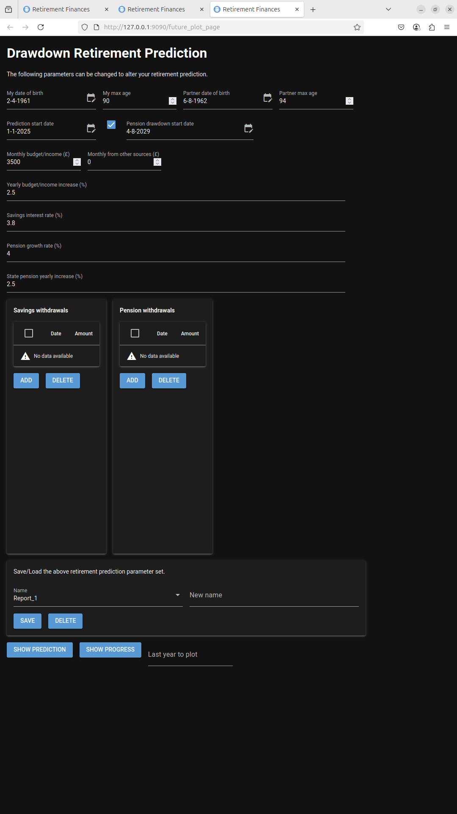

alt text

The SHOW PREDICTION button was then selected and the following plot was generated.

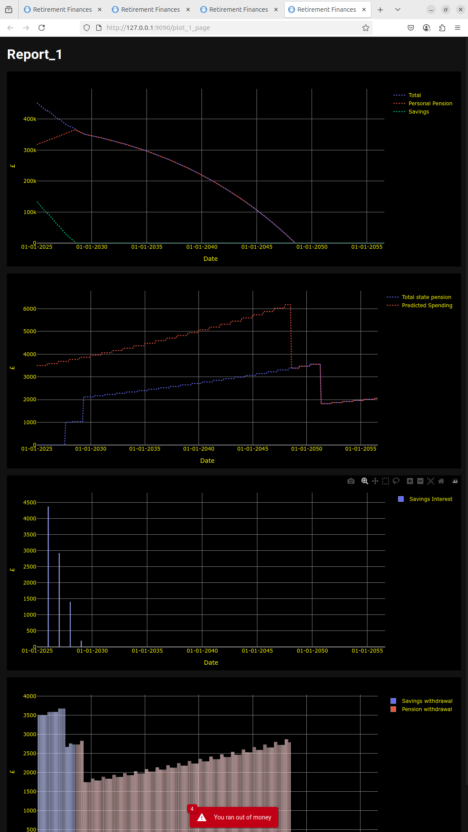

alt text

Note that each plot has a toolbar (move mouse to the top right of the plot area to show it) that is as shown below. The default zoom tool is selected to allow you to drag a rectangle over the plot area to zoom in.

alt text

alt text

Based on the parameters entered into the Drawdown Retirement Prediction form the red warning indicates message indicates that the money ran out during the plan.

The first plot shows how your savings and pension dropped over time.

Savings were initially used to pay your monthly income/budget and automatically switched to using pensions when the savings ran out.

If the ‘Pension drawdown start date’ is changed to be the same as the report start date (1-1-2025) then pensions would be used from the start. This was changed and the SHOW PREDICTION button was then selected again.

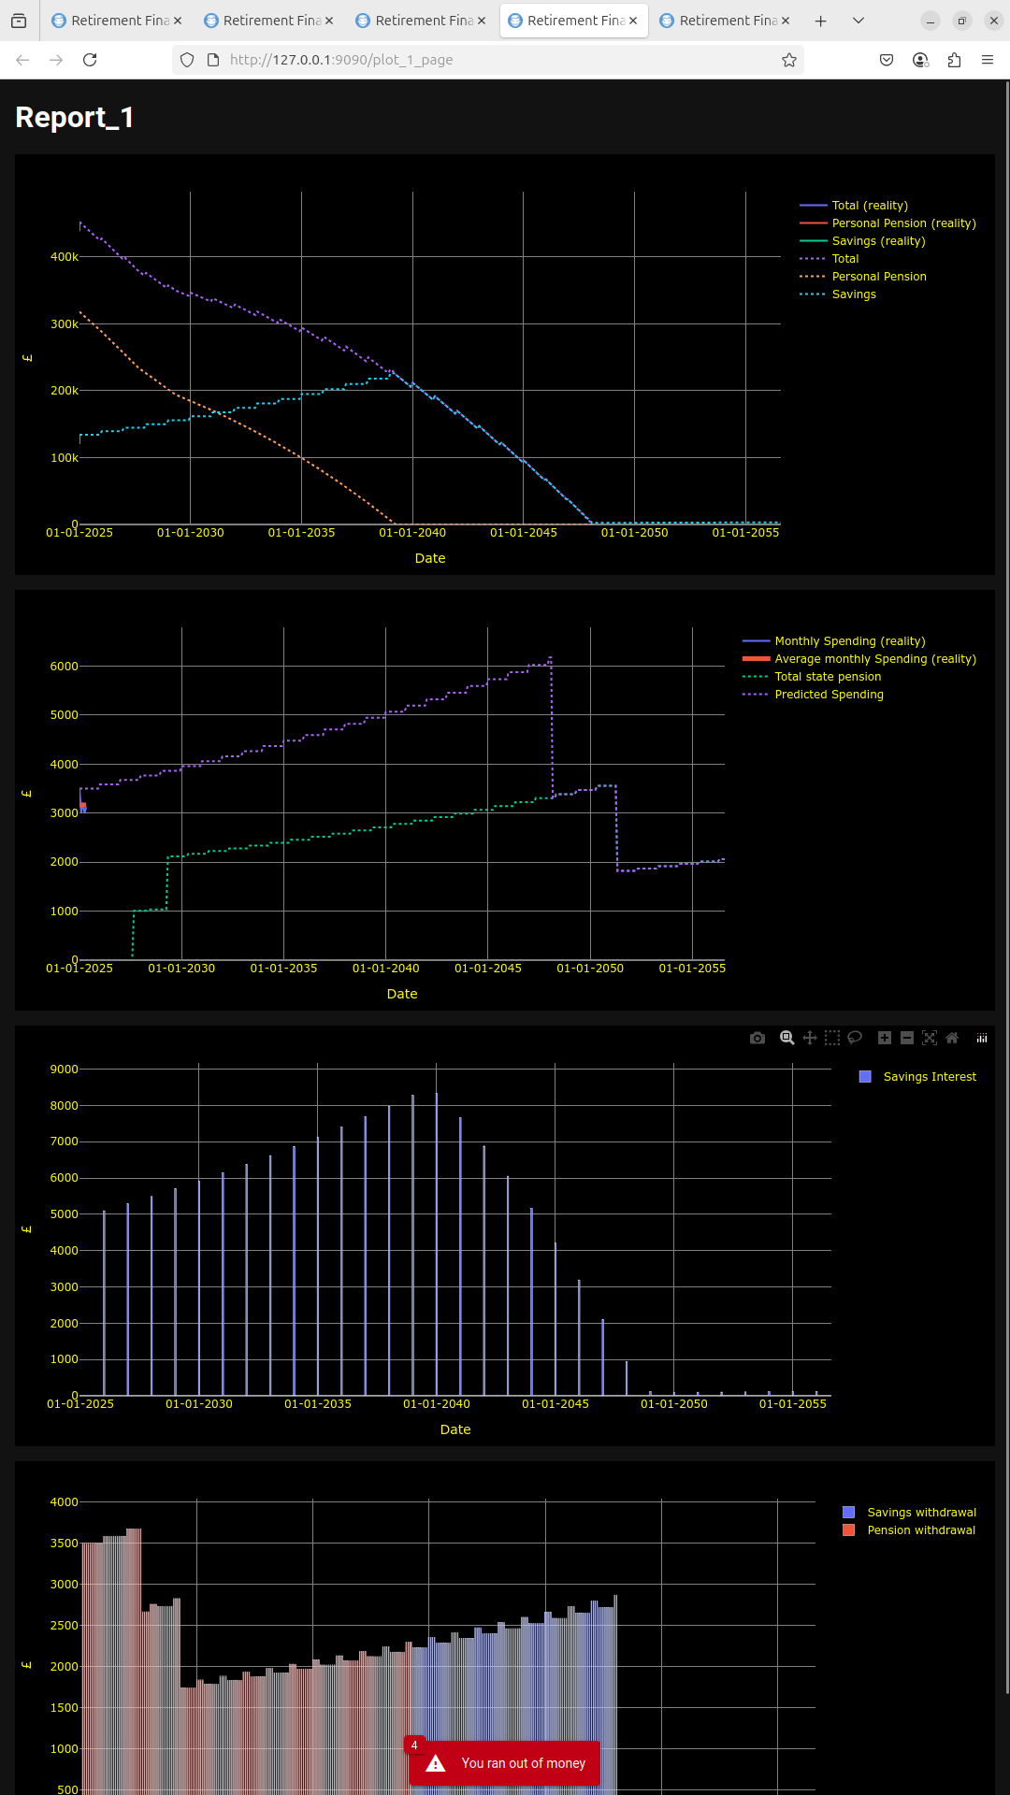

alt text

The first plot now shows the pensions dropping first. Savings increases until savings have to be used to pay the monthly budget/income. However the result is the same, the money runs out.

This shows how you can play with all the parameters available on the form and how it can change the prediction.

For the next plot the Monthly budget/income value is changed to £3000 from £3500 and the SHOW PREDICTION button was then selected again as shown below.

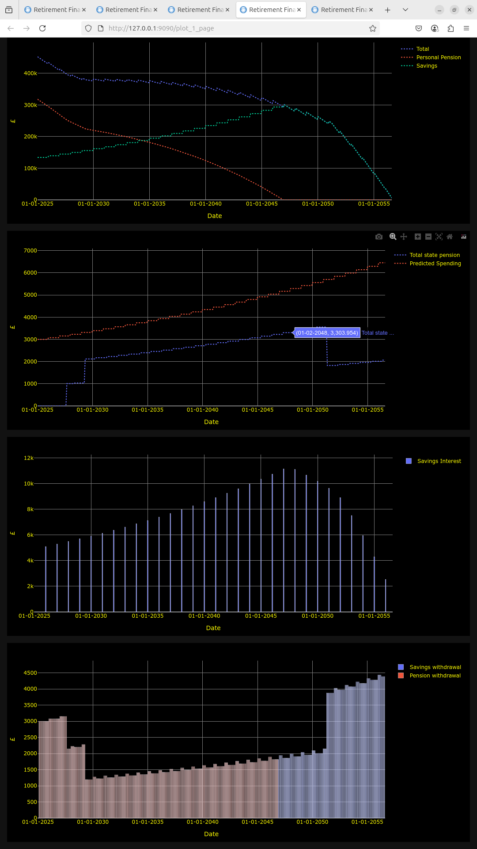

alt text

This time the money did not run out (only just). Adjusting the other parameters on the form will also have effects on the outcome.

The second row plot shows the income from state pensions. On it you can see when yours and you partners cuts in. As state pension is received it reduces the amount needed from pensions or savings to meet the monthly budget/income.

The third row on the plot shows the predicted amount received from interest on savings. This is based on the interest rate/s that you entered on the Drawdown Retirement Prediction form.

The final row shows how money is used from either pensions or savings to meet your monthly budget/income. The castellated effect is due to the gap between the start of the year when an increment in spending is shown and the change in the state pension (April). The increase on the right hand side is because the App assumes that when one of you dies their state pension will stop. Therefore money to meet your monthly budget/income has to come from other sources.

Click here if you wish to see how to compare the predictions with reality.

# COMPARING PREDICTIONS WITH REALITY

## Checking your monthly spending

To plot your monthly spending you should regularly update the MONTHLY SPENDING table with details of your monthly spending.

The monthly spending example data shown previously is used. The Drawdown Retirement Prediction form was completed as shown below. Note that the Last Year to plot field was set to 2025 so that only one year is plotted.

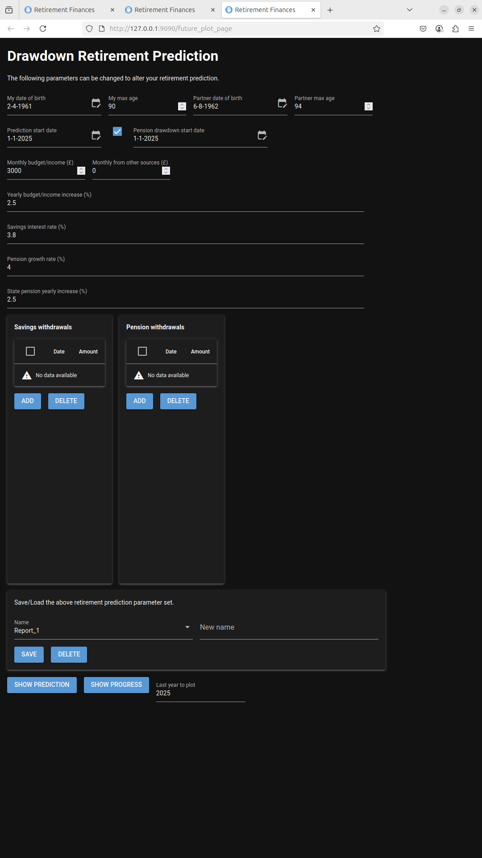

alt text

The SHOW PROGRESS button was then selected and the following plot is produced.

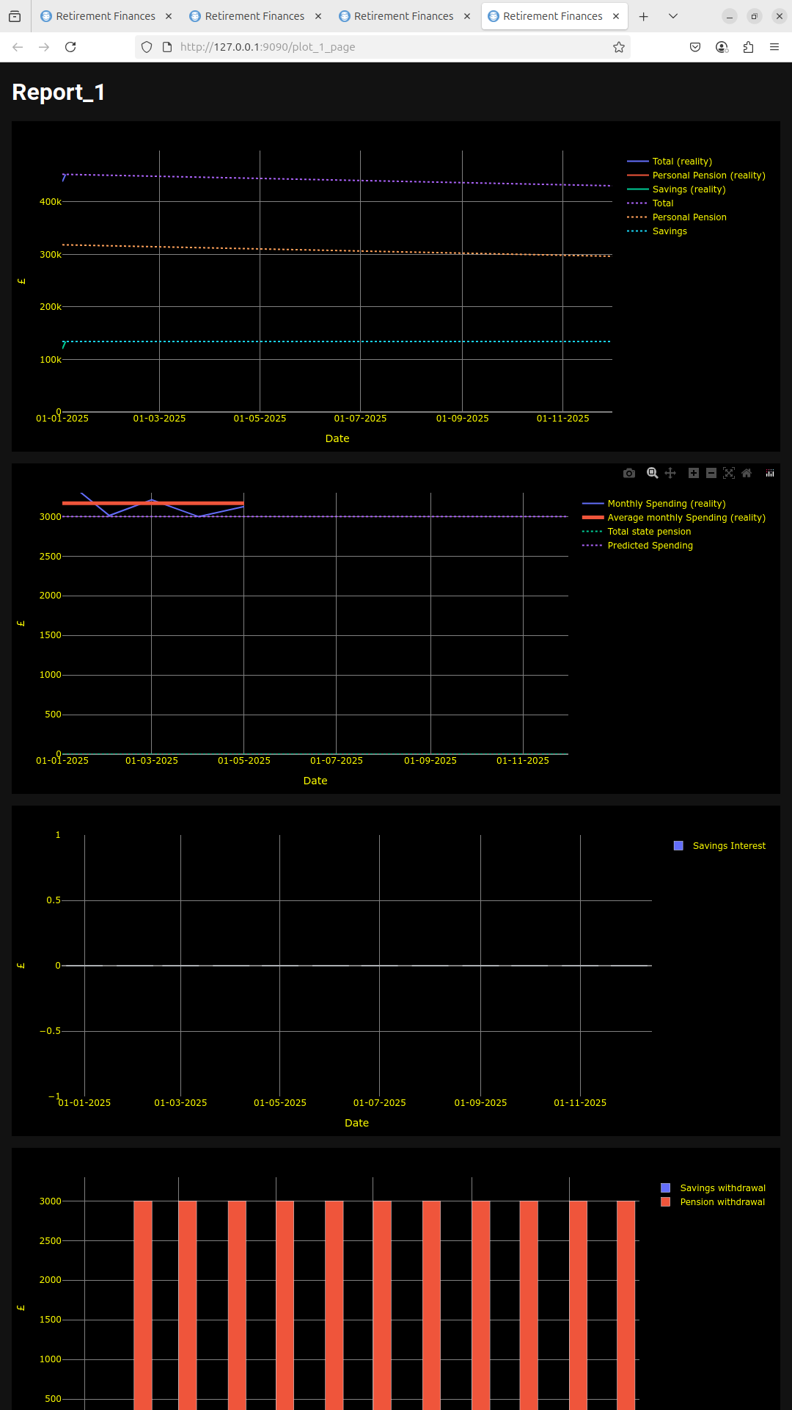

alt text

The second plot now shows the ‘Monthly Spending (Reality)’ and ’Average monthly spending (reality) traces. The predicted spending is shown on this plot. No state pension is shown because no state pension is being received in this year.

This shows data over a few months. It should become more useful as time progresses and more real data is available.

### Note

Any of the traces can be hidden if required by clicking on the legend name on the right hand side of the plot area.

# Checking your pensions and savings performance.

In order to compare the predictions with reality you must, over time, enter data into the App that details how each Savings account and pension changes. At any time you can update the value in a savings or pension tables and this is then used to show how the real values in your savings and pensions change.

For purposes of this example the Savings and Pensions were updated so that they both grew by ~ 4% a year for 3 years from 2025. Three separate values (one for each year) were entered for each of the Savings and pensions accounts. The Drawdown Prediction Retirement form was then updated as shown below. Note the Last year to plot is set to 2029.

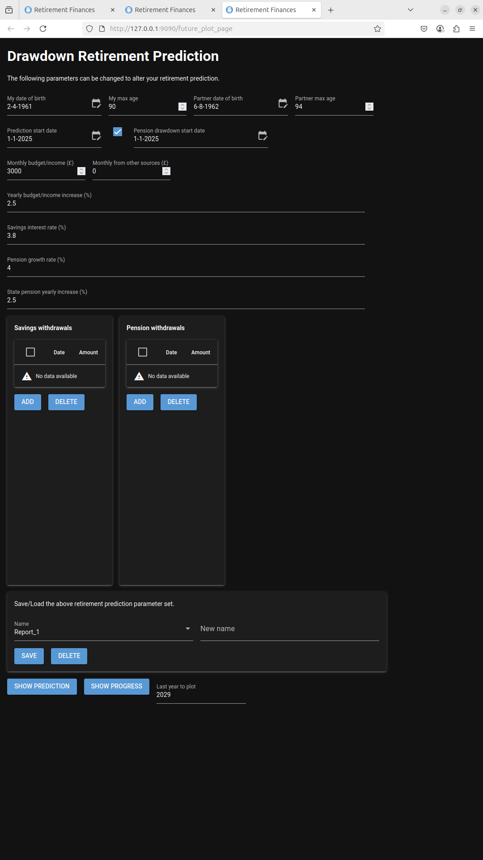

alt text

The SHOW PROGRESS button was selected and the following plot was generated.

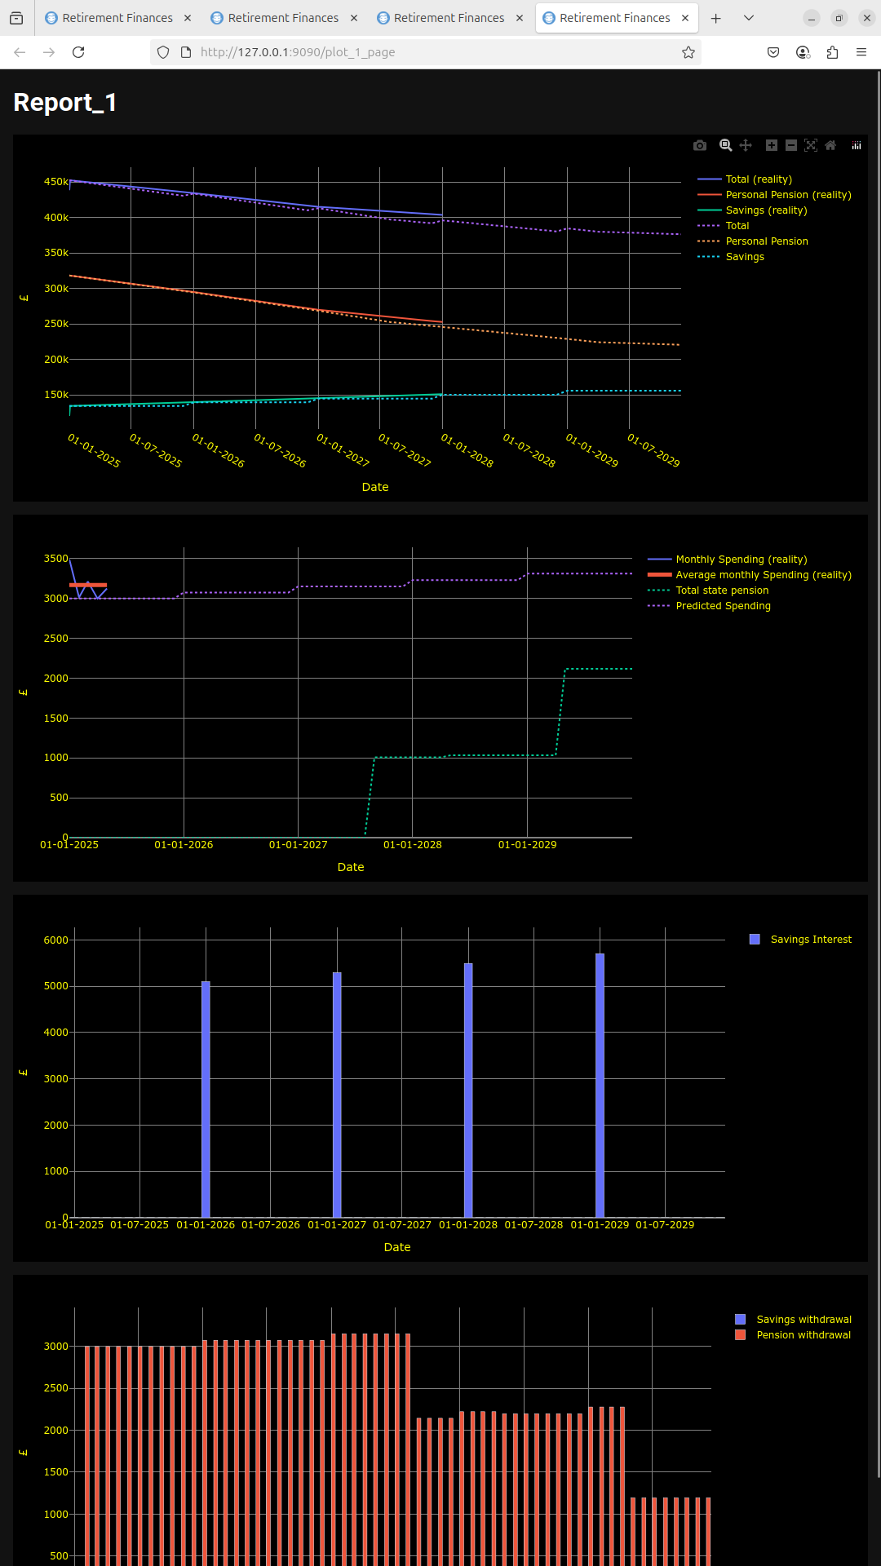

alt text

The plot now shows the real value traces as non dashed lines and the predicted values as dashed lines. You can zoom into section of the plot of by dragging a rectangle over the area you wish to view. An example of this is shown below.

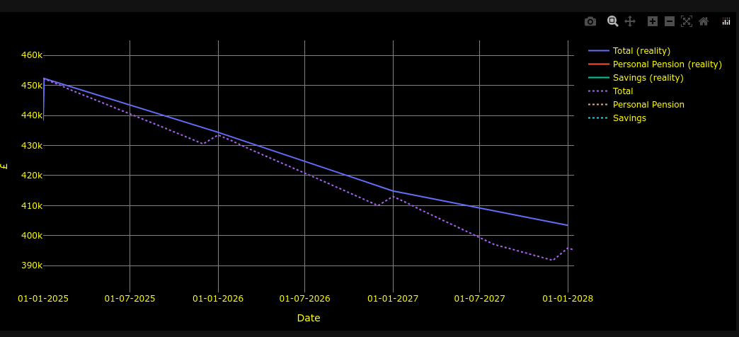

alt text