**Lecture 1: Getting started to R and R studio**

**1.1 About the R Environment**

R is an open-source, fully-featured statistical analysis software. You can work directly in R but we recommend using RStudio, a graphical interface. RStudio is an open-source, integrated development environment (IDE) for R. RStudio combines a powerful code/script editor, special tools for plotting and for viewing R objects and code history, and a code debugger.

R is an integrated suite of software facilities for data manipulation, calculation and graphical display. Among other things it has

* an effective data handling and storage facility
* a suite of operators for calculations on arrays, in particular matrices
* a large, coherent, integrated collection of intermediate tools for data analysis,
* a graphical facilities for data analysis and display either directly at the computer or on hardcopy, and
* a well-developed, simple and effective programming language (called ‘S’) which includes conditionals, loops, user defined recursive functions and input and output facilities

**1.2 R and statistics**

R environment is very closely related to statitics and sometimes it says R as a statistics system. There are about 25 packages supplied with R (called “standard” and “recommended” packages) and many more are available through the CRAN family of Internet sites (via https://CRAN.R-project.org) and elsewhere

**1.3 About R and R studio**

R is the basic package we are using. R Studio is an add-on that make R easier to use for beginners. I encourage you to learn to use R, especially if you will be taking other statistics courses, where you may be expected to know how to use it.

**1.4 These instructions should work for Windows and MAC users for installing R and R Studio.**

**1.4.1.INSTALLING R:**

Go to http://www.r-project.org/, and in the “Getting Started” box, click on “download R.” Find a site of your choice.

Click to go to that site. Click on your operating system (Windows, MAC, Linux) and follow directions. If Windows, click on “base” and then on Download R 3.4.1 for Windows. (Note that 3.4.1 is the current version as this is being written, but use whatever shows up as current.) You may need to save the file “R-3.4.1-win.exe,” and then click on it to execute it. When the dialog box opens, click “RUN.” A Setup Wizard should appear. Keep clicking “Next” (or change features if you understand them), until it is finished. You should now see an icon on your desktop, with a large capital “R.”

**1.4.2 INSTALLING R STUDIO:**

Go to http://www.rstudio.com, click on “Download RStudio” and follow the directions for your operating system.

**1.4.3 EXITING R AND R STUDIO**

You can exit both at the same time using File→ Quit R Studio Or you can type q() at the command prompt. Note that this is the letter q followed by open and closed parentheses.

**1.5 R and R studio environment**

In this tutorial, we provide a detailed overview of the RStudio IDE and its functionality. You will learn to navigate and use the Console, Source, Environment, and Files panes.

**1.5.1 Console plane**: The Console Pane is the interface to R. If you opened R directly instead of opening RStudio, you would see just this console. You can type commands directly in the console. The console displays the results of any command you run

**1.5.2 Source Pane**: The Source Pane is a text editor where you can type your code before running it. You can save your code in a text file called a script. Scripts have typically file names with the extension .R. You can also run code by pressing Ctrl+Enter.

**1.5.3 The Environment Pane:** The Environment Pane includes an Environment and a History tab. If you are using RStudio you will also see a Connections tab. The Connections tab makes it easy to connect to any data source on your system.

**1.5.4 The Files Pane:** The Files Pane includes several tabs that provide useful information like contents of your working directory, Plot tab and the packages tab.

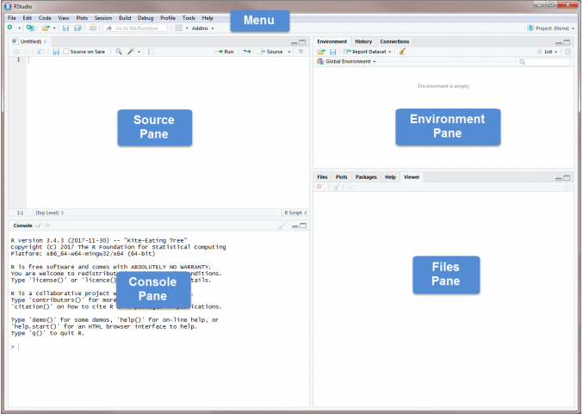

Fig.1 R Script (Ctrl+Shift+N) window

**1.6 The Menu**

The Menu includes drop-down menus as well as buttons for opening, saving, and viewing or editing datasets. Here we list a few of the things you can do from each drop-down menu.