程序报告

学号： 姓名：

- 问题重述
（简单描述对问题的理解，从问题中抓住主干，必填）
====================================================================
这个问题是要使用DQN算法让机器人自动探索迷宫，DQN使用深度神经网络来学习机器人在不同状态下的动作价值，从而选择最佳动作到达目标点。这个问题的主干为使用经验重放记忆（如使用ReplayDateset类存储实验数据），实现DQN算法。

- 设计思想
（所采用的方法，有无对方法加以改进，该方法有哪些优化方向（参数调整，框架调整，或者指出方法的局限性和常见问题），伪代码，理论结果验证等… 思考题，非必填）
====================================================================

- 代码内容
（能体现解题思路的主要代码，有多个文件或模块可用多个"===="隔开，必填）
====================================================================
class Robot(QRobot):
valid_action = ['u', 'r', 'd', 'l']

''' QLearning parameters'''
'''明白 epsilon 和 gamma 的意义，调节参数观察效果'''
epsilon = 0.5 # 初始贪心算法探索概率
gamma = 0.94 # 公式中的 γ

EveryUpdate = 1 # the interval of target model's updating

"""some parameters of neural network"""
'''调节网络参数'''
target_model = None
eval_model = None
learning_rate = 1e-3 # 参数更新的学习率
step = 1 # 记录训练的步数

def __init__(self, maze):
"""
初始化 Robot 类
:param maze:迷宫对象
"""
super(Robot, self).__init__(maze)
'''设置奖励值'''
maze.set_reward(reward={
"hit_wall": 10.,
"destination": -50.,
"default": 1.,
})
self.maze = maze
self.maze_size = maze.maze_size

"""build network"""
self.target_model = None
self.eval_model = None
self._build_network()

"""create the memory to store data"""
max_size = max(self.maze_size ** 2 * 3, 1e4)
self.memory = ReplayDataSet(max_size=max_size)

def _build_network(self):
seed = 0
random.seed(seed)

"""build target model"""
self.target_model = Model(state_size=2, action_size=4, seed=seed)

"""build eval model"""
self.eval_model = Model(state_size=2, action_size=4, seed=seed)

"""build the optimizer"""
self.optimizer = paddle.optimizer.Adam(learning_rate=self.learning_rate,parameters=self.eval_model.parameters())

def target_replace_op(self):
"""
Soft update the target model parameters.
θ_target = τ*θ_local + (1 - τ)*θ_target
"""
""" replace the whole parameters"""
self.target_model.set_state_dict(self.eval_model.state_dict())

def _choose_action(self, state):
state = np.array(state, dtype='float32')
state = paddle.to_tensor(state)
if random.random() < self.epsilon:
action = random.choice(self.valid_action)
else:
self.eval_model.eval()
with paddle.no_grad():
q_next = self.eval_model(state).numpy() # use target model choose action
self.eval_model.train()

action = self.valid_action[np.argmin(q_next).item()]
return action

def _learn(self, batch: int = 1):
if len(self.memory) < batch:
print("the memory data is not enough")
return
state, action_index, reward, next_state, is_terminal = self.memory.random_sample(batch)

""" convert the data to tensor type"""

state = paddle.to_tensor(state,dtype='float32')
action_index = paddle.to_tensor(action_index,dtype='int32')
reward = paddle.to_tensor(reward,dtype='float32')
next_state = paddle.to_tensor(next_state,dtype='float32')
is_terminal = paddle.to_tensor(is_terminal,dtype='int32')

self.eval_model.train()
self.target_model.eval()

"""Get max predicted Q values (for next states) from target model"""
Q_targets_next = self.target_model(next_state).detach().min(1).unsqueeze(1)

"""Compute Q targets for current states"""

Q_targets = reward + self.gamma * Q_targets_next * (1 - is_terminal)

"""Get expected Q values from local model"""
self.optimizer.clear_grad()

Q_expected = self.eval_model(state)
action_index_onehot = fluid.layers.one_hot(action_index, 4)
action_index_onehot = fluid.layers.cast(action_index_onehot, dtype='float32')
Q_expected = fluid.layers.reduce_sum(fluid.layers.elementwise_mul(action_index_onehot, Q_expected), dim=1)

"""Compute loss"""
loss = F.mse_loss(Q_expected, Q_targets)
loss_item = loss.item()
""" Minimize the loss"""
loss.backward()
self.optimizer.step()

"""copy the weights of eval_model to the target_model"""
self.target_replace_op()

return loss_item

def train_update(self):
state = self.sense_state()
action = self._choose_action(state)
reward = self.maze.move_robot(action)
next_state = self.sense_state()
is_terminal = 1 if next_state == self.maze.destination or next_state == state else 0

self.memory.add(state, self.valid_action.index(action), reward, next_state, is_terminal)

"""--间隔一段时间更新target network权重--"""
if self.step % self.EveryUpdate == 0:
self._learn(batch=1)

"""---update the step and epsilon---"""
self.epsilon = max(0.2, self.epsilon * 0.995)

self.step += 1
return action, reward

def test_update(self):
state = np.array(self.sense_state(), dtype=np.int16)
state = paddle.to_tensor(state,dtype='float32')

self.eval_model.eval()
with paddle.no_grad():
q_value = self.eval_model(state).cpu().numpy()

action = self.valid_action[np.argmin(q_value).item()]
reward = self.maze.move_robot(action)

return action, reward

- 实验结果
（实验结果，必填）
====================================================================
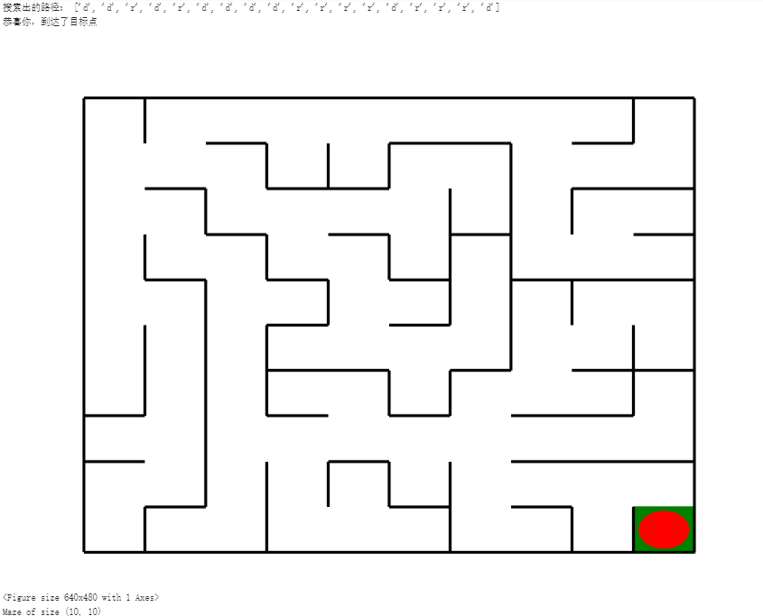
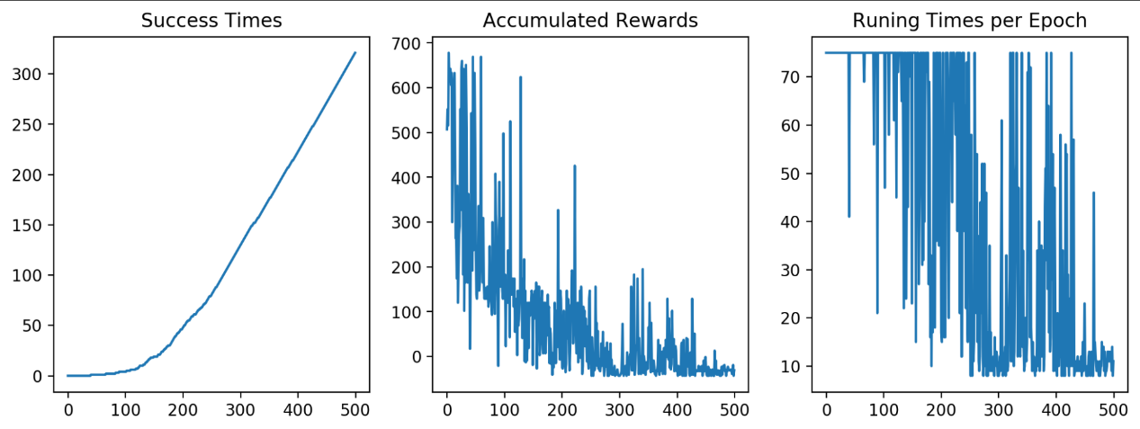

- 总结
（自评分析（是否达到目标预期，可能改进的方向，实现过程中遇到的困难，从哪些方面可以提升性能，模型的超参数和框架搜索是否合理等），思考题，非必填）
====================================================================

