Direct Payment Personal Assistant commissioning team process
From April 2023 ALL DPs with a Personal Assistant must be sent through to the DP PA team including where a review has taken place (except planned short breaks). The DP PA Team will ensure that the forms and commissioning requirements are completed correctly to reduce the returns by Service Placement Team.
The DP PA Team will also complete all the PA checks, we have a legal responsibility to ensure the PA’s employment status is accurate, that the PA has a current DBS in place, and contingency arrangements have been agreed and understood. Where the PA is claiming to be self-employed the DP PA Team will undertake the checks and ensure the PA understands their roles and responsibilities.
The DP PA team can provide consistent and accurate employment advice, they will discuss and agree the PA rates ensuring they are inline with the affordability within the personal budget.
You can only access this process via the Conversation 3 - Building a good life or Review Conversations – community-based services.
Stage 1
- Complete the sections for the building a good life/keeping in touch and request for a financial assessment to be sent immediately to ACFS to start the financial assessment process.
- Then click the forms and letters icon to add the Care and Support plan/Review of Care and Support plan this will always be required where there is a request for a DP with PA
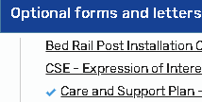
This must be attached BEFORE the request for services otherwise information will not pull through correctly and you will need to rewrite information.

- Complete section 1 - 4 of the Care and Support Plan/Review of Care and Support plan

- Section 5 Arranging my support, select how the support will be arranged, if there are other services including managed services, please ensure you make the correct selection.
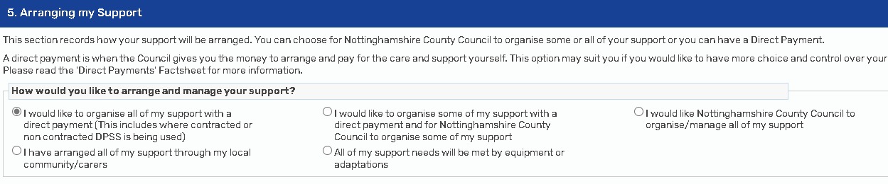
You will need to identify whether the individual has mental capacity to accept a Direct Payment, if they do not have mental capacity then an authorised person will need to be identified, if a person does not have capacity to request a Direct Payment and there is no-one to act as an Authorised Person, a Direct Payment must not be given. For more information on Capacity please see Direct Payments guidance – section 3.3 page 13
- If there are any other DP or managed services you can complete this now, or at stage 2 once the PA has been identified and PA services have been arranged and costed into the Care and Support plan – the DP PA team will complete the DP PA relevant information in section 5 arranging my support, any other support is your responsibility to review and ensure it is correct.

- Use the forms and letters icon to attach the request for services form

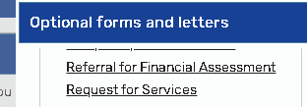

- Ensure all mandatory information is complete in section 1 - Personal Details of the Request for services form
- Select the required services from section 2 - Service Information, Direct Payment PA Service must be selected to complete the required information 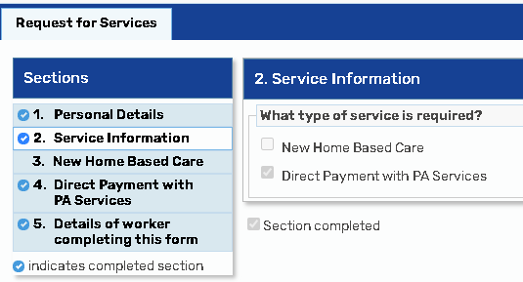
You can select multiple options where there are multiple services required. The DP PA request will be sent to the DP PA team and all other services such as new Home-Based Care will be sent to the Service Placement team.

- Section 4 – Direct Payment with PA Services
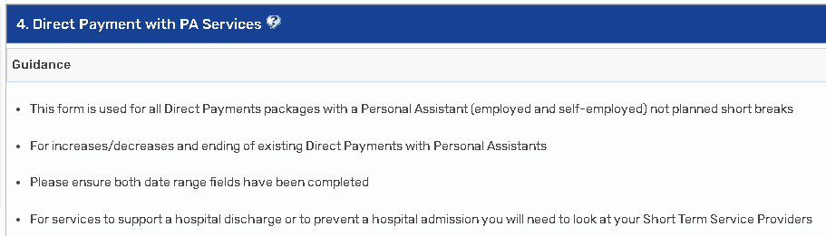

You can now complete this section with the required package information.
- If a family member, friend, neighbour, or someone already known to the individual has already been identified as a PA then this can be recorded in this section and the DP PA team will complete the required forms such as DP agreement, DBS request, DP Calculator and any DPSS order forms where required.

- If no potential PA has been identified the DP PA team will need as much information as possible in order to recruit to the PA role

- Earliest start date – This can be as early as the date of conversation where the PA support has already been identified as a person known to the individual. This is often the date of conversation as the start date as the PA is already providing support to the individual.

- Where a PA has not yet been identified the earliest start date can be today, or a future date if known.

- Latest start date – This date field is not mandatory but if for any reason there is a date that the support must be in place by then please record this here. This might be a date of discharge from hospital for example.

- Mental Capacity – Should pre-fil from section 5 of the Care and Support plan where this section has been completed prior to attaching the request for service.

- Identified Personal Assistants – Please record if any PAs have already been identified including employment status such as employed or self-employed and the contingency arrangements if the family will cover for the PAs annual leave or sickness if known.

- Support needs – Please complete these sections as fully as possible, this will help the DP PA team to identify a PA with the level of skills required to meet the needs of the individual, if you know there will be more than 1 PA required for hoisting, please record this, and total number of hours required and how these will be split.

- Section 5 – complete any missing/mandatory information in this section if required.

- The final part to stage 1, is to send the request for services to the DP PA team you will need to click on the requests icon and select the – Requests for services – Direct Payments Personal Assistants and sent this to the DP PA Commissioning team – Save and close.
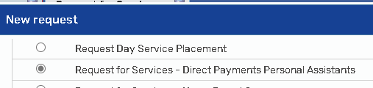
Whilst you are awaiting the recruitment, set up, forms and commissioning to be completed you can check up on the status of this by taking a look at the DP Team tracking form that will be added to each step once it has been picked up by the DP PA team and they have started the DP PA process.
The DP Tracking form will be attached to the commissioning step;
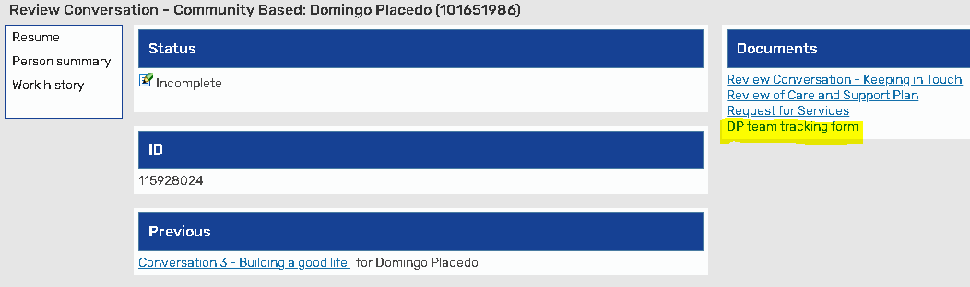
When you click on the hyperlink you can access the form to see the status, or view this from within the step;
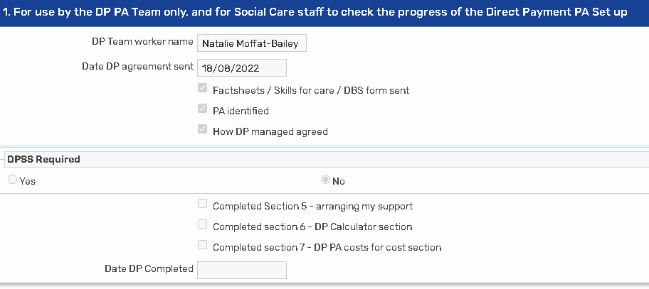

Stage 2
Once the DP PA team have completed the DP PA assocaited tasks as above, you will receive notfication that the request for services DP PA has been completed.
The DP PA team will have completed the following sections of the care and support plan for DP PA packages only, any other services including Agency DP, Day Service DP, managed homecare, managed Day services will need to be completed by the operational team workers, Social care workers or Community Care officers
- Section 5 Arranging my support – any other services.
- Section 6 DP Calculator – any other DP services will also need to be recorded to give the total DP Costs
- Section 7 Costs – any other services including Health funding and S117.
You can now complete any other services and requests if you have not already done so prior to sending to the DP PA team.
Once any other requests have been completed including manager approval you can send your step to SPT/DIT to be commissioned by selecting the relevant team from the next actions.

When you are reviewing a DP PA package with other DP or managed services
- DP calculator
Any review of a DP with a PA either employed or self-employed will require a DP Calculator and any other DP Services will also need to be included on the DP Calculator to ensure that the total cost of ongoing DP is calculated.

- What to check
When reviewing a DP PA package, you will need to check that everything is working well, this includes the PAs support. You will need to ensure that all services have the correct costs and rates especially where the manages services have been uplifted. It is your responsibility to ensure the managed services and any other DP service information is accurate on the care plan.

- Increase/reductions to a DP PA package.
These will need to be completed by the DP PA team, please send a request for services to the DP PA team to ensure that the calculations are correct, and the DP PA set up was completed accurately including the PA employment status and advice and information given to both PA and employer on roles and responsibilities.

- Forms required.
- A new DP Agreement ACM39 required annually or if there are any changes to how the DP will be managed (PPC/TPMA), or any changes to the authorise or nominated party.
- DP Calculator required for any changes to a DP package that includes PA support.
- Any changes to DPSS support will require a new order from
- ACM33 required for any Health funding.
Once the operational team worker picks up a review, they will review the package of support and any commissioning requirements for the PA’s will be completed by the DP PA team.
If there are any changes to hours/rates the DP PA team will undertake all the forms, documents, and checks and ensure all the commissioning aspects are correct to reduce SPT returns.
They will complete all the commissioning processes that they already do for the setup of new DP’s, we are just providing information and advice and collating all documents and ensuring everything is uploaded and the care plan is completed correctly.
The DP PA commissioning team has taken on all the below commissioning aspects of Personal Assistant DPs (new and reviews not planned short breaks) all you need to do is complete and send a request for services form and request and send to the team via the Mosaic step.
- Sending /receiving and uploading the DP Agreement/ACM39 (where not already completed)
- Recruiting Personal Assistants where they have not already been identified.
- Discussing how the DP will be taken/managed.
- Completing the order form for DPSS support, and uploading this
- Completing the DP Calculator for PA services only
- Updating the cost section on the Care and Support plan with the accurate DP PA costs
- Providing employment guidance and advice to individuals and PA’s
- Identifying the PA’s employment status
- Discussing the PA’s responsibilities and rates
- Completing all relevant PA checks such as DBS and HMRC CEST for self-employed PA’s
- Ensuring Employer liability/public liability is in place.

SPT have to ensure the information they receive is correct in order to commission.
- ACM39 requirements – Physical signature, full document to be uploaded as financial document - Agree with ACFS to case note where overtime and no face-to-face visit for return of ACM39 to allow commissioning.
- DPSS Signatures on ACM39 only required for TPMA.
- Note on step for information – such as see case note or as agreed by GM/ Solo non contracted DPSS support.
- Where a DP Calculator has been used it MUST match on-going costs for all DP services including Agency
- Section 5 CASP – ensuring this is accurate, matches the DP Agreement (with support is only selected where there is DPSS support in place/nominated person, not required for authorised person only)
- Costs – all DP Costs can be input as a total ongoing DP with a breakdown in the description to make it clear, rather than separate lines for each DP service (breakdown is in DP Calculator)

For support around DP PA packages please contact.
DPPAcommissioningteam DPPAcommissioningteam@nottscc.gov.uk
For general support around commissioning Direct Payments please contact.
DP Enquiries DPEnquiries@nottscc.gov.uk
All Direct Payment information and guidance can be found.
Direct Payments support area | Nottinghamshire County Council Intranet (nottscc.gov.uk)

