

Policy Library Pro Forma

This information will be used to add a policy, strategy, guidance or procedure to the Policy Library.

Title:
Direct Payments for adults - staff guidance

Aim / Summary:
To provide information to staff about Direct Payments, including to an “Authorised Person”.

Document Type (Click the relevant box.):

Policy | ☐ | Guidance | ☒
Strategy | ☐ | Procedure | ☐

Approved By: Clare Gilbert | Version Number *: 2.0
Date Approved:  18/03/2022 | Proposed Review Date:  January 2026

Author: Laura Chambers | Responsible Team: Strategic Commissioning
Contact Number: 0115 9932563 | Contact Email: Laura.chambers@nottscc.gov.uk

Please Include Any Supporting Documentation:
- ACM 39 Direct Payment “Agreement and Set-up Document”http://home.nottscc.gov.uk/working/departments/asch/asch-documents/acm39
- Direct Payments in Residential Care - a step by step guide.
- ACM/35/DP/RC - Direct Payments in residential care – care home record for support plan
- Selecting a Direct Payments Support Provider (fact sheet)
- Adult Social Care Strategy
- Direct Payment Factsheet
- Direct Payments pre-payment debit cards

Review Date: 14.3.22
6.2 Reviewing the Direct Payment in the light of changes in employment law
Updated with the new National Living Wage for 2022 of £9.50 for employing a Personal Assistant as agreed at committee on 14th March 2022
Sleep-in rate also updated inline with the Government guidance based on the increase to the National Living Wage

Direct Payments for Adults - Staff Guidance

Table of Contents
1. Public Information p5
1.1. What is a Direct Payment? p5
1.2 How COVID-19 impacts on how Direct Payments can be used during this period. p5

2. How a Direct Payment can be used p6

2.1 General principles p7
2.2 Restrictions on the use of Direct Payments p10
2.3 Using Direct Payments to pay for Residential and Nursing Home Care p11
2.3.1 If the care home will accept a Direct Payment p11
2.3.2 Agree the start date p12
2.4 Using Direct Payments to pay close family members for management and/or administrative support p12
2.5 Using Direct Payments to pay for local authority services p12

3. Setting up a Direct Payment p13
3.1 Providing information p13
3.2 Requesting a Direct Paymentp13
3.3 Capacity and capability – the role of the Authorised Person and the Nominated Person. p13
3.3.1 Who can act as an Authorised Person? p14
3.4 Fluctuating Capacity p16
3.5 The Direct Payment Agreement (ACM39) p18
3.6 The start date of the Direct Payment p20
3.7 Service User Contributions - charging and payment process p20

4. Managing a Direct Payment p21
4.1 Process for choosing the most appropriate method to manage the Direct Payment p21
4.2 Managing a Direct Payment through a Pre-Paid Debit Card (PDC) p23
4.2.1Making Payments through a Pre-paid Debit Card (PDC) p24
4.3 Managing a Direct Payment through a separate bank account p24
4.4 Third Party Managed Accounts (TPMAs) p24
4.4.1 Using a managed account provided by a Direct Payment Support Service (DPSS) p25
4.5 Using a managed account managed by NCC Adult Care Financial Service (ACFS) for agency only support packages p26

5. Direct Payment Support Services p26
5.1 Choosing to use a Direct Payment Support Service (DPSS) p27
5.2 Using a TPMA to pay for Agencies Only p28

6. Different Ways to use a Direct Payment and using the Direct Payment Calculator to work out the cost p29
6.1 Becoming an Employer of Personal Assistants p29
6.1.1 Responsibilities of the employer p30
6.1.2 Employing a Personal Assistant and calculating the cost p31
6.1.3 What employment costs need to be covered in the support plan? P32
6.1.4 Statutory requirements: p32
6.1.4.1Employers Liability Insurance p32
6.1.4.2 Employers National Insurance Contributions p33
6.1.4.3 Holidays and breaks p33
6.1.4.4 Statutory sick/maternity payments/redundancy p34
6.1.4.5 Employer’s Health and Safety duties p34
6.1.5 Administrative Costs p36
6.1.5.1 Contracts of Employment & Notice Period p36
6.1.5.2 Back- up and contingency p37
6.1.6 Disclosure and Barring Service Checks (DBS) p37
6.1.6.1 Where the DBS Check reveals that someone is on a barred list p39
6.1.6.2 Where the DBS reveals there is a positive disclosure p39
6.1.6.3 What if a Disclosure and Barring Service check is not pursued? P40
6.1.6.4 What if a Direct Payment recipient does not consent to the Council undertaking the DBS check on their behalf? p41
6.1.7 Issues related to Modern Day Slavery to be aware of when employing Personal Assistants p42
6.2 Reviewing the Direct Payment in the light of changes in employment law p42
6.3 Employing a close relative living in the same household p43
6.3.1Definition of a close relative p44
6.4 Employing a family member/neighbour/friend not living in the same household p44
6.5 Recruiting a Personal Assistant who is not already known to the DP Recipient p45
6.6 Self-Employed Personal Assistants p45
6.6.1 Self- Employment and CQC Registration p46
6.7 Direct Payments to agencies, including micro – providers p47
6.7.1 Where someone previously Self-Funding their Care moves onto a Direct Payment p49
6.8 24hr care packages p51
6.9 Provision of equipment p51
6.9.1 Using a Direct Payment to buy general equipment or appliances p52
6.10 Direct Payments and VAT p52
6.11 Additional Support re Direct Payments set up available from Direct Payment Quality Officers p52

7. Integrated Personal Commissioning p52

8.Direct Payments and Auditing p52
8.1 Audit Alerts for breach of Direct Payment Agreement p52
8.2 Recovery of surplus Direct Payment money p54
8.3 Recovery of money due to misuse of Direct Payments p54
8.4 Investigating Potential Misuse of Direct Payment Monies p60

9. Operational Reviewing of Packages p63
9.1 Initial Reviews p63
9.2 Annual Reviews p64

10. Ending the Direct Payment p66

1. Public Information

If a person is eligible for social care support following assessment, staff have a duty to inform him/her about personal budgets and Direct Payments. Fact sheets for the public are available in the Publications Directory.

1.1. What is a Direct Payment?

Direct Payments are monetary payments from the Council that are made to individuals who request them, in order to meet some or all of their eligible social care and support needs. People who take a Direct Payment choose and pay for their care and support services themselves. Direct Payments offer an alternative to Managed Personal Budgets, which involve the Council arranging and paying for the care and support services that are needed.

Flow chart for setting up a Direct Payment See Appendix 1

1.2. How COVID-19 impacts on how Direct Payments can be used during this period.

The Government coronavirus guidance for people receiving a Direct Payment was updated on the 11 March 2021.
This encourages Local Authorities to ensure they are flexible in their approach to people who use a direct payment during this period.
The key areas for teams to consider from the government guidance are:
- Local Authorities to be flexible around family members living in the same household being employed as Personal Assistants (PAs)
Section 6.3 of this DP guidance currently advises that “a close relative living in the same household as the person cannot be employed by them to provide care and support unless there are exceptional circumstances”

We would see changes made due to coronavirus as an ‘exceptional circumstance’ and would allow family members living in the same household to be employed as PAs to meet eligible needs during this period. Any decision to allow this should be made on a person-by-person basis and be recorded in the person’s support plan, giving an explanation for the decision.

Top Tip – Where it is agreed for a family member living in the same household to be employed as a PA, schedule an early review so it can be decided what is best on a long-term basis after the COVID period.

- Audit processes to be adapted to allow flexibility including enabling people to carry forward DP funds into the next financial year.

Currently DP policy allows 6 weeks of DP money to be built up within the DP account and ACFS will only recoup DP monies in excess of this. If there are reasons that more funds are needed within a person’s account, a decision needs to be made and recorded in the support plan, giving an explanation why. If extra money is being rolled over due to coronavirus, think about scheduling an early review to look at this again after the COVID period.

- Direct Payments to be used flexibly with no unreasonable restrictions as long as they are being used to meet eligible outcomes.

Our DP policy encourages creative and innovative ways of using a DP, using strength-based approaches to meet eligible outcomes. We ask that a person receiving a DP tell the Council if the DP is going to be used for something other than that what is identified in their support plan so this can be updated if agreed

If at review you find that due to coronavirus the DP recipient has used the DP differently to meet their outcomes, but has not told the Council in advance, you will need to consider whether to agree the different use of the DP.

ACFS will continue to notify you where the DP has not been used as stated within the support plan, but when receiving these, teams should then make a decision on a person-by-person basis as to whether this is appropriate or not and record the rationale for their decision.

- Ensure contingency arrangements are in place for DP recipients.

We encourage you to support individuals to develop contingency plans in case their usual support cannot be provided. This could be if someone employs a PA, what their cover arrangements would be if they were off sick or self-isolating. The cover could be by informal support or through an alternative provision. Contingency planning also needs to consider and include any unpaid support that is provided on a regular basis. Contingency arrangements should be recorded in the person’s support plan.

If you need any extra support in relation to this guidance, please contact the DP Enquiries Team by emailing DPEnquiries@nottscc.gov.uk

2. How a Direct Payment can be used

2.1 General principles

Discussions with the person with support needs about how a Direct Payment is going to be used should take place as part of the support planning process. Staff should refer to the guidance on Assessment, Eligibility, support planning and Personal Budgets for further details. As set out in section 3.4 of that guidance, a holistic approach to support planning is encouraged, during which any friends or family who have been identified as being important to the individual’s well-being should be involved. This might include informal carers, or friends willing to provide support (paid or unpaid) at short notice that could be named in the contingency planning.

The completed support plan should include details of how the Direct Payment will be used to meet the needs identified in the assessment in order to meet the associated outcomes. This means that it should be clear to both the individual and the authority how the money is to be spent on what support, goods, activities, or services, and how these elements of support will enable identified needs to be met. The support plan should record specifically what the Direct Payment will be used for including where can be used flexibly as long as meet outcomes. This will ensure the person is clear what the Direct Payment can or cannot be used for, it will also assist staff when it comes to review. If the Direct Payment includes costs for activities these should be included within the support plan. If activities are not included, it is best practice to state this within the support plan as well to avoid any confusion in the future. Any steps taken to ensure the person understands what the Direct Payment can and can’t be used for and all of their Direct Payment responsibilities within the DP Agreement should be recorded within the Case notes and this should be cross referenced within the Costing section of the support plan (e.g., see case noted dated 5th March discussion to ensure understanding of DP responsibilities.) It would also be useful to fill in the Staff Checklist for completing a support plan for a Direct Payment and saving within the documents section of the person’s Mosaic records.

Individuals should be helped to consider how they will measure the success or otherwise of the support their Direct Payment has purchased (i.e., what looks like ‘good’ to them in terms of, for example, greater independence, better health, more social inclusion and so on).
A Direct Payment can be used to meet eligible needs in a variety of ways, and it is fine for it to be used creatively if it can be demonstrated that an eligible outcome identified within the support plan will be met by the service / item being purchased with the Direct Payment. Chapter 12 of the Care and Support Statutory Guidance states that the Direct Payment is designed to be used flexibly and innovatively. There should be no unreasonable restrictions placed on the use of the Direct Payment if it is being used to meet eligible care and support needs and is legal to do so. For this reason, it is not possible to provide a comprehensive and definitive list of what Direct Payments can and can’t be used for. What is an appropriate use of a Direct Payment for one person may not be appropriate for another. However, there are some basic principles that should be applied.

Any support, activities, or services that a Direct Payment is used to fund must:

- Meet eligible needs as identified in the assessment
- Meet needs in a way that enables the person to achieve personal outcomes, which should be recorded in the support plan
- Be affordable and sustainable. As stated in the Adult Social Care Strategy, there may be some needs which can be met from other sources (such as community or informal support).
- achieve the personal outcomes that have been identified in the support plan. All of the money should not be spent on meeting one need if this means that other needs cannot be met. If there are other elements of support as well as the Direct Payment (i.e., managed services such as contracted homecare) then these should also be referenced.
- Be cost effective.
- Be legal
- Be an appropriate use of social care funding

Case Example 1

Peter is a young man with learning disabilities. His assessment identified that he has needs arising from his learning disability. Because of these needs, Peter is unable to achieve outcomes relating to the following outcome domains.

Making use of necessary facilities or services in the local community including public transport and recreational facilities or services
Maintaining personal hygiene
Being appropriately clothed

The assessment indicated that Peter would require 2 hours a week of support to make use of necessary facilities or services, 12 hours a week of support to maintain personal hygiene and 7 hours a week of support to be appropriately clothed. He has an indicative personal budget of £320 a week (£16,640 per year).

As part of the support planning process, Peter chose personal outcomes that were important to him. These included being dressed in clothes of his choosing, having a shower each day, and being washed and shaved in the morning. He also wanted to attend Nottingham Forest home games.

Initially, Peter asked if he could use his Direct Payment to buy a Nottingham Forest season ticket, which would cost £460 a year. Peter was advised that this was not an appropriate use of the Direct Payment because although this would help him achieve an outcome that was important to him, the money would not be used to meet the need that prevented him from achieving the outcome. The need, arising from his learning disability, related to his inability to travel independently to matches and to manage inside the ground. However, Peter was able to use his Direct Payment to pay for a Personal Assistant to support him to travel to the matches and manage safely while he was there, because this support was meeting his needs. The cost of 3 hours of support at £11.16 for 20 matches a year averages out at just under 1.2 hours of support per week.

Nottingham Forest allows carers into the ground at a concessionary price so, using the Direct Payment, Peter and his family were able to purchase a season ticket for the carer for £150 This worked out at £2.88 per week when averaged out over the year. So, the level of support for this activity is within the level identified in the assessment and can be paid for within the indicative budget.

Peter also chose to use the rest of his Direct Payment to employ a Personal Assistant to meet his other needs.

Case Example 2

Rachel has assessed eligible needs arising from a physical disability. She is unable to achieve outcomes relating to the following outcome domains;

Maintaining personal hygiene
Making use of necessary facilities or services in the local community including public transport and recreational facilities or services
Being appropriately clothed
Maintaining a habitable home environment

The assessment indicated that Rachel would require 12 hours of support per week to maintain personal hygiene, 4 hours of support per week to make use of necessary facilities or services, 7 hours of support per week to be appropriately clothed and 4 hours of support per week to maintain a habitable home environment. She has an indicative personal budget of £432 a week (£22,464 per year).

Rachel decided to use much of her Direct Payment to purchase support from a local agency that she had come to know well and trust. However, one of the personal outcomes that she wanted to achieve (linked to making use of necessary facilities or services in the local community) was to be able to choose and buy her own weekly shopping. Rachel’s physical disability prevented her from doing this independently. Previously, a support worker from the agency had spent 3 hours a week supporting Rachel to do her shopping, at a cost of £42 per week.

Rachel asked if she could use her Direct Payment to purchase a tablet device to enable her to do her shopping online. It was agreed that this would meet an assessed need and help her achieve an important personal outcome of having greater control over her life & her diet. When the costs were analysed, it was found that the price of the tablet, plus the cost of an internet connection, delivery costs and agency time to put the shopping away were less over the first year than the cost of the alternative support from a support worker.

Rachel’s request to purchase a tablet device on which to do her shopping was approved on the basis that it addressed an assessed need in order to help her achieve a personal outcome, could be afforded within the amount of indicative budget linked to the need and could be demonstrated to be a cost-effective approach.

Case Example 3

Roger is a 78-year-old man who has eligible needs arising from increasing frailty due to a long-term health condition. He is unable to meet outcomes relating to the following outcome domains:

Maintaining personal hygiene
Managing toilet needs

Roger used his Direct Payment to purchase support from an agency. He had heard that a Direct Payment could be used to purchase a tablet device and asked if he could do this. Roger was advised that this would not be an appropriate use of his Direct Payment because the tablet would not be used to meet his needs to achieve personal outcomes associated with his particular case.

2.2 Restrictions on the use of Direct Payments

There are a few general restrictions on how a Direct Payment can be used. These include paying for:

- Anything that is against the law
- All forms of gambling, including bingo
- Things that other sources of income would normally pay for, including day to day food bills, rent or mortgage payments, utility bills, cigarettes, alcohol, clothes, furniture, decorations
- Personal debts
- Anything that exposes a person to serious physical or financial risk
- More than four weeks of respite/short term care in a care home at any one time
- Provider agencies to deliver personal care where they are not registered as a domiciliary care agency with the Care Quality Commission to provide personal care
- Health services
- Family members living in the same household, unless there are exceptional circumstances (Covid-19 would be considered an exceptional circumstance where the use of a family member being employed as PA would be considered on a person-by-person basis), indicated in the risk enablement plan (located in the forms icon within care and support plan and review of support plan episodes) and agreed at Group Manager level.
- For a service for which the person is not eligible based on other Council eligibility criteria (e.g., A Direct Payment could only be used for Transport if a recipient is eligible for Transport as per Transport Policy)

In exceptional circumstances there may be other exemptions from this list. However, these must be based on evidence and staff must discuss any exceptional circumstances with their line manager

2.3 Using Direct Payments to pay for Residential and Nursing Home Care

The Care and Support (Direct Payment) Regulations 2014 allow Nottinghamshire County Council to make a Direct Payment to secure long term care in a care home (Schedule 4).
Direct Payments should be offered to all people moving into residential and nursing care.
The personal budget will be the same as it is for a managed care home placement. The Council is not giving people more money for a Direct Payment than they would receive for a managed service.
- Ageing Well - the Direct Payment will be based on the current banded rates and the dementia quality mark.
- Living Well - the Direct Payment will be as per contractual agreement.
- Continuing healthcare funding (CHC) - if there is CHC funding this will either be paid directly to the care home by the CCG, or paid as a managed personal budget by NCC and recouped on a Section 256.

2.3.1 If the care home will accept a Direct Payment

The Person choosing to have a Direct Payment and/or family need to select a care home, we then need to clarify with the care home that they will accept this method of payment.
Give people clear information about the responsibilities of the Direct Payment and ensure they understand them as outlined in the Direct Payment Agreement and Set Up document (ACM/39).
- It is essential that you explain to people the responsibilities of taking a Direct Payment. This offer is for people and/or family members who want this responsibility and understand what it entails. The ACM/39 states all the responsibilities including a section on spending the direct payment in long term residential/nursing care. Make sure you have the up to date version of the agreement. Get it signed by the necessary parties and give them a copy.
- Person with assessed needs or authorised person signs the Direct Payment Agreement (ACM/39)
- Scan the agreements onto Mosaic (or save to Mosaic if using Total Mobile version) – the Direct Payment will not be paid by ACFS until they are on the Mosaic records.
- The pre-paid debit card option, should be offered to all new Direct Payment recipients, including those living in care homes, it is the Council’s preferred option for managing the money. Ensure you understand how the card works and what people need to do. There is a fact sheet available that will explain the pre-payment card.
- An individual can cease the Direct Payment and return to a managed service at any time, giving four weeks’ notice in writing.
- The Direct Payment account must be used for the sole purpose of the Direct Payment.
- The Direct Payment will be paid in the same way as a community Direct Payment; as a NET payment four weeks in advance. Staff must ensure that people understand what they have to do to manage the Direct Payment
- The personal contribution must be paid into the Direct Payment account and the Person with assessed needs, the nominated or authorised person must pay the care home provider the full cost of care from this account.

2.3.2 Agree the start date (and end date if existing resident transferring from a managed payment)

If the person is in a care home and changing from a managed service to a Direct Payment, consult the ACFS payment schedule to ensure the dates line up. If the service user is moving into a care home for the first time, please enter the start date in the costing section of the support plan.

Further information can be found in the Staff Guidance on Commissioning Care Home Placements

2.4 Using Direct Payments to pay close family members for management and/or administrative support

The Care Act now allows for the payment of close family members living in the same household to provide management and /or administrative support to Direct Payment holders in cases where the local authority determines this to be necessary. This is intended to reflect the fact that in some cases, especially where there are multiple complex needs, the Direct Payment amount may be substantial. Requests for arrangements of this kind should be referred to a Team Manager and the Strategic Commissioning Team can provide further advice where required through the DPEnquiries@nottscc.gov.uk email address. Payments to close family members to provide care and support services are dealt with in section 14 below.

2.5 Using Direct Payments to pay for local authority services

The Care Act now gives local authorities the discretion to allow Direct Payments to be used to pay for local authority services in some circumstances. As a rule, Direct Payments should not be used to pay for local authority provided services from the “home” authority. It should be easier and less burdensome for the Council to provide care and support services direct to the person under a “managed personal budget” arrangement.

However, in some circumstances the Council does have discretion to provide care and support services by receiving a Direct Payment, for example where someone wishes to make a one-off purchase of a day care place. In such cases it might be less burdensome to accept the Direct Payment amount rather than providing the service and then reducing the Direct Payment accordingly. Requests for arrangements of this kind should be referred to a Team Manager and the Strategic Commissioning Team can provide further advice where required through the DPEnquiries@nottscc.gov.uk email address.

Where an internal Local Authority service is being used, the service needs to provide the Individual requiring support with an invoice so that the costs can be paid out of the Direct Payment.

3. Setting up a Direct Payment

3.1 Providing information

Direct Payments are the Government’s and the Council’s preferred way of providing a personal budget. Social Care Worker should ensure that people are given relevant and timely information and advice about Direct Payments, so that they can decide about whether to request a payment. This should be provided to all people where eligible for support when completing their support plan. A Direct Payments fact sheet is available to help with this.

3.2 Requesting a Direct Payment

The route to a Direct Payment is for a person with assessed needs or an authorised person on the person’s behalf to request one. The Council supports the person’s right to make this request by providing information and advice. A Direct Payments fact sheet is available to help with this.

People must not be forced to take a Direct Payment against their will or because there is no alternative way to provide care and support. Instead, people should be informed of the choices available to them and a Direct Payment should always be offered as an option to meet the assessed needs of the individual.

3.3 Capacity and capability – the role of the Authorised Person and the Nominated Person.

If someone permanently lacks capacity an Authorised Person can request and receive the Direct Payment on an individual’s behalf.

Care Act guidance states that the steps to follow after receiving a request for a Direct Payment will depend on whether the person has been assessed as having capacity to make a decision about Direct Payments or not and this has to consider their capability to understands their responsibilities in relation to the Direct Payment as per the Direct Payment Agreement. It is the Social Care Worker’s responsibility to determine this. Further information and advice about assessing capacity is contained in chapters 6 and 12 of the Care Act Guidance.

If a person is assessed as not having capacity to request a Direct Payment, this should be recorded in the Capacity Episode in Mosaic.

If a person is assessed as not having capacity to request a Direct Payment, with certain exceptions, councils now have a duty to make Direct Payments in respect of that person, provided there is an Authorised Person who is willing to take on responsibility and who meets all the conditions set out in the Care Act Regulations including having capacity to manage the Direct Payment.

The Authorised Person receives the Direct Payment on behalf of the person needing care and support and takes on the full range of responsibility associated with this. An Authorised Person is only required where a Mental Capacity Assessment has been undertaken and determined that an individual lacks capacity to request and /or manage Direct payment monies.

If a person does not have capacity to request a Direct Payment and there is no-one to act as an Authorised Person, a Direct Payment must not be given, regardless of any other practical support that may be available to manage the Direct Payment, for example from friends or family or from a Direct Payment Support Service. In such circumstances a managed personal budget must be used. A Team Manager cannot sign a Direct Payment instead of an Authorised Person.

3.3.1 Who can act as an Authorised Person?

It is for the Council to determine the suitability of a person to act as an Authorised Person and whether making a Direct Payment to the Authorised Person is an appropriate way to meet the needs of the person requiring Care and Support. The Care Act 2014 Regulations set out a process to ensure that the best interests of a person lacking capacity are prioritised above all other considerations, irrespective of the relationship of the proposed Authorised Person to the person requiring support. In the first instance it will be the Assessment Worker who is responsible for doing this. If there is any doubt about whether it is in a person’s best interest, the matter should be referred to a Team Manager and any subsequent decision should be clearly recorded in the Best Interests section of the Capacity Episode in Mosaic.

The first choice of Authorised Person would normally be someone who is already acting as a “formal representative”. This is likely to be a family member or friend involved in the person’s unpaid care and support.

Someone can become a formal representative in one of two ways;

- If the person has been given lasting power of attorney by the person needing services at some point before, they lost mental capacity; or

- If the person has been appointed a deputy for the person needing services by the Court of Protection under section 16 of the Mental Capacity Act 2005.

Where there is no formal representative identified or the formal representative does not wish or is not suitable / capable of acting as an Authorised Person, Assessment Workers should consider whether someone other than the formal representative is considered to be the most appropriate choice of Authorised Person by those consulted about making Direct Payments in respect of a person lacking capacity (see below for further details on the duty to consult).

Before the Council agrees to allow a request for an Authorised Person to act on behalf of a person lacking capacity for the purpose of receiving a Direct Payment, it must be satisfied that the person meets the five conditions as set out in section 32 of the Care Act 2014.

- Each of these conditions must be met in their entirety. Failure to meet any of the conditions would result in the request being declined. The conditions are:

- Where the person is not authorised under the Mental Capacity Act 2005 but there is at least one person who is so authorised, that person who is authorised supports the person’s request;

- The local authority is not prohibited by regulations under section 33 from meeting the adult’s needs by making Direct Payments to the Authorised Person, and if regulations under that section give the local authority discretion to decide not to meet the adult’s needs by making Direct Payments to the Authorised Person, it does not exercise that discretion;

- The local authority is satisfied that the Authorised Person will act in the adult’s best interests in arranging for the provision of the care and support for which the Direct Payments under this section would be used;

- The local authority is satisfied that the Authorised Person can manage the Direct Payment by himself or herself, or with whatever help the authority thinks the Authorised Person will be able to access;

- The local authority is satisfied that making Direct Payments to the Authorised Person is an appropriate way to meet the needs in question.

As part of the process of determining the suitability of a person to act as an Authorised Person, Assessment workers should, as far as reasonably practical and appropriate, consult and take into account the views of the following people;

- Anyone named by the Person receiving support, before they lost capacity, as someone to be consulted on these issues or other welfare matters.

- Anyone currently engaged in caring for the person lacking capacity or with an interest in their welfare.

- Any representative (done of lasting power of attorney (LPA) or deputy appointed by Court of Protection under s.16 MCA 2005) or surrogate (done of LPA or deputy with powers in relation to decisions about care provision), whether or not they are going to take on the role of suitable person.

- The person themselves, according to the principles in the MCA and Code of Practice regarding their: past and present wishes and feelings; beliefs and values that would be likely to influence the person’s decision if they had capacity; any other factors the person would be likely to consider if he/she were able to do so.

Any decision that is made in relation to the use of an Authorised Person should be recorded in the Best Interests Section of the Capacity Episode in Mosaic.

3.4 Fluctuating Capacity

If fluctuating capacity is a known issue, this should be covered in the support plan, which details the steps to be taken where capacity fluctuates. For example, where the person has fluctuating capacity and has capacity at the point that the Direct Payment is agreed, the assessor should discuss the option of giving a family member or friend a lasting power of attorney to manage their affairs relating to personal welfare should the person lose the capacity to consent to Direct Payments at a later date.

Care Act Regulations state that the Direct Payment does not need to be terminated due to a subsequent lack of capacity if;

- The authority is satisfied that the adult’s lack of capacity to make the request is temporary; and
- Another person who appears to the authority to be capable of managing a Direct Payment is prepared to accept and manage such payments on behalf of the adult during the period of the adult’s incapacity.

- Where the person has fluctuating capacity and lacks capacity at the point that the Direct Payment is agreed, an ‘Authorised Person’ must be appointed. If the person then regains capacity for a temporary period, the Authorised Person can continue in this role and continue to receive the Direct Payment if:

- The Council is satisfied that the person’s capacity to request a Direct Payment is temporary; and the Direct Payments made during the period that the person has the capacity to request a Direct Payment are made subject to an additional condition that the Authorised Person allows the person to manage the Direct Payments themselves for any period during which the Council is satisfied that the adult has the capacity to request the making of Direct Payments.

- Where the person with support needs regains capacity on a long term or permanent basis, the Council must discontinue payments to the Authorised Person. However, before Direct Payments to the Authorised Person can be terminated it is necessary to either start making Direct Payments to the Service User themselves or to arrange services for them, according to their wishes.

A Nominated Person can help a Direct Payment Recipient manage the money

Staff must be satisfied that the Service User who is receiving the Direct Payment, or the Authorised Person receiving it on his/her behalf is able to understand and take on the practical tasks associated with managing a Direct Payment,

A person may have the capacity to request a Direct Payment, but not be capable of managing the various aspects of the Direct Payments. These include the financial arrangements required to manage the money, (e.g., set up and run a bank account, deal with, and pay invoices etc.) and the management of the care and support, (e.g., giving guidance and support to PAs or managing a constructive relationship with a Care Agency).

If a person has capacity to request a Direct Payment (either in his/her own right or as an Authorised Person) but is not capable or willing to take on the practical tasks associated with managing the Direct Person, another person can agree to take on these tasks. The Care Act refers to this person as a Nominated Person.

Unlike the Authorised Person, the Nominated Person does not take on the legal responsibilities related to having the Direct Payment or of being an employer. These responsibilities remain with the Person with support needs or an Authorised Person.

A Nominated Person could be a friend, a family member, or a Direct Payment Support Service where they are providing a Third-Party Managed Account offer.

For each individual case, consideration should be given to the extent to which a person can manage all aspects of the Direct Payment, taking into account the support that is available to that person, including from a Nominated Person.

If a person is not able to manage any aspect of the Direct Payment with the support that is available, the Direct Payment should not be given, and a managed personal budget should be offered instead.

3.5 The Direct Payment Agreement (ACM39)

The provision of a Direct Payment is dependent upon potential recipients signing a formal agreement with the Council that sets out the roles and responsibilities of all parties involved. The Agreement should be completed and signed when setting up a new Direct Payment and ideally at least annually at review.

The Direct Payment Agreement is available;

- As an editable Word document on the intranet http://home.nottscc.gov.uk/media/2905666/directpaymentagreementformacm39.docx
- On Total Mobile
- On Mosaic Forms

The Agreement may require signatures from a number of different parties, depending on who is involved. All the required signatures must be present on one completed form. Partially completed forms are not acceptable and will be returned to the members of staff responsible for completing them. This will result in a delay in the Direct Payment being commissioned and paid.

It is likely that a printed, hard copy of the form will be required if all the parties needing to sign it are not present when it is created. For example, it may be necessary to send the form to a DPSS provider who is not present at the support planning meeting.

The completed and signed hard version of the Agreement should be scanned and uploaded to Mosaic as a “Financial Document” and named “ACM39 Direct Payment Agreement”. It is important to follow this naming protocol.

If it is necessary for a hard copy of the Agreement to be created, signed, and uploaded to Mosaic, any version of the form that has originally been created in Mosaic or Total Mobile should be deleted. This will ensure that the only version of the Agreement that appears in an individual’s Mosaic record will be the completed, signed one.

In some circumstances, for example if all parties needing to sign the Agreement are present, it may be possible to create, sign and save the Agreement electronically using Total Mobile.

The Agreement is a very important document. Staff must take the necessary time and provide advice and information to ensure that Direct Payment recipients fully understand the contents and meaning of the Agreement and what they are signing up to. The steps taken to ensure the Person receiving support / Authorised Person understands all of their responsibilities in relation to the DP Agreement should be case noted and reference to this included within the individual’s support plan under the notes section.

It is recommended that, for all Direct Payments, the assessment worker should discuss the Direct Payment Agreement as part of the support planning conversation. If the person receiving support lacks capacity to request a Direct Payment and an Authorised Person is going to receive the Direct Payment, the discussion about the Direct Payment Agreement should be held with the Authorised Person and it is the Authorised Person who must sign the form.

The Direct Payment Agreement should be updated at least Annually when undertaking annual review. If the only Agreement in existence is an old version (pre-March 2021) or if relevant details have changed, a new Direct Payment Agreement must be completed and signed by all parties. If an unplanned review is undertaken to adjust the care package and there is a new version of The DP Agreement already in Mosaic that has been signed in the last year, then a new DP agreement will not be required. It should though be signed at the next scheduled review (Annually).

It has been agreed that if a Care package amendment is used which can only be used in specific circumstances such as short-term changes to packages and Provider rate changes / cost corrections that a new DP Agreement is not required. It is also not required if an unplanned review is undertaken over the phone.

In order for the Agreement to be completed, discussions about a number of related issues will need to have been concluded:

- Whether a “Nominated Person “is needed to help the Direct Payment recipient manage the money and if so, who the nominated person will be
- Where the Direct Payment will be paid (a Pre-paid Debit Card Account or a separate bank account)

Depending upon the circumstances of the case, the following signatures may be needed on the Direct Payment Agreement:

- The person receiving support if he/she has capacity. Otherwise, the Authorised Person
- The Nominated Person if it has been agreed that such a person (whether a friend, family member or a DPSS provider) is needed to provide support to help the Direct Payment recipient (whether this is the person receiving support or the Authorised Person) to manage the money
- The Nottinghamshire County Council Social Care Worker.

Please Note: A DPSS only needs to sign the Direct Payment Agreement when they are managing the monies through a Third-Party Managed Account (TPMA). They do not need to sign if only providing payroll support.

3.6 The start date of the Direct Payment

The start date of the Direct Payment is the date given by the commissioning worker in Mosaic. However, the date on which the first payment will actually be made is dependent on receipt of the following by Adult Care Financial Services:

- Purchase Order
- Completed and signed Direct Payment Agreement uploaded into Mosaic. Assessment workers must ensure that the Agreement is signed by all relevant parties and that only one version of the Agreement is saved in Mosaic.

3.7 A person’s assessed contributions - charging and payment process

The Council will carry out a Financial Assessment to see whether someone has to contribute towards their Personal Budget. This is done in line with the Care Act 2014 and the Council’s Charging Policy. For Direct Payment Service Users any contribution is deducted from the weekly personal budget amount; the remainder being paid into the Direct Payment bank account. This means that if the Direct Payment recipient does not pay his/her contribution into the Direct Payment bank account, there will be a shortfall in the funds available to pay for the level of support that has been assessed as being needed.

The person with assessed support needs /Authorised Persons and their families should be made aware that the contribution always pays the first part of all care and support costs. The Council’s payments will make up the remainder. The full assessed contribution needs to be paid into the Direct Payment bank account even if less support hours are used than what is in the support plan. This means that as long as the total of all the care and support costs is greater than the total amount paid in contributions, any surplus identified in the Direct Payment bank account will be requested to be returned to the Council. Direct Payment recipients would only be reimbursed any contribution if they have contributed more than what has been spent on care and support.

An individual’s contribution should be paid into the Direct Payment bank account every 4 weeks in advance in line with the payments we make to them. A standing order is the preferred method of making contribution payments.

Often there is a delay between the Direct Payment starting and the person with assessed support needs /Authorised Person knowing what they have to contribute. The Council will pay the gross (full) amount of the personal budget until the financial assessment is completed. Once the contribution is known, this will then be applied from the start date of the Direct Payment. Following this, some of the Council’s monthly payments will be reduced to take account of the initial overpayment. Therefore, to ensure there is enough in the Direct Payment account to cover costs of care, the person with assessed support needs/Authorised Person needs to ensure he/she puts some money aside from the start of care in order to pay this into their Direct Payment account once their financial assessment is completed. Social Care Workers should make the Service User/Authorised Person aware of this and may want to suggest a minimum weekly amount they put aside to avoid accumulating a large deficit.

If the cost of the care package/Personal Budget is lower than the individual’s personal contribution, then they are liable for the full cost of their care and are not eligible for a Direct Payment as they will become a self-funder of their support. They should be provided with a copy of the Council’s self-funder guide to care and support.

If the Direct Payment is to be used to pay for residential care, Adult Care Financial Services (ACFS) will need to be informed as the contribution is calculated differently.

For details of the financial assessment by Adult Care Financial Services (ACFS) and charges see the factsheet, Contributions towards a personal budget.

4. Managing a Direct Payment

4.1 Process for choosing the most appropriate method to manage the Direct Payment

A Direct Payment can be managed via a number of different options which include a Pre-paid Debit Card (PDC) (which is the Council’s preferred method). An individual can set up a dedicated separate bank account, or a Third-Party Managed Account (TPMA) through a Direct Payment Support Service (DPSS) can be used.

A more detailed description of each method of managing a Direct Payment is detailed in sections 4.2, 4.3, 4.4, 4.5

A simple process map for staff is shown below in Diagram 1.

The starting point with any Direct Payment package is to determine that the person with assessed support needs or an Authorised Person, has capacity to manage the Direct Payment. The outcome of the Capacity Assessment should be recorded on Mosaic.

If the person with assessed support needs or an Authorised Person does not have capacity to manage a Direct Payment and they do not have anyone who can act as an Authorised Person for them, they will not be able to have a Direct Payment and support will need to be provided through a managed service.

If the individual has capacity or has an Authorised Person, it should be first determined whether the individual could manage the Direct Payment through the use of a Pre-paid Debit Card (PDC). This could either be by themselves or through a Nominated Person. If additional support is required with set up, the Social Work Team can contact a Direct Payment Quality Officer through the DPEnquiries@nottscc.gov.uk email address. The Quality Officers will be able to guide a staff member through the set-up process and in exceptional circumstances can undertake a joint visit to assist with set up. If having a PDC is not an appropriate option, the Direct Payment recipient can choose to manage the Direct Payment through a separate bank account. (Please note that if an individual/ Authorised person is able to manage a Direct Payment through a separate bank account there should be no reason they could not manage a pre-paid card as this is just a bank account without a high street branch.) If neither of the above options are feasible then a Third-Party Managed Account (TPMA) through a Direct Payment Support Service (DPSS) should be considered.

4.2 Managing a Direct Payment through a Pre-Paid Debit Card (PDC)

The PDC scheme that the Council operates in conjunction with Pre-Paid Financial Services (a company of EML Payments Ltd) functions in the same way as a regular bank account and is the Council’s preferred way for Service Users to manage their Direct Payment. This also applies in circumstances where an Authorised Person has been appointed to manage the Direct Payment on behalf of a person with assessed support needs who lacks capacity.

A PDC account should be offered to all new Direct Payment recipients as the starting point for managing the Direct Payment as it is easier for the Individual to manage without the need to provide Bank statements at audit. (The person can though, choose to use an alternative method of managing the money, following the flow chart above Diagram 1). people who are already receiving a Direct Payment and using a conventional bank account should also be made aware, at review, of the option to have a PDC account and the benefits to them of this method of managing the Direct Payment.

If a PDC is chosen, the person with assessed support needs /Authorised Person should be given a copy of the fact sheet, Direct Payment pre-paid debit cards [PDF] which will provide details on the benefits of having a PDC and the process of activating and using the card.
If the person with assessed support needs /Authorised Person needs someone to assist with the use of the PDC, a third party can be nominated, and they will have the same access as the Service User/Authorised Person. This will usually be the Nominated Person stated on the Direct Payment Agreement form. However, the Person with support needs/Authorised Person will take full responsibility for the appropriate management of the Direct Payment in line with the Direct Payment Agreement and Direct Payment Policy. Where the person with support needs has capacity but does not have the ability to manage the Direct Payment account via the PDC, and they do not have anyone to take on this role for them, a Third-Party Managed Account (TPMA) with a Direct Payment Support Service (DPSS) may have to be considered instead of the use of a PDC.

Staff should always indicate on the Direct Payment Agreement form and support plan radio button where a PDC is going to be used to manage a Direct Payment. By doing so, this will be the trigger for ACFS to order the card and get the PDC set up.

There are no costs to the Direct Payment recipient for a PDC. All fees associated with a PDC are paid centrally by the Council, so do not need to be included in the Support plan or costed into the Direct Payment.

4.2.1Making Payments through a Pre-paid Debit Card (PDC)

If an individual is familiar with the use of internet banking, then a PDC will be a very good option to explore as one-off or regular payments can easily be made online using the card.
Payments to providers can be made over the phone by giving the long 16-digit number on the front of the card. Payments made over the phone, or the internet will require the security number to be given (this is the three last digits on the back of the card).

Payments can also be made by inserting the card into a card machine and inputting the PIN number. Receipts should be kept for all payments made this way.

If an individual is unable to make a payment online and the provider will not accept payments directly over the phone, it is possible to use the Prepaid Financial Services (PFS) phone banking service. If this is required, please contact ACFS for the phone number. This option should only be used after the above alternatives have been explored as the Council will be charged £2.50 for every call to this number. It should be noted that the Phone banking service option is still more cost effective to the Council than using a TPMA, but more importantly it enables the individual to have more control over payments than using a TPMA. To access the Telephone banking number please request this by emailing DPEnquiries@nottscc.gov.uk

The PFS telephone banking number should only be used to make payments. It should not be used for checking an account balance or reporting a card stolen as this should be done through the free IVR numbers that are listed within the factsheet for Direct Payment Pre-paid Debit Cards [PDF].

4.3 Managing a Direct Payment through a separate bank account

If an individual has chosen not to manage the account through a PDC they can open a separate dedicated bank account purely for the Direct Payment. This account should be in the name of the person receiving support or Authorised Person, but a Nominated Person can be used to manage the account. Whether a separate bank account or a PDC account is used, Direct Payment recipient must keep all relevant documents supporting payments made from the account. Where cash withdrawals or cheque payments have been made from a regular bank account, receipts for these must also be kept. This supporting documentation will be requested at regular audits by the Council’s Adult Care Financial Services Team along with bank statements for the period being audited.
The Social Care Team may also need to request to see copies of bank statements at Assessment and support plan reviews and /or when any concerns have been identified by Adult Care Financial Services and passed through to the Social Care Team to investigate further.

Social Care Workers should always view the latest ACFS Audit case notes in Mosaic prior to a visit and follow up on any actions stated within them.

4.4 Third Party Managed Accounts (TPMAs) through a DPSS

In some situations, a person may have capacity to request a Direct Payment, but not be able to manage the money themselves. For example, a person’s financial history may indicate that there is a need for more intensive support with paying staff or providers or someone may lack the ability or confidence to operate a bank account and deal with making payments. In such situations, a Nominated Person can operate a managed account, in effect a holding account for that person, who will pay their support bills for them. This can either be an arrangement with a friend or family member acting on an unpaid basis, or a paid for service from a Direct Payment Support Service.

If a TPMA is chosen, the Direct Payment recipient should be given a copy of the Fact Sheet Direct Payments Managed Accounts.

The option to use a TPMA should be carefully considered in the context of what is needed, the costs involved and the person’s underlying capability to use a Direct Payment. Note that this capability, or lack of it, should not be confused with people’s need for care and support. Someone with complex and multiple support needs may nevertheless be willing and able to manage their Direct Payment.
Direct Payments are about people being in control and this includes control of their own payments and finances. The most empowering way of supporting the person should always be considered before it is agreed that a Nominated Person or DPSS will operate a managed account on behalf of the Direct Payment recipient.

From 15th March 2021 the way DPSS’s are provided has changed. The Council now commissions directly with 5 contracted Providers. These are listed below:
- Penderel’s Trust Limited
- People plus Group Limited
- Purple Zest Limited

- Rosekel Resourcing Limited
- Solo Support Services Limited

Where a TPMA is being used from a contracted DPSS the costs of this will be paid directly to the provider and no-longer into the Direct Payment. The Council would not usually pay more for a package than what can be commissioned through an equivalent available managed service and a TPMA should be factored within these costs.

4.4.1 Using a managed account provided by a Direct Payment Support Service (DPSS)

Currently people who require a managed account and who do not have a friend or family member to manage these on an unpaid basis can choose from any of the Council’s Contracted Direct Payment Support Service providers, providing that:

The costs for this can be met from their indicative budget if it has been assessed as necessary and recorded in their support plan along with some rationale for the level of support agreed. Where a Contacted DPSS provider is used for a TPMA then the costs will now be paid directly to the provider, and this will be recorded within the individuals care and support plan costing section (section 8) using the DPSS radio buttons. A step by step DPSS guidance document has been created that details the new commissioning process for staff.

An individual can choose to use a provider who is not a Council accredited provider, but these must be considered on a case-by-case basis and the Council will not be responsible for the quality of the service. The DP recipient will be responsible for ensuring the service meets all of the requirements set out within the DP agreement and the DPSS will need to sign the DP Agreement.

4.5 Using a managed account managed by NCC Adult Care Financial Service (ACFS) for agency only support packages

From the 15th March 2021 if a Direct Payment is set up for agency only support and a managed account is required, this can now be provided by the Councils ACFS team. This will be undertaken by the ACFS team setting up a pre-paid debit card in the name of the individual receiving support and managing the card on behalf of the individual. It will work in the same way as a TPMA provided by a DPSS but just in house. The service though cannot be accessed where a Personal Assistant is involved as the Council will not be involved in providing payroll support.

To access the service, tick the relevant radio box within section 7 of the individuals care and support plan. Once the Direct payment is set up By the Data input Team ACFS will then be notified who will set up the account. No costs are required within the support plan for this service.
5. Direct Payment Support Services

Chapter 12 of the Care and Support Statutory Guidance states that, in considering any request for a Direct Payment, the local authority must be satisfied that the person is able to manage the Direct Payment by him or herself, or with whatever help or support the person will be able to access.

A Direct Payment recipient (and Authorised Persons) may need help with managing and administering aspects of the Direct Payment, either separate to or in addition to the management of the money through a Nominated Person and a Third-Party Managed Account. Many of these management or administrative tasks are likely to be associated with the responsibilities of being an employer, but they may also include tasks such as setting up bank accounts and arranging payments to agencies. Such support can come from a variety of sources:

- Informal/unpaid support from friends and family members
- Support from the District Team, Countywide Review Team worker or Direct Payment Enquiries Team for simple, time limited tasks associated with setting up the Direct Payment, for example setting up the PDC or bank account and establishing payment arrangements initial employment support if considering employing a PA and signposting on how to source a Personal Assistant.
- Paid support from a family member living in the same household to provide management and/or administrative support
- Paid support from a Direct Payment Support Service, the cost of which must be incorporated into the Direct Payment

5.1 Choosing to use a Direct Payment Support Service (DPSS)

A Direct Payment Support Service (DPSS) is an independent organisation that can provide various types of support to Service Users or Authorised Persons, to help them to set up and manage a Direct Payment and to fulfil their responsibilities as an employer.

The starting point for any discussion with a person about support services to help them manage their Direct Payment should always be the nature of the support they will need. It is the responsibility of the assessment worker to support the person to make an informed decision on how they want to meet their Direct Payment support needs. This includes whether or not they need a support provider organisation (rather than a friend or family member).

With clarity about this, a person with assessed support needs can, if necessary, consider the offers that different DPSS providers advertise and the extent to which they can meet their needs. A number of organisations offer Direct Payment Support Services in Nottinghamshire. They range from large national companies to small local organisations. Some offer a wide range of services, others are more limited. The range of services that can be provided includes:

- Giving employment advice
- Assisting Service Users to recruit Personal Assistants
- Obtaining Disclosure and Barring (DBS) checks (The Council will now be the first option for undertaking these checks)
- Helping to arrange Employer Liability Insurance
- Providing a payroll service
- Operating Third Party Managed Accounts (TPMAs)
- Providing a telephone helpline or on-going advice and guidance

The Council’s current position is that people who require new arrangements with a DPSS should be offered the opportunity to use one of the Council’s contracted providers. These are organisations that have been tendered for a contract and are able to meet all of the Councils specification and quality requirements. An individual though can choose to go with a different provider.

The contracted provider organisations are listed on the Council’s public web pages and within the selecting a Direct Payment Support Service factsheet. This factsheet provides information about what support can be provided as well information about each of the 5 contracted providers so that an individual can make an informed choice of who they would like to go with.

Social Care Worker should provide individuals with the information about organisations offering support. The person with assessed support needs should be encouraged to consider more than one provider and to ask questions in relation to their own circumstances and needs.

Social Care Workers can support a person to weigh up the different options but should not make recommendations or choices on behalf of the individual. When a staff member does more than offer information and support to Direct Payment recipients on selecting a service provider, the staff member and local authority may be considered by the individual or others to have made a recommendation. Any specific recommendation from a staff member to purchase a service could result in the Council having a duty to intervene where there are issues of service satisfaction. The Direct Payment Agreement sets out the expectation that Direct Payment recipients should manage the relationship with providers themselves.

Before finalising a decision about which provider to use, individuals should be advised to look on their websites to check the availability and where a none contracted provider is used the cost of their services. It is important to check that the information is up to date.

If an individual chooses a contracted provider, the social care worker should fill in the new order form and send to the appropriate provider (via an encrypted email such as Cryptshare) and once signed upload it to Mosaic as this is the individual contract between the Council and the provider for the provision of this service for the DP recipient. The cost will be paid directly to the provider and not included within the Direct Payment. A step by step DPSS guidance document has been created that details the new commissioning process for staff.

Where a none contracted DPSS is used, the cost of the DPSS is included within the support plan as per previous arrangements.

Staff must be satisfied that the Direct Payment recipient (including Authorised Person) is able to understand and take on the responsibilities of managing a Direct Payment (see section 4).

The Strategic Commissioning Team can aid staff or Direct Payment recipients where they are unable to identify a suitable DPSS.

5.2 Using a TPMA provided by a DPSS to pay for Agencies Only

Where a Direct Payment is being used solely for purchasing support from an agency and a TPMA through a DPSS is going to be used, consideration should be taken around the following areas:

Could the needs be met in a more cost-effective manner by using a commissioned managed service provider? Could a Pre- paid Debit Card be used as an alternative means of managing the Direct Payment rather than a TPMA? (Would this be an option if support was provided with the set-up of the card and could a nominated individual assist with the management of the card).

If a TPMA is going to be used the weekly cost needs to be included when calculating the cost of the care package. If the overall cost is greater than maximum DP rate payable per hour or, for non-contracted agency, if higher than that of a commissioned managed service in that area, then it would require a Team Manager to approve the higher rate, or the Direct Payment recipient can choose to top-up the difference signing the top-up contract. (An individual should not have to top-up the payments if an equivalent alternative provider is not available).

6. Different Ways to use a Direct Payment and using the Direct Payment Calculator to work out the cost

A Direct Payment can be used to pay for a variety of services or equipment to meet an individual’s outcomes as outlined within their support plan. This can include becoming an employer and employing a Personal Assistant; using an agency to provide support; using an external Day Service; paying for activities; and purchasing equipment.

To ensure that the correct amount of Direct Payment is commissioned, Assessment/Review workers must complete the Direct Payment Calculator. A Direct Payment cannot be commissioned if the calculator is not completed for Personal Assistant Packages and your step will be returned by the Data Input Team if the DP Calculator has not been completed.

The DP Calculator must be used for Packages where some or all of the support is provided by a Personal Assistant (including Self-Employed PA’s).

You do not need to complete a calculator in the following circumstances.

- When an amendment is requested, but a review is not planned in response to the request and an initial calculator has not yet been completed.
- For a one-off payment
- Where the DP is being used for an Agency / Day service package only without the use of a PA. In this situation the worker ticks the agency box within the support plan to indicate what the Direct Payment will be used for and the fill in the name of the agency in the mandatory text field. (This does not include self-employed Personal Assistants as a DP calculator is still required for packages where some or all of the support is provided by a self-employed Personal Assistant.

Comprehensive guidance on how to use the DP Calculator can be found in Appendix 3.

6.1 Becoming an Employer of Personal Assistants

6.1.1 Responsibilities of the employer

Where a person is considering using their Direct Payment to employ a Personal Assistant(s), he or she will need to be informed of the legal responsibilities of becoming an employer under UK employment law. The chart below summarises these employment responsibilities:
Employment Responsibilites

Working Time Directive

Health and Safety

Recruiting

Liability Insurance

Fair Treatment

Data Protection - Records

Tax and NI

Employment Contracts

National Minimum Wage

Right to Work in the UK

Training

Pension Enrolment
Skills for Care have published some useful information and guidance about the roles and responsibilities involved in the Employing Personal Assistants Toolkit, which is available to download.

If someone is employing a Personal Assistant for the first time, they should be provided with a copy of the Skills for Care Employing Personal Assistants Toolkit (which is also available in an easy read version). Any on-going support needs in relation to employment responsibilities that are identified should be discussed with the individual. If they require support, they should be enabled to choose a DPSS. Any such support will need to be included in the support plan and where necessary the associated costs (for example for payroll support) will need to be incorporated into the Direct Payment. The Direct Payment calculator should be used to work out the amount of Direct Payment that needs to be commissioned. Where someone is becoming an employer, we strongly recommend as a minimum that they use a DPSS to undertake payroll support to ensure that appropriate HMRC and payroll costs are calculated effectively.

If someone declines to take advice from a DPSS where they intend to become an employer, the risk enablement process within the support plan should be used to decide as to whether the person should be supported to become an employer or not. Where a decision is made that the person will become an employer, the risk enablement plan (located in the forms icon within care and support plan and review of support plan episodes) needs to record how they will meet the employment responsibilities summarised above. If there is any reason to believe that the person may lack the capacity to be an employer, the appropriate mental capacity tests should be carried out to establish capacity, and the results recorded. (See Empowerment Matters Mental Capacity Act guide for more information

It should be noted that some specialist insurers also offer advice on employment issues as part of their standard employer’s liability policy (for example a 24-hour specialist HR line is offered by Fish Insurance, Mark Bates Ltd, (formerly known as Premier Care) and Surewise.com. Social Care Workers may wish to discuss this with the individual to establish whether this service is sufficient for their needs.

More detailed information for Direct Payment recipients wishing to take on employment responsibilities without using a DPSS is available from the Disability and Tax website, who offer a Disability Tax Guide.

6.1.2 Employing a Personal Assistant and calculating the cost

Assessment workers are responsible for calculating the weekly cost of the Direct Payment. To do this the Direct Payments Calculator should be completed. The worker needs to enter the rate of pay that will be being paid to the Personal Assistant. The Calculator will then add on all necessary on costs and as long you do not get a warning at the bottom of the calculator warning that it is more than can usually be paid then it is fine to proceed. Where a warning is obtained a Team Manager will need to make a decision on a case-by-case basis on whether the package can be approved at a higher rate. The total package costs are expected to be within the indicative personal budget parameters. The Council is required to estimate a reasonable cost of providing the service and to make Direct Payments of equal value. The amount of the weekly Direct Payment will consider any personal contribution to be made by the DP recipient and is paid net of any personal contribution. The Direct Payment must be sufficient to enable the DP recipient to lawfully obtain a service of a standard that the Council considers to be reasonable, and it should include associated costs, where necessary.
Further information about all these costs can be found in the Skills for Care ‘Employing Personal Assistants’ Toolkit Section 3 Before your Personal Assistant starts.

6.1.3 What employment costs need to be covered in the support plan?

The rules and regulations regarding employment mean that people who employ their own staff will need to consider additional costs other than the wages they pay to a Personal Assistant. The Council must ensure that any costs associated with these requirements can be met from the indicative budget. The Direct Payments calculator incorporates all the standard relevant costs. Some of these costs are worked out automatically (e.g., holiday cover and National Insurance contributions), while other costs (e.g., the cost of employer liability insurance) need to be established and entered manually into the calculator. The following sections describes the costs that need to be considered.

6.1.4 Statutory requirements:
6.1.4.1Employer’s Liability Insurance

This insurance covers the employer should their employee be injured while working. There are several insurance companies who offer this type of insurance specifically for people who use Direct Payments. The market has developed to offer both basic and enhanced insurance packages. The basic insurance covers all statutory legal requirements whereas enhanced insurance will cover additional protection – for example, to cover awards made as a result of employment tribunal claims.

Staff should ensure that the support plan includes enough Direct Payment money for the person to buy the basic insurance as a minimum.

Mark Bates Ltd: The Home of Premier Care https://markbatesltd.com/products/independent-living/home-employment-insurance and FISH www.fishinsurance.co.uk and Surewise.com https://www.surewise.com/direct-payments/are three of the main insurance providers in the market.

Staff may wish to consider whether there are any identified risks to the person and/or Council prior to agreeing an enhanced insurance premium. These may include a person’s condition or personality that make the breakdown of relationships more foreseeable or where there is a history of dismissing Personal Assistants.

Some policies also include redundancy cover in the event of the Direct Payment being reduced or withdrawn, the individual moving into residential or nursing care, or the death of the Direct Payment recipient. Please ensure that the individual is fully aware of the cover they have, so that the authority does not make redundancy payments unnecessarily. The Direct Payment recipient should not need to make a redundancy payment out of their own estate and where necessary a one-off Direct Payment may be required to cover these payments where it cannot be obtained through the employer liability insurance. The Employer Liability Insurance Company provider should be contacted in the first instance regarding any possible redundancy payments.

If a person is becoming an employer for the first time, a one-off payment Must be commissioned to pay for the first insurance premium. The on-going cost of the annual insurance renewal premium should be included as part of the calculation of weekly cost of the Direct Payment. The Direct Payment Calculator will work out what one-off and on-going costs need to be considered.

Where a Direct Payment recipient is using a self-employed Personal Assistant and this status has been confirmed (see section 6.6) a Direct Payment recipient does not need to take out employer liability insurance as they are not the employer. The self-employed Personal Assistant should arrange their own insurance cover. The Direct Payment recipient can ask to see this for confirmation.

6.1.4.2 Employer’s National Insurance Contributions

Employer’s National Insurance Contributions are payments made by the employer to HMRC. These are different to the contribution that is deducted from the employee’s wages.

The requirement to make these payments depends on the level of wages paid to the employee and is currently set at 13.8% on wages paid above £156 for each employee. However, this cost will be offset to some degree if the employer applies for the employment allowance. This is the amount on which they do not have to pay employer national insurance contributions. From April 6th, 2020, the employment allowance is up to £4,000.

The on-going cost of employer’s national insurance will be worked out by the Direct Payment Calculator and included as part of the calculation of weekly cost of the Direct Payment.

6.1.4.3 Holidays and breaks

Under UK employment law, all employees are entitled to 5.6 weeks holidays each year. Anyone employing a Personal Assistant will need to have enough money to cover the costs of buying in additional support when their Personal Assistant is on holiday/breaks. This could also include agency cover (should they have no other way of getting support i.e., support provided by a family member to cover Personal Assistants annual leave).

If the person has regular short breaks in a residential care home, these breaks should be used as an opportunity for Personal Assistant’s to take their annual leave.

The cost of 5.6 weeks of additional support should be included as part of the calculation of weekly cost of the Direct Payment. This calculation will be automatically undertaken for you using the Direct Payment Calculator.

There is a requirement for at least 5.6 weeks holiday for full time workers to be taken by Personal Assistants. It should not be the case where a Personal Assistant chooses to take the holiday pay without having the time off work.

6.1.4.4 Statutory sick/maternity payments/redundancy

In particular circumstances, employers will have to make statutory payments to their employees. Some of these costs (e.g., maternity pay) are recoverable from any tax or national insurance contributions paid to Her Majesty’s Revenue and Customs (HMRC). Statutory sick pay is not recoverable from HMRC.

Additional costs for these payments should not be included in the support plan. If insufficient funds are available as surplus in a Service User’s account when payments are required, an additional one-off Direct Payment should be arranged. In situations where the money will be recovered by the Direct Payment recipient at a later stage (for example maternity pay may be refunded by HMRC at the end of the financial year), arrangements should be made to ensure that this is paid back into the Direct Payment account.

If a Direct Payment package needs to be ended where a Personal Assistant is employed there may be a need for a redundancy payment to be made. Employees may be entitled to redundancy payments if they have been continuously employed for at least 2 years. The ACAS website provides information on when someone is entitled to redundancy and how to calculate the redundancy payment. If a Direct Payment ends and the Personal Assistant is entitled to a redundancy payment, funds remaining in the Direct Payment account should be used in the first instance to meet the redundancy payment. If there is not enough in the account to cover the redundancy payment a one-off payment will be required to cover the redundancy. Under the Care Act 2014 a Local Authority is obliged to ensure there is enough money provided within a Direct Payment to cover an individual employer’s employment responsibilities. The Direct Payment Recipient’s Employer Liability Insurance company should be contacted in the first instance to see if they will cover any redundancy payment as part of the cover offered.

6.1.4.5 Employer’s Health and Safety duties

Employers have a legal duty to ensure that their employees are safe. There may be additional costs that need to be included in the support plan to ensure that the person employing their own Personal Assistant can meet these requirements. This may include training courses such as a moving and handling course or protective items such as gloves and aprons and where multiple Personal Assistants are employed could include notepads to be used as communications books. Staff should always support the person to consider what needs to be included based on any risks identified in their assessments.

On the Notts Help Yourself website there is a link to the Skills for Care Individual Employer Funding pages, where individual employers can apply for funding to cover a variety of training courses for their Personal Assistants. This funding stream should be explored in the first instance.

Also within the “do you provide a service” section of the Notts Help Yourself website there is a list of Training Courses in Nottinghamshire . A description of the course you are looking for (e.g., medicine) can be entered into the search bar.

Enrolment into workplace pension schemes (and how to check this at review). The law on workplace pensions has now changed and every employer must comply. This includes people employing Personal Assistants using Direct Payments. UK employers must automatically enrol their staff into a workplace pension if they meet certain criteria. People aged over 22 and under state pension age who earn more than £192 per week or £833 per month must be automatically put into a pension scheme by their employer (these figures are reviewed every year). Other people meeting certain criteria have the right to ask to be put into a pension scheme.

Existing employers will have been given a staging date - this is the date the automatic enrolment duties come into effect. From 01 October 2017 all new employers have immediate automatic enrolment duties (staging dates will not apply). This means automatic enrolment duties start as soon as a Personal Assistant is employed.

There is more information available for employers on the Pensions Regulator website http://www.thepensionsregulator.gov.uk/pensions-reform.aspx.

An essential guide for people who employ their own care and support staff is also available.

The Skills for Care ‘Employing Personal Assistants’ toolkit has a section on pensions for Personal Assistants.

The employer minimum contributions are being phased in, to 3% by October 2018. Pension contributions are not paid on the first £116 per week that a Personal Assistant earns. The pension costs should be included as part of the calculation of weekly cost of the Direct Payment. The Direct Payment calculator will work out what the minimum contributions will be.

When a person employs Personal Assistants, staff should check at review whether the person has met his or her responsibilities in relation to pension auto enrolment. the person should be asked;

- Have they been given a “staging date” by the Pensions Regulator – if so, when?
- For those people who have been given a “staging date” Have they complied with the responsibilities of notifying and enrolling staff?
- For those people who have been given a “staging date” that has passed, have they completed a “declaration of compliance”. If so, ask to see a copy of the declaration and make a note to confirm that you have seen it.
- If PAs have been enrolled onto pension schemes, what is the weekly cost of the employer’s contribution?

Most people who employ Personal Assistants use a DPSS to provide payroll support services. Most DPSSs will support people with their pension responsibilities as part of this service, but there may be an additional charge. The most straightforward way to gather the above information is to ask the person, in advance of the review, to provide written details from their DPSS provider. If there is any doubt, as part of the review process, arrange to contact the DPSS to confirm with them directly what is happening and if necessary, plan any corrective action as part of the review.

6.1.5 Administrative Costs

People using Direct Payments do have to keep records and files of any employment responsibilities that mean additional costs may occur. If these are likely to be regular costs, they should be recorded in the support plan and included as an element of the weekly Direct Payment. If they are likely to be occasional costs, these can be funded from any surpluses in accounts subject to a request from the employer and where costs are reasonable. In practice this means that such occasional administrative costs do not need a cost to be recorded in the support plan but should still be recorded within the support plan for information and to assist with ACFS Team audits.

6.1.5.1 Contracts of Employment & Notice Period

The person employing staff should issue their Personal Assistant/s with a contract of employment. The Employing Personal Assistants Toolkit produced by Skills for Care has a section on what should be included within a contract. As a minimum, the contract should include: Tasks being undertaken (These can be taken from the outcomes within the support plan), pay; contracted hours; annual leave; and the notice period. The notice period is the period of notice required by either the employer, if the Personal Assistant is planning to leave their employment, or by the employee, before their hours of work can be stopped. Notice should be given in writing on both sides.

If a care package involving the employment of Personal Assistants is reduced following a review, the change to the Direct Payment amount must be timed to take account of the Personal Assistant’s notice period.

Whether there is a contract or not, the law stipulates that the Personal Assistant should get one week’s notice for each year that they have been employed with that employer. This means 0-12 months = 1 weeks’ notice, 13 – 24 months = 2 weeks’ notice and so on.

Best practice would be that in the first instance contact would be made with the Direct Payment Recipient’s Employer Liability Insurance Company to seek advice from them on what the notice period should be.

6.1.5.2 Back- up and contingency

The employment of staff involves planning for staff absence due to sickness/annual leave or if they decide to leave. People should always consider a back-up plan. This may be a particular problem where only one Personal Assistant is employed, and a person should be encouraged to consider employing more than one Personal Assistant where possible.

Back up plans may require additional costs, for example, where an agency will cover. It is not always possible to determine the exact costs of any contingency. For people who employ Personal Assistants allowing the equivalent of one week’s Direct Payment should be included in the ongoing Direct Payment as a contingency amount. The Direct Payment calculator will work out what this amount should be. If there are legitimate costs associated with an unforeseen event that cannot be met by any accrued money in the person’s Direct Payment account a one-off payment should be commissioned. Requests for such payments should be processed in a timely manner so as to avoid any risks to the continuity of care. Examples of legitimate, but unplanned for costs include; Personal Assistants who have extended periods of sickness leave, redundancy costs and periodic recruitment costs. It is always worth checking whether some or all of these costs are covered by the Direct Payment Recipient’s Employers’ Liability Insurance. If it is a large package of care that involves the employment of multiple Personal Assistants, it would be worth noting within the support plan that surplus funds in the account can be used for recruitment purposes of Personal Assistants if required. A cost will not to be included, but by recording this within the support plan will identify to ACFS Audit Team that surplus can be used for this purpose. It will therefore be deemed as appropriate expenditure. A checklist has been created for staff to assist with completing support plans where a Direct Payment is being used.

Details of any contingency arrangements should be included within the individual’s support plan.

6.1.6 Disclosure and Barring Service Checks (DBS), Right to work in the UK Checks

The generic role of a personal assistant involves them undertaking ‘regulated activity’. This means that a Direct Payment recipient has a legal responsibility under the Safeguarding Vulnerable Groups Act 2006, to ensure that anyone they employ is not on a barred list. If the Personal Assistant is self-employed the Direct payment recipient should ask to see a copy of the Personal Assistants DBS check to confirm that a satisfactory check has been undertaken and they are not on a barred list. Section 9 of the Safeguarding Vulnerable Groups Act states that a person commits an offence if they permit an individual to engage in a regulated activity from which they are barred.

It is likely that most activities carried out by Personal Assistants will be “regulated activities”. For instance, if they involve the provision of assistance (or prompting and supervision) in relation to general household matters which is required by reason of age, illness or disability (e.g. managing someone's cash, paying their bills or doing their shopping) or the provision of relevant personal care (eating or drinking, toileting; washing or bathing; dressing; oral care; or the care of skin, hair or nails) or in certain cases providing transportation or the provision of psychotherapy or counselling, but not life coaching, to an adult which is related to health care that the adult is receiving from, or under the direction or supervision of, a health care professional.

The only way for a Direct Payment recipient, as the employer of a Personal Assistant to meet this requirement is to ensure that an Enhanced DBS and Barred List check is undertaken for any individual they employ. This will make sure the individual employer can meet their legal responsibilities of not employing any person who is on a barred list.

The Council would therefore expect all Direct Payment recipients to ensure that a Right to Work in the UK check, and an Enhanced DBS and Barred List check is undertaken for each Personal Assistant they employ. Although the Council is not the Personal Assistant’s employer, the Council can assist the Direct Payment recipient to discharge their legal responsibilities as employer in this regard by undertaking Right to Work in the UK checks and Enhanced DBS and Barred List checks for potential Personal Assistants, in its role as an “Umbrella Organisation”. This is on the instruction of the Direct Payment recipient( by completing the DBS Request form which should be provided to the Direct Payment recipient at set up and at each subsequent review) and the Personal Assistant will agree to this by filling in the electronic DBS form. This would be the standard way of ensuring an Enhanced DBS and Barred list check is undertaken.

The Council requires a DBS and Barred List check to be renewed at least every three years Where a Direct Payment recipient is already employing a Personal Assistant, the Council expects that the status of any DBS check will be checked at the annual review of the care and support plan. Direct Payment recipients will be required to sign the Direct Payment agreement which covers a Direct Payment recipient’s responsibility in relation to DBS checks. A DBS request form should be given to the Direct Payment recipient to be completed and returned to DPEnquiries@nottscc.gov.uk at each review to ensure all Personal assistants DBS checks are up to date.

Assessment and review workers should inform people that employ staff through a Direct Payment that they have a legal responsibility to ensure that all Personal Assistants they employ are not on a barred list. The Council therefore expects that an Enhanced DBS and Barred list check will be undertaken on any staff he/she intends to employ including existing Personal Assistants. The requirement that a Direct Payment recipient does not employ someone who is on a barred list is also applicable if the Direct Payment recipient employs a family member as their Personal Assistant. This will be the case when there is considered to be a “commercial” arrangement where the Personal Assistant is employed and paid from the Direct Payment to deliver directed services. In these circumstances, a DBS check is also recommended when the prospective Personal Assistant is a family member or has a close personal relationship with the Direct Payment recipient.

Assessment and review workers should provide each Direct Payment recipient with a DBS request form when completing a support plan and at each review, so that they can fill in the details for all of their Personal Assistants they currently employ or are about to employ so that consent can be given for a DBS check to be undertaken. The Service User will need to provide the name and email address for each Personal Assistant so that the Personal Assistant can be contacted to undertake their part of the DBS process and provide consent for the check to be undertaken. If it is an existing Personal Assistant and they currently have an existing Enhanced DBS and Barred List check in place the DBS reference number will be needed to be recorded on the form and the date of issue. This will enable the DBS to be renewed within 3 years of the issue date.

As part of the DBS check process, staff within the Strategic Commissioning’s Direct Payment Project Team will be involved in undertaking the ID verification and “right to work” checks on each Personal Assistant. If the DBS comes back as positive, then staff from the Strategic Commissioning Team will meet with the Personal Assistant to view the DBS certificate in order to make a suitability decision on the appropriateness of the individual being employed as a Personal Assistant.

The Process map in the Direct Payment support area of the intranet advises on the process.

6.1.6.1 Where the DBS Check reveals that someone is on a barred list

If the DBS check reveals that the someone is on a Barred List, then they are forbidden from working in the capacity of a Personal Assistant and a Direct Payment cannot be used to employ this individual. The Council will have a duty to notify the relevant Authorities that someone is seeking to work in a capacity from which they are barred as the Individual has committed an offence under the Safeguarding Vulnerable Groups Act 2006 for seeking employment for a role they are barred from. Assessment and review staff will be notified in this situation and should then support the Direct Payment recipient to source alternative means of support which may mean a managed service rather than a Direct Payment.

Where someone is revealed as being on a barred list they cannot be employed in the role of a Personal Assistant and if a Direct Payment recipient chose to employ someone who is on a Barred list, they would be committing an offence under section 9 of the Safeguarding Vulnerable Groups Act 2006.

6.1.6.2 Where the DBS reveals there is a positive disclosure

Where the DBS check reveals recorded information, the Direct Payment recipient will be required to make a suitability decision to determine whether it is safe and appropriate to employ the person. A Council Officer from the Strategic Commissioning Team will undertake this process, which will involve them having sight of the DBS certificate. The Personal Assistant will sign an engagement form which informs them that the Council will undertake a Suitability Decision on behalf of the Direct Payment recipient if the DBS check reveals recorded information. This will require the permission of the prospective Personal Assistant. If the Personal Assistant does not agree for the Council to undertake the suitability decision the Council will take the view that a Direct Payment is not an appropriate way to meet the individual’s care and support needs and the offer of a Direct Payment to employ a Personal Assistant will be withdrawn.

In cases where an Enhanced DBS and Barred List or Right to Work check reveals information recorded, the DP recipient will be required to make a “suitability decision” in order to determine whether it is safe and appropriate to employ the person. Where the Enhanced DBS and Barred List check is undertaken by the Council, a Council Officer will be required to participate in this process which will involve the Council Officer having sight of the DBS certificate. This will require permission of the prospective employee, as there is no legal requirement within the DBS checking process for the Council to be involved in this way. However, unless agreement is given by the prospective employee for the Council to undertake the suitability decision on the Direct Payment recipient’s behalf the Council cannot be confident that sufficient measures are in place to safeguard the DP recipient from harm. In such circumstances a decision will be made on a case-by-case basis as to whether the Direct Payment is the most appropriate way to meet the needs of the individual in this situation for the employment of the prospective Personal Assistant. Where the Direct Payment recipient uses an alternative organisation to undertake the DBS check, they should notify the Council if there is a “positive disclosure” so that the Council can undertake a suitability decision as outlined above.

If, having viewed the DBS certificate, the Council deem that the Personal Assistant is not suitable to be employed as a Personal Assistant through a Direct Payment, then this must be recorded in the support plan. If the Service User is insistent on employing the Personal Assistant regardless of the suitability decision, a decision would need to be made on a case-by-case basis by a Group Manager as to whether the Direct Payment can be used. If it is deemed that it can be used this must be recorded within the Risk enablement plan (located in the forms icon within care and support plan and review of support plan episodes). Where the Group Manager decides that a Direct Payment is not suitable to be used for a Personal Assistant, assessment and review staff in this situation should support the Direct Payment recipient to source alternative means of support which may mean a managed service rather than a Direct Payment. A person can choose to employ a Personal Assistant who has been deemed not suitable by the Council, but this would have to be funded directly by the individual.

6.1.6.3 What if a Disclosure and Barring Service check is not pursued?

If a Direct Payment recipient refuses to undertake an Enhanced DBS and Barred List check for the staff they are employing, a decision will need to be made by a Team / Group Manager as to the appropriateness of the Direct Payment being used in this situation. This decision will be made on a case-by-case basis by a Team / Group Manager and the outcome will need to be recorded in the risk enablement plan (located in the forms icon within care and support plan and review of support plan episodes). Where a Personal Assistant is employed without a DBS Check being in place the Direct Payment recipient will be advised that this is at their own risk and that they have legal responsibilities as the employer to ensure any person they employ is not on a barred list in line with the Safeguarding vulnerable Groups Act 2016. Where possible a signed agreement will be obtained to evidence this.

6.1.6.4 What if a Direct Payment recipient does not agree to the Council undertaking the DBS check on their behalf?

Where an individual does agree to undertake a DBS check for all of their Personal Assistants but does not consent to the Council undertaking the checks, it is possible for them to source these checks from an alternative organisation such as a DPSS. Where a Direct Payment recipient chooses to use an alternative organisation to request the DBS check on their behalf rather than the Council, the equivalent funds that it would cost the Council to undertake the check will be put within the Direct Payment account to cover this. The Direct Payment recipient will be required to provide evidence to the Council that the DBS check has been undertaken by providing the DBS ID number. Any organisation undertaking an Enhanced DBS check for a Direct Payment recipient should share with the Direct Payment recipient if there is a positive disclosure. The Direct Payment recipient should then notify the Council so that they can undertake a suitability decision to determine whether it is appropriate for the Direct Payment to be used to employ the Personal Assistant.

6.1.6.5 What if the Personal Assistant does not engage with the DBS process

If a Personal assistant does not engage with the DBS process by either not filling in their part of the online form or not booking onto a DBS Clinic, then a decision will need to be made whether it is appropriate for the DP to be used to employ the PA.

The PA will be contacted once the form has been received to advise them to fill in their part of the form. If 2 weeks pass without completion, they will be contacted again to chase up. If 4 weeks pass without engagement, then the DP Project Team will contact the DP recipient by phone to advise of the non-engagement. If 6 weeks pass from the receipt of the DBS form without the PA engaging, then a letter will be sent to the DP recipient advising that if the PA does not engage within 16 Days of the letter being sent out then it may result in a Decision being made that the DP can no longer be used for the employment of the PA. The relevant Social Care Team will be notified at the point of the letter going out. They will also be notified if the PA does not engage after 16 days of the letter going out. At this point a Group Manager would need to make the decision as to whether the DP can be used to employ the PA going forward. By the PA not engaging with the process the Council would not be able to undertake a suitability decision to determine whether Conditions 3 and 4 of Section 31 of the Care Act 2014 are satisfied. Therefore, in most cases it would not be appropriate to use the DP for the employment of the specified PA. In this situation appropriate notice would need to be given to the PA including any Redundancy payment they may be entitled to. The Team would then need to support the Individual to find alternative support arrangements which could be using an alternative PA or an Agency provision.

If a decision was made by a Group Manager on a case-by-case basis to allow the DP to continue to be used for the employment of the PA, this should be recorded within the Risk enablement plan (located in the forms icon within care and support plan and review of support plan episodes).

6.1.7 Issues related to Modern Day Slavery to be aware of when employing Personal Assistants

To minimise the risk of Modern-Day Slavery occurring, it is the Council’s Policy that where a Personal Assistant is employed using a Direct Payment, the Council recommends that the Direct Payment recipient checks that the bank details they are paying the Personal Assistant’s wages into matches that of the Personal Assistant providing support. The Council would recommend that where a Direct Payment recipient employs multiple Personal Assistants that each individual Personal Assistant’s wages are paid into a separate bank account.

If a Direct Payment recipient has any concerns regarding the bank account details, they are requested to pay a Personal Assistant’s wages into, they should raise this with the Multi Agency Safeguarding Hub (MASH) at the earliest opportunity by calling 0300 500 8080.

6.2 Reviewing the Direct Payment in the light of changes in employment law

From 1st April 2022, for all employees over 23 years of age, the new government statutory minimum hourly rate of pay is£9.50 (the National Living Wage or NMW). The rate will continue to rise for a number of years to come. The current rates for Social Care Worker aged 21 to 22 is £9.18per hour and for those aged 18 to 20 it is £6.83 per hour and for under 18’s it is £4.81 per hour.

These changes mean for anyone who employs Personal Assistants aged over 23 they must ensure that they are being at least £9.50 per hour.

The Councils current position regarding “sleep-ins” are that they should earn an average of at least NLW per hour for sleep in hours. So even if a worker is allowed to sleep at work, if they are required to stay at their workplace, then all their hours are covered by NLW regulations.

This means if any worker is paid, on average, less than the National Living Wage over their pay reference period, they will be entitled to a pay rise. This does not mean that sleep-ins have to be paid at the NLW level, but just that, overall, total pay for total hours worked must be at least the NLW.

At the point of regular review, or sooner if requested, the package costs should be analysed, and the DP Calculator should be completed where a Personal assistant is used for some or all of the Direct Payment support. It is important to ensure that:

- All relevant costs are included (e.g., pension contributions, insurance etc.)
- The number of hours being provided is in line with the support plan
- All elements are being paid at the correct rate (e.g., relevant national living wage rates are paid)
- The costs are sustainable (e.g., over the period of the next 12 months there will be enough money to meet all costs, including periodic costs such as paying for holiday cover)

To help with completing the analysis, the Direct Payment recipient should be asked to gather all information about the pay rates and hours of work of all personal assistants in advance of the review. The best way to do this is to ask for copies of recent pay slips. The rates of pay should be equal to or greater than the national living wage.

A check should be done to ensure that employee tax and national insurance is being deducted. If employees have been enrolled onto pension schemes, then their pension contributions should also be deducted. All these deductions should show on the pay slip.

If the pay rate (the hourly rate that the Personal Assistant is paid in his/her salary) is lower than the national living wage, it must be increased.

For people who need a member of staff to sleep in overnight at their place of work, a new standard rate of £107.09 per night is applicable from April 2022. However, for people employing Personal Assistants to provide sleep in cover, the relevant section in the Direct Payment calculator should be completed with an hourly rate that is equivalent to the National Living Wage.

6.3 Employing a close relative living in the same household Back to contents

A close relative living in the same household as the Person with assessed needs cannot be employed by them to provide care and support unless there are exceptional circumstances which mean that this is the only way support can be provided. We would see changes made due to coronavirus as an ‘exceptional circumstance’ and would allow family members living in the same household to be employed as PAs to meet eligible needs during this period. Any decision to allow this should be made on a person-by-person basis and be recorded in the person’s support plan, giving an explanation for the decision. Any decision to allow this would need to be reviewed on a regular basis to ensure it is still appropriate.

6.3.1Definition of a close relative

A spouse (husband or wife)
A civil partner
The other member of the unmarried or same sex couple of which they are a part; or
A close relative with whom they live, or the spouse or partner of that close relative

A decision to employ a close relative to provide care and support needs to be approved by a Group Manager and recorded within the risk enablement plan (located in the forms icon within care and support plan and review of support plan episodes).

The Care Act now allows for close family members living in the same household to provide management and /or administrative support to Direct Payment holders in cases where the local authority determines this to be necessary. This is intended to reflect the fact that in some cases, especially where there are multiple complex needs, the Direct Payment amount may be substantial. Requests for arrangements of this kind should be referred to a team manager and the Strategic Commissioning Team can provide further advice.

6.4 Employing a family member/neighbour/friend not living in the same household

Requests for funding a Personal Assistant who is a friend, neighbour or relative and who is currently providing unpaid support will require a carers assessment to determine what the carer/relative is willing and able to continue to provide in an unpaid capacity. It may be that the carer requires some help in order to continue to provide unpaid support and the provision of a carer’s personal budget (where the carer is eligible) may support them to continue.

An example would be a relative who is willing and able to provide meals and take the person out and about but is unable to continue to provide other types of support without payment because there has been a change in their circumstances or in the needs of the person, they provide care for.

The assessment worker needs to consider the issues here; the first is whether there is enough evidence to suggest that the unmet needs are eligible; the second is if the unmet needs are eligible, then how does the person wish these to be met? If they wish to employ a previously unpaid carer, the worker needs to discuss the pros and cons of this type of arrangement.

Whilst employing a family member/neighbour/friend can often seem like a good solution, special consideration needs to be given to some of the potential issues. These include:

- The employment has to be done legally and can affect other benefits.

- The Direct Payment recipient has to be able to direct their care and support to be provided in the way that they want.

- Conflicting loyalties when the Direct Payment recipient knows the family member/neighbour/friend depends on the income they receive from the Direct Payment. This can affect their relationship as by being employer they will have an additional Employer / Employee relationship which may impact on any existing relationship with the prospective Personal Assistant

The Direct Payment recipient would still need to ensure that the family member/neighbour/friend they are going to employ as a Personal Assistant is not on a barred list. This would mean that an Enhanced DBS and Barred List check should be undertaken.

Before any family member/neighbour/friend is employed, these issues need to be discussed with the Direct Payment recipient and the proposed employee and recorded on the risk enablement plan (located in the forms icon within care and support plan and review of support plan episodes). This will ensure everyone is fully aware of the potential consequences. During COVID period more flexibility should be allowed in who is employed as a Personal Assistant, but decisions should still be made on a person-by-person basis.

6.5 Recruiting a Personal Assistant who is not already known to the DP recipient

If an individual is looking to recruit a Personal Assistant, the first place to look would be the Personal Assistant Directory on the Nott’s Help Yourself Website. All of the Personal Assistants listed on the directory have some current capacity and have all completed the Council’s Support with Confidence Accreditation programme. Through the Support with Confidence scheme all Personal Assistant’s will complete 3 modules of E-learning, 2 references will be obtained and an Enhanced DBS and Barred List check for both Adults and Children will be undertaken.

To access the Personal Assistant’s contact details you will need to sign in to the Notts Help Yourself website or create an account if not done so previously.

Once signed into the site you can also post a job vacancy for a Personal Assistant on the website free of charge which will be automatically sent out to all Personal Assistants who have completed the Support with Confidence scheme. Alternatively, you can advertise for Personal Assistants through recruitment websites, but there may be a cost to this, you can also use a DPSS to assist with recruitment, but again a charge would be incurred for this, and this would need to be included within the support plan.

6.6 Self-Employed Personal Assistants

Someone’s employment status is not a matter of choice and depends on the relationship and tasks being carried out. In order to safeguard Service Users from potential unforeseen tax liabilities, it is Nottinghamshire County Council’s view that payment cannot be made to self- employed personal assistants until their employment status has been confirmed as being self-employed using Her Majesty's Revenue and Customs (HMRC) status indicator tool.

This should be completed by the Personal Assistant. The Personal Assistant should complete the tool online. If the Personal Assistant requires support to complete the tool, they should call HMRC directly on 03001232326 and select option 2. An HMRC advisor will then go through the questions within the Employment Status Indicator Tool. These questions relate to the terms and conditions under which the Personal Assistant will provide support to the person requiring support, therefore, to ensure that these are conveyed accurately to the HMRC Advisor and to enable any questions that might arise to be answered, it is recommended that the person receiving support is present when the call is made. The HMRC advisor will ensure that the tool is completed and that a decision is made. The advisor will then send the Personal Assistant a certificate confirming-his/her employment status.

If the HMRC Employment Status Indicator tool confirms that the Personal Assistant is self-employed for tax purposes, then he/she will need to provide the Council’s Assessment Worker with a copy of the Employment Status Certificate provided by HMRC or a copy of the Outcome of the Employment Status Indicator tool. This will then need to be scanned onto the person’s Mosaic records and reference made to it in the risk enablement plan (located in the forms icon within care and support plan and review of support plan episodes) stating that the Personal Assistant’s self- employed status has been confirmed. The Personal Assistant is then effectively a sole trader who can set his/her own rate of pay, in the same way that a larger care agency could. However, in line with normal practice guidance for payment to larger agencies, the Council would not usually agree to pay an hourly rate for agency support through a Direct Payment that is higher than an hourly rate for a commissioned service paid for through an available equivalent service that can be commissioned by the Council. This would be decided on a case-by-case basis.
Where the outcome of the Employment Status Indicator Tool is that the Personal Assistant would be employed for tax purposes then the Personal Assistant cannot be treated as being self-employed. In such circumstances the Direct Payment recipient must take on the full responsibilities of becoming an employer, including taking out Employment Liability Insurance and providing a payroll service.

The Council will not make Direct Payments available in cases where the prospective recipient proposes to employ an individual who claims to be self-employed without evidence (copy of the HMRC Employment Certificate) being supplied to demonstrate that the self-employed status is authentic in relation to the specific job role in question.

The Risk Enablement plan (located in the forms icon within care and support plan and review of support plan episodes) would need to be reviewed on a regular basis as someone’s employment status could change as the nature of the support changes, especially as it increases. For further details see the fact sheet, The Employment of Personal Assistants.

6.6.1 Self- Employment and CQC Registration

Current guidance from Skills for Care around whether it is necessary for a self-employed Personal Assistant to register with CQC if they provide a regulated activity such as Personal Care states that;

Personal Assistants who are directly employed by an individual, or related third party, and self-employed personal assistants with an agreement to work directly for an individual do not need to be CQC registered.
This is because CQC’s definition of employment is broader than that of HMRC. It includes people who are directly employed by an individual and also those that are self-employed.

There are exceptions to this as outlined below.

If a personal assistant has set up their own private limited company, of which they are the sole employee, and they provide Personal Care in the person who requires support own home they will be required to register with Care Quality Commission (CQC) as they will not meet the exception stated on the CQC website of being employed directly by the individual or Third party who require care. This is because they are employed by their limited company.

When assessment staff are recording information within a support plan regarding the use of a self-employed Personal Assistant, they should confirm the HMRC status as stated above. If the individual has set up as a limited company the company must be registered with CQC if it provides a regulated activity such as Personal Care.

If a person employs more than 1 Personal Assistant and they have all been considered to be self-employed using the HMRC Employment Status Indicator and they are organising their shifts between themselves, they will need to seek clarification from CQC whether they need to register if they provide personal care. This is because they could be classified as being a Partnership, and Partnerships are required to register with CQC if they provide a regulated activity.

6.7 Direct Payments to agencies, including micro - providers Back to contents

A person may wish to directly commission a provider agency/micro provider with their Direct Payment. They may choose this as an option because they are keen to use a specific agency, they do not wish to become an employer or because it will mean that they will receive support more quickly. Where this is the case, assessors will need to calculate the cost of the Direct Payment in the following way;

Where a person chooses to use a Direct Payment to pay for support from a non-contracted service provider, the worker will need to use the Maximum Direct Payment rate for that area or contracted rate if the provider is contracted in that area OR Day Service Matrix per session.

As a guideline the Council will not fund Direct Payments that cost more than the Maximum Direct Payment/contracted rates, or available services identified via the Home-Based Care portal or Care and Support Enablement framework except, in exceptional circumstances on a case by case basis. Authorisation would be required from Group Manager for this to occur. If the Council cannot meet the needs through an available via the Home Based Care or Care and Support Enablement then, the DP recipient should not have to pay the top-up and NCC would need to pay the full amount which would be agreed by a Team / Group Manager.

Where the person with support needs or a third party agrees to pay a top up, please ensure that the top-up radio button within the support plan is ticked to indicate this and the weekly amount is included within the costing section. It is important to note that the Council expects a provider to invoice the Service User for the hours they have provided in arrears and the Council will not usually agree to the payment of Provider invoices in advance of the support being provided.

Where there is an available provider who can provide support to meet the individual’s eligible outcomes within agreed contracted rates and this option is both available and appropriate taking into consideration the person’s needs and preferences, the Council should only offer the final budget allocation (Direct Payment) based on the costs of what could be commissioned by the Council for an equivalent available service. Direct Payment budgets that are greater than the benchmark cost of an equivalent contracted service from a core provider need to be agreed at a Community Care Prioritisation Panel.

If a Direct Payment recipient chooses a more expensive provider that is not approved by the Community Care Prioritisation Panel, then they can choose to top-up the difference. This must be recorded within the support plan, clearly stating the top-up amount payable. This top-up would be payable in addition to any personal contribution required to be paid.

In all circumstances the Council should provide access to information to ensure benefits are maximised and consideration has been given to the use of adaptations and equipment, including tele-care.

The care agency/micro provider will be responsible for the health and safety of its staff and for ensuring that they have the necessary training and that appropriate Public Liability Insurance and Employers Liability Insurance, if applicable, is in place. If agency/micro provider staff are working in an individual’s home and they have concerns about their own or the Direct Payment recipients’ welfare, they should raise it with their line manager and inform the individual receiving support of their concerns. If the micro provider does not have a line manager (sole trader) then they need to raise their concerns with the Council by ringing 0300 500 80 80.

If the care agency / micro provider will be responsible for undertaking a regulated activity such as personal care they will be required to be registered with the CQC. This is a legal requirement. The assessment worker should ensure that the agency / micro provider is CQC registered if they will be providing personal care before authorising a Direct Payment. This can be done so by visiting www.cqc.org.uk. If clarification is needed regarding this, advice can be sought through the DPEnquiries@nottscc.gov.uk email address.

Where someone employs a Micro provider where there is only 1 member of staff (sole trader) it is likely that they will not need to be registered with CQC even if providing regulated activity as they will be likely to be classified as self-employed. Skills for Care guidance advises that “PAs who are directly employed by an individual, or related third party, and self-employed PAs with an agreement to work directly for an individual do not need to be CQC registered.” If they have set up a limited company and provide a regulated activity, they will need to register with CQC. You can contact www.cqc.org.uk for further information and clarification.

If a Direct Payment recipient encounters difficulty with their support from a care agency/micro provider and they cannot resolve this difficulty themselves, they should refer to the Council on 0300 500 80 80 and ask for a review. Priority should be given to completing this review.

6.7.1 Where the Individual chooses to use a more expensive provider than an equivalent available service that can be purchased by the Council.

Section 26 of the Care Act 2014 states that the amount of the Personal Budget is ““the cost to the local authority of meeting those of the adult’s needs which is required or decides to meet”. The statutory guidance goes on to say that “the Personal Budget must always be an amount sufficient to meet the persons care and support needs and must include the cost to the local authority of meeting the persons needs which the LA is under a duty to meet or has exercised its power to do so.”
Therefore, the Council needs to decide on case-by-case basis on the amount of DP required to meet an individual need. If needs cannot be met by maximum DP rate payable per hour or that of an NCC commissioned managed service in that area,, then the Council should agree to pay the full cost of agency and a top-up would not be required. The Council cannot set a maximum rate that can be paid for a service and cannot insist on an individual making a top-up where the Council cannot meet the assessed needs through an alternative suitable service.
Where it has been evidenced that all of the assessed needs can be met through an equivalent available provider an individual does have the right to use a more expensive provider and can choose to top-up the difference.
From June 2020 where a person has chosen to use a more expensive provider than an equivalent available service that can be purchased by the Council, the person making the top-up will need to sign a Direct Payment Top-Up Contract form. This form can be found on the Direct Payment Support Pages of the intranet under the heading forms and letters.
The Top-Up Contract form will then need to be uploaded to Mosaic documents within the Care and Support Plan / Review of Support Plan and a copy given to the person making the top-up. The top-up amount will need to be entered into the top-up box within the costing section of the Support Plan. A copy of the Support Plan must be given to the DP Recipient / Authorised Person. Where the package is reviewed, and the top-up amount is changed a new copy of the Support Plan must be shared with the DP Recipient / Authorised Person. A new Top-Up Contract is not required, but if the DP Agreement has not been signed in the last year, this needs to be updated.
A top-up agreement is required for anyone who has chosen to use a more expensive provider than maximum DP rate payable per hour or that of an NCC commissioned managed service in that area, that could be purchased by the Council. This includes for existing individuals already paying top-up when they are reviewed. The Top-Up Contract should be uploaded to the Support Plan and sent through to DIT to commission a top-up element (for information only purposes). This should be undertaken at review even if there are no other changes to the package to ensure that the top-up element is commissioned. It will then show on the person’s Mosaic front screen as a costing element.
Where someone has agreed that they are willing to pay a top-up towards the cost of the support the Social Care Worker should ensure the follow steps are undertaken.
- Have a conversation with the person who has agreed to pay the top-up to ensure that the top-up amount is affordable and sustainable, emphasising that a top-up is in addition to any assessed contribution. A DP should not be agreed that includes a top-up component that is not affordable or sustainable.
- Evidence of alternative equivalent services that could be used to meet the assessed needs without the need of a top-up should be provided. (Where the needs cannot be met through an alternative service then a top-up should not be put in place and a decision would be required by Team / Group Manager to pay the full costs.)
- Go through the Top-Up contract with the person agreeing to pay the top-up to ensure they understand their responsibilities in relation to the contract.
- The Top-Up Contract document should be signed and uploaded to Mosaic and sent through to the Data Input Team so that the top element can be added to Mosaic.
- At each review, the Social Care Worker, needs to determine whether the rate being paid is still greater than could be purchased by the Council for an equivalent available service. If it is no-longer higher, the top-up should be ended and the Council pay the full amount, backdated to the date the Council rate changed if appropriate. The worker should also ascertain whether the top-up amount being paid is still affordable and sustainable.
- Case note to evidence that the above steps were undertaken.

6.7.2 Where someone previously Self-Funding their Care moves onto a Direct Payment

Where someone who was previously self-funding their care through an agency goes under the threshold where some all of their support will now be funded through a Direct Payment, it is Essential that the rates of the agency are determined. The Service User should be advised to inform the Agency that they are moving onto a Direct Payment providing the date that this will start. They should also check with the agency if there is a different rate for a Direct Payment than what is used for a Self-Funder. Some agencies do charge more for Self-funders than through a Direct Payment, so it is Important that the Direct Payment recipient is being charged at the Direct Payment rate from the date they move onto a Direct Payment. Where the Direct Payment rate of the chosen agency is higher than maximum DP rate payable per hour or that of an NCC commissioned managed service in that area, the individual should be advised that they can choose different provider at a lower rate, move to a managed service, or can choose to top-up the difference between the agency rate and what could be commissioned by the Council.

6.8 24hr care packages

In exceptional circumstances there are some people with very high levels of need who require support for 24 hours a day, 7 days per week.

If approved, payments should be calculated using the DP calculator where a Personal Assistant will be used. If the PA is being not being paid directly from the DP Recipient, and they are paid by an Agency this will not require a DP Calculator as this will be Agency support and no HMRC contributions are required to be calculated into the DP. In all cases, there should be an assessment of health care needs, and joint funding should be sought from NHS budgets as appropriate.

Issues to consider;

It may be more cost effective to purchase support to cover a 24-hour period from a live-in provider who may specialise in delivering live in care at an agreed set weekly rate.

If the Direct Payment recipient wishes to employ a team of Personal Assistants, the cost can be considered on a salary basis as opposed to basing it on an hourly rate.

During support planning it is important to consider whether there is more than one support option available and capable of meeting the person’s eligible outcomes. Consideration of the options would need to take account of all the circumstances and preferences of the person balanced with cost effectiveness. Where there is more than one available and appropriate option, the council can consider use of resources and in some circumstances, this may mean that the budget agreed will be less than the cost of the person’s preferred option.

6.9 Provision of equipment

Please see Assessment, Eligibility, Support planning and Personal Budgets – Staff Guidance and the ICES – Personal Budgets for Community Equipment Guidance

6.9.1 Using a Direct Payment to buy general equipment or appliances

A Direct Payment can be used to purchase general equipment/appliances, for example, a computer or washing machine, if:

- All alternative funding streams have been explored first, including budgeting loan from the Department of Work and Pensions (DWP)
- It has been identified that the equipment will meet an identified outcome in the most cost-effective way and reduces the need for long-term support
- A one- off Direct Payment can be made to fund general equipment/appliances
The Council encourages creative use of Direct payment if they meet the needs identified within the person’s support plan.

6.10 Direct Payments and VAT

Support purchased using the Direct Payment may be subject to Value Added Tax (VAT). The VAT rules are complex, but usually when VAT is charged by a provider it should be included in the hourly rate quoted.

6.11 Additional Support re Direct Payments set up available from Direct Payment Quality Officers

If, after looking through the Staff Guidance, staff require any additional support regarding any aspect of a Direct Payment or a particular case relating to a Direct Payment, an email can be sent to DPEnquiries@nottscc.gov.uk . One of the Direct Payment Quality Officers will aim to respond directly within 2 working days. There are also numerous resources on the Direct Payment Support area of the Intranet.

7. Integrated Personal Commissioning
Please see link to the Integrated support plan guidance with details on how to record an integrated budget within the support plan.

8.Direct Payments and Auditing

Assessment workers must make Direct Payment recipients aware of the Council’s Direct Payments auditing process at the early stage of discussions about Direct Payments. Please see: Direct Payments Auditing – ACFS Roles and Responsibilities (Chart A) as well as the Council’s factsheet Direct Payments Auditing.

8.1 Audit Alerts for breach of Direct Payment Agreement

There are several reasons why a person with support needs /Authorised Person may be in breach of their Direct Payment Agreement. During the audit carried out by ACFS, certain checks will be carried out on the Direct Payment account, and Alerts will be raised to the relevant involved Social Work team. In the majority of cases these Alerts will be in respect of the following breaches:

- Failure to supply bank statements and/or supporting evidence of how the Direct Payment money has been spent after repeated requests
- Unintentional misuse, or possible fraudulent use of the Direct Payment money by spending it on things not agreed within the support plan
- Failure to pay the correct contribution into the Direct Payment bank account
- Failure to open a dedicated Direct Payment bank account and/or operate this appropriately (for those employing a Personal Assistant, this includes failure to pay tax and national insurance to HMRC, and/or payment of employer’s liability insurance)

Social Care Workers will need to action the queries or instruction detailed in the Alert and subsequent ACFS Audit Case Note, following these up to a satisfactory resolution. This may involve further investigation and liaison with the Service User/Authorised Person and ACFS. All ACFS Alerts including those relating to Bank Statements should be reviewed as a priority as they could indicate be in a breach of the Direct Payment Agreement. ACFS will always undertake chasing up of bank statements which have not been sent on request. Therefore, if an Alert is raised to the Social Work team for failure to provide bank statements and/or supporting evidence, it is important that a review is scheduled as soon as possible. The outcome of the review might be that the Service User is moved to a Pre-Paid Card or onto a managed Staff should follow Chart D Staff Guidance on non-return of Direct Payments bank statements within 2 weeks of receiving the alert.

All ACFS Alerts will be sent to the district team to whom the case is open or who are responsible for commissioning the package.

If at review you find that due to coronavirus the DP recipient has used the DP differently to meet their outcomes, but has not told the Council in advance, you will need to consider whether to agree the different use of the DP.

ACFS will continue to notify you where the DP has not been used as stated within the support plan, but when receiving these, teams should then make a decision on a person-by-person basis as to whether this is appropriate or not and record the rationale for their decision. A more flexible approach at this time will be allowed as long as the Direct payment has still been used to meet then needs identified within the individual’s support plan.

8.2 Recovery of surplus Direct Payment money

At the beginning of the Direct Payment arrangement, an adequate amount of money is negotiated which can be built up as a surplus. As a guideline, this can be up to 6 weeks’ worth of the gross weekly Direct Payment to pay for tax liabilities, holiday pay, emergencies etc. to be met. The Council will seek to recover money where it is satisfied that it is just not spent and is not required by the person to meet their support needs. Where the surplus exceeds the agreed level, the Direct Payment recipient will be asked to repay the excess back to the Council. This information is outlined in the Direct Payment Agreement.

Where a Service User is paying a contribution toward their Direct Payment, this will be taken into account when the calculation is made about the amount of Direct Payment that is to be recovered. The Service User’s contribution always pays the first part of all care and support costs. The Council’s payments will make up the remainder. This means that as long as the total of all the care and support costs is greater than the total amount paid in contributions, any excess of surplus identified in the Direct Payment bank account will be requested to be returned to the Council. individuals would only be reimbursed any contribution if they have contributed more than what has been spent on care and support.

8.3 Recovery of money due to misuse of Direct Payments

Suspected misuse of Direct Payment money will be alerted to the appropriate District Team by ACFS and may require further investigation with discussion between the ACFS Team Leader/Team Manager and Social Care Team Manager, with advice from Legal Services as required. The S/W / CCO should follow the DP Misuse Decision Tree when dealing with ACFS alerts regarding potential misuse of Direct Payments.

If the Council is satisfied that the Direct Payment has been intentionally misused, a decision should be made as to whether, and if so how, to recover the misspent money. In most cases, this will be through the issuing of an invoice (sundry debtor) by ACFS. ACFS will need written approval from the Social Care Team Manager for the invoice to be raised.

Once an invoice is raised, the debt falls within the remit of the Debt Recovery Team who have the systems and resources in place to deal with any non-payment. Debt Recovery can also approve or decline any request to pay the invoice by instalments.

It would then be necessary to reconsider whether the person is still eligible to receive Direct Payments, given their failure to adhere to the terms and conditions of the Direct Payment Agreement.

8.4 Investigating Potential Misuse of Direct Payment Monies

Where a worker receives an ACFS alert regarding potential misuse of a Direct Payment they should make contact with the person with support needs / Authorised Person to undertake an exploratory conversation to determine whether any misuse has in fact taken place and, if so, whether there was deliberate intent. During this interaction the worker should not use language which indicates that deliberate misuse or fraud is suspected or assumed. It should just be information gathering at first. A Decision Tree (Insert hyperlink) has been created to assist staff in understanding what steps to take when dealing with an ACFS alert relating to potential misuse. This Decision Tree should be followed in all cases.

Are the Concerns Substantiated?
The Worker needs to use the information gathering session with the person with support needs / Authorised Person to help determine whether misuse has in fact taken place. If it is determined that misuse has not occurred, it is important that staff follow the Decision Tree and make changes to the support plan as required to ensure that all expenditure is clearly recorded and also to record on Mosaic case notes the support plan the steps taken to avoid the same issue reoccurring. This will prevent future ACFS alerts being raised for the same issue. The ACFS alert form should then be filled out, detailing the actions taken to deal with the enquiry and why it is not considered as misuse. If the worker has evidence that misuse has occurred, they will progress to the ‘Misuse’ section of the Decision Tree.

Was the misuse of the Direct Payment Deliberate?
In the misuse section of the Decision Tree it is firstly important to determine whether the misuse was deliberate or not. To help reach this decision it is necessary to ensure that the Council can evidence that it has provided the person with support needs / Authorised Person with all the relevant information to ensure they understood their responsibilities under the Direct Payment Agreement and what the Direct Payment could and could not be spent on. This would include:
- locating a case note record to evidence that the person with support needs / Authorised Person had the Terms and conditions of the Direct Payment Agreement explained to them and that their understanding of the information was checked
- locating a completed Direct Payment Staff Support Plan Checklist on Mosaic
- Locating the support plan that clearly details what the Direct Payment could or could not be used on.
- Locating a MOSAIC case note that states the person with support needs / Authorised person was sent a copy of the Support Plan
If the above evidence cannot be located, then the misuse would be treated as not deliberate.
For non-deliberate misuse, a Team Manager decides whether the misused amount of Direct Payments monies should be claimed back by the Council. In most cases the Council should be looking to claim back the Direct Payment money that has not been spent in accordance with the Support plan. Where a decision has been made not to claim back the money, the rationale for this should be clearly recorded within case notes and then referenced within the support plan costing section. As previously highlighted above, the support plan should be amended to record any steps taken to minimise the misuse occurring again in the future. If it is not the first time that an ACFS alert has been raised for potential misuse relating to the person with support needs / Authorised Person, then continue to the ‘Minimise Risk’ section of the Decision Tree.
If it was determined at the start of the misuse section of the Decision Tree that the misuse was intentional then complete either the ‘person with support needs / Authorised Person Fraud’ section or the ‘Third-Party Fraud’ section of the Decision Tree.

Where the misuse was considered deliberate and undertaken by the Service User / Authorised Person
Where the worker identifies deliberate misuse by the person with support needs / Authorised Person, they need to move onto the ‘Process to Deal with Service User Fraud’ section of the Decision Tree. The first step is to refer the case through to the Internal Audit Team. They will determine whether fraud has occurred beyond reasonable doubt. If this is the case it will be passed onto the Police to investigate. On completion of the Police investigation, the worker will be notified of the outcome and if necessary, steps will need to be taken to move the person with support needs off the Direct Payment and onto a managed service if still eligible for support. (Notice will need to be given and this may require redundancy payments if they are employing a Personal Assistant.)
If the Police take the decision not to formally investigate the suspected misuse of Direct Payment funds, a decision will be made on a case-by-case basis by the Council (Internal Audit Team, in consultation with Legal Services, and Service Directors / Elected Members as required) as to whether the Council will pursue a private prosecution. Where a private prosecution is pursued, the worker is notified of the outcome and steps will need to be taken to move the individual off the Direct Payment and onto a managed service if still eligible for support (notice will need to be given and this may require redundancy payments if they are employing a Personal Assistant).
If the Council chooses not to pursue a private prosecution but to pursue the return of mis-spent Direct Payment monies, then the worker will need to fill in the ACFS alert form instructing to proceed with the debt recovery route. An invoice will be raised for the total of misused Direct Payment monies.

Where the Misuse is determined as intentional but was undertaken by a third-party.
Where the Decision Tree indicates that deliberate misuse of the Direct Payment has occurred and this misuse was undertaken by someone other than the person with support needs / Authorised Person, then the ‘Process to deal with Third-Party Fraud’ section of the Decision Tree should be followed. This requires the Social Worker to make a referral through to the Multi Agency Safeguarding Hub (MASH) for them to determine whether it is classed as financial abuse. If the MASH team determine it to be a safeguarding issue it will be processed through this route. Once the outcome is known - which could include Police prosecution - a decision would then need to be made to as to whether to recover monies from the third party. The ACFS alert form should be completed detailing all actions taken, including the decision to recover monies.
If MASH do not proceed with safeguarding the worker should refer the case back to the Internal Audit Team to decide whether fraud occurred.
If the Internal Audit Team determine that it is not fraud, the case would be passed onto the involved Social Work Team manager to decide whether to recover the monies of not (in most circumstances this should be the case). If the third party is the also the Nominated Person on the Direct Payment Agreement, then a decision should be made as to whether this arrangement is appropriate or not. If not, a new Nominated Person (which could include a Direct Payment Support Service through a Third-Party Managed Account) would be required, or it should be considered as to whether the Service User could manage the Direct Payment without a Nominated Person.
If no alternative Nominated Party is identified, and the person with support needs cannot manage the Direct Payment themselves, then the Direct Payment may need to be ended and the individual moved to a managed service for their support needs to be met. The support plan should be updated, and any steps taken to minimise the risk of misuse occurring in the future should be recorded within the support plan / Mosaic case notes. The ACFS alert form should then be completed notifying ACFS of all actions taken and whether or not to proceed with debt recovery.

Where action needs to be taken to minimise the risk of abuse occurring in the future
If, when using the Decision Tree, it indicates that action needs to be taken to minimise the risk of misuse occurring in the future,. the next action will depend on how the Direct Payment is currently managed. If it is currently managed through a Third-Party Managed Account (TPMA) by a Direct Payment Support Service (DPSS), then the only option would be to move the person onto a managed personal budget (notice will need to be given and this may require redundancy payments if they are employing a Personal Assistant.) The support plan would need updating to reflect the change and the ACFS alert form would need to be completed notifying ACFS of the actions taken and whether or not it is necessary to proceed with debt recovery.
If the Direct Payment recipient is managing the Direct Payment through a Pre-Paid Debit Card (PPDC), a TPMA can be considered to manage the Direct Payment to minimise the risk of misuse occurring in the future. This will require a new Direct Payment Agreement form completing and signing by all involved parties including the DPSS. The Support Plan will need to be updated detailing all steps taken to minimise the risk of misuse occurring in the future and the ACFS alert form will need to be filled in to detail all actions taken and whether the Team Manager has advised to proceed with debt recovery. If a TPMA is not appropriate it will need to be a managed Personal Budget (and so would follow the steps above).
If the Direct Payment recipients currently managing the Direct Payment through a separate, self-managed bank account, then the first consideration would be whether a PPDC is an appropriate method for them to manage the Direct Payment. If this is appropriate, then this should be recorded within the Support Plan and the ACFS alert form should be filled in to notify ACFS of all actions taken and whether to proceed with debt recovery. An email should also be sent to the ACFS Direct Payments Team to advise that a new PPDC is required. The balance of the bank account will also need transferring into the PPDC account. If it is not appropriate to move the Direct Payment recipient onto a PPDC, then the worker will need to consider a TPMA as outlined previously and then fill in the ACFS Alert form to record actions taken and whether to proceed with debt recovery.

Where there is a need to recover funds
If by using the Decision Tree it highlights that we should seek to recover funds, this can be done in either one of two ways.

- If the individual can pay the amount back in full, arrangements can be made to pay the money directly back into the Direct Payment account. ACFS should be alerted to this using the ACFS alert form.

- If the money cannot be paid back directly into Direct Payment account, then it will need to be noted within the ACFS alert form that it needs to be passed through to the Debt Recovery Team to recover funds via an invoice.

9. Operational Reviewing of Packages
Reviews

Assessment workers should always check the audit history in Mosaic and if necessary, seek further information from ACFS before the review to see if there are any issues regarding the payments or previous audits. Assessment / review workers should always check what service and or equipment is being used at review and this should be recorded within the new support plan completed at review. The Assessment should ascertain how well the service is being provided and if there are any changes in the cost of the package at review compared to what was in the original support plan.

As a guideline the Council will not fund Direct Payments that cost more than maximum DP rate payable per hour or that of an NCC commissioned managed service in that area, except in exceptional circumstances on a case-by-case basis. Authorisation would be required from Group Manager for this to occur.

9.1 Initial Reviews

Direct Payments Regulations state that local authorities must review the making of the Direct Payment within the first six months of making the first payment. This provision is intended to be used for Direct Payments made under the powers in the Care Act, rather than pre-existing ones.

This review is intended to ensure that the person is comfortable with using the Direct Payment and experiencing no initial issues. It should ideally be incorporated within the initial review of the care and support plan 6-8 weeks after sign-off.

The reviewer is expected to liaise with ACFS before the review, to obtain copies of bank statements that will have been submitted as part of the initial audit of the Direct Payment and to check whether there are any issues regarding payments. ACFS workers have an auditing role, which is outlined in section 9.2. However, they have no practical knowledge of individual cases, so will only be able to offer advice about the audit trail.

The review should include elements such as managing and using the Direct Payment and a discussion to consider any long-term support arrangements. The review worker should ensure that the Service User continues to understand his/her responsibility and obligations agreed within the Direct Payment agreement. The review worker should check that the person receiving the Direct Payment:

- Has set up a bank account for the Direct Payment or is using a Pre-paid Debit Card and has set up the relevant payments
- Has had a financial assessment with ACFS
- Is paying any assessed contribution into their Direct Payment account or onto the Pre-Paid Debit Card
- Has employer’s liability insurance
- Is happy with any Direct Payment Support Service; has agreed work taken place, do any changes need to be made?
- Is keeping records as advised within the Direct Payment “Agreement and Set-up Document”
- Is spending the Direct Payment to meet agreed outcomes by checking bank statements and relating payments to the support plan
- Is not accruing too much Direct Payment money in the account. If at the initial review there is already unexpected accrual of Direct Payment monies in the person’s Direct Payment account, the reviewer needs to understand the reasons for the accrual and to take appropriate action

A new Direct Payment calculator should be completed at each review where a Personal Assistant or non-contracted Direct Payment Support Service is used for all or part of the overall support package to ensure that all the calculations within it are accurate and up to date.

9.2 Annual Reviews

The Direct Payment Regulations also set out that, following the initial review, the local authority must then review the making of the Direct Payment no later than every 12 months. If possible, the annual review of the Direct Payment should be aligned with the general review of the care plan. Where a Direct Payment is being allocated to a nominated/Authorised Person, or where there may be a family carer being paid for administrative support, the review should incorporate all these parties as well as the person in need of care and support. This will ensure that the local authority receives views from everyone involved in the Direct Payment, so that it can satisfy itself that there are no initial issues that require resolving.

The review should include consideration of the Direct Payment “Agreement and Set-up Document”. Reviewing the document enables any changes to be recorded. For example, a person may have used an agency initially, but has since moved on to employ a Personal Assistant.

The DPSS costs need to be reviewed and altered on the set-up document and in the support plan, to ensure enough money is available for the following year’s budget where further support is needed.

Any one-off costs also need to be entered on the support plan. Some of these one-off costs may recur every year, for example, the annual administration fee and transaction charge for the Pre-paid Debit Card

As with initial reviews, the reviewing worker should liaise with ACFS before the review, to obtain copies of bank statements that will have been submitted as part of the annual audit of the Direct Payment and to check whether there are any issues regarding payments. The reviewing worker should also ensure that the person with support needs;

Is spending the Direct Payment to meet agreed outcomes by checking bank statements and relating payments to the support plan
Is not accruing Direct Payment money in the account. If at review there is an unexpected accrual of Direct Payment monies in the person’s Direct Payment account, the reviewer needs to understand the reasons for the accrual and to take appropriate action.

The Care and Support Statutory Guidance states that the outcome of the annual review of the Direct Payment should be written down, and a copy given to all parties. Where there are issues that require resolving, the resolution method should be agreed with all parties involved, as far as is reasonably practicable. Where appropriate, people should be advised of their rights to access the Council’s complaints procedures.

A new Direct Payment calculator should be completed at each review where a Personal Assistant or non-contracted Direct Payment Support Service is used for all or part of the overall support package to ensure that all the calculations within it are accurate and up to date.

If it is agreed that a support package will be reduced at a review, then appropriate notice (usually a minimum of 4 weeks unless stated differently in provider / Personal assistant contract) should be given.

10. Ending the Direct Payment

If a Direct Payment is no longer needed (due to changes in needs or eligibility of the person with support needs, or if it is agreed it is no longer an appropriate way for services to be delivered), a Termination Order should be raised in Mosaic.

Social Care Worker should then update the details within the support plan and put details in the notes field of the episode when sending through to the Data Input Team to be ended. This goes to the Data Input Team, who in turn raise an alert to ACFS to cease payments.

It is important that this is done as soon as possible so that excess payments are not made to the Direct Payment recipient, which would then need to be recouped.
is important that appropriate notice is provided so that notice can be given to the support provide / Personal Assistant(s) notice (usually a minimum of 4 weeks unless stated differently in provider / Personal assistant contract). If A Personal Assistant is being used, they may be entitled to a redundancy payment. (Please refer to Section 6.1.4.4

Appendix 1- Flowchart Setting up a Direct Payment
Assessment stage
Refer to ACFS for a financial assessment

Support planning stage

Direct Payment chosen
Yes
No
Agree how person wants to use a Direct Payment
Follow this staff guidance to recruit suitable person
Arrange managed service

Does the person have mental capacity?

Yes
No
Work with chosen DPSS if required
Support Service User to choose a suitable Direct Payment Support Service (DPSS)
Normally a Direct Payment Support Service would not be required unless a
3rd party managed account is needed (explore alternatives) option
Other use of Direct Payment e.g., other support services
Employ Personal Assistant(s)
Employ agency/micro provider
Support plan
Support plan
- Cost support package
Manager to authorise support plan
Support plan
- Cost personal assistant
- Cost ongoing DPSS required
- Cost any set up charges
Service User to open bank account unless:
- one off Direct Payment
- using prepayment card

Assessment worker to commission Direct Payment in Framework
Service User & assessment worker to agree and sign 2 copies of DP Agreement 1 copy for Service User
1 copy to be scanned to documents (Mosaic)

Appendix 2 - Who can act as an Authorised Person?

The need to consult

It is for the Local Authority to determine whether it is in the best interests of a person who lacks capacity to make a Direct Payment to an Authorised Person. In the first instance it will be the Assessment Worker who does this. If there is any doubt about whether it is in a person’s best interest, the matter should be referred to a Team Manager and any subsequent decision should be clearly recorded in the Case Notes in Mosaic.

In all cases assessment workers should, as far as reasonably practical and appropriate, consult and consider the views of the following people before making and recording a best interest decision to make Direct Payments to an Authorised Person:

Anyone named by the person with support needs before they lost capacity, as someone to be consulted on these issues or other welfare matters.

Anyone currently engaged in caring for the person lacking capacity or with an interest in their welfare.

Any representative (done of lasting power of attorney (LPA) or deputy appointed by Court of Protection under s.16 MCA 2005) or surrogate (done of LPA or deputy with powers in relation to decisions about care provision), whether or not they are going to take on the role of an Authorised person.

The person themselves, according to the principles in the MCA and Code of Practice regarding their: past and present wishes and feelings; beliefs and values that would be likely to influence the person’s decision if they had capacity; any other factors the person would be likely to consider if he/she were able to do so.

Who can act as an Authorised Person?

A person cannot just decide to act as an Authorised Person in order to receive Direct Payments on behalf of a person. Staff must still follow the process set out in the regulations to ensure that the best interests of the person lacking capacity are prioritised above all other considerations, irrespective of the relationship of the proposed Authorised Person to the person requiring support.

The formal representative (can also be called a “surrogate”) would normally be the first choice of Authorised Person and is likely to be a family member or friend involved in the person’s unpaid care and support.

Someone can become a formal representative in one of two ways:

If the person has been given lasting power of attorney by the person needing services at some point before, they lost mental capacity; or

If the person has been appointed a deputy for the person needing services by the Court of Protection under section 16 of the Mental Capacity Act 2005.

Where there is no formal representative, or the formal representative does not wish/or is not suitable to act as an Authorised Person

Where there is no formal representative identified or the formal representative does not wish or is not suitable / capable of acting as an Authorised Person, assessment workers should consider whether someone other than the formal representative is considered to be the most appropriate choice of authorised person by those consulted about making Direct Payments in respect of a person lacking capacity. Such a person must meet all of the conditions set out in section 21.6

Who cannot act as an Authorised Person?

A formal representative/other specified person will not be able to act as an Authorised Person where:

There are protection of vulnerable adults and safeguarding issues.

There may be a conflict of interest, where a situation has the potential to undermine the impartiality of a person because of the possibility of a clash between the person’s self- interest, professional interest or public interest.

An example of conflict of interest would be where a person is providing or plans to provide support to the person for which they will be paid but also acts or plans to act as an Authorised Person for the Direct Payment. In this situation, the advice would be that the person could not do both, to act in both capacities would effectively be acting as employer (Authorised Person) and employee.

The Council has any other significant concerns.

The final decision must be made by a group manager. In circumstances where an appropriate ‘Authorised Person’ cannot be identified to act in the best interests of the person with support needs following completion of a Mental Capacity Assessment a managed personal budget should be offered instead.

Conditions to be met by the Authorised Person

Before the Council agrees to allow a request for an Authorised Person to act on behalf of a person lacking capacity for the purpose of receiving a Direct Payment, it must be satisfied that the person meets the five conditions as set out in section 32 of the Care Act 2014.

Each of these conditions must be met in their entirety. Failure to meet any of the conditions would result in the request being declined. The conditions are:

Where the person is not authorised under the Mental Capacity Act 2005 but there is at least one person who is so authorised, that person who is authorised supports the person’s request;

the local authority is not prohibited by regulations under section 33 from meeting the adult’s needs by making Direct Payments to the Authorised Person, and if regulations under that section give the local authority discretion to decide not to meet the adult’s needs by making Direct Payments to the Authorised Person, it does not exercise that discretion;

The local authority is satisfied that the Authorised Person will act in the adult’s best interests in arranging for the provision of the care and support for which the Direct Payments under this section would be used;

the local authority is satisfied that the Authorised Person is capable of managing Direct Payment by himself or herself, or with whatever help the authority thinks the Authorised Person will be able to access;

The local authority is satisfied that making Direct Payments to the Authorised Person is an appropriate way to meet the needs in question.

The Authorised Person must sign and adhere to the conditions set out in Direct Payment Agreement which include the legal and financial responsibility for any arrangements entered into on behalf of the person with support needs. This includes taking on the responsibility as an employer for any Personal Assistant employed to provide support and the contractual responsibilities with any agency or provider used to provide support. The Authorised Person must open and manage a separate bank account or pre-paid debit card account or nominate a third party to do so.

Safeguarding and the Authorised Person Back to contents

Assessment workers must make a person who is considering the role of an Authorised Person aware of the consequences of financial misconduct or other forms of neglect or ill-treatment. This comes under the 2005 Mental Capacity Act, which says that anyone who wilfully neglects or ill-treats a person lacking capacity can be found guilty of a criminal offence under the Act, which is punishable by up to five years in prison, or a fine, or both.

In addition, the Fraud Act 2006 created a new offence of ‘fraud by abuse of position’. Which is punishable by up to 10 years in prison, or a fine, or both This may apply to a range of people including:

Attorneys under a lasting power of attorney (LPA) or
Enduring power of attorney (EPA) or
Deputies appointed by the Court of Protection to make financial decisions on behalf of a person who lacks capacity.

Anyone acting as an Authorised Person may be guilty of fraud if they dishonestly abuse their position, intend to benefit themselves or others, or cause loss or expose that person to the risk of loss.

The Regulations also provide councils with the power to impose other conditions on the Authorised Person if they think it is necessary to do so in the best interests of the person who needs support.

Appendix 3 DP Calculator Guidance
Appendix 3

Direct Payment Calculator – Staff Guidance version A4 – 15th March 2021

Contents

The staff guidance contains the following sections

- Where the calculator can be found and when it should be used
- Before you start
- User guide
- Recording calculator information in the support plan
- Actions in MOSAIC and sending the calculator to DIT
- Sharing the calculator with others
- If you are amending an existing package
- If you need help

1. Where the calculator can be found and when it should be used

1.1 The Direct Payment Calculator can be found in the Care and Support Plan within Mosaic. When you start a new calculator, you should always use it where a PA is used for support, and it will be the latest version. The calculator will be routinely updated.

1.2

1.2 The calculator must be used for all new cases and every time an existing case is reviewed where a Personal Assistant (employed or self-employed) is being used for all or part of the Direct Payment. A DP calculator is not required where the DP is being used for an agency / day service / one off payments including where a contracted DPSS is used as long as there is no PA component to the support.

1.3 Once an initial calculator has been completed, a further up-dated calculator should be completed every time there is a package amendment where required in line with 1.2.

1.4 You do not need to complete a calculator in the following circumstances;

- When an amendment is requested, but a review is not planned in response to the request and an initial calculator has not yet been completed.
- For a one- off payment.
- When only a short-term change to a package is required, this must be clearly stated.
- When the DP is being used for an Agency / Day service only without any PA. (This does not include Self-employed PAs where a calculator is always required.)

2. Before you start

2.1 You will need to gather together some information in order to complete the calculator. Some of this information will be available from the existing Support Plan, some of it you will need to agree with the Direct Payment recipient and some of it may need to be provided by the DPSS provider / DPSS order form the main pieces of information that are needed are;

- How many hours of support will be provided?
- If an agency is to be used, which one will it be and what are the hourly rates for each visit where different rates apply? (If a non-contracted DPSS is being used or the package is being provided by both PAs and an agency the calculator will need to be completed out in full covering full care package costs.)
- If a Day Service is to be used what is the sessional rate? (If a non-contracted DPSS is being used or the package is being provided by both PAs and a day service the calculator will need to be completed out in full covering full care package costs.)
- If Personal Assistants are being used, how many hours will each one work and how much will they be paid per hour. This is the actual salary that they will receive, which must be at least the National Living Wage.
- The name and costs for any non-contracted DPSS provider so that the costs are included within the DP What is the cost of the Employers Liability Insurance that is going to be used? (Where Employed PAs are used this is mandatory)

3. Direct Payment Calculator – User Guide
3.1 To access the DP Calculator in the Care and support plan / review of care and support plan please follow the below steps:
- Open a Care and Support Assessment / review of care and support assessment
- Add the Care and Support Plan / Review of care and support plan
- Complete section 7 my support, with the DP package information such as how will the DP be managed, what support will be purchased and Agency name. You will be able to see/use the DP Calculator at any time, but the DP Calculator tab will be mandatory where a PA is used/selected in section 7.
- Section 8 DP Calculator, start date required (most recent/current change only)
Please select which services are going to be used, multiple options can be selected Agency/Self Employed PA’s, or Day services, Employed PA’s or any other weekly service which will then expand new sections out to be completed
- Section 9 – Costs - Please complete the DPSS (if any) on this tab before you complete the DP Calculator tab, as the DPSS costs pull through so that this is calculated in the personal budget, but NOT the total on-going costs

3.2
Agency/Self-employed PA’s - this includes the agencies that charge different rates and bank holidays:
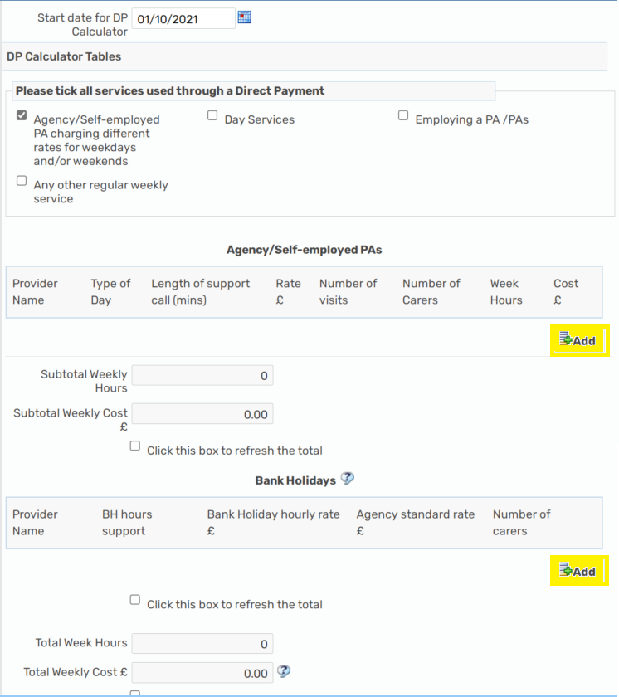
Please click add to input the Agency/Self-employed PA name, day (weekday, evening, weekend where rates are different), length of call (15/30/45/60mins) the rate per call, the number of visits per week (NOT HOURS), the number of carers, this will then work out the costs/total hours for you, please remember to click refresh each time you add a service.
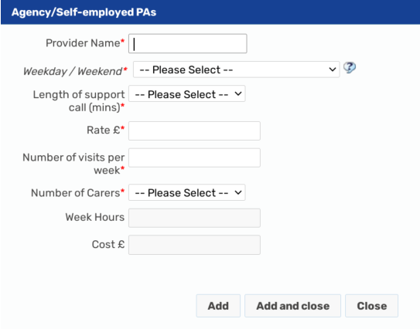
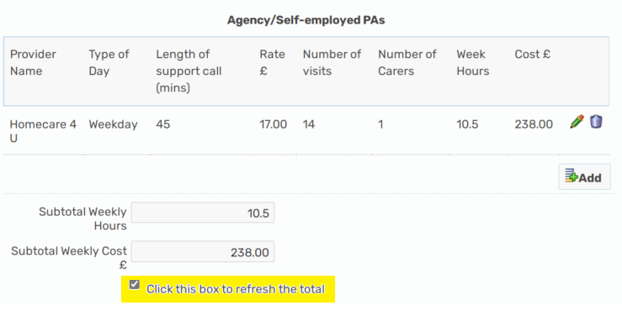
You can add as many different rates as required and as many separate calls, these will all be added into the total costs/total hours
Bank holiday hours / rates:
There are currently 8 bank holidays in a year, and we always work out the bank holiday costs based on the full 8 days of the year. The bank holiday hours of support are the total annual hours allocated for this. If someone usually has a total of 2.5 hours a day you times this by 8 days to give you a total of 20 bank holiday hours. Some providers charge different rates on Xmas/New Year, so you would put 5 x normal day hours through at one rate, and then 2 x normal day hours at the different rate. You will need to know what the normal hourly rate is to complete this section:
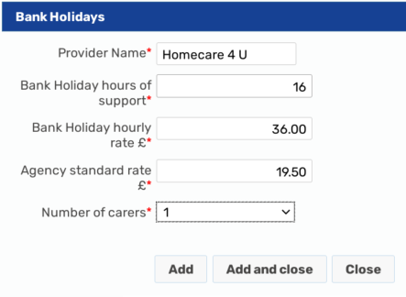
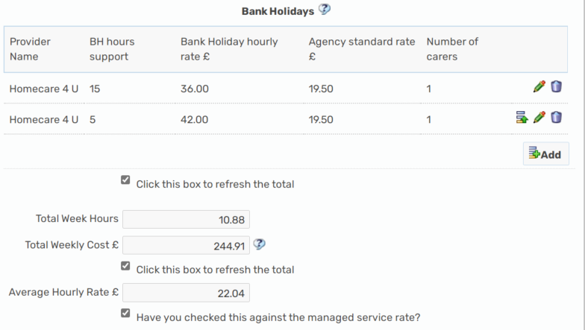
Once you have completed all support via a DP onto the DP Calculator, please refresh the totals then complete the cost section with the costs as per calculated for you and pulled through as a summary to the top of the cost section.
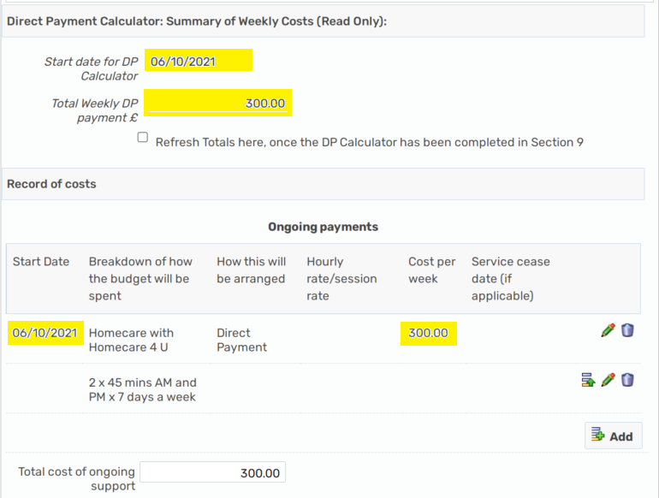
Day Service:
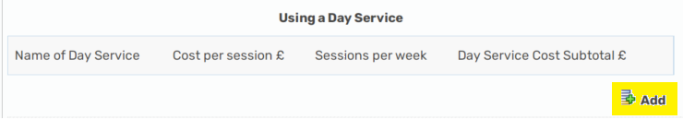
Please click add to add the Day Service Name, cost per session and sessions per week, this will the calculate the total cost and include this in the total cost summary
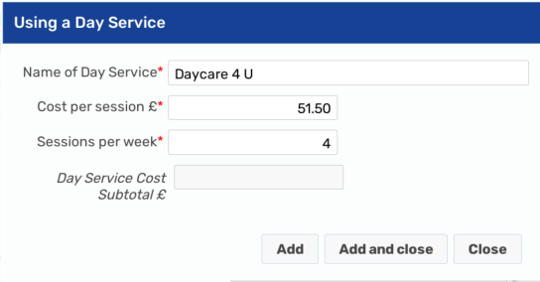
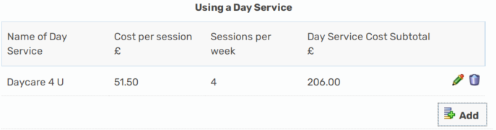
Please remember to click the refresh button each time a new service is added
Employing a PA/PAs
The mandatory fields where a PA is employed are – PA Name, Holiday cover arrangements, Employers Liability, and is a DPSS being used, this is because these are requirements for an Employed PA.
We have tried to copy over all the information from the Excel DP Calculator PA table, some information might not be relevant, please only input information in the relevant boxes, we do NOT need 0 to be input at all. You can only input information into the white boxes, the slightly greyed out boxes are going to calculate figures for you.
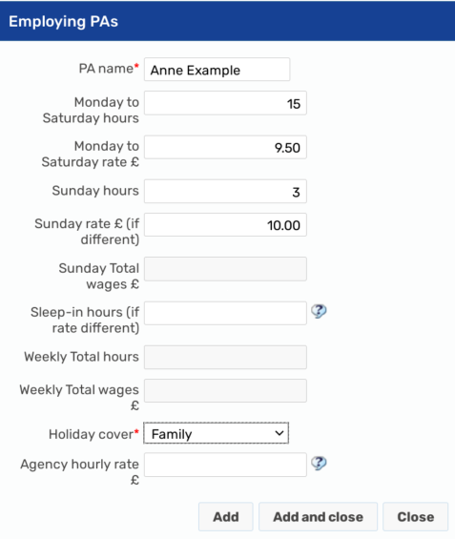
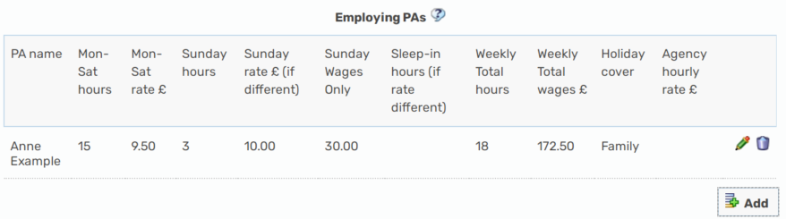
Where there is more than 1 PA Employed, you will need to add a new line for each PA
Please state whether the Employers Liability insurance has been set up Yes/No – it is a requirement where a PA is employed. The answer to this question will determine whether a one off should be calculated for the initial set up of the insurance or not, where this has NOT been set up and a one off is required, the worker will need to ensure this is put onto the one-off section in the Cost section 9 of the plan to be commissioned by DIT:
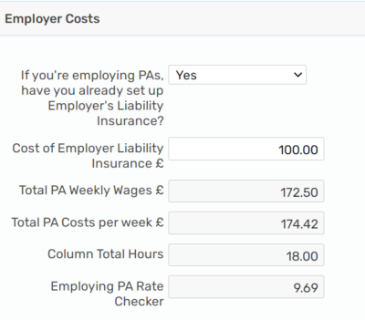

Direct Payment Support Services:
Contracted DPSS provider (Purple, SOLO, Penderel’s Trust, People Plus and Rosekel)
Where a contracted DPSS is used, this information will pull through from the cost section, please ensure you have completed the contracted DPSS provider details in the cost section 9:
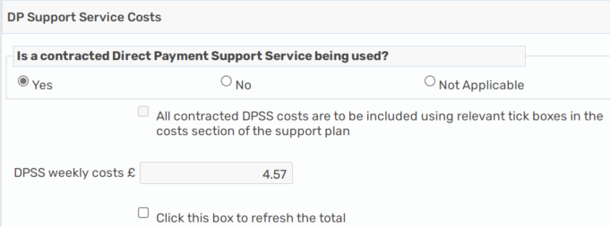

NON-CONTRACTED DPSS –
Where a non-contracted DPSS provider is used, we need to ensure this money is calculated and paid into the DP account to be paid directly by the DP Recipient (as it used to be): 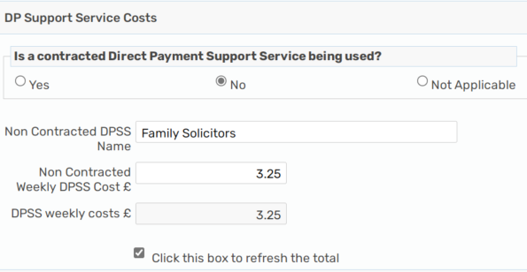
All the associated DP costs will be calculated at the bottom in the Direct Payment Summary of weekly costs, please ensure you have refreshed the totals:
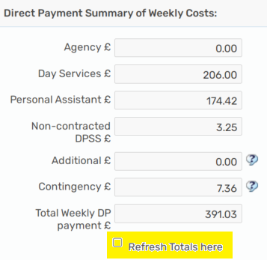

Any contracted DPSS costs will NOT be included in the total weekly DP payment, but for Non-contracted DPSS this will be as the DP Recipient will need to pay the provider directly

Completing the Cost section:
Once the DP calculator section has been completed, the total summary costs and start date will pull through onto the cost section to make it easier for you to copy the total DP costs into the on-going cost section now that they have all been calculated for you, YOU NO LONGER HAVE TO ADD CONTINGENCY IN SEPARATELY, this is included in the PA costs;
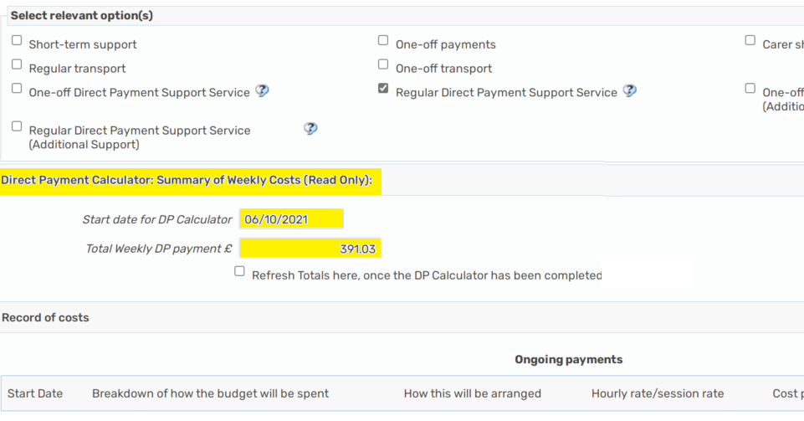
Please then add the normal breakdown/detail of support into the on-going costs using the DP Calculator costs for the Direct Payment elements of the on-going support ensuring the start date and the total cost of DP matches:
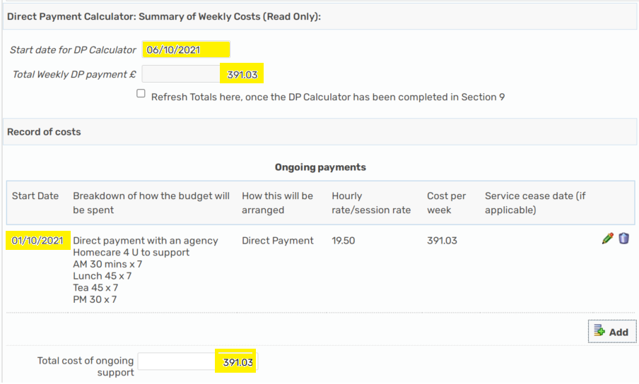

Multiple Change dates:
Where there are multiple change dates to a package you can use the DP calculator to work out the costs for each date, however you can only have 1 version of this, and you would need to overwrite any information with the most recent/current change ensuring the date is correct. There is no requirement for a DP Calculator for each change date. DIT only need to the most recent change date and detail of support. If you wanted to do so, you can print the CASP DP Calculator section to a PDF document and save/upload to the Mosaic record, but this is not a commissioning requirement.
For example:
If you have 2 changes to the DP to commission, one from 1.7.21 to increase the hours from 10 to 15, and then another change on 1.9.21 to 2x PA instead of 1 and total of 20 hours. You can do this as below:
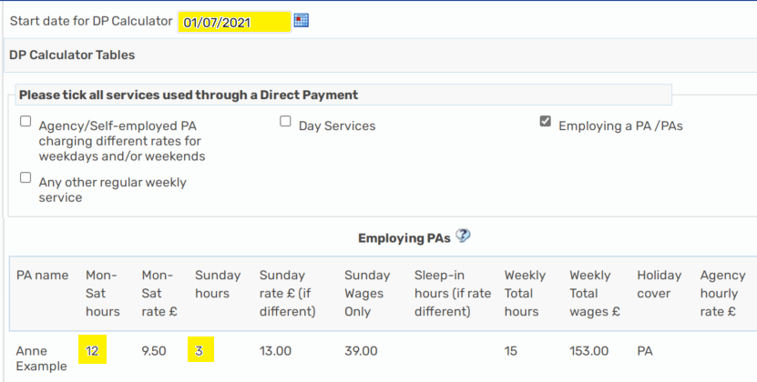
Put the date and hours and all other details onto the DP Calculator section
Refresh the totals
Go to the Cost section
Complete the DP date, detail and cost as per the summary and put an end date as the date before the next change (31.8.21):
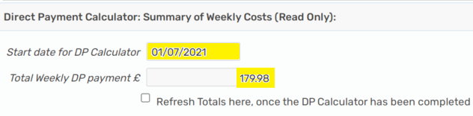
Go back to the DP Calculator section
Change the date to the next change date, this example is 1.9.21
Delete the current information, update with new information
Refresh the totals
Go back to the cost section and copy the new information over
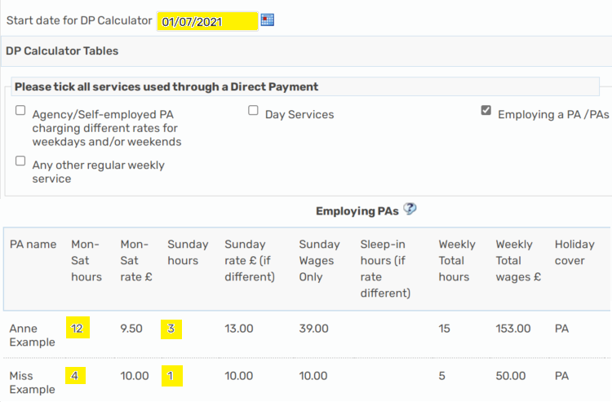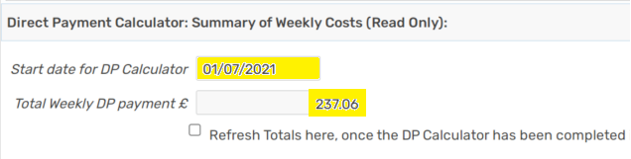
To create the DP Calculator as a PDF document, please click on the PDF icon within your step at the top of the screen:
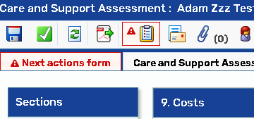
Select section 8 for the DP Calculator, then output to PDF, you can then save/upload this if you wish to do so:
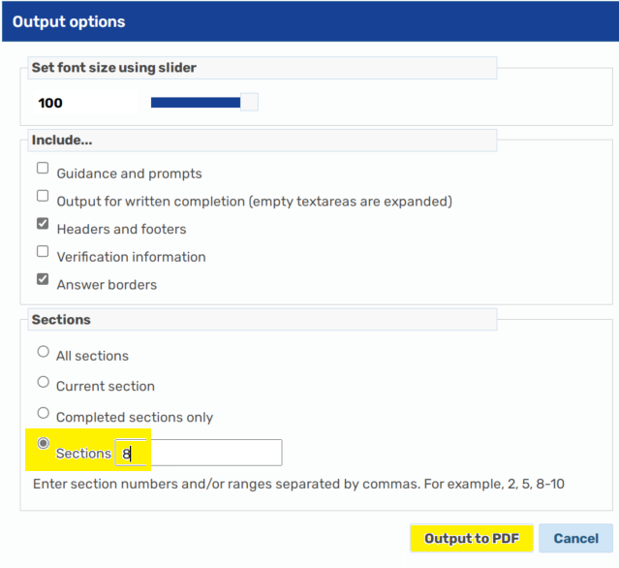
DPSS notice period
As the contracted DPSS costs are NOT included in the total cost of the Mosaic DP Calculator you would not need a separate calculator or the DPSS notice date as the start date. Please put the start/change date on the DP Calculator section as the actual date of provider/support/hours start/change date. The DPSS start date will be recorded in the cost section 9 under the DPSS sections.

5. Actions in MOSAIC and sending the calculator to DIT

4.1 If the support plan is agreed by your manager, you can submit the commissioning step to the Data Input Team (DIT) for the package to be commissioned. As part of this action there is a text box in which you can add a note. Use this to tell DIT anything that is relevant. For example, if there are multiple changes to a direct payment within one commissioning step, write a note to say why this is.

4.2 If your manager does not initially agree the support plan and you need to change the details of the package, you will need to amend the calculator costs from the commissioning step, make the necessary changes before re-submitting the step to your manager.

5. If you are amending an existing package
5.1 If a calculator has already been completed, either as part of setting up a new DP or at review, a new calculator should subsequently be completed for every package amendment where a PA included Self-employed is used for some/all of the care and support package. If a calculator has been completed for the previous package, you can access this via the previous care and support plan DP Calculator section.

6. If you need help
If you have any questions about using the calculator contact Strategic Commissioning through the Direct Payments enquiry e-mail address DPenquiries@nottscc.gov.uk

