
Dual Screens

A new function has been switched on which allows you to have two step windows open, one editable, the other read only.
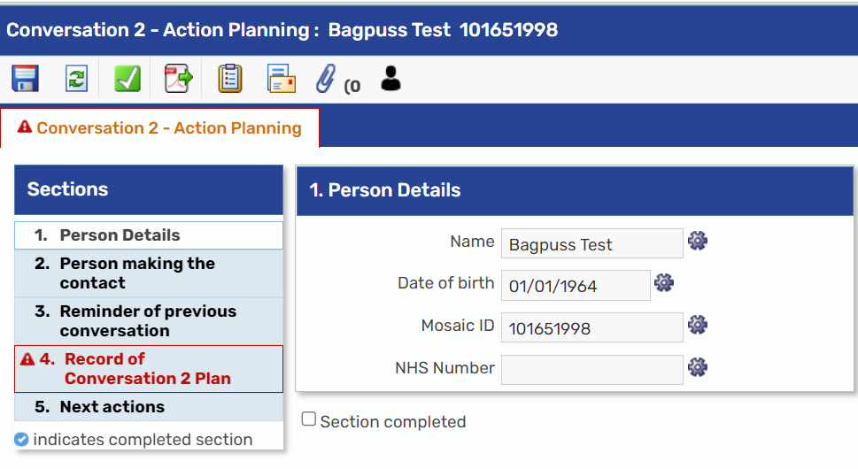
Start the first step, then go back to the home page.

Then click on one of the other existing steps
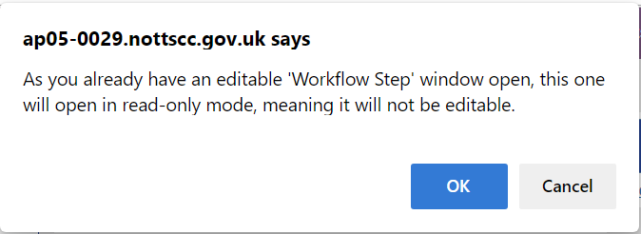
A warning message will appear on the screen.

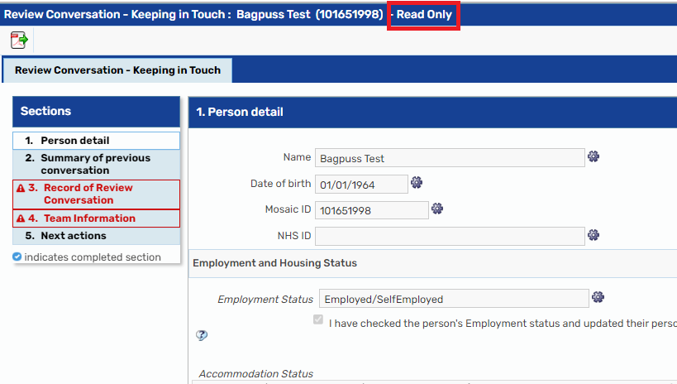
The editable window will be labelled at Read Only at the top of the screen

Having two windows open means you can refer to an old review or assessment step at the same time as updating the new one.

