

 |  | Easy Read:
Who:
This letter is from Nottinghamshire County Council’s insert team, dept or area of work
What:
This letter is about:

1-2 lines saying what the letter is about and insert appropriate symbol to support text
 |  | Further explanation and context to be included here along with relevant symbols to support what is being said
What you need to do:

Say if the letter is for information only or bullet point what the person needs to do
When you need to do it

Say if there is a deadline for the person to do something or date when something will happen
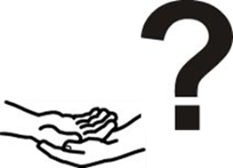 |  | If you are worried or have any questions you can talk to someone by phoning:
 |  | Name of team and/or person  Add contact details

When you send easy read to accompany a standard letter

- Keep to 1 A4 sheet of paper
- Make sure it includes what it’s about, what the person needs to do, dates when something needs doing or when something will happen or change
- Make sure it has a phone number the person can call if they are worried or need more information
- Make sure that at the end of the full letter it includes the explanation of why we are including an easy read sheet (see below)

 | We send easy read information along with our standard letters. If you would also like this letter in a different format, please contact us on (add contact details)

