

Factsheet 4: How to find and recruit a Personal Assistant

How to find a Personal Assistant (PA)
Firstly follow the link to the Nottinghamshire Help Yourself Personal Assistant Directory.

Next click on the ‘Find a Personal Assistant’ button:
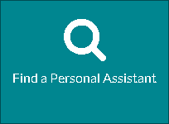

This button will then take you to the list of PAs listed on Notts Help Yourself Website on PA Directory.

Once you can see the list of PAs, you can filter your search using a variety of filter options such as ‘Area Served’ or ‘Tasks’. You can do this by looking on the left hand side of the screen and selecting the option that relates to yourself i.e. you could filter your search to the area ‘Newark and Sherwood’ to find PAs who are willing to work in this area. See example:

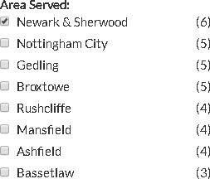

Please note: the figures relating to area were correct on the date this factsheet was published. All the PAs listed have some current capacity to pick up new work.

Once you are happy with your search criteria, you can look through the list of PAs and click into each of their profiles by clicking on the blue title of each post. This will then take you to the PA’s profile where you will be able to view more details.

If you find a PA that you would like to interview, please find their contact details under the ‘About the PA’ section.

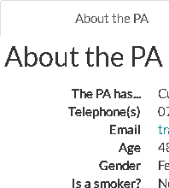
Please note: you must be logged in to access the Personal Assistant’s details. If you require support in creating an account and logging in please email: nottshelpyourself@nottscc.gov.uk

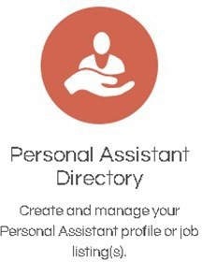
2. How to post a job vacancy

Firstly, you will need to log into your Nottinghamshire Help Yourself account or create an account.
Once you have done this you need to click on the orange icon for the ‘Personal Assistant Directory’.

Next click on ‘+ Create a new job listing’.



Next, please complete all the required fields, provide as much detail as possible and read the guidance throughout the form.


On completion of the form click the green ‘Save Profile’ button at the bottom of the page. Your listing will then come through to the Notts Help Yourself team for approval before going live on the site.

You will be able to see your listing and its status as indicated in the Personal Assistant Directory.

3. How my personal information is used
The Council is committed to protecting your privacy and ensuring all personal information is kept confidential and safe. For more details see our general and service specific privacy notices at: https://www.nottinghamshire.gov.uk/global- content/privacy

4. Contact information
If you have any questions about anything contained in this leaflet relating to Direct Payments, please contact:
The Direct Payment Enquiries Team: - Phone: 0115 8044945
Email: dpenquiries@nottscc.gov.uk

If you need to contact someone about the support, you are already receiving contact
Phone: 0300 500 80 80 - Monday to Thursday: 8.30am to 5.30pm, Friday: 8.30am to 4.30pm
Calls cost no more than a standard geographic charge and are included in discount packages and inclusive minutes schemes
Enquiries: www.nottinghamshire.gov.uk/contact
Website: www.nottinghamshire.gov.uk
Deaf / hard of hearing:
- Text relay service: Dial 18001 0115 9774050 from your textphone or the Relay UK app.


Download the SignVideo app to communicate with Nottinghamshire County Council in British Sign Language via an interpreter. Visit www.nottinghamshire.gov.uk/contact-us for more information.

Phone 0300 500 80 80 if you need the information in a different language or format.

The Council is committed to protecting your privacy and ensuring all personal information is kept confidential and safe. For more details see our general and service specific privacy notices at:
https://www.nottinghamshire.gov.uk/global-content/privacy

