

Mosaic support - Completing an ACM33 Form

IMPORTANT – PLEASE NOTE:
- Once you have completed the ACM33 form in Mosaic it must be sent to Finance for checking using the ‘Request 1. SCW Pass ACM33 to Finance Worker. This must also be used to resubmit an ACM33 that has been rejected for correction

- Please do not finish an ACM33 step by clicking the ‘green tick’ icon. The ACM33 must only be finished by the ACM33 Finance worker once all the required authorisations have been obtained

- Once an ACM33 has been processed by Finance, please do not make any changes to it. If you need to make a correction, or submit a subsequent change, this must be done by starting a new template.

Where to find the ACM33 template

The ACM33 is a next action from the following steps in Mosaic:

- Conversation Three - Assessment Conversation
- Review Community Based Services
- Review Long Term Care
- Review Conversation – Community Based
- Review Conversation – Long Term Care
- Continuing Health Care Panel
- Request Care Package Amendment

Quick guide
At the very top of the ACM33 form there is a question asking you require guidance to complete the ACM33 – if you select ‘Yes’ a quick guide will display.
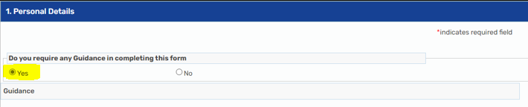

‘Person Details’ section
Fields marked with a red star are mandatory. If you click 'save'  this will highlight the fields that need to be completed before you pass the form to finance.
(Doing this will ensure there is no missing information that is required to progress the ACM33 and will avoid it been returned).
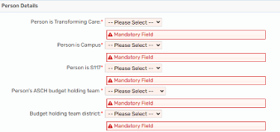

When completing the percentage contributions for NCC & the Integrated Care Board (ICB) they must add up to 100% otherwise the alert message will remain on screen and incorrect percentages will affect all the calculations within the form.
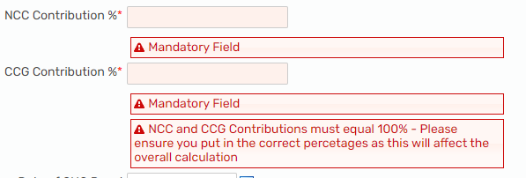

If the answer to the question "Reason for issue of ACM33" is "Change to existing joint funding" two further question will appear.
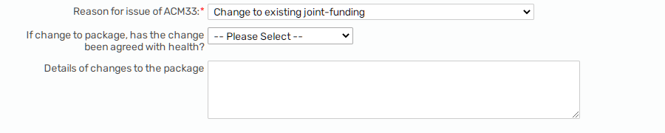

‘Details of changes to the package’ - this is a free text field. Please give a brief explanation of what changes are being made to the care package (e.g. reduction to 1:1 hours/addition of transport).
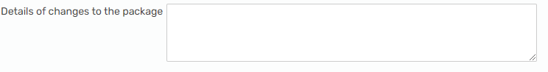

‘If change to package, has the change been agreed with health?’
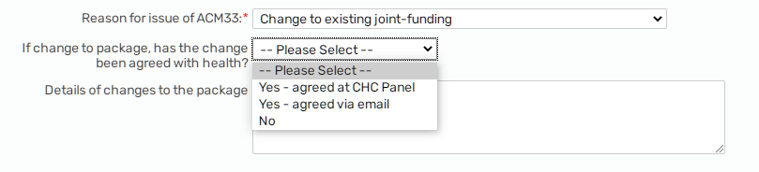

If ‘Yes – agreed at CHC Panel’ is selected the field ‘Date of CHC Panel’ becomes a mandatory field which must be completed.
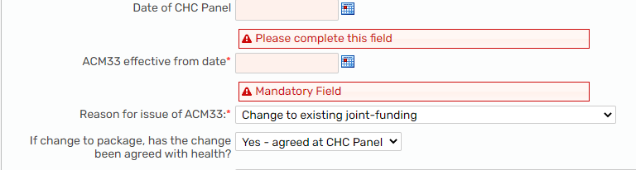

If ‘Yes – agreed via email’ is selected two further mandatory questions appear:
- Name of contact
- Date agreed
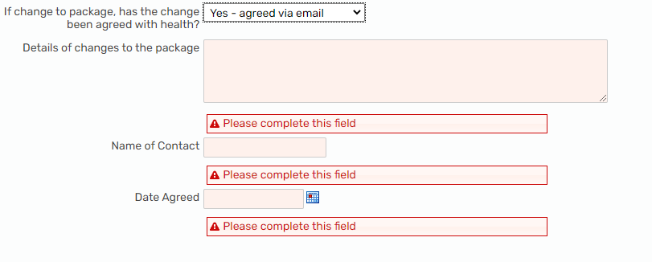

Please note: Unless it is a new joint funding agreement that has been confirmed via CHC Panel step, emailed agreement must be obtained from Health and uploaded to case notes prior to submitting the ACM33 to prevent it from being returned.

Types of ACM33 within this form

Within Mosaic it is possible to complete all types of the ACM33:
- Ongoing Package (previously in SharePoint)
- One off (previously in SharePoint)
- Continuing Care Package for Non-Standard Agreement (previously a word document)

Only one type of the ACM33 can be completed at a time (e.g. you can’t include one off costs on an ongoing ACM33). When you click on the radio button for the type of ACM33 you require, the relevant questions will open.

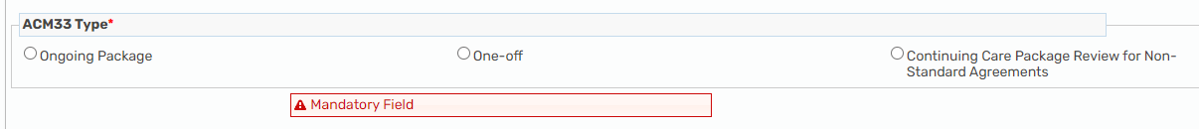

Ongoing ACM33

When selecting the ongoing package, the 3 different element types required appear – ‘Days per year’, ‘Weeks per year’ and ‘Entire year’ (these have been designed to be used exactly how they were in SharePoint).

These are tables so that all required services can be added individually.

You must select the correct duration in order for the element to be shown as an option in the dropdown box. e.g. Short Breaks Respite will only appear within the ‘Days’ section as they are allocated for a number of nights/days per year. Internal Day Services will only appear in the ‘Weeks’ section as they are only open for 50 weeks per year. DPs appear only in the ‘Entire Year’ section as they are always provided for 365 days per year. If the element you are looking for is not available to select from the dropdown menu, then you have selected the wrong duration.

5a) Days per Year

This section is to be used for services that are provided for a limited number of days (or nights) per year. This would generally be short breaks, and any associated 1:1 or transport.

NB: Short breaks taken at an NCC internal short breaks unit should be added under the 'Internal Short Breaks Respite' sub-section (see below).

NB: If the service is to be provided for 365 days per year, it needs to be added under the 'Entire year' section.

Internal Short Breaks Respite
As the calculations for Internal short breaks respite are different, they have been put into a separate section – if required you will need to answer ‘Yes’ to the question ‘Internal Short Breaks Required?’ and the section will appear.
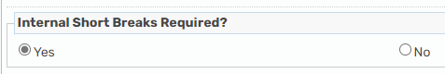
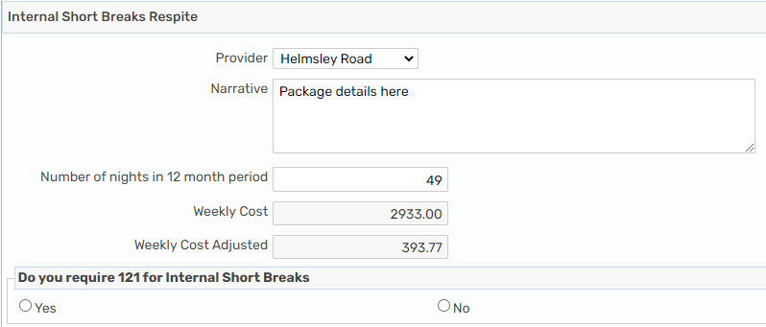

Within this section there is a further question ‘Do you require 121 for Internal Short Breaks?’
If needed, click 'Yes' and the questions will appear for you to complete those details.
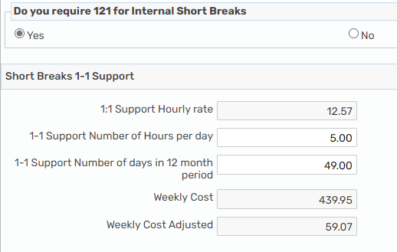

5b) Weeks per Year

This section is to be used for services that are provided for less than 52 weeks per year. This would generally be Matrix rate day services (which would be added under the 'Matrix day service required' sub-section – see below). Any associated 1:1 and transport would also be added under the 'Weeks per year' header.

NB: If the service is to be provided for 52 weeks per year, it needs to be added under the 'Entire year' section

Matrix Day Service Rates
Day services commissioned using Matrix rates have a separate section as the rates are built into the ACM33 template. If required, click 'Yes' to the question ‘Matrix Day Service Required' and this will open up a date field. There are 2 sets of rates within the form, previous year rate and current year rates. The correct rates for the date selected will be calculated by the form.

Please ensure that the date entered into this section is the effective date of the ACM33 that you are completing - not the original start date of the provision as this may cause the wrong rate to be pulled through.

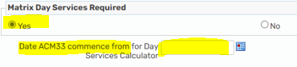

Once you have entered the date this will open up a further field in which to add the details of the day service.
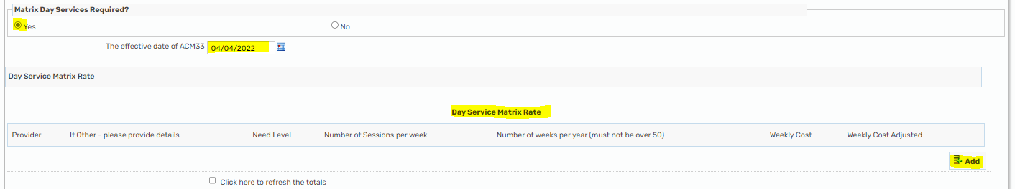

The rates are built into the template within the ‘Need Level' dropdown.
NB: 100% Health Funded rates are also included in the dropdown.
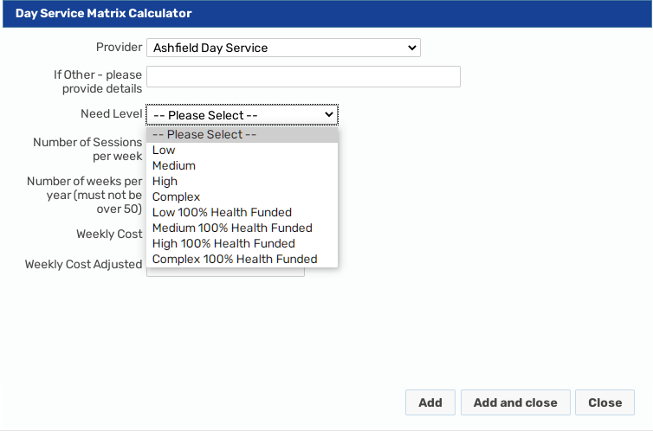

NB: when completing the number of weeks please do not add more than 50 weeks per year as the internal day services take a 2 week break every year. The cost adjustment for the service being provided for fewer than 52 weeks per year will be calculated in the background of the template and shown in the ‘Weekly cost adjusted’ column.
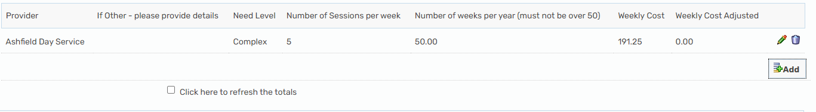

As seen in the screenshot above when initially adding the service to the table the ‘Weekly cost adjusted’ is showing as zero. Due to the numerous complex calculations the form needs to be ‘refreshed. This is achieved by clicking on the 'Click here to refresh totals' checkbox (it may need a couple of clicks).
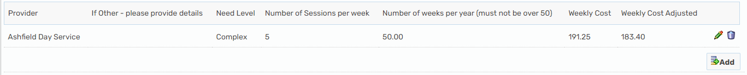

5c) Entire Year

This section would be used for the majority of service as they are provided for 365 days per year (i.e. home care, direct payments, residential/nursing care, supported living etc.).
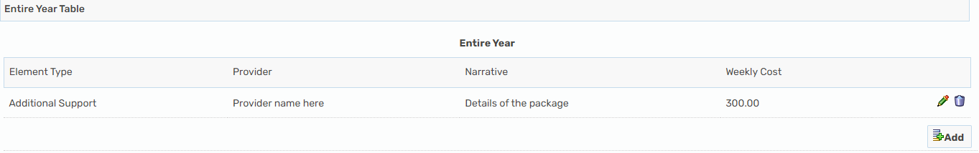

NB: The nursing placement in this dropdown is for use when FNC is not applicable. Nursing placements with FNC should be added under the sub-section 'Nursing placement with FNC Required?' (see below).
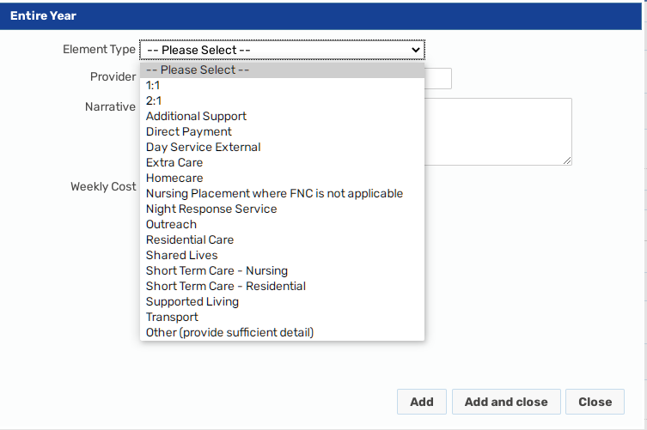

For nursing placements with FNC please tick 'Yes' to the question 'Nursing placement with FNC Required?' This opens a date field. The FNC rates for the current and previous year are built into the template, therefore, the rate pulled through to the template will be dictated by the date entered in this field and whether ‘Standard’ or ‘Legacy’ rate is selected from the dropdown menu. Please ensure that the date added here is the effective date of the ACM33 that you are completing - not the original start date of the provision as this may cause the wrong FNC rate to be pulled through.
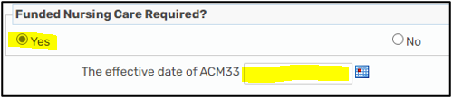

Once the date has been entered further fields will become visible in which to add the nursing placement details.
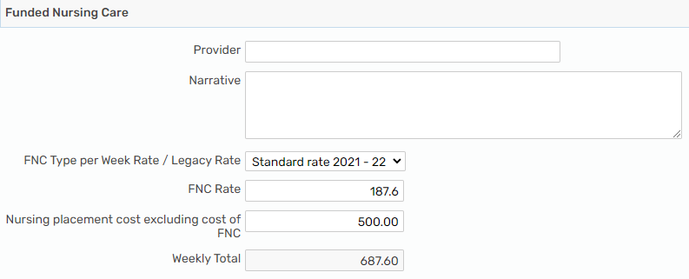

Once all the required elements have been put into the form there is a ‘Totals’ field which calculates the totals of each section to give all the information required. Due to the numerous complex calculations the form needs to be refreshed. This is achieved by clicking the 'Click here to refresh totals' checkbox (it may need a couple of clicks).
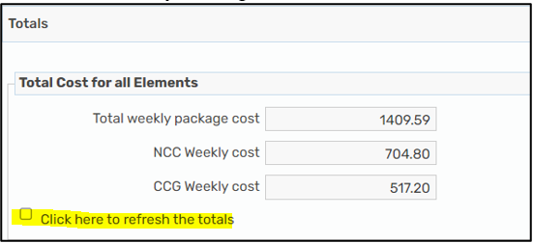

One-Off ACM33

If you require the one-off element select the ‘One-off’ ACM33 type and add the details of the package in the table.
The form will complete the total calculations based on the percentage contribution from NCC and the ICB.
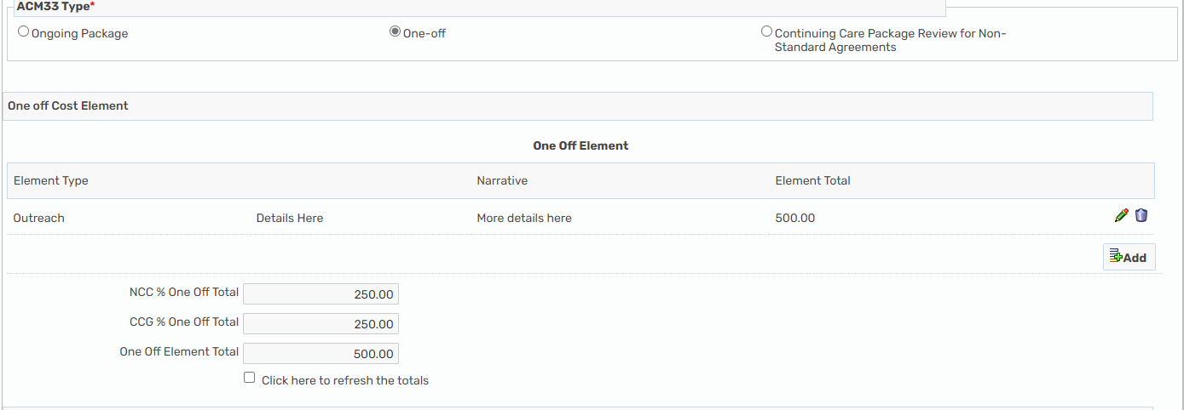

Non-Standard ACM33
(Previously completed on a word document)

To complete a Non-Standard ACM33 select ‘Continuing Care Package Review for Non-Standard Agreements’ from the ACM33 Type.

This is in a table format to enable all the different elements for days per year / weeks per year and entire year, or one-off costs. The form will calculate the weekly costs for the elements.
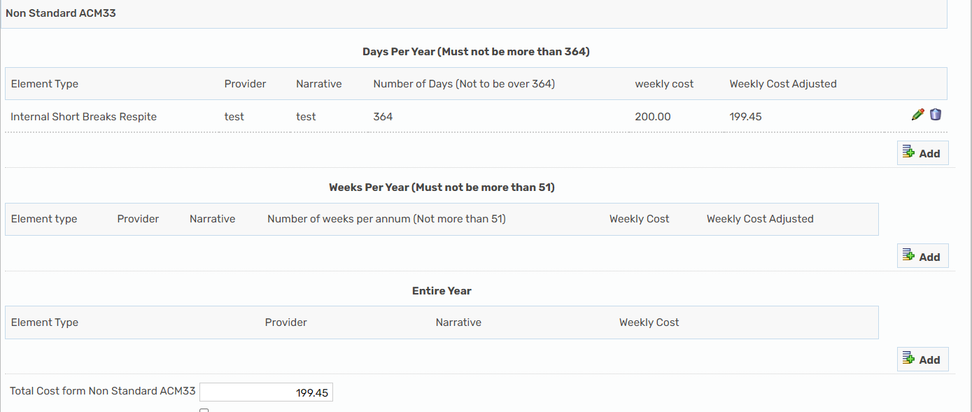

Because the contribution calculations for these will vary depending upon the individual’s funding agreement there are no calculations completed by the Mosaic form, so please ensure all the relevant information is documented in the free text fields (an example is give below):
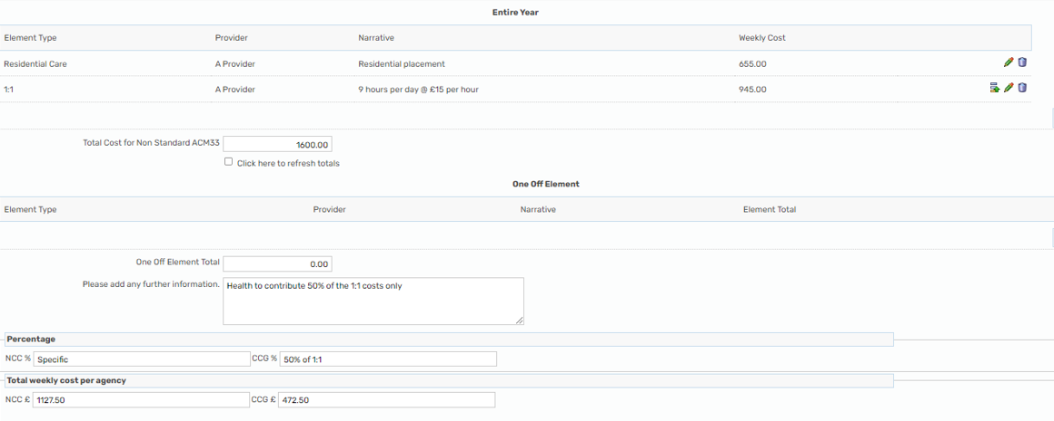

To send ACM33 to Finance Worker for processing

Once you have completed all the relevant information the form should be sent to Finance for processing via ‘Requests’/‘Request’ 1.SCW Pass ACM33 to Finance Worker.
If the form is correct, they will reassign the step to the ACM33 Finance Worker and then pass it to the Group Manager for signing.
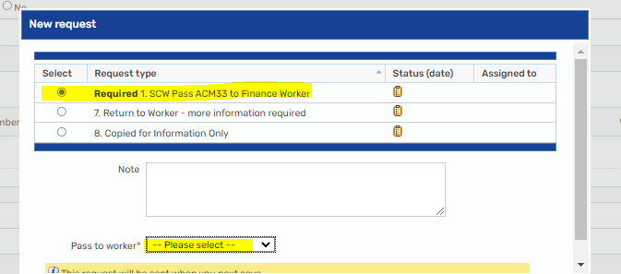

ACM33s that are rejected for correction

If there are errors or queries on an ACM33, they will be rejected back to the SCW by the ACM33 Finance Worker for correction or clarification. They will be returned direct to the incoming work folder via Request 7, which will detail the issues that need to be addressed.
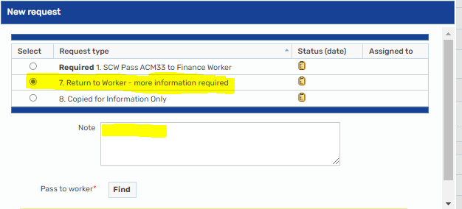

Once amended, Request 7 should be marked as completed by the SCW and then the ACM33 should be resubmitted to Finance via ‘Requests’/’Request 1.SCW Pass ACM33 to Finance Worker’.
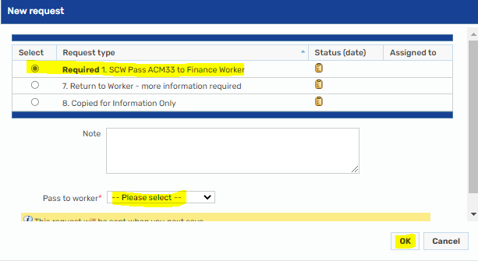

Remainder of the ACM33 process

- Once the ACM33 has been processed by Finance, the ACM33 Finance worker will send it to the relevant Group Manager for Authorisation via ‘Request 2. Finance Pass to GM’
- Once Authorised (using the Verification checkbox) the GM will send the ACM33 to Business Support via ‘Request 3. GM Pass to Business Support’
- Business support send the ACM33 to Health for authorisation. They will also send ‘BS notification of single signed ACM33 to SCW’ to the worker who has started the form advising that the Care and Support Plan can be updated and sent to the SPT for commissioning.
- One authorised, Health return the ACM33 to the ACM33 Finance Worker who will then finish the step.

