Updating a person’s Employment Status:
If you are completing a ‘Conversation 3 – Building a Good Life’ or ‘Review Conversation – Keeping in Touch’ for someone who is under 65 you will be required to update further questions around the person’s Employment Status.
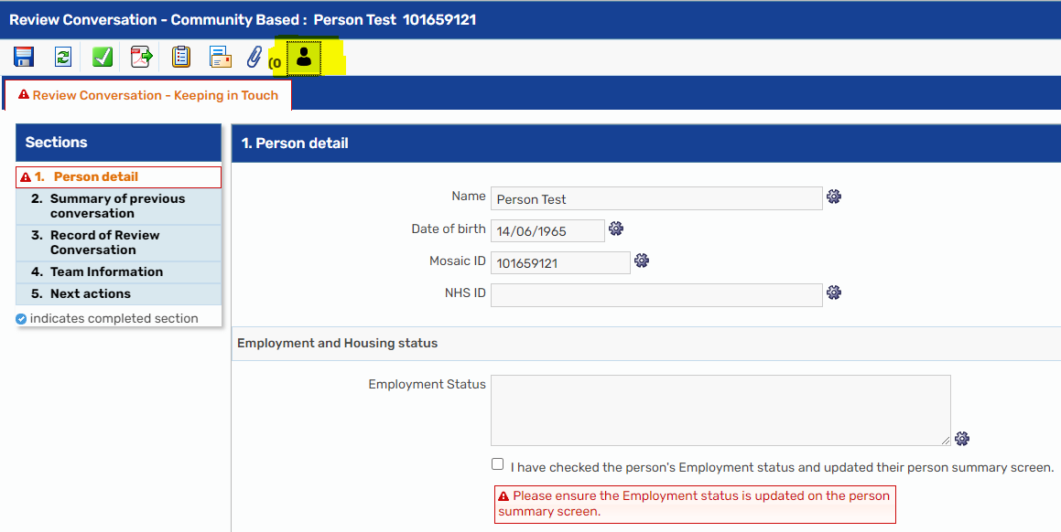
If the Employment status is not up to date on the person summary screen a message will appear in the form directing you to do so, this can be done by clicking the silhouette person icon (highlighted above). This will then take you to the person’s summary screen.
Here you can update the Employment Status
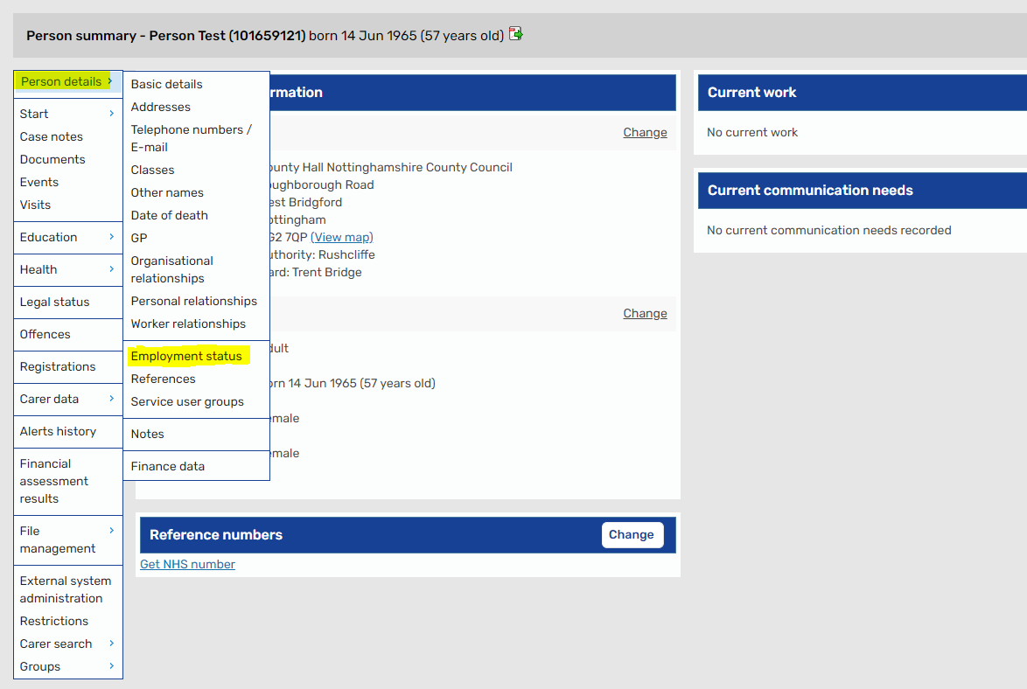

Here you will be able to add details of the Employment Status.
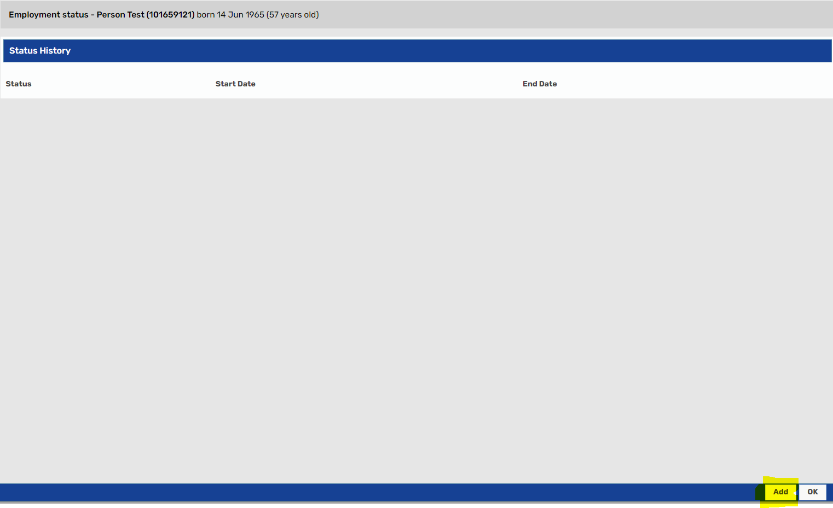
Here you will need to add a start date and select the appropriate status:
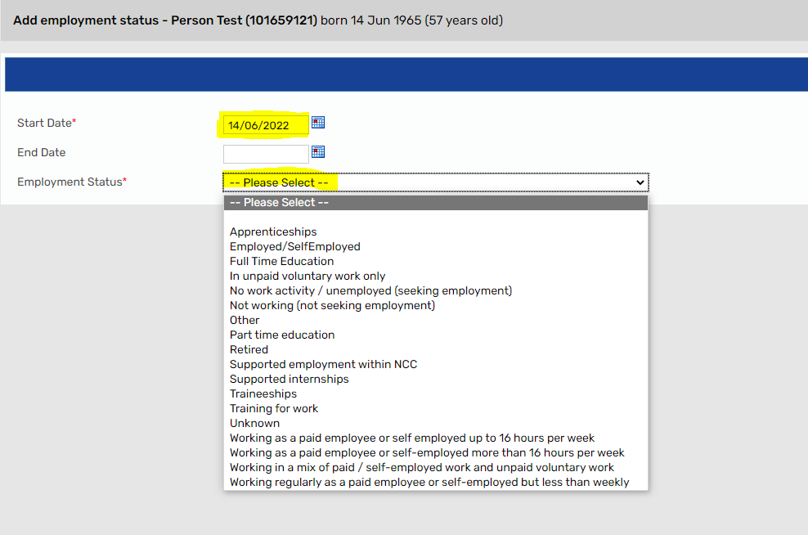

This will then be pulled through into your form allowing you to continue.

