Step by Step guide – Request for Services Agency

Prior to sending the request for service please ensure the following has been completed.
Provider must have already been sourced.
The Agency, Day Service or Supported Living provider are not on the contracted provisions via the following links
Day Opportunities | Nottinghamshire County Council
Home Based Care services | Nottinghamshire County Council Intranet (nottscc.gov.uk)
Supported living | Nottinghamshire County Council Intranet (nottscc.gov.uk)
If the provision is contracted, please discuss with the DP Recipient if they wish to receive the funding via a managed account. If the person wishes to receive the funds via a Direct Payment, please proceed to complete the request for services form. Advise the DP Recipient NCC will only pay the equivalent cost of the provisions contacted rates.
If the rate exceeds the highest rate for a DP for the persons district and this is deemed an exceptional circumstance and Team Manager/Group Manager approval has been authorised, please record this in the summary of support box ensuring there is also a case note uploaded to support this.
If no exceptional circumstances are agreed then advise on the request for services form, the rates exceed and negotiation with provider or Top up is to be discussed with DP Recipient.

Step 1: Care and Support Plan
Please ensure sections 1-4 are completed and the ‘Mental Capacity’ section of section 5 (see image below) mirroring the signatures on the DP Agreement (ACM39).
The worker will be responsible to ensure the DP Recipient understood and agrees to the conditions in the DP Agreement. Ensure the agreement is signed by the DP Recipient/Nominated or Authorised person along with the workers signature, then uploaded to Mosaic before progressing to the next step.
Direct Payment Agreement can be found on the DP Support Area. Please ensure you always use the agreement from the support area and not a saved file, as this is updated regularly.
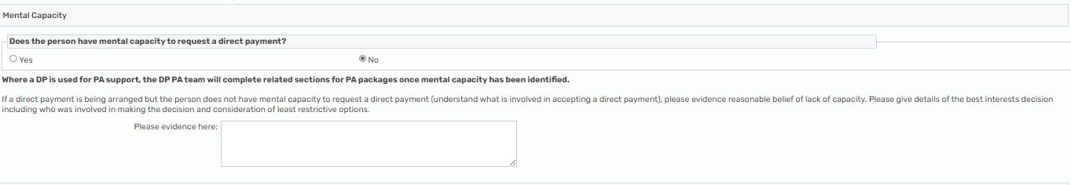
Support Plan - Capacity example

If person is accessing Day Services please see example below
If the person is attending a day service, you will need to complete the ‘Day Service Support Needs Matrix’.
Click the forms and letters icon at the top of the review step and add the ‘Day Service Support Needs Matrix’ form

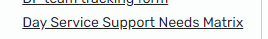

Ensure the matrix score provided is added to the request for services form when completing.

Please ensure you have completed all of Step 1 before progressing to step 2
Step 2: Adding the request for services form

When the above step is complete, please add the request for services form by using the forms and letters icon at the top of the page and select the Request for Services (shown below).

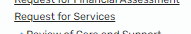

Step 3: Completing the Request for Services Agency form

3.1 Complete Personal Details tab on the left-hand side
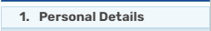

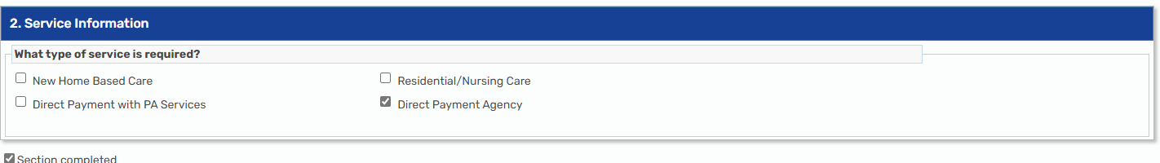
3.2 Tick the Direct Payment Agency box

3.3 Go to the Direct Payment Agency tab on the left-hand side to complete the correct form
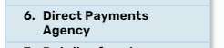

3.4 Fill in the Agency/Day Service/Providers details in the boxes, please ensure all contact details are provided.
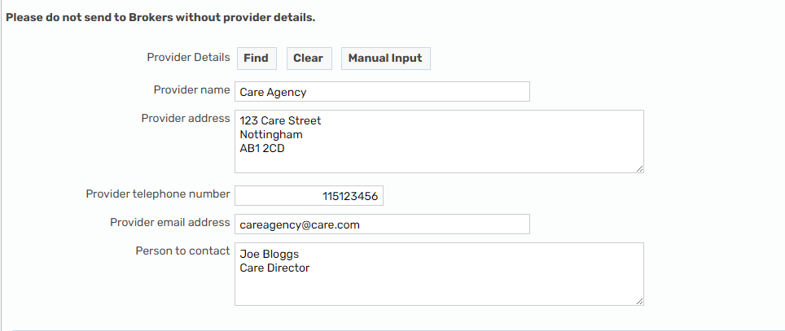
EXAMPLE

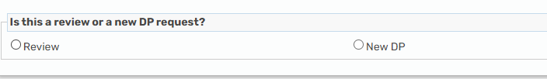
3.5 On the request for services form select if the request is for a New DP set up or a Review.

New DP

New DP

3.6 Enter the agreed start date provided by the Agency/Day Service etc.
EXAMPLE
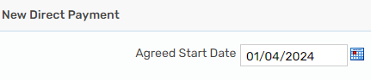

3.7 Complete the Mental Capacity section ensuring this matches the DP Agreement signed and uploaded.
If person lacks capacity, ensure Authorised Person contact details are provided in the box
EXAMPLE
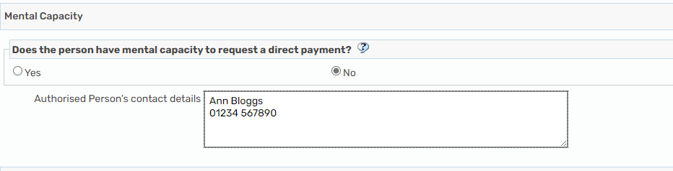

3.8 Complete the support needs boxes shown below ensuring as much information as possible is recorded.
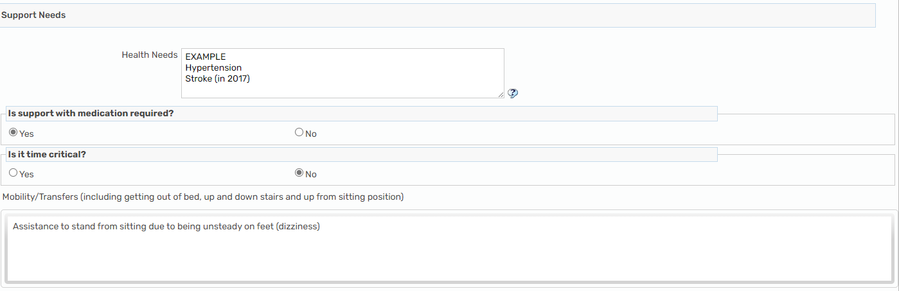

3.9 When completing the following boxes ensure as much detail about the support is provided i.e Days, times, length and purpose of calls.
- Including risks associated i.e hoarder, pets.
- Carers required for support

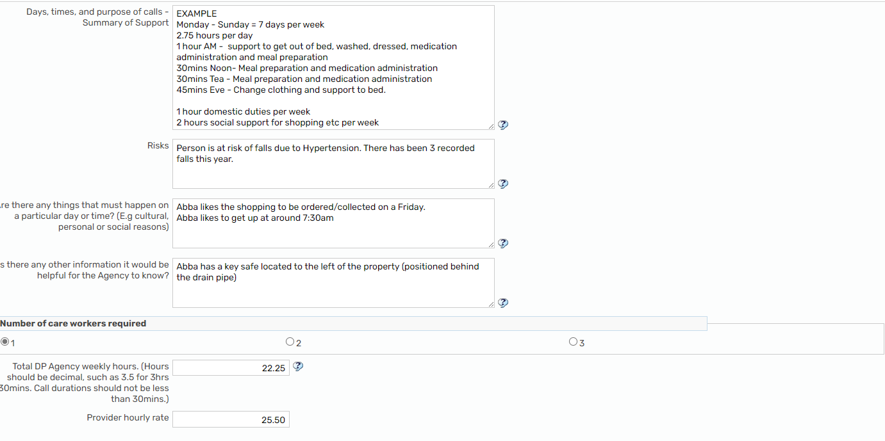
Agency example

Day Service example
Ensure the day service matrix score is inputted in this section, specify the cost per session and how many sessions/days they will attend per week. 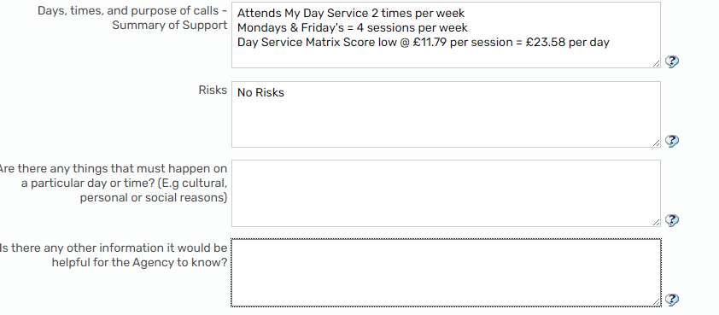

3.10 Ensure you select the number of carers required and enter the per week in the weekly hours box.
If this is for a Day Service or creative commissioning, please leave blank.
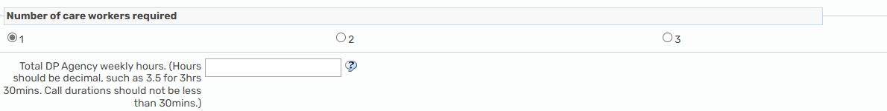

3.11 Enter the Agencies hourly rate and if there are additional cost for evening, weekends and bank holidays, specify this in the box provided below.
Agency
EXAMPLE
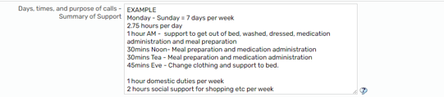
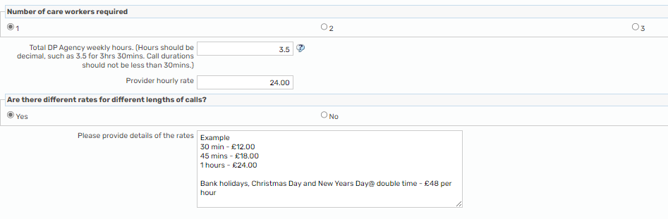

If the provider is a day service or the budget is being used creatively see examples below.
Day Service costings
EXAMPLE
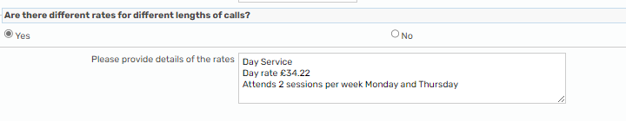

Creatively
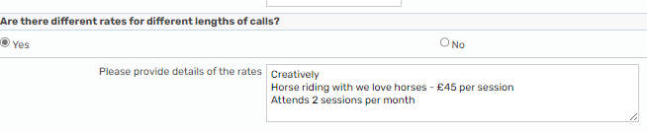
EXAMPLE

If the rate exceeds the highest rate for a DP for the persons district and this is deemed an exceptional circumstance and Team Manager/Group Manager approval has been authorised, please record this in the summary of support box ensuring there is also a case note uploaded to support this.
If no exceptional circumstances are agreed then advise on the request for services form, the rates exceed and negotiation with provider or top up is to be discussed with DP Recipient.

Review DP
3.11 Please select review on the radio button and enter the date the Direct Payment package will be changing.
When completing the following boxes ensure as much detail about the support is provided i.e Days, times, length and purpose of calls.

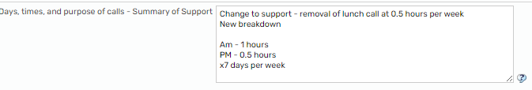

Step 4: communication tracker
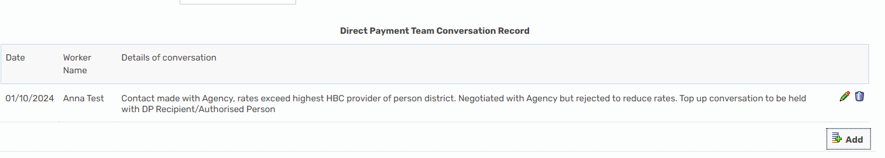
The DP Commissioning worker will upload updates. The Social Worker/Community Care Officers can also use this to communicate with the allocated DP Commissioning worker.

Step 5: Completion
DP Commissioning Team will ensure that relevant documents/checks are completed and notify the worker once the DP commissioning has been completed on the support plan.
The worker will then need to check
- Any other commissioning such as managed services is up to date with the provisions on the mosaic front screen or changes being made to the managed services are correct on the support plan
- Complete an ACM33 where health funded is in place
- One-Off Payments
Once the above has been completed and checked, the worker will need to send to SPT to ensure commissioning is complete.

