Social Care workers guide to Mosaic DP Calculator
Following feedback from social care workers about issues completing the DP Calculator, we’ve added the DP Calculator to the CASP in Mosaic to save needing to upload a separate document, or to complete multiple DP Calculators for each change date, and there is an option to work out the average hourly rate for agencies that charge different rates for different call lengths or bank holidays.
To access the DP Calculator in the Care and support plan / review of care and support plan please follow the below steps:
- Open a Care and Support Assessment, Review of care and support assessment or the conversation three workflow
- Add the Care and Support Plan / Review of care and support plan
- Complete section my support/arranging my support, with the DP package information such as how will the DP be managed, what support will be purchased and Agency name. You will be able to see/use the DP Calculator at any time, but the DP Calculator tab will be mandatory where a PA is used/selected in arranging my support.
- DP Calculator, start date required (most recent/current change only)
Please select which services are going to be used, multiple options can be selected Agency/Self Employed PA’s, or Day services, Employed PA’s or any other weekly service which will then expand new sections out to be completed
- Costs - Please complete the contracted DPSS (if any) on this tab before you complete the DP Calculator tab, as the contracted DPSS costs pull through so that this is calculated in the personal budget, but NOT the total on-going costs
Where the DP Calculator is showing as mandatory, but you do not have a PA or non-contracted DPSS provider in place, please input the start date of the DP into the DP Calculator, and select not applicable to the contracted DPSS question:
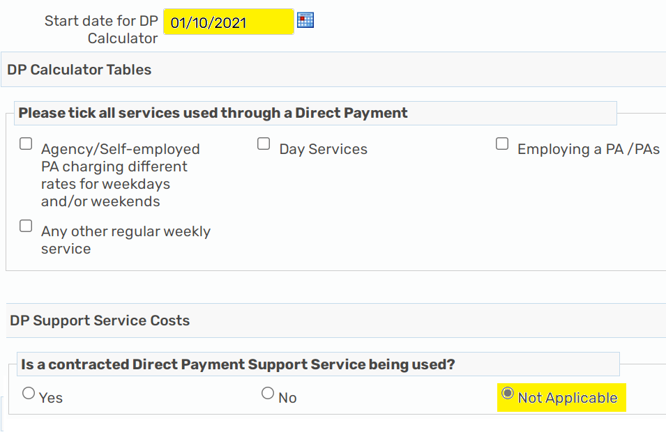

Agency/Self-employed PA’s - this includes the agencies that charge different rates and bank holidays:
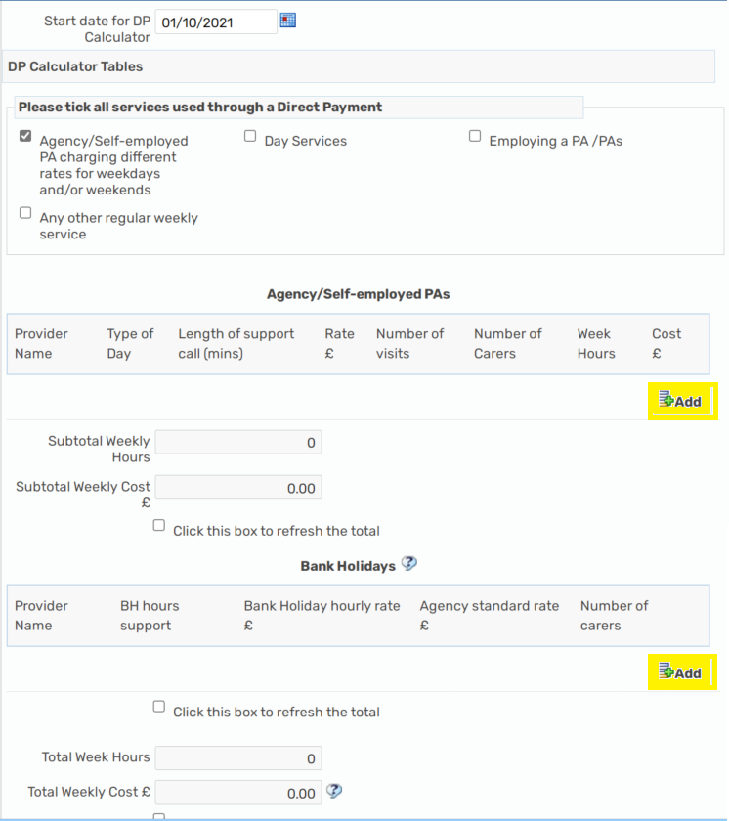
Please click add to input the Agency/Self-employed PA name, day (weekday, evening, weekend where rates are different), length of call (15/30/45/60mins) the rate per call, the number of visits per week (NOT HOURS), the number of carers, this will then work out the costs/total hours for you, please remember to click refresh each time you add a service.
If the Agency does not have separate rates for different lengths of calls you can use the flat rate option, and the total number of hours for the visits and this will calculate the costs.
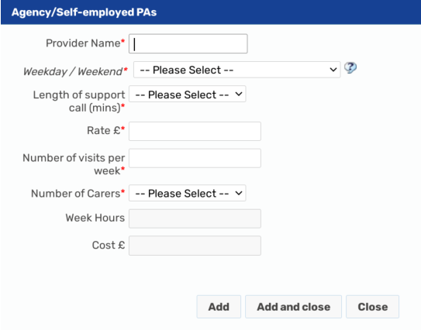
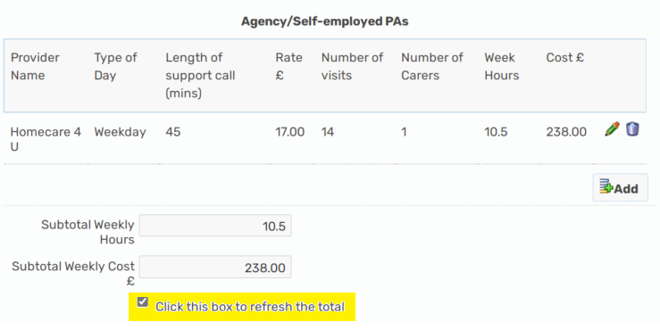
You can add as many different rates as required and as many separate calls, these will all be added into the total costs/total hours
Bank holiday hours / rates:
There are currently 9 bank holidays in a year, and we always work out the bank holiday costs based on the full 9 days of the year. The bank holiday hours of support are the total annual hours allocated for this. If someone usually has a total of 2.5 hours a day you times this by 9 days to give you a total of 22.5 bank holiday hours. Some providers charge different rates on Xmas/New Year, so you would put 6 x normal day hours through at one rate, and then 2 x normal day hours at the different rate. You will need to know what the normal hourly rate is to complete this section:
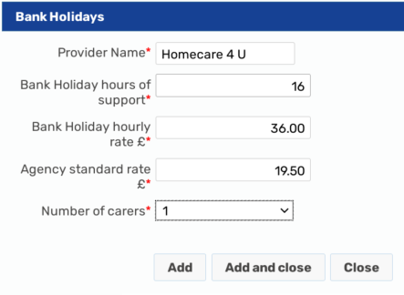
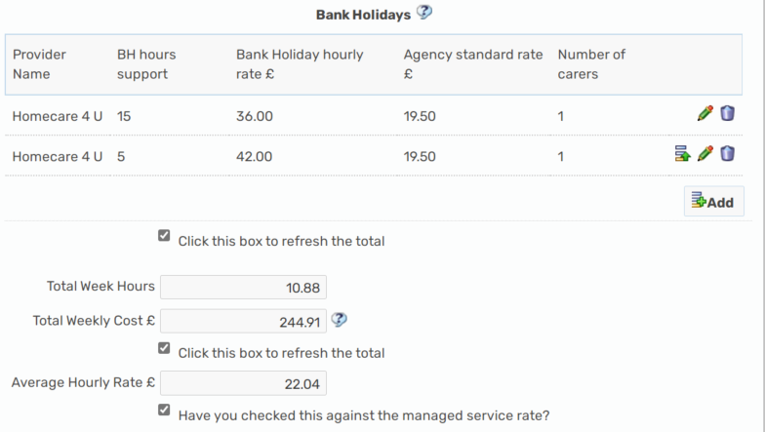
Once you have completed all support via a DP onto the DP Calculator, please refresh the totals then complete the cost section with the costs as per calculated for you and pulled through as a summary to the top of the cost section.
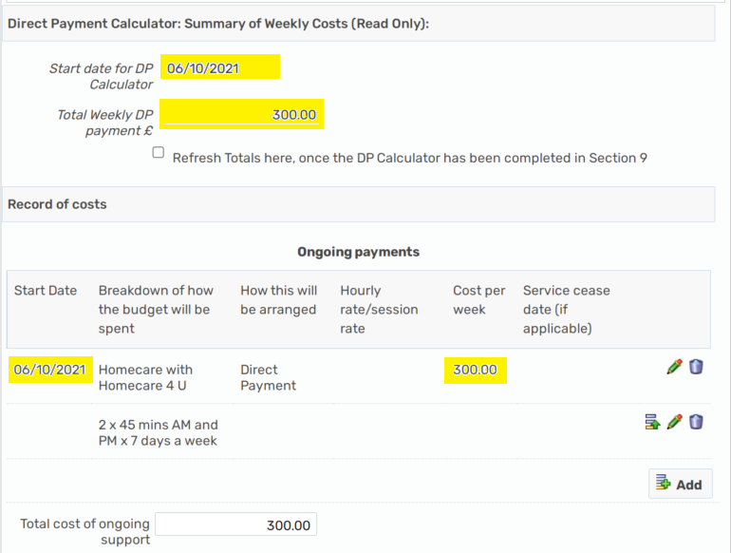
Day Service:
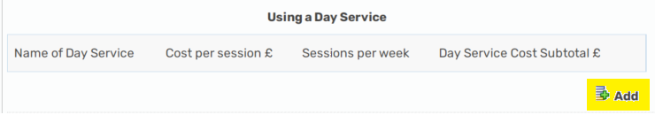
Please click add to add the Day Service Name, cost per session and sessions per week, this will the calculate the total cost and include this in the total cost summary
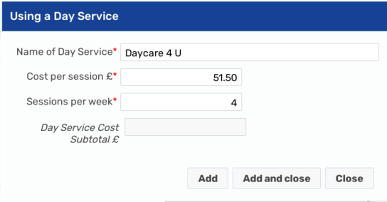
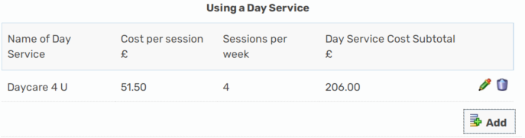
Please remember to click the refresh button each time a new service is added
Employing a PA/PAs
The mandatory fields where a PA is employed are – PA Name, Holiday cover arrangements, Employers Liability, and is a DPSS being used, this is because these are requirements for an Employed PA.
We have tried to copy over all the information from the Excel DP Calculator PA table, some information might not be relevant, please only input information in the relevant boxes, we do NOT need 0 to be input at all. You can only input information into the white boxes, the slightly greyed out boxes are going to calculate figures for you.
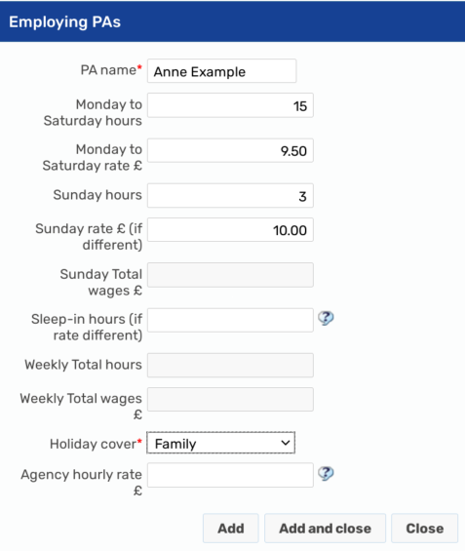
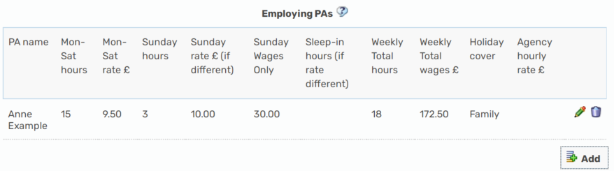
Where there is more than 1 PA Employed, you will need to add a new line for each PA
Please state whether the Employers Liability insurance has been set up Yes/No – it is a requirement where a PA is employed. The answer to this question will determine whether a one off should be calculated for the initial set up of the insurance or not, where this has NOT been set up and a one off is required, the worker will need to ensure this is put onto the one off section in the Cost section 9 of the plan to be commissioned by DIT:
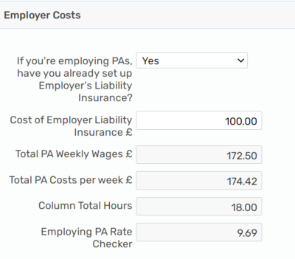

Direct Payment Support Services:
Contracted DPSS provider (Purple, SOLO, Penderel’s Trust, People Plus and Rosekel)
Where a contracted DPSS is used, this information will pull through from the cost section, please ensure you have completed the contracted DPSS provider details in the cost section:
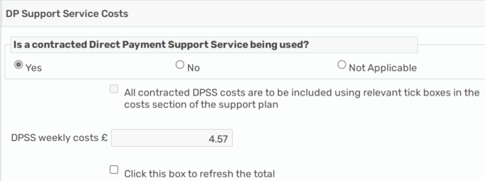

NON-CONTRACTED DPSS –
Where a non-contracted DPSS provider is used, we need to ensure this money is calculated and paid into the DP account to be paid directly by the DP Recipient (as it used to be): 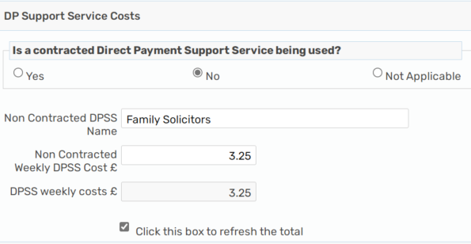
All the associated DP costs will be calculated at the bottom in the Direct Payment Summary of weekly costs, please ensure you have refreshed the totals:
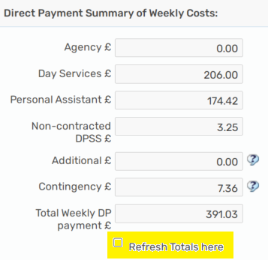

Any contracted DPSS costs will NOT be included in the total weekly DP payment, but for Non-contracted DPSS this will be as the DP Recipient will need to pay the provider directly

Completing the Cost section:
Once the DP calculator section has been completed, the total summary costs and start date will pull through onto the cost section to make it easier for you to copy the total DP costs into the on-going cost section now that they have all been calculated for you, YOU NO LONGER HAVE TO ADD CONTINGENCY IN SEPARATELY, this is included in the PA costs;
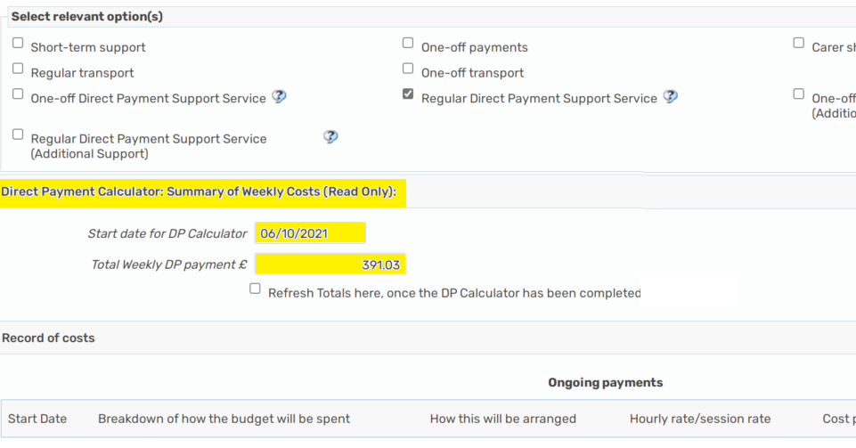
Please then add the normal breakdown/detail of support into the on-going costs using the DP Calculator costs for the Direct Payment elements of the on-going support ensuring the start date and the total cost of DP matches:
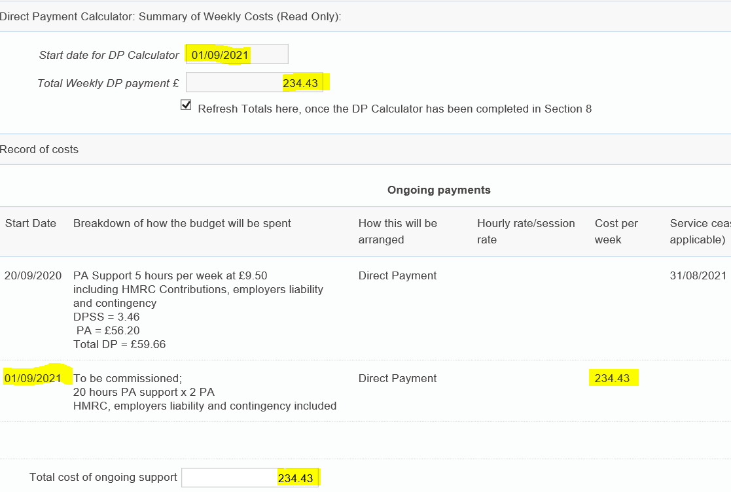

Multiple Change dates:
Where there are multiple change dates to a package you can use the DP calculator to work out the costs for each date, however you can only have 1 version of this and you would need to overwrite any information with the most recent/current change ensuring the date is correct. There is no requirement for a DP Calculator for each change date. DIT only need to the most recent change date and detail of support. If you wanted to do so, you can print the CASP DP Calculator section to a PDF document and save/upload to the Mosaic record, but this is not a commissioning requirement.
For example:
If you have 2 changes to the DP to commission, one from 1.7.21 to increase the hours from 10 to 15, and then another change on 1.9.21 to 2x PA instead of 1 and total of 20 hours. You can do this as below:
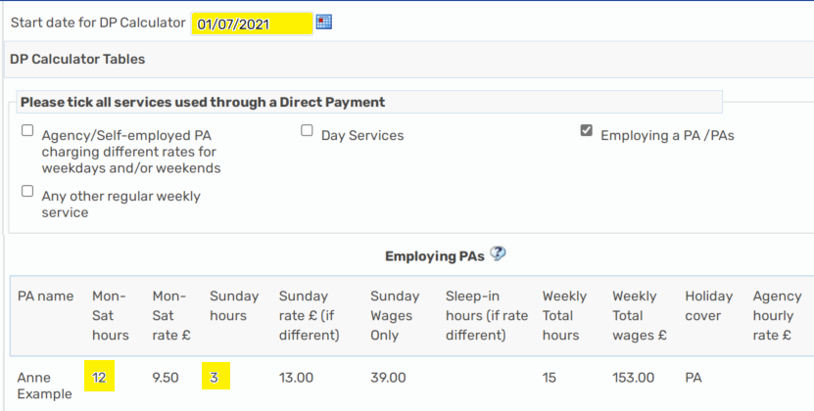
Put the date and hours and all other details onto the DP Calculator section
Refresh the totals
Go to the Cost section
Complete the DP date, detail and cost as per the summary and put an end date as the date before the next change (31.8.21) :
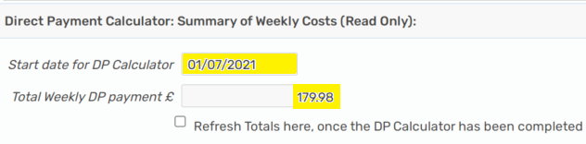
Go back to the DP Calculator section
Change the date to the next change date, this example is 1.9.21
Delete the current information, update with new information
Refresh the totals
Go back to the cost section and copy the new information over

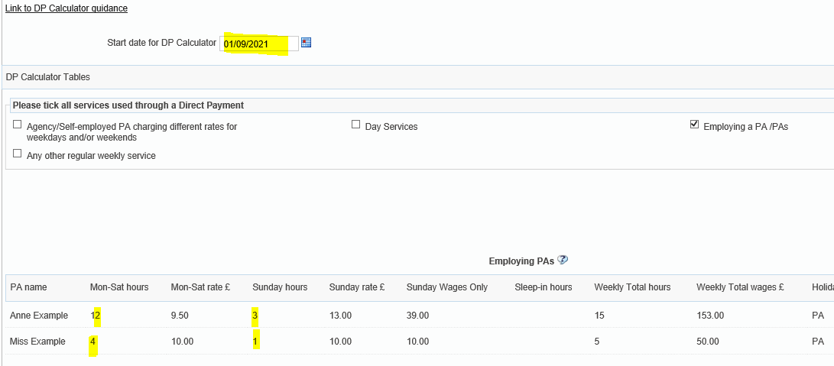
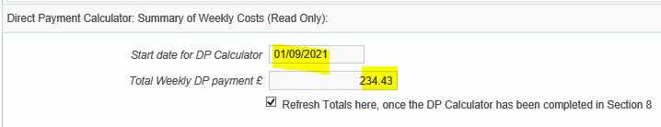
To create the DP Calculator as a PDF document, please click on the PDF icon within your step at the top of the screen:
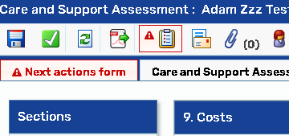
Select section 8 in the old care and support plan for the DP Calculator, in the conversation three workflow the DP Calculator is section 6, then output to PDF, you can then save/upload this if you wish to do so:
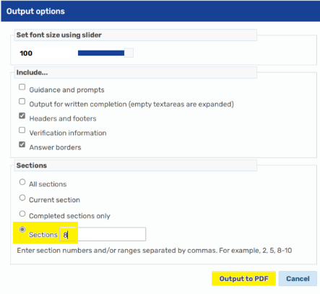
DPSS notice period
As the DPSS costs are NOT included in the total cost of the Mosaic DP Calculator you would not need a separate calculator or the DPSS notice date as the start date.
Please put the start/change date on the DP Calculator section as the most recent change date whether this is the change of support or the date the contracted DPSS is removed from the ongoing DP and paid centrally on the new process.
The DPSS agreed start/change date will be recorded in the cost section on the CASP under the DPSS sections – and will not necessarily be the same start/change date as the support.
Please input the ‘old DPSS rates’ as an individual line on the ongoing cost section with an end date (date prior to agreed start/change date with DPSS provider)
Uplift to costs
Where there is an uplift provider rate only (no change to services provided/hours of support/provider) a ‘Request care package amendment step – Care and Support Plan update’ should be used. If there is also a change in support hours or provider, then this should be done via a review step.
Rules for DIT
DIT check the following before they are able to commission, if you have not completed the step correctly or have not uploaded the correct forms, then your step will not be commissioned by DIT:

- A DP Agreement – ACM39 is required for ALL Direct Payments and uploaded as a financial document - at least one annually, March 21 version or newer, signed by all required parties, no change to how DP will be taken, no change to authorised/nominated persons
- An Order form is required for contracted DPSS commissioning, signed by all and uploaded as a financial document
- Arranging my Support should be completed fully for the Direct Payment options, including how the DP will be taken (PPC/TPMA) and what support will be commissioned under the DP (PA/Day service/Agency including Agency name)
- DP Calculator is required where a PA is used for all/some support with the DP
- Costs should have the same start date and total cost of DP matching the DP Calculator section
- The current minimum wage for Employed PA’s must be used for ongoing packages

