DPSS Changes to Care and Support Plans and Commissioning
The commissioning of the Direct Payment Support Services changed from 15th March 2021, in line with the contract for the DPSS’s being held with NCC and will no longer be paid into the DP and will be paid to the DPSS directly by Notts County Council. This has enabled us to request certain specifications from the DPSS’s and means that all contracted providers will now have the same rates for each service, they will all provide the same services and the quality of provider can be monitored more consistently.
What you need to do...
DPSS Factsheet
If a DP Recipient requires support from a DPSS you will now provide them with the DPSS factsheet containing all the information on the newly accredited providers, there are now 5 contracted providers. This factsheet details the providers list of services, they will now all have the same charges and services so the DP Recipient will be able to decide which provider they would like to use based on the one page information for each provider on the factsheet that contains each web address and contact details.
Order Form – Please see an example at the end of this document.
Once a provider has been chosen you will need to complete the order form (found on DP support area and available in Mosaic documents). This will need to be signed by yourself and sent to the DPSS provider to sign and returned before you send the CASP to be commissioned by the Data Input Team. Only once the required support has been agreed with the provider and the order form is signed and uploaded to Mosaic (as a financial document) can the commissioning be done. This is to ensure the commissioning is correct and the agreement between NCC and DPSS is in place. The worker (Social worker/CCO) is the NCC representative and must sign. Please complete your details in the Commissioning partner representative section, and the DPSS provider in the Provider representative section.
Once a form has been agreed and uploaded you will not need to get a new form signed until there is a change to the level of needs, or the provider. This does not need to be updated annually at review unless there is a change to level of support required from the DPSS as a new order form is required if there are any changes in what elements are required be this one off or regular.
Commissioning elements:
Employment Support
- Employment initial advice and support (one off payment) For those individuals who express an interest in employing a PA, this support will help them to decide whether to become an employer.
- Employment support recruitment (one off payment) For information, advice and guidance to carry out recruitment including job descriptions, placing job adverts, setting the rate of pay etc.
- Employment support to be an employer (one off payment) Once a PA has been recruited support with legal and contractual arrangements and good practices as an employer
- Enhanced DBS Check (One off) usually done by NCC however the individual can request the DPPS does this
- Employment Additional support (one off payment) for any support not covered by the specification above, is required, for example, direct support to interview job candidates or deal with disciplinary issues
Payroll support
- Payroll band one (1-3 PAs) -ongoing payment
- Payroll band 2 (4-6 PAs) -ongoing payment
- Payroll band 3 (7+ PAs) - ongoing payment

TPMA support
- Managed account - ongoing payment

Additional Support – (Previously ongoing support)
- Additional support – one off – standard hourly rate multiplied by number of hours
- Additional support - ongoing payment – standard hourly rate multiplied by number of hours equated over the year
Where a DBS check for the Personal assistant is required, this will usually be done by NCC via the DPEnquires Team when the DP recipient completes the online DBS request form. If the DP recipient chooses not to have this done by NCC that is fine, but this will need to be recorded with a reason on Mosaic. If the PA already has a DBS (Enhanced for Adults and Children dated within 3 years) then this can be accepted but the DBS form needs to be completed with this information which is sent to DP Enquiries to monitor.
Payroll, depending on how many PA’s are employed there are set rates for all commissioning elements. Please ensure the correct amount of agreed PA’s are put on the order form and the correct level of support is selected on the drop-down options for how many PAs are going to be used for support, the number of PA’s will affect the cost for this service.
TPMA, there is a set rate for the annual cost of a Third-Party Managed Account with a contracted provider, any extra support that is required throughout the year can be commissioned as a one-off amount or as a regular payment split over the year, please see below.
Additional support would be where a DP Recipient requires a face to face (or equivalent alternative) for any extra support, needs to be justified in the CASP and agreed by Team Manager/Group Manager. This can be commissioned as a one-off annual amount or as an ongoing amount, if the DP is ended part way through the year if this support is paid as a one off any overpayment will be recouped, with an ongoing payment there is no recoup requirement as we will only have paid for the support received. This should only be used in exceptional circumstances where specific support above what is required in the other elements and details of this support should be provided. Telephone support is already covered in Payroll and Third-Party Managed accounts. For any support, please contact DP Enquiries prior to set up on a case-by-case basis.
Inhouse Managed account with NCC ACFS, this can be arranged for new DPs with Agency only support, where it is deemed DPSS’s support is required. For this support, please ensure you have selected the NCC inhouse support on how the DP will be managed on both the ACM39 DP Agreement and my support/arranging my support section of the Care and Support Plan. Where you are transferring an existing DP package with Agency only support where at Review it has been agreed to move to the in-house arrangement, either because they are unhappy with their current DPSS and do not want an alternative DPSS provider or they request this support please send an e-mail to ACFS DP team to notify them of the change to how the DP is managed and the you will need to select the inhouse managed account options on the ACM39 – DP agreement and the Care and support plan my support section (similar to the Pre-paid card) to notify ACFS of the inhouse request for a managed account.
Care and Support Plan changes...
My Support / Arranging my support
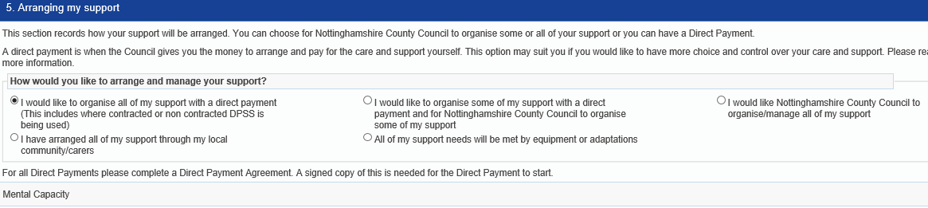

What option do you select?
‘How would you like to arrange and manage your support?’
For a Direct payment either the 1st option, all of the support to be a DP or if this is a mixed package with managed services (internal day services or a managed home care), you will need to select the 2nd option.

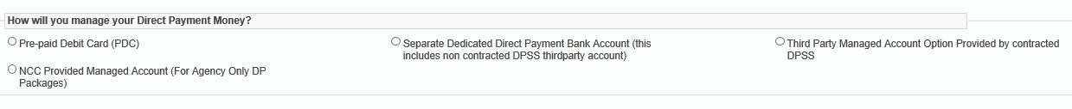

‘How will you manage your Direct Payment Money?’
The options;
- Pre-paid Debit card – preferred method where possible
- Separate dedicated DP account
- Third party managed account with contracted DPSS – only considered after the above 2 options
- NCC Provided Managed account for Agency only (please see in house ACFS managed account information on page 2)

There are radio buttons for the Direct Payment options. One of the new options will be for DPSS (contracted providers & non contracted) and another for NCC’s new inhouse DPSS for Agency DP’s only.

Cost section
If a DPSS is required you will now need to select the option of DPSS services from the radio buttons at the top of the cost section, as you would for Transport or one-off costs. There are 4 DPSS options, Regular DPSS and One off DPSS, additional support one off and the on-going additional support, you can commission both regular ongoing elements as well as one-off payments if required. Once you tick into the DPSS option you will get a new section expand on the plan below the ongoing payments section.
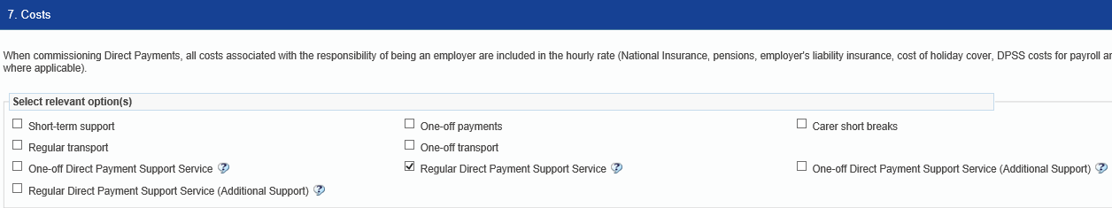

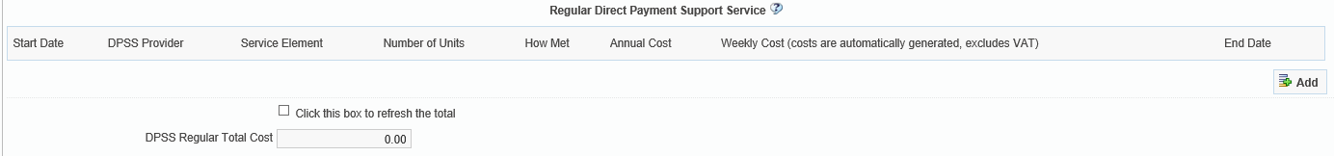

You will need to use the add button to input the relevant information. The contracted 5 providers are in a drop-down menu, you must select the relevant DPSS provider and elements which must match the order form that has been uploaded.
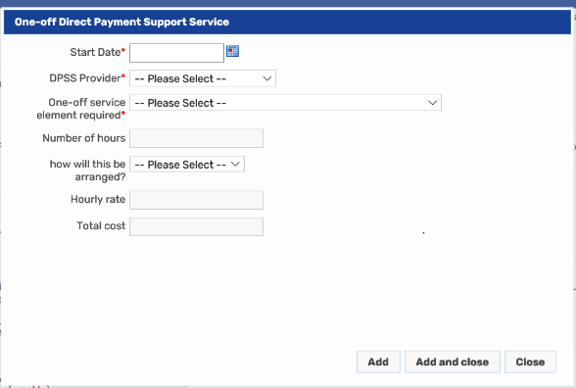
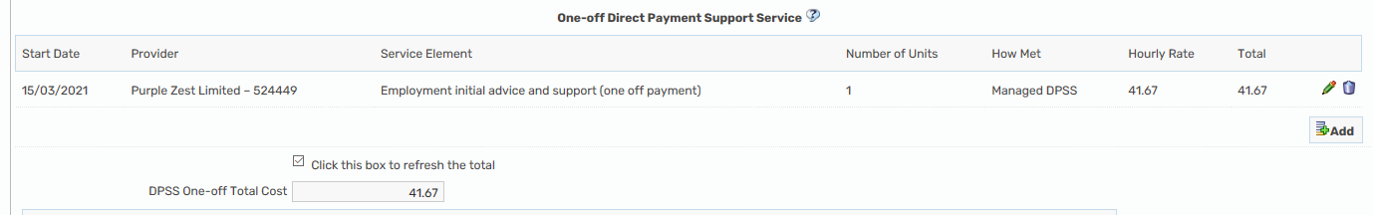
Please ensure you click to refresh the total cost
Review of a DP with DPSS already in place
Any change to current DPSS arrangements will require 4-week notice period to all providers. Please see pay cycles on DP Support area
At Review, the DP recipient will need to be advised about the new DPSS contracted providers and given the DPSS Factsheet (found on the DP Support area). Any individual that has a review completed with one of the contracted providers MUST be moved onto the new DPSS commissioning process as part of the Review, completing an order form with the provider and agreeing the date for the new costs.
If their current DPSS provider has been successful in becoming one of the contracted providers then as long as the DP Recipient wishes to stay with this provider then all that will change is the DP Recipient will no longer have to pay the DPSS, NCC will make this payment directly to the DPSS provider instead. The money in the DP for support will not reduce, only the money allocated for the DPSS payment will no longer be paid to the DP account and be paid directly to the provider by NCC instead. This does mean that if the DP recipient have any concerns about the DPSS this can now be dealt with by NCC as we hold the contract and specification requirements. You will however need to review the support that is provided by the DPSS in line with the new order form and the order form should be signed and uploaded before any commissioning is sent to DIT. The DPSS costs will also need to be removed from the ongoing cost on the CASP and the new sections of the CASP should be completed to ensure the elements are commissioned sperate from the ongoing DP.
If for any reason the DP recipient wishes to remain with the current arrangement of paying the provider themselves and having the money in the DP Account, then this can be agreed in exceptional circumstances by a manager.
If the DP Recipients’ current DPSS provider is not one of the new contracted providers then you will need to advise we now have contracted providers for the DPSS services where the contract is direct with NCC and certain specification requirements are now in place for the DPSS to meet, please provide them with the DPSS factsheet. If they chose to stay with their current provider, then NCC will only pay the contracted rates for the DPSS services in most cases and a top up or negotiation with DPSS maybe required. In exceptional cases where a GM approves a higher rate, the additional costs need to be included in the ongoing weekly DP in the additional costs section of the DP calculator and this will continue to be paid into the DP account.
To commission the change with DIT where there is also a change to the support on a different date to the DPSS agreed change over.
For example, you have completed a Review on the 1st March 2022, and you are increasing the support hours from 5 hours per week to 10 hours per week, but the DPSS provider (People plus) require a notice period of 4 weeks, you would commission this as follows;
First you will need to find out the old DPSS costs, you can find these on the previous care and support plan or an old excel DP Calculator found in the documents, attachments.
You will then need to use the DP Calculator to give you the increase in the care costs from 5 hours to 10 hours, the date on the DP Calculator will always be the most recent change date. So, although the support is changing from 5 – 10 hours on the 1st March in this example, as the DPSS money will still be included in the DP until 1st April, the date of the DP Calculator will show as 1st April;
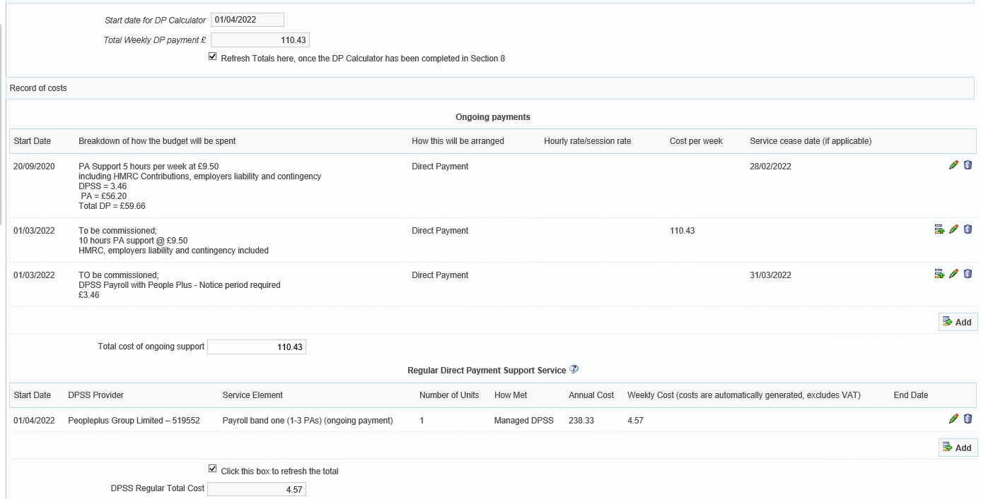
Please only include the on-going cost of the DP in the cost per week section, and any other on-going services. Any services that are ending need to have the weekly cost removed. I would recommend writing ‘to be commissioned’ in the description for any service that has not yet been commissioned and will be ending such as the DPSS element in this example above.
The end date for any services ending will be the date prior to the newly agreed services, this is for both on-going support and DPSS elements.

DP Calculator – Required for ALL Personal Assistant packages and Non-contracted DPSS providers
The DP calculator has been updated and is now found with the Care and support plan and review of care and support plan. Where a contracted DPSS provider is used (Penderel’s, People Plus, Purple, Rosekel or SOLO) there is no facility to input the contracted costs into the DP Calculator as this is no longer paid into the DP account, however this information will be pulled through from the cost section where the new DPSS element have been used.
The old Excel version of the DP Calculator is now void and should not be used for commisisoning any packages in the current financial year.

Contracted providers
Please complete the DPSS section in the cost section of the care and support plan using the drop-down sections for the provider and the element to be commissioned such as Payroll.
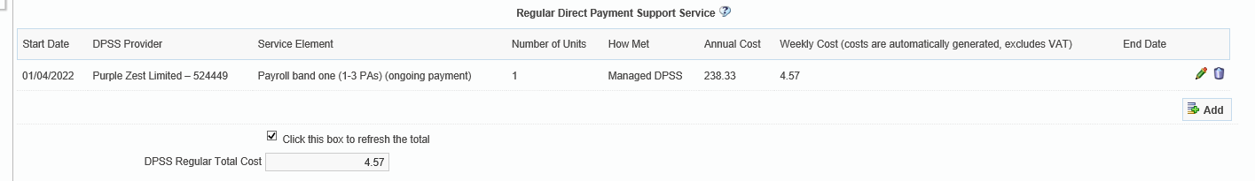
When selecting the contracted provider in the DP Calculator, this will pull through the costs into the DP Calculator so that the cost of the DPSS is included in the total cost of the personal budget and the total average hourly rate for either Agencies or PA’s.
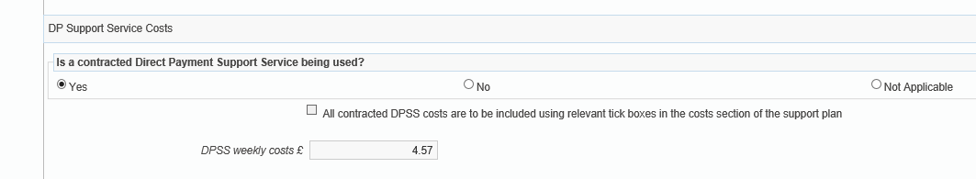
You will need to include the costs for any non-contracted providers such as a family solicitors, accountant or providers such as Rowan on the DP calculator to ensure this is still paid into the DP account for services such as Payroll where an employed PA is used under the Direct Payment.
Non-contracted providers
If you are using non-contracted provider, then the money will still be paid into the DP and the DP Recipient will need to make these payments to the DPSS provider as the arrangement was before. Please check the costs for services with the DP Recipient, if they are less than our contacted rates then we will still pay up to the contracted rate for DPSS services into the DP.
Where the DP recipient choses to an alternative DPSS provider to one of the contracted ones, you will need to advise that NCC will only pay the set contracted rate for services and any additional cost would either have to be paid by the DP Recipient as a top-up or be agreed on a case-by-case basis by a manager where deemed reasonable/suitable.
When completing the DP Calculator, you will need to select non-contracted provider and manually input the costs (contracted rates can be found on the order form or manager approval for a different rate). The money will be paid into the DP and should be put in the ongoing support on the care and support plan in the costs section and commissioned the old way.
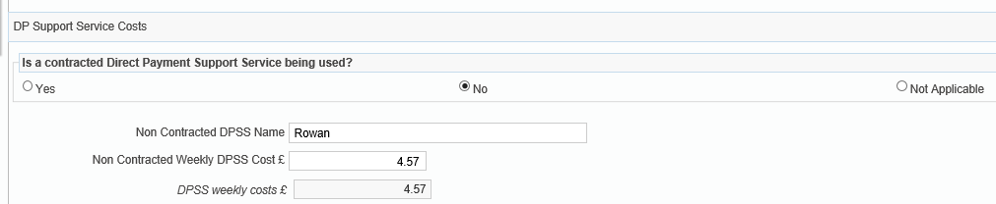

Rules for sending commissioning to DIT –
- Order form and Cost section of the Care and support plan must all match provider and services and start dates – if not the episode will be re-opened.
- If there is no DP Agreement in place or the one uploaded does not meet the criteria (at least one annually, March 21, signed by all required parties, change to how DP will be taken, change to authorised/nominated persons) then the episode will be re-opened.
- If there is no DP calculator for any package with a Personal Assistant (Employed/Self-employed) or non-contracted DPSS provider, the step will be re-opened
- If there is no signed order form uploaded as a financial document to Mosaic documents the episode will be re-opened for any contracted provider after start/change the 15^{th of} March 2021.
- Where the DPSS has not been separated from the DP in the ongoing costs – the episode will be reopened. – Unless clearly stated the DPSS is to remain in the DP
- If there is an order form on Mosaic, this will always be a contracted provider and commissioned as a separate element from the DP regular and the commencement date must match the dates in the CASP
- For in-house Agency only ACFS third party managed accounts, the ACM39 – DP Agreement and CASP MUST have the relevant options selected for how the DP will be managed, no order form is required.
- DP will still be paid as Net, only the DPSS element will be paid centrally and will be uplifted for contracted providers annually or when required. You will not have to commission an episode to uplift the costs of the DPSS element only.
- The cost of the DPSS will still, as previously, be included in the overall cost of the DP. For PA packages where there is DPSS support and only a small number of hours per week may show as higher than normally paid and need to be approved by a Team Manager.
- Any contracted DPSS support with a start/change date after 15th March 2021 must follow the new process with the order form.

PLEASE SEE BELOW FOR ORDER FORM EXAMPLE

