Social Worker/Practitioner Requesting a new Service for Home Based Care

A new Home-Based Care request can only be requested via the following steps:
- Conversation 3 – Building a good life
- Review Conversation – Long Term Care
- Review Conversation – Long Term Care

Please Note: Any increases/ decreases or ending of Home-Based Care will be continue to be processed in the same way via the ‘Home Based Care amendment’ by the Social Worker
Request a Home-Based Care Service
- Within any of the steps listed above in optional forms select ‘Request for Services’
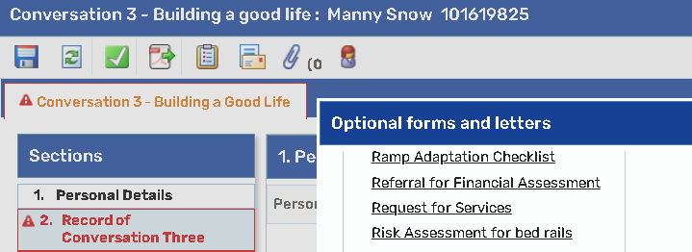
- Ensure Section 1 ‘Personal Details’ has the correct information and add the district
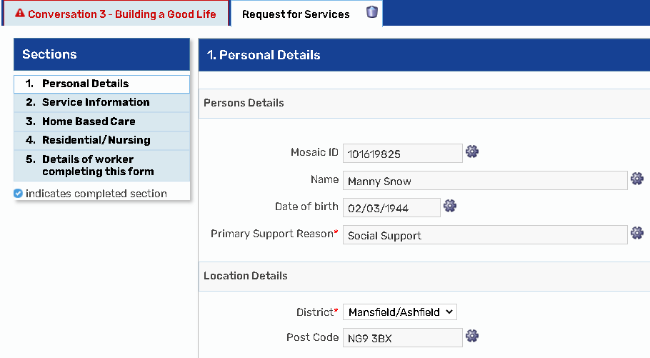
- Section 2 ‘Service Information’ – select Home Based Care
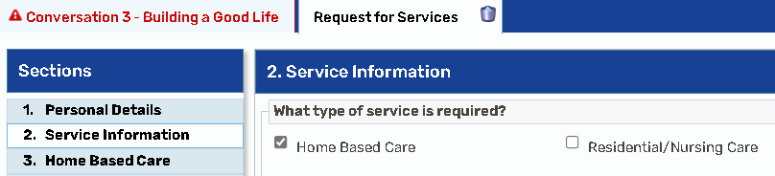

- Section 3 ‘Home Based Care’ – complete all questions
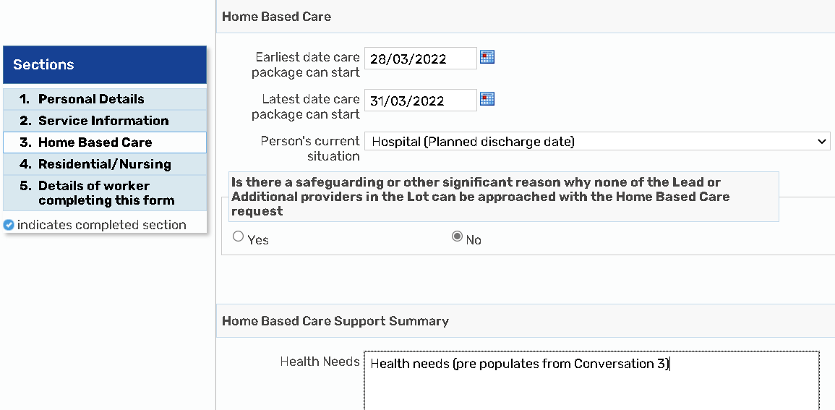
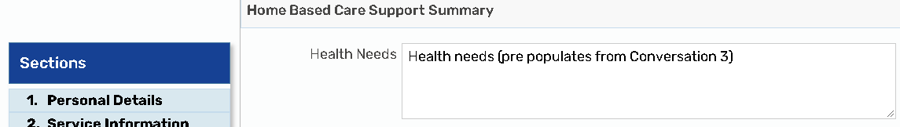
Please Note: Health Needs prepopulates from ‘Conversation 3 – Building a good life’, Section 2 – ‘What would the person like us to know about their health and / or disability?
Ensure you save before opening the ‘Request for Services’ form

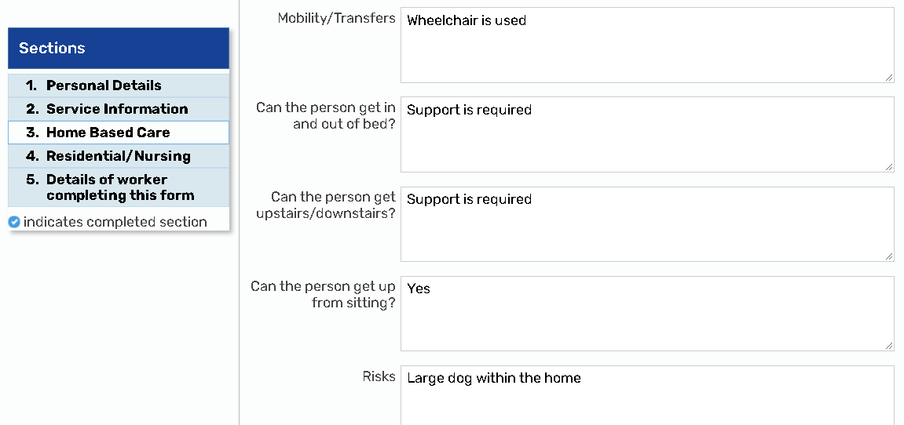
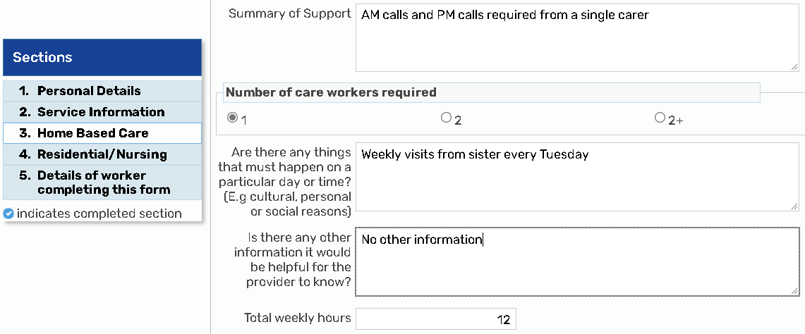
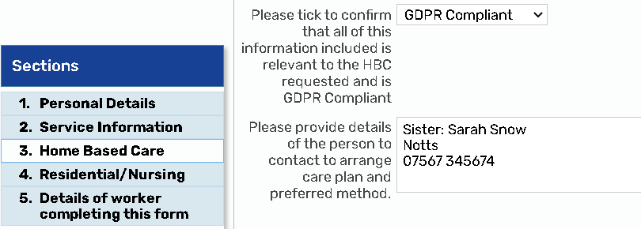
- Section 5 Add ‘Details of worker completing this form’
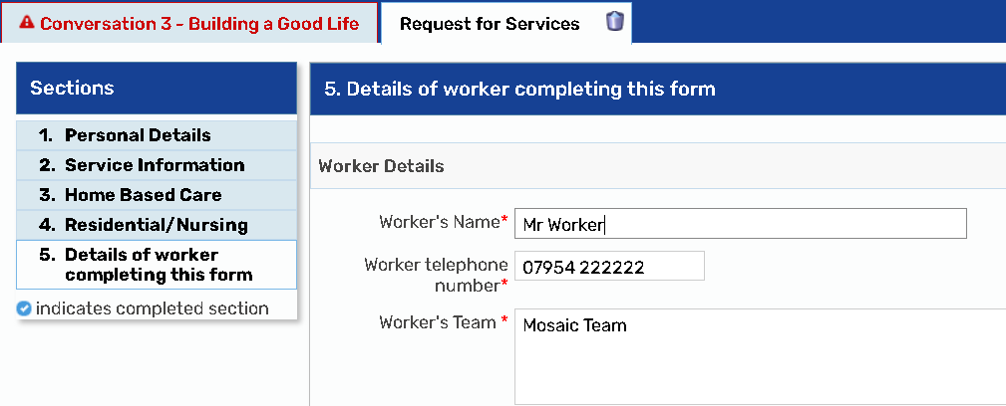
- Send request to the appropriate Service Placement Team
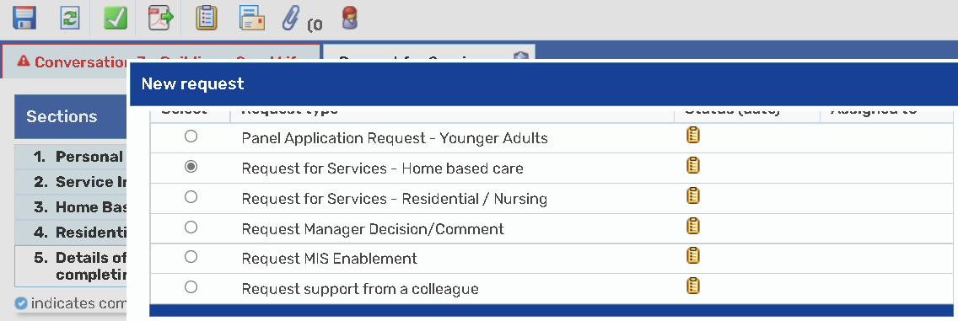
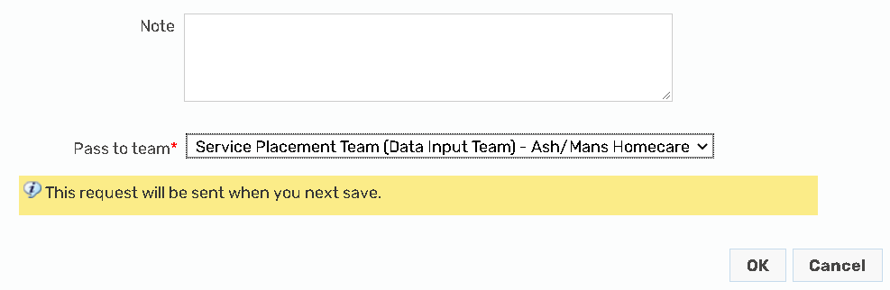
- Save and close the step

The Service Placement Team will:
- Trigger the Home-Based Care request step
- Carry out the portal function to identify a provider
- If no provider is available via the portal, then the service Placement team will make a request via QMM
- Once a provider is identified the Service Placement Worker will
  - Complete the portal process
  - Update the ‘Ongoing Payment’ table in the ‘Costs’ section of the Care & Support Plan with the details of the Home-Based Care service
  - Complete the original request you sent to let you know the work has been processed
You will then need to:
- Ensure your ‘Care and Support Plan’ has been completed
- Request sent to your manager for authorisation
- Select the appropriate next actions, ensuring that you have sent the ‘Purchase Personal Budget (includes Homecare)’ to the Service Placement team
