Service Request for new or changed Day Services
A new or changed Day Services service request can only be requested via the following steps:
- Conversation 3 – Building a good life
- Review Conversation – Community Based services
- Review Conversation – Long Term Care
Request a Day Service
- Within any of the steps listed above in optional forms select ‘Request for Services’
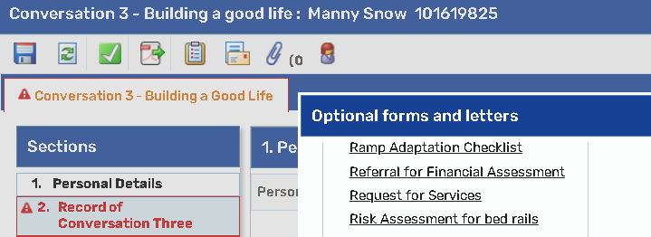
- Ensure Section 1 ‘Personal Details’ has the correct information. You must make sure the ‘Primary Support Reason’ has populated information from the Person Summary screen as well as adding the appropriate district
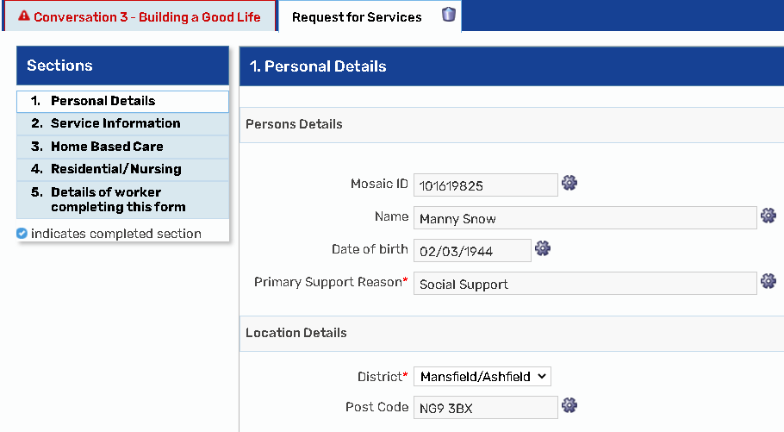

- Section 2 ‘Service Information’ – select Managed Day Service
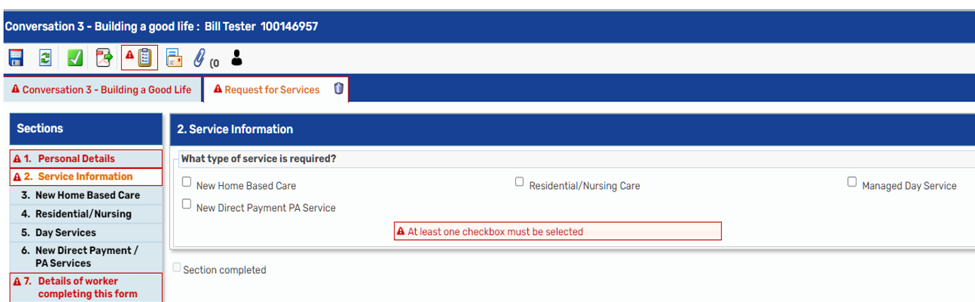

- Section 5 select ‘Day Services’ and then complete all the questions that appear. Initially you will be asked to indicate whether the request:
  - is for a new Day Service or for a change to an existing Day Services service
  - is for an internal service, an external service, or a spot contracted service

- Complete the information about the service that is required. All Day Services should be on Mosaic before they can be commissioned therefore the provider needs to be searched for by clicking on the “Find Provider” tab. You can then indicate the sessions that are required.
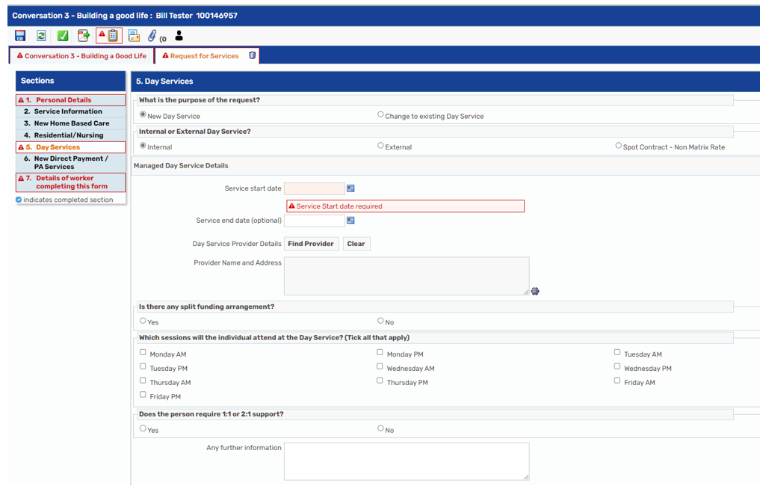
- Section 5 continued - if the person requires an extra support worker, over and above what is offered by the Day Service, click “yes” to the question ‘does the person require 1:1 or 2:1 support?’ – this will display further fields to provide the number of hours and the hourly rate.

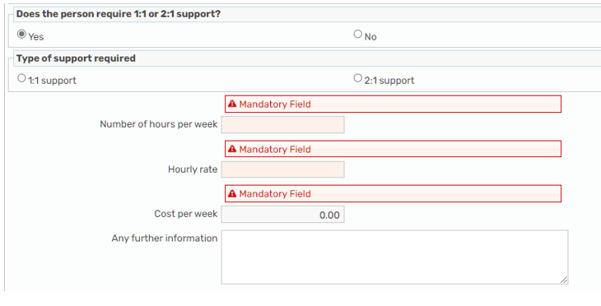

- Section 5 continued - if a second Day Service provider is required for a person, click “yes” to the question ‘Do you require an additional Day Service Provider for this person?’ Further fields will then appear for you to complete.
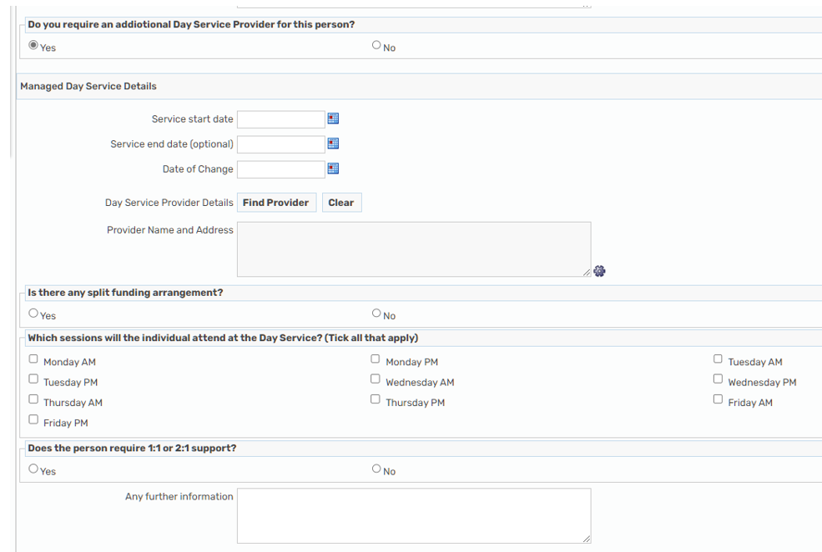

- Section 5 continued - if you are requesting an Internal or External Day Service, the Matrix rates will show. If you are selecting a ‘Spot Contract – Non-Matrix Rate’ Day Service, the Day Service Matrix section will be hidden.
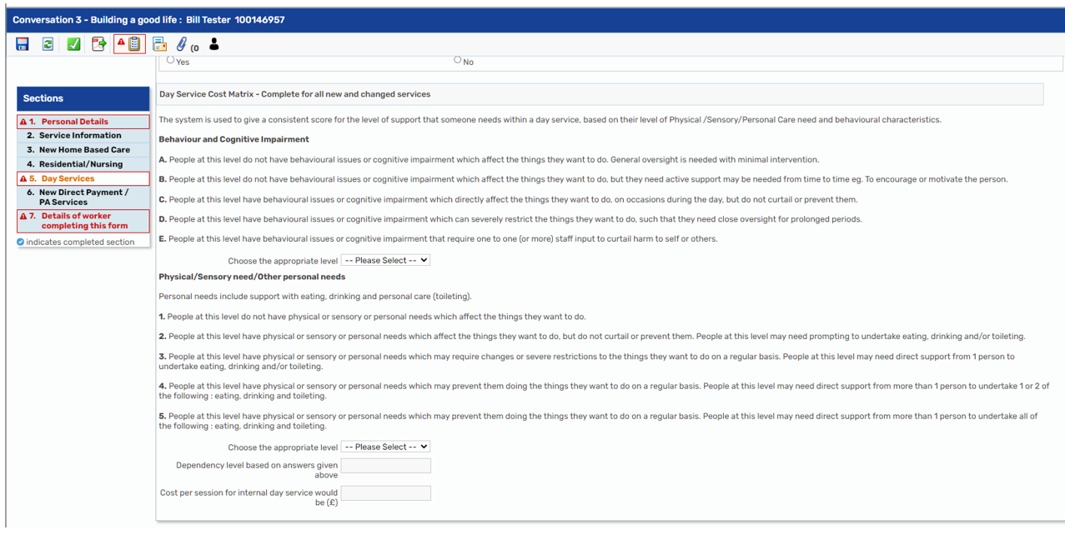

- Section 7: Add ‘Details of worker completing this form’
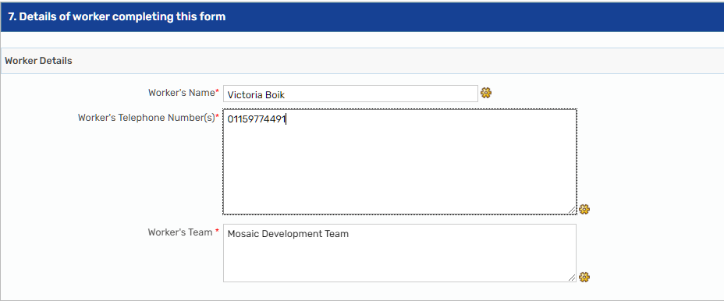

- Send the request to the appropriate Service Placement Team by clicking on the clipboard icon


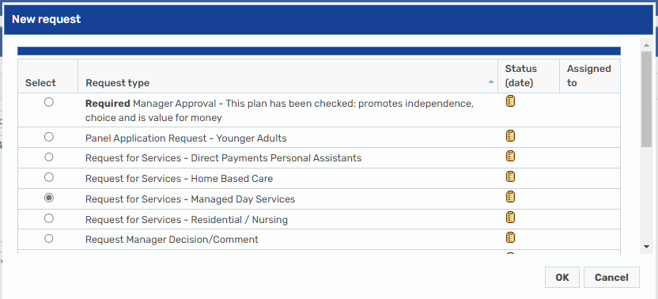
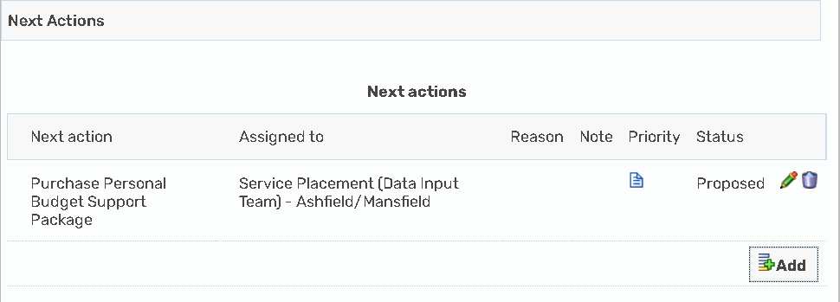
- Save and close the step – once you have completed the Service Request you do not need to update the ‘Costs’ section of the Care & Support Plan, the Service Placement Team will do this for you.

- What happens next?

- The Service Placement Team will:
- Receive the request
- Ensure the costs added are correct
- Update the ‘On Ongoing Payment’ table in the ‘Costs’ section of the Care & Support Plan with the details of the Day Service
- Complete the original request you sent to let you know the work has been processed

- You will then need to:
- Ensure your ‘Care and Support Plan’ has been completed
- Send a Request to your manager for authorisation
- Select the appropriate next actions, ensuring that you have sent the ‘Purchase Personal Budget to the Service Placement team

