Social Worker Requesting a new Service Residential / Nursing Care
A new Residential / Nursing service request can only be requested via the following steps:
- Conversation 3 – Building a good life
- Review Conversation – Community Based services
- Review Conversation – Long Term Care
Request a Residential / Nursing Care Service
- Within any of the steps listed above in optional forms select ‘Request for Services’
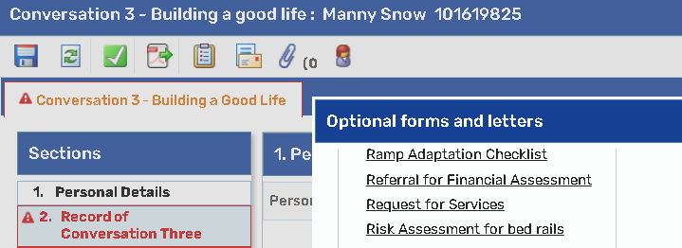
- Ensure Section 1 ‘Personal Details’ has the correct information. You must make sure the ‘Primary Support Reason’ has populated information from the Person Summary screen as well as adding the appropriate district
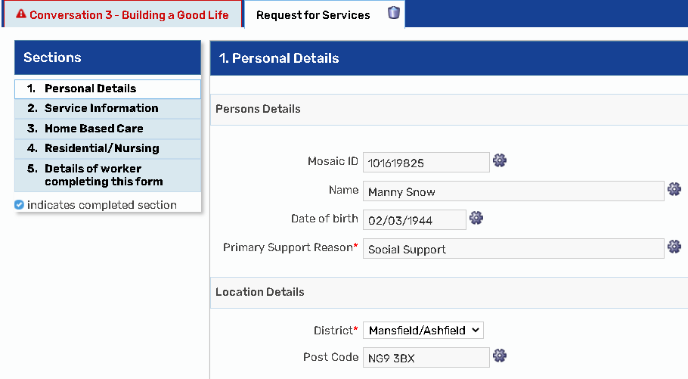

- Section 2 ‘Service Information’ – select Residential / Nursing Care
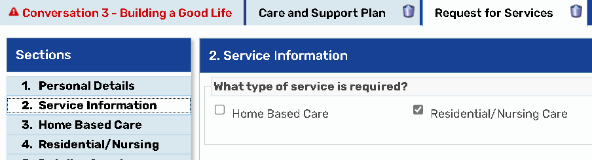

- Section 4 ‘Select ‘Residential Care’ and select ‘New Service’ then complete all the questions that appear
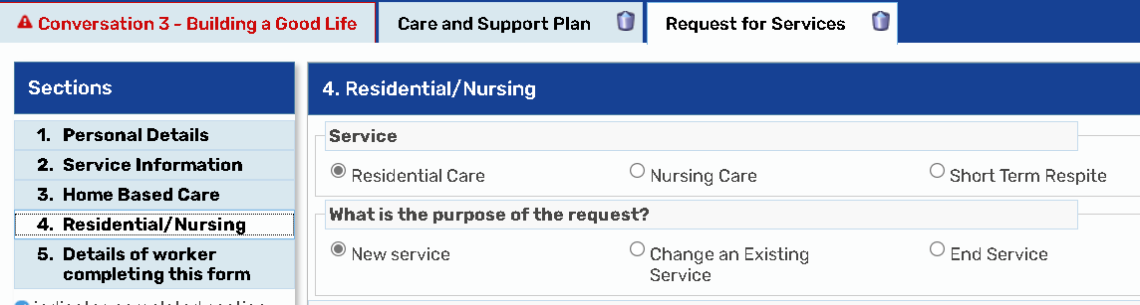

Please Note: If the Service you required was Nursing or Short-Term Respite you would follow the exact same process but just select the Service you require

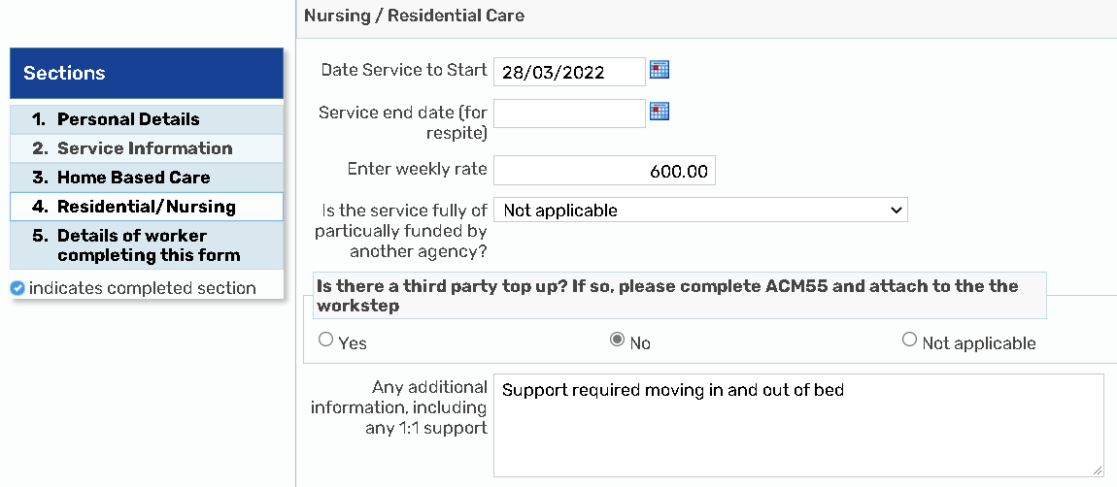
Please Note: If you answer Yes to the question, ‘Is there a third party top up? If so, please complete ACM55 and attach to the work step’, attach the form by selecting the paper clip shown below:

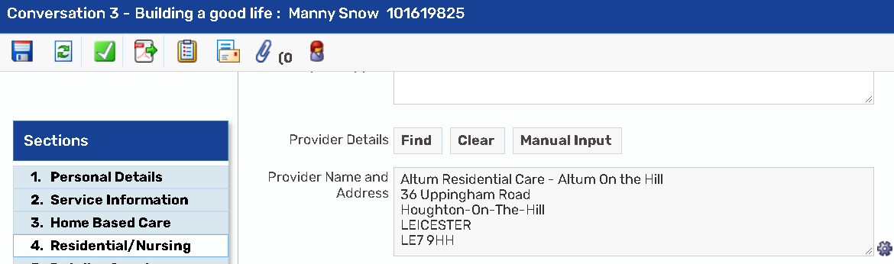

- Section 5 Add ‘Details of worker completing this form’
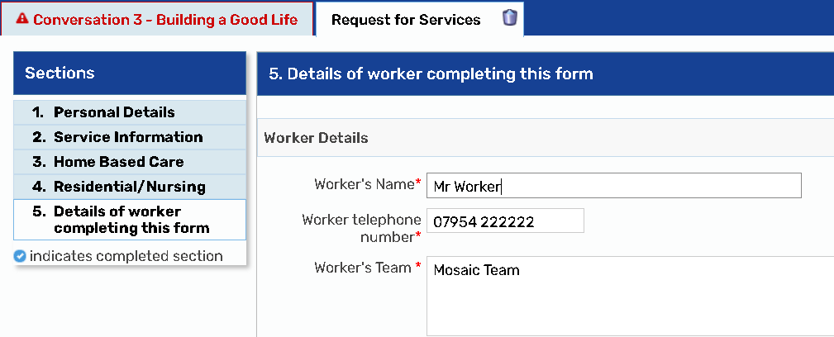
- Send request to the appropriate Service Placement Team
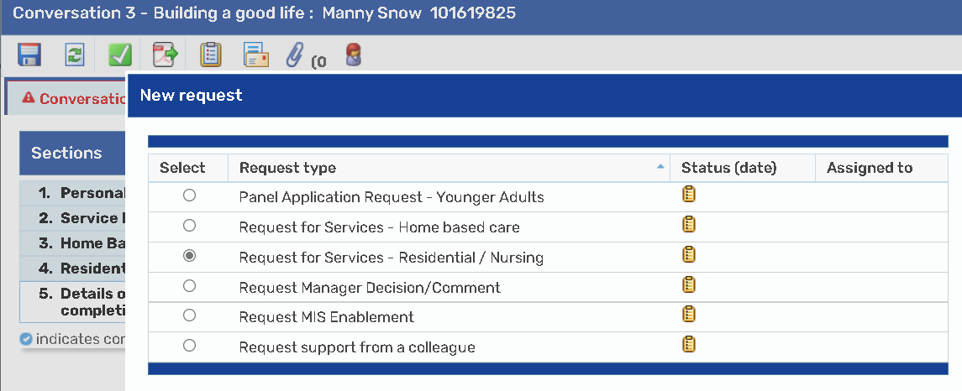
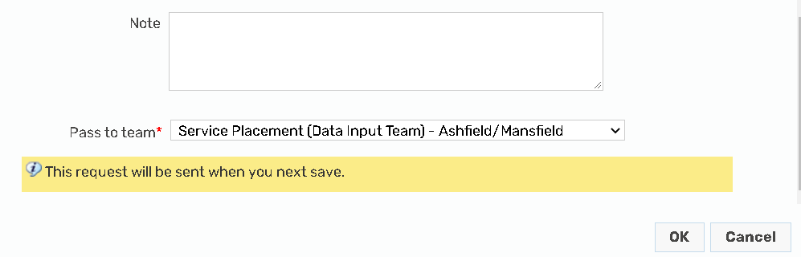

- Save and close the step
The Service Placement Team will:
- Receive the request
- Ensure the costs added are correct
- Update the ‘On Ongoing Payment’ table in the ‘Costs’ section of the Care & Support Plan with the details of the Residential service
- Complete the original request you sent to let you know the work has been processed
You will then need to:
- Ensure your ‘Care and Support Plan’ has been completed
- Send a Request to your manager for authorisation
- Select the appropriate next actions, ensuring that you have sent the ‘Purchase Personal Budget to the Service Placement team
