SCW – Request Finished – Send To NCC Finance:

The ‘CHC Panel Step’ is created by the GM. A request is sent to the SCW to advise the outcome of the panel and the required actions. The request is received into the SCW’s Incoming Requests folder. The SCW completes the tasks required before sending a further request to finance to complete the step.

1. Click the Incoming Requests folder.

2. Click icon next to the step to be worked on.
3. Click Resume Work to open the step.

4. Click tab to view the actions required. | * Where the request is sent to the incorrect SCW follow ‘SCW – Request Sent To Incorrect SCW – Reassignment Required:’ process below.
5. Once the actions are completed click 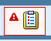 icon.

6. Click the request (red text) | 
7. Click the Completed radio button

8. Click OK

9. Click  icon

10. Click Send request

11. Select Required 2. Actions finished, pass to finance | 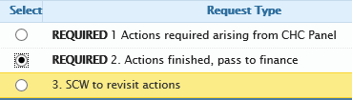
12. Select CHC Finance Worker
13. Click OK
14. Click icon.
15. Click Yes to save changes
16. Task End

SCW – Request Sent To Incorrect SCW – Reassignment Required:

1. Click  icon | Follows on from No.4 above.
2. Click the request (red text) | 
3. Click the Returned radio button

4. Enter an explanatory note

5. Click OK

6. Click icon.  7. Click Yes to save changes  8. Task End | *The request is sent to finance to be re-assigned.

