PACKAGE APPROVAL REQUEST FORM
(To be used for changes of care packages and new package requests)
Persons name:
Persons DOB: |  |  | NHS number: |  |  | If known
Name of ICB: |  |  | Broad Care ID: |  |  | If known
S117 /Transforming Care |  |  | Mosaic ID:
Current Package
Full breakdown of costs: | Please list all elements of the person’s current commissioned care package.  This should include every costed component, for example: Long-Term Care (LTC), Supported Living, Day Care, and Planned Short Breaks.  These details can be found under Care Packages Provided and then under the heading Care Package. If it has lapsed by the element this means that this is no longer commissioned  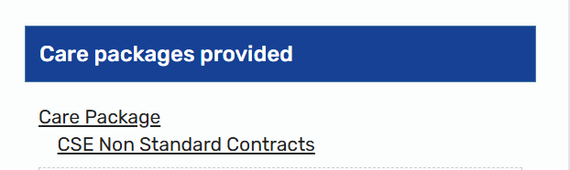 | Total package cost: Weekly or one-off payment |  |  |  | Enter the total weekly cost of care, calculated by adding together all active commissioned elements.
 |  | NCC contribution:  Include % split if applicable |  |  |  | Write the current weekly cost to NCC  And include the % split
 |  | ICB contribution:  Include % split if applicable |  |  |  | Write the current weekly cost to NCC  And include the % split
New Package
Reason for change: | Please explain why the weekly cost is changing. This may include, but is not limited to: an increase or decrease in care provision, a one-off payment, short-term or temporary support, or a change in the funding split between the Local Authority and the ICB.  Any changes to weekly cost that is also funded with health will need a PAR form completing
Start date of change: | The date of the agreed change to the commissioned costs.
Full breakdown of costs: | Enter the revised weekly cost of the care package following the agreed changes. This should include all commissioned elements within the new or amended package (or state if this is a one-off payment).  For community support, DP, 1:1 please ensure you input the hourly rate | Total package cost: Weekly or one-off payment |  |  |  | Enter the total weekly cost of care, calculated by adding together all active commissioned elements.
 |  | NCC contribution:  Include % split if applicable |  |  |  | Write the current weekly cost to NCC  And include the % split
 |  | ICB contribution:  Include % split if applicable |  |  |  | Write the current weekly cost to NCC  And include the % split
Details for NCC Finance
Social worker name: |  | NCC Cost Centre: |  |  |  | The cost centre can either be found under the existing care package under care packages provided  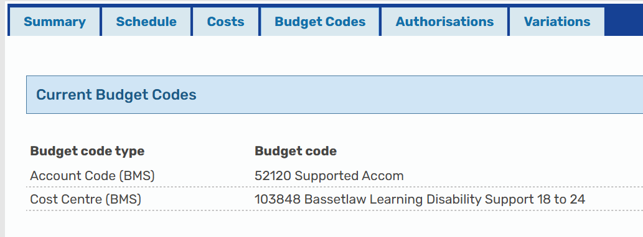  Or  There is a tab within the joint funding split calculator that has a list of costs centres relevant to your team
I confirm that approval from the Local Authority Head of Service has been sought, and approval of the rates has been given.
Authorising Head of Service: | In this box you will need the HOS signature before sending the form to the ICB
Date HoS authorised: | Date it was signed by HOS
ICB Authorisation (to be completed by the ICB only)
Approved: | Yes / No
Comments:
Name: |  |  |  | Date:

