
Case History

Case History is a new tab on the Person Summary screen. It allows you to see what steps, case notes and address changes have happened to the person.
It is a continuous log of activity that provides quick access to and navigation of the evolution of the case. It also introduces a lot of new events and adds some greater interactivity.

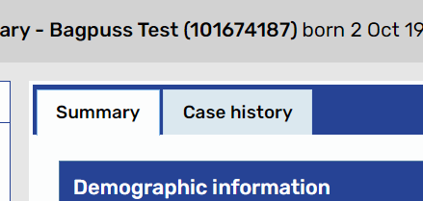
Click on the Case History tab

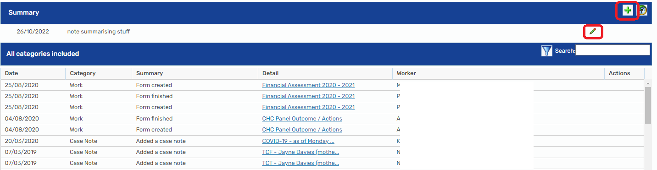
You can add a summary at the top by clicking on the green cross, or amend an existing summary note using the pencil. You can also filter to only see case notes or steps (which are recorded as “Work”), and click on any of the blue links if you want to look at the case note/steps themselves.

