All guidance, step by step guides, factsheets, letters and forms are all located on the DP Support area - Direct Payments support area | Nottinghamshire County Council Intranet (nottscc.gov.uk)
- Check capacity – if required an authorised/nominated party to be put in place
- Request a financial assessment and discuss the requirement to pay towards the support
- Decide on support PA/agency/Day service etc where a PA is used;
Complete the request for services form and request and send to the DP PA team who will check the below
- DBS form to be completed and sent to DPEnquires Disclosure and Barring Service checks for personal assistants | Nottinghamshire County Council
- Conformation of Employed or Self Employment – CEST tool to be completed and uploaded to Mosaic - Check employment status for tax - GOV.UK (www.gov.uk)
- Employer Liability insurance for the DP Recipient if the PA is Employed – If Pa is Self-employed it is recommended the PA has Public Liability insurance

- How will the DP be managed? Either a Pre-paid card (auto audited by ACFS no need for bank statements), a separate bank account (where statements must be sent in for audit) or a third party managed account with a Direct Payment Support Service (DPSS)
- DP Agreement/ACM39 to be understood and signed by all required parties and uploaded to Mosaic
- DP Calculator to be completed for any DP with a PA, and can be used to work out Agency weekly costs and average hourly rates to compare with managed service costs
- If there is continuing health care contribution in the form of a section 28a then and ACM33 will need to be completed
- The Care and support plan must match the costs on the DP Calculator and ACM33 (if applicable) before sending to SPT to commission

- Step 1:
Complete Care and Support Assessment / Conversation step – agreeing and discussing outcomes for support plan.
- Step 2:
Request a financial assessment (ACFS) and discuss the requirement to pay towards the support
- Step 3:
Identify if a PA would be suitable, if so send a request for services to the DP PA commissioning team. If you are reviewing a DP with a PA you must send as request for services to the DP PA team to complete the commissioning requirements such as DBS/ order forms, PA checks and DP Calculator/ costs
- Step 4:
Complete section 5 – Arranging my support of the care plan to show what the DP will be used for and any support from Authorised/nominated persons and the details

On Section 5 of the Care and Support Plan, make sure you select the appropriate options to suit the individual’s choices relating to their package of care, this section must be completed fully and accurately. 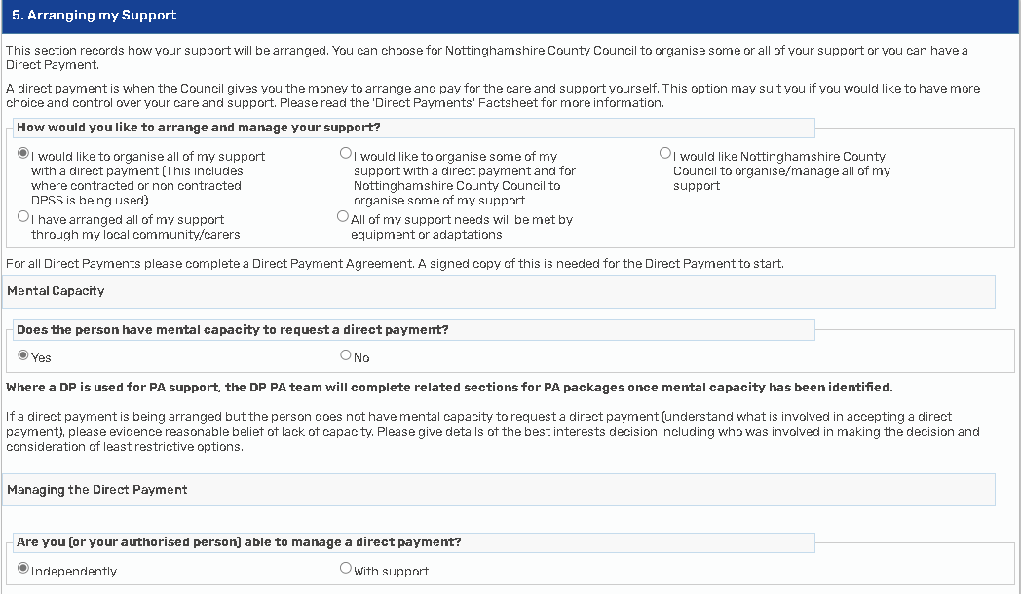

- Step 5:
Complete the Section 6 Direct Payment Calculator for any DP packages that include DPSS support or a Personal Assistant (For Agency/Day service only no DP calculator is required)
Complete all sections of the calculator relevant to the package. There is guidance on the Direct Payment Support Area on how to complete the calculator, if the DP Calculator is used then the costs must match.
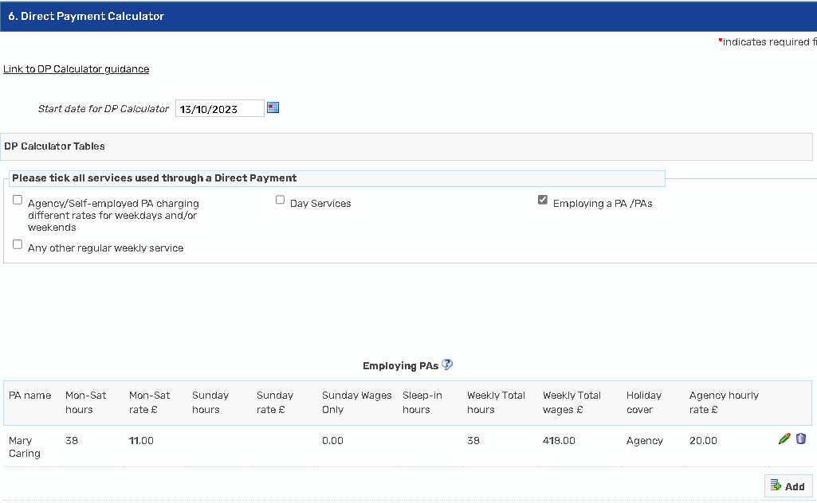

- Step 6:
Complete the cost section 7
Important: Ensure that your indicative budget is the same on your Care and Support plan as it is on the Care and Support Assessment.
On Section 7, make sure you are clear with the wording and ensure you complete the date and costs as appropriate – (the example used is for a PA, the costs are taken from the calculator. Important: always take the cost from the Direct Payment Calculator you have completed)
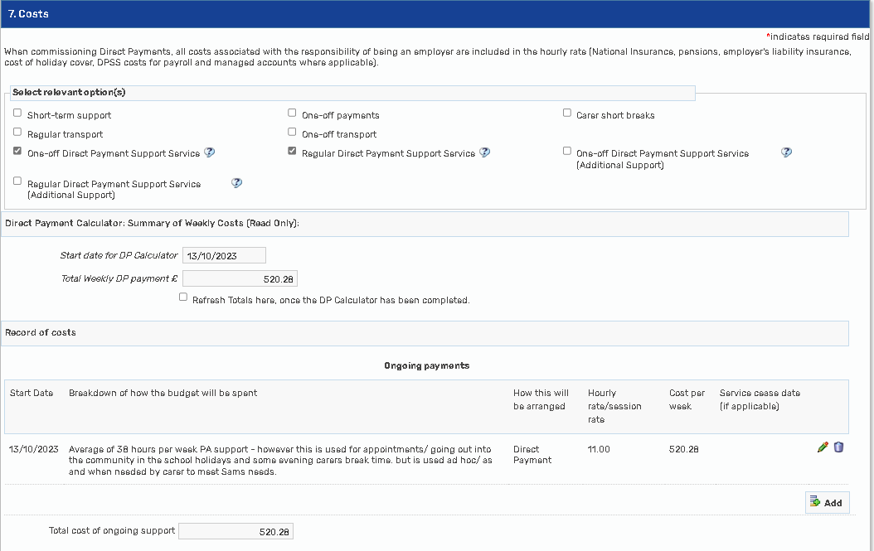

The DPSS costs are now separated on the cost section of the CASP, please ensure you select the correct support and if you are completing a review this support must be reviewed, and an order form to be completed if required.

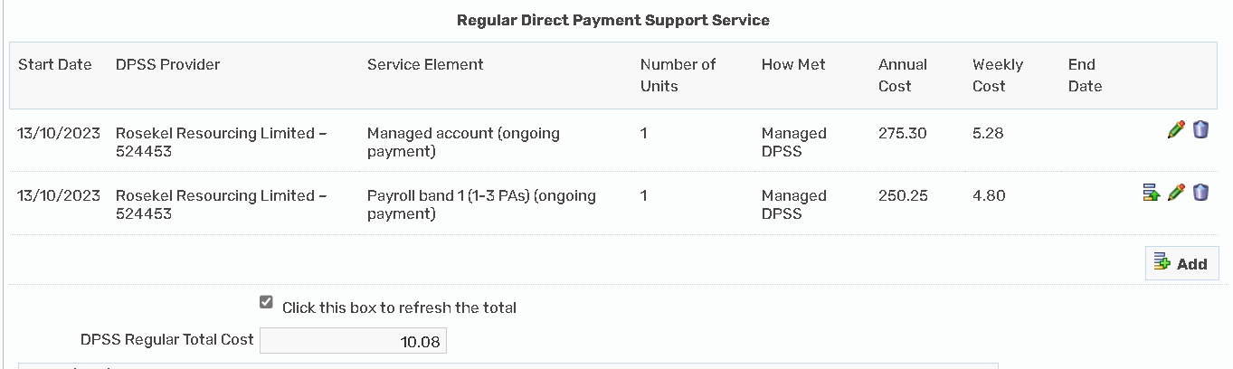

• Step 7:
Once you have approval from your manager and have completed all the steps for your assessment /conversation as required (e.g mental capacity assessment/financial assessment) you will then need to send your step to the Service Placement team (SPT) to be commissioned.
Click on the ‘Next Actions’ form and complete the box that comes up as below (writing a note in the box is useful for the SPT team such as – Non contracted DPSS support, Rates agreed by Group Manager)
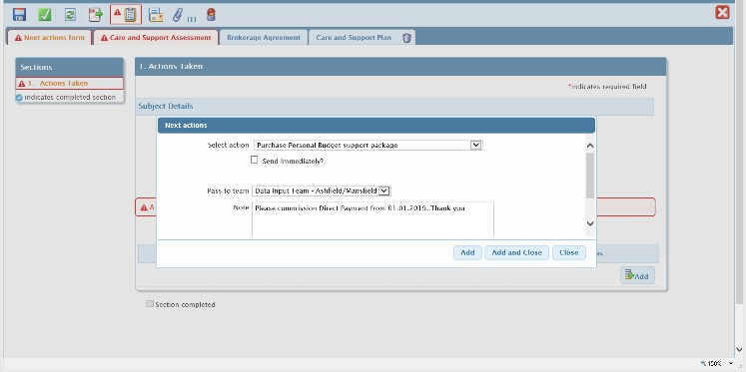

When the above is completed you will then need to click the green tick to finish your step. This will then send the step to SPT who will set up the commissioning on Mosaic and forward the step to your manager for a final budget approval. They will also notify Adult Care Financial Services (ACFS) and the worker who has requested the amendment to update you when commissioning has been completed.

Important:
- If you are setting up a Direct Payment Support Service (DPSS) please ensure you complete the correct order form and upload this into documents on Mosaic.
- Remember to send the Support Plan to all relevant recipients such as the individual requiring support and any DPSS that are managing the DP Account.

- The ACM39 / DP Agreement should be signed by the social care worker, the DP Recipient/authorised person and where the DPSS are managing the DP account they sign as the nominated party (managed account only, do not sign for payroll only)

- SPT must have a ACM39 /DP Agreement signed with 12 months that matches the request, an order form for DPSS support with commencement date and services matching the CASP, the start/change date of DP and costs to match the DP Calculator where required, the provider details to be accurate throughout the CASP

