To arrange a top-up, this must first be discussed with the Direct Payment (DP) recipient.
This is to make sure it’s affordable, especially if they’ve chosen a more expensive DP provider. This may be because:
- The provider charges more than the maximum allowed DP rate, or
- The person could be supported through existing contracted services (like Home-Based Care, Care and Support Enablement, or Day Services), in which case the provider should be paid the standard contracted rate via a DP, or
- The individual has chosen the more expensive provider and has agreed to pay the extra cost themselves, on top of any assessed contribution.

Please ensure you are aware of the contracted rates as a comparison this can be found on Home Based Care services | Nottinghamshire County Council Intranet or email csesupport@nottscc.gov.uk

A top-up can be paid directly by the DP Recipient receiving the support or a family member (third party), please see the DP Staff guidance for more information.
Staff guidance document – Section 6.7

- The Care and Support Plan DP Calculator
When entering the provisions being used hourly/session/day rate. This must be put into the Calculator at the providers actual costs (see below example)

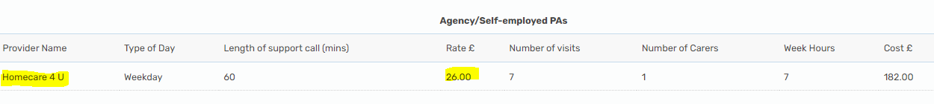
E.g. Agency/CSE

The bank holiday rates must also be entered with the correct rates (see below example)
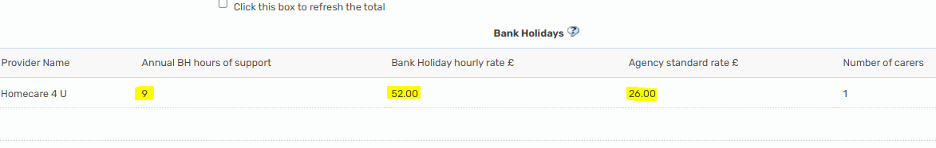

- The average hourly rate generated by the DP Calculator should be used to calculate difference with the Maximum DP Rate for that person’s district based or based on available services via Home Based Care (HBC) /day service matrix/CSE rates.

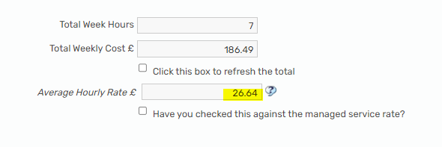

The sum required to work out the weekly top up would be (average hourly rate – Maximum DP Rate OR Contracted Rate x hours per week) e.g. (£26.64 - £22.24 = £4.40 x 7 hours = £30.80 top-up per week)

E.g. Day Service

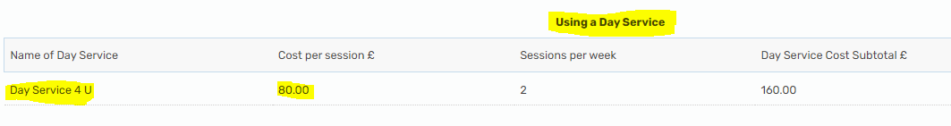

Please ensure the day service matrix is used to calculate the top-up. (DP Day Service session rate – Day service matrix session rate x sessions per week)

- This top-up figure will then need to be entered onto the calculator selecting the ‘any other regular weekly service’ radio button.

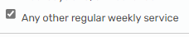

Input the information as demonstrated below. Ensuring the minus is inputted in the cost section to ensure the costs are deducted.

- This top-up amount will then be shown in the break down to ensure the correct amount of DP is paid and should be recorded in the cost section of the Care and Support Plan.
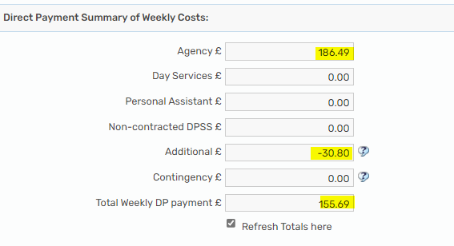

- Section 7 - Costs
Please include start date of agreed top up, but do not put costs weekly ongoing costs. Only input agreed weekly DP amount in ongoing cost description so that the DP amount paid is the maximum NCC will pay and does not include the top up amount.

The agreed top-up amount needs to be recorded in the top-up section. Third party’s name to be recorded if they have agreed to pay a top-up, the DP Recipient can also make this payment.

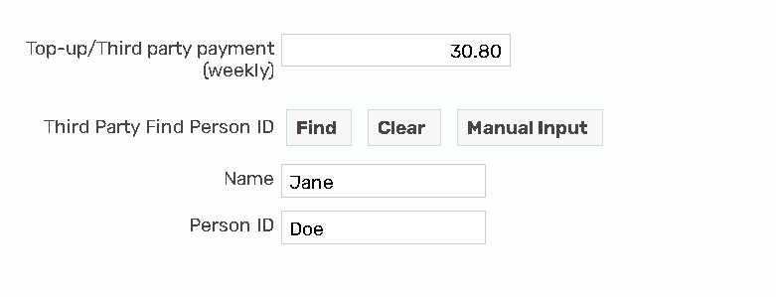

Complete a Top up agreement form located on the Direct payment support area – Direct Payment Top up agreement
Ensuring the signature of DP Recipient or Authorised Person, worker and date agreed match the support plan, and upload this to the Mosaic documents as a financial document, to be named;
DP Top up agreement

