Direct Payment Agreement and Mental Capacity
Ensuring the DP Agreement is correctly completed.

Does the person have/lack capacity to receive a Direct Payment?
It is the responsibility of the Social Worker/Community Care Officer to establish capacity of the Person in order to receive a Direct Payment.
The worker will be responsible to ensure the DP Recipient understands and agrees to the conditions in the DP Agreement. Ensure the agreement is signed by the DP Recipient/Nominated or Authorised person along with the workers signature, then uploaded to Mosaic as a ‘Financial Document’, the file should be named ‘DP Agreement (ID Number) (Initials) (Date signed)’ e.g. ‘DP Agreement 1234568 AB 01.04.2024’

DP Recipient lacks capacity
If the DP Recipient has been deemed by the Social Worker/Community Care Officer to lack capacity, then there must be an authorised person appointed. An Authorised Person can be a relative, friend or trusted person. The Authorised Person will be responsible for the conditions stated in the DP Agreement. The DP Recipient is therefore not required to sign the DP Agreement.
If NCC have been appointed deputy for the DP Recipient, they will need to sign the DP Agreement as the Authorised Person.
The worker will require to provide details of the DP Recipient in section 1 of the DP Agreement, details for the Authorised Person in section 2 and the Authorised Person requires to sign in agreement with the conditions stated In the DP Agreement.

Authorised Persons details and signature
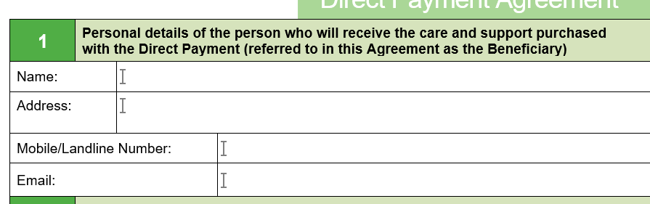
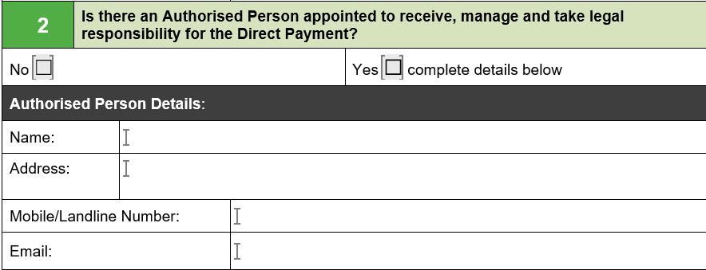

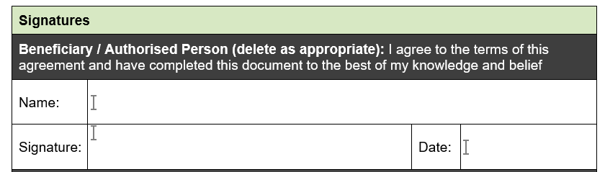

If the DP Recipient has been deemed to have capacity – The DP Recipient details and signature will need to have been provided in the boxes displayed below on the DP Agreement uploaded to Mosaic.
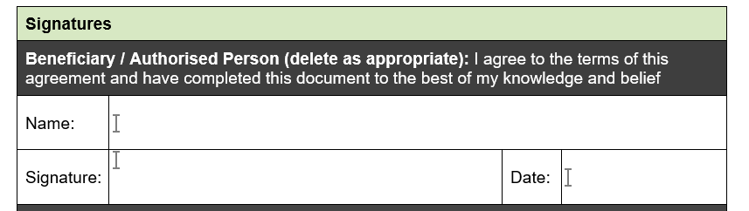


DP Recipient has capacity but would like to select a Nominated person/Direct Payment Support Service
If the Direct Payment Recipient has capacity but wishes for someone to manage the Direct Payment Account on their behalf, they may select either a relative, friend or trusted member to be their ‘Nominated Person’. The DP Recipient will hold responsibility of the conditions outlined in the DP Agreement, but the nominated person will also require to sign the DP Agreement to confirm they agree to conditions stated in section 8 of the DP Agreement.
The DP Recipient can instead wish to have a Direct Payment Support Service (DPSS), to manage the account on their behalf (third party managed account TPMA), via our contracted providers (Solo, Penderels, PeoplePlus, Purple & Rosekel), or internally with ACFS or a non-contracted provider. In this instance the Direct Payment Recipient should be provided with the information for the 5 contracted providers using the fact sheet uploaded to the Direct Payment Support Area (Selecting a Direct Payments Support Service – fact sheet 5). If they opt to use a non-contracted service, NCC will only pay the cost of the contracted service, any service above this cost, the Direct Payment Recipient will need to top up the difference in cost. If a DPSS is selected to manage the account, the DPSS provider will require to sign the DP Agreement along with the DP Recipient to agree to conditions stated in section 9 of the DP Agreement.
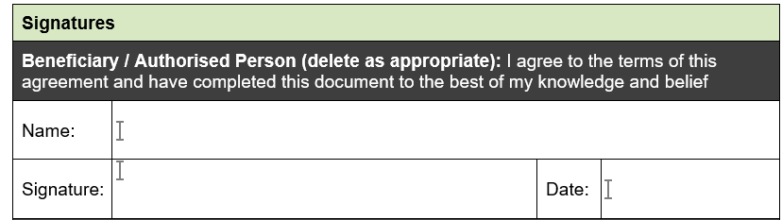

DP Recipients details and signature

Nominated person or DPSS details and signature.

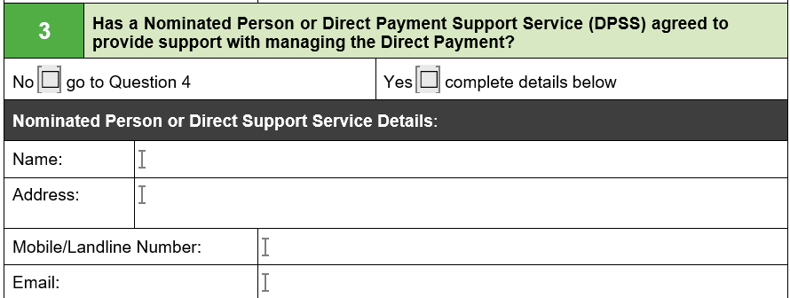
DPSS, ACFS or Nominated Person details and signatures

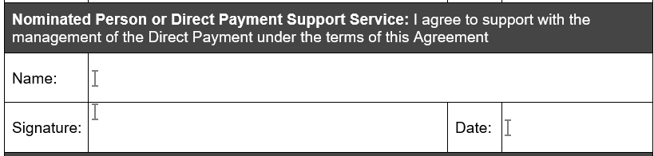

Method if payments
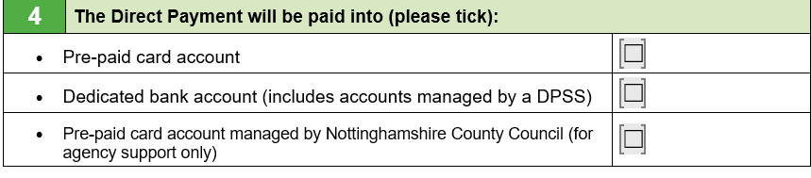
The chosen method must be documented in section 4 of the DP Agreement.

