1. Create Step:
The ‘Step’ is created by authorised staff to record the outcome of a CHC / s117 panel and advise the SCW of the actions required. The step is initiated outside of standard Mosaic workflow.

Process:
1. In the service users Mosaic record click start > new…
2. Click Continuing Health Care Panel
3. Click CHC Panel Outcome/Actions to open the form:
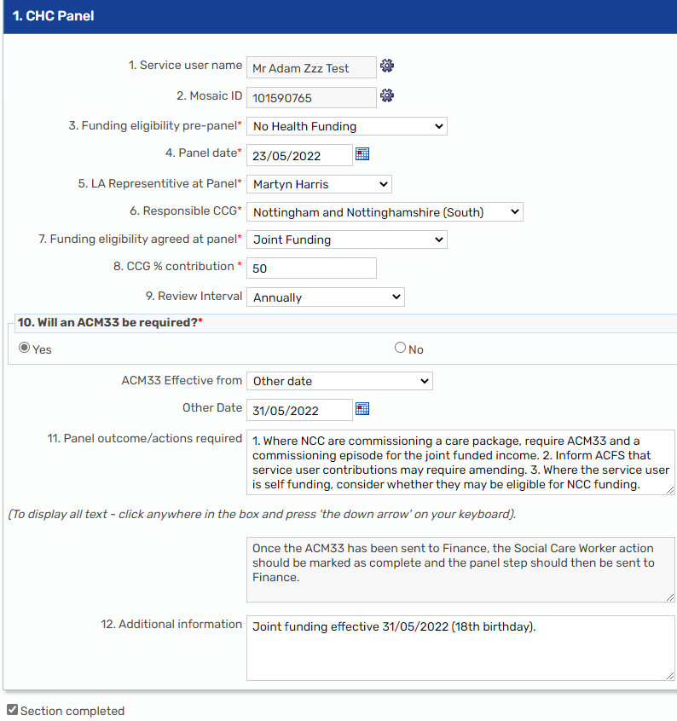 | Information Only  - **ALL FIELDS ARE MANDATORY**  - Box 10 is populated automatically with pre-defined actions governed by the selection of boxes 3 and 7.  - Text in box 10 may be edited or deleted as required.  - Where the text does not fully appear in box 10 click inside the box and press the down arrow ↓ on the keyboard.  - Box 11 may be used to record additional information where necessary.  - **ALL FIELDS ARE MANDATORY**
4. **ALL FIELDS ARE MANDATORY**. Once form is completed click 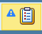 icon.
5. Click the radio button Required 1. Actions required arising from CHC panel  6. Click Find  7. Enter Locality Team in Organisation Name field. press Enter on the keyboard.  8. Hover the mouse pointer over the required Team and click their name.  9. Click Ok  10. Click icon  11. Click Yes to save changes. | 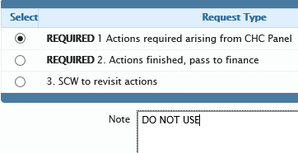  *Please do not use the notes section on this screen.
13. Click Incomplete Work folder
14. Click icon next to the step to be re-assigned  15. Click Assign Work  16. Select CHC Finance Worker  17. Click OK  18. On rare occasions it may be inappropriate to use a Step to record the Panel Outcome, and in such cases, a case note will suffice. Examples of this, are where the service user is fully Health funded with no recent previous involvement by NCC, and continues to be.  Task End | *The request is received into the SCW’s Incoming Requests folder. The step itself sits in the finance Incomplete Work folder until completed.

