

Mosaic Support : NHS Spine Mini Service (Mini-Spine)

The NHS Spine Mini Service (Mini-Spine) provides an interface to the NHS Spine system and enables a simplified method for accessing demographic data on the Spine system, in particular to verify a person’s NHS number and to get a person’s NHS number as held on the Spine system.

Please note that you no longer need to manually enter NHS numbers on service user’s records. It is advised you use this guidance to either obtain a person’s NHS number or to verify an existing NHS number.

IN MOSAIC, CHECK THE PERSON’S FRONT SCREEN TO IDENTIFY WHETHER OR NOT THEY HAVE AN NHS NUMBER LISTED IN THE REFERENCE NUMBERS SECTION.

If the person record DOES NOT have an NHS number listed

- If the person DOES NOT have an NHS number listed click GET NHS NUMBER and the Mini-Spine will automatically try to match the Mosaic data with the NHS systems data in order to obtain a verified NHS number. | 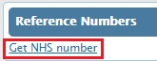
- If the Mini-Spine matches the Mosaic data with the NHS systems data the FIND NHS PERSON RESULTS screen will display the person’s NHS details and their NHS number.

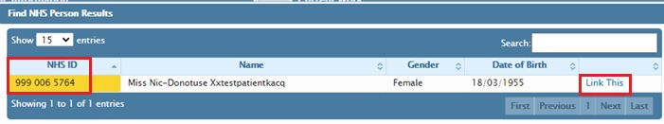

- After checking the details click LINK THIS which will auto-populate the NHS number in Mosaic as verified which is confirmed with a green tick | 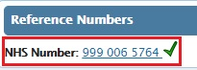
- If the Mini-Spine is not able to find a match with the NHS systems data the FIND NHS PERSON RESULTS screen will show NO RECORDS TO DISPLAY.

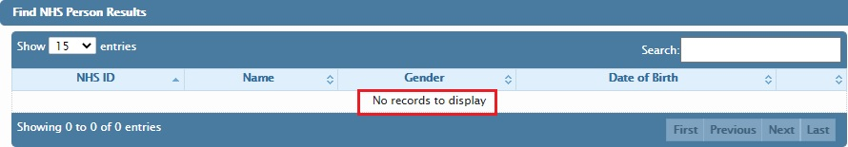

If the person record DOES have an NHS number listed

- If the person DOES have an NHS number listed but it hasn’t been verified (ie no green tick is displayed) click VERIFY to try to match the Mosaic data with the NHS systems data. | 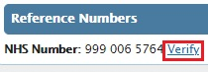
- If a match is found the NHS number will automatically be verified and a green tick will be displayed. | 

- If a match is not found a failure notification will be displayed. | 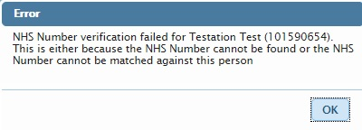
A video tutorial is also available at http://home.nottscc.gov.uk/working/departments/asch/mosaic/tutorials#mini

