Multiple changes to DP, including an uplift:
Where there are multiple change dates to a package you can use the DP calculator to work out the costs for each date, however you can only have 1 version of this and you would need to overwrite any information with the most recent/current change ensuring the date is correct. There is no requirement for a DP Calculator for each change date. SPT only need to the most recent change date and detail of support. If you wanted to do so, you can print the CASP DP Calculator section to a PDF document and save/upload to the Mosaic record, but this is not a commissioning requirement.
For example:
If you have 2 changes to the DP to commission, one from 1.9.22 to increase the hours from 10 to 15, and then another change on 1.4.23 to increase the PA hourly rate due to minimum wage increase;
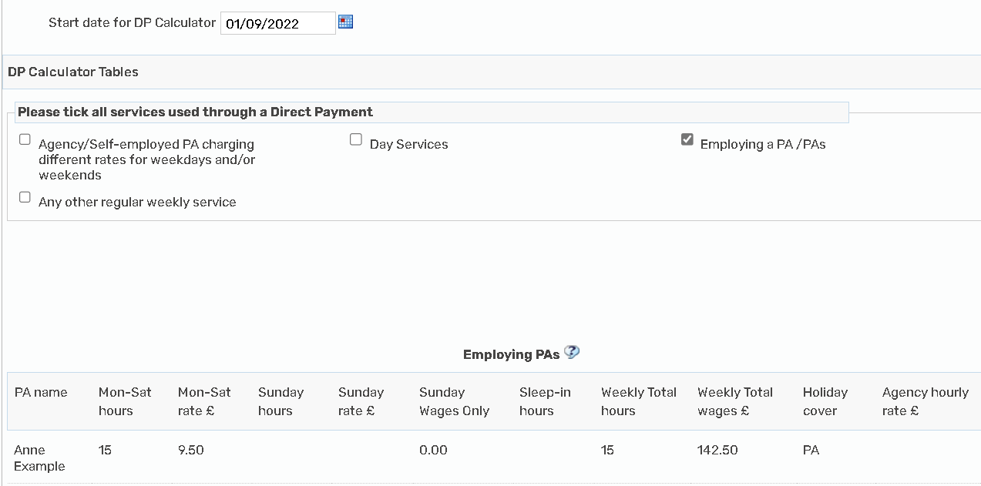
Put the date and hours and all other details onto the DP Calculator section
Refresh the totals
Go to the Cost section
Complete the DP date, detail and cost as per the summary and put an end date as the date before the next change (31.8.22) :
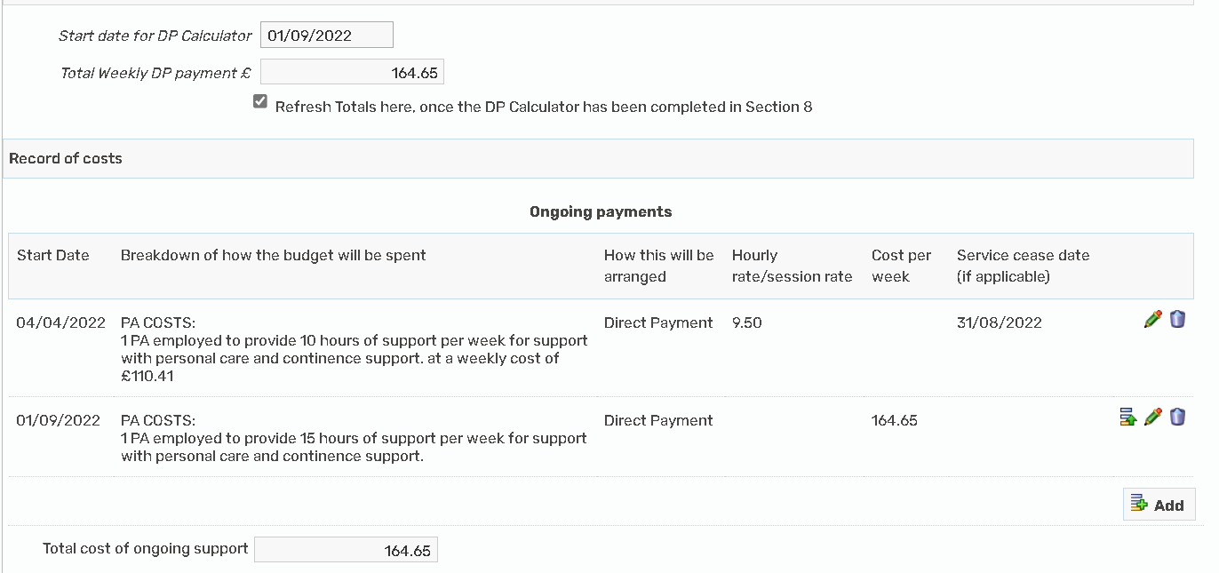

Go back to the DP Calculator section
Change the date to the next change date, this example is 1.4.23
Delete the current information, update with new information such as new min wage figure for April 2023 - £10.42
Refresh the totals
Go back to the cost section and copy the new information over
Dp Calculator;
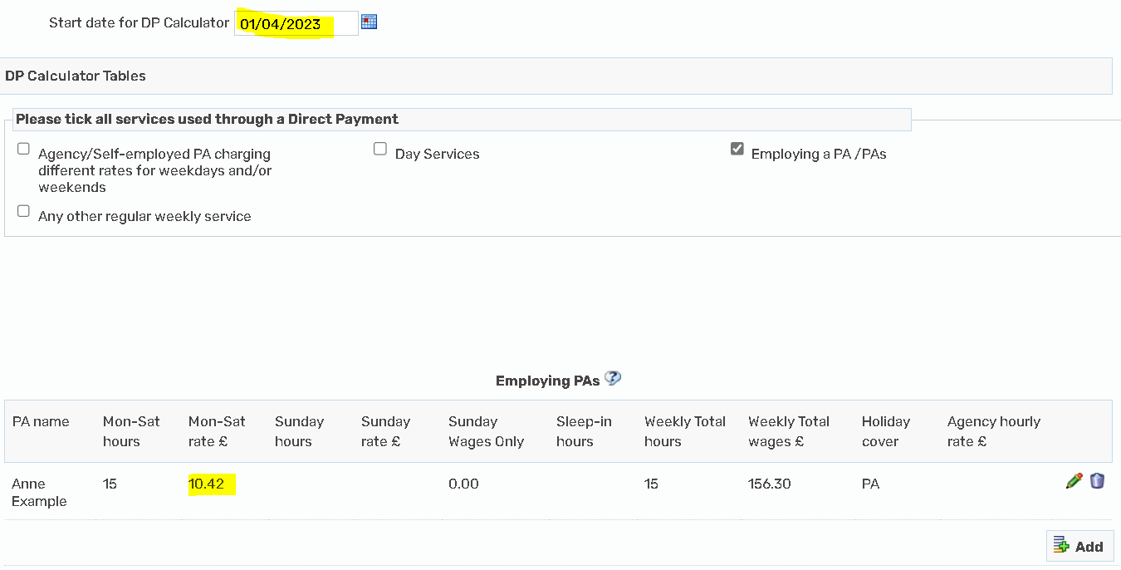
Cost section:
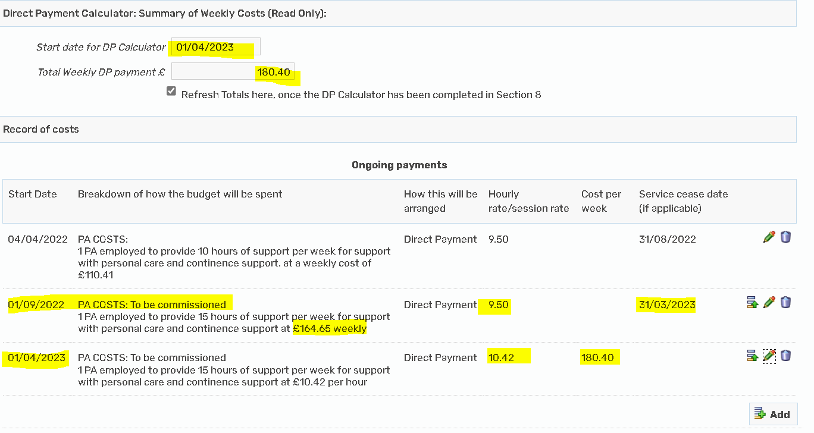

To create the DP Calculator as a PDF document, please click on the PDF icon within your step at the top of the screen:
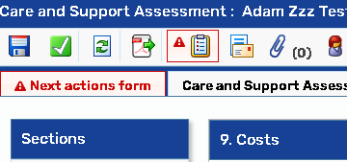
Select section 8 in the Review of care and support plan for the DP Calculator, in the conversation three workflow the DP Calculator is section 6, then output to PDF, you can then save/upload this if you wish to do so:
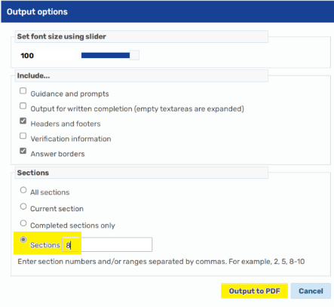
DPSS notice period
As the DPSS costs are NOT included in the total cost of the Mosaic DP Calculator you would not need a separate calculator or the DPSS notice date as the start date.
Please put the start/change date on the DP Calculator section as the most recent change date whether this is the change of support or the date the contracted DPSS is removed from the ongoing DP and paid centrally on the new process.
The DPSS agreed start/change date will be recorded in the cost section on the CASP under the DPSS sections – and will not necessarily be the same start/change date as the support.
Please input the ‘old DPSS rates’ as an individual line on the ongoing cost section with an end date (date prior to agreed start/change date with DPSS provider)
Uplift to costs
Where there is an uplift provider rate only (no change to services provided/hours of support/provider) a ‘Request care package amendment step – Care and Support Plan update’ should be used. All changes to DP’s with a PA require a DP Calculator as a mandatory requirement the only exception to this is where a PA is used as part of the planned short breaks as the DP Calculator does not facilitate short break commissioning.
If there is also a change in support hours or provider, then this should be done via a review step.

