MOSAIC Guidance

Further Conversation Required
March 2022

3 Conversations Intranet Page can be found at:
Three conversations | Nottinghamshire County Council Intranet (nottscc.gov.uk)

For further assistance in using Mosaic – please contact:

mosaicdevelopment@nottscc.gov.uk

Tel: 0115 97 73784

Important Notice: Records should only be accessed where there is a lawful and business need to do so. All activity on Mosaic can be audited and is subject to compliance spot checks. Any irregular activity could result in disciplinary action up to and including dismissal. Unlawful activity on Mosaic may also result in prosecution under the provisions of the Data Protection Act 2018.

Contents

Further Conversation Required Page 3

Action | Screen View
Further Conversation Required  To be completed by District Team or Worker  From the Current Work folder, click on the blue arrow icon 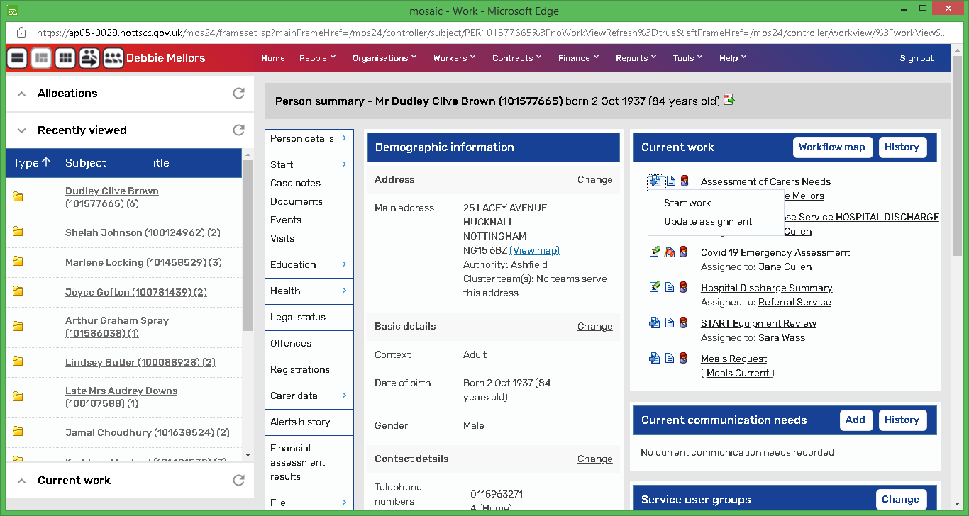 on the left-hand side of the title and select Start Work  Within the step there is one Section:  - Actions Taken  Click on Add  There are 3 possible actions that can be selected.  - Conversation 1 – Listen and Connect  - Conversation 2 – Action Planning  - NFA  Select the appropriate Action(s) and Assign to the appropriate worker or team. Then click on Add and Close.  Click on green tick to complete the Step. | 