

Creating and modifying person addresses in Mosaic Guidance

Table of Contents
1. Introduction 1
2. Creating a new address for a person 1
2.1 Creating an address for a person not living in the UK 4
3 Modifying an address for a person 5
3.1 Updating an existing address 5
3.1 Moving address 6
4 Amending Basic Details 8
4.1 Amending Basic Details to indicate a person’s death (ACFS only) 9

1. Introduction

The following guidance describes the steps needed to create or modify a person’s address in Mosaic.

In considering this guidance, please note that addresses on Mosaic have multiple uses, for example, contact details used by social care workers, care home addresses and addresses used for payments and billing. Please ensure that you only create or update the address relevant to your task. Billing and Remittance addresses should only be added or amended by Adult Care Financial Services (ACFS).

Creating a new address for a person

Find the person using their Person ID

Select People -> Find Person from the main menu

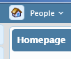

Enter the Person ID in the Person Reference box

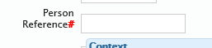

Click Find

From the Find Person Results, click on the name of the person. This displays the Person Summary.

From the person menu, select Person Details -> Addresses

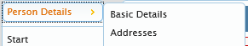

This will show you the currently configured addresses for this person.

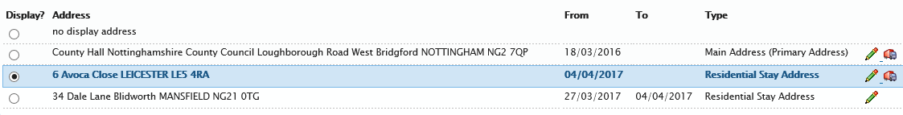

To enter a new address, click Add at the bottom of the screen.

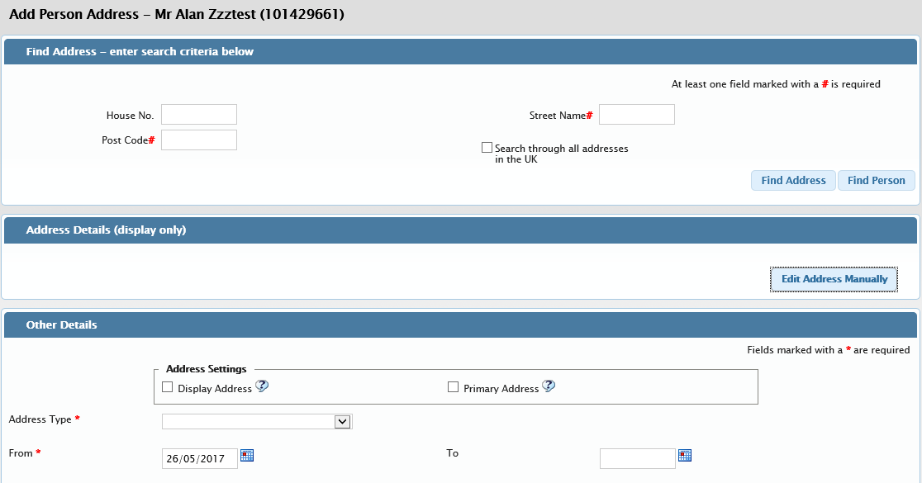

It is recommended that the Post Code is used to search for an address before entering it manually. This will reduce the number of errors in addresses, as the PAF file from the Post Office is regularly updated in Mosaic.

For non-Nottinghamshire addresses, the ‘Search through all addresses in UK’ box must be ticked for the postcode/street name search to occur.

Addresses can also be identified using the Find Person option, for example, where a bill is to be addressed to another person also on Mosaic.

Once an address is selected from the find option, it will appear in the Address Details window. The address can now be manually edited, to add any specific details not included from the PAF file. To add an address which the PAF file does not find, ‘Edit Address Manually’ option allows for an address to be manually entered.

The Other Details box allows for the type of address to be setup.

Below are the Address Types available and a description of what they are used for.

Main Address | The main address for the person
Residential Stay Address | This is the residential stay address for the person, for example, if they have entered a care home
Work | This is the work address for the person
Remittance Address (payment cycle) | This is the remittance address for the person (if Direct Payment) or provider, linked to payment cycles
Billing Address (billing cycle) | This is the billing address for the person, linked to billing cycles.

Please note: if there is no active remittance or billing address, the payment and billing processes use the main address.

The relevant Address Type should be selected from the dropdown list.

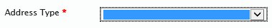

The From date is the date at which this address is valid from.

Do not select Display Address or Primary Address if you are entering a Remittance Address or Billing Address. The Display Address is the address that shows on the Person Summary and Primary Address indicates where a person primarily resides. These are usually both selected for the Main Address/Residential Stay Address.

The Household Structure, Tenure Type and Access Notes are more relevant to Main Address and should not be used.

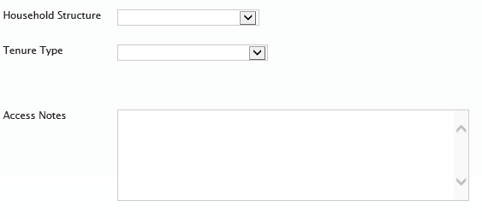

Click Save to save this new address.

When you have finished ensure the correct box is selected for Display Address. This is usually the Residential Stay Address or the Main Address (Primary Address).



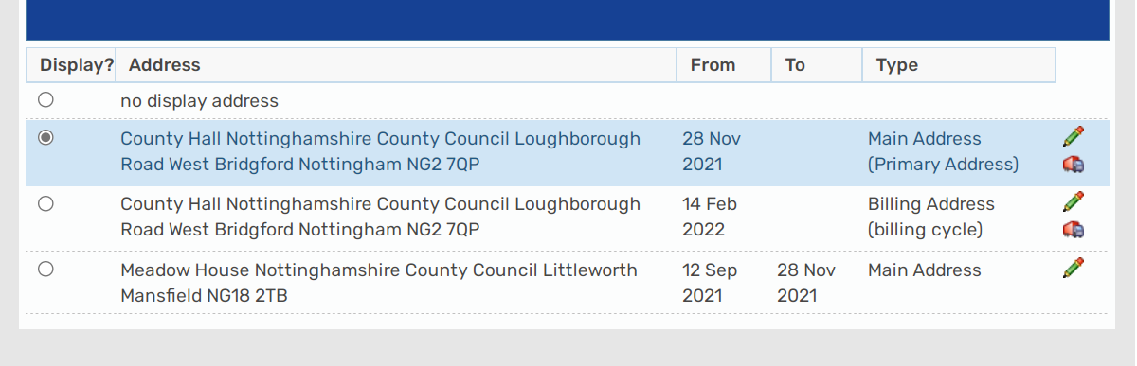

Creating an address for a person not living in the UK

Find the person using their Person ID

Select People -> Find Person from the main menu



Enter the Person ID in the Person Reference box



Click Find

From the Find Person Results, click on the name of the person. This displays the Person Summary.

From the person menu, select Person Details -> Addresses



This will show you the currently configured addresses for this person.
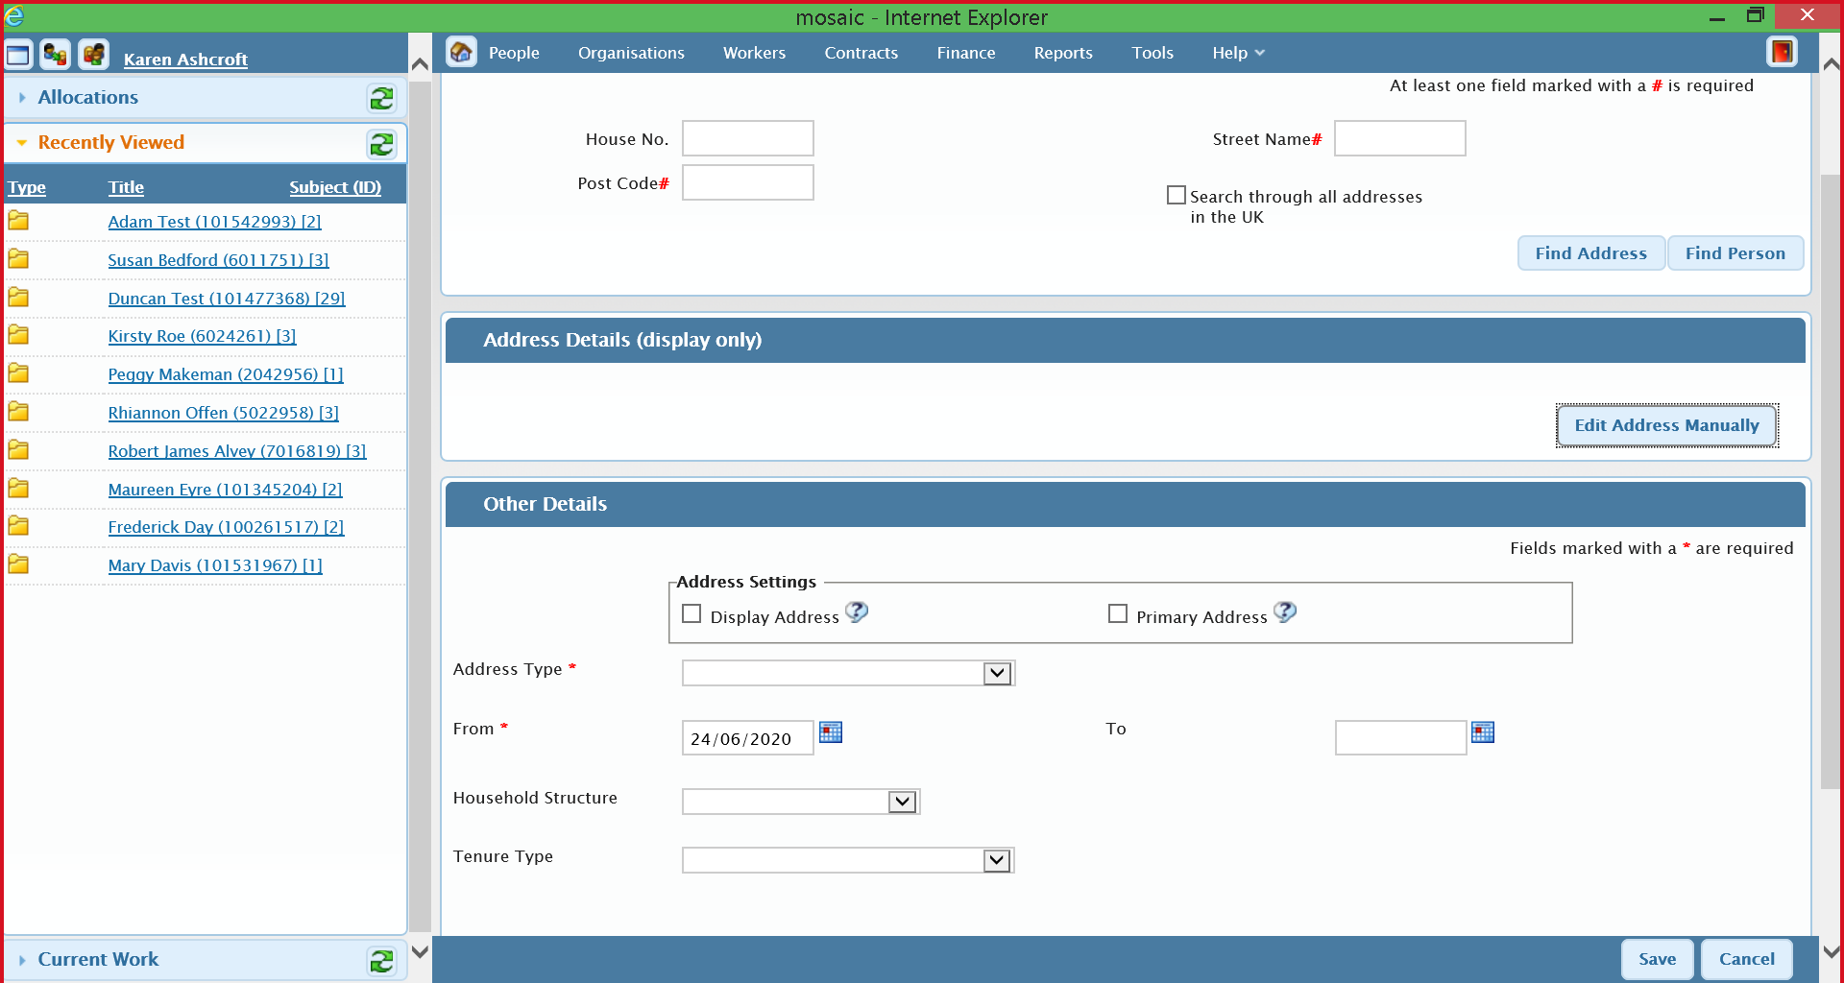

Click on Edit Address Manually and key the details into the relevant fields. Please note - If adding a c/o address this is added in the building field. If adding a zip code this is added in the post code field.

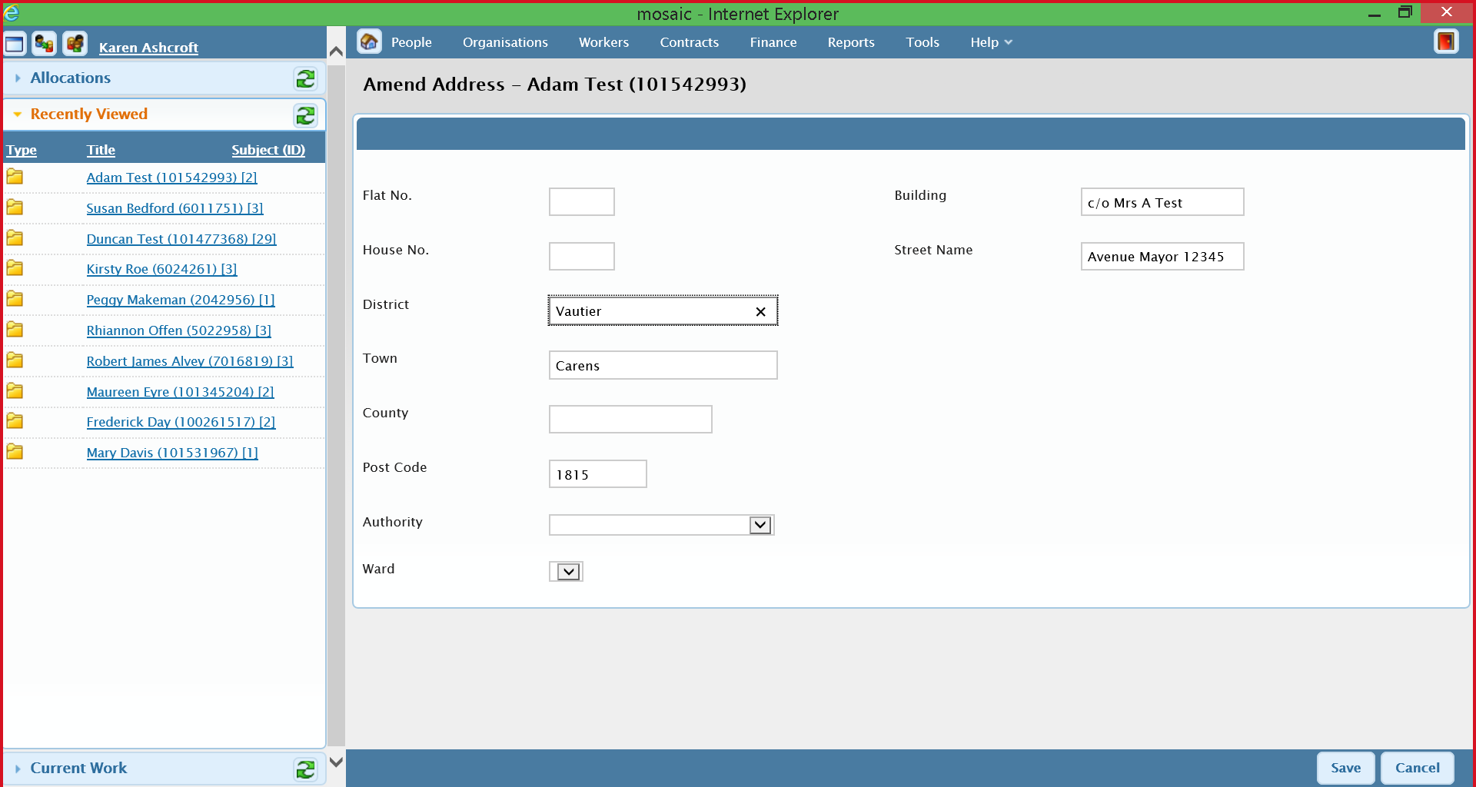

Modifying an address for a person

3.1 Updating an existing address

From the person menu, select Person Details -> Addresses



This will show you the currently configured addresses for this person.



To update an existing address, due to an error in the address information, click on the pencil symbol next to the relevant address.

The Address Details (display only) can be modified using the Edit Address Manually button.

All Other Details can also be changed from this screen.

Click Save to save the changes or Cancel to exit without saving the changes.

Moving address

To move a person from one address to another click on the lorry symbol next to the relevant address.


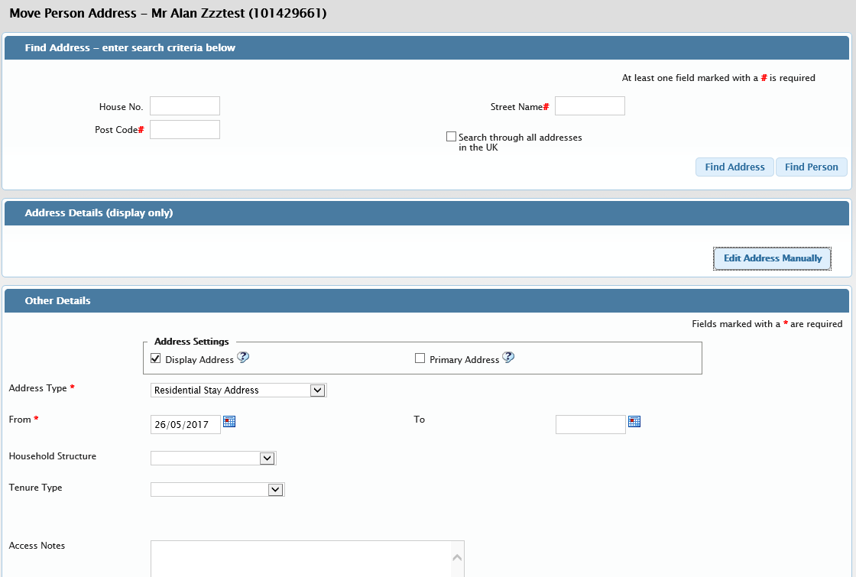

It is recommended that the Post Code is used to search for an address before entering it manually. This will reduce the number of errors in addresses, as the PAF file from the Post Office is regularly updated in Mosaic.

For non-Nottinghamshire addresses, the ‘Search through all addresses in UK’ box must be ticked for the postcode/street name search to occur.

Addresses can also be identified using the Find Person option, for example, where a bill is to be addressed to another person also on Mosaic.

Once an address is selected from the find option, it will appear in the Address Details window. The address can now be manually edited, to add any specific details not included from the PAF file. To add an address which the PAF file does not find, ‘Edit Address Manually’ option allows for an address to be manually entered.

The Other Details box allows for the type of address to be setup.

Below are the Address Types available and a description of what they are used for.

Main Address | The main address for the person
Residential Stay Address | This is the residential stay address for the person, for example, if they have entered a care home
Work | This is the work address for the person
Remittance Address (payment cycle) | This is the remittance address for the person (if Direct Payment) or provider, linked to payment cycles
Billing Address (billing cycle) | This is the billing address for the person, linked to billing cycles.

Please note: if there is not active remittance or billing address, the payment and billing processes will use the main address.

The relevant Address Type should be selected from the dropdown list.



The From date is the date at which this address is valid from.

Do not select Display Address or Primary Address if you are entering a Remittance Address or Billing Address.

The Household Structure, Tenure Type and Access Notes are more relevant to Main Address and should not be used.



Click Save to save this new address.

4.0 Amending Basic Details in Person Summary
When adding a person sometimes it is necessary to add other names for eg. a previous name, preffered name or also known as name. In these instances you should follow the guidelines below. Do not add anything to the person’s first name or last name in the Basic Details screen.

From Person Details click on Other Names

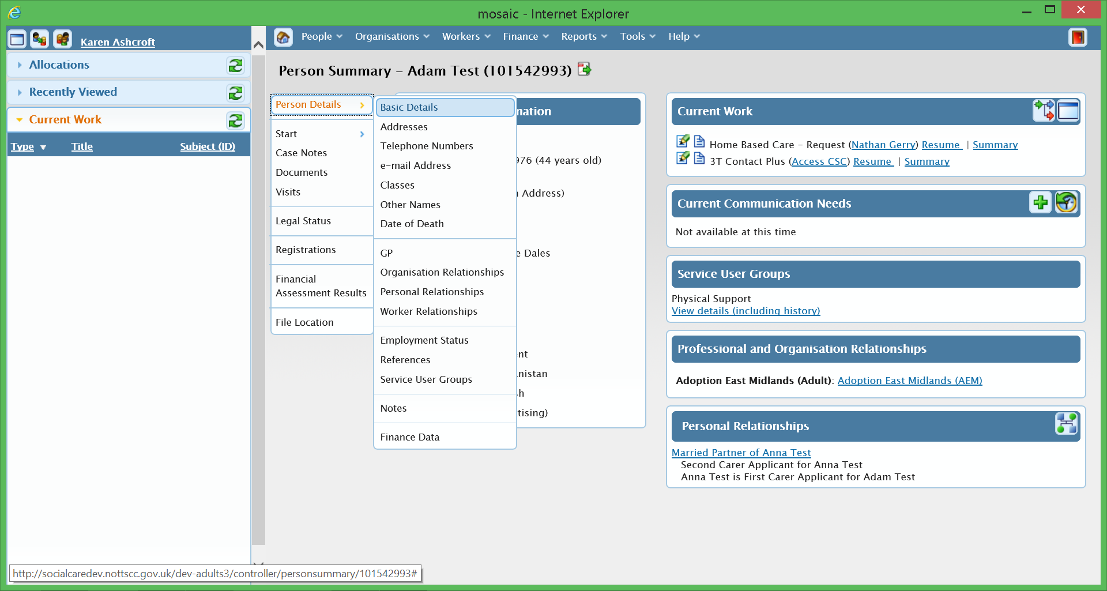

Click on Add from the bottom right hand side of the screen and key the additional detail into this screen.

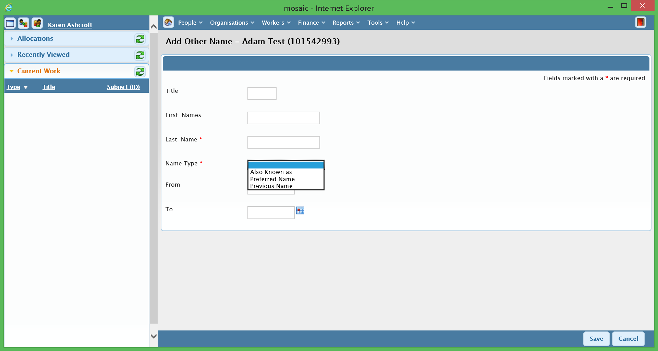

4.1 Amending Basic Details to indicate a person’s death (ACFS only)

In this instance you can add detail to the person’s first name or last name in the Basic Details screen. This is required so that a bill is suitably addressed following a person’s death.

From the Person Details click on Basic Details. Add the word ‘The’ in the Title field and add the title ‘Late Mr/Mrs/Miss’ in the First Name field before the person’s name.

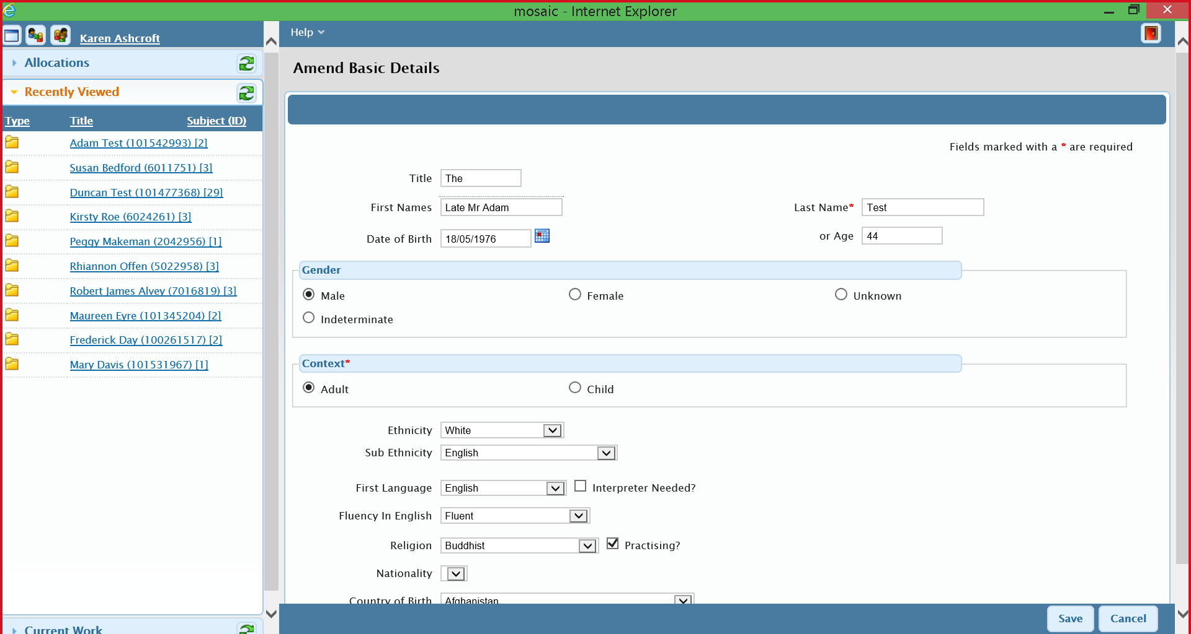

The address is then amended to indicate the person is deceased.

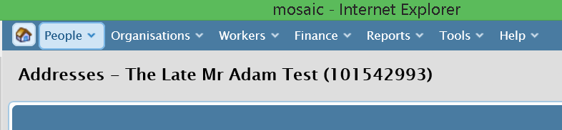
When later searching for this person a % sign should be added before the first name to ensure this person is returned in the search results.

