MOSAIC Guidance

Conversation 1 – Listen and Connect
March 2022
Reviewed November 2022

3 Conversations Intranet Page can be found at:
Three conversations | Nottinghamshire County Council Intranet (nottscc.gov.uk)

For further assistance in using Mosaic – please contact:

mosaicdevelopment@nottscc.gov.uk

Tel: 0115 97 73784

Important Notice: Records should only be accessed where there is a lawful and business need to do so. All activity on Mosaic can be audited and is subject to compliance spot checks. Any irregular activity could result in disciplinary action up to and including dismissal. Unlawful activity on Mosaic may also result in prosecution under the provisions of the Data Protection Act 2018.

Contents

Starting Conversation 1 – Listen and Connect Page 3
Section 1: Person Details Page 3
Section 2: Person making the contact Page 3
Section 3: Record of Conversation One Page 5
Other Forms and Letters Page 6
Section 4: Next Actions Page 6

Action | Screen View
Conversation 1 – Listen and Connect  To be completed by Social Worker, Occupational Therapist.  From the Current Work folder, click on the blue arrow icon 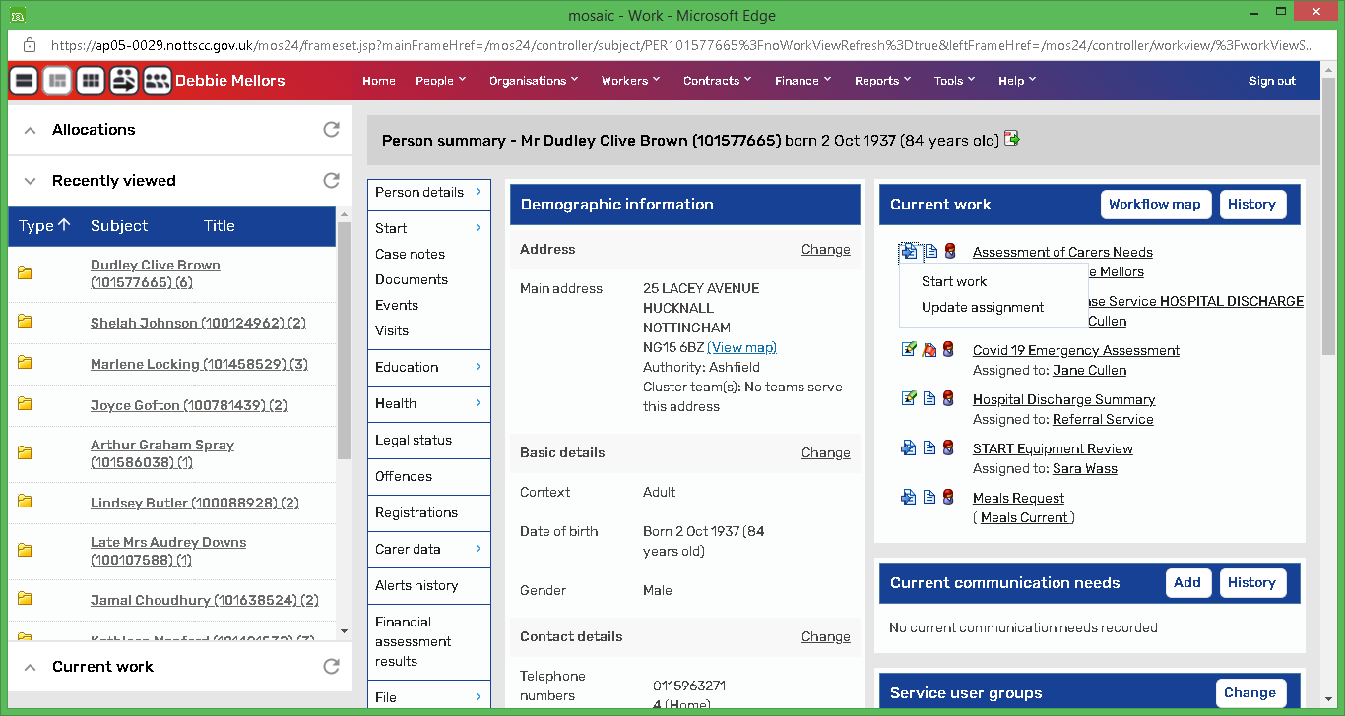 on the left-hand side of the step title and select Start Work  Within the step there is one Form with four Sections:  - Person Details  - Person making the contact  - Record of Conversation One  - Actions Taken  Section 1: Person Details  Section is pre-populated with information provided. Check to ensure it is correct.  Section 2: Person making the contact  Select the appropriate radio buttons for each question, but please note that there are hidden fields for three of the questions, depending on your response to them:  - Are you contacting us about yourself? If you select No, further fields will appear that you need to complete  There are further hidden fields within this option that may need to be completed:  - If you select Other as a contact  - If you select No, that the person is not aware of the contact  - If you select Yes that the person needs support to be fully involved  - If you select Sometimes that the person needs support to be fully involved  - If you select No, the person does not have mental capacity to agree to the process  - Do you need support to be fully involved?  - If you select Yes, you will need to complete an additional field.  - If you select Sometimes, you will need to complete an additional field.  - Does the person have mental capacity to agree to the assessment process? If you select No, you will need to complete an additional field.  Section 3: Record of Conversation One  - Select the appropriate responses for each question.  - If you are completing Occupational therapy Work, please answer ‘Yes’ to this question and complete the questions that pop up:  - ‘Is a further conversation required’ is a Mandatory Field.  - Actions Taken is a Mandatory Field. Please note that there are hidden fields for three of the options if they are selected:  - If ‘Provided the person basic equipment or adaptations’ is selected, you must complete the Equipment and adaptations table  - If ‘Provided low cost service – payment card’ is selected, you must complete the Cost of prepayment card field  - If ‘Other’ is selected, you must complete the Detail field  - Select the appropriate responses for each question – note that the Area of ASCPH you work for is a Mandatory Field, and you will also need to select the team you work for  - Do you agree to us sharing your information? If you select No, you will need to complete an additional field.  Before you complete Section 4: Next actions, you can add an additional form or letter if required. Click on the Forms and Letters icon on the toolbar and select the form.  Section 4: Next Actions  There are 13 possible actions that can be selected.  - ADVIS PIW Enablement Plan  - ADVIS Reablement specialist conversation  - Assessment of Carers Needs *  - Assistive Technology Request *  - Conversation 2 – Action planning  - Conversation 3 – Building a good life  - HPAS – email sent  - Major Adaptation Assessment Phase *  - Meals Request *  - MIS PIW Request *  - NFA  - OT 0 Follow up *  - Send to Benefits Team *  - Steps marked with an * have the option of being sent immediately without completing the step - if you want to move something on but also keep your conversation open. Tick the ‘Send Immediately’ box, Assign, then add and close the action.  - As soon as you save or save and close the step, that action will be sent.  Click on green tick to complete the Step. | 