MOSAIC Guidance

Conversation 2 – Action Planning
March 2022
Reviewed November 2022

3 Conversations Intranet Page can be found at:
Three conversations | Nottinghamshire County Council Intranet (nottscc.gov.uk)

For further assistance in using Mosaic – please contact:

mosaicdevelopment@nottscc.gov.uk

Tel: 0115 97 73784

Important Notice: Records should only be accessed where there is a lawful and business need to do so. All activity on Mosaic can be audited and is subject to compliance spot checks. Any irregular activity could result in disciplinary action up to and including dismissal. Unlawful activity on Mosaic may also result in prosecution under the provisions of the Data Protection Act 2018.

Contents

Starting Conversation 2 – Action Planning Page 3
Section 1: Person Details Page 3
Section 2: Person making the contact Page 3
Section 3: Reminder of previous Conversation Page 5
Section 4: Record of Conversation 2 Plan Page 5
Other Forms and Letters Page 7
Section 5: Next Actions Page 7

Action | Screen View
Conversation 2 – Action Planning  To be completed by Social Worker, Occupational Therapist.  From the Current Work folder, click on the blue arrow icon 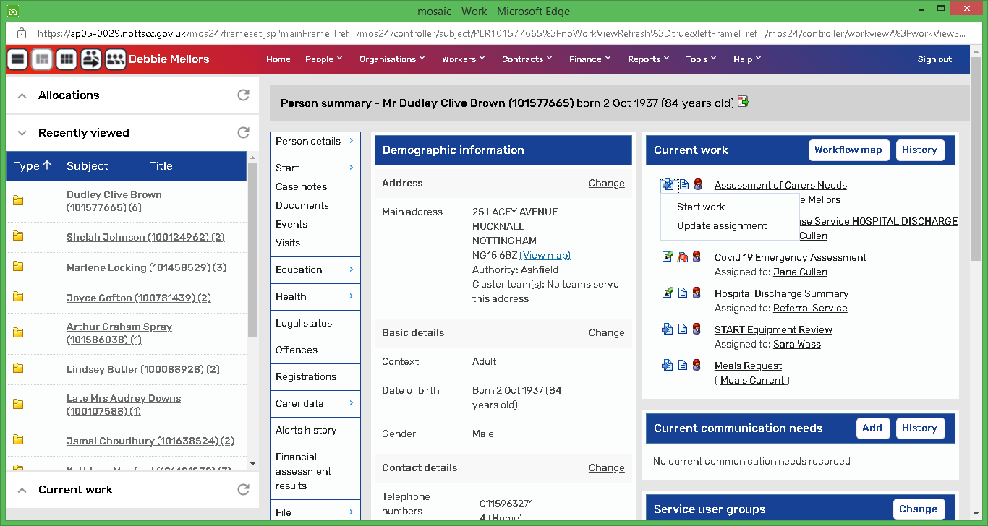 on the left-hand side of the step title and select Start Work  Within the step there is one Form with five Sections:  - Person Details  - Person making the contact  - Reminder of previous conversation  - Record of Conversation Two Plan  - Next Actions  Section 1: Person Details  Section is pre-populated with information provided. Check to ensure it is correct.  Section 2: Person making the contact  The responses from Conversation 1 will pre-populate this section, but they can be over-ridden. If you need to change the response, select the appropriate radio button for each question, but please note that there are hidden fields for three of the questions, depending on your response to them:  - Are you contacting us about yourself? If you selected No, further fields will appear. They will be pre-populated from the Conversation 1 step, but can be changed  There are further hidden fields within this option that may need to be completed:  - If you selected Other as a contact, further fields will appear. They will be pre-populated from the Conversation 1 step, but can be changed  - If you select No, that the person is not aware of the contact, a further field will appear. It will be pre-populated from the Conversation 1 step, but can be changed  - If you select Yes that the person needs support to be fully involved, a further field will appear. It will be pre-populated from the Conversation 1 step, but can be changed  - If you select No, the person does not have mental capacity to agree to the process, a further field will appear. It will be pre-populated from the Conversation 1 step, but can be changed  - Do you need support to be fully involved?  - If you select Yes, you will need to complete an additional field. It will be pre-populated from the Conversation 1 step, but can be changed  - If you select Sometimes, you will need to complete an additional field. It will be pre-populated from the Conversation 1 step, but can be changed  - Does the person have mental capacity to agree to the assessment process? If you select No, you will need to complete an additional field. It will be pre-populated from the Conversation 1 step, but can be changed  Section 3: Reminder of Previous Conversation  Section is pre-populated from Conversation 1.  Section 4: Record of Conversation Two Plan  - Select the appropriate responses for each question.  - If you are completing Occupational therapy Work, please answer ‘Yes’ to this question and complete the questions that pop up:  - Create a Conversation Two Plan by clicking Add.  Enter the details of the Plan, including the completion if appropriate. Click Add and Close or Add if you need to create/update another Action.  The Action now appears on the form and each action within the plan can be updated by clicking on the green pencil or deleted by clicking on the dustbin.  - Record what has been done against your actions in the above Action plan/Conversation Two plan table.  Record Updates, including the completion if appropriate. Click Add and Close or Add if you need to create/update another Plan.  The Updates now appear on the form and can be updated by clicking on the green pencil or deleted by clicking on the dustbin.  - Tick Only if you want to arrange some Short-Term support for the person  If you tick this box, hidden fields appear ABOVE it that need to be completed.  - Arranging Support  - Types of support you wish to set up. Whichever one you tick (you can tick multiple types), will create another table for you to complete  - Is a Conversation 3 Required? This is a Mandatory field.  - Actions Taken is a Mandatory Field. Please note that there are hidden fields for two of the options if they are selected:  - If ‘Provided the person basic equipment or adaptations’ is selected, you must complete the Equipment and adaptations table  - If ‘Other’ is selected, you must complete the Detail field  - Select the appropriate responses for each question.  Before you complete Section 5: Next actions, you can add an additional form or letter if required. Click on the Forms and Letters icon on the toolbar and select the form.  Section 5: Next Actions  There are 18 possible actions that can be selected.  - ACM33 *  - ADVIS PIW Enablement Plan  - ADVIS Reablement specialist conversation *  - Assistive Technology Request *  - Commence Short Term Independence Service (STIS) *  - Conversation 3 – Building a good life *  - Financial Adjustment/Amend Reablement Service *  - Major Adaptation Assessment Phase *  - Meals Request  - MIS Enablement Plan *  - MIS PIW Request *  - MIS Reablement  - NFA  - OT – Follow up *  - Request a Financial Assessment on a Person *  - Send to Benefits Team *  - Short term Home Care  - START Initial Screening *  - Steps marked with an * have the option of being sent immediately without completing the step - if you want to move something on but keep your conversation open. Tick the ‘Send Immediately’ box, Assign, then add and close the action.  - As soon as you save or save and close the step, that action will be sent.  - Click on green tick to complete the Step. | 