2025 Minor Adaptations Requisition template
Prescriber Name: | Person’s Webelms code:
Prescribers PIN code: | Date of order:

BATH – GRAB RAILS – template 2
Please draw the rail position on this template

Rail Position: |  | 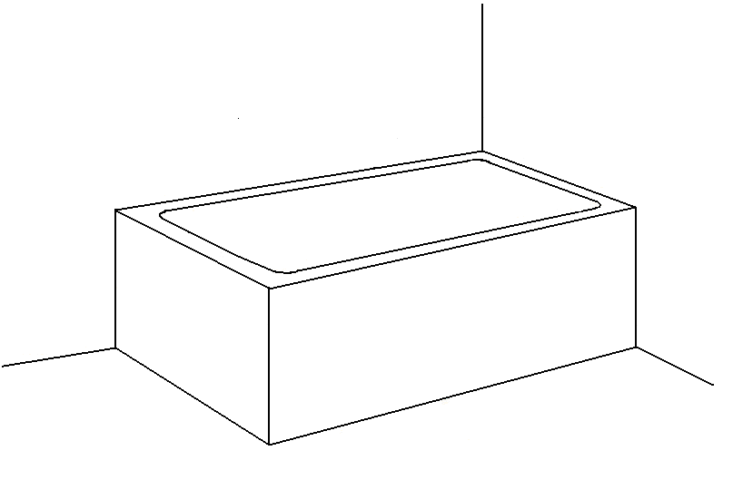
Vertical
Horizontal
Angled

Details of bath / shower equipment in situ:
Length of plastic rail required: |  | 300mm / 12 inch |  |  | 450mm / 18 inch
Measurement from centre point of rail in cm or mm: | A. Vertical (from bath rim)
 | B. Horizontal (from corner)
It is the Prescribers responsibility to ensure that the Person is within the weight limit of any adaptation requested.

