2025 Minor Adaptations Requisition template
Prescriber Name: | Person’s webelms code:
Prescribers PIN code: | Date of order:
DOORWAY – GRAB RAILS G
Please draw the rail position on this template
Looking from which direction – inside or outside?

 |  | 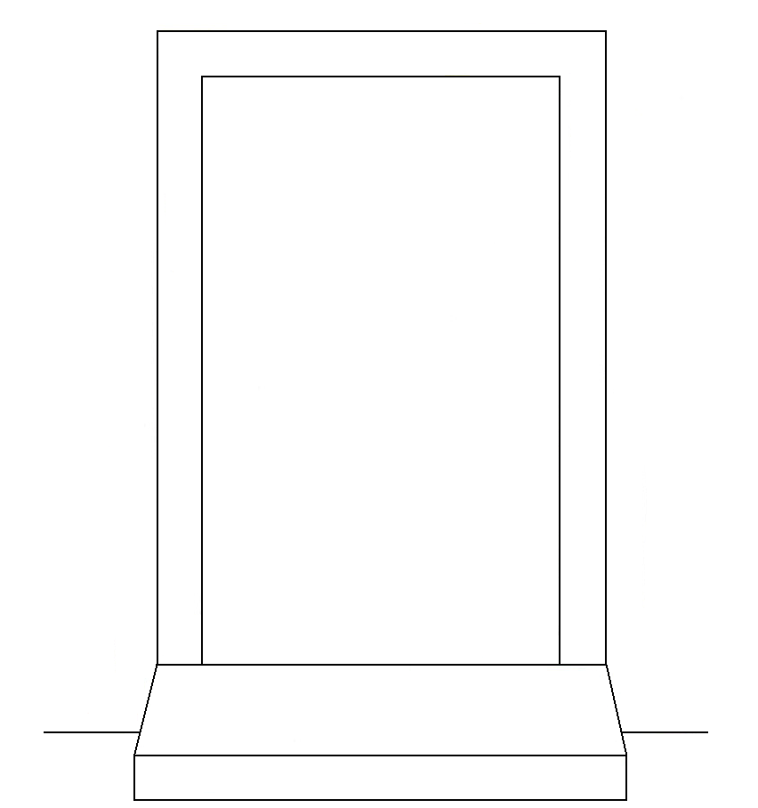
Rail Location: |  |  | Which side of door?
Front door |  |  | Left
Side Door |  |  | Right
Back Door |  |  | Both
Other
(Please state)

Length of rail required: | 450mm / 18 inch |  | 610mm / 24 inch
Measurement taken from | Top of step |  | Ground floor
Vertical measurement from centre point of rail in cm or mm:
Tech / Contractor will fit as close to doorframe as possible unless stated otherwise
It is the Prescribers responsibility to ensure that the person is within the weight limit of any adaptation requested.

